**What is GitHub? When was it created? Why? By who? What similar platforms exist? Why would you use such a platform?**

GitHub is a cloud-based service that helps developers store and manage their code, as well as track and control changes to their code. GitHub is associated to two connected principles:

* Version control
* Git

GitHub was created in 2008 by Chris Wanstrath, PJ Hyett, Tom Preston-Werner and Scott Chacon.

There are other similar platforms like GitLab, BitBucket, Beanstalk, Launchpad, SourceForge, Phabricator, GitBucket etc. Github is used because it supports version control i.e. when multiple developers are working we can keep track of different versions.

**Git Tutorial:**

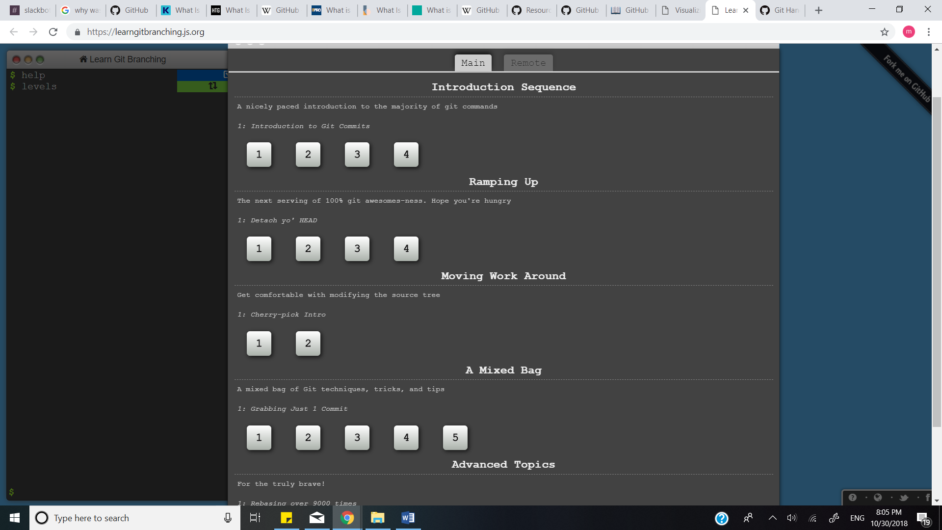

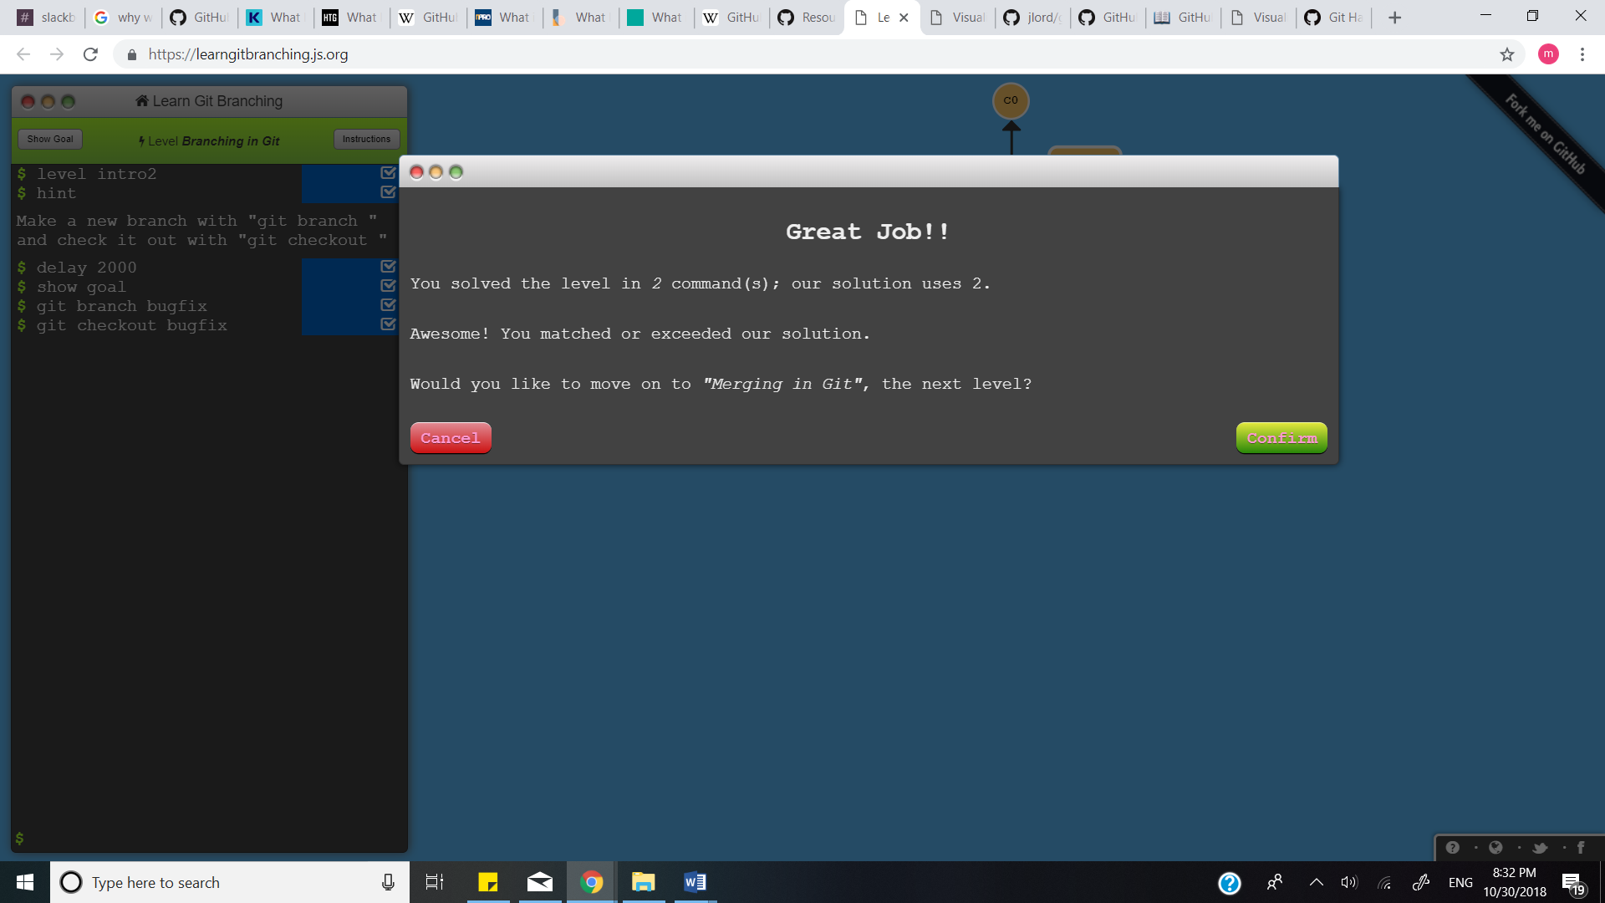

**Define the following terms in the context of Git:**

* **Repository:** Location where projects are stored. Each project has its own repository, can be accessed with the unique URL. Repositories can be Private or Public.
* **Commit:** Used to commit the recently added files to the branch and save changes to project/repository. We can use with '-m' to specify commit message. Command used is git commit
* **Push**: Used to push the changes which are made in the project into the repository so that others can have access to the changes made in the project.
* **Branch**: Lightweight movable pointer to various commits. Basically, Parallel version of codebase. Default branch name in Git is master.
* **Fork**: It is a copy of repository. It makes easy for developer to make changes without affecting the original project.
* **Merge**: Used by git pull to incorporate changes from another repository and can be used by hand to merge changes from one branch into another.
* **Clone**: Clone is copying the repository. It creates its own separate history and also works on a complete different environment from the original repository.
* **Pull**: Used to pull the project/files/code from the remote location.
* **Pull request**: Helps to display the changes that has been pushed in repository on GitHub

**Pushing the document in repository CS6432018:**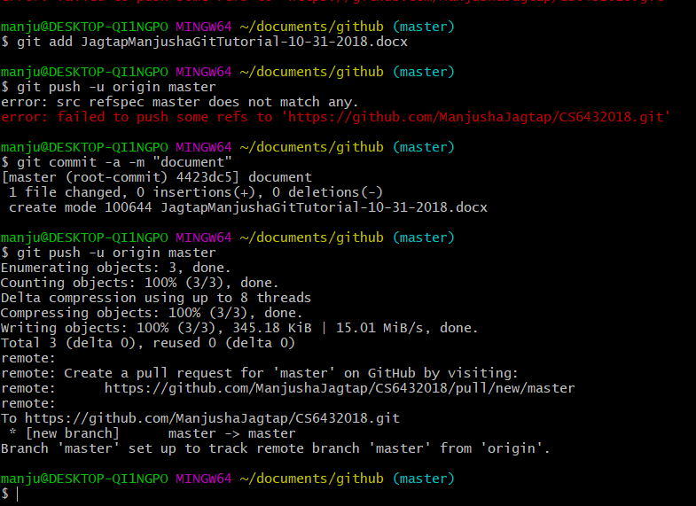

**The Readme file is updated with the name Jagtap, Manjusha 31 October 2018 11:04 PM**

**The repository has been forked and the file has been cloned.**

**Pull Request has been sent.**

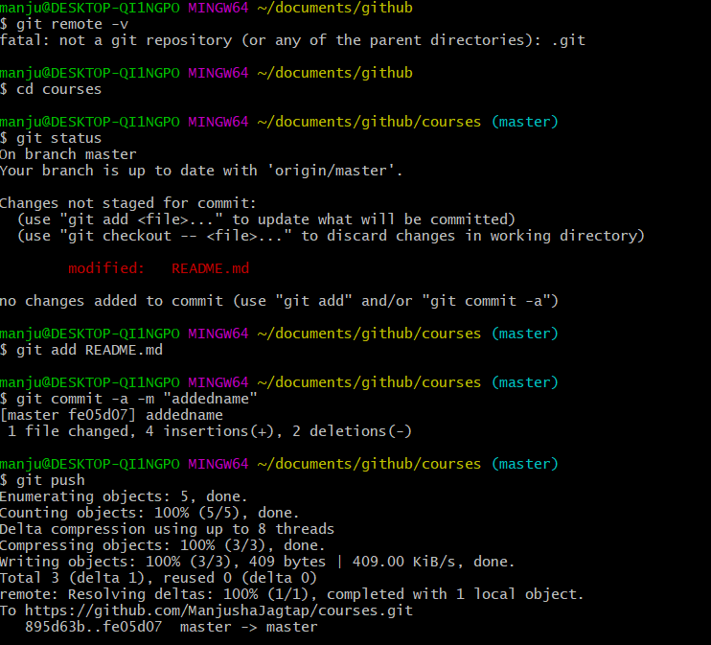

**Adding an Issue :**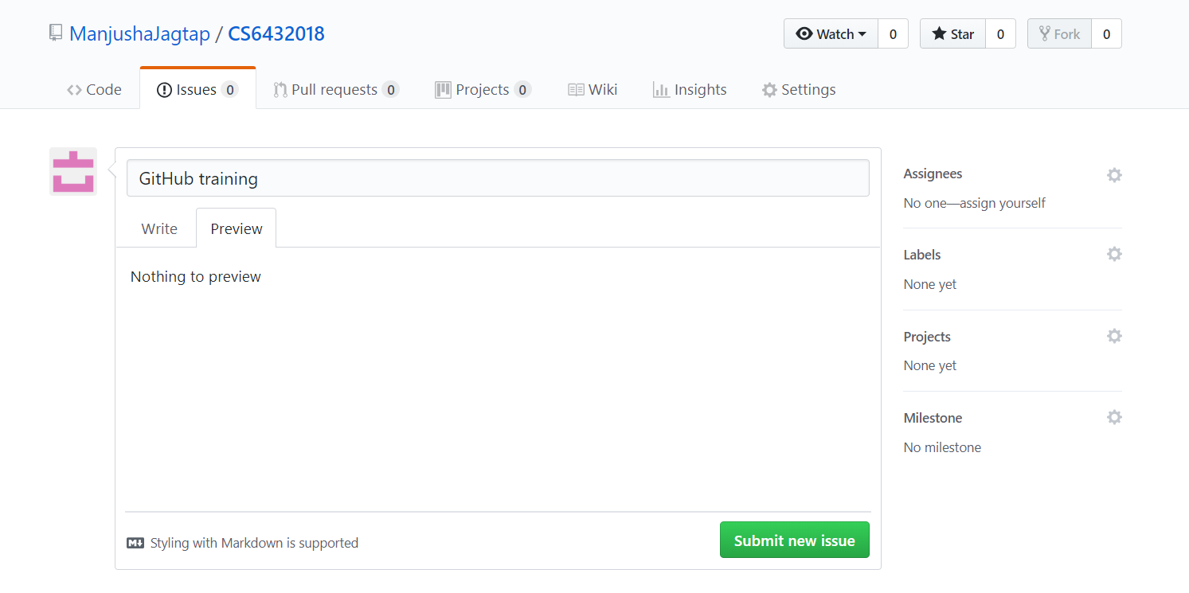

**Wiki Page is created:**

