PROJECT REPORT
CUSTOMER CHURN PREDICTION
AND EXPLAINABLE RETENTION INTELLIGENCE SYSTEM
Internship Project Report

Submitted by
Manjushree Gandham
Academic Year: 2026

Certificate
This is to certify that Manjushree Gandham, has successfully completed the internship project titled “Customer Churn Prediction and Explainable Retention Intelligence System.”
The work presented in this report describes the design, implementation, evaluation and documentation of a machine-learning system for predicting customer churn using a public telecommunications customer dataset.
The project includes data preparation, exploratory analysis, comparative model development, stratified cross-validation, hyperparameter tuning, performance evaluation, explainability using SHAP, customer risk classification and retention-oriented recommendations.
The report is submitted as part of the requirements of the internship / academic project and represents the work completed during the stated internship period.

Role | Name / Signature | Date
Intern / Student | Manjushree Gandham | 10-08-2026
Project Guide | ____________________ | ____________
Department / Coordinator | ____________________ | ____________

Acknowledgement
I would like to express my sincere gratitude to everyone who supported the completion of this internship project. The project provided an opportunity to apply machine-learning concepts to a practical customer analytics problem and to understand how predictive models can be connected to business decision-making.
I am grateful to the project guide, faculty members and internship coordinators for their guidance, feedback and encouragement throughout the work. Their suggestions helped shape the project from a basic classification exercise into a more structured end-to-end machine-learning workflow.
I also acknowledge the developers and organizations that made the public telecommunications churn dataset, software libraries and technical documentation available. The project relies on Python, pandas, scikit-learn, XGBoost, imbalanced-learning tooling, SHAP and visualization libraries.
Finally, I acknowledge the support of peers, family and colleagues who encouraged consistent learning, experimentation and documentation during the internship.

Abstract
Customer churn is a business-critical classification problem in which the objective is to identify customers who are likely to discontinue a service. This project develops an end-to-end machine-learning workflow using the IBM Telco Customer Churn sample dataset. The dataset contains 7,043 customer records and 21 original columns, including demographic, service, account, billing and churn information. After removing the customer identifier and preparing the target, 19 predictive features are used.
The dataset contains 5,174 non-churned customers and 1,869 churned customers, corresponding to a churn rate of approximately 26.54%. Because the classes are imbalanced, the project evaluates models using multiple metrics rather than accuracy alone. The final implementation compares a Decision Tree, a tuned Random Forest and a tuned XGBoost classifier. Stratified five-fold cross-validation is used during randomized hyperparameter search.
On the held-out test set, the tuned XGBoost model achieves 80.41% accuracy, 66.67% precision, 52.41% recall, 58.68% F1-score and 0.8485 ROC-AUC. The tuned Random Forest achieves a lower accuracy of 75.66% but a substantially higher churn recall of 78.88%. This demonstrates that model selection depends on the business objective: XGBoost provides stronger overall ranking performance, while Random Forest identifies more of the actual churners.
The project extends prediction into decision support through probability-based risk levels and retention recommendations. SHAP is incorporated for model explainability, and the complete preprocessing-model pipeline is serialized for reproducible inference.

Keywords & Executive Summary
Keywords
Customer churn, telecommunications, binary classification, Random Forest, XGBoost, Decision Tree, ROC-AUC, recall, SHAP, predictive analytics, customer retention, machine learning.
Executive Summary
The project addresses a practical question: can customer attributes and service information be used to identify customers who are likely to leave? The implemented solution follows a reproducible pipeline from data loading through inference.
- Dataset: 7,043 records and 21 original columns.
- Predictors after removing customerID: 19.
- Target: Churn, encoded as 0 = No and 1 = Yes.
- Train/test split: 80% / 20% with stratification.
- Models: Decision Tree, tuned Random Forest and tuned XGBoost.
- Validation: stratified 5-fold cross-validation inside randomized search.
- Primary tuning metric: ROC-AUC.
- Best overall test ROC-AUC: XGBoost, 0.8485.
- Best churn recall among the three models: Random Forest, 78.88%.
- Example inference: the demonstration customer receives 69.98% predicted churn probability and Medium Risk classification.

1. Introduction
Customer churn refers to the loss of an existing customer or subscriber. In telecommunications, churn is particularly relevant because customers can change providers while continuing to consume a similar category of service. A predictive churn system can help an organization prioritize retention activity before the customer leaves.
Traditional reporting describes what happened, such as how many customers left during a period. Predictive analytics attempts to answer what may happen next. In this project, the target variable represents whether a customer churned, and the machine-learning task is to estimate the likelihood of that outcome from available customer information.
The project is intentionally designed as an end-to-end workflow rather than a single model experiment. Data quality, preprocessing, class distribution, validation, metric selection, model comparison, explainability and deployment-oriented serialization are treated as connected components.
Project Motivation
A useful churn model must balance statistical performance with practical actionability. A model that has high accuracy but misses most churners may have limited value for retention. Conversely, a model that flags almost every customer may overwhelm a retention team. Therefore, this project compares several metrics and explicitly discusses the trade-off between overall discrimination and churn recall.
1.1 Background and Context
The project uses the IBM Telco Customer Churn sample dataset. IBM describes the sample as tracking a fictional telecommunications company and customer churn using variables such as demographics, dependents, monthly charges and service information. The project uses the CSV version included with the internship repository.
The original dataset contains 7,043 observations and 21 columns. One column, customerID, is an identifier and is removed before modeling. The remaining variables include categorical attributes such as contract type, payment method and internet service, as well as numerical attributes such as tenure, monthly charges and total charges.
The target distribution is not balanced: 5,174 customers are labeled No and 1,869 are labeled Yes. This means a model can obtain a deceptively strong accuracy score by favoring the majority class. The project therefore includes precision, recall, F1-score and ROC-AUC in addition to accuracy.
The project is also designed with an internship-oriented objective: demonstrate an ability to translate a business problem into a machine-learning problem, build a reproducible pipeline, evaluate competing algorithms, communicate trade-offs and produce a deployable prediction artifact.

1.2 Problem Statement, Objectives and Scope
Problem Statement
Develop a binary classification system that predicts customer churn from demographic, service, account and billing attributes, compares multiple machine-learning algorithms, and converts the resulting probability into a practical customer-risk and retention workflow.
Objectives
- Understand the structure and quality of the telecommunications churn dataset.
- Clean and transform raw data into a model-ready representation.
- Explore churn distribution and relationships between customer attributes and churn.
- Develop baseline and ensemble tree-based classification models.
- Use stratified five-fold cross-validation and randomized hyperparameter search.
- Evaluate models using accuracy, precision, recall, F1-score and ROC-AUC.
- Use SHAP to support explainability of tree-based model predictions.
- Create a reusable saved pipeline for prediction on new customers.
- Generate risk categories and retention recommendations from churn probability.
Scope
The scope covers predictive classification on the provided static dataset. It does not include live customer data, production CRM integration, causal inference, survival analysis or financial ROI measurement. These are considered future extensions.
2. Literature Review
The literature on customer churn prediction spans classical statistical methods, decision trees, ensemble learning, support vector machines, neural networks and more recent explainable machine-learning approaches. A systematic review by Eria and Marikannan reported that decision trees, neural networks, support vector machines and Naïve Bayes are among commonly used techniques in telecom churn research, while data imbalance and high-dimensional datasets remain recurring challenges.
More recent reviews continue to emphasize the importance of feature preparation, model comparison, evaluation design and the integration of additional behavioral or contextual data. This project therefore focuses on a compact but rigorous tabular-data pipeline rather than attempting to maximize algorithmic complexity.
The literature also shows that the highest accuracy model is not always the most useful operational model. In churn prediction, recall can be important because false negatives correspond to customers who churn but were not identified for intervention. ROC-AUC is useful for measuring ranking quality across thresholds, while F1-score provides a balance between precision and recall.
The following pages summarize the methodological foundations relevant to the selected models and explainability approach.
2.1 Foundational Algorithms
Decision Trees
Decision trees recursively partition observations using feature-based rules. Their main advantage is interpretability: a prediction can be described through a sequence of splits. In the project, the Decision Tree acts as a baseline that provides a reference point for the ensemble models.
Random Forest
Breiman's Random Forest framework combines multiple randomized decision trees. The ensemble reduces dependence on a single tree and can capture nonlinear relationships and interactions. The project uses class_weight='balanced' for the Random Forest classifier and tunes the number of estimators, tree depth, minimum sample constraints and feature-selection strategy.
XGBoost
Chen and Guestrin introduced XGBoost as a scalable tree-boosting system. Boosting constructs an ensemble sequentially, allowing later trees to focus on errors made by earlier trees. The project tunes learning rate, tree depth, number of estimators, subsampling, column sampling and minimum child weight.
These models are complementary: the Decision Tree provides a simple baseline, Random Forest emphasizes robust bagging-style ensemble learning, and XGBoost provides gradient-boosted decision trees with a richer hyperparameter space.
2.2 Churn Prediction Research
Ahmad, Jafar and Aljoumaa studied telecom churn using machine-learning techniques and social network analysis. Their work compared Decision Tree, Random Forest, gradient boosting and XGBoost and reported improved AUC when additional network-derived features were introduced. This highlights the importance of feature richness as well as model choice.
A 2022 study focused on XGBoost for telecom churn and emphasized the challenge of imbalanced customer data. The work reported strong performance on a large native telecom dataset, illustrating the suitability of boosting methods for structured churn data while also reinforcing that results depend strongly on the dataset and feature space.
A 2024 study on telecom churn prediction similarly compared machine-learning techniques and emphasized the value of identifying churn reasons so that predictions can support retention strategies. This is closely aligned with the present project's extension from a classifier to risk segmentation and recommendations.
A 2025 systematic review by Tebu and Izang synthesized research on telecom churn prediction and highlighted data integration, model selection and the need to address data privacy and methodological challenges. The project reflects these themes by maintaining a reproducible preprocessing pipeline and explicitly discussing limitations.
2.3 Explainability and Imbalanced Classification
Class Imbalance
Chawla et al. introduced SMOTE as a synthetic minority over-sampling technique for imbalanced classification. SMOTE remains an important reference for churn modeling because churn is frequently the minority class. However, the final executed version of this project does not apply SMOTE. Instead, it uses stratified sampling for evaluation and class weighting for the Random Forest model. This distinction is important for reproducibility.
Explainable AI
Lundberg and Lee introduced SHAP as a unified framework for interpreting model predictions using additive feature-attribution values. In this project, SHAP is applied to the fitted tree-based model after preprocessing so that feature contributions can be examined in the transformed feature space.
Evaluation
The scikit-learn metric framework provides accuracy, precision, recall, F1 and ROC-AUC functions used in this project. ROC-AUC evaluates ranking performance over classification thresholds, while recall focuses on the proportion of actual positive cases identified.
2.4 Research Gap and Project Positioning
The reviewed literature shows three recurring needs. First, churn prediction should be evaluated using more than accuracy. Second, model performance should be connected to operational decisions rather than treated as the final output. Third, explainability is increasingly important when predictions influence customer treatment.
The project positions itself as an educational, internship-oriented implementation that integrates these ideas in one reproducible pipeline. It does not claim state-of-the-art performance. Instead, it demonstrates a transparent comparison of three strong tabular classifiers, disciplined validation and an inference workflow.
Project Contribution
- A clear end-to-end pipeline from raw CSV to saved inference model.
- Comparison of a simple baseline with tuned ensemble models.
- Use of stratified cross-validation and ROC-AUC for hyperparameter selection.
- Explicit analysis of the trade-off between XGBoost's overall performance and Random Forest's churn recall.
- Explainability support through SHAP.
- Conversion of model probability into actionable customer-risk categories and retention suggestions.

3. Methodology
The methodology follows a sequential machine-learning lifecycle. The dataset is loaded and inspected, data quality issues are handled, the target is separated from the predictors, and an 80/20 stratified split is created. A ColumnTransformer performs one-hot encoding for categorical variables while leaving numerical variables in numeric form.
Three classifiers are trained. The Decision Tree provides a baseline. Random Forest and XGBoost are tuned using RandomizedSearchCV with five stratified folds and ROC-AUC scoring. After tuning, the best estimator from each search is evaluated once on the held-out test set.
The evaluation stage produces confusion matrices, ROC curves, precision-recall curves and a model comparison table. The selected model is then analyzed with feature importance and SHAP where supported. Finally, the complete preprocessing-model pipeline is serialized using pickle and used by a prediction function.
Methodological Principle
The central principle is separation of training information from held-out evaluation information. Preprocessing is contained inside the pipeline so that transformations are fitted as part of model training and cross-validation rather than manually applied to the complete dataset before splitting.
3.1 Dataset and Data Dictionary
The dataset contains 7,043 rows and 21 original columns. After dropping customerID, the modeling dataset contains 19 predictors and one binary target. There are 15 categorical predictors and four numerical predictors.
Category | Variables / Examples
Demographic | gender, SeniorCitizen, Partner, Dependents
Tenure / financial | tenure, MonthlyCharges, TotalCharges
Phone | PhoneService, MultipleLines
Internet | InternetService, OnlineSecurity, OnlineBackup
Protection / support | DeviceProtection, TechSupport
Streaming | StreamingTV, StreamingMovies
Account | Contract, PaperlessBilling, PaymentMethod
Target | Churn
The target distribution is 5,174 No Churn and 1,869 Churn observations. The resulting churn rate is approximately 26.54%. The class distribution motivates the use of recall, F1 and ROC-AUC alongside accuracy.

3.2 Data Cleaning and Preprocessing
Cleaning
- customerID is removed because it is an identifier rather than a predictive attribute.
- TotalCharges is converted to numeric using coercion for invalid entries.
- Eleven TotalCharges entries become missing after conversion and are filled with zero in the executed notebook.
- Churn is mapped from Yes/No to 1/0.
Encoding
Categorical variables are processed with OneHotEncoder(handle_unknown='ignore', drop='first'). This avoids imposing artificial numerical ordering on nominal categories. The encoder is fitted inside the ColumnTransformer that forms part of the final pipeline.
Split Strategy
The data is divided into 5,634 training observations and 1,409 testing observations using an 80/20 stratified split. Stratification preserves the approximate class ratio between training and testing.
Important Implementation Note
Although SMOTE is discussed in the literature review because it is a common response to class imbalance, the final executed notebook does not use SMOTE. Random Forest uses class_weight='balanced', while all models use stratified evaluation. This report reflects the code that was actually executed.
3.3 Exploratory Data Analysis
Exploratory data analysis was used to understand the target distribution and the behavior of numerical and categorical variables before model training.
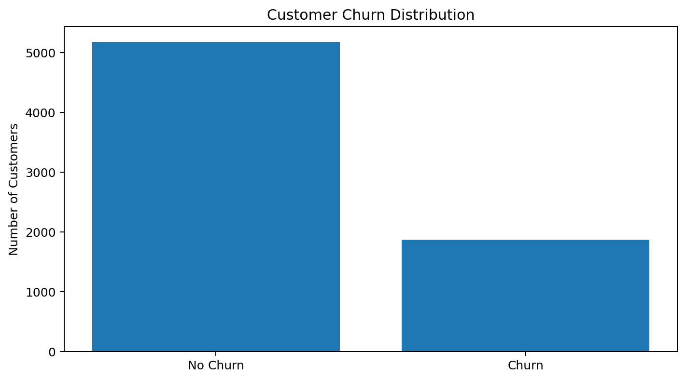
The target distribution shows that 5174 customers did not churn and 1869 customers churned. The minority class represents approximately 26.54% of the dataset.
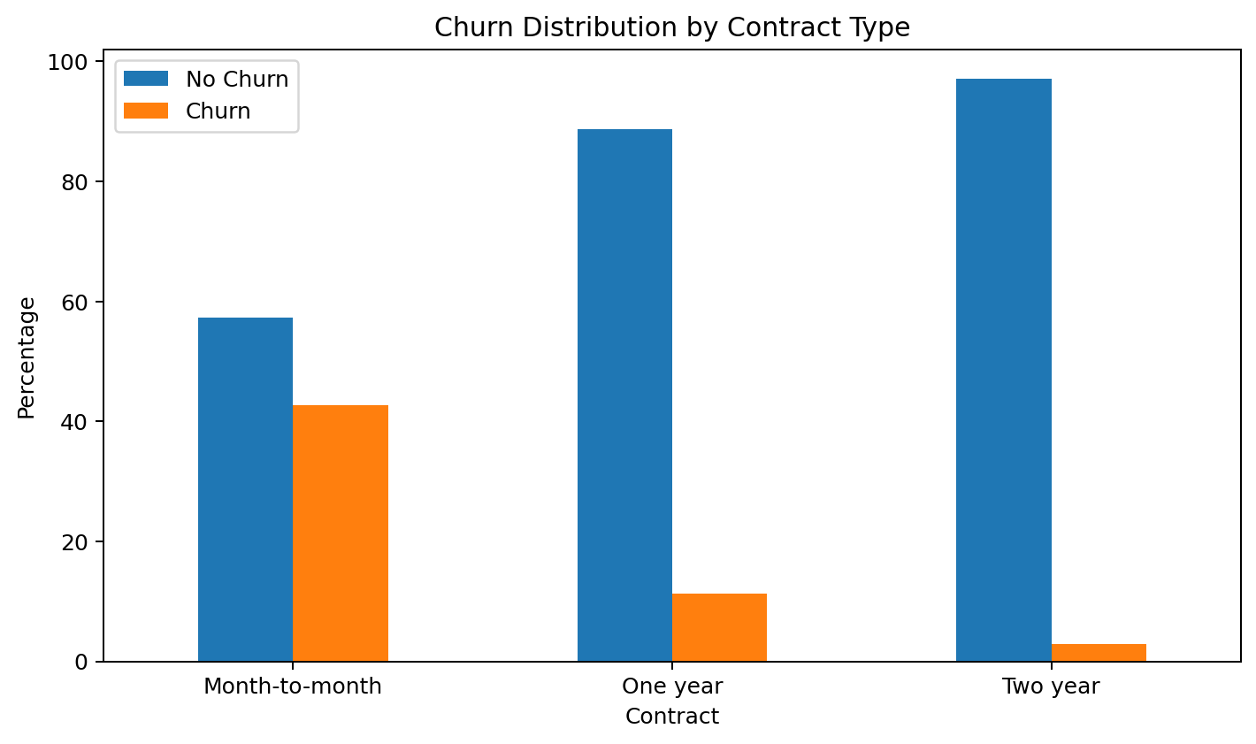
Contract type is one of the business-relevant categorical dimensions examined during EDA. Such comparisons are useful because the model later combines contract information with other service and billing variables.

3.4 Model Development
Decision Tree
The Decision Tree classifier provides a transparent baseline. It uses class_weight='balanced' and a fixed random state. The model achieved 73.46% accuracy and 0.6514 ROC-AUC on the test set.
Random Forest
The Random Forest is configured with class_weight='balanced'. Randomized search explores tree count, maximum depth, minimum split size, minimum leaf size and max_features. The selected configuration uses 300 trees, maximum depth 10, minimum leaf size 4, minimum split 2 and sqrt feature selection.
XGBoost
XGBoost is tuned across estimator count, depth, learning rate, subsampling, column sampling and minimum child weight. The selected configuration uses 500 estimators, depth 4, learning rate 0.01, subsample 0.7, colsample_bytree 0.7 and min_child_weight 1.
These configurations are empirical results of the executed randomized searches and should be reproduced by running the notebook with the same dataset and random state.
3.5 Validation and Hyperparameter Tuning
RandomizedSearchCV is used to reduce the computational cost of exploring the full hyperparameter space while still testing multiple parameter combinations. Both ensemble models use five-fold StratifiedKFold with shuffle=True and random_state=42.
Model | Search iterations | CV folds | Scoring
Random Forest | 20 | 5 | ROC-AUC
XGBoost | 25 | 5 | ROC-AUC

The best cross-validation ROC-AUC for Random Forest is 0.84663, while XGBoost reaches 0.85005 during cross-validation. The final held-out test ROC-AUC values are 0.8447 and 0.8485 respectively. The small reduction from cross-validation to test performance is expected because the test set is not used during hyperparameter selection.
Why ROC-AUC?
ROC-AUC evaluates the model's ability to rank positive and negative observations across thresholds. This is useful for churn because the business may later choose a threshold based on retention capacity, campaign cost or the relative cost of missed churn.

4. System Design
The system is designed as a modular prediction pipeline. Each stage has a clear responsibility and can be tested independently.
Layer | Responsibility
Data layer | Load and inspect the Telco churn CSV.
Preparation layer | Clean values, encode target and define predictors.
Transformation layer | One-hot encode categorical variables using ColumnTransformer.
Model layer | Train Decision Tree, Random Forest and XGBoost.
Validation layer | Perform stratified five-fold randomized hyperparameter search.
Evaluation layer | Calculate accuracy, precision, recall, F1 and ROC-AUC.
Explainability layer | Generate feature importance and SHAP analysis.
Inference layer | Load serialized pipeline and predict new customers.
Decision layer | Assign risk level and generate retention recommendations.

This layered design supports maintainability. A future web interface can call the same inference function without rewriting preprocessing or model logic.
4.1 Data Flow and Processing Pipeline
The data flow can be summarized as follows:
RAW CSV → DATA INSPECTION → CLEANING → TRAIN/TEST SPLIT → COLUMN TRANSFORMATION → MODEL TRAINING → CROSS-VALIDATION / TUNING → HELD-OUT TEST EVALUATION → EXPLAINABILITY → SAVED PIPELINE → NEW CUSTOMER INFERENCE → RISK LEVEL → RETENTION ACTION.
Training Path
Training data passes through the preprocessing transformer and then into each classifier. Hyperparameter search repeats this process over stratified folds. The test set remains separate until the final evaluation.
Inference Path
At inference time, a new customer's raw attributes are passed to the saved pipeline. The same categorical encoding used during training is applied automatically, after which the classifier returns a class prediction and probability. This probability is then mapped to a Low, Medium or High risk category.
Reproducibility
The pipeline is saved as customer_churn_complete_pipeline.pkl and model metadata is saved separately. This reduces the risk of inconsistent preprocessing between development and inference.

4.2 Prediction and Retention Logic
The project converts predicted churn probability into three operational risk categories:
Probability | Risk | Suggested action
< 50% | Low Risk | Continue regular engagement.
50% to < 75% | Medium Risk | Add to proactive retention campaign.
≥ 75% | High Risk | Prioritize immediate retention outreach.

The thresholds are heuristic rather than optimized against an explicit business cost function. They are intended to demonstrate how a probability output can be translated into a decision workflow.
Demonstration Prediction
The notebook tests a demonstration customer with one month of tenure, a month-to-month contract, no technical support and electronic-check payment. The saved pipeline predicts churn with probability 69.98%, placing this example in the Medium Risk category.
Retention Recommendations
- Offer a discounted annual or two-year contract.
- Provide an early-tenure loyalty incentive.
- Offer a technical-support trial.
- Encourage automatic payment enrollment.
- Prioritize proactive retention outreach.
5.1 Software Environment and Project Structure
The project is implemented in Python and developed as a Jupyter Notebook suitable for execution in VS Code or a standard Jupyter environment. The GitHub-ready project includes the notebook, dataset, README, requirements file, presentation and license.
Component | Technology
Language | Python
Data manipulation | pandas, NumPy
Visualization | Matplotlib, Seaborn
Classifiers | scikit-learn DecisionTreeClassifier, RandomForestClassifier
Boosting | XGBoost XGBClassifier
Model search | RandomizedSearchCV
Explainability | SHAP
Serialization | pickle
Notebook | Jupyter / VS Code

Repository Structure
The GitHub-ready repository is organized around reproducibility: Customer_Churn_Internship.ipynb contains the implementation, WA_Fn-UseC_-Telco-Customer-Churn.csv contains the dataset used by the notebook, README.md documents the project, requirements.txt records dependencies, and the PowerPoint provides the presentation deliverable.
5.2 Core Implementation Details
Preprocessing Pipeline
A ColumnTransformer contains two branches: categorical features use OneHotEncoder with handle_unknown='ignore' and drop='first'; numerical features pass through unchanged. The preprocessor is embedded in an imbalanced-learn Pipeline object, although no oversampling step is present in the final pipeline.
Model Search
RandomizedSearchCV evaluates 20 Random Forest configurations and 25 XGBoost configurations. The search is parallelized with n_jobs=-1. The random state is fixed at 42 to improve reproducibility.
Serialization
The selected model pipeline is serialized with pickle. Loading the saved object restores both preprocessing and classification logic, allowing raw customer dictionaries to be transformed and predicted without reconstructing the preprocessing steps manually.
Prediction API in the Notebook
The function predict_customer_churn accepts a customer dictionary, converts it to a one-row DataFrame, produces a prediction and probability, and maps the probability to a risk category. A separate recommendation function generates retention actions from customer attributes and predicted risk.

6. Results
The final held-out test set contains 1,409 customers. The following table summarizes the executed model results.
Model | Accuracy | Precision | Recall | F1 | ROC-AUC
Decision Tree | 73.46% | 50.00% | 47.33% | 48.63% | 0.6514
Tuned Random Forest | 75.66% | 52.77% | 78.88% | 63.24% | 0.8447
Tuned XGBoost | 80.41% | 66.67% | 52.41% | 58.68% | 0.8485
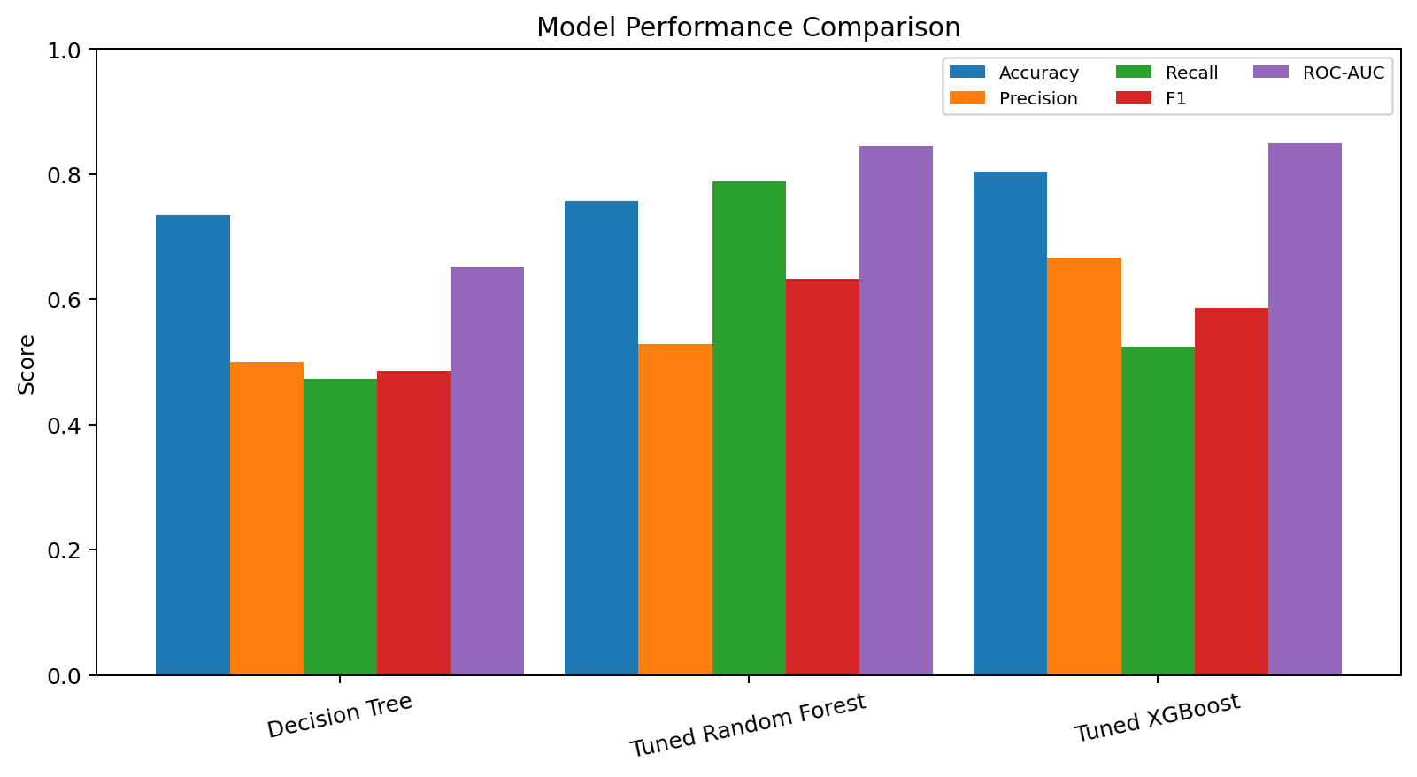
The results show that the tuned XGBoost classifier provides the highest accuracy and ROC-AUC, while the tuned Random Forest provides the highest recall for the churn class.
6.1 Model-wise Results and Interpretation
Decision Tree
The Decision Tree reaches 73.46% accuracy and 0.6514 ROC-AUC. Its churn recall is 47.33%. This establishes a baseline but is clearly weaker than the tuned ensemble models on ranking performance.
Tuned Random Forest
Random Forest reaches 75.66% accuracy, 52.77% precision, 78.88% recall, 63.24% F1 and 0.8447 ROC-AUC. Its most important practical characteristic is the high recall for churn. It identifies a larger share of actual churners, although it also generates more false positives than XGBoost.
Tuned XGBoost
XGBoost reaches 80.41% accuracy, 66.67% precision, 52.41% recall, 58.68% F1 and 0.8485 ROC-AUC. It provides the strongest overall discrimination and precision among the three models, but its recall is lower than Random Forest.
Model Selection
If the selection criterion is overall ROC-AUC and accuracy, XGBoost is the preferred model. If the business priority is to catch as many churners as possible, Random Forest may be preferable or its classification threshold could be adjusted. This is a central finding of the project.
6.2 Explainability, Example Prediction and Business Findings
The project demonstrates that model evaluation should be aligned with the business problem. The difference between XGBoost and Random Forest is not simply a question of which model is 'better'; it reflects different error profiles.
- XGBoost has the highest test accuracy at 80.41%.
- XGBoost has the highest test ROC-AUC at 0.8485.
- XGBoost has the highest precision at 66.67% among the tested models.
- Random Forest has the highest churn recall at 78.88%.
- The demonstration customer receives a 69.98% churn probability and Medium Risk classification.
- SHAP is integrated to support explanation of tree-based predictions.
- The saved pipeline supports reproducible inference on new customer records.
Business Interpretation
A retention team with limited capacity may prioritize high-risk customers first. A team whose main objective is broad churn coverage may prefer a higher-recall operating point. In a production setting, threshold selection should be based on campaign capacity, customer lifetime value, intervention cost and the cost of missed churn.
Ethical Considerations
Churn predictions should be used as decision support rather than automatic justification for differential treatment. Model outputs can reflect historical patterns and may not establish causation. Sensitive or inappropriate attributes should be reviewed carefully, and customers should not be penalized solely because a model assigns them higher churn risk.

7. Conclusion and Future Scope
Conclusion
This project developed a complete customer churn prediction workflow using a public telecommunications dataset. The implementation covers data cleaning, exploratory analysis, feature transformation, model development, stratified cross-validation, randomized hyperparameter tuning, multi-metric evaluation, explainability, serialization and retention-oriented inference.
The executed experiments show that tuned XGBoost provides the best overall test performance among the three evaluated models, with 80.41% accuracy and 0.8485 ROC-AUC. Tuned Random Forest provides the highest churn recall at 78.88%, illustrating an important business trade-off. The result is a stronger internship project because it demonstrates model reasoning rather than relying on a single accuracy value.
Future Scope
- Optimize the classification threshold using explicit retention costs and benefits.
- Calibrate probabilities and evaluate PR-AUC and cost-sensitive metrics.
- Experiment with CatBoost and LightGBM for categorical-heavy data.
- Add feature engineering based on service tenure, service count and interaction variables.
- Deploy the model through a Streamlit dashboard or REST API.
- Add model and data drift monitoring.
- Connect predictions to a retention-campaign outcome dataset.
- Explore customer lifetime value and uplift modeling so that the system predicts who is likely to churn and who is most likely to respond to an intervention.
- Validate the approach on non-public or organization-specific data before production use.

References
1. IBM. Telco Customer Churn sample data. IBM Cognos Analytics documentation. Accessed 2026.
2. scikit-learn documentation. Classification metrics and model evaluation. Accessed 2026.
3. Project source code and executed notebook: Customer Churn Internship project repository prepared for this internship deliverable.
Reference Notes
The literature review uses the sources above to provide methodological context. Project-specific numerical results in this report are derived from the executed internship notebook and supplied dataset rather than copied from external studies.

