

Big Data Framework [DATA406]

News Trend Analysis using Apache Spark and Kafka

Submitted on :11/05/2026
Submitted to : Rahul Bharath
Submitted by :
Manjushree M R - 2023UG000175
Karthik - 2023UG000161
Nikhil - 2023UG000177

1. Introduction 3
2. Problem Statement 4
3. Objectives 4
4. Scope of the Project 5
5. System Requirements 6
6. System Architecture 6
6.1. Data Pipeline 8
Data Flow: 8
7. METHODOLOGY 9
7.1 Dataset Collection 9
7.2 Data Preprocessing 10
7.3 Kafka Integration 10
8. IMPLEMENTATION AND ANALYSIS 11
8.1 Year-wise Trend Analysis 11
8.2 Month-wise Trend Analysis 12
8.3 Source Analysis 13
8.4 Category Analysis 14
8.5 Category Trend Across Years 15
9. RESULTS AND DISCUSSION 16
10. LIMITATIONS 17
11. FUTURE ENHANCEMENTS 17
12.CONCLUSION 17

Introduction
In today’s digital world, a huge amount of news data is generated every second through online newspapers, websites, blogs, and social media platforms. The rapid growth of digital media has made news information easily accessible to people across the world. As millions of articles are published daily, it becomes very difficult to manage, process, and analyze such large volumes of data using traditional data processing systems. Manual analysis of this data is time-consuming and inefficient, especially when the dataset continuously grows in size and complexity. Therefore, there is a strong need for advanced technologies that can efficiently handle large-scale data processing and analysis.
Big Data technologies play an important role in solving these challenges. Tools such as Apache Spark and Apache Kafka are widely used for processing and managing massive datasets efficiently. Apache Spark is a powerful distributed computing framework that enables fast data processing, cleaning, transformation, and analysis. It can process large amounts of structured and unstructured data much faster than traditional systems. Apache Kafka is a distributed messaging and streaming platform that helps in handling continuous streams of data in real time. Kafka allows data to be transferred efficiently between different stages of the data pipeline, making it highly suitable for large-scale data applications.
This project focuses on News Trend Analysis using Apache Spark and Kafka. The main aim of the project is to process and analyze large-scale news datasets to identify meaningful trends and patterns. The project involves data preprocessing, cleaning, transformation, and analytical processing using Spark. Kafka is integrated to simulate streaming-based data flow between different components of the system. Through this approach, various analyses such as year-wise trends, month-wise trends, source-wise analysis, and category-wise distribution are performed.
Trend analysis helps in understanding how news publishing patterns change over time. By analyzing trends, it becomes possible to identify active publishing periods, major news sources, and category distributions. Visualizations are also used in this project to represent the analytical results clearly and effectively. Overall, the project demonstrates how Big Data technologies can be used to efficiently process large datasets and extract valuable insights from real-world news data.

Problem Statement
The rapid growth of digital media has resulted in the generation of a massive amount of news data every day. Traditional data processing systems are not capable of efficiently handling such large-scale datasets because they are limited in terms of processing speed, storage capacity, and scalability. As the volume of news articles increases continuously, managing and analyzing this data using conventional methods becomes difficult, time-consuming, and inefficient.
Another major challenge is extracting meaningful trends and patterns from the news data. News articles are generated from multiple sources and belong to different categories, making the dataset highly complex and unstructured. Without proper analytical tools, it becomes difficult to identify publishing patterns, source activity, category distribution, and changes in trends over time. Manual analysis of such huge datasets is not practical and may lead to inaccurate or incomplete results.
To overcome these challenges, there is a need for scalable and efficient Big Data processing systems that can handle large volumes of data quickly and accurately. Technologies like Apache Spark and Apache Kafka provide distributed processing and streaming capabilities that help in managing and analyzing large-scale datasets efficiently. Therefore, this project aims to develop a News Trend Analysis system using Spark and Kafka to process news data, identify trends, and generate meaningful insights through visualization and analytical techniques.

Objectives
The main objectives of the project are:
- To efficiently process large-scale news datasets using Apache Spark.
- To perform data cleaning and preprocessing for improving data accuracy and consistency.
- To analyze news publishing trends over time using year-wise and month-wise analysis.
- To identify the most active news sources through source-wise analysis.
- To study the distribution of news categories and understand content patterns.
- To integrate Apache Kafka for simulating streaming-based data processing.
- To visualize analytical results using graphs and charts for better understanding of trends and patterns.
- To demonstrate the importance of Big Data technologies in handling and analyzing large datasets efficiently.

Scope of the Project
The scope of this project mainly focuses on analyzing large-scale news datasets using Big Data technologies such as Apache Spark and Apache Kafka. The project is designed to process and examine news articles collected from different sources in order to identify meaningful trends, patterns, and publishing behaviors. By using advanced data processing techniques, the system helps in understanding how news content changes over time and how different news publishers contribute to the dataset.
The project includes batch processing of news data using Apache Spark. The dataset is cleaned, transformed, and processed in batches to improve efficiency and accuracy. Batch processing allows the system to handle large volumes of data at once and perform analytical operations such as year-wise analysis, month-wise analysis, source-wise analysis, and category-wise distribution. This approach helps in generating structured insights from unorganized news data.
Another important scope of the project is trend visualization. The analytical results obtained from the processed data are represented using graphs and charts to make the trends easier to understand. Visualizations such as line graphs, bar charts, and pie charts are used to display publishing trends, category distributions, and source activity. These visual representations help users easily identify patterns and variations in the data.
The project also includes the integration of Apache Kafka to simulate a streaming data pipeline. Kafka is used for transferring processed data between producers and consumers efficiently. Although the project mainly uses batch processing, Kafka integration demonstrates how real-time data streaming systems can be implemented in Big Data applications. Overall, the project provides a scalable and efficient framework for processing, analyzing, and visualizing large-scale news datasets using modern Big Data technologies.

System Requirements
This project requires both hardware and software components for efficient processing and analysis of large-scale news datasets. Since the project uses Big Data technologies such as Apache Spark and Apache Kafka, the system should support distributed data processing, streaming, and visualization operations. The following requirements were used for implementing the project successfully.
Hardware Requirements
- Processor : Intel i5 or above
- RAM : Minimum 8 GB
- Storage : Minimum 256 GB
- System Type : 64-bit Operating System
Software Requirements
- Operating System : Windows 10/11
- Programming Language : Python
- Apache Spark
- Apache Kafka
- Jupyter Notebook
- Python Libraries:
  - Pandas
  - PySpark
  - Matplotlib
  - Kafka-python
These tools were used for data preprocessing, batch processing, Kafka integration, analytical processing, and visualization of trends.

System Architecture
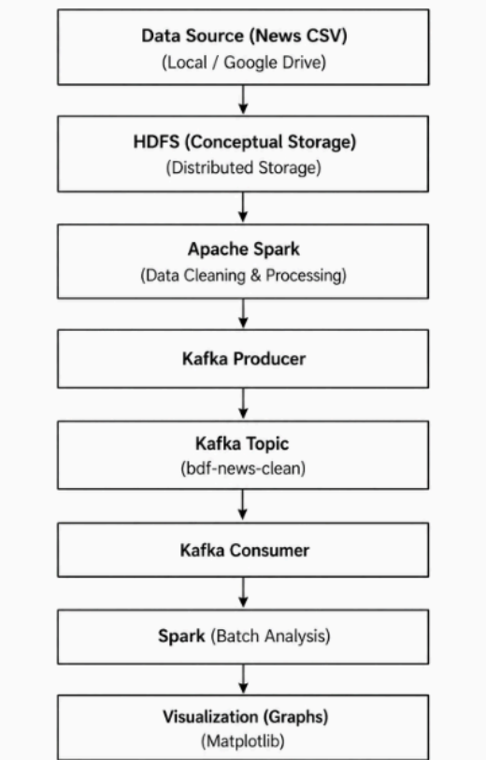
The system architecture of the project describes the complete workflow involved in processing and analyzing large-scale news datasets using Apache Spark and Apache Kafka. The architecture is designed to efficiently handle data preprocessing, streaming, analytical processing, and visualization. It provides a scalable framework for managing large amounts of news data and extracting meaningful insights from it.

The architecture consists of multiple components that work together to process the data efficiently. Each component performs a specific task in the overall workflow.

Data Source: The data source used in this project is a news dataset stored in CSV format. The dataset contains information such as news title, publication source, category or section, and date of publication. This raw dataset serves as the input for the entire processing pipeline. Since the dataset contains missing values and inconsistent entries, preprocessing is required before analysis.

Apache Spark: Apache Spark is used as the main data processing engine in the project. Spark performs operations such as loading the dataset, cleaning the data, handling missing values, filtering incorrect records, and extracting useful attributes like year and month from the date column. Spark is capable of processing large datasets efficiently using distributed computing techniques, making it suitable for Big Data applications.

Kafka Producer: After preprocessing the dataset using Spark, the cleaned data is sent to Apache Kafka through a Kafka Producer. The producer is responsible for publishing the processed news records into a Kafka topic. This helps in creating a streaming-based data flow between different stages of the system architecture.
Kafka Topic: Kafka Topic acts as a temporary storage and messaging channel between the producer and consumer. In this project, the cleaned news data is stored inside a Kafka topic named bdf-news-clean. The topic ensures efficient transfer of messages and supports scalable data communication within the pipeline.

Kafka Consumer: The Kafka Consumer reads the news records from the Kafka topic in batches. These records are then converted back into Spark DataFrames for further processing and analysis. The consumer helps in simulating streaming data processing and enables smooth integration between Kafka and Spark.

Analysis Layer: The analysis layer performs different types of analytical operations on the processed data. Using Spark, analyses such as year-wise trend analysis, month-wise trend analysis, source-wise analysis, and category-wise distribution are carried out. This layer helps in identifying patterns, publishing behavior, and trends in the news dataset.

Visualization Layer: The visualization layer is used to represent the analytical results in graphical form. Various charts and graphs such as line graphs, bar charts, and pie charts are used to display trends and distributions clearly. Visualization helps users easily understand the insights obtained from the dataset and improves the overall interpretation of results.

Overall, the system architecture demonstrates the integration of Apache Spark and Apache Kafka for efficient processing, streaming, analysis, and visualization of large-scale news data.

6.1. Data Pipeline
The data pipeline represents the complete flow of data throughout the system. It explains how raw news data is processed, transferred, analyzed, and visualized using Apache Spark and Apache Kafka. The pipeline is designed to handle large-scale datasets efficiently by combining batch processing and streaming concepts. Each stage of the pipeline performs a specific operation that contributes to the overall analysis of news trends.

Data Flow:
CSV Dataset → Apache Spark → Kafka Producer → Kafka Topic → Kafka Consumer → Spark Processing → Analysis → Visualization
Initially, the news dataset stored in CSV format is loaded into Apache Spark. Spark reads the dataset and performs preprocessing operations such as removing unnecessary columns, handling missing values, filtering invalid records, and extracting important fields like year and month from the date column. This preprocessing step ensures that the data becomes clean, structured, and suitable for analysis.
After preprocessing, the cleaned data is transferred to Apache Kafka through a Kafka Producer. The producer sends the processed news records into a Kafka topic named bdf-news-clean. Kafka acts as a distributed messaging system that enables efficient communication between different components of the pipeline.
The Kafka Topic temporarily stores the streamed messages and makes them available for consumption. A Kafka Consumer continuously reads the messages from the topic in batches. These batches are then converted back into Spark DataFrames for further analytical processing.
Once the data is received from Kafka, Apache Spark performs different analytical operations such as year-wise trend analysis, month-wise trend analysis, source-wise analysis, and category-wise distribution analysis. Spark processes the data efficiently and generates structured results for visualization.
Finally, the processed analytical results are represented using graphs and charts. Visualizations such as line graphs, bar charts, and pie charts help in understanding patterns, trends, and publishing behavior within the news dataset. The data pipeline therefore provides a smooth and scalable workflow for processing and analyzing large-scale news data using Big Data technologies.

METHODOLOGY

7.1 Dataset Collection
The dataset used in this project consists of news articles collected and stored in CSV format. The dataset contains important attributes such as news title, publication source, category or section, and date of publication. These attributes are essential for performing trend analysis and identifying publishing patterns across different years, months, categories, and news sources.
The dataset was loaded into Apache Spark for processing and analysis. Since the raw dataset contained missing values, inconsistent records, and unnecessary columns, preprocessing was required before performing analytical operations. The selected dataset provided sufficient information for analyzing publishing behavior and understanding trends in large-scale news data.

7.2 Data Preprocessing
Data preprocessing is one of the most important stages of the project because the raw news dataset contained noisy and inconsistent data. Apache Spark was used to clean and transform the dataset into a structured format suitable for analysis.
Initially, the dataset was loaded into Spark with proper parsing to handle multiline text and quoted values correctly. Only relevant columns such as title, publication, section, and date were selected for processing, while unnecessary columns were removed. Missing values in important columns like title and publication were handled by removing incomplete rows. Missing values in the section column were replaced with the value “Unknown” to maintain consistency.
The date column was validated using pattern matching techniques to remove invalid records. After validation, year and month values were extracted from the date column for trend analysis. The original date column was then removed, and the extracted year and month values were converted into integer data types. Incorrect rows caused by CSV formatting issues were also eliminated. Finally, the cleaned dataset was cached to improve processing efficiency during analysis.

7.3 Kafka Integration
Apache Kafka was integrated into the project to simulate a streaming-based data processing pipeline. Kafka helps in transferring processed data efficiently between different stages of the system architecture.
After preprocessing the dataset using Apache Spark, the cleaned data was sent to a Kafka topic through a Kafka Producer. The producer continuously published the processed news records into the Kafka topic named bdf-news-clean. Kafka acted as a messaging system that stored and managed the data stream.
A Kafka Consumer was then used to read the messages from the Kafka topic in batches. The consumed data was converted back into Spark DataFrames for analytical processing. This integration demonstrated how streaming systems can be combined with Spark to handle large-scale data efficiently.

IMPLEMENTATION AND ANALYSIS

8.1 Year-wise Trend Analysis
The year-wise trend analysis was performed to study the variation in the number of news articles published during different years. The graph shows the total article count from 2016 to 2019. From the analysis, it can be observed that the year 2016 recorded the highest number of articles with approximately 273 articles. In 2017, the number of articles dropped significantly to around 224 articles, indicating a decrease in publishing activity during that year.
The publishing activity increased again in 2018, reaching nearly 272 articles, which is almost equal to the count observed in 2016. However, in 2019, the article count decreased to around 231 articles. The graph clearly shows fluctuations in the number of published articles over the years rather than a steady increase or decrease.
This analysis helps in understanding how news publishing activity changed over time and identifies years with high and low publication trends. The line graph provides a clear visualization of these yearly variations and highlights the inconsistency in article publishing patterns.
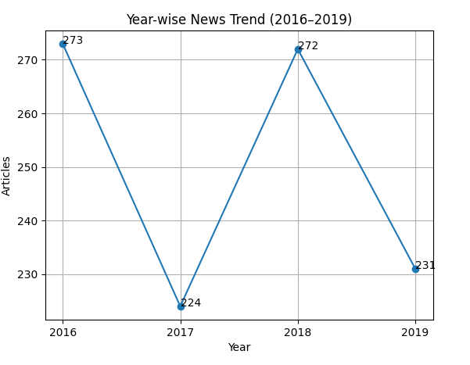

8.2 Month-wise Trend Analysis
The month-wise trend analysis was carried out to understand the publishing behavior of news articles across different months and years. The graph compares monthly article counts for the years 2016, 2017, 2018, and 2019. Most months show a relatively stable range of articles between 15 and 30, indicating consistent publishing activity throughout the year.
A major observation from the graph is the sharp spike in June 2019, where the article count suddenly increased to approximately 100 articles. This indicates an unusual rise in publishing activity during that period. On the other hand, February 2018 recorded a noticeable drop compared to other months, showing lower publishing activity.
The years 2016 and 2018 display comparatively stable trends with moderate fluctuations, while 2017 shows relatively lower and more stable article counts throughout the year. Overall, the graph indicates that news publishing activity experiences seasonal fluctuations and sudden spikes during certain periods.
This analysis helps in identifying peak publishing months and understanding monthly variations in news trends.
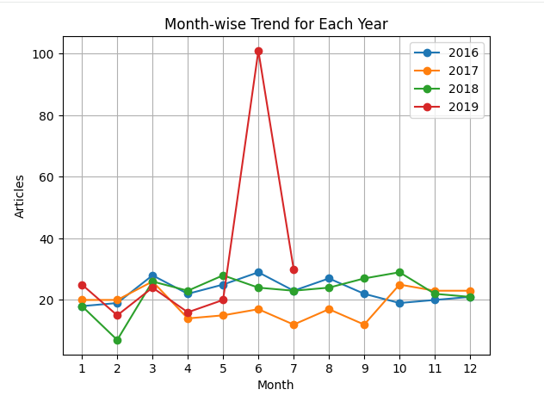

8.3 Source Analysis
The source analysis was performed to identify the most active news publishers in the dataset. The bar graph represents the top news sources based on the number of articles published. From the analysis, Reuters emerged as the most active news source with the highest number of articles, approximately 273 articles. This indicates that Reuters contributed the largest share of news content within the dataset.
Vox was identified as the second most contributing publisher with around 223 articles. Vice and TMZ also showed significant publishing activity with moderate article counts. Other news publishers such as Vice News, Hyperallergic, and Business Insider contributed comparatively fewer articles.
The graph clearly shows the variation in contribution levels among different publishers. Some sources are highly dominant, while others contribute smaller portions of the overall dataset. This analysis helps in understanding which news organizations are more active in publishing news articles and how the dataset is distributed across different sources

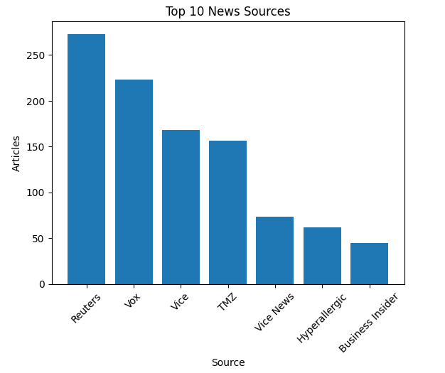
8.4 Category Analysis
Category analysis was performed to study the distribution of news articles across different categories or sections. The pie chart represents the percentage contribution of each category within the dataset. From the analysis, it can be observed that the “Unknown” category dominates the dataset with approximately 67.2% contribution. This indicates that a large portion of the dataset contains missing or undefined section values.
Among the known categories, Market News and World News contributed around 8.1% each, making them the most significant categories after the Unknown section. Business News contributed approximately 7.2% of the dataset, while categories such as Wires and Financials contributed smaller percentages.
The pie chart clearly illustrates that a large amount of data lacks proper categorization, which affects the overall category analysis. However, the analysis still provides useful insights into the distribution of known news categories and their relative importance within the dataset

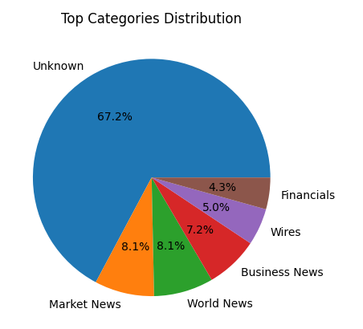
8.5 Category Trend Across Years
The category trend across years analysis was performed to examine how different news categories changed over time. The graph compares category-wise article counts across multiple years. From the analysis, it is evident that the “Unknown” category remained dominant throughout all years due to the presence of missing or undefined section values in the dataset.
Market News showed high publishing activity during 2016 and 2017 but experienced a decline in the later years. World News displayed steady growth over time, especially during 2019, indicating an increase in the number of world-related news articles. Business News also showed gradual improvement in article counts across the years.
One important observation from the graph is the sharp increase in the Wires category during 2019. This sudden spike indicates a major rise in publishing activity for that category during that particular year. Overall, the graph highlights how publishing patterns and category distributions changed across different years.
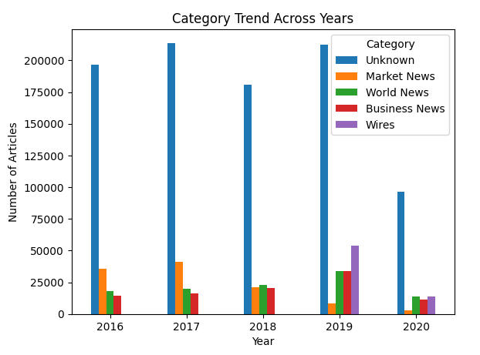
This analysis helps in understanding category growth trends, identifying dominant categories, and observing sudden increases or decreases in publishing activity over time.

RESULTS AND DISCUSSION
The project successfully demonstrated the use of Apache Spark and Apache Kafka for processing and analyzing large-scale news datasets. The implementation of Spark helped in efficiently handling data preprocessing tasks such as cleaning, filtering, handling missing values, and extracting useful attributes from the dataset. Kafka integration enabled smooth data transfer between different stages of the pipeline and simulated a streaming-based processing environment.
The analytical results obtained from the project provided meaningful insights into news publishing trends and patterns. The year-wise trend analysis showed fluctuations in the number of articles published between 2016 and 2019. The analysis revealed that 2016 and 2018 recorded comparatively higher publishing activity, while 2017 and 2019 showed lower article counts. This indicates that publishing activity varied across different years instead of following a constant growth pattern.
The month-wise trend analysis highlighted seasonal variations in news publishing. Most months maintained stable publishing activity; however, certain periods showed sudden peaks and drops. A significant increase in publishing activity was observed during June 2019, while some months showed comparatively lower article counts. These variations helped in understanding monthly publishing behavior and identifying unusual activity periods.
The source analysis identified Reuters as the most active news publisher within the dataset, followed by Vox, Vice, and TMZ. This analysis helped in understanding the contribution of different publishers and identifying dominant news sources. Similarly, category analysis showed that the “Unknown” category occupied a major portion of the dataset due to missing or undefined section values. Among the known categories, Market News, World News, and Business News contributed significantly to the dataset.
The category trend analysis across years further revealed changes in category-wise publishing activity over time. Market News showed higher activity during the earlier years, while World News and Business News displayed gradual growth in later years. The Wires category experienced a sudden spike in 2019, indicating increased publishing activity for that category during that period.
The use of graphs and visualizations improved the understanding of analytical results by representing trends and distributions clearly. Line graphs, bar charts, and pie charts made it easier to identify patterns, variations, and dominant categories within the dataset. Overall, the project demonstrated that Big Data technologies such as Apache Spark and Apache Kafka are highly effective for processing, analyzing, and visualizing large-scale news datasets efficiently.

LIMITATIONS
- The dataset is limited to news data from only a few years (2016–2019).
- Presence of missing and undefined values affected category analysis accuracy.
- Many records were categorized as “Unknown” due to missing section information.
- The system mainly uses batch processing instead of complete real-time streaming.
- Apache Kafka was integrated only for simulated streaming purposes.
- Hadoop Distributed File System (HDFS) was not implemented for distributed storage.
- The dataset contained noisy and inconsistent entries caused by CSV formatting issues.
- Additional preprocessing was required to handle invalid dates and incorrect records.
- The project was tested on a limited dataset size and not on very large enterprise-scale data.
- Real-time user engagement metrics such as likes, shares, and comments were not included in the analysis.

FUTURE ENHANCEMENTS
- Integrate real-time live news streaming for continuous analysis.
- Implement machine learning algorithms for trend prediction and forecasting.
- Improve category classification to reduce “Unknown” values.
- Integrate sentiment analysis to understand public opinion on news topics.
- Use Hadoop Distributed File System (HDFS) for scalable distributed storage.
- Optimize system performance for handling larger datasets efficiently.
- Include user engagement metrics such as likes, comments, and shares.
- Develop a real-time dashboard for live visualization and monitoring.
- Extend the system to analyze multilingual news datasets.
- Improve Kafka streaming architecture for full real-time processing capabilities.

12.CONCLUSION
This project successfully demonstrated the use of Apache Spark and Apache Kafka for processing and analyzing large-scale news datasets. Apache Spark was effectively used for data preprocessing, cleaning, transformation, and analytical processing, while Apache Kafka was integrated to simulate a streaming-based data pipeline for efficient data transfer.
The project performed different analyses such as year-wise trend analysis, month-wise trend analysis, source analysis, category analysis, and category trend analysis across years. These analyses helped in identifying publishing patterns, source activity, seasonal fluctuations, and category distributions within the news dataset.
The use of graphs and visualizations made it easier to understand the analytical results and identify important trends and variations in the data. The project also highlighted the importance of Big Data technologies in handling large and complex datasets that cannot be processed efficiently using traditional systems.
Although the project has certain limitations such as missing values, limited dataset range, and batch-based processing, it successfully achieved its objectives and demonstrated the practical implementation of Spark and Kafka for large-scale data analysis. Overall, the project provides meaningful insights into news publishing behavior and shows how Big Data technologies can be effectively applied for real-world analytical applications.

