Feature1: Bar graph chart using chart.js

API end points were created and then consumed in a bar graph chart. The changes are reflected in the graph in real time. I have used database of a hypothetical university and tried to consume the API end points generated in a chart, made using chart.js.

1. Below screenshot shows the API end points created. If I change a record in the student database “records”, changes are reflected in the bar graph

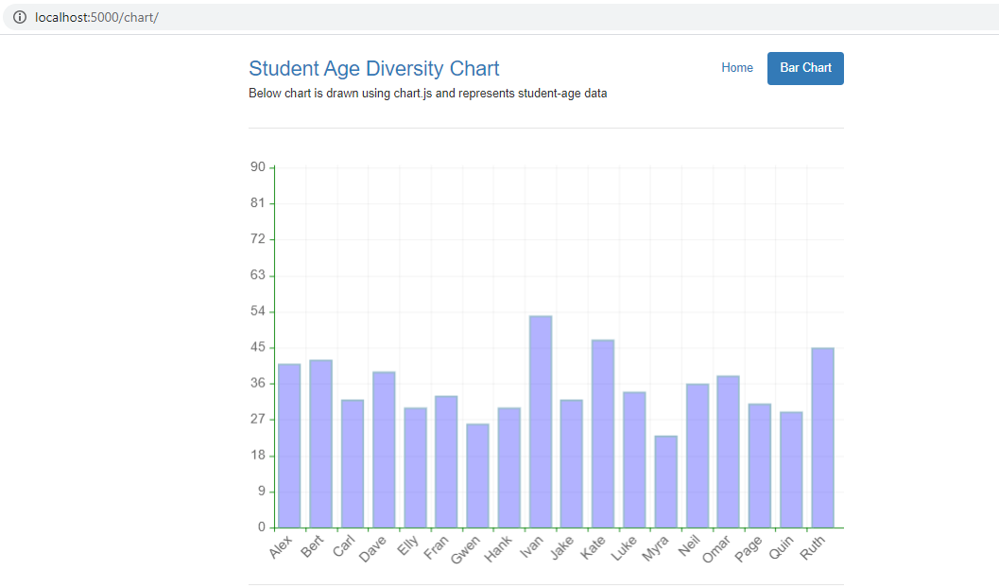

Fig.1

1. New record added – Name-Gari Age-28

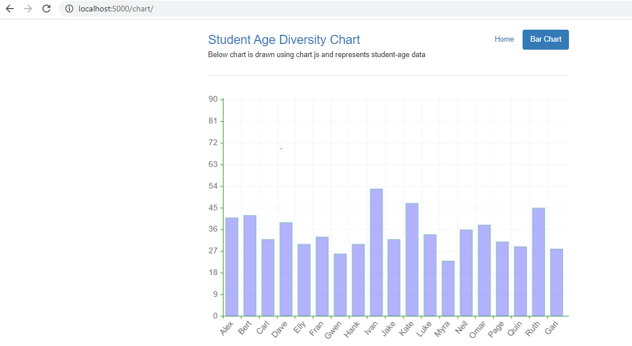

Fig.2

1. Age for a record updated
2. Record deleted- Name ”Ruth”

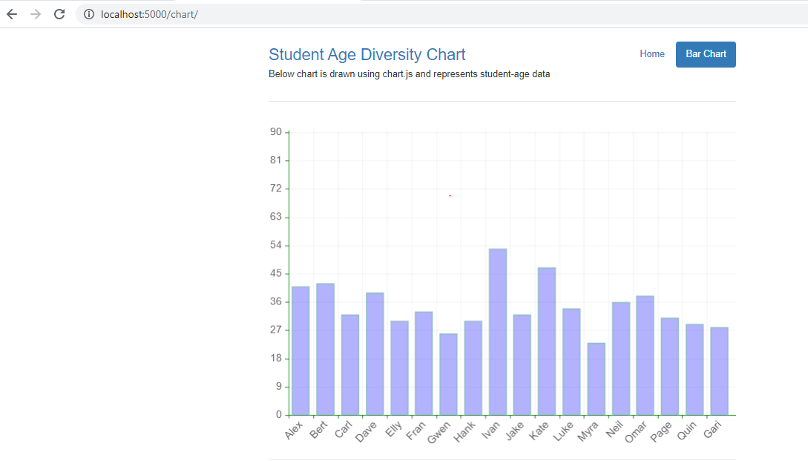

Fig.3

Chart color and other configurations are customizable as per need.

Feature2: Calendar API

I have embedded a Google calendar in a university website. The calendar shows a list of the college events. Everyone who is invited to the event can see the event details and has permissions to edit and delete the event. They can also add new events.

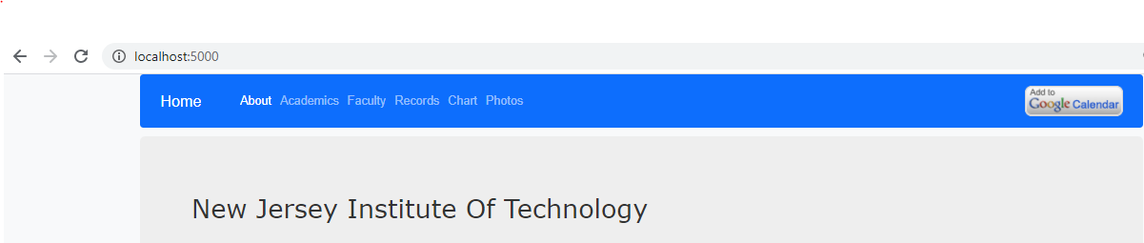

Fig.1: Calendar at the homepage of the college website

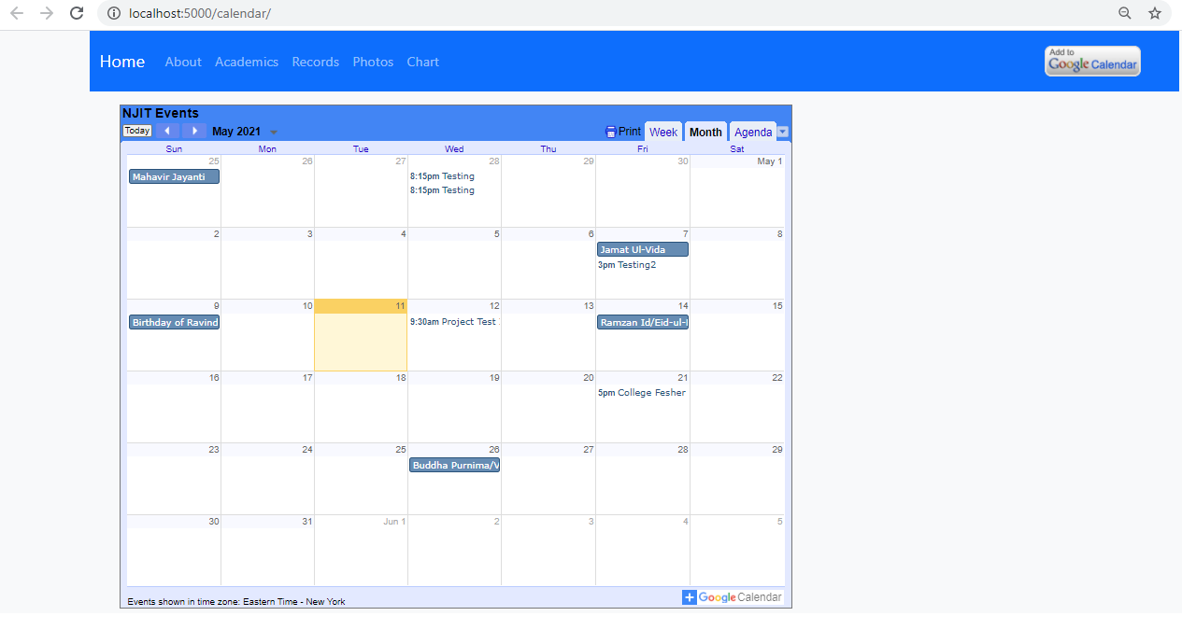

Fig.2: Month view of the calendar

1. Below screenshot shows I created a new event sent the invite to my team member.

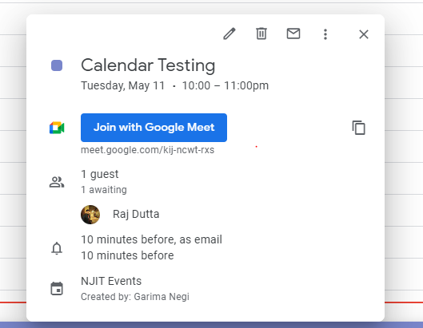

Fig.3 Invitation sent

1. They get the invite and accepts the invitation

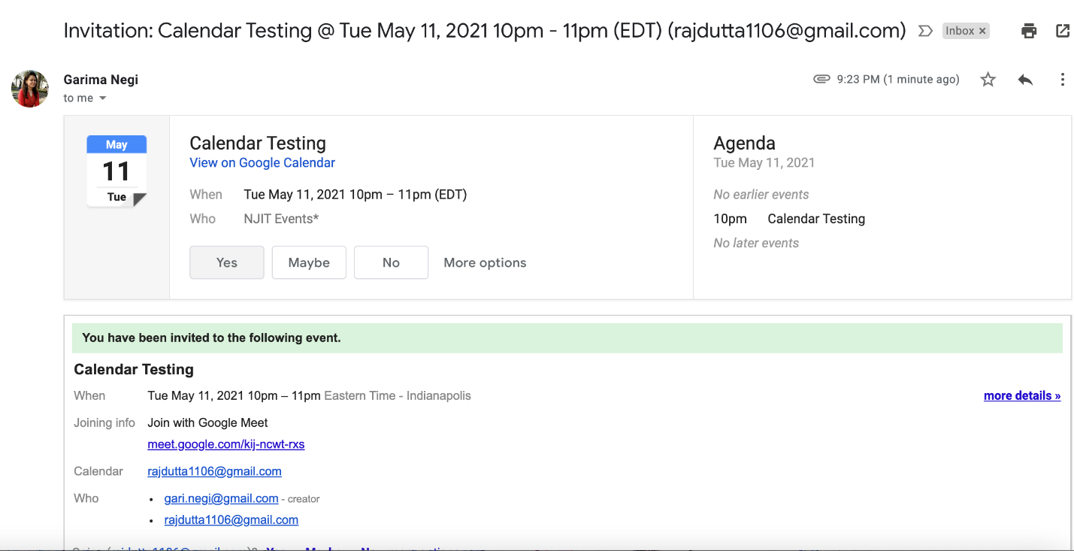

Fig.4 Invitation received

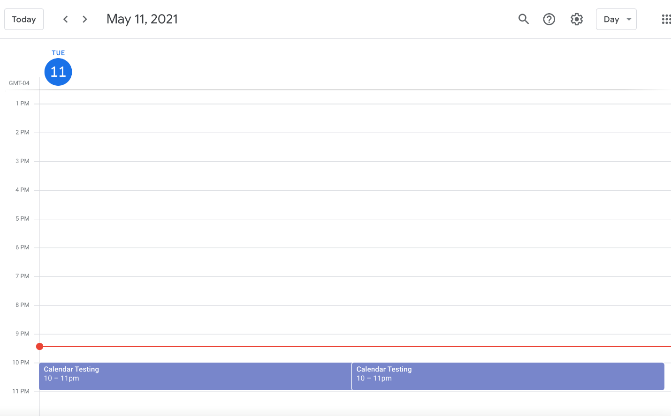

Fig.5 Invitation accepted and reflected in the Calendar

1. All those who get the invitation will get pop-up before the event, 15 minutes before (this is customizable)
2. I can also share the link for the calendar so that if anyone wants to view the calendar events (even if they are not a part of any invitation) can view the calendar and make a new event invite
3. Calendar for the month view is default and can be changed to week view

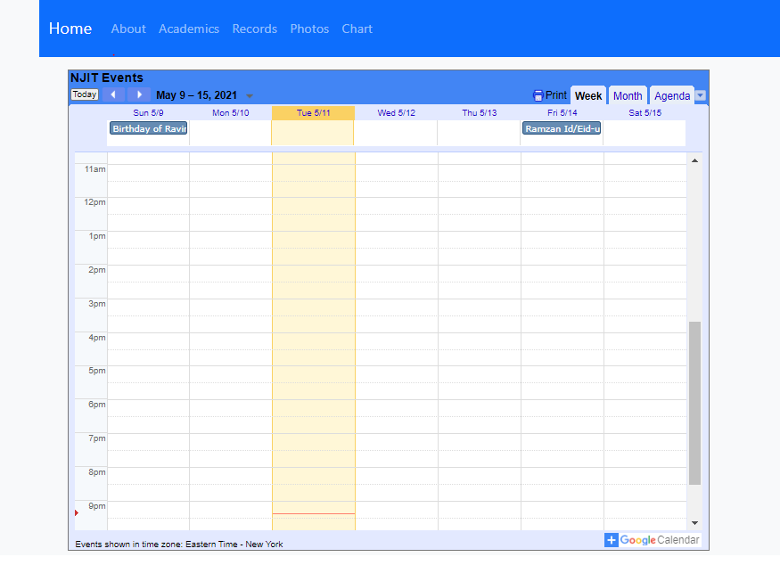

Fig.6: Week View

1. I can click on the week view to see the university’s week events
2. I can customize the calendar as per my need
3. I can change the font size of calendar
4. I can change the color of the calendar

Feature3: Student Login and Registration

Login Page

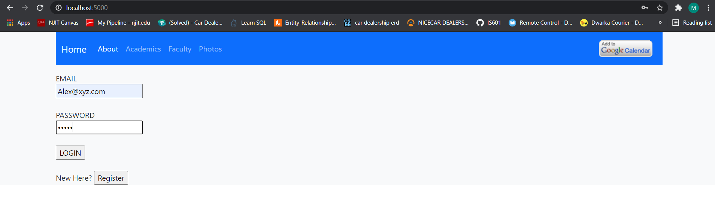

1. We use the email and password for the login.
2. If the email and password is already present in the database then after successful login it redirects to index page of the website.

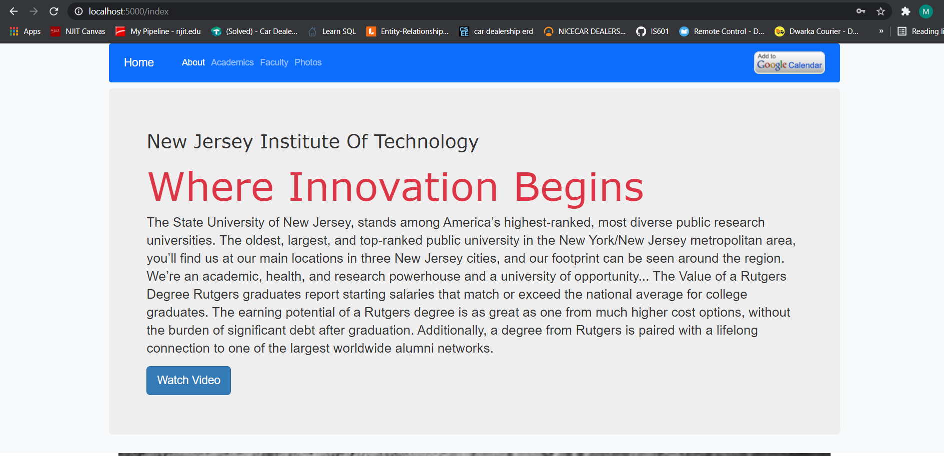

1. If we haven’t registered yet then the login goes unsuccessful and shows the following error.

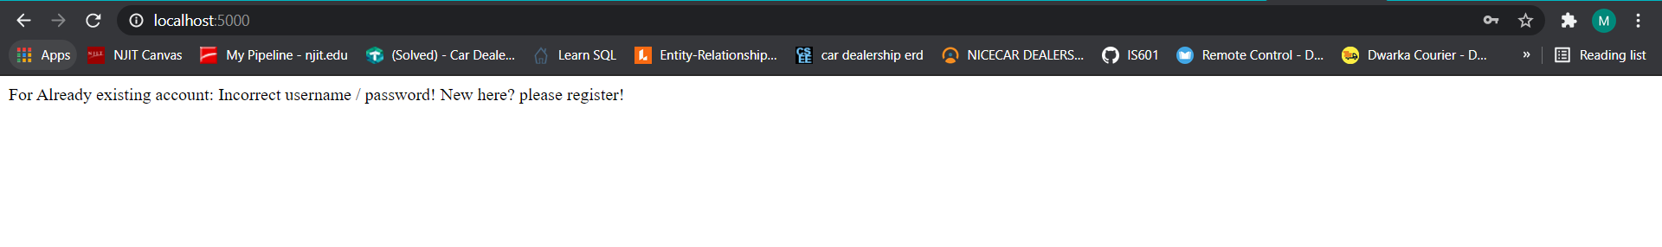

1. We need to go back to “Home” page for the registration.

Registration Page

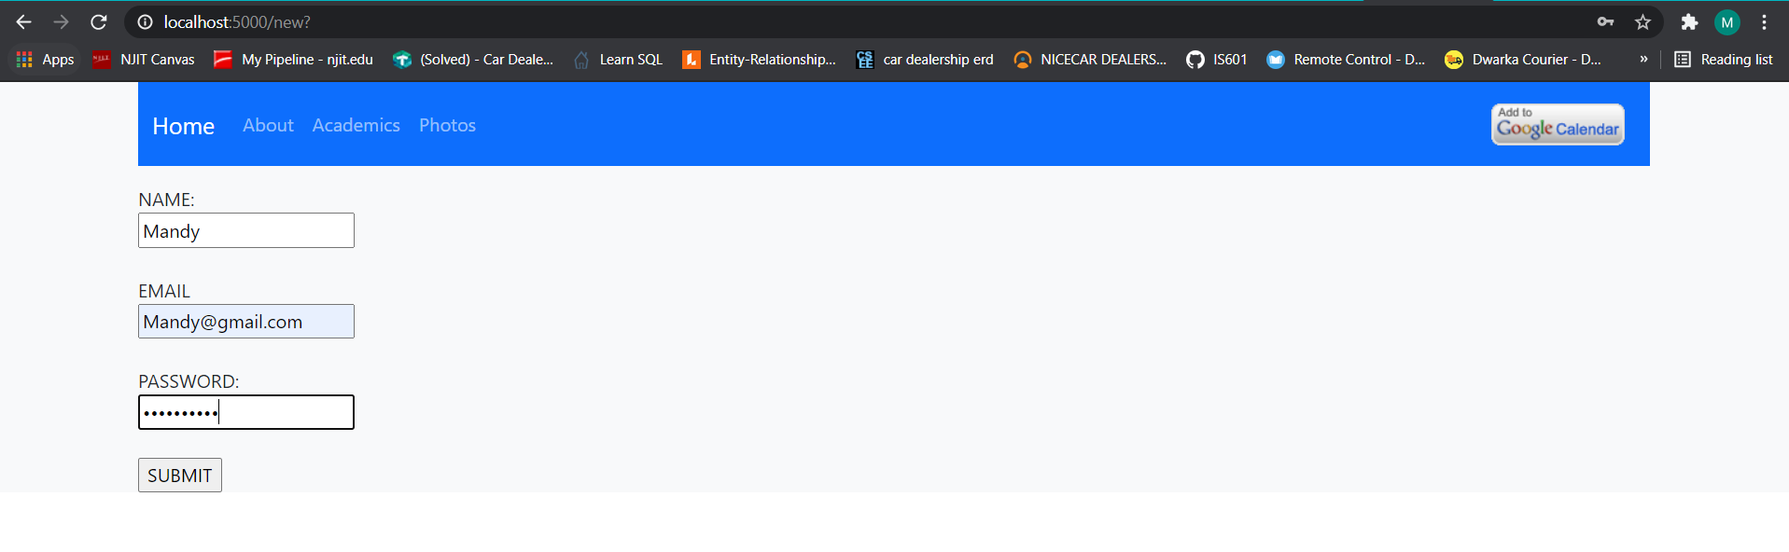

1. By clicking on the “SUBMIT” button our registration will be successful, and it will take us to the login page.
2. Once the previously registered email and credentials is entered, we will be able to get into the website.