

CENTENNIAL COLLEGE PROGRESS CAMPUS

COURSE COMP213 Fall 2019

ASSIGNMENT #3

Select a product that you really like (example: a TV set, a laptop, a car, etc.)
Find information about your favourite product on the Internet.
Using the product information (picture, description, features, similar products, company that sells the product), create in MS Expression Web 4 an HTML page with content similar to the following screenshot of a typical product online page:

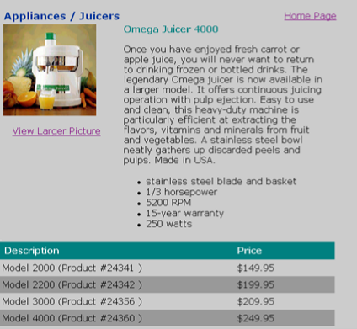

Required Features:

- Add a banner for your page (not shown in above picture) to include a product-related picture, the product company logo hyperlinked to their website, some title text.
- When you click the “View Larger Picture” hyperlink, open another document called Details.html, that displays a detailed (larger) picture of your product and a “back” hyperlink to the product info page.
- Upload your Assignment3.html and Details.html documents to the studentweb server, and provide an “Assignment 3” hyperlink to it from your index page. Remember to upload the picture files to the server too.
This assignment is due on Fri Oct 18 at 10pm. Late submissions are allowed only for 2 additional days and they are marked out of 80%.

