Eternal Garden Price List with ingredients

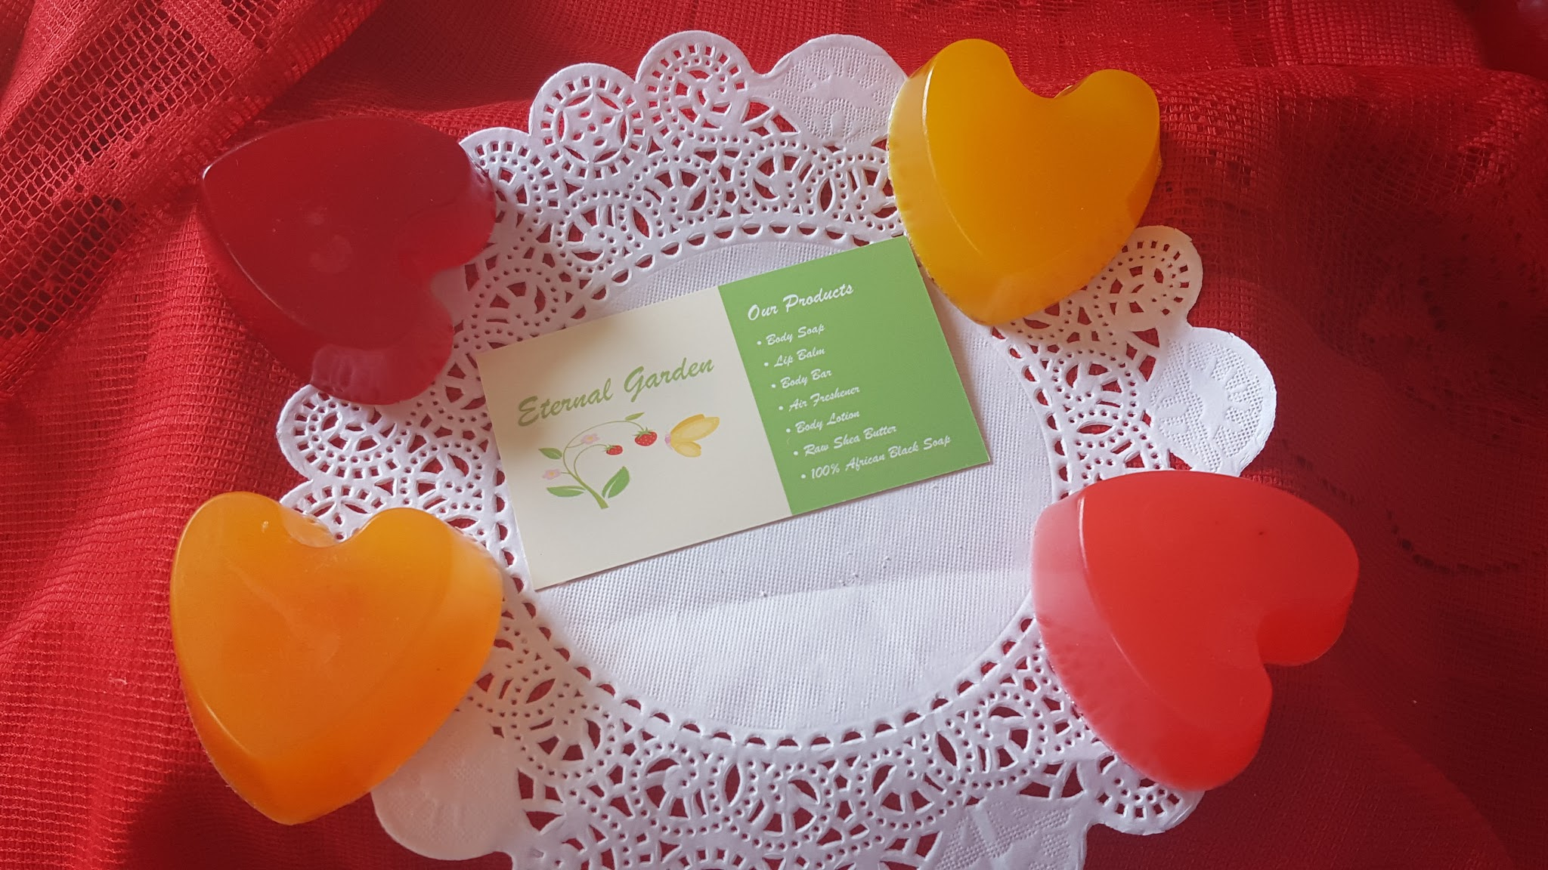

PRICE $3.00 Handmade Small Soap Vegetable base(,Sorbitol(moisturizer),purified water, Palmate(palm oil) Sodium Cocoste (Coconut oil) Doccule glycoside water, Fragrance oil, colorant

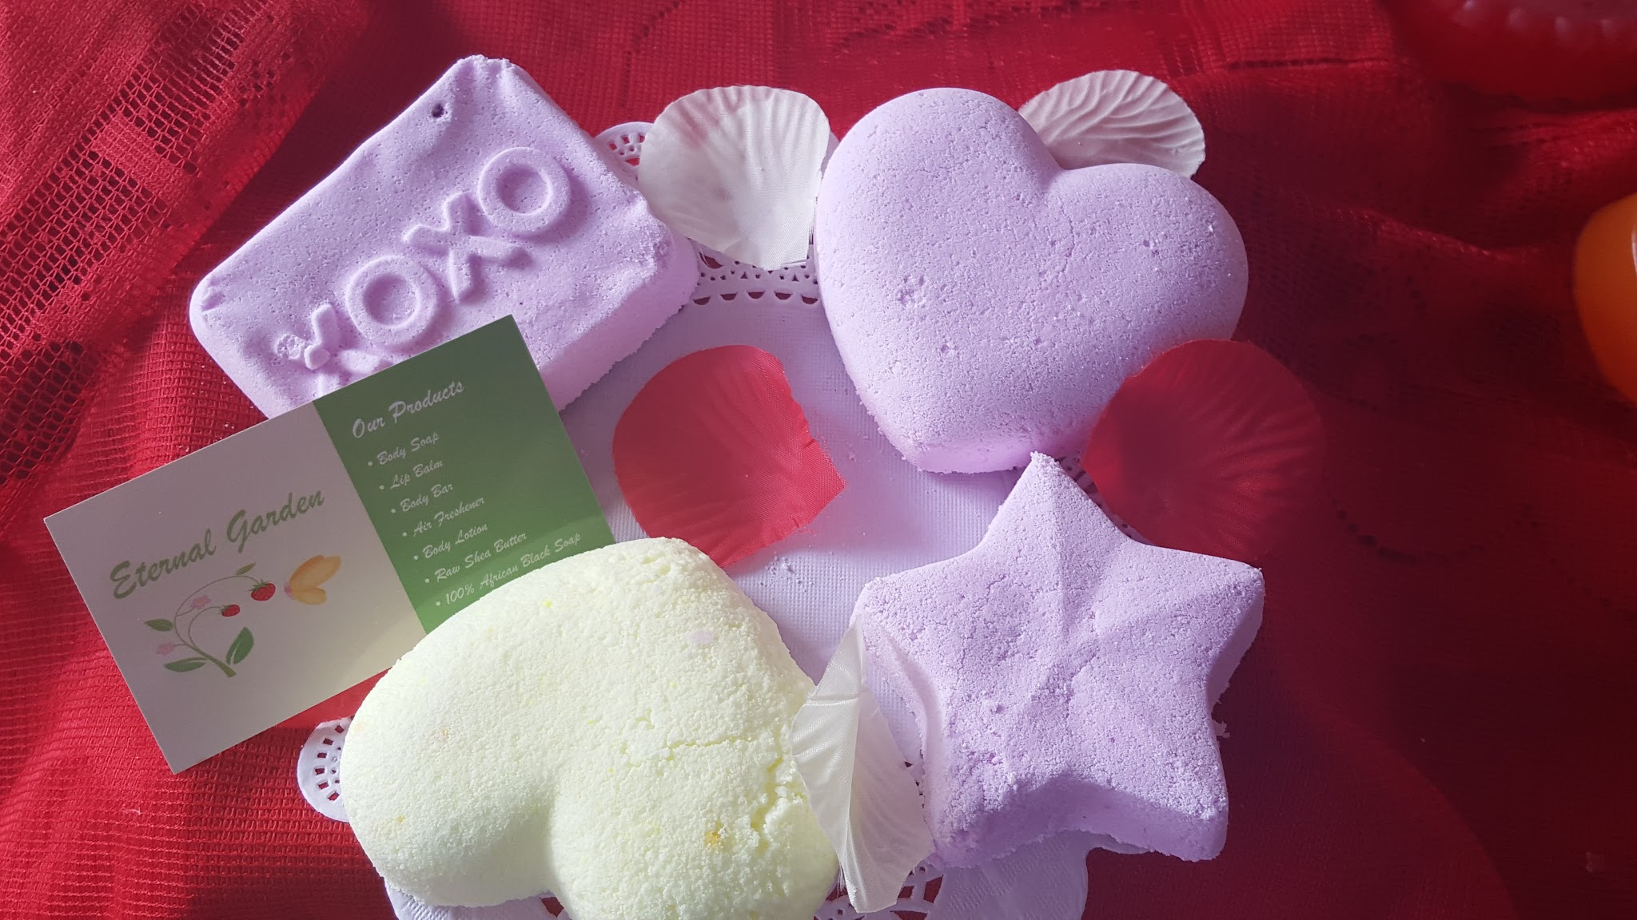

PRICE $6.00Large Bath Bombs Ingredients: Baking Soda, granulated citric acid, Witch Hazel, Almond oil, Fragrance oil

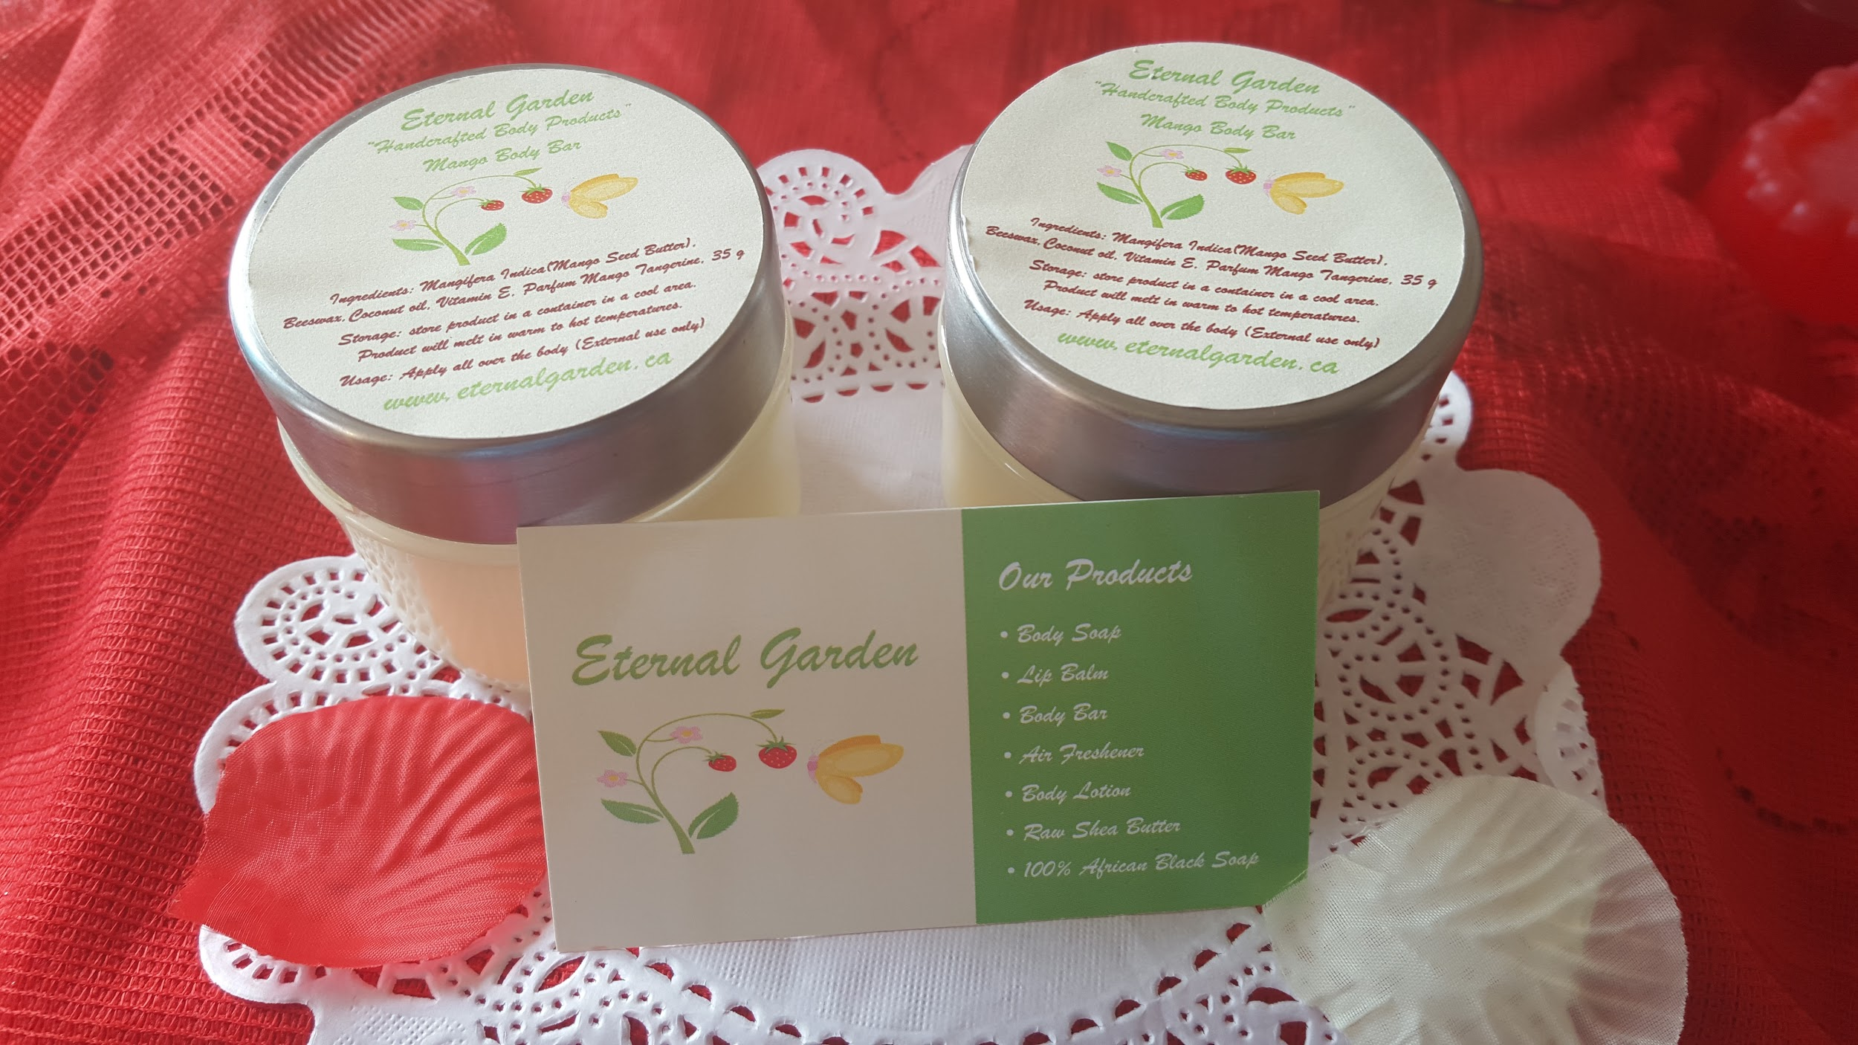

Price $10.00 Body Bar in a Jar aloe Vera/mango, Cocoa butters, Vitamin E, Coconut oil, Beeswax, fragrance oil

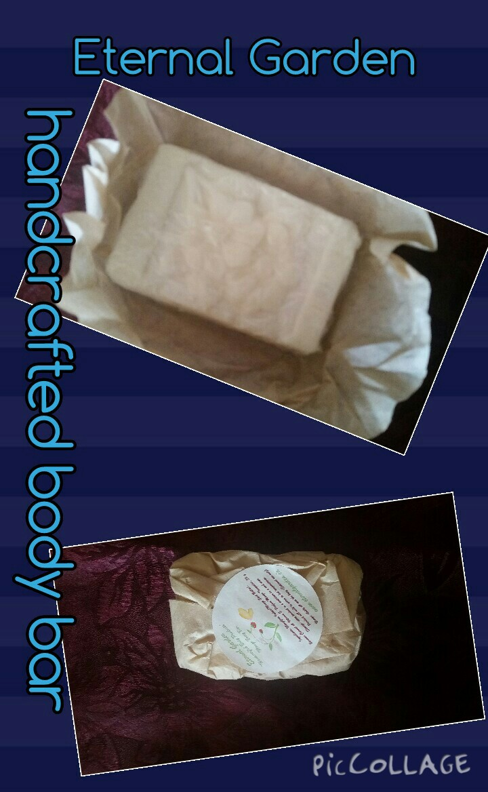

PRICE $9.00 Body Bar aloe Vera/mango, Cocoa butters, Vitamin E, Coconut oil, Beeswax, fragrance oil

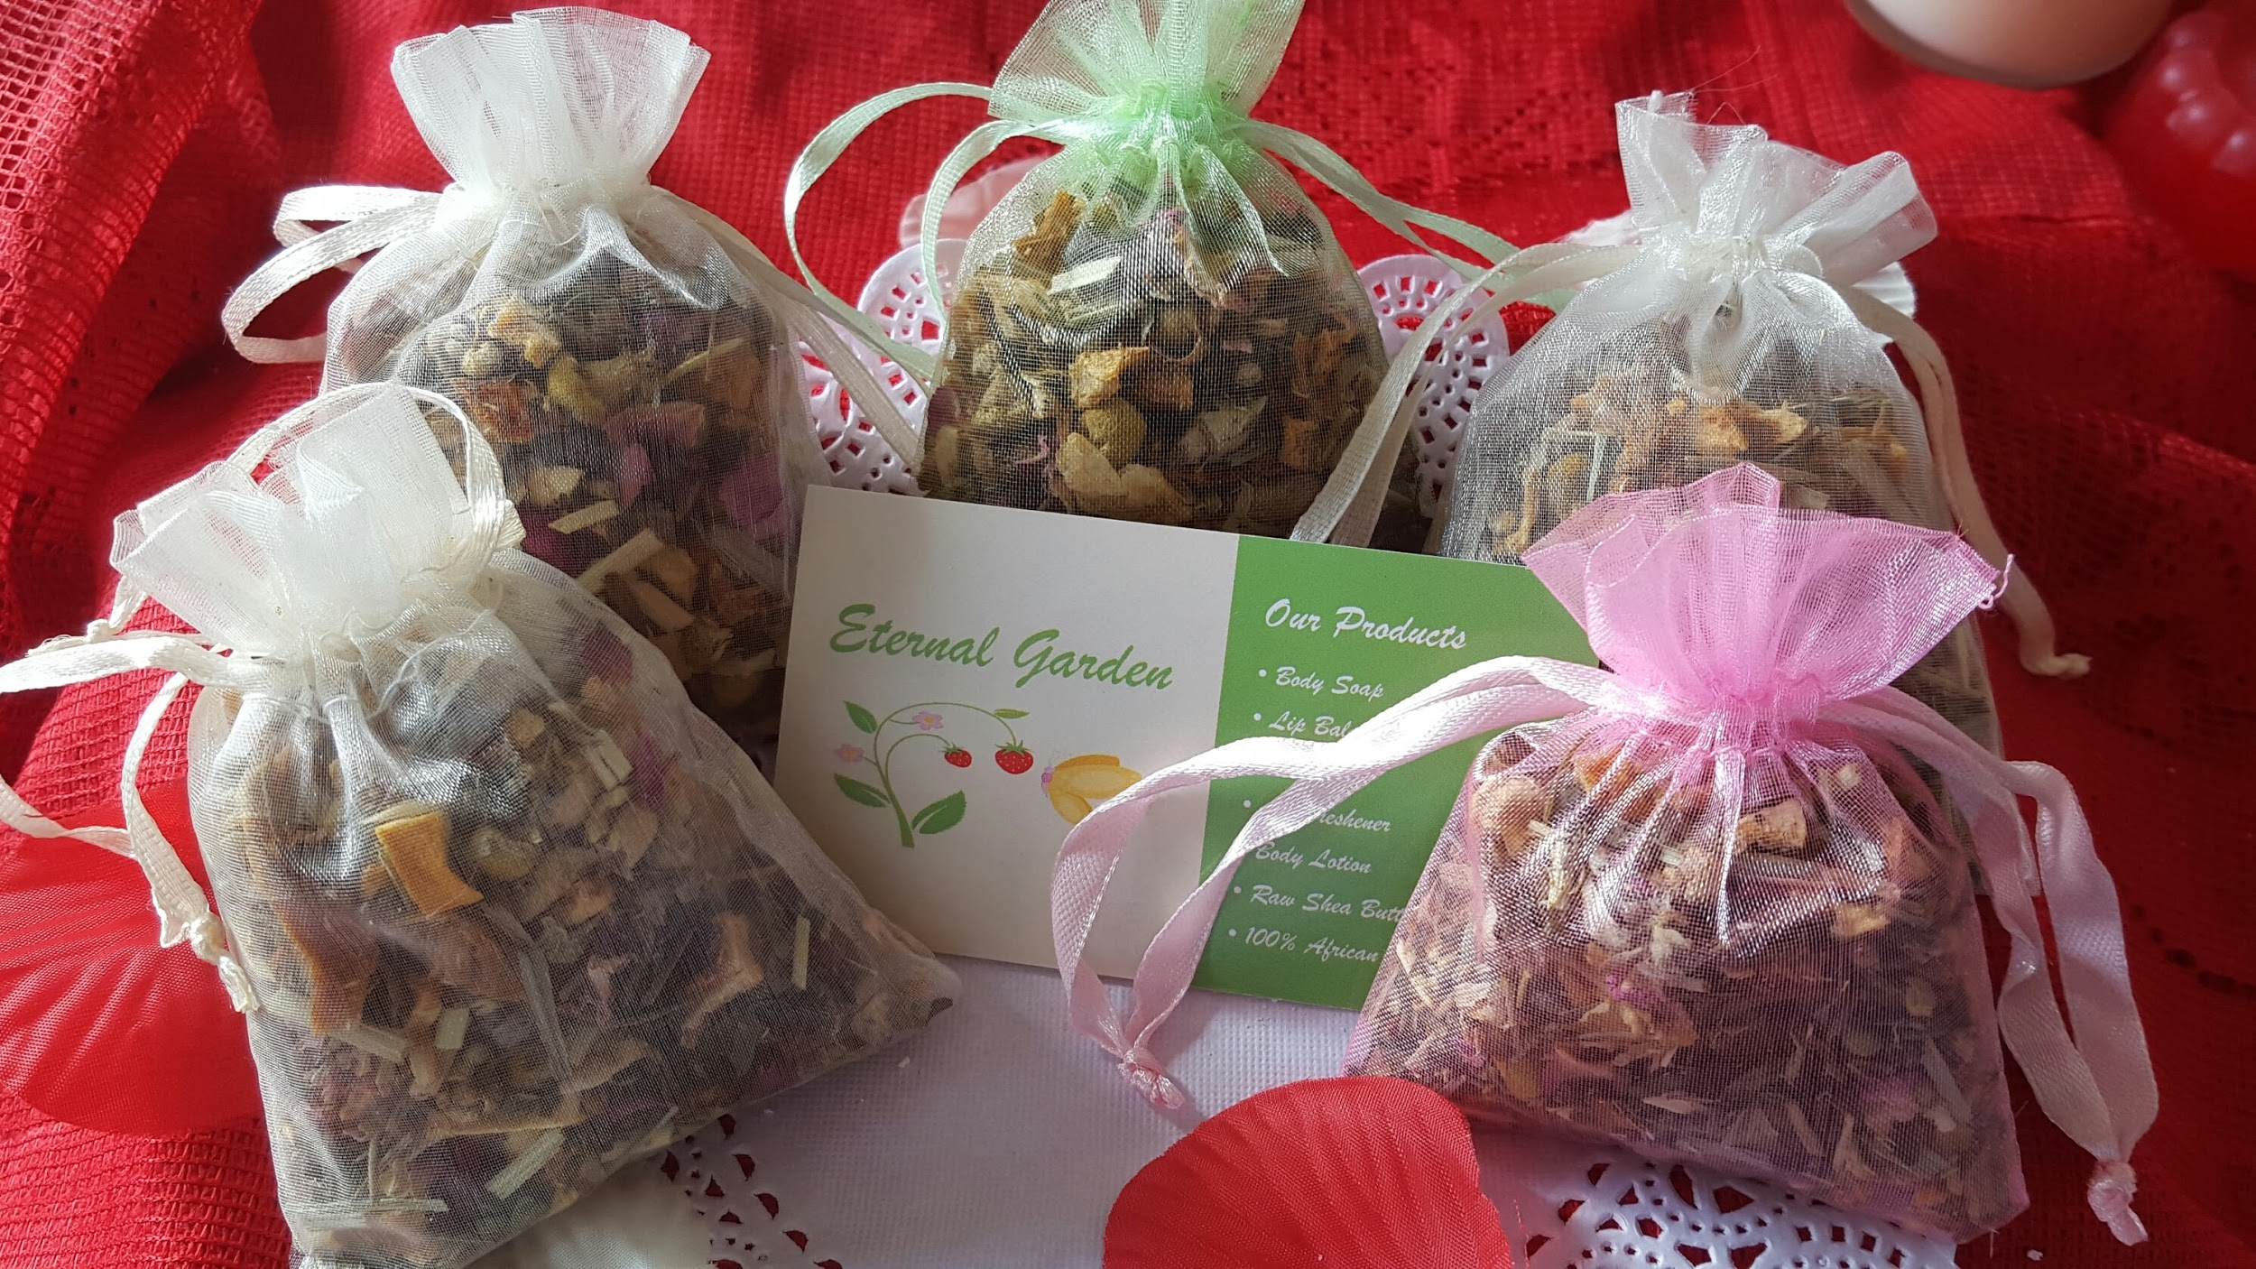

Price: $4.00 Potpourri Sachet dried fruit and flowers and fragrance oil

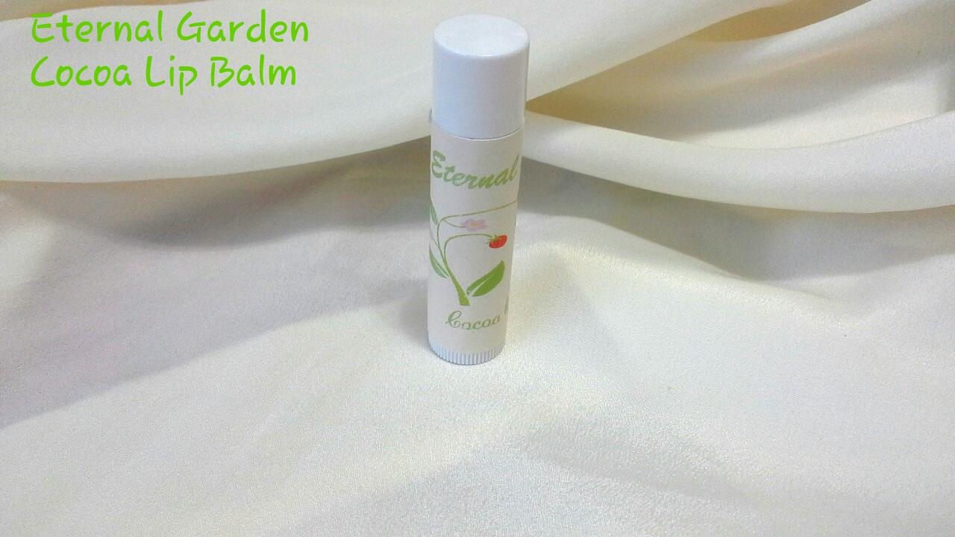

PRICE $ 3.50 Cocoa Lip Balm, Aloe Vera, Mango, Cocoa butters, Vitamin E, Coconut oil, Beeswax, fragrance oil

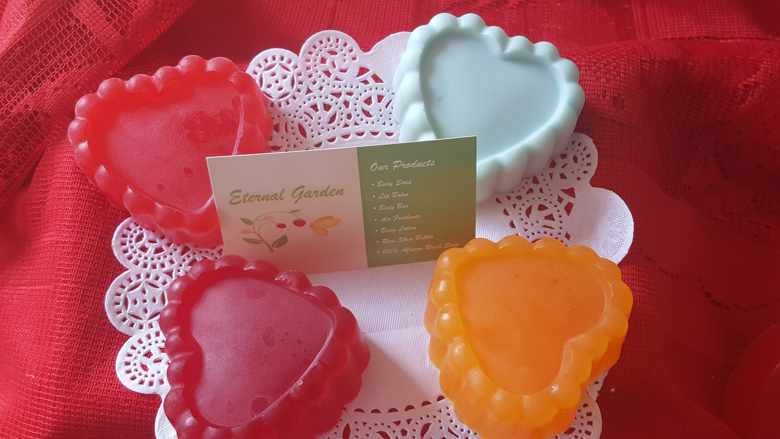

Price 6.00 Vegetable base, glycerine (Sorbitol (moisturizer), purified water, Palmate (palm oil) Sodium Cocoste (Coconut oil) Decyl glycoside water, Fragrance oil, colorant