A

# PROJECT REPORT ON

**“Online News Portal”**

**SUBMITTED TO**

**Banaskantha District Kelvani Mandal Sanchalit**

### Smt. B.K.Mehta I.T.Centre (BCA College)

**OPP.S.T WORKSHOP, HIGHWAY, PALANPUR - 385001.**



# As a Partial fulfillment of the course of

**BACHELOR OF COMPUTER SCIENCE & APPLICATION Year-2023-2024**

**Developed by: Roll No: Exam No:**

|  |  |  |
| --- | --- | --- |
| Meet Mevada | 97 |  |
| Nimal Patel | 83 |  |
| Priyank Patel | 84 |  |

**INTERNAL GUIDE :-**

**Shri.Parvin Ami**

# Banaskantha District Kelvani Mandal Sanchalit

### Smt. B.K.Mehta I.T.Centre (BCA College)OPP.S.T

**WORKSHOP, HIGHWAY, PALANPUR - 385001.**

***Affiliated TO***

(Hemchandracharya North Gujarat University, Patan)

7

***CERTIFICATE***

### TO WHOM SO EVER IT MAY CONCERN

**This is to certify that following students of B.C.A. have completed their project work on “Online News Portal” satisfactorily in partial fulfillment of requirement of BACHELOR OF COMPUTER SCIENCE & APPLICATION of Hemchandracharya North Gujarat University, Patan in the year 2023-2024.**

**Serial No. Name Of Student Roll No. Exam No.**

|  |  |  |  |
| --- | --- | --- | --- |
| 1 | Meet Mevada | 97 |  |
| 2 | Nimal Patel | 83 |  |
| 3 | Priyank Patel | 84 |  |

### 

### 

# -:Project Guide:- Principal

**Shri.Parvin Ami** **Dr.N.S.Gupta**

**(Smt.B.K.Mehta I.T.Centre-**

**BCA College, Palanpur)**

**Index**

|  |  |  |
| --- | --- | --- |
| SR.NO | DESCRIPTION | PAGE NO |
| 1 | PROJECT PROFILE | 4 |
| 2 | ABSTRACT | 5 |
| 3 | ACKNOWLEDMENT | 6 |
| 4 | INTRODUCTION | 7 |
| 5 | OVERALL DESCRIPTION | 8 |
| 6 | DEPLOYMENT TIME REQUIREMENTS | 10 |
| 7 | SYSTEM REQUREMENTS | 11 |
| 8 | DATA MANAGEMENT | 17 |
| 9 | ONLINE NEWS PORTAL ,SCREEN SHOTS | 19 |
| 10 | CONCLUSION | 36 |
| 11 | REFERENCES | 37 |

# Project Profile

|  |  |
| --- | --- |
| PROJECT TITLE | ONLINE NEWS PORTAL |
| Objective of Project | The main objective of project is to people can watch news online at home any time. |
| Front End | HTML, CSS, BOOTSTRAP |
| Back End | PHP |
| Server | Google Chrome |
| Tools | Visual Studio Code |
| Design & Functionality | HTML , CSS |
| Documentation Tool | Ms Office 2010 |
| Developed By | Nimal Patel [83]  Meet Mevada [97]  Priyank Patel[84] |
| Internal Guide | Shri.Parvin Ami |
| Submitted To | B. K. Mehta I.T Centre BCA College , Palanpur . |
| Team Size | THREE |
| Project Duration | 80 Hour |

**ABSTRACT**

This project focuses on the development of an online news portal, aiming to provide users with timely and engaging content across various topics. Through a comprehensive exploration of modern web technologies, including multi-tiered architecture, server and client-side scripting, and robust database management, this endeavor seeks to create a dynamic and user-friendly platform.

By leveraging tools such as Backend PHP, and Frontend HTML, CSS, BOOSTRAP and MySqli database, this project aims to deliver a seamless user experience while empowering administrators with efficient content management capabilities. Through this endeavor, we endeavor to shed light on the intricate technological framework underpinning the digital news ecosystem, paving the way for the future of online journalism.

Stay tuned as we delve into the complexities of building and implementing an online news portal, and explore the transformative potential of technology in shaping the way news is consumed and disseminated in the digital age.

# ACKNOWLEDGEMENT

In completing this graduate project, We've been fortunate to receive invaluable help, support, and encouragement from numerous individuals. We extend my deepest gratitude to each of them for their unwavering cooperation and assistance.

We extend my deepest gratitude to Shri.Parvin Ami for his exceptional guidance and support throughout this project in the field of Computer Science at Smt. B. K. Mehta I.T. Center. His continuous feedback and encouragement have been instrumental in shaping the success of this endeavor. Shri.Parvin Ami profound knowledge and dedicated approach have left a lasting impression on me, which We are confident will benefit me significantly in my future endeavors.

We extend my heartfelt gratitude to Dr. Namrata Gupta, the principal of our college, whose unwavering support and guidance have been instrumental throughout this endeavor.

In the process of completing this graduate project, We've been fortunate to receive assistance, guidance, and encouragement from various individuals.

We are deeply grateful to Mr. Divyang Shah, my teacher, whose support and mentorship have been invaluable throughout this journey.

# 1.0 INTRODUCTION:-

The online news industry is rapidly gaining momentum as a widely embraced platform for accessing news and information. Increasingly, individuals are turning to online news portals to stay informed about current events and developments. It is evident that the practice of consuming news digitally is becoming increasingly prevalent.

The objective of this project is to develop a comprehensive online news portal where users can access news articles and updates conveniently through the internet. However, for the purpose of this paper, the focus will be on providing news related to various categories.

An online news portal serves as a virtual platform on the internet where users can explore different categories and select articles of interest. Users have the flexibility to navigate through the portal, read articles, and stay abreast of current affairs. Additionally, features such as search functionality and article categorization enhance the user experience.

Upon selecting articles of interest, users may have the option to save them for later reading or share them with others. The portal may also facilitate user engagement by allowing comments on articles and fostering discussions. Furthermore, users may receive email notifications for breaking news or updates in their areas of interest.

In conclusion, the development of an online news portal aims to provide users with a convenient and efficient platform for accessing news and staying informed about current events in various categories.

### OVERALL DESCRIPTION:

#### Description:

* + - Any visitor can access news articles and view available content on the online news portal.
    - Visitors have limited access and can only view available news articles and content
    - Admins can add new category and articles, edit article information, and remove articles as needed.
    - Admins have the authority to manage user accounts, including adding, editing, or removing user profiles.
    - This structure ensures that the online news portal functions effectively, providing access to news articles for all visitors while offering additional features and privileges for registered users and administrators.

#### Scope:

* The scope of an online news portal encompasses the creation, curation, and delivery of timely and credible news content to a diverse audience through various digital platforms.
* The online news portal introduces a feature where users can subscribe to alerts for breaking news stories and updates on specific topics of interest, ensuring they stay informed in real-time

#### Using the code:

1. Attach the database in your "MySQLi Server Management Studio Express".
2. Run the application on Microsoft Visual Studio Code as web site.
3. Locate the databas

#### Web Pages details:

* + - User Pages:
      * Home (index) Page
      * Category Page (multiple category)
    - Admin Pages :
      * Admin Home
      * Add Category
      * Add Post
      * Add user
      * Website settings

# 3.0 DEPLOYMENT TIME REQUIREMENTS

|  |  |  |
| --- | --- | --- |
| **Hardware Requirement** | **Server side (Minimum Requirements)** | |
| Processor | Core2Duo 2.5 GHz |
| RAM | 2 GB |
| HDD | 20 GB |
| **Client side (Minimum Requirements)** | |
| Processor | Dual-Core 2.5 GHz |
| RAM | 1 GB |
| HDD | 10 GB |

|  |  |  |
| --- | --- | --- |
| **Software Requirement** | **Server side (Minimum Requirements)** | |
| Operating System | Windows, Linux |
| Database | My SQLi |
| **Client side (Minimum Requirements)** | |
| Operating System | Windows, Linux, Mac |
| Browser | Google Chrome Latest |

* 1. **SYSTEM REQUREMENTS:**

### Use-case Diagram:

### C:\Users\meet\OneDrive\Pictures\use case diagram.png

* 1. **Data flow Diagram:**
     + A data flow diagram is a graphical view of how data is processed in a system in terms of input and output. The Data flow diagram (DFD) contains some symbol for drawing the data flow diagram.
* **CONTEXT LEVEL DFD :**

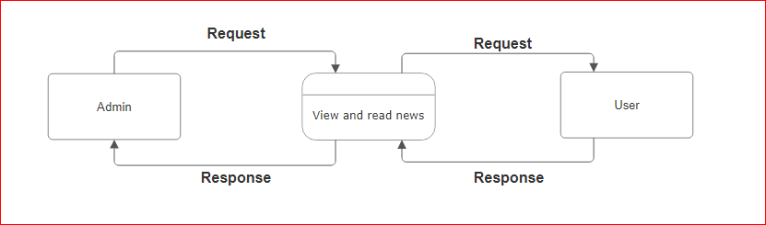

**ADMIN DFD**

* **0 LEVEL DFD for ADMIN :**

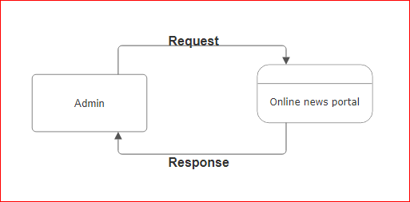

**1ND LEVEL DFD for ADMIN :**

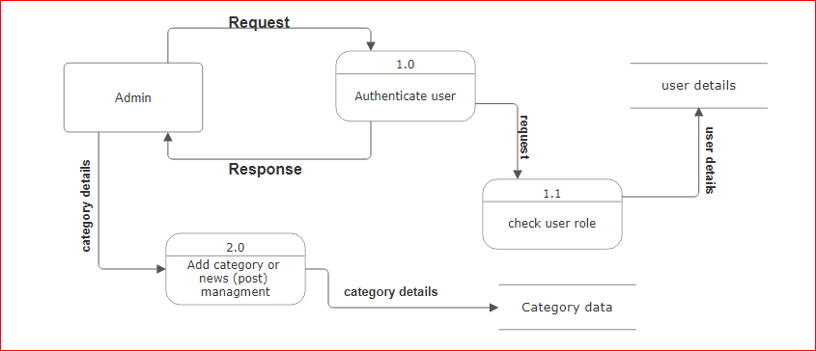

* **2ND LEVEL DFD for ADMIN :**

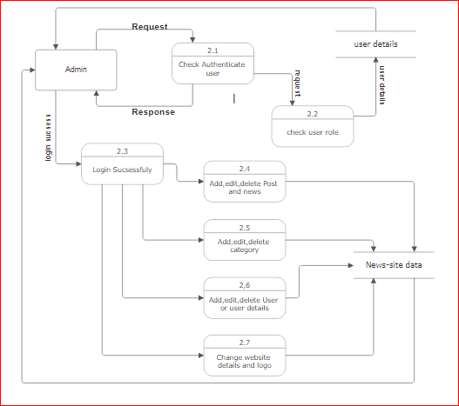

* **1st Level DFD for USER:**

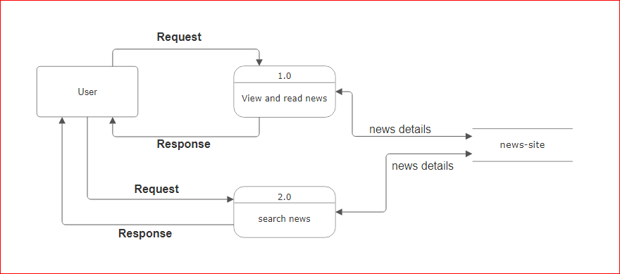

* 1. **Data Management**

### Database Table

* + - The design of the database was similar to the analysis phase. The database has been developed using SQL Server.
    - These are the main tables in the application and others are lookup and query tables.

Table 1: CATEGORY Table

* **category table**

|  |  |  |  |
| --- | --- | --- | --- |
| **Column Name** | **Data Type** | **Index** | **Description** |
| category_Id | int(11) | Primary Key,AI | Category_ID |
| category_Name | varchar(100) | Not null | Category_Name |
| post | int(11) | Not null | POST |

Table 2 :POST Table

* **post table:**

|  |  |  |  |
| --- | --- | --- | --- |
| **Column Name** | **Data Type** | **Index** | **Description** |
| post_Id | int(11) | Primary,foreign Key,AI | Post ID |
| title | varchar(100) | Not null | Post Title |
| description | text | Not null | Post Description |
| category | varchar(100) | Not null | Post Category |
| post_Date | int(50) | Not null | Post Date |
| author | int(11) | Not null | Post Author |
| post_Img | Varchar(100) | Not null | Post Image |

Table 3:SETTINGS Table

* **settings table:**

|  |  |  |  |
| --- | --- | --- | --- |
| **Column Name** | **Data Type** | **Index** | **Description** |
| id | int(11) | Primary Key,AI | Setting id |
| websitename | int(60) | Not null | Websitename |
| logo | varchar(50) | Not null | Website logo |
| footerdesc | varchar(255) | Not null | Website footer description |

Table 4: USER Table

* **user table:**

|  |  |  |  |
| --- | --- | --- | --- |
| **Column Name** | **Data Type** | **Index** | **Description** |
| user_Id | int(10) | Primary Key,AI | User ID |
| first_name | varchar(30) | Not null | User first name |
| last_name | varchar(30) | Not null | User last name |
| username | varchar(30) | Not null | User name for login |
| password | varchar(40) | Not null | password |
| role | int(11) | Not null | ROLE user/admin |

# ONLINE NEWS PORTAL:

# The Online News Portal is an online communication medium for internet users which are read all over the world. ...

# The news portal development allows to publish publications, press releases, columns, articles, blogs and other news related content. A news portal is an access point to news;

# This is generally thought of as a Internet connection to a news source but the definition of a Portal would include a newspaper, magazine or any other access to news. A web portal is any access point to the Internet.

### HOME PAGE:

* The Home Screen will consist of screen were one can browse through the news which we have on our website.

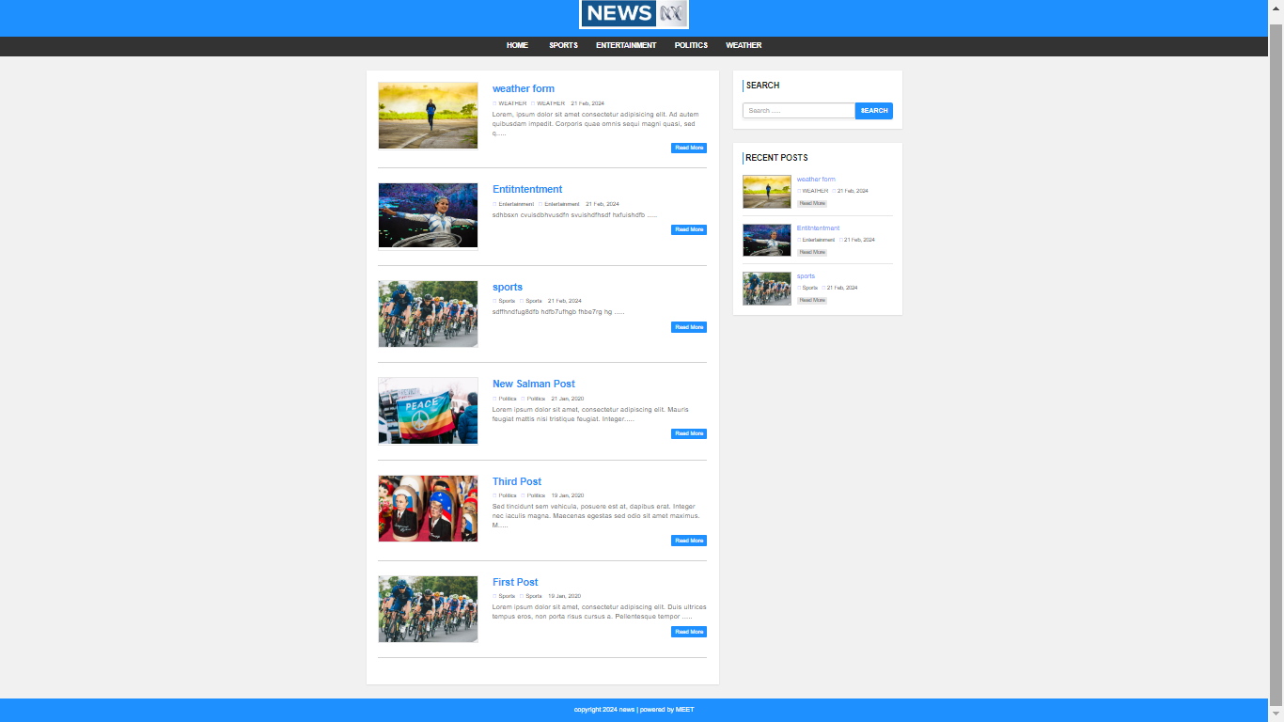

* **This is all category in screen**

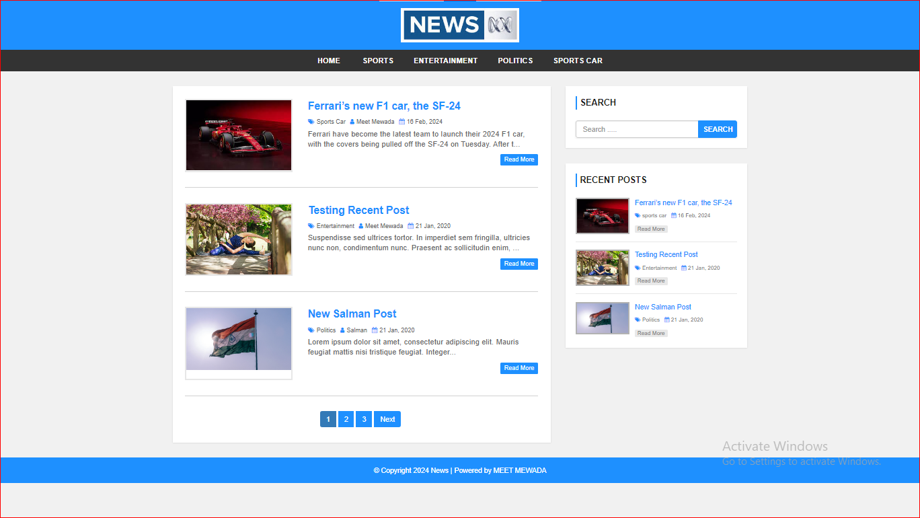

* **All category Page :**
  + - This page consists of category details. This page appears same for both visitors and users.
    - Admin and Normal user can be add multiple category in Online News Portal
* **Category Page**

* Category(Sports)

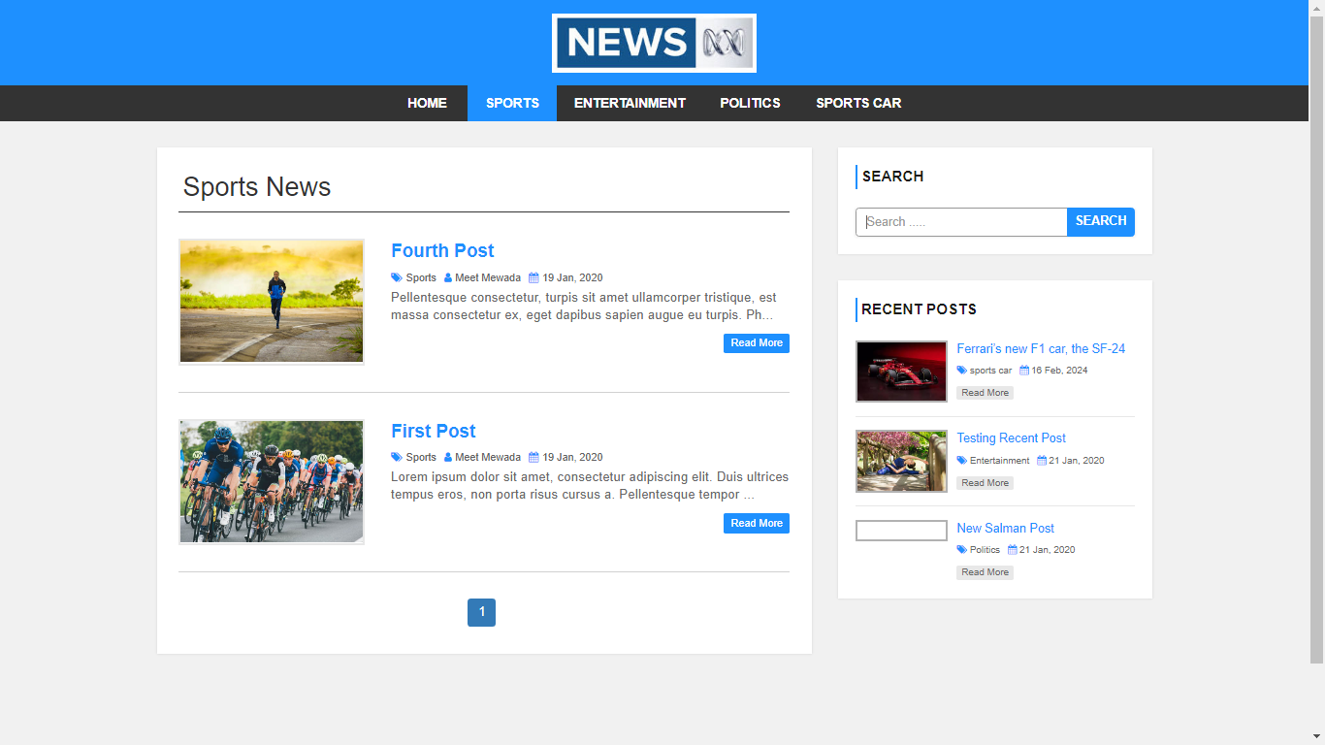

* Category(Entertainment)

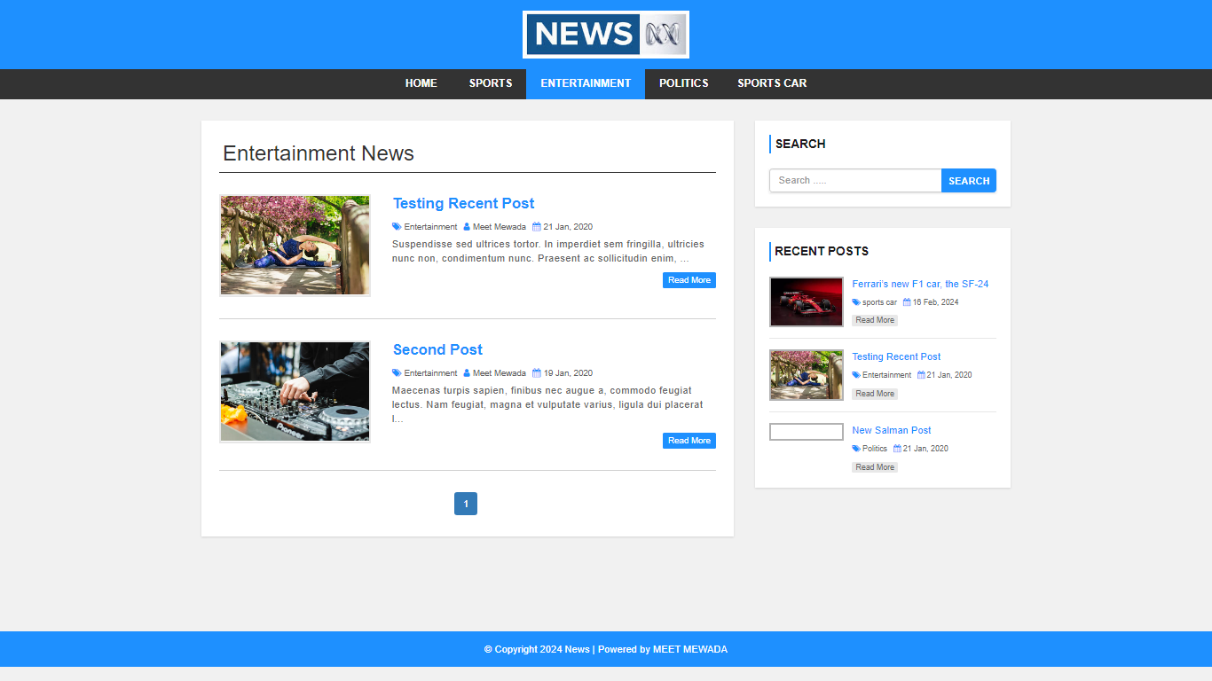

* Category (Politics)

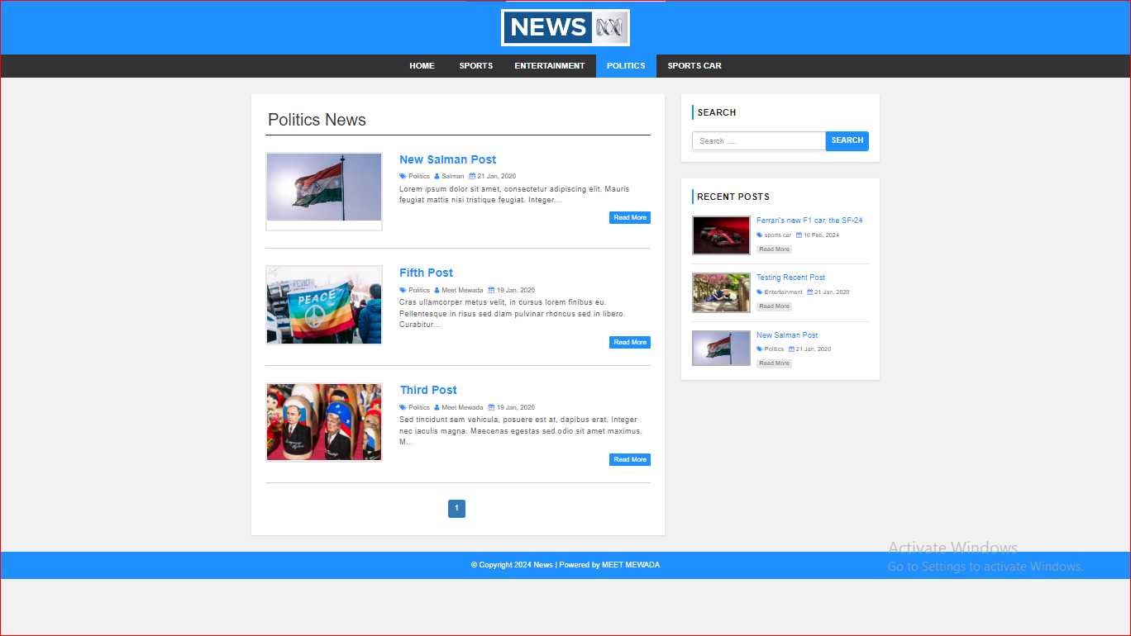

* Category(Sports car)

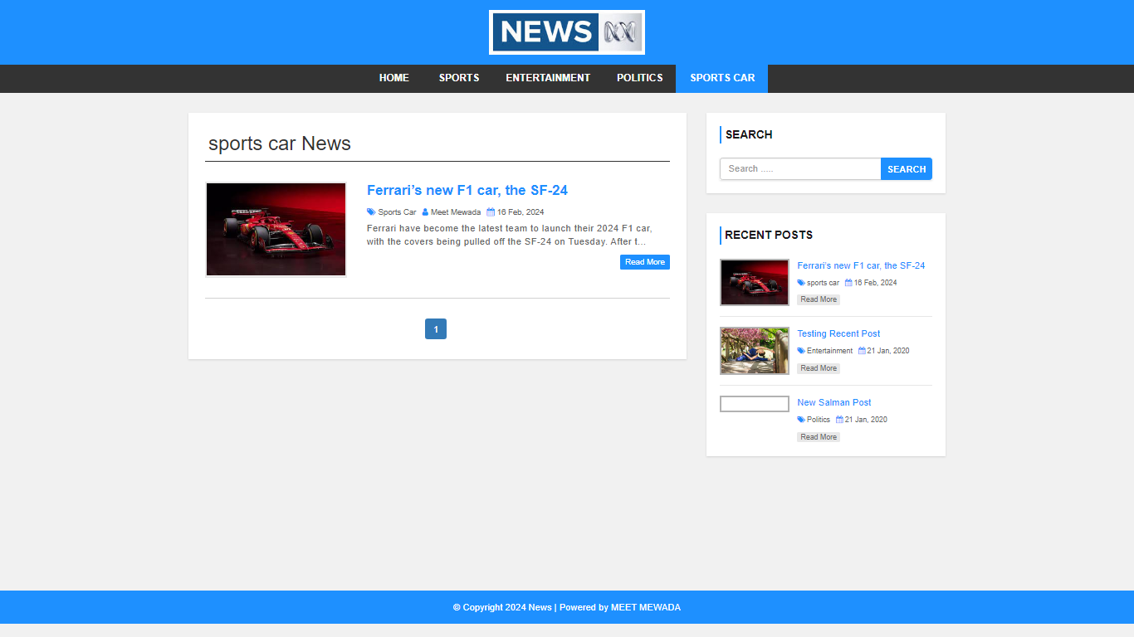

* ADMIN PAGE
* Admin and Normal user can be Login hear

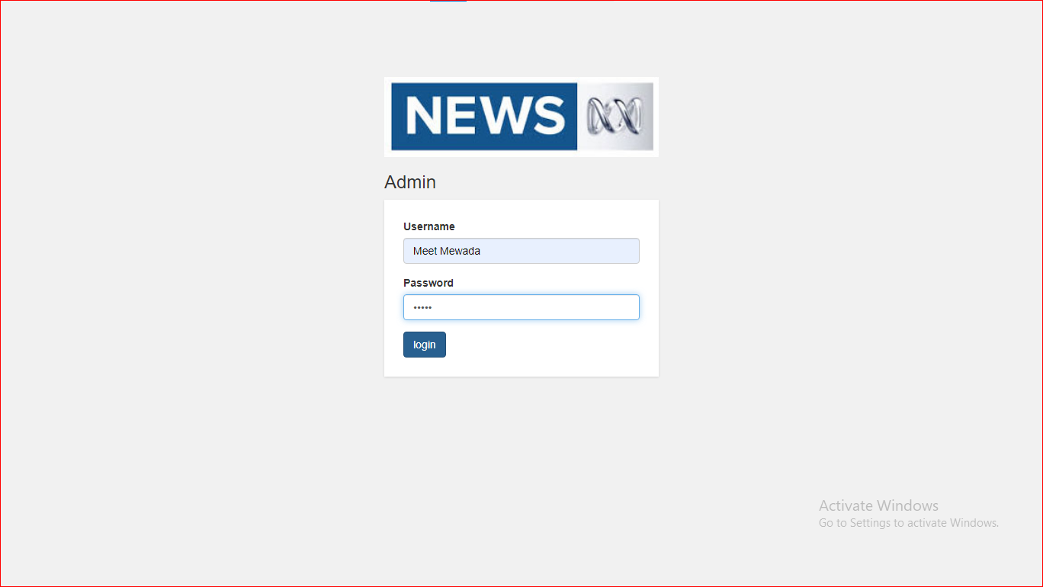

* Admin Post page
* All post details and Edit and Delete a post and News Hear

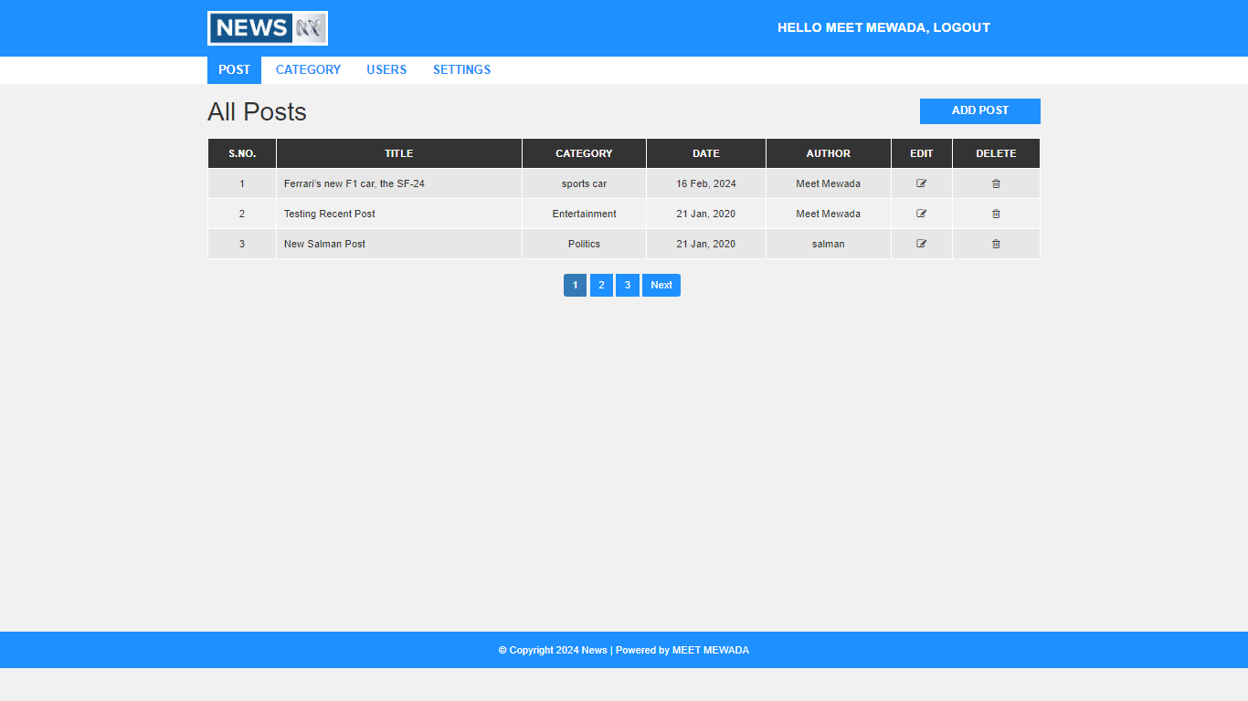

* Admin can be Add New Post Hear

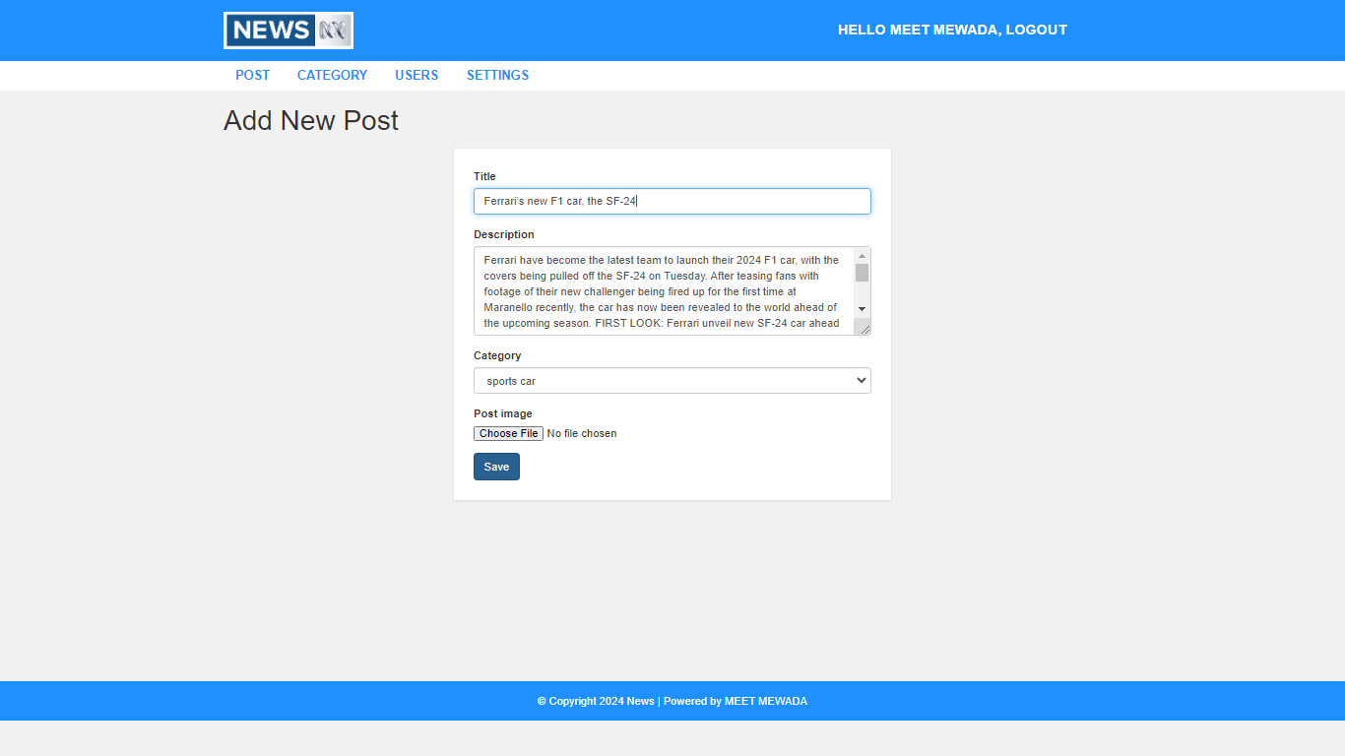

* Admin can be Update News and post

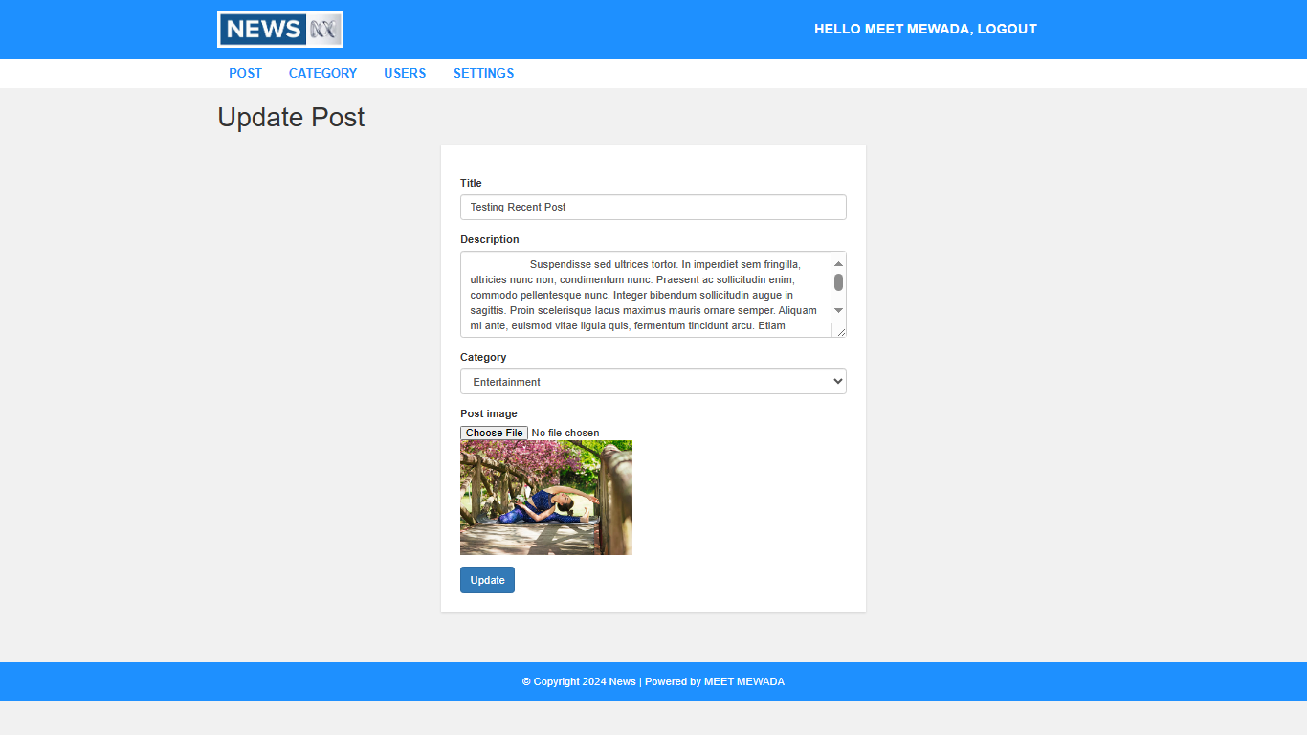

* Admin Category page
* All Ctegory details hear and Admin add New category Edit and Delete a Category

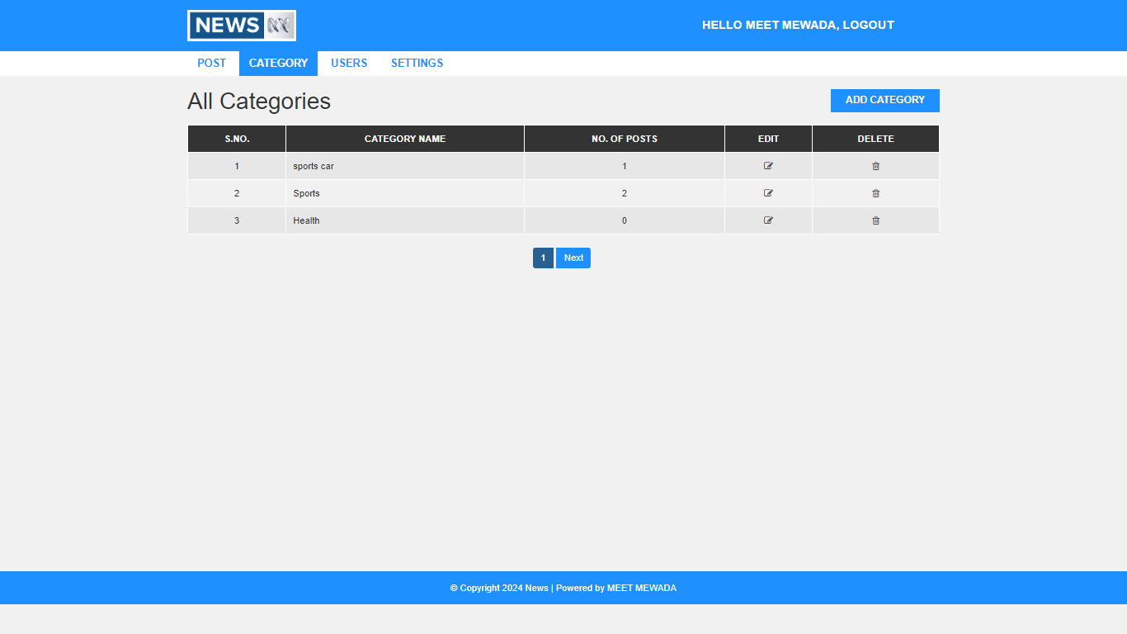

* Admin can be Add New Category

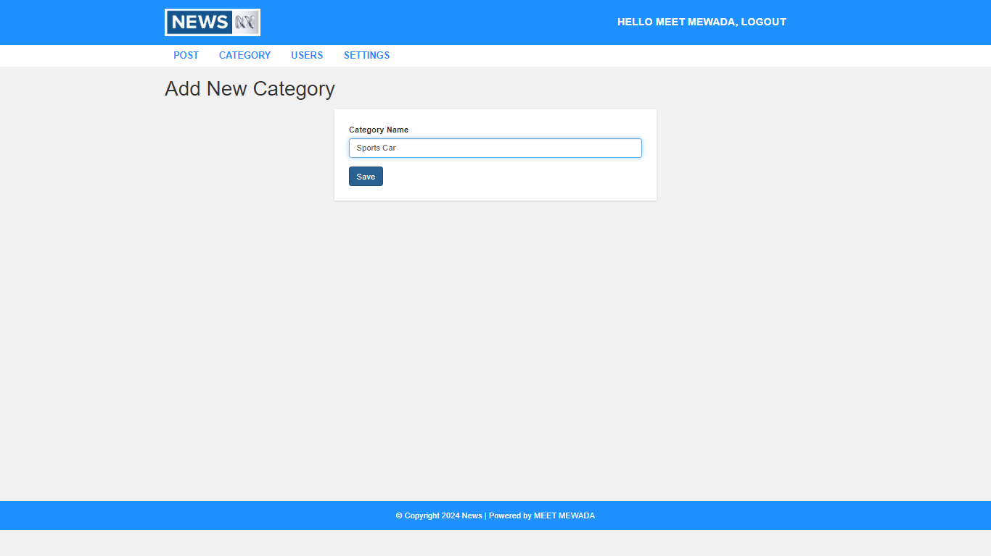

* Admin Users Page
* All User details hear and Admin can be Edit and Delete a User

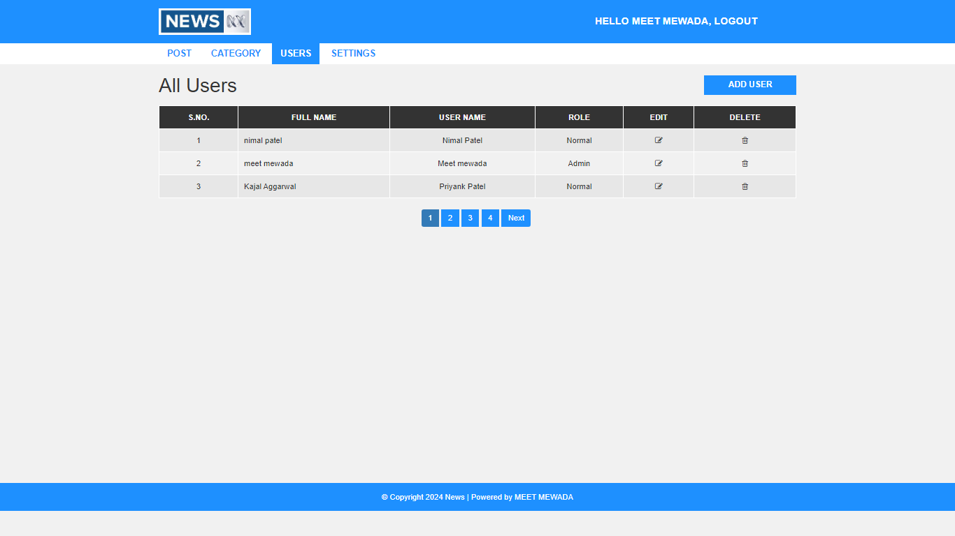

* Admin can be Update Category

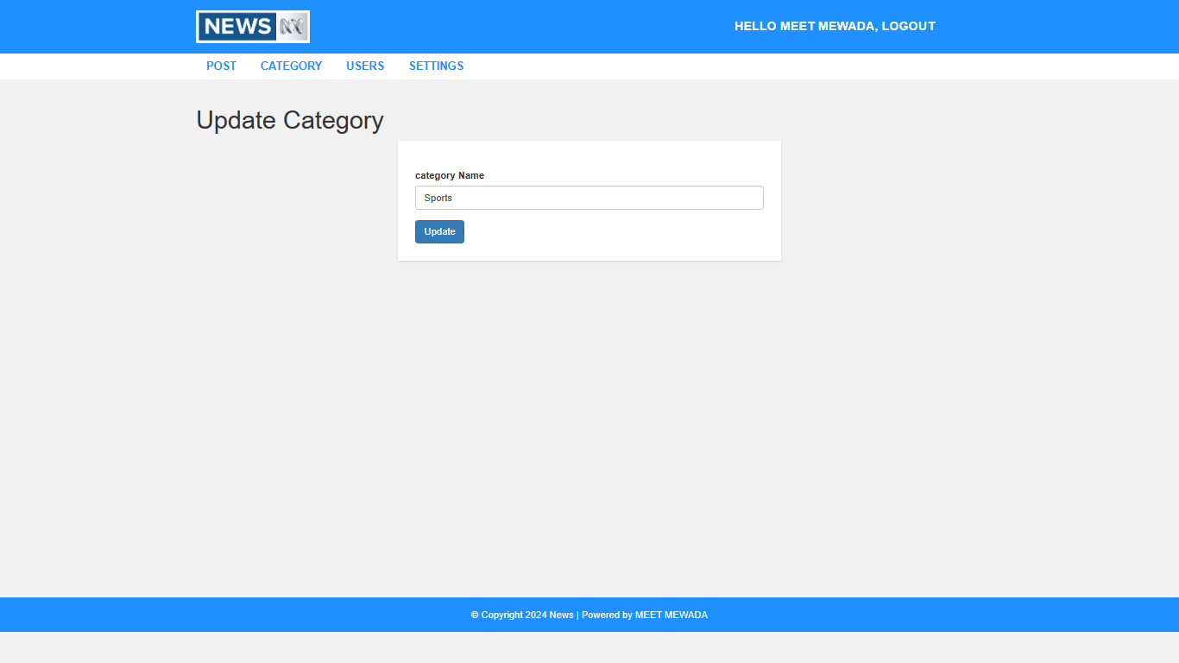

* Admin can be add new user like this new user add by its role like normal user and admin

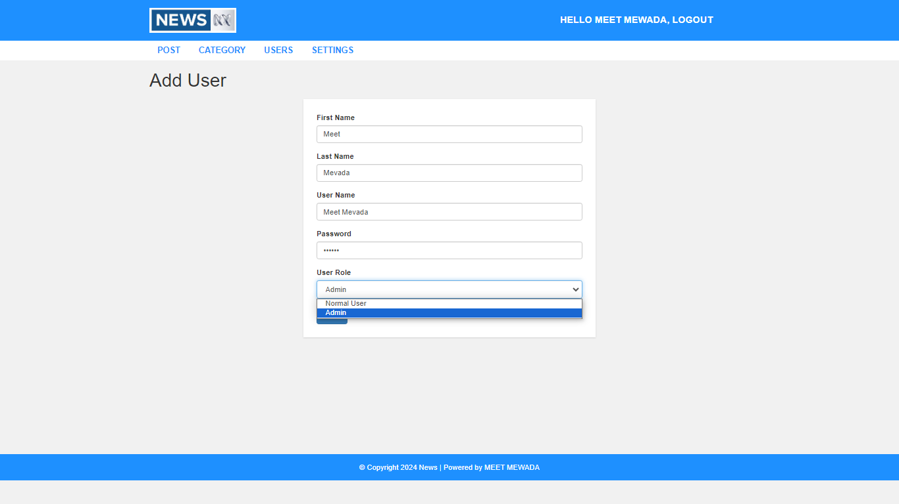

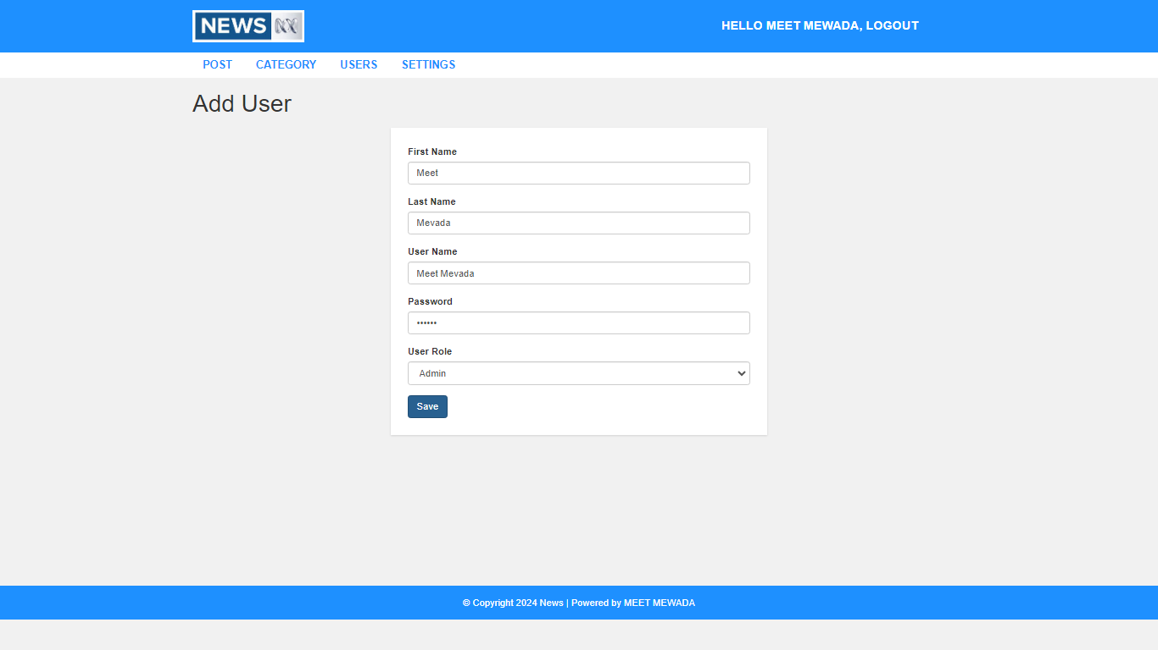

* Admin can be Update or modify user details

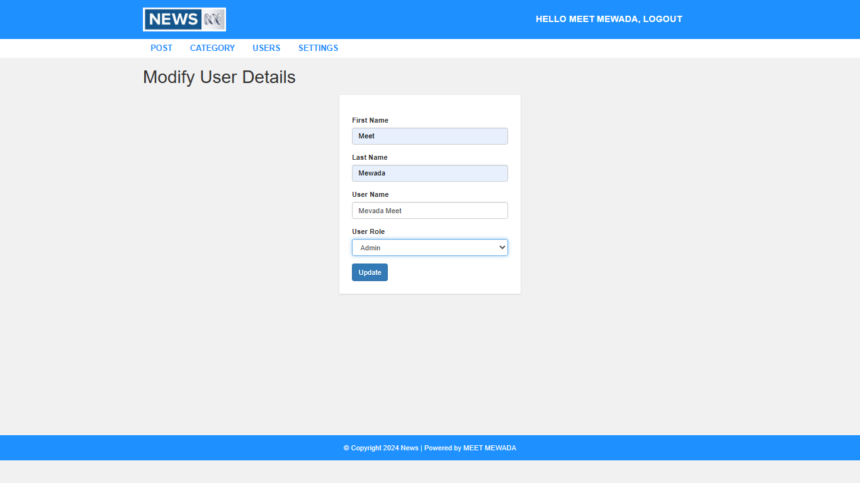

* Admin Website Settings Page
* Admin can be change website name logo and footer details hear

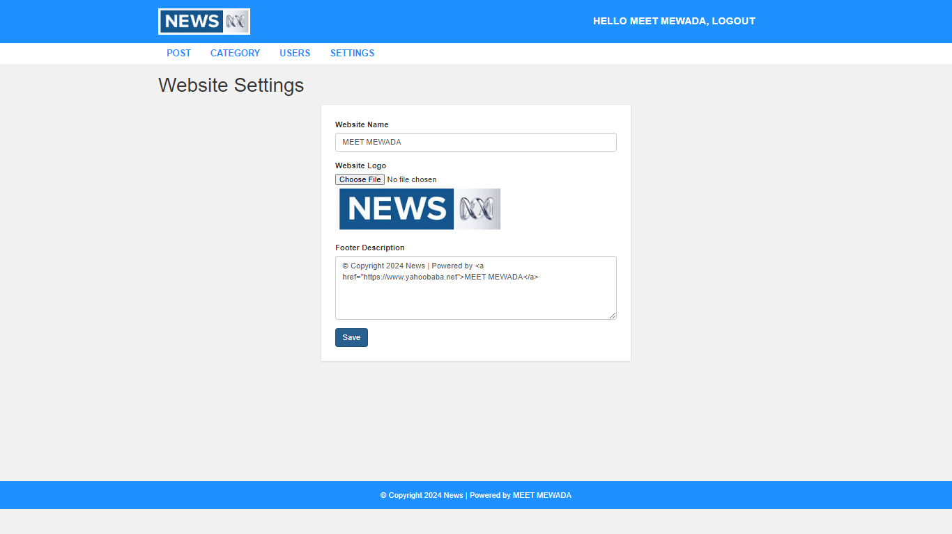

# Conclusion:

* **CONCLUSION AND FUTURE WORK**
* After processing through all phases of the system development life cycle, the online news portal is developed. In future it will be hosted on the internet server which will be accessed by all people in the world and can view the site and learn as much as news and information about the world.
* The Administrator or editor who will be assigned for editing or managing or controlling will be given the secure login information and will change or modify the website as per the requirements. Also in future we can add more category to support cars,time of india, and other electronic devices updates in news
* In today's Web development, a good site design is essential. A bad design will lead to the loss of visitors and that can lead to a loss of business. In general, a good page layout has to satisfy the basic elements of a good page design. This includes color contrast, text organization, font selection, style of a page, page size, graphics used, and consistency. In order to create a well- designed website for a specific audience,
* The developer needs to organized and analyze the users' statistics and the background of the users. Although it can be hard to come up with a design that is well suited to all of the users, there will be a design that is appropriate for most of the audience. The better the page design, the more hits a website will get. That
* implies an increase in accessibility and a possible increase in business

# References:

* + 1. <http://www.w3schools.com/>
    2. <https://www.javatpoint.com/php-projects>
    3. <https://www.php.net/manual/en/language.references.php>
    4. <https://www.divyabhaskar.co.in/>
    5. <https://www.thehindu.com/news/international/>

