# **Git and Shell Commands**

### **1. Navigating and Creating a Directory**

* ls: Lists files and directories in the current directory.
* cd r:: Changes to the root of the 'r' drive.
* mkdir GitRepo: Creates a new directory named "GitRepo".
* cd GitRepo/: Navigates into the "GitRepo" directory.
  + These steps set up the workspace for the Git project.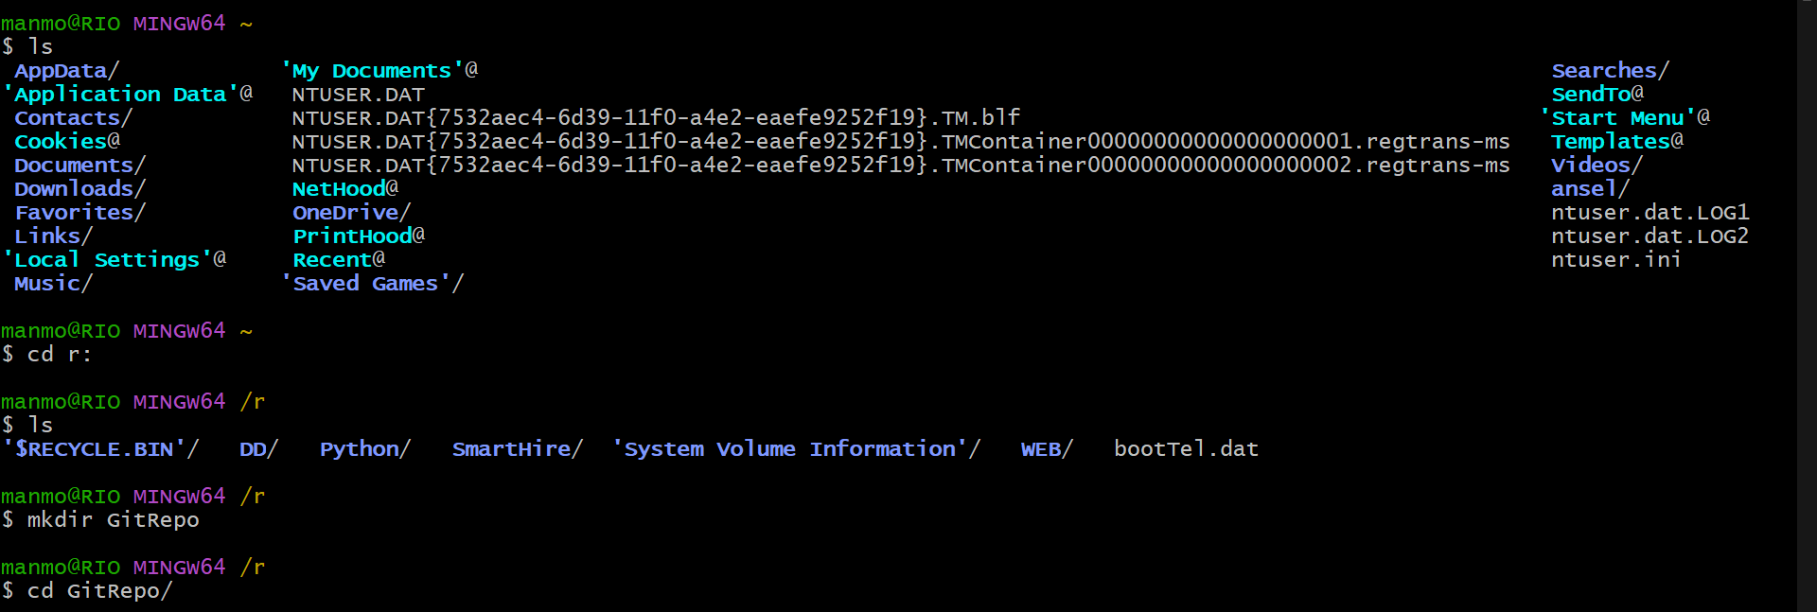

### **2. Initializing a Git Repository**

* git init: Initializes an empty Git repository in "GitRepo", creating a .git subdirectory.
* git branch -M main: Renames the default branch from "master" to "main".

### **3. Connecting to a Remote Repository**

* git remote add origin https://github.com/ManmohanSinghRaghav/VersionControlLecture.git: Adds a remote repository named "origin" with the specified GitHub URL.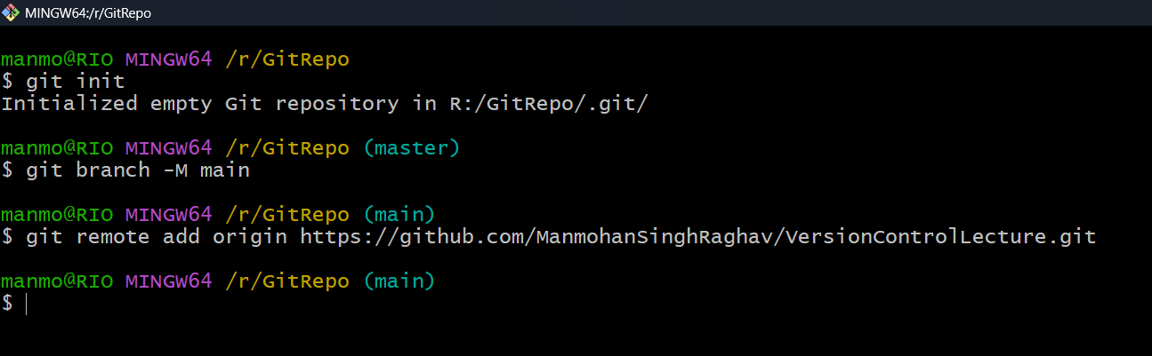

### **4. Creating and Editing Files with Nano**

* nano calc.java: Creates and edits a Java file with a "Calculator" class including addition, subtraction, multiplication, and division methods.
* nano gitlist.txt: Creates and edits a text file listing common Git commands.

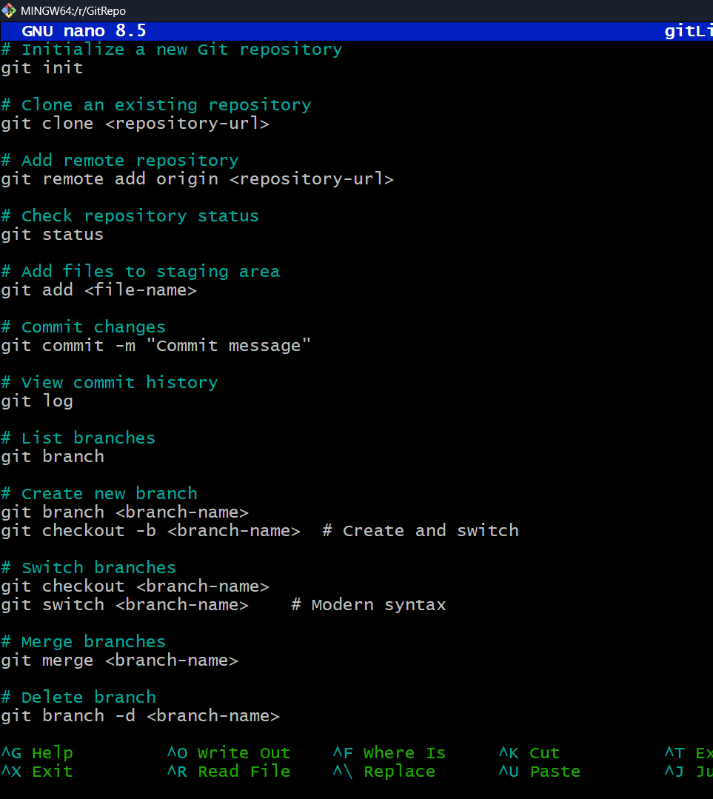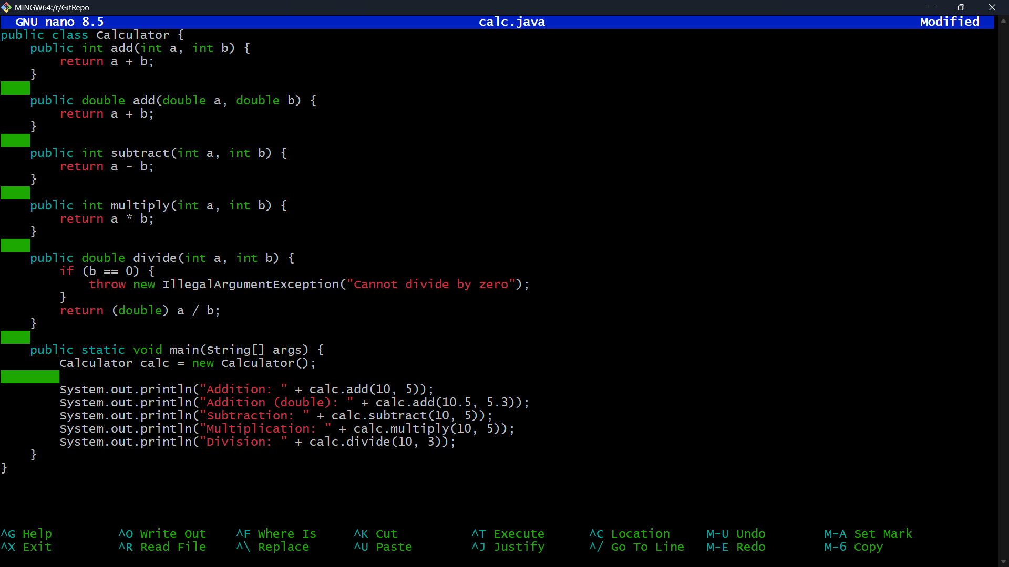

### **5. Staging Files for a Commit**

* git add calc.java and git add gitlist.txt: Stages the files for commit.
* **Warning**: "LF will be replaced by CRLF" indicates line ending conversion due to Windows (CRLF) vs. Git's internal (LF) format.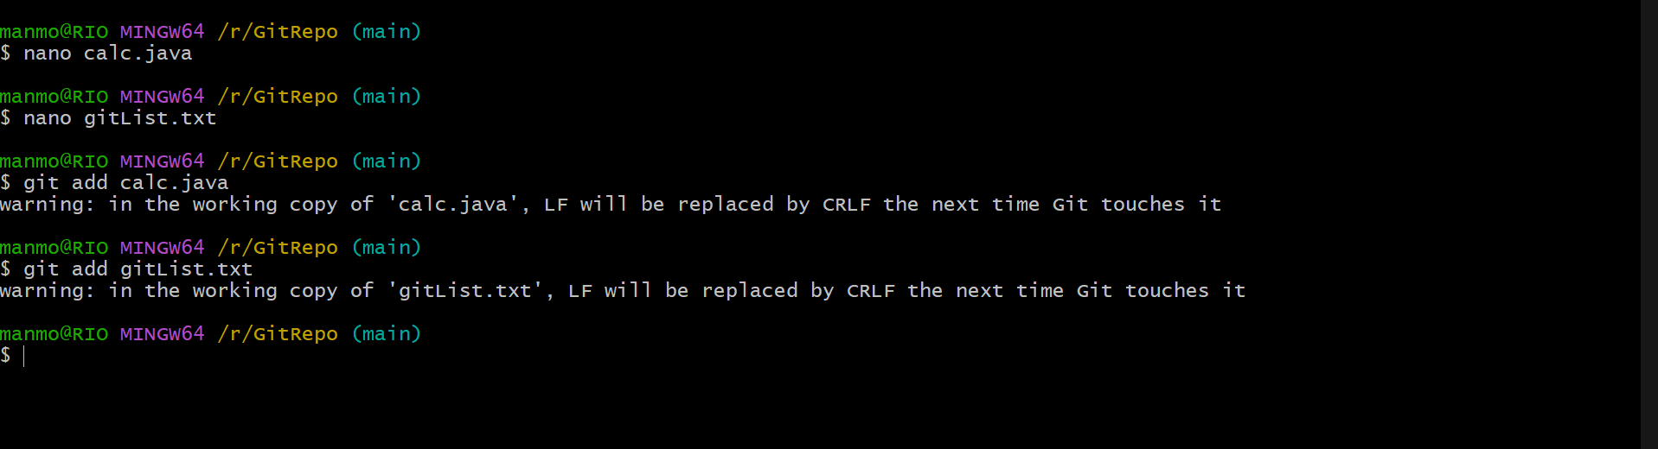

### **6. Committing Changes**

* git commit -m "Created and added java file with git commands": Commits the staged files with a descriptive message.

### **7. Pushing Changes to the Remote Repository**

* git push -u origin main: Pushes committed changes to the remote "main" branch and sets up tracking.