Available online at

https://journal.uitm.edu.my/ojs/index.php/MJCET Malaysian Journal
of Chemical Engineering and

e-ISSN: 2682-8588
Malaysian Journal of Chemical Engineering & Technology 8(2) 2025, 52–65
Technology

Sensitivity analysis of reaction kinetics in saponification of ethyl acetate and sodium hydroxide in continuous stirred tank reactor (CSTR)
Nur Hannani Mohamad Azehar¹, Sherif Abdulbari Ali^{2*}
^{1,2}Faculty of Chemical Engineering, Universiti Teknologi MARA, 40450 Shah Alam, Selangor

ARTICLE INFO | ABSTRACT
Article history:  Received 29 August 2025  Revised 03 October 2025  Accepted 22 October 2025 Online first  Published 31 October 2025 | Continuous stirred-tank reactors (CSTRs) are integral to industrial chemical processes due to their uniform mixing and steady-state operation. The saponification of ethyl acetate with sodium hydroxide is a widely used model reaction for studying kinetics in CSTRs. Understanding the sensitivity of reaction kinetics to operating conditions is critical for enhancing reactor performance, ensuring consistent product quality, and minimizing inefficiencies. Reaction kinetics in a CSTR are influenced by reactant concentrations, temperature, and flow rate. Misidentifying or poorly optimizing these parameters can result in suboptimal performance and reduced conversion efficiency, posing challenges for industrial applications. This study conducts a detailed sensitivity analysis to identify the key parameters influencing the saponification reaction in a CSTR. It quantifies how variations in these parameters affect conversion efficiency and overall reaction performance, providing actionable insights for process optimisation. A reaction kinetics model was selected and validated using robust pilot-plant experimental data. Parameters, including reactor temperature, were systematically analysed through numerical simulations to assess their sensitivity and impact on system performance. The validated model demonstrated strong agreement with experimental results, yielding RMSE values ranging from 0.0007 to 0.0013 and R² values between 0.9996 and 0.9999 across 30, 40, 50, and 60 °C. Maximum deviation remained below 0.6 %, highlighting the model’s predictive accuracy and industrial applicability. Sensitivity analysis showed the greatest marginal benefit between 30 and 40 °C, with a peak sensitivity ratio of 0.00072, indicating that small temperature adjustments in this range have the greatest impact on the final conversion of ethyl acetate. This study sets
Keywords:
CSTR
Sensitivity analysis Reaction kinetics Saponification Ethyl acetate RSME
Sodium hydroxide
DOI:
10.24191/mjcet.v8i2.8714

2*Corresponding author. E-mail address: abdulbari@uitm.edu.my

itself apart from classical saponification research by integrating pilot-plant data with MATLAB-based analysis, offering a validated dataset
and a meaningful contribution to chemical reaction engineering.

INTRODUCTION

Continuous stirred tank reactors (CSTRs) are widely utilised in industrial chemical processes for their ability to maintain steady-state conditions, ensuring uniform product quality and scalability (Cherkasov et al., 2022). These reactors are essential in industries such as food processing, pharmaceuticals, and petrochemicals, where continuous production and strict process control are required (Hu, 2021). Their design facilitates homogeneity through continuous stirring, enabling uniform reactant distribution, catalyst presence, and heat regulation (Scott, 1991). Such features are particularly useful in reactions like the saponification of ethyl acetate with sodium hydroxide, which require consistent reaction environments for optimal performance (Harmon Ray & Villa, 2000). Recent studies have emphasised the importance of advanced sensitivity analysis techniques to improve such processes (Florez-Orrego et al., 2022). The saponification of ethyl acetate with sodium hydroxide is a widely studied reaction in chemical engineering education and research, typically carried out in batch or continuous stirred-tank reactors (Mesfer, 2018). The process produces ethanol and sodium acetate and is controlled by parameters such as temperature, reactant concentration, residence time, and mixing conditions, which strongly influence the overall kinetics (Danish et al., 2015; Ihsanullah et al., 2015).

The operation of CSTRs depends heavily on precise control of parameters such as temperature, agitation speed, reactant concentration, and flow rates (Ihsanullah et al., 2015). Effective heat exchange systems in these reactors prevent localised temperature spikes and drops, ensuring safety and reliability (Wang et al., 2020). This makes them suitable for highly regulated industries such as pharmaceuticals, where consistency in quality is critical (Berton et al., 2020). Despite these advantages, challenges remain in enhancing reaction parameters for maximum yield and efficiency. Studies have shown that artificial intelligence integration and advanced computational methods improve optimisation processes and ensure accurate predictions for complex chemical systems (He, 2023; Sysoev, 2023).
Given the importance of process optimisation in chemical engineering, enhancing CSTR performance remains a focus area for researchers. Variations in operational parameters influence reaction kinetics, but their combined effects remain poorly understood (Borovinskaya et al., 2019). Improving kinetic modelling techniques and conducting sensitivity analysis can address these gaps, leading to better designs for sustainable and cost-effective industrial applications. Multi-stage modelling techniques and sensitivity metrics have been used to improve reaction stages and reduce by-product formation (Sultan et al., 2024). This research specifically investigates the saponification of ethyl acetate with sodium hydroxide, exploring the impact of operational parameters on reaction kinetics and reactor performance.
Saponification of ethyl acetate with sodium hydroxide is a well-established model reaction frequently employed in chemical engineering studies because of its simplicity, reproducibility, and clear kinetic behaviour. It proceeds as a homogeneous second-order liquid-phase reaction, where the rate is proportional to the product of ethyl acetate and sodium hydroxide concentrations. Prior work has characterised this system using batch and continuous reactors, with conductometric and titrimetric techniques commonly

applied to monitor conversion (Das et al., 2011; Mukhtar et al., 2017). These studies consistently report Arrhenius-type temperature dependence, with activation energies in the range of 41 to 48 kJ·mol⁻¹, confirming its suitability for kinetic modelling and validation studies (Das et al., 2011; Petek & Krajnc, 2012). As such, it serves as an ideal benchmark for sensitivity analysis and reactor-scale investigations in both laboratory and pilot-plant environments.
Other previous studies have analysed specific parameters such as flow rates and temperature in isolation, often neglecting their interactive effects (Ihsanullah et al., 2015; Nauman, 2008). However, studies focusing on sensitivity analysis for integrated parameter enhancement remain limited. For example, Ihsanullah et al. (2015) examined the influence of varying inlet flow rates on CSTR performance and reported significant effects on conversion and residence time. Similarly, Nauman (2008) investigated the role of reactor temperature, demonstrating that higher temperatures accelerate reaction rates. While these studies highlighted the importance of individual parameters, their outcomes were limited to single-variable perspectives without considering combined interactions. MATLAB simulations and kinetic modelling provide robust frameworks for evaluating the effects of multiple variables simultaneously (Levenspiel, 1999). Recent work has demonstrated the effectiveness of dynamic parameter adjustments and AI-driven approaches in achieving higher process efficiency and scalability (Sultan et al., 2024). In the present study, a computational model will be developed and validated with experimental data to assess the impact of temperature, flow rates, and reactant concentration on reaction kinetics. The results aim to establish improved strategies for reactor operation and contribute to sustainable chemical processing methods.
While the saponification reaction in CSTRs is a classical subject, the novelty of the present study lies in the integration of pilot-scale experimental data with detailed sensitivity analysis and rigorous error quantification. This approach extends beyond the scope of earlier works, which often relied on bench-scale studies or purely theoretical modelling, thereby providing both practical engineering insight and methodological innovation

METHODOLOGY

Overview
This study investigated the sensitivity of reaction kinetics in a continuous stirred tank reactor (CSTR) using MATLAB, focusing on the saponification of ethyl acetate with sodium hydroxide. The methodology involved process modelling, mathematical model selection, model implementation using MATLAB ode45, simulation CSTR dynamics, sensitivity analysis, and experimental validation with optimisation (Fig.1). Sensitivity analysis evaluated the effects of main parameters of temperature, reactant concentrations, and flowrate on reactor performance.

Mathematical Model Selection
Process Selection

Model Implementation in MATLAB
Simulation of CSTR Dynamics

Sensitivity Analysis

Visualisation and Interpretation
Experimental Validation

Fig. 1. Research methodology framework Source: Authors’ own data

Process Selection
The chemical reaction model selected for this study was saponification, specifically saponification of ethyl acetate with sodium hydroxide, which is represented by

CH₃COOC₂H₅ (l) + NaOH (aq.) → CH₃COONa (aq.) + C₂H₅OH (aq.) (1)

where reactants: CH₃COOC₂H₅ (ethyl acetate, C_{A}) and NaOH (sodium hydroxide, C_{B}) while products: CH₃COONa(sodium acetate, C_{C}) and C₂H₅OH (ethanol, C_{D})
Reactor Assumptions:
    - Continuous operation, well-mixed
    - Constant temperature and volume (V)
    - No side reactions
    - Reaction followed second-order irreversible kinetics:

r = kC_{A}C_{B} (2)

where r is the rate of reaction, C_{A} is the concentration of ethyl acetate, C_{B} is the concentration of sodium hydroxide, and k is the reaction rate constant.

Mathematical model selection
Mass balance equations: For reactant CA, CB:

dCA = Fin (C
− C ) − kC C
(3)

dt V
A,in A A B

dCB = Fin (C
− C ) − kC C
(4)

dt V
B,in B A B

For products CC, CD:

dCc = ^{Fin} (−C )+kC C

(5)

dt V C A B

dCD = ^{Fin} (−C )+kC C
(6)

dt V
B A B

where C_{A}, C_{B}: concentrations of ethyl acetate and sodium hydroxide, C_{C}, C_{D}: concentrations of sodium acetate and ethanol, C_{A,in}, CB,in: inlet concentration of reactants, Fin: volumetric flow rate of the reactants, V: reactor volume, and k: reaction rate constant
Equations (1) to (7) collectively define the kinetic framework, where (1) represents the overall saponification reaction, (2) specifies the second-order rate law, (3)−(6) establish the component mass balances, and (7) introduces the Arrhenius temperature dependence of the rate constant. Together, these equations formed the basis for simulating the reactor dynamics.
Temperature Dependency (Arrhenius Equation):

Ea
−
k = Ae RT (7)

where: A: pre-exponential factor, Ea: activation energy, R: gas constant, T: temperature
The system of mass balance equations (3)−(6) was implemented in MATLAB and solved using the ODE45 routine. The reaction rate constant at each temperature was evaluated through the Arrhenius relation in Equation (7), ensuring that temperature dependence was fully incorporated into the dynamic simulation. Building on this framework, the kinetic parameters which are the pre-exponential factor (A) and activation energy (Ea) were estimated directly from experimental data through nonlinear regression against the Arrhenius model. Experimental conversion data across multiple temperatures (30–60 °C) were
simultaneously fitted to the saponification kinetic model, and a nonlinear least-squares optimisation was carried out to minimise the deviation between simulated and experimental conversions. From this regression, both A (L·mol⁻¹·min⁻¹) and E_{a} (J·mol⁻¹) were numerically determined with their respective units, providing reproducible and transparent values derived directly from experiment rather than assumed constants.

To evaluate model accuracy, two statistical measures were applied. The coefficient of determination (R²) quantified the fit between simulated and experimental data, while the root-mean-square error (RMSE) measured the average magnitude of deviation between predictions and observations. Together, these metrics provided a credible and reliable basis for assessing model performance and comparing it with established kinetic studies.

Sensitivity analysis
Mass balance simulations were conducted by varying reactor temperature from 30 to 60 °C in 10 °C increments. At each set point, the validated kinetic model computed the 15-minute conversion; thermal sensitivity was then determined from the conversion differences between temperature steps, and model accuracy was assessed against experimental data.

Validation and optimisation
The results from simulation were validated by comparing MATLAB outputs with experimental conversion data. MATLAB tools were used to optimise conditions to maximise reactant conversion while minimizing energy use and cost. Results under optimised conditions were verified through additional simulations to confirm practical feasibility.

Visualisation and interpretation
The simulation outputs, including transient and steady-state conversion profiles, sensitivity trends, and parameter effects, were visualised through MATLAB plots. Graphs highlighted critical factors for performance improvement, aiding decision-making, and optimisation.

RESULTS AND DISCUSSION

Model validation
The proposed kinetic model was assessed against experimental conversion data at four operating temperatures (30, 40, 50, and 60 °C). These experimental data were generated in a BP1000 pilot-plant CSTR with 2.5 L working volume using equimolar feeds of 0.1 M ethyl acetate and 0.1 M NaOH, stirred at 180 rpm. Samples were withdrawn at 1, 3, 6, 9, 12, and 15 min, quenched with HCl, and analysed by conductivity via a calibration curve and back-titration to determine conversion. As summarised in the Appendix, the root-mean-square error (RMSE) remained very low, ranging from 0.0007 to 0.0013, while the coefficient of determination (R²) exceeded 0.9996 under all conditions, indicating near-perfect agreement between simulation and experiment.
Moreover, a full set of point-by-point results in the table (Appendix) further confirms this excellent fit, where at each temperature the simulated conversion profiles track the experimental data almost exactly, with only minor deviations at early and mid-reaction times. These detailed comparisons verify that the second-order kinetic expression reliably describes both the temporal evolution and plateau behaviour of the saponification reaction across the entire temperature range. These four data sets emphasise the accuracy of the kinetic parameters and support confident application of this model for reactor design, scale-up calculations, and even real-time digital-twin control of the saponification process.

Conversion – times profile
Fig. 2 presents all four kinetic profiles in a single plot to highlight the effect of temperature on reaction rate. The progressively steeper initial slopes with increasing temperature directly reflect the Arrhenius dependence of the rate constant. For instance, nearly 50% conversion is reached in under 3 min at 60 °C, whereas the 30 °C curve takes nearly 9 min. After approximately 12 min, all curves converge near their asymptotic conversions, ranging from 0.43 to 0.45, indicating that higher temperatures accelerate the approach to steady state but do not significantly alter the ultimate conversion. This composite visualisation thus serves as a rapid tool for selecting residence times across a target conversion range.

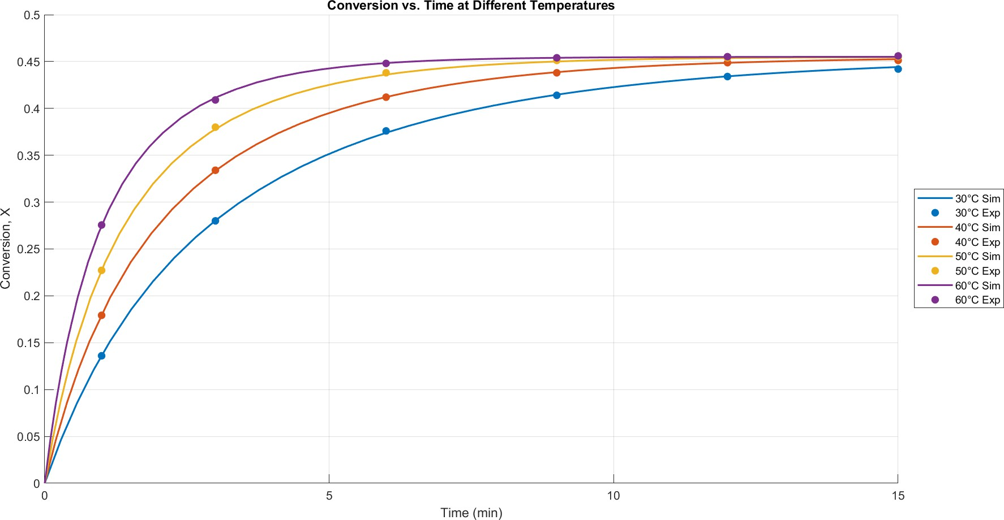

Fig. 2. Conversion profiles (X) as a function of time for each temperature Source: Authors’ own data

In Fig. 3 at 30 °C, conversion climbs from 0 to 0.136 in the first minute and reaches 0.442 by 15 min. The model yields an RMSE of 0.0012 and R² of 0.9998, with a maximum point-wise deviation of 0.54% at t = 3 min. The slight underprediction at early times with an error of 0.147% suggests minor thermal gradients or sampling lags in the experimental setup. Still, overall, the second-order kinetic law accurately captures the slow-to-moderate rate behaviour at this temperature.

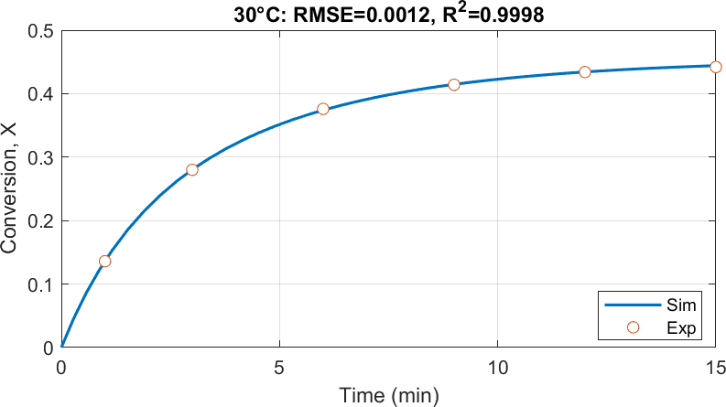

Fig. 3. Conversion vs time at 30 °C

Source: Authors’ own data

At 40 °C, conversion reaches 0.334 by 3 min and 0.451 by 15 min as shown in Fig. 4. The exceptionally low RMSE of 0.0007 and R² of 0.9999 indicate an almost exact match. The largest single-point error (0.29%) occurs at t = 15 min, likely due to precision limits in analytical measurement. The minimal residuals confirm that mass-transfer limitations are negligible and that the kinetic model parameters are most accurate in the mid-range temperature.
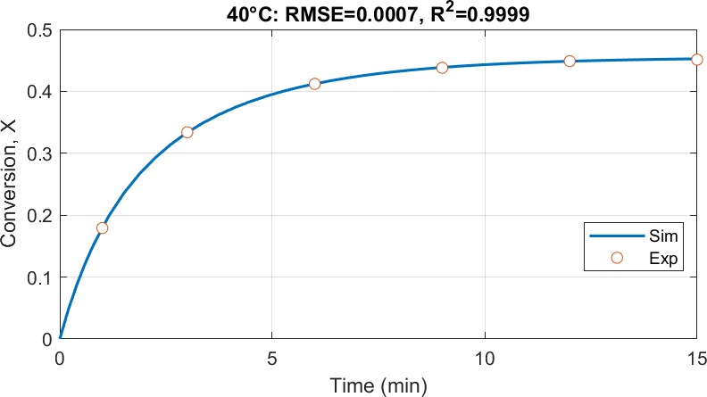
Fig. 4. Conversion vs time at 40 °C

Source: Authors’ own data

The trend depicted in Fig. 5 shows that at 50 °C, the reaction accelerates markedly, achieving 0.380 conversion by 3 min and plateauing near 0.455 by 15 min. The RMSE increases slightly to 0.0013, with the maximum error of 0.59 % occurring at t = 3 min. This elevated early-time deviation may reflect transient heat-transfer effects as the reactor warms rapidly, but the R² of 0.9997 confirms that the overall kinetic form remains valid.
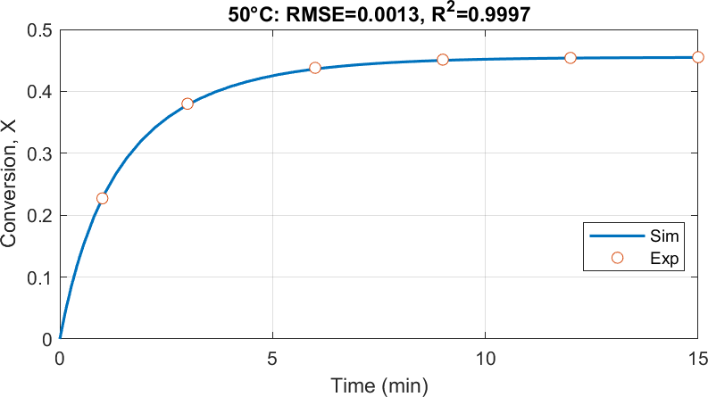

Fig. 5. Conversion vs time at 50 °C

Source: Authors’ own data

The graphical representation in Fig. 6 at 60 °C highlights that conversion reaches 0.409 in 3 min and
0.456 by 15 min. The RMSE of 0.0012 and R² of 0.9996 indicate excellent agreement, with a maximum error of 0.56% at time, t = 3 min. The slightly larger residuals at early times again point to rapid heating transients, yet the fit confirms that even under the fastest kinetics, the model reliably predicts conversion within industrial-acceptable error bounds (< 1%).
Model-accuracy guidelines recommend keeping errors below 2% for detailed models and below 5% for broader applications (Leveneur 2023; Álvarez et al. 2021). Even small experimental uncertainties can otherwise amplify during parameter estimation (Alberton et al. 2009). In this study, RMSE values of 0.0007
−0.0013, R² > 0.9997 and error percentage below 1% fall comfortably within those limits, demonstrating high reliability. This aligns with the widely accepted benchmark that a model is considered credible when R² approaches 1 and error metrics such as mean squared error (MSE), root mean square error (RMSE), mean absolute percentage error (MAPE), and mean absolute error (MAE) approach zero (Temizel & Soylu 2025).

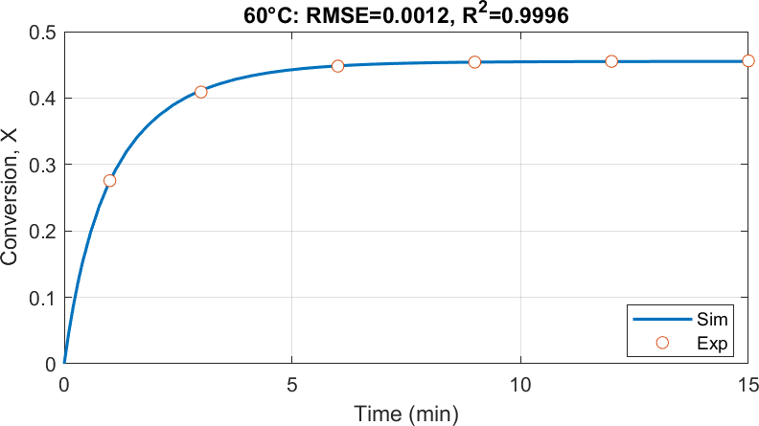

Fig. 6. Conversion vs time at 60 °C

Source: Authors’ own data

Determination of the most influential kinetic parameter
A straightforward sensitivity analysis based on final conversions at 30, 40, 50, and 60 °C in Table 1 shows that raising the temperature from 30 to 40 °C delivers the largest gain in conversion, which is ΔX = 0.0072, corresponding to the highest sensitivity per degree Celsius. Above 40 °C, the incremental benefit of heating falls off sharply, where sensitivity drops to 0.00040 per degree Celsius for the 40 °C to 50 °C step and to just 0.00008 per degree Celsius from 50 to 60 °C. Similar behaviour is seen in the study of ethyl acetate saponification (Mukhtar et al., 2017) and in reactor modelling efforts (Wijayarathne & Wasalathilake, 2014), which report that while reaction rates increase strongly with temperature at lower ranges, the incremental gains per degree reduce as temperature rises, likely due to diffusion, heat transfer or equilibrium-type limitations.
Table 1 Sensitivity analysis based on final conversion at different temperatures

Temperature (°C) | Final Conversion (X) | ΔX (Change in Conversion) | ΔT  (°C) | Sensitivity  (ΔX/ΔT)
30 | 0.4440 | – | – | –
40 | 0.4512 | 0.0072 | 10 | 0.00072
50 | 0.4552 | 0.0040 | 10 | 0.00040
60 | 0.4560 | 0.0008 | 10 | 0.00008
Source: Authors’ own data

In practical terms, this means that temperature is indeed the dominant kinetic control parameter, but its impact is most pronounced in the lower-temperature window. Beyond about 40 °C, the reaction is approaching its kinetic limit and potentially equilibrium, so further heating yields diminishing returns in conversion. Similar findings have been reported in the literature, where Mukhtar et al. (2017) showed that

while the rate constant for saponification increases with temperature up to 70 °C, the conversion curves tend to flatten at higher temperatures, reflecting reduced incremental gains. A related study by Shafiq et al. (2015) also observed that above ~30 to 35 °C, further temperature increases produced only minor improvements in conversion despite higher rate constants. Likewise, Mesfer (2018) found that conversion rises sharply between 20 to 40 °C, but additional heating beyond this range resulted in progressively smaller benefits. Together, these findings support the conclusion that the reaction exhibits diminishing temperature sensitivity beyond approximately 40 °C. Thus, for both laboratory enhancement and industrial scale-up, efforts to maximise yield should focus on precise control within the 30 to 40 °C range, where each degree of heating delivers the greatest boost while avoiding unnecessary energy expenditure at higher temperatures.

CONCLUSION

In conclusion, this study demonstrates that a kinetic modeling approach, supported by sensitivity analysis, can reliably capture the behavior of the saponification of ethyl acetate in a CSTR and translate laboratory observations into a predictive framework for process design. The identification of temperature as the dominant factor highlights the critical importance of thermal control in optimizing reactor performance and minimizing variability. The developed model, grounded in Arrhenius kinetics, provides a practical foundation for “what-if” process evaluations, scale-up, and waste minimization strategies. Beyond its specific application, the methodology illustrates how experimentally validated kinetic modeling can bridge the gap between bench-scale experimentation and industrial implementation. Future extensions of this approach to broader temperature ranges and variable operating conditions will further strengthen its applicability to real-world reactor systems.

ACKNOWLEDGEMENTS/FUNDING

The study was supported by the Faculty of Chemical Engineering, Universiti Teknologi MARA, Shah Alam, Selangor, Malaysia.

CONFLICT OF INTEREST STATEMENT

The authors declare that there are no financial, professional, or personal interests that could be construed as influencing the content, results, or interpretations presented in this research.

AUTHORS’ CONTRIBUTIONS
Nur Hannani Mohamad Azehar: Conceptualisation, methodology, formal analysis, investigation and writing-original draft and editing; Sherif Abdulbari Ali: Conceptualisation, supervision, writing- review and editing, and validation.

REFERENCES

Alberton, A. L., Schwaab, M., Schmal, M., & Pinto, J. C. (2009). Experimental errors in kinetic tests and its influence on the precision of estimated parameters: Part I-Analysis of first-order reactions. Chemical Engineering Journal, 155(3), 816–823. https://doi.org/10.1016/j.cej.2009.08.012
Álvarez, C., Espinel, E., & Noriega, C. J. (2021). Study of different alternatives for dynamic simulation of a steam generator using MATLAB. Fluids, 6(5), 175. https://doi.org/10.3390/fluids6050175
Berton, M., de Souza, J. M., Abdiaj, I., McQuade, D. T., & Snead, D. R. (2020). Scaling continuous API synthesis from milligram to kilogram: extending the enabling benefits of micro to the plant. International Journal of Flow Chemistry, 10(1), 73–92. https://doi.org/10.1007/s41981-019-00060-x
Borovinskaya, E., Khaydarov, V., Strehle, N., Musaev, A., & Reschetilowski, W. (2019). Experimental studies of ethyl acetate saponification using different reactor systems: The effect of volume flow rate on reactor performance and pressure drop. Applied Sciences, 9(3), 532. https://doi.org/10.3390/app9030532
Cherkasov, N., Adams, S. J., Bainbridge, E. G. A., & Thornton, J. A. M. (2022). Continuous stirred tank reactors in fine chemical synthesis for efficient mixing, solids-handling, and rapid scale-up. International Reaction Chemistry and Engineering, 8(2), 266–277. https://doi.org/10.1039/d2re00232a
Danish, M., Khaloofah, M., Mesfer, A., Rashid, M., & Al Mesfer, M. K. (2015). Effect of operating conditions on CSTR performance: An experimental study. International Journal of Engineering Research and Applications, 5(2), 74–78.
Das, K., Sahoo, P., Sai Baba, M., Murali, N., & Swaminathan, P. (2011). Kinetic studies on saponification of ethyl acetate using an innovative conductivity-monitoring instrument with a pulsating sensor. International Journal of Chemical Kinetics, 43(11), 648–656. https://doi.org/10.1002/kin.20597
Florez-Orrego, D., Sharma, S., & Navabi, S. (2022). Editorial: Integration and optimization in the chemical process industry. Frontiers in Chemical Engineering, 4, 961022. https://doi.org/10.3389/fceng.2022.961022.
Harmon Ray, W. & Villa, C. (2000). Nonlinear dynamics found in polymerization processes — A review. Chemical Engineering Science, 55(2), 275–290. https://doi.org/10.1016/s0009-2509(99)00323-1.
He, Z. (2023). Optimization of chemical environmental protection and energy sustainable development. Applied and Computational Engineering, 3(1), 211–215. https://doi.org/10.54254/2755-2721/3/20230414
Hu, C. (2021). Reactor design and selection for effective continuous manufacturing of pharmaceuticals. Journal of Flow Chemistry, 11, 242–262. https://doi.org/10.1007/s41981-021-00164-3
Ihsanullah, I., Ahmad, M. I., Ullah, I., Ahmad, M. I., & Younas, M. (2015). Optimization of saponification reaction in a continuous stirred tank reactor (CSTR) using design of experiments. Pakistan Journal of Engineering and Applied Sciences, 16. https://www.researchgate.net/publication/274635862
Leveneur, S. (2023). Kinetic modelling: Regression and validation stages, a compulsory tandem for kinetic model assessment. Canadian Journal of Chemical Engineering, 101(12), 7078–7101. https://doi.org/10.1002/cjce.24956
Levenspiel, O. (1999). Chemical Reaction Engineering (3rd ed.). Wiley India.
Mesfer, M. K. A. (2018). Experimental study of batch reactor performance for ethyl acetate saponification. International Journal of Chemical Reactor Engineering, 16(1), 20160174. https://doi.org/10.1515/ijcre-2016-0174

Mukhtar, A., Shafiq, U., Qazi, M. O., Qadir, H. A., Qizilbash, M., & Awan, B. A. (2017). Kinetics of alkaline hydrolysis of ethyl acetate by conductometric measurement approach over temperature ranges (298.15–343.15 K). Austin Chemical Engineering, 4(1), 1046.
Muktar, A., Shafiq, U., Khan, A., Qizilbash, M., & Abdul Qadir, H. (2015). Estimation of parameters of Arrhenius equation for ethyl acetate saponification reaction. Research Journal of Chemical Sciences, 5(11), 46–50.
Nauman, E. B. (2008). Chemical reactor design, optimization, and scaleup (First edition). Wiley & Sons, Inc.
Petek, A., & Krajnc, M. (2012). The enthalpy and entropy of activation for ethyl acetate saponification. International Journal of Chemical Kinetics, 44(10), 692–698. https://doi.org/10.1002/kin.20712
Scott, K. (1991). The continuous stirred tank electrochemical reactor. An overview of dynamic and steady state analysis for design and modelling. Journal of Applied Electrochemistry, 21(11), 945–960. https://doi.org/10.1007/BF01077579
Sultan, F., Lodhi, M. W., Fatima, R., Ishaq, M. S., & Chambashi, G. (2024). Computing the solution trajectories, steady state approximation, and sensitivity analysis in complex chemical reaction mechanism. AIP Advances, 14(4). 045027. https://doi.org/10.1063/5.0203877
Sysoev, A. (2023). Sensitivity analysis of mathematical models. Computation (Basel), 11(8), 159. https://doi.org/10.3390/computation11080159.
Temizel, B., & Soylu, E. N. (2025). Modeling of diatom indices (Bdı, Tdı and Gdı) based on the physico-chemical structure of the river ecosystem with machine learning and artificial intelligence methods; A comparative example. Environment, Development and Sustainability, 1–29. https://doi.org/10.1007/s10668-025-06186-4
Wang, Z., Zhang, Y., & Li, D. (2020). Temperature Optimization Control of CSTR. 2020 IEEE International Conference on Information Technology, Big Data and Artificial Intelligence (ICIBA), 1, 1040–1043. https://doi.org/10.1109/ICIBA50161.2020.9276793
Wijayarathne, U., & Wasalathilake, K. (2014). Aspen Plus simulation of saponification of ethyl acetate in the presence of sodium hydroxide in a plug flow reactor. Journal of Chemical Engineering & Process Technology, 5(6), 205. http://dx.doi.org/10.4172/2157-7048.1000205


© 2025 by the authors. Submitted for possible open access publication under the terms and conditions of the Creative Commons Attribution (CC BY) license (http://creativecommons.org/licenses/by/4.0/).

SUPPLYMENTARY MATERIALS

- Data conversion comparison and model validation metrics:

  - Model validation metrics for CSTR Saponification kinetic model at different temperatures

Temperature (°C) | RMSE | R² | Error Range (%) | Max Error (%)
30 | 0.0012 | 0.9998 | 0.05–0.53 | 0.53
40 | 0.0007 | 0.9999 | 0.03–0.29 | 0.29
50 | 0.0013 | 0.9997 | 0.06–0.59 | 0.59
60 | 0.0012 | 0.9996 | 0.0002–0.56 | 0.56
  - Experimental and Simulated Conversion at 30 °C

Time (min) | Conversion Experimental (X) | Conversion Simulated (X) | Error (%)
1 | 0.1360 | 0.1358 | 0.1475
3 | 0.2800 | 0.2803 | 0.1022
6 | 0.3760 | 0.3740 | 0.5376
9 | 0.4140 | 0.4146 | 0.1514
12 | 0.4340 | 0.4342 | 0.0512
15 | 0.4420 | 0.4442 | 0.4864
  - Experimental and Simulated Conversion at 40 °C

Time (min) | Conversion Experimental (X) | Conversion Simulated (X) | Error (%)
1 | 0.1792 | 0.1789 | 0.1675
3 | 0.3340 | 0.3335 | 0.1463
6 | 0.4120 | 0.4122 | 0.0373
9 | 0.4380 | 0.4387 | 0.1537
12 | 0.4488 | 0.4486 | 0.0382
15 | 0.4512 | 0.4525 | 0.2915
  - Experimental and Simulated Conversion at 50 °C

Time (min) | Conversion Experimental (X) | Conversion Simulated (X) | Error (%)
1 | 0.2272 | 0.2268 | 0.1868
3 | 0.3800 | 0.3778 | 0.5914
6 | 0.4380 | 0.4360 | 0.4470
9 | 0.4512 | 0.4500 | 0.2578
12 | 0.4540 | 0.4537 | 0.0621
15 | 0.4552 | 0.4547 | 0.1077
  - Experimental and Simulated Conversion at 60 °C

Time (min) | Conversion Experimental (X) | Conversion Simulated (X) | Error (%)
1 | 0.2756 | 0.2744 | 0.4476
3 | 0.4090 | 0.4113 | 0.5634
6 | 0.4480 | 0.4484 | 0.0888
9 | 0.4540 | 0.4540 | 0.0003
12 | 0.4552 | 0.4549 | 0.0653
15 | 0.4560 | 0.4550 | 0.2085

