**Campus Connect**

**A Minor Project Synopsis Submitted to**



**Rajiv Gandhi Proudyogiki Vishwavidyalaya, Bhopal**

**Towards Partial Fulfillment for the Award of**

**Bachelor of Technology**

**(Computer Science and Engineering)**

**Submitted By**

**Mahi Patel(0827CS211140)**

**Mann Gupta(0827CS211144)**

**Piyush Mallick(0827CS211173)**

**Under the Supervision of**

**Prof. Sushma Khatri**



**Department of Computer Science and Engineering**

**Acropolis Institute of Technology & Research, Indore**

**July-Dec 2023**

# Introduction of the Project

The driving force behind this project is to address common challenges and concerns associated with our current bus services. These challenges include unpredictability in bus arrival times and lack of real-time information for passengers. By implementing the Campus Connect App, we aim to offer precise, up-to-the-minute information on bus locations, routes, and schedules, thereby making travelling more efficient, convenient, and safe for our community members.

Campus Connect is a simple technological solution designed to enhance the transportation experience for students, faculty, and staff at the Acropolis Institute of Technology and Research. This innovative system provides real-time information about the institute's bus services, ensuring greater convenience and efficiency for all users.

# Objective

The specific objectives of the Campus Connect are as follows:

* + 1. To Implement a real-time bus tracking system to provide accurate and up-to-the-minute information on the location and status of institute buses, ensuring passengers can plan their journeys efficiently.
    2. To Develop a user-friendly mobile app that offers detailed route information, including bus stops, schedules, and routes, to enhance convenience and reduce confusion among users.
    3. To Create a notification system within the app to keep users informed about bus arrivals, delays, or route changes, improving transparency and reliability.
    4. To Establish a user-friendly interface and feedback mechanism that allows passengers to report issues, provide feedback, and suggest improvements, enabling continuous enhancements to the transportation service.

# Scope

The Campus Connect project, designed initially for educational institutions, holds potential for broader applications. Its Real-Time Bus Tracking system, user-friendly app, and Notification System could benefit urban transit, corporate campuses, hospital complexes, theme parks, events, residential communities, tourism hubs, and corporate shuttles. This adaptable technology promises to revolutionize transportation, providing precise information and enhancing user experience in diverse settings beyond campus environments.

**Boundaries and Limitations:**

* + 1. **Network Connectivity:** The app's real-time tracking and notification features depend on network connectivity. Users may experience limitations in areas with poor or no network coverage.
    2. **Accuracy of Information:** Real-time tracking accuracy may be influenced by GPS and network signal quality. Minor discrepancies in bus locations can occur.
    3. **Privacy:** Privacy concerns related to location tracking will be addressed, with user consent and data protection measures in place.
    4. **Infrastructure:** The project assumes the availability of the required technological infrastructure, including GPS-equipped buses and network connectivity.
    5. **Budget Constraints:** The project's scope may be constrained by budget limitations, potentially impacting the pace of implementation and feature development.
    6. **User Adoption:** The success of the project relies on user adoption and engagement. Encouraging all stakeholders to use the app effectively may be a challenge.

# Study of Existing System

Existing System/Application **1: Chalo App**

Chalo is a free app that allows you to live track your bus and tells you at what time your bus will reach your stop. This app is generally used by municipalities of cities (cities like Mumbai, Indore etc.) to provide bus tracking features for public transportation.

* **Advantages: -**

1. This app is easy to use, tracks buses in real time, provides cashless payment options and provides features like Chalo Card that regular travelers could use.
2. This app also provides a feature that gives the estimated fare to reach a certain destination and has multi-modal integration i.e., allows users to plan journeys that involve multiple modes of transportation.
3. This app also gives information about the occupancy of the bus.

* **Disadvantages: -**

1. Limited Coverage: - The app's effectiveness may be limited in regions where public transportation infrastructure is not well-developed.
2. Data Accuracy: - The accuracy of real-time information is contingent on the data provided by transportation authorities, which may not always be up-to-date or accurate.
3. Integration Issues: - This leads to inconsistencies in information.

* **Gaps Identified: -**

1. Accessibility Features: Enhancements in accessibility features for users with disabilities, such as voice commands, screen reader compatibility, and options for larger text or high-contrast interfaces.
2. Community Engagement: Creating mechanisms for users to provide feedback, report issues, and suggest improvements directly within the app can help in continuously refining the service.
3. Emergency Response Integration: Integrating features that allow users to quickly contact emergency services or share their location with trusted contacts in case of an emergency.

* Reference links: -

<https://chalo.com/>

<https://play.google.com/store/apps/details?id=app.zophop&hl=en_IN&gl=US&pli=1>

<https://www.reddit.com/r/mumbai/comments/w2jkrv/chalo_app_feedback/>

<https://www.quora.com/How-is-the-Chalo-app-able-to-track-the-crowd-in-the-bus-More-precisely-Im-asking-about-software-or-which-method>

Existing System/Application 2: **Track Your Truck**

Track Your Truck provides real-time tracking and visibility of a company's vehicles, which helps in reducing unauthorized vehicle usage, ensuring drivers follow designated routes, and enhancing overall operational efficiency.

* **Advantages: -**

1. Real-time Tracking: Provides accurate and up-to-date information on the location of vehicles, enabling companies to make informed decisions in real-time.
2. Increased Efficiency: Optimizes routes and schedules, leading to reduced fuel consumption, maintenance costs, and improved overall operational efficiency.
3. Improved Customer Service: Allows businesses to provide accurate and reliable ETAs to customers, enhancing customer satisfaction.
4. Enhanced Security: Helps in vehicle recovery in case of theft and provides added security for both vehicles and drivers. And Compliance and reporting on driver’s behavior.

* **Disadvantages: -**

1. Cost: Implementing and maintaining a GPS tracking system can involve upfront costs for hardware, software, and ongoing subscription fees.
2. Privacy Concerns: Some employees may be concerned about the tracking of their movements, which can raise privacy issues that need to be addressed.
3. Integration Challenges: Depending on the existing systems and infrastructure of a company, integrating a tracking system may require some adjustments.

* **Gaps Identified: -**

1. Integration with other Systems: Depending on the specific needs of a company, there may be a need for seamless integration with existing software and systems, which might require customization.
2. Advanced Analytics: While basic reporting is typically provided, some companies may require more advanced analytics for in-depth insights.

* **Reference link: -**

[www.trackyourtruck.com/fleet-tracking-systems/bus-tracking/](http://www.trackyourtruck.com/fleet-tracking-systems/bus-tracking/)

Existing System/Application 3: **LocoNav**

Loconav is an Indian-based fleet management and vehicle tracking solution provider. Loconav addresses the issue of vehicle tracking and security for businesses and individuals. It allows users to monitor the real-time location of their vehicles, which is crucial for logistics and transportation companies. It provides features like fuel monitoring and optimization, Driver behavior Monitoring, and route optimization.

* **Advantages: -**

1. Real-time Tracking: Provides real-time tracking of vehicles, enabling businesses to monitor the movement of their fleet.
2. Cost Efficiency: Helps in reducing operational costs through features like fuel monitoring and route optimization.
3. Improved Security: Enhances the security of vehicles by providing anti-theft features and real-time alerts.
4. Driver Behavior Improvement: Allows businesses to monitor and improve driver behavior, leading to safer and more efficient operations.

* **Disadvantages: -**

1. Cost: The initial investment for the hardware and software may be a significant expense for smaller businesses.
2. Dependence on Technology: Relies on GPS and other technologies, so disruptions in connectivity or technical issues can affect its effectiveness.
3. Training Required: Users may need some training to fully utilize all the features and capabilities of the platform.

* **Gaps Identified: -**

1. Limited Integration: Depending on the specific requirements of a business, there might be a need for more seamless integration with other software or systems.
2. Support for Diverse Vehicle Types: To cater to a broader range of businesses, Loconav may need to offer support for various vehicle types beyond just trucks and commercial vehicles, such as passenger cars or specialized equipment.
3. Driver Engagement: Implementing features that actively engage and motivate drivers to adhere to safety guidelines and best practices, such as gamification elements, could be considered.

* **Reference link: -**

<https://loconav.com/bus-tracking-system>

Existing System/Application 4: **WLIUS School Bus Tracking**

A complete solution for schools to streamline student and school bus tracking, prioritize student safety, accountability, and communication by combining real-time GPS tracking, RFID Tags to identify and account for student ridership, and the ParentLink App to share live ETA’s and alerts with parents.

* **Advantages: -**

1. Enhanced Safety: Parents and school administrators can monitor the bus location in real-time, ensuring the safety of the students.
2. Improved Communication: Parents receive timely updates about the bus's location, reducing anxiety and uncertainty.
3. Efficient Route Planning: The system can help optimize bus routes, leading to reduced travel time and fuel costs.
4. Attendance Management: It aids in accurate attendance records, ensuring that no student is left behind or unaccounted for.
5. Emergency Response: In case of any emergencies or accidents, the system provides instant information about the bus's location.

* **Disadvantages: -**

1. Cost: Implementing and maintaining a tracking system can be expensive, especially for smaller schools or districts with limited budgets.
2. Privacy Concerns: Some parents or students may have concerns about their location being tracked, raising privacy issues.
3. Technical Glitches: The system relies on technology, and technical glitches or failures may occur, leading to inaccurate tracking information.
4. Dependence on Internet Connectivity: The effectiveness of the tracking system is contingent on a stable internet connection, which may not always be available in certain areas.

* **Gaps Identified: -**

1. Integration with School Calendar: Syncing the tracking system with the school calendar to account for holidays, early dismissals, and other special events.
2. Emergency Response Integration: Linking the tracking system with local emergency services for quick response in case of accidents or medical emergencies.
3. Geo-fencing: Setting up virtual boundaries to alert school administrators and parents if the bus deviates from its designated route.

* **Reference link:-**

[https://wlius.com/applications/school-bus-tracking**/**](https://wlius.com/applications/school-bus-tracking/)

Existing System/Application 5: **Track School Bus**

TrackSchoolBus is a complete solution for ensuring school transportation safety and better fleet management. This feature-rich school bus tracking system helps school authorities, parents, transport managers, etc., which ensures student safety inside and outside the school bus.

* **Advantages: -**

1. Real-Time Tracking: Provides live updates on the location of the school bus.
2. Safety Assurance: Enhances the safety of students by allowing parents and schools to monitor their movements.
3. Efficient Routing: Helps in optimizing routes, reducing fuel costs, and minimizing travel time.
4. Attendance Monitoring: Allows for accurate attendance records and helps in case of emergencies.
5. Communication Tools: Enables communication between parents, drivers, and schools for any issues or updates.

* **Disadvantages: -**

1. Cost: Implementing such a system may require an initial investment in hardware and software.
2. Privacy Concerns: Some individuals may have concerns about the level of monitoring and data collection involved.
3. Technical Issues: Like any technological solution, there may be occasional technical glitches or outages.

* **Gaps Identified: -**

1. Coverage Limitations: Depending on the technology used, there may be areas with limited or no tracking coverage.
2. User Training: Ensuring that all relevant parties (parents, school staff, bus drivers) are proficient in using the system may be a challenge.
3. Integration with Existing Systems: Compatibility with existing school management systems or databases may require attention.

* **Reference link: -**

<https://www.trackschoolbus.com/features/>

**Comparison Between Existing System:**

# Project Description

Campus Connect is an exciting initiative aimed at revolutionizing transportation within our campus community. The project focuses on several key objectives to ensure a seamless and convenient experience for all passengers. One of the major enhancements is the introduction of a Real-Time Bus Tracking system, providing precise and up-to-date information on the whereabouts of institute buses. This feature empowers passengers to plan their journeys efficiently. Additionally, a user-friendly mobile application will be developed, offering comprehensive route information, including schedules, stops, and routes. This will eliminate confusion and provide maximum convenience for users. To further enhance reliability, a robust Notification System will be integrated within the app, delivering timely updates on bus arrivals, delays, or route changes. Moreover, the app will be designed for cross-platform compatibility, ensuring accessibility on both iOS and Android devices. Its user-friendly interface will cater to a diverse user base with varying levels of technical expertise. To foster continuous improvement, a feedback mechanism will be established, allowing passengers to report issues, offer suggestions, and provide valuable feedback. Campus Connect aims to create a transportation system that meets the diverse needs of our campus community, making travel on campus a seamless and user-centric experience.

# Methodology/Planning of the Project work

**Planning:**

**a. Project Goal:** Develop a comprehensive transportation solution for the campus community, featuring real-time bus tracking, a user-friendly mobile application, and a robust notification system.

**b. Stakeholder Identification:**

* Passengers
* Bus Operators
* Administrators
* Developers

**c. User Stories and Features:**

* + User registration and login
  + View live bus locations
  + Set bus arrival alerts
  + Access comprehensive route information
  + Receive timely updates on bus arrivals, delays, and route changes
  + Provide feedback and suggestions
  + Admin dashboard for system management

**d. Release Planning:**

* + Sprint 1 (2 weeks):
* User authentication and registration
* Admin dashboard layout design
  + Sprint 2 (2 weeks):
* Live bus tracking feature
* User feedback module
  + Sprint 3 (2 weeks):
* Bus arrival alerts
* Mobile application UI/UX design
  + Sprint 4 (2 weeks):
* Route information integration
* Cross-platform compatibility testing
  + Sprint 5 (2 weeks):
* Notification system implementation
* Final testing and bug fixes
  + Sprint 6 (2 weeks):
* Deployment and launch
* Marketing and user onboarding

**Methodology (Agile):**

**a. Product Backlog Creation:**

* Gather and prioritize user stories based on stakeholder input.

**b. Sprint Planning:**

* Select user stories for the upcoming sprint based on priority and feasibility.

**c. Sprint Execution:**

* Daily stand-up meetings to discuss progress, challenges, and plan the day's tasks.
* Develop, test, and integrate selected features.

**d. Sprint Review:**

* Demo completed features to stakeholders for feedback and validation.

**e. Sprint Retrospective:**

* Evaluate the sprint, identify what went well and areas for improvement.

**f. Incremental Development:**

* Continuously integrate new features into the existing system.

**g. Continuous Testing:**

* Conduct unit testing, integration testing, and user acceptance testing (UAT) in each sprint.

**h. Feedback Integration:**

* Incorporate stakeholder feedback into subsequent sprints.

**i. Deployment and Monitoring:**

* Deploy the system on a staging environment for final testing.
* Monitor the live system for any issues or performance concerns.

**j. Marketing and User Onboarding:**

* Promote the mobile application to the campus community.
* Provide training and resources for users to maximize the benefits of the system.

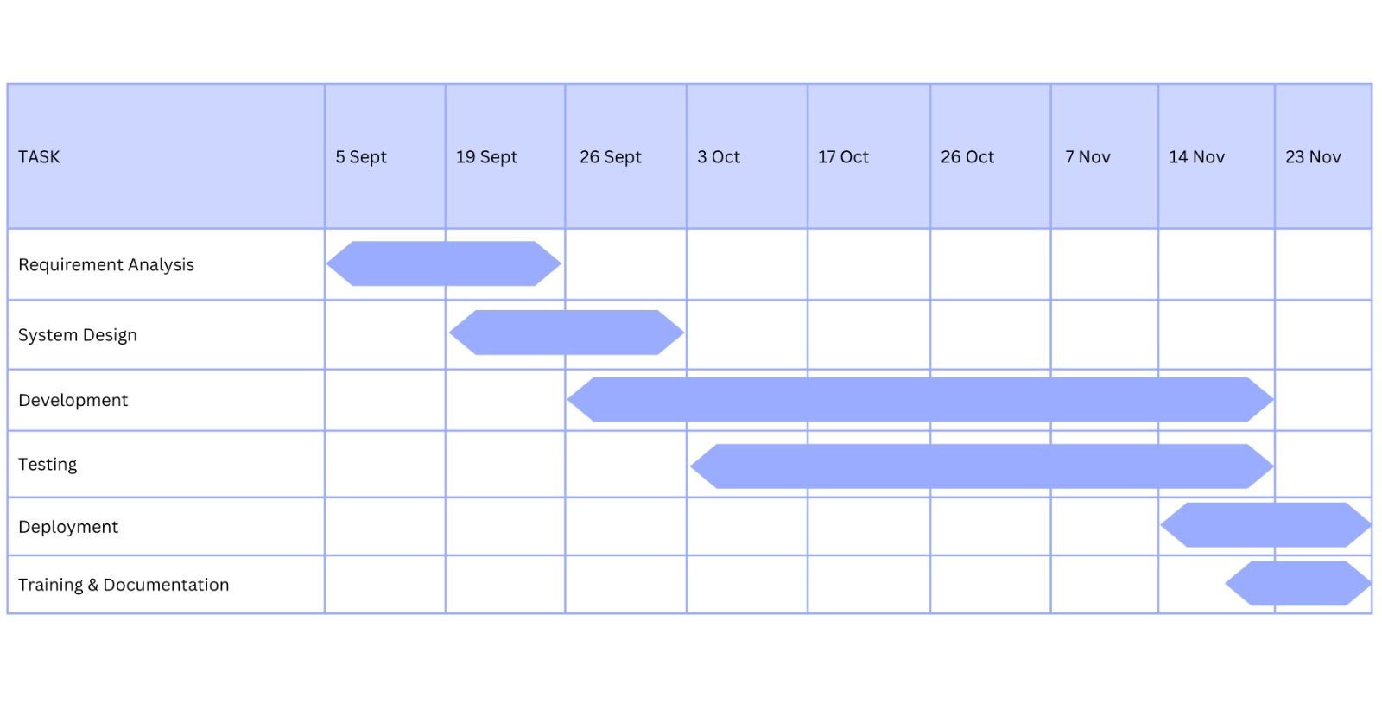

Fig 2: Gantt Chart

# Features

The main features and functionalities of the Campus Connect project include:

* **User Authentication and Registration:** User login and registration functionality for secure access to the app.
* **Admin Dashboard Layout Design:** Design an intuitive admin dashboard for managing user accounts, bus tracking, and feedback.
* **Live Bus Tracking Feature:** Real-time GPS-based bus tracking for users to view buses on a map.
* **User Feedback Module:** A module for users to submit feedback, report issues, and offer suggestions.
* **Bus Arrival Alerts:** Alert system for notifying users about upcoming bus arrivals.
* **Mobile Application UI/UX Design:** Intuitive and user-friendly interface design for a seamless experience.
* **Route Information Integration:** Integration of comprehensive route information including schedules, stops, and maps.
* **Cross-Platform Compatibility Testing:** Testing to ensure the app works smoothly on both iOS and Android devices.
* **Notification System Implementation:** Implement notifications for bus arrivals, delays, and route changes.
* **Final Testing and Bug Fixes:** Thorough testing and resolution of any remaining bugs or issues.
* **Deployment and Launch:** Prepare the application for deployment on app stores (Google Play Store and Apple App Store).
* **Marketing and User Onboarding:** Develop a marketing strategy to promote the app and provide resources for user onboarding.

**Overall, users will be able to:**

* Track buses in real-time to plan their journeys efficiently.
* Access comprehensive route information, including schedules, stops, and routes.
* Receive timely updates on bus arrivals, delays, or route changes.
* Use the application on both iOS and Android devices for maximum accessibility.
* Navigate the app with ease due to its user-friendly interface.
* Provide feedback to help improve the system and address any issues or suggestions.

# System architecture

Designing a bus tracking system involves several components working together. Here’s a basic system architecture for a bus tracking system with Bus GPS client, mobile app, server, database, and admin panel:

**a. GPS Client (Bus):**

* Each bus is equipped with a GPS device that periodically sends its location data to the server. This device could be a GPS receiver with a cellular or other wireless communication module.

**b. Mobile App:**

* + The mobile app is used by passengers to track the buses in real-time. It can be developed for iOS and Android platforms.
  + The mobile app communicates with the server to retrieve bus locations and display them on a map interface.

**c. Server:**

* The server is the core component that manages the communication between the GPS clients, mobile app, and the database.
* It handles requests from the mobile app for bus locations and updates the database with new data from the GPS clients.
* It should also handle authentication, authorization, and encryption for secure communication.

**d. Database:**

* The database stores various types of data such as bus locations, routes, user information, and historical data.
* It can be a relational database (e.g., MySQL, PostgreSQL) or a NoSQL database (e.g., MongoDB) depending on the specific requirements of the application.

**e. Admin Panel:**

* + - The admin panel provides an interface for administrators to manage the system. This can include features like:
    - User management (adding/removing users, assigning roles)
    - Bus management (adding new buses, updating bus information)
    - Route management (defining and modifying routes)
    - Accessing reports and analytics.

**f. Communication Protocols:**

* Communication between different components can be facilitated using HTTP/HTTPS for web-based communication, or other protocols like MQTT, WebSocket, or custom protocols depending on specific requirements.

**g. APIs:**

* The server exposes APIs that allow the GPS clients and mobile app to send and receive data. This includes APIs for:
* Registering buses and mobile devices
* Retrieving bus locations
* Updating bus information
* Authenticating users

**h. Security:**

* Implement security measures like HTTPS for secure communication, encryption for sensitive data, and proper authentication and authorization mechanisms to protect the system from unauthorized access.

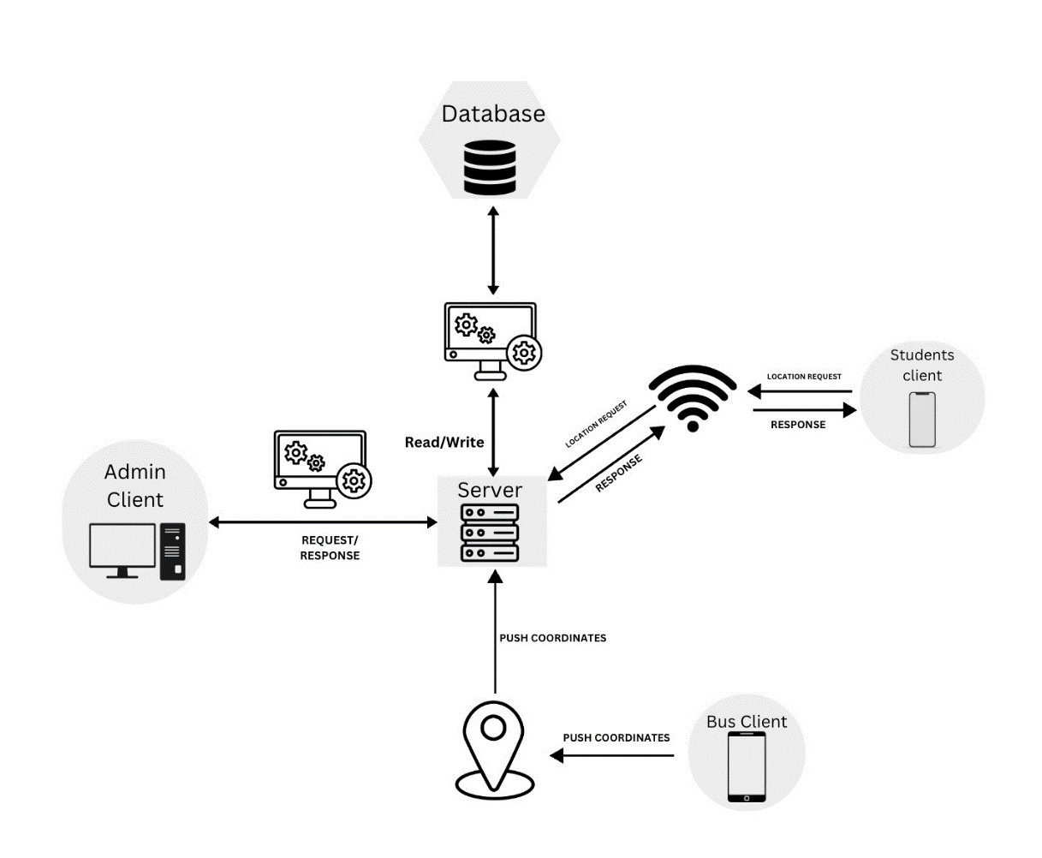

Fig 3: Components of System Architecture and their interaction

# User Interface (UI)

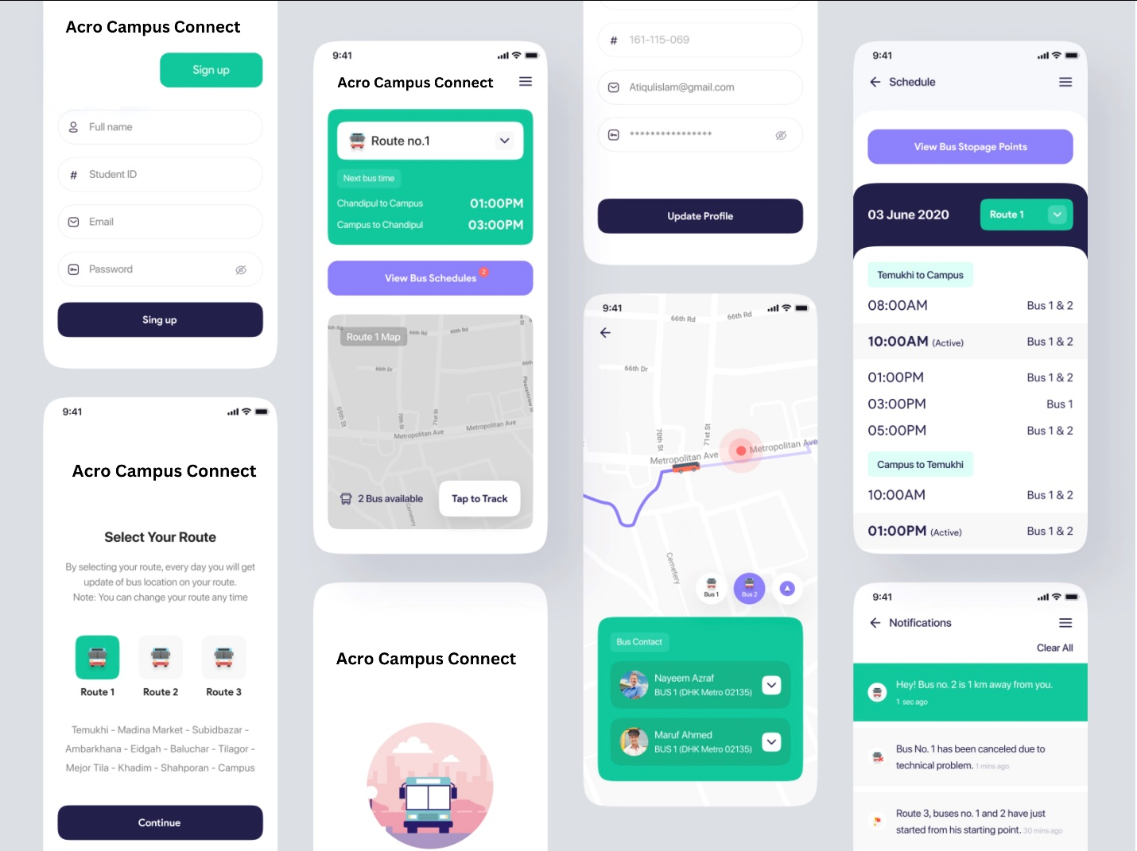

1. **Login Page:** The Login Page provides a secure entry point for registered users to access the application. Users will authenticate using their credentials.
2. **Registration Page:** The Registration Page allows new users to create an account by providing necessary information. This step ensures access to the app's features.
3. **Dashboard (User):** The User Dashboard serves as the central hub for passengers. Here, they can view live bus locations, submit feedback, and set notification preferences.
4. **Dashboard (Admin):** The Admin Dashboard is a specialized interface for administrators. It grants access to manage user accounts, monitor bus locations, and review user feedback.
5. **Live Bus Tracking Map:** This page displays the real-time locations of institute buses on a map. Users can visually track the buses in motion.
6. **Feedback Submission Form:** The Feedback Submission Form enables users to report issues, offer suggestions, and provide valuable feedback about their experiences.
7. **Bus Arrival Alerts Settings:** In this section, users can customize their notification preferences for receiving alerts about bus arrivals, delays, or route changes.
8. **Route Information Page:** This page provides comprehensive information about bus routes, including schedules, stops, and maps for user convenience.
9. **Notification Center:** The Notification Center aggregates all relevant alerts and updates for easy reference, ensuring passengers stay informed in real-time.
10. **Settings and Account Management:** Users can manage their account settings, including profile information, password changes, and notification preferences in this section.
11. **Marketing and Onboarding Pages:** These pages are dedicated to guiding users through the onboarding process, providing resources, and promoting the benefits of the Campus Connect app.
12. **Error and Feedback Handling Pages:** These pages address scenarios like incorrect login credentials, network errors, or successful feedback submissions, ensuring a smooth user experience.

# Technology Stack

**Languages:**

* + Dart: It is a language used in Flutter to develop Mobile Application.
  + JavaScript: It is a programming language used for NodeJS for backend.

**Tools:**

* Project IDX: A digital toolbox browser-based development IDE with collaboration.
* Postman: It is a widely used tool for testing and interacting with APIs.
* AWS web servers: Hosting services provided by AWS for deploying and managing web applications and websites on the cloud.

**Frameworks**:

* + Flutter: Google’s open-source framework for building cross-platform mobile, web application with single codebase.

**Database**:

* + MySQL: It is a Relational DBMS that uses SQL for data management.

**Backend**:

* + Nodejs: It is a JavaScript runtime that allows server-side programming with non-blocking I/O model.

# Testing Plan

**Testing Plan:** Bus Tracking System

**a. Unit Testing:**

* + Objective: Validate individual units of code for correctness.
  + Components to Test:
* User authentication module
* Live bus tracking algorithm
* Notification system logic
* Route information integration

**b. Integration Testing:**

* + Objective: Ensure that different modules work together as expected.
  + Scenarios to Test:
  + User registration and login with live tracking feature
  + Mobile application integration with notification system
  + Route information integration with live bus tracking

**c. User Acceptance Testing (UAT):**

* + Objective: Validate if the system meets user expectations and requirements.
  + Test Cases:
  + Users can register and log in successfully.
  + Users can view live bus locations accurately.
  + Users receive timely notifications for bus arrivals, delays, and route changes.
  + Users can access comprehensive route information.

**d. Cross-Platform Compatibility Testing:**

* Objective: Ensure the mobile application functions correctly on both iOS and Android devices.
* Devices to Test:
  + iPhone models (various versions)
  + Android smartphones (various makes and models)

**e. Load and Performance Testing:**

* + Objective: Evaluate system performance under peak load conditions.
  + Scenarios to Test:
  + Simulate a large number of simultaneous user requests during peak usage times.
  + Measure response times and system stability.

**f. Security Testing:**

* + Objective: Identify and address potential security vulnerabilities.
  + Areas to Test:
  + Data encryption during transit and storage
  + Authorization and access control mechanisms
  + Secure handling of user credentials

**g. Feedback Mechanism Testing:**

* Objective: Ensure the feedback system functions smoothly for users to report issues, offer suggestions, and provide feedback.
* Test Cases:
* Users can submit feedback through the mobile application.
* Administrators receive and process feedback appropriately.

**h. Usability Testing:**

* + Objective: Evaluate the user-friendliness and intuitiveness of the mobile application.
  + Scenarios to Test:
* Users with varying levels of technical expertise can navigate and use the app effectively.

**i. Regression Testing:**

* + Objective: Verify that new updates or fixes do not introduce new bugs.
  + Cases to Re-Test:
  + Core functionalities like user authentication, live tracking, and notifications.

**j. Compatibility Testing (with Various Browsers and Devices):**

* + Objective: Ensure the web interface of the admin dashboard is compatible with different browsers and devices.

**k. Accessibility Testing:**

* + Objective: Evaluate the application's accessibility for users with disabilities.
  + Areas to Test:
  + Screen reader compatibility
  + Contrast and color schemes for visibility

**l. Documentation Verification:**

* + Objective: Ensure all project documentation is complete and accurate.

# Expected Outcome

**Campus Connect revolutionizes campus transportation:**

* **Real-Time Bus Tracking**: Provides precise bus locations for efficient travel planning.
* **User-Friendly App:** Offers easy route info, reducing confusion and empowering users.
* **Robust Notifications:** Timely updates on arrivals, delays, ensuring reliability.
* **Cross-Platform Access:** Compatible with iOS and Android for broad user reach.
* **Inclusive Interface:** Easy for all, regardless of technical expertise.
* **Feedback Loop**: Enables continuous improvement through user input.

**Benefits to Society:**

* **Eco-Friendly Impact:** Cuts emissions, fostering a sustainable campus environment.
* **Traffic Management**: Eases congestion, benefiting both campus and community.
* **Enhanced Accessibility:** Inclusivity for users of all technical levels.
* **Efficiency Gains:** Real-time updates save time, resources, and increase productivity.
* **Safety Assurance:** Prompt notifications minimize risks associated with transportation.

In summary, Campus Connect transforms campus travel, benefiting both the community and society.

# Resources and Limitations

To successfully design and develop the Campus Connect project, several key resources will be required:

**a. Hardware:**

* Servers and hosting infrastructure for the Real-Time Bus Tracking system and the Mobile Application.
* Mobile devices for testing the application on both iOS and Android platforms.
* Networking equipment to ensure a stable and reliable connection between bus and server.

**b. Software:**

* Development tools and integrated development environments (IDEs) for both iOS and Android platforms.
* Backend development frameworks for building the Real-Time Bus Tracking system and managing the data.
* Database management systems (DBMS) for storing and retrieving route information,
* Schedules, and uses data.
* Geospatial software for mapping and tracking bus locations.
* Notification system software for timely updates to users.

**c. Data:**

* Geographic data for accurately mapping campus routes, bus stops, and surrounding areas.
* Historical traffic and routing data for optimizing routes and schedules.
* User data (anonymized and securely managed) for feedback, usage patterns, and preferences.
* Real-time data feeds for traffic conditions and weather updates.

**d. Human Resources:**

* Software developers with expertise in mobile application development, backend
* Development and UI/UX designs.
* Data analysts for processing and interpreting user feedback and usage patterns.
* Project managers to oversee the development process and ensure timely delivery.
* Quality assurance testers to thoroughly test the application for bugs and usability issues.

**e. Financial Resources:**

* + Budget for hardware procurement, software licenses, development tools, and data Acquisition.
  + Salaries for developers, testers, and project managers.
  + Marketing and promotional expenses for app launch and user adoption.

**Limitations of the Project:**

1. **Dependence on Technology:** The success of the project relies heavily on the availability and reliability of technological components like GPS, mobile networks, and server infrastructure. Technical failures in any of these areas could disrupt the service.
2. **Privacy Concerns:** Collecting and managing user data requires strict adherence to privacy regulations. Ensuring the security of personal information is crucial to building and maintaining trust.
3. **Initial Investment:** The development and implementation of the Campus Connect system will require a significant initial investment in hardware, software, and human resources.
4. **Maintenance and Updates:** The system will need ongoing maintenance, updates, and support to keep it current and functional. This includes addressing compatibility issues with new device models or operating systems.
5. **User Adoption:** Encouraging users to adopt the app and consistently provide feedback may be a challenge. Clear communication and user education will be essential.
6. **Environmental Factors:** Weather conditions, especially in regions prone to extreme weather, could affect the accuracy of real-time tracking and bus schedules.
7. **Regulatory Compliance:** Adherence to local transportation and data privacy regulations will be critical to the success of the project. Non-compliance could lead to legal issues and fines.
8. **Network Connectivity:** Reliance on mobile networks for data transmission may lead to service disruptions in areas with poor or no network coverage.

By addressing these potential limitations and effectively allocating resources, the Campus Connect project can work towards revolutionizing transportation within the campus community.

# Conclusion

In conclusion, Campus Connect stands poised to revolutionize transportation within our campus community. Through the implementation of a Real-Time Bus Tracking system, students will have access to precise and timely information regarding the location of institute buses, enabling them to plan their journeys with utmost efficiency. The development of a user-friendly mobile application will further streamline the experience, offering comprehensive route details, schedules, and stops, thereby eliminating confusion and maximizing convenience. The integration of a robust Notification System will enhance reliability, ensuring passengers receive timely updates on bus arrivals, delays, or route alterations. With cross-platform compatibility and a user-centric interface, the app will cater to a wide array of users, regardless of technical expertise. Additionally, the establishment of a feedback mechanism will foster continuous improvement, allowing passengers to report issues, offer suggestions, and contribute valuable insights. Ultimately, Campus Connect is dedicated to creating a transportation system that caters to the diverse needs of our campus community, prioritizing seamlessness, and user-centricity in every aspect of travel on campus.

# References

* Chalo. (n.d.). Available: https://chalo.com/ [Accessed: Sep. 20, 2023].
* Zophop on Google Play. (n.d.). Available: https://play.google.com/store/apps/details?id=app.zophop&hl=en_IN&gl=US&pli=1 [Accessed: Sep. 2, 2023].
* Chalo App Feedback. (n.d.). Reddit. Available: https://www.reddit.com/r/mumbai/comments/w2jkrv/chalo_app_feedback/ [Accessed: Sep. 12, 2023].
* How is the Chalo app able to track the crowd in the bus? More precisely, I'm asking about software or which method. (n.d.). Quora. Available: https://www.quora.com/How-is-the-Chalo-app-able-to-track-the-crowd-in-the-bus-More-precisely-Im-asking-about-software-or-which-method [Accessed: Aug. 26, 2023].
* Fleet Tracking Systems for Buses. (n.d.). Track Your Truck. Available: www.trackyourtruck.com/fleet-tracking-systems/bus-tracking/ [Accessed: Sep. 3, 2023].
* Bus Tracking System. (n.d.). Loconav. Available: https://loconav.com/bus-tracking-system [Accessed: Sep. 6, 2023].
* School Bus Tracking App - Real Time GPS Tracking System. (n.d.). WLI US. Available: https://wlius.com/applications/school-bus-tracking/ [Accessed: Sep. 11, 2023].
* School Bus Tracking System Features. (n.d.). TrackSchoolBus. Available: https://www.trackschoolbus.com/features/ [Accessed: Sep. 16, 2023].
* pub.dev. (n.d.). Available: https://pub.dev/ [Accessed: Sep. 20, 2023].
* OpenAI ChatGPT. (n.d.). Available: https://chat.openai.com/ [Accessed: Sep.1, 2023].