Feature Selection Techniques in Machine Learning

Feature selection is a way of selecting the subset of the most relevant features from the original features set by removing the redundant, irrelevant, or noisy features.

While developing the machine learning model, only a few variables in the dataset are useful for building the model, and the rest features are either redundant or irrelevant. If we input the dataset with all these redundant and irrelevant features, it may negatively impact and reduce the overall performance and accuracy of the model. Hence it is very important to identify and select the most appropriate features from the data and remove the irrelevant or less important features, which is done with the help of feature selection in machine learning.

Feature selection is one of the important concepts of machine learning, which highly impacts the performance of the model. As machine learning works on the concept of "Garbage In Garbage Out", so we always need to input the most appropriate and relevant dataset to the model in order to get a better result.

In this topic, we will discuss different feature selection techniques for machine learning. But before that, let's first understand some basics of feature selection.

ADVERTISEMENT

* **What is Feature Selection?**
* **Need for Feature Selection**
* **Feature Selection Methods/Techniques**
* **Feature Selection statistics**

What is Feature Selection?

**A** feature is an attribute that has an impact on a problem or is useful for the problem, and choosing the important features for the model is known as feature selection. Each machine learning process depends on feature engineering, which mainly contains two processes; which are Feature Selection and Feature Extraction. Although feature selection and extraction processes may have the same objective, both are completely different from each other. The main difference between them is that feature selection is about selecting the subset of the original feature set, whereas feature extraction creates new features. Feature selection is a way of reducing the input variable for the model by using only relevant data in order to reduce overfitting in the model.

So, we can define feature Selection as, "***It is a process of automatically or manually selecting the subset of most appropriate and relevant features to be used in model building***." Feature selection is performed by either including the important features or excluding the irrelevant features in the dataset without changing them.

Need for Feature Selection

Before implementing any technique, it is really important to understand, need for the technique and so for the Feature Selection. As we know, in machine learning, it is necessary to provide a pre-processed and good input dataset in order to get better outcomes. We collect a huge amount of data to train our model and help it to learn better. Generally, the dataset consists of noisy data, irrelevant data, and some part of useful data. Moreover, the huge amount of data also slows down the training process of the model, and with noise and irrelevant data, the model may not predict and perform well. So, it is very necessary to remove such noises and less-important data from the dataset and to do this, and Feature selection techniques are used.

Selecting the best features helps the model to perform well. For example, Suppose we want to create a model that automatically decides which car should be crushed for a spare part, and to do this, we have a dataset. This dataset contains a Model of the car, Year, Owner's name, Miles. So, in this dataset, the name of the owner does not contribute to the model performance as it does not decide if the car should be crushed or not, so we can remove this column and select the rest of the features(column) for the model building.

Below are some benefits of using feature selection in machine learning:

* **It helps in avoiding the curse of dimensionality.**
* **It helps in the simplification of the model so that it can be easily interpreted by the researchers.**
* **It reduces the training time.**
* **It reduces overfitting hence enhance the generalization.**

Feature Selection Techniques

There are mainly two types of Feature Selection techniques, which are:

* **Supervised Feature Selection technique**  
  Supervised Feature selection techniques consider the target variable and can be used for the labelled dataset.
* **Unsupervised Feature Selection technique**  
  Unsupervised Feature selection techniques ignore the target variable and can be used for the unlabelled dataset.

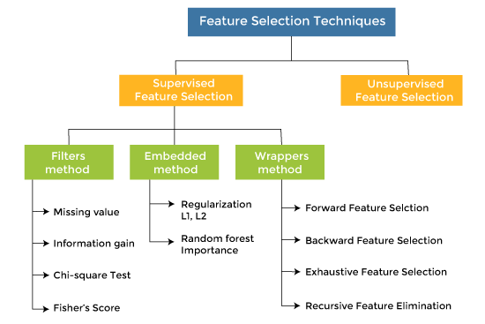

There are mainly three techniques under supervised feature Selection:

1. Filter Methods

In Filter Method, features are selected on the basis of statistics measures. This method does not depend on the learning algorithm and chooses the features as a pre-processing step.

The filter method filters out the irrelevant feature and redundant columns from the model by using different metrics through ranking.

The advantage of using filter methods is that it needs low computational time and does not overfit the data.

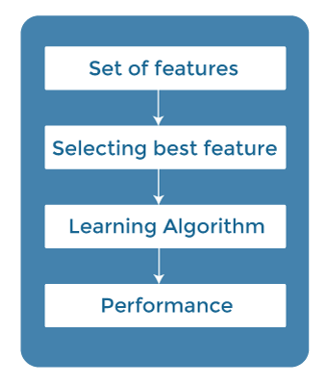

Some common techniques of Filter methods are as follows:

* Information Gain
* Chi-square Test
* Fisher's Score
* Missing Value Ratio

**Information Gain:** Information gain determines the reduction in entropy while transforming the dataset. It can be used as a feature selection technique by calculating the information gain of each variable with respect to the target variable.

**Chi-square Test:** Chi-square test is a technique to determine the relationship between the categorical variables. The chi-square value is calculated between each feature and the target variable, and the desired number of features with the best chi-square value is selected.

**Fisher's Score:**

Fisher's score is one of the popular supervised technique of features selection. It returns the rank of the variable on the fisher's criteria in descending order. Then we can select the variables with a large fisher's score.

**Missing Value Ratio:**

The value of the missing value ratio can be used for evaluating the feature set against the threshold value. The formula for obtaining the missing value ratio is the number of missing values in each column divided by the total number of observations. The variable is having more than the threshold value can be dropped.



Information gain calculates the reduction in entropy from the transformation of a dataset. It can be used for feature selection by evaluating the Information gain of each variable in the context of the target variable.

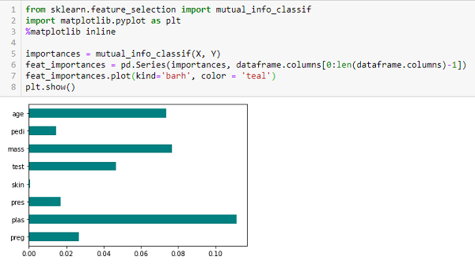Chi-square Test

The Chi-square test is used for categorical features in a dataset. We calculate Chi-square between each feature and the target and select the desired number of features with the best Chi-square scores. In order to correctly apply the chi-squared to test the relation between various features in the dataset and the target variable, the following conditions have to be met: the variables have to be *categorical*, sampled *independently,*and values should have an *expected frequency greater than 5*.

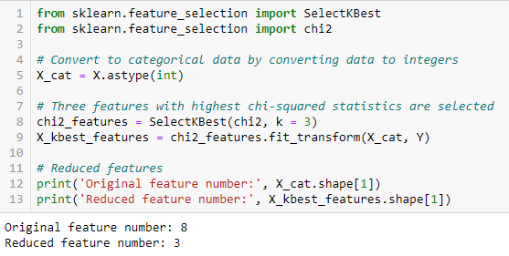

Fisher’s Score

Fisher score is one of the most widely used supervised feature selection methods. The algorithm we will use returns the ranks of the variables based on the fisher’s score in descending order. We can then select the variables as per the case.

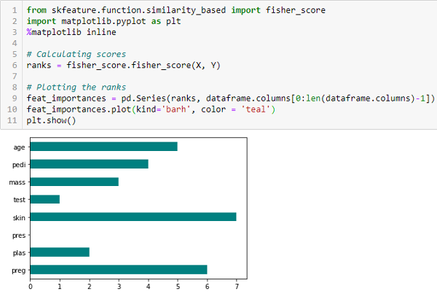

Correlation Coefficient

Correlation is a measure of the linear relationship between 2 or more variables. Through correlation, we can predict one variable from the other. The logic behind using correlation for feature selection is that good variables correlate highly with the target. Furthermore, variables should be correlated with the target but uncorrelated among themselves.

If two variables are correlated, we can predict one from the other. Therefore, if two features are correlated, the model only needs one, as the second does not add additional information. We will use the Pearson Correlation here.

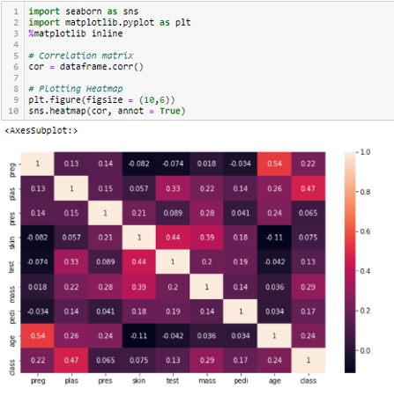

We need to set an absolute value, say 0.5, as the threshold for selecting the variables. If we find that the predictor variables are correlated, we can drop the variable with a lower correlation coefficient value than the target variable. We can also compute multiple correlation coefficients to check whether more than two variables correlate. This phenomenon is known as multicollinearity.

Variance Threshold

The variance threshold is a simple baseline approach to feature selection. It removes all features whose variance doesn’t meet some threshold. By default, it removes all zero-variance features, i.e., features with the same value in all samples. We assume that features with a higher variance may contain more useful information, but note that we are not taking the relationship between feature variables or feature and target variables into account, which is one of the drawbacks of filter methods.

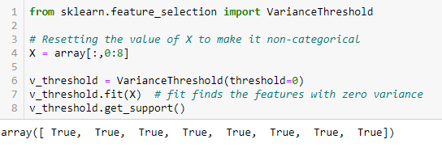

The get_support returns a Boolean vector where True means the variable does not have zero variance.

Mean Absolute Difference (MAD)

‘The mean absolute difference (MAD) computes the absolute difference from the mean value. The main difference between the variance and MAD measures is the absence of the square in the latter. The MAD, like the variance, is also a scaled variant.’ [1] This means that the higher the MAD, the higher the discriminatory power.

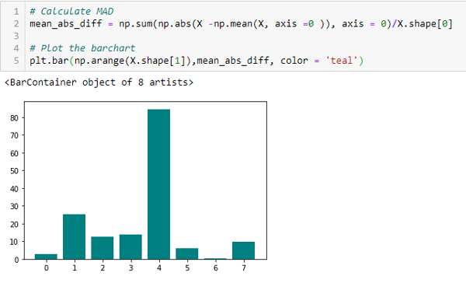  
**Dispersion Ratio**

‘Another measure of dispersion applies the arithmetic mean (AM) and the geometric mean (GM). For a given (positive) feature Xi on n patterns, the AM and GM are given byAM and GM

respectively; since **AMi ≥ GMi**, with equality holding if and only if **Xi1 = Xi2 = …. = Xin**, then the ratio

RM  
*can be used as a dispersion measure. Higher dispersion implies a higher value of Ri, thus a more relevant feature. Conversely, when all the feature samples have (roughly) the same value, Ri is close to 1, indicating a low relevance feature.’ [1]*  
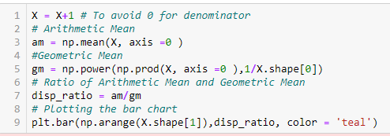  
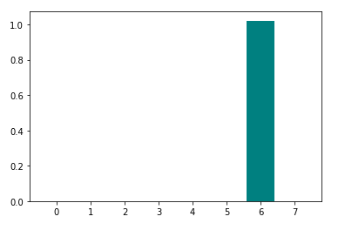

1. Wrapper Methods

In wrapper methodology, selection of features is done by considering it as a search problem, in which different combinations are made, evaluated, and compared with other combinations. It trains the algorithm by using the subset of features iteratively.

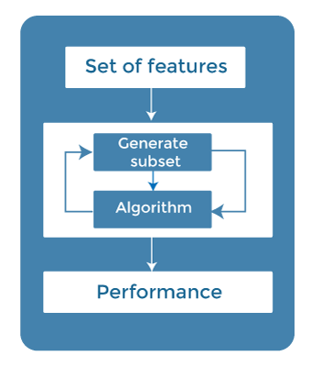

On the basis of the output of the model, features are added or subtracted, and with this feature set, the model has trained again.

Some techniques of wrapper methods are:

* **Forward selection** - Forward selection is an iterative process, which begins with an empty set of features. After each iteration, it keeps adding on a feature and evaluates the performance to check whether it is improving the performance or not. The process continues until the addition of a new variable/feature does not improve the performance of the model.
* **Backward elimination** - Backward elimination is also an iterative approach, but it is the opposite of forward selection. This technique begins the process by considering all the features and removes the least significant feature. This elimination process continues until removing the features does not improve the performance of the model.
* **Exhaustive Feature Selection-** Exhaustive feature selection is one of the best feature selection methods, which evaluates each feature set as brute-force. It means this method tries & make each possible combination of features and return the best performing feature set.
* **Recursive Feature Elimination-**  
  Recursive feature elimination is a recursive greedy optimization approach, where features are selected by recursively taking a smaller and smaller subset of features. Now, an estimator is trained with each set of features, and the importance of each feature is determined using *coef_attribute* or through a *feature_importances_attribute.*
* Forward Feature Selection
* This is an iterative method wherein we start with the performing features against the target features. Next, we select another variable that gives the best performance in combination with the first selected variable. This process continues until the preset criterion is achieved.
* 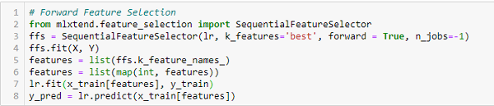
* Backward Feature Elimination
* This method works exactly opposite to the Forward Feature Selection method. Here, we start with all the features available and build a model. Next, we the variable from the model, which gives the best evaluation measure value. This process is continued until the preset criterion is achieved.
* 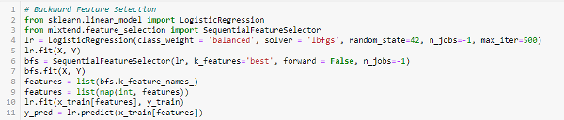
* This method, along with the one discussed above, is also known as the Sequential Feature Selection method.
* Exhaustive Feature Selection
* This is the most robust feature selection method covered so far. This is a brute-force evaluation of each feature subset. This means it tries every possible combination of the variables and returns the best-performing subset.
* 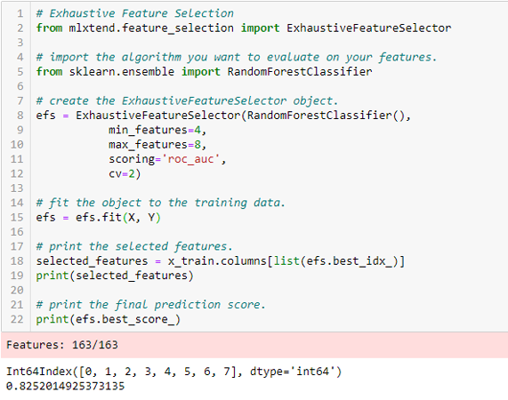
* Recursive Feature Elimination
* ‘*Given an external estimator that assigns weights to features (e.g., the coefficients of a linear model), the goal of recursive feature elimination (RFE) is to select features by recursively considering smaller and smaller sets of features. First, the estimator is trained on the initial set of features, and each feature’s importance is obtained either through a coef_ attribute or a feature_importances_ attribute.*  
  *Then, the least important features are pruned from the current set of features. That procedure is recursively repeated on the pruned set until the desired number of features to select is eventually reached.’*  
  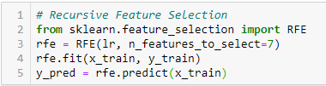

3. Embedded Methods

Embedded methods combined the advantages of both filter and wrapper methods by considering the interaction of features along with low computational cost. These are fast processing methods similar to the filter method but more accurate than the filter method.

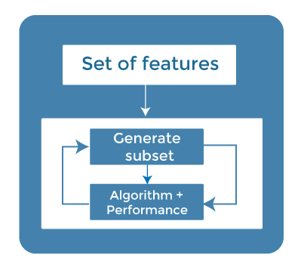

These methods are also iterative, which evaluates each iteration, and optimally finds the most important features that contribute the most to training in a particular iteration. Some techniques of embedded methods are:

* **Regularization**- Regularization adds a penalty term to different parameters of the machine learning model for avoiding overfitting in the model. This penalty term is added to the coefficients; hence it shrinks some coefficients to zero. Those features with zero coefficients can be removed from the dataset. The types of regularization techniques are L1 Regularization (Lasso Regularization) or Elastic Nets (L1 and L2 regularization).
* **Random Forest Importance** - Different tree-based methods of feature selection help us with feature importance to provide a way of selecting features. Here, feature importance specifies which feature has more importance in model building or has a great impact on the target variable. Random Forest is such a tree-based method, which is a type of bagging algorithm that aggregates a different number of decision trees. It automatically ranks the nodes by their performance or decrease in the impurity (Gini impurity) over all the trees. Nodes are arranged as per the impurity values, and thus it allows to pruning of trees below a specific node. The remaining nodes create a subset of the most important features.

Embedded Methods

These methods encompass the benefits of both the wrapper and filter methods by including interactions of features but also maintaining reasonable computational costs. Embedded methods are iterative in the sense that takes care of each iteration of the model training process and carefully extract those features which contribute the most to the training for a particular iteration.

Let’s discuss some of these techniques here:

LASSO Regularization (L1)

Regularization consists of adding a penalty to the different parameters of the machine learning model to reduce the freedom of the model, i.e., to avoid over-fitting. In linear model regularization, the penalty is applied over the coefficients that multiply each predictor. From the different types of regularization, Lasso or L1 has the property that can shrink some of the coefficients to zero. Therefore, that feature can be removed from the model.

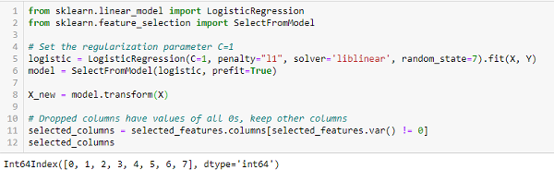

Random Forest Importance

Random Forests is a kind of Bagging Algorithm that aggregates a specified number of decision trees. The tree-based strategies used by random forests naturally rank by how well they improve the purity of the node, or in other words, a decrease in the impurity (**Gini impurity**) over all trees. Nodes with the greatest decrease in impurity happen at the start of the trees, while notes with the least decrease in impurity occur at the end of the trees. Thus, by pruning trees below a particular node, we can create a subset of the most important features.

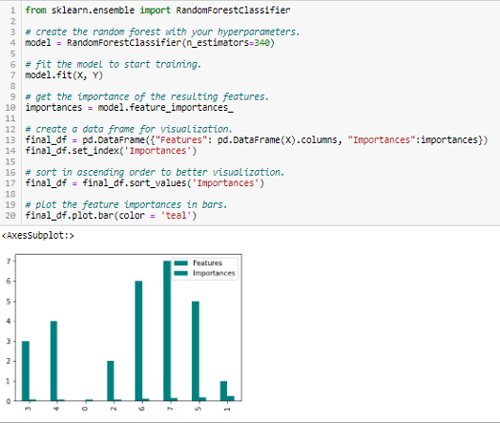

How to choose a Feature Selection Method?

For machine learning engineers, it is very important to understand that which feature selection method will work properly for their model. The more we know the datatypes of variables, the easier it is to choose the appropriate statistical measure for feature selection.

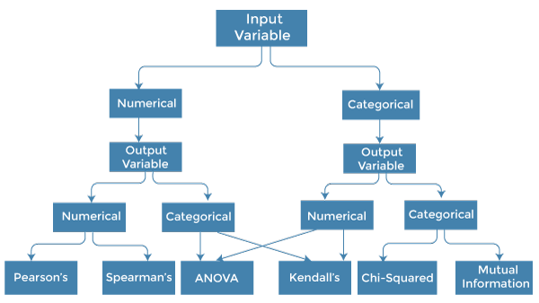

To know this, we need to first identify the type of input and output variables. In machine learning, variables are of mainly two types:

* **Numerical Variables:** Variable with continuous values such as integer, float
* **Categorical Variables:** Variables with categorical values such as Boolean, ordinal, nominals.

Below are some univariate statistical measures, which can be used for filter-based feature selection:

**1. Numerical Input, Numerical Output:**

Numerical Input variables are used for predictive regression modelling. The common method to be used for such a case is the Correlation coefficient.

* Pearson's correlation coefficient (For linear Correlation).
* Spearman's rank coefficient (for non-linear correlation).

**2. Numerical Input, Categorical Output:**

Numerical Input with categorical output is the case for classification predictive modelling problem**s.** In this case, also, correlation-based techniques should be used, but with categorical output.

* **ANOVA correlation coefficient (linear).**
* **Kendall's rank coefficient (nonlinear).**

**3. Categorical Input, Numerical Output:**

This is the case of regression predictive modelling with categorical input. It is a different example of a regression problem. We can use the same measures as discussed in the above case but in reverse order.

**4. Categorical Input, Categorical Output:**

This is a case of classification predictive modelling with categorical Input variables.

The commonly used technique for such a case is Chi-Squared Test. We can also use Information gain in this case.

**We can summarise the above cases with appropriate measures in the below table:**

|  |  |  |
| --- | --- | --- |
| **Input Variable** | **Output Variable** | **Feature Selection technique** |
| Numerical | Numerical | * Pearson's correlation coefficient (For linear Correlation). * Spearman's rank coefficient (for non-linear correlation). |
| Numerical | Categorical | * ANOVA correlation coefficient (linear). * Kendall's rank coefficient (nonlinear). |
| Categorical | Numerical | * Kendall's rank coefficient (linear). * ANOVA correlation coefficient (nonlinear). |
| Categorical | Categorical | * Chi-Squared test (contingency tables). * Mutual Information. |