Test Cases:
Scenario 1: Start the process
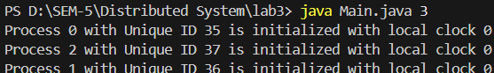
Three processes are initialized, each with a logical clock value set to 0.
Scenario 2: Local events
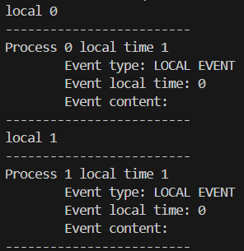
Performing local events on Process 0 and Process 1 increments the logical clock of both processes by 1.
Scenario 3: Send and Receive events
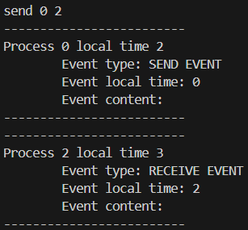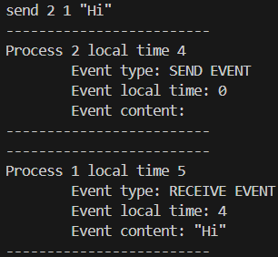
Process 0, with a local clock value of 1, sends a message to Process 2 with its logical clock value of 0. First, Process 0 increments its own clock by 1, updating it to 2. It then sends the message to Process 2 with the timestamp of 2. Upon receiving the message, Process 2 updates its clock to the maximum of its current value and the received timestamp, and then increments it by 1 which results in 3.
In second image, process can also send message alongside timestamp.
Scenario 4: Exit command
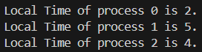
By using the `exit` command, the application returns a message indicating the final timestamp for each process.

