Idea Submission Template for AI Unlocked

Name of your Institute: Indian Institute of Technology, Guwahati
Challenge Area: Agent Teamwork (Track 4)
Your Team Name: LetMeTry
Registered Email ID of your Team Lead: mannaarkadeb@gmail.com
Orchestrated Intelligence: A Verifiable Multi-Agent System for Adaptive Planning and Execution

The Team
I am a 20 years old Engineer at an IIT. I am always curious to build something new, serve a larger audience with my own innovation and modern technologies. So, I found AI Unlock as a great opportunity. So, I jumped into it, pulled up my socks and dived into it.

The Concept
I decompose the task of intelligent planning into specialized, interacting skill-machines with explicit protocols for negotiation, verification, and continual learning. I am trying to turn planner/retriever/executor into composable skills that can be dynamically assembled into workflows, verified formally for correctness of critical steps, and audited for traceability.
The system is a personalized, audit-ready planning and execution architecture that combines a hierarchical task network with a probabilistic MDP(Markov Decision Process) planner to produce a primary plan, contingency branches, and a probability-weighted timeline with expected slack under uncertainty. Planning is grounded by a continuously updated, user-specific knowledge graph and a two-stage retrieval pipeline that pairs fast semantic search with symbolic constraint filtering and evidence scoring to prevent hallucinations. Execution is handled by a verifiable action engine that distinguishes soft and hard actions, enforces preconditions and postconditions through formal checks, and guarantees transactional safety with rollback and remediation. Coordination across multiple agents follows a bounded, explainable consensus protocol to avoid conflicts, while a personalized policy adapts over time via feedback-driven online learning with safe exploration. All decisions and actions are logged as append-only events with privacy-first controls and optional tamper-evident auditability.

Target Audience or Market
My target audience is primarily the student community including University and College Students along with Intermediate level students. They will be highly benefited by my novel solution which will make it easy for them to –
1) Semester Planning 2) Exam Preparation 3) Assignment Tracking
Again my solution can also be useful for Educators (Teachers) as well as working professionals by helping them in –
- Course scheduling 2) Project Planning and Management 3) Task delegation
Existing tools like Google Assistant and other task managers do not reason across long timelines. They lack specialization and coordination. They are motly not equipped with AI tools, so my approach and solution would be able to cater a better purpose for all the above groups of people.

Personas

Here I have provided example of 2 personas from different walks of life, along with how my solution will be able to efficiently cater their needs

Persona 1 :
Aman – Engineering Student
Age : 20 Specialization – Computer Science & Engineering
Pain Points: 1) Overlapping deadlines 2) Last-minute exam stress 3) Poor long-term planning
Goals: 1) Structured semester planning 2) Balanced workload 3) Clear daily -> weekly -> monthly -> yearly goals
How My Solution Helps: 1) Generate a semester roadmap 2) Adjusts plans dynamically 3) Sends remainder and progress updates

Persona 2:
Neha – Project Team Lead
Age : 29 Work – Software engineer at a Multi National Company
Pain Points: 1) Missing important deadlines 2) Lack of coordination at team work 3) Stress at work place 4) Extreme workload
Goals: 1) Clear Execution roadmap 2) Reminders about deadlines 3) Coordination and time management at work
How My Solution Helps: 1) Breaks projects into phases 2) Executes task tracking automatically 3) Plans team work

How it works:

1. Input capture

User supplies: goal, preferences, hard constraints (dates), soft constraints (workload), external tokens (course syllabus, calendar invite).

Input is normalized to structured constraints and seeded into the user KG(Knowledge Graph).

2. Planner pipeline

Stage A — Constraint extraction: symbolic constraints (deadlines, prerequisites), optimization targets (minimize weekly hours variance).

Stage B — HTN(Hierarchical Task Network) decomposition: top-level goal → milestones → tasks (each task annotated: effort estimate, skill required, earliest/latest).

Stage C — Probabilistic scheduling: use a discrete-time MDP(Markov Decision Process) solver (e.g., value iteration on small horizon) to produce expected completion times and contingency branches.

Output: canonical plan JSON with task graph, confidence scores, critical path, and contingency nodes.

3. Retriever pipeline

Query Planner tasks for resource needs.

Search order: local Knowledge Graph → personal docs (uploaded syllabus, notes) → institutional APIs (LMS, calendar) → web (when allowed).

For each retrieved doc/resource: compute Evidence Score = semantic relevance × provenance trust × recency.

Attach pointers and short citations to tasks (so plan is traceable).

4. Executor pipeline

Soft actions (generate study blocks, create templates) performed after Planner approval.

Hard actions prepare a pre-flight checklist:

Preconditions verified (calendar free slots, duplicate checks).

Dry-run performed: e.g., generate ICS file preview.

On commit: perform action via connector (Google Calendar / Outlook / LMS API / Slack).

Postconditions verified (event exists, API returns success). Any mismatch triggers automated remediation tasks and notifies user.

5. Negotiation & human-in-the-loop

Before hard commits, system presents a compact negotiation digest: suggested changes, alternatives, expected risk.

User can accept, tweak, or reject. Planner re-runs HTN local edit with updated constraints.

6. Feedback & learning

Telemetry: accept/reject decisions, task completion times, manual edits.

Online learning updates user-specific weights (e.g., aggression in scheduling, typical task durations).

Aggregate anonymized signals feed a global model for system improvement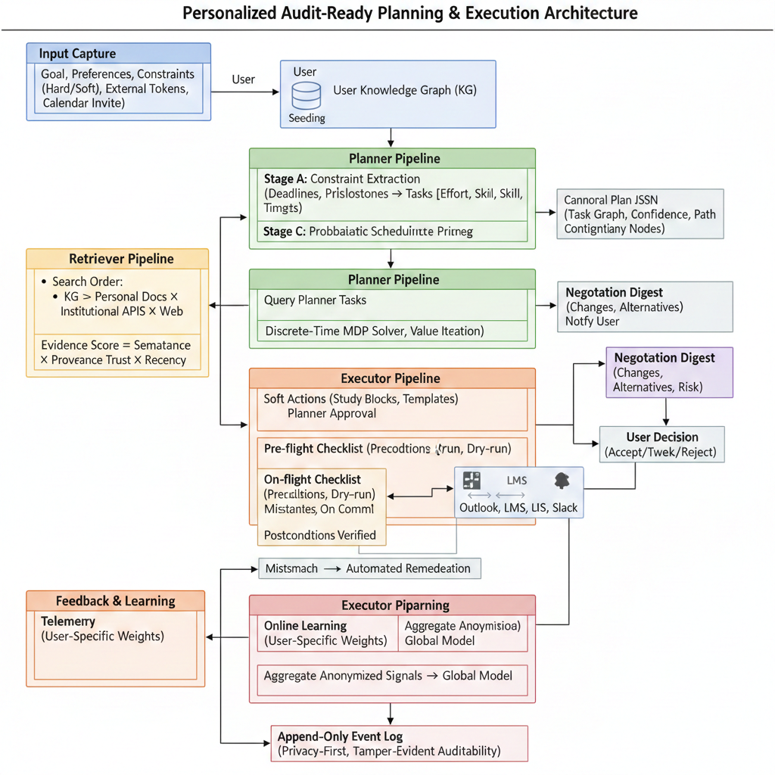

Core Technologies

In order to build multiagent system, I shall use LangChain, LangGraph, LlamaIndex or similar AI agents and tools. Apart from that following are the technologies to beused for specialized tasks in my solution
Planner Agent – MDP(Markov Decision Process) solver, HTN (Hierarchical Task Network) Library, PDDL (Planning Domain Definition Language) interpreter
Retriever Agent – Vector DataBase like Azure Cognitive search vectors, Chroma DB, etc. and LLM Embedding (like Gemini/Azure OpenAI, etc.)
Executor Agent – Calender APIs like that of Google/Outlook, Messaging platforms like MS Teams

Other Technologies – Kafka (for streaming), Networkx or similar for Graph generation for Knowledge Graph.
Further many more technologies are to be used in later stages in order to build application/ website and to make my solution scalable.

The Business Plan:
I shall try to launch my product step by step and checking my reach at each step and keeping an eye on customer response and feedback . The steps can be –
- Free (Student Focused) – Basic plan generation, limited number of hard actions per month
- Pro (Individual Subscriber) – Full plan generator, personalized policy learning, unlimited soft actions, Price ranging below Rs 1000 per month
- Institute/Enterprise Level – Multi user , admin dashboard, usage analytics along with policy injection
Further plans regarding the business can be thought own the way to production and scalabiltiy

Additional Information:
My work is strongly aligned with the AI-agent–focused challenge track. I am actively building a system centered on intelligent agents that can autonomously plan, retrieve information, and execute tasks with minimal human intervention. The core idea is to move beyond single-model solutions and demonstrate how multiple AI agents can collaborate, each with a clearly defined role, to solve complex, multi-step problems.

Looking ahead, I plan to extend the system by introducing more specialized agents, such as a Reminder Agent to proactively handle deadlines and notifications, and an Evaluation Agent to assess progress, performance, and outcomes. These additions will further strengthen the autonomy and usefulness of the overall architecture.

I am also exploring voice-based interaction to make the system more natural and accessible, allowing users to interact with agents through spoken commands and feedback. Finally, integration with external platforms such as calendars and Learning Management Systems (LMS) is a key future goal. This would enable seamless synchronization with real-world schedules and academic workflows, making the system more deeply embedded in everyday use.

Research Links :
https://www.researchgate.net/publication/391661197_AI-Powered_Smart_Study_Planner_Enhancing_Personalized_Learning_Through_Intelligent_Scheduling

https://github.com/Huzaifa-X/AI-Powered-Study-Planand-Book-Summarization

https://levelup.gitconnected.com/how-i-built-an-ai-powered-study-scheduler-that-adapts-to-my-mood-time-and-productivity-708e001b2350

