

**THIS IS THE HOMEPAGE.THERE ARE THREE BUTTONS IN NAVIGATION BAR.**

**HOME,LOGIN AND REGISTRATION.**

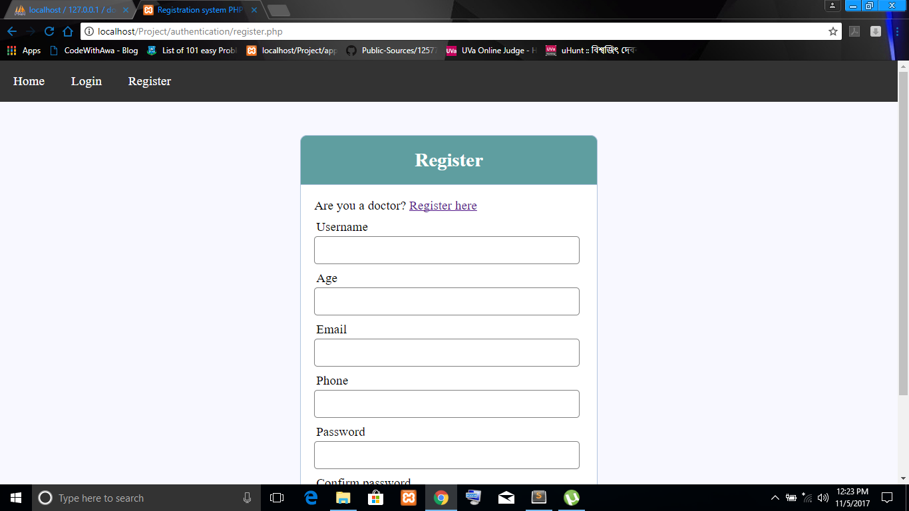

THIS IS THE REGISTRATION PAGE FOR PATIENT.IF THE USER IS A DOCTOR HE/SHE HAS TO CLICK ‘REGISTER HERE’.

BY FILLING UP NECESSARY INFORMATION USER CAN COMPLETE HIS REGISTRATION.

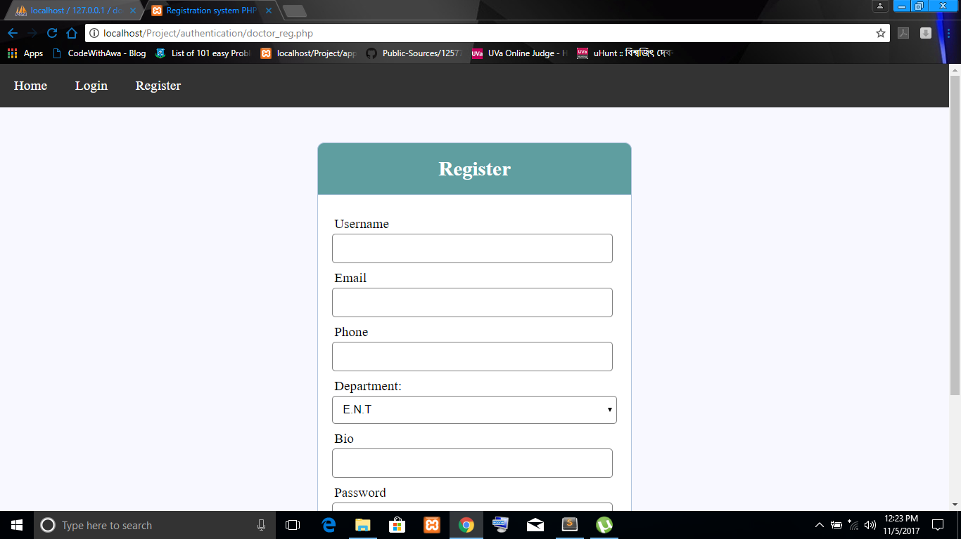

THIS IS REGISTRATION PAGE OF DOCTOR. BY FILLING UP NECESSARY INFORMATION DOCTOR CAN COMPLETE HIS REGISTRATION.THIS PAGE CAN REDIRECT HIM TO HIS PROFILE.

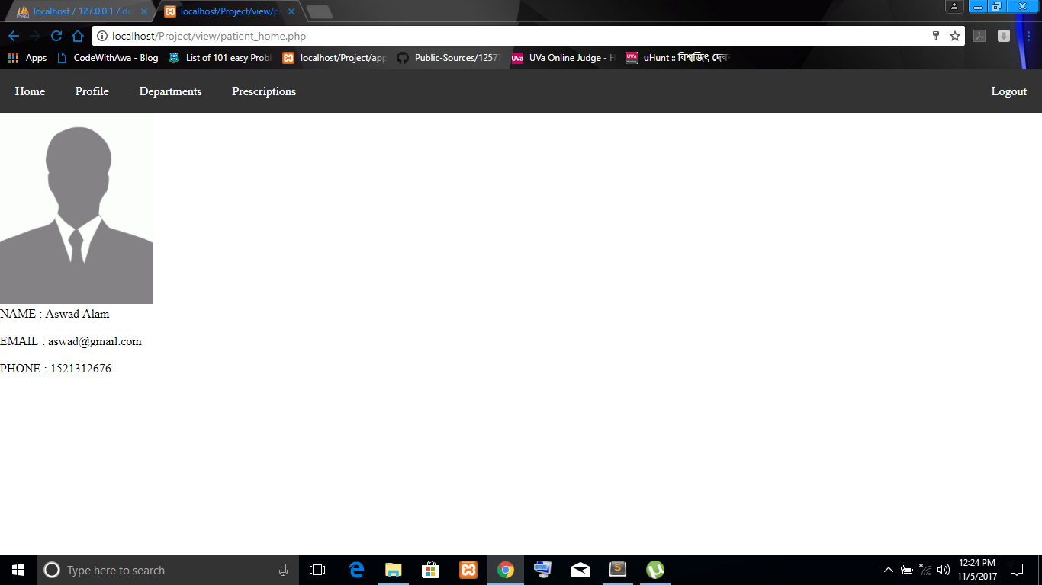

THIS IS THE PROFILE OF PATIENT CONTAINING NAME,EMAIL & PHONE NUM.THERE IS A LOG OUT BUTTON IN TOP-RIGHT CORNER.

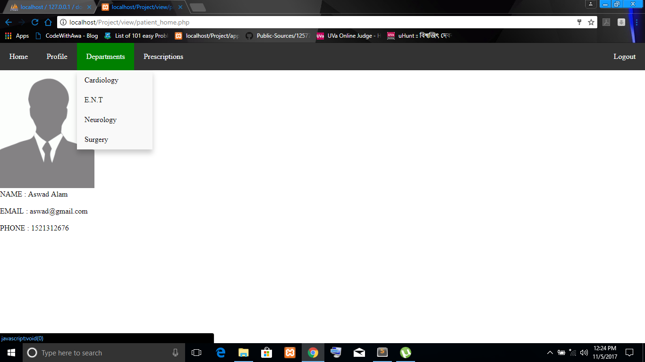

IN PATIENT PROFILE ,IN NAV BAR THERE WILL BE DEPARTMENTS LIST AND BY SELECTING DESIRED DEPARTMENT USER CAN FIND THE LIST OF DOCTORS OF THAT DEPARTMENT.

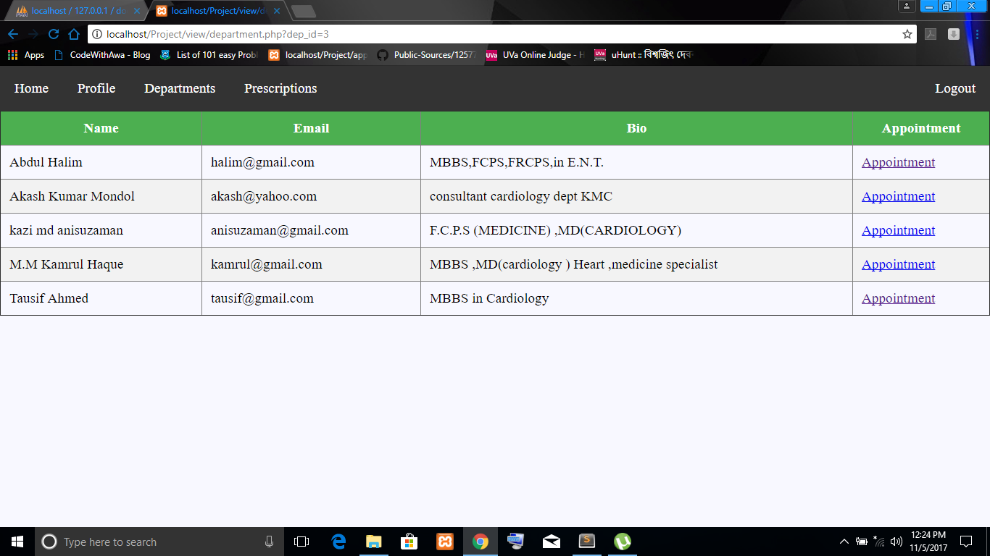

BY SELECTING DEPARTMENT LIST OF DOCTOR WILL BE SHOWN CONTAINING NAME,E-MAIL, BIO & APPOINTMENT BUTTON WHICH WILL TAKE THE APPOINTMENT.

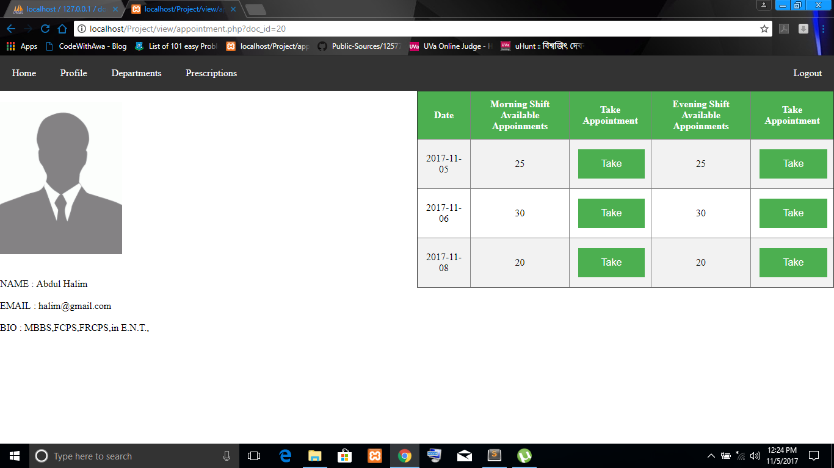

THIS IS THE DOCTOR’S PROFILE WHICH A USER CAN SEE.AVAILABLE APPOINTMENT IN A PARTICULAR DATE FIXED BY THAT DOCTOR IS GIVEN THERE.BY CLICKING ‘’TAKE ‘’ BUTTON APPOINTMENT WILL BE TAKEN.AND MESSAGE WILL BE SHOWN IF APPOINTMENT IS NOT AVAILABLE.

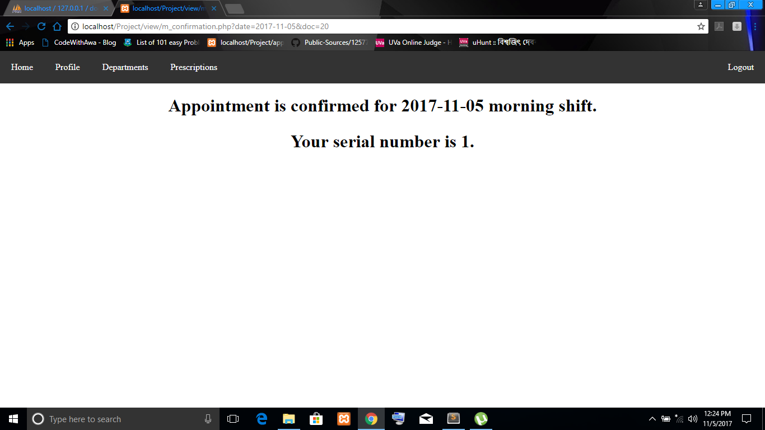

BY CONFIRMING THE DOCTOR AND THE DATE CONFIRMATION MESSAGE WILL BE SHOWN CONTAINING DATE,SHIFT AND SERIAL NUMBER.

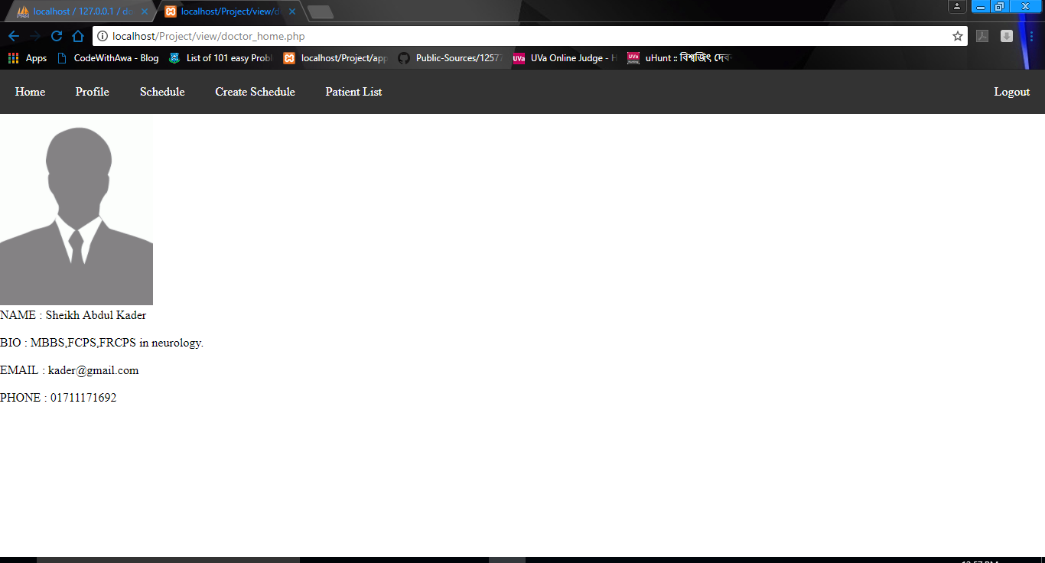

THIS IS A DOCTORS PROFILE.AFTER LOGGING IN AS A DOCTOR THIS PAGE WILL BE SHOWN.THIS PAGE WILL CONTAIN HOME,PROFILE,SCHEDULE,CREATE SCHEDULE AND PATIENT LIST.

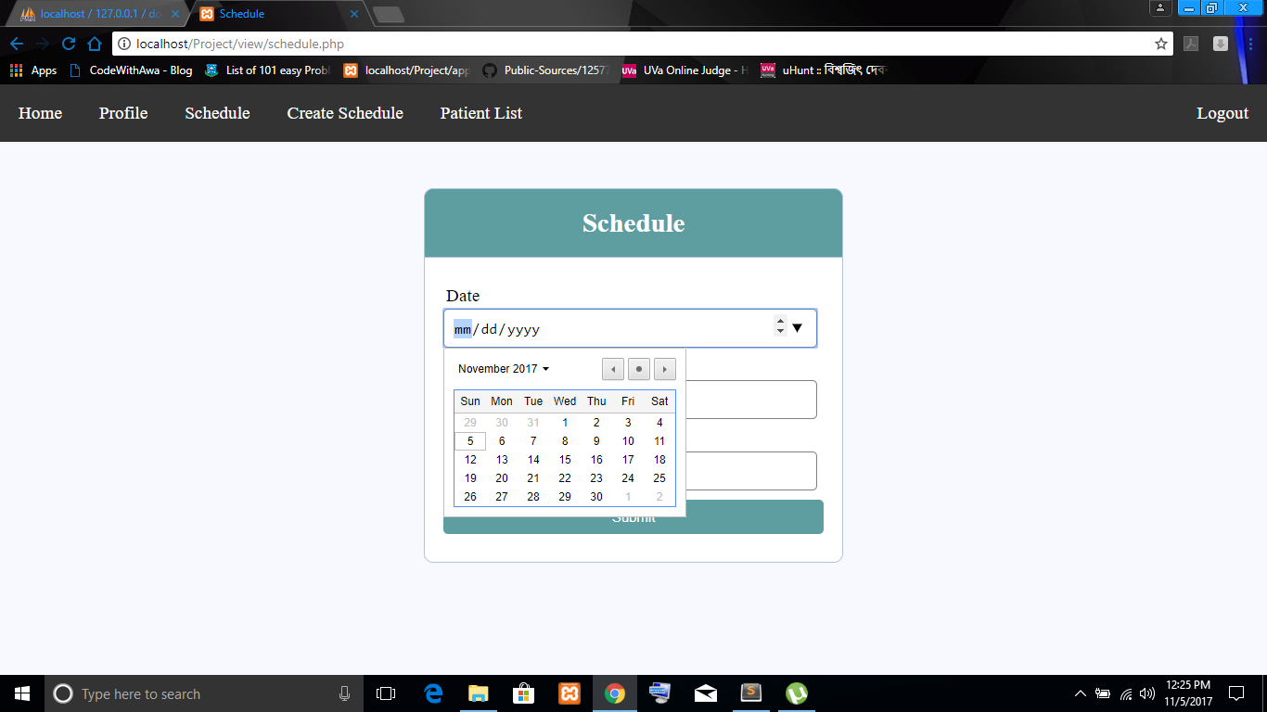

BY CLICKING “CREATE SCHEDULE” THIS PAGE WILL COME.AND MAXIMUM NUMBER OF SERIAL IN BOTH SHIFT CAN BE FIXED BY DOCTOR .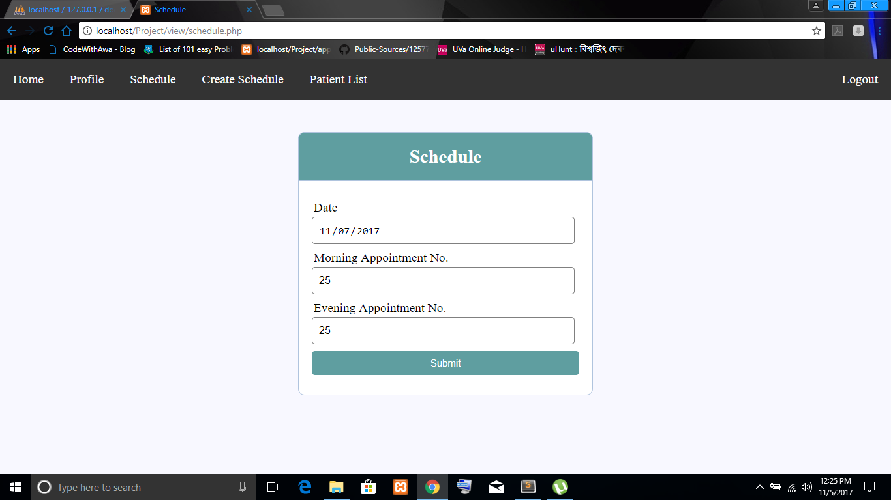

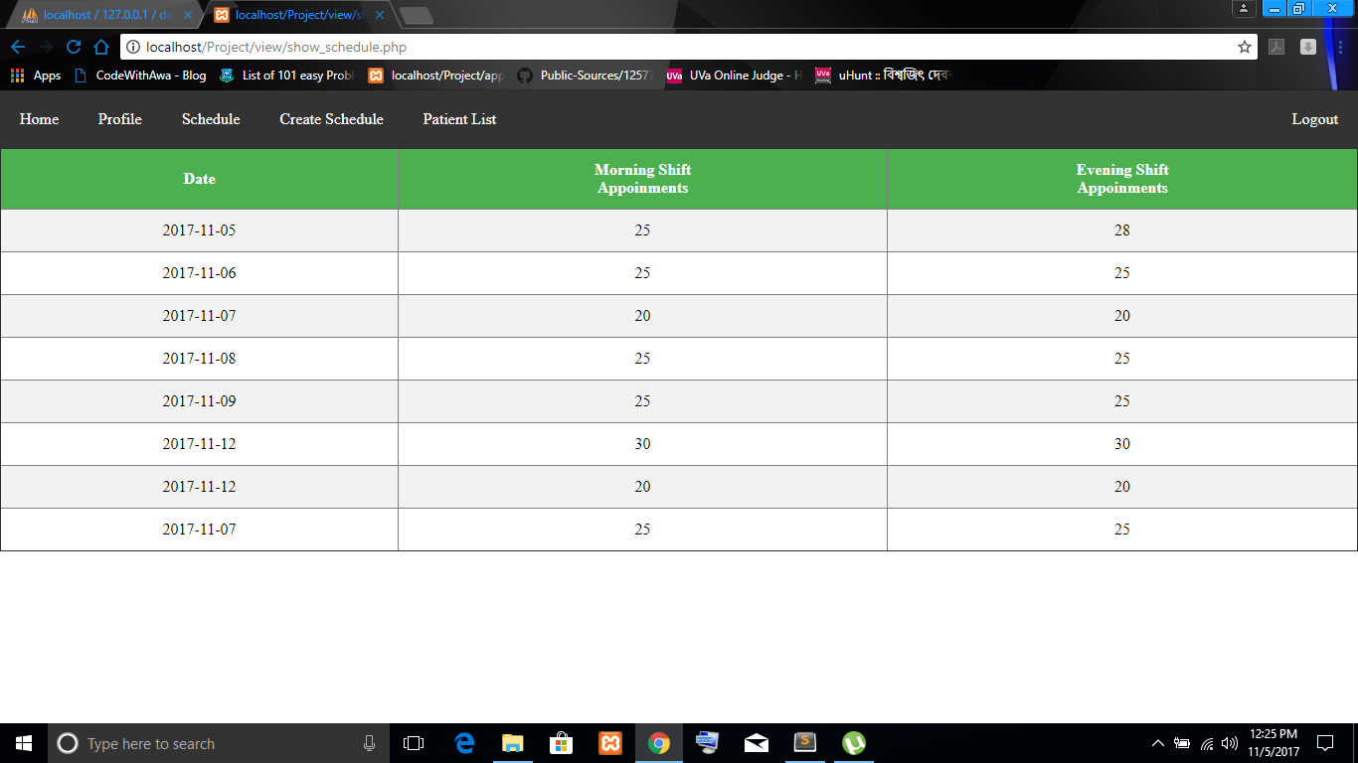

THIS IS SCHEDULE OF DOCTOR’S PROFILE . DOCTOR CAN SEE HIS CURRENT AND FUTURE SCHEDULE HERE .

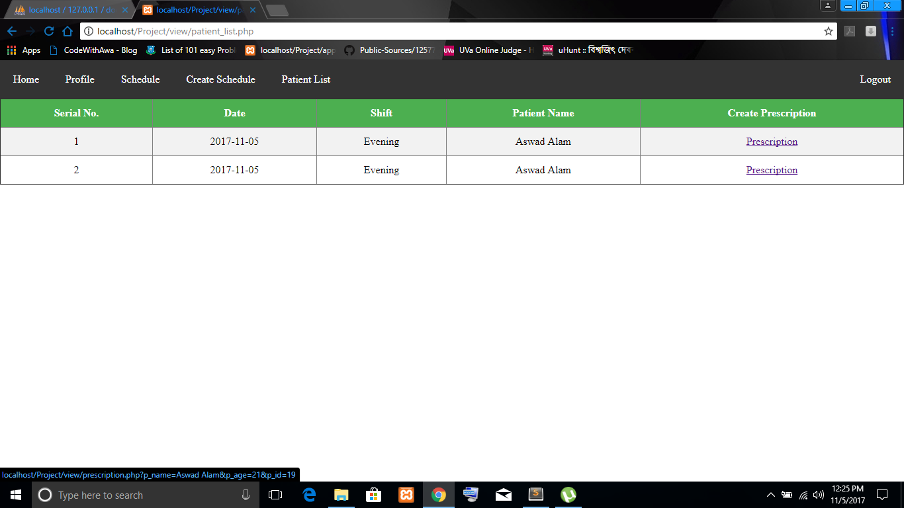

THIS IS THE LIST OF APPOINTED PATIENT .

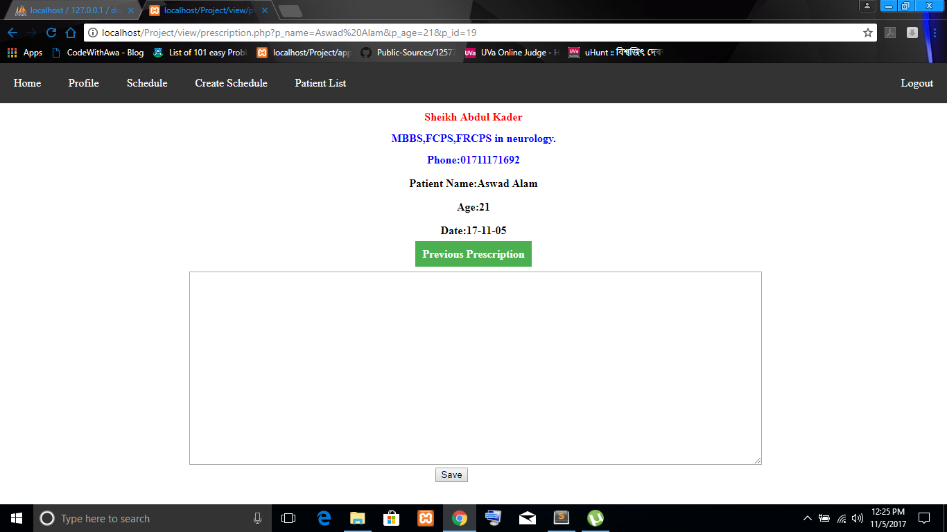

THIS IS THE PRESCRIPTION PAGE CONTAINING DOCTOR NAME, HIS BIO ,CONTACT NO ,PATIENT NAME ,HIS AGE AND DATE .

PREVIOUS PRESCRIPTION IS ALSO GIVEN HERE IF THE PATIENT HAD VISITED THE DOCTOR EARLIER .

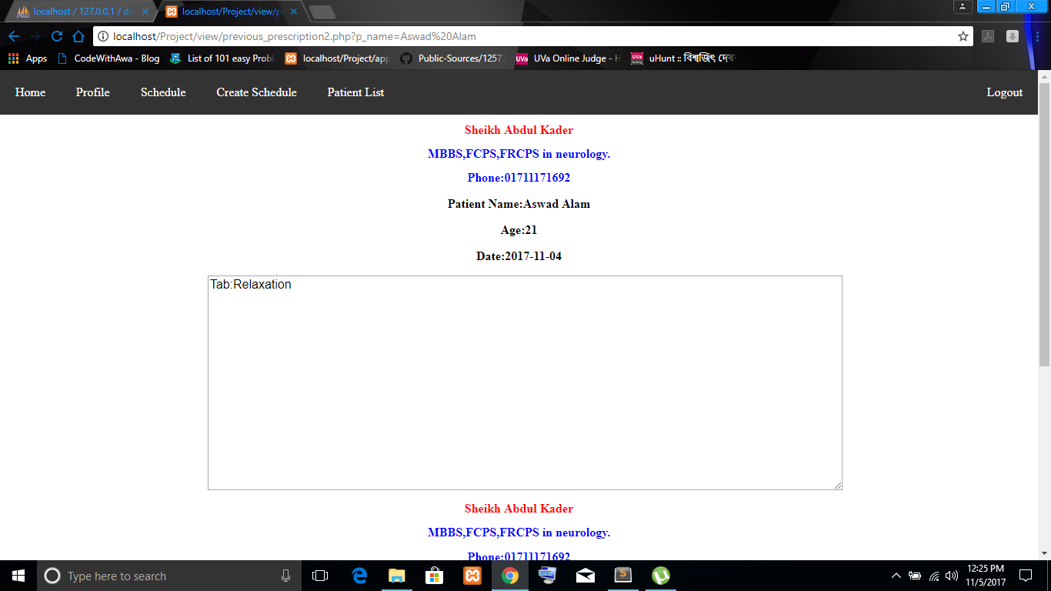

THIS IS THE PRESCRIPTION OF PATIENT . PATIENT CAN SEE THE PRESCRIPTION IN HIS PROFILE ALSO .

THANK YOU !!!