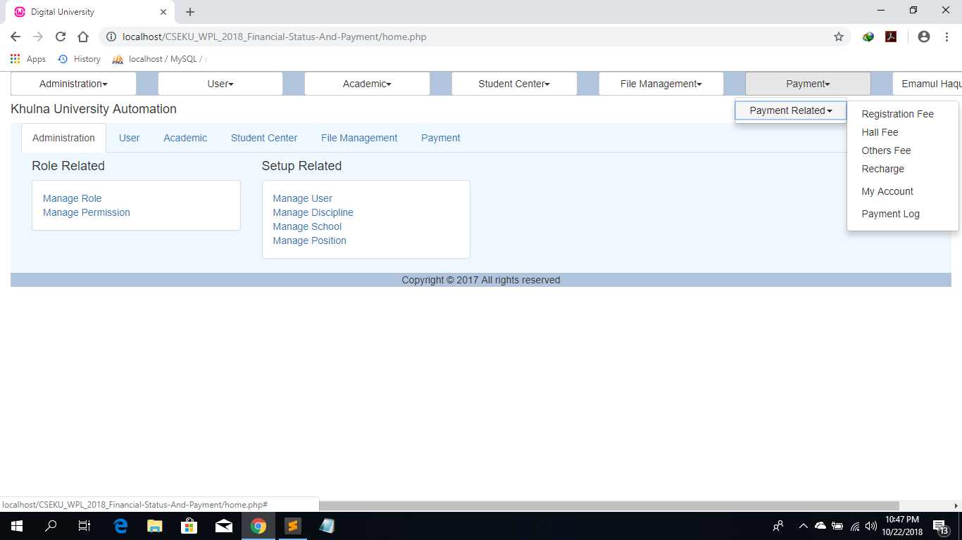

This is the home page of Financial status and payment.

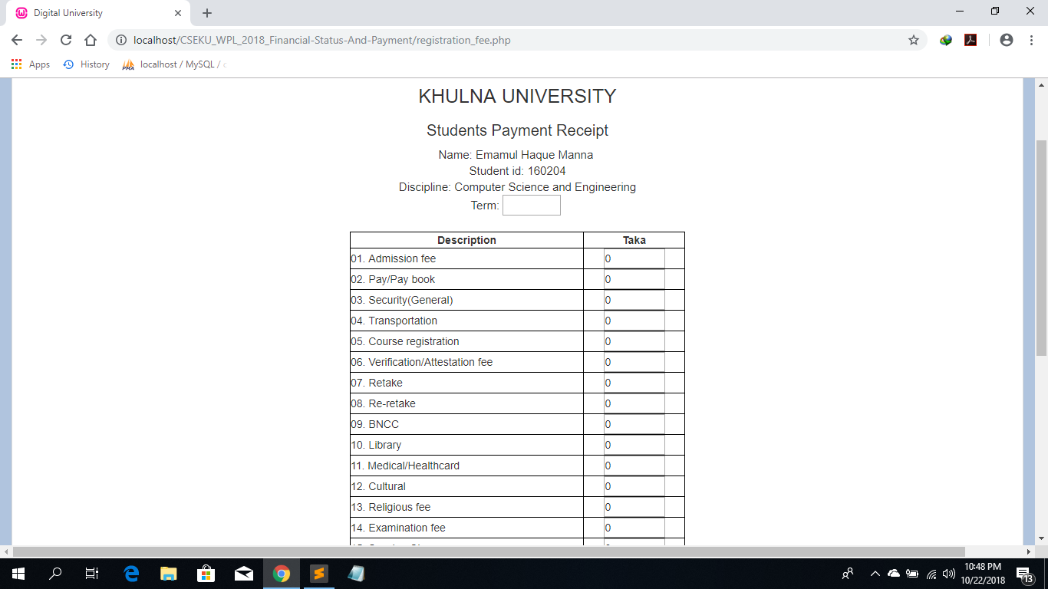

By clicking on Register fee this page will appear.

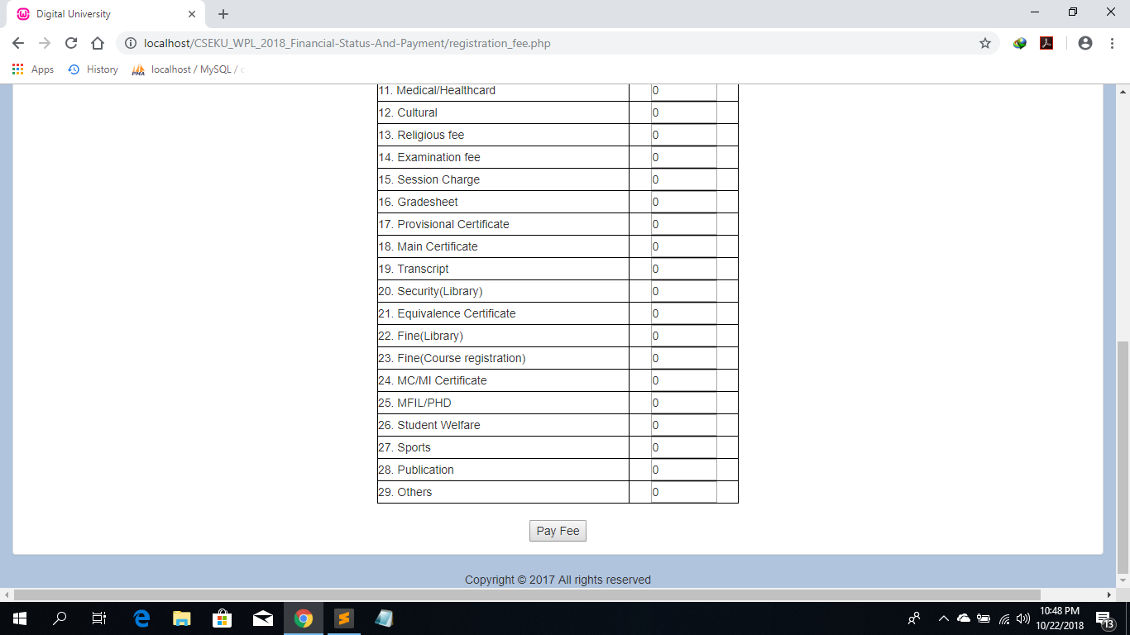

And then after pressing the “Pay Fee” button user can pay the registration fee.

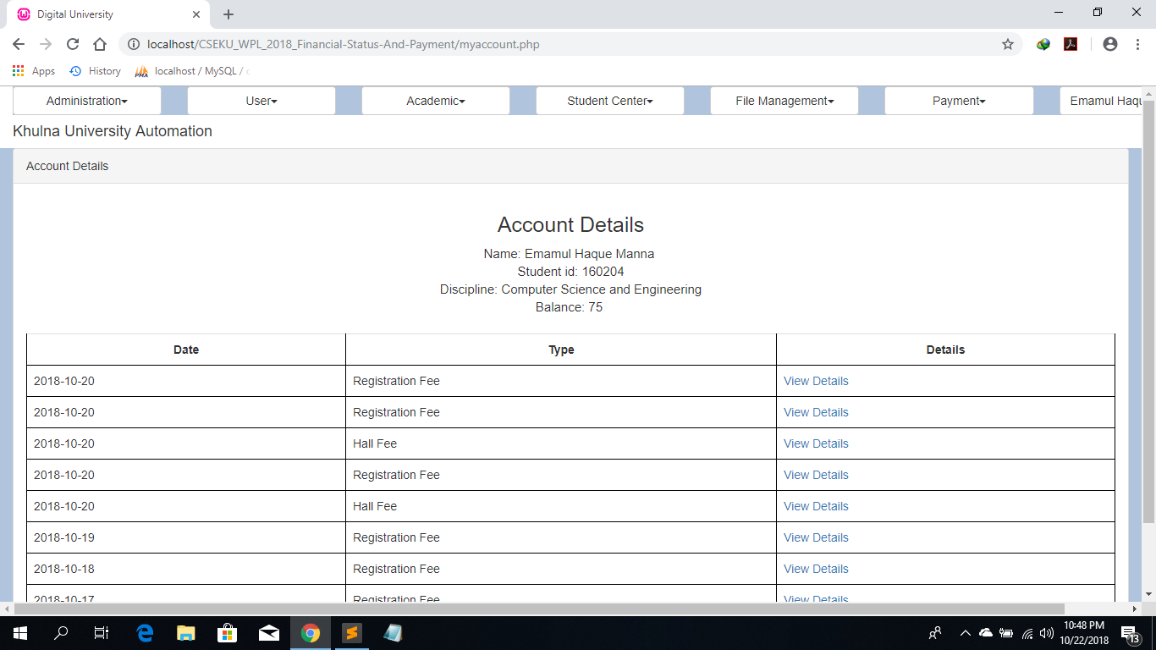

In the homepage by clicking on my account in the payment module the account details will appear.Here user also can see his balance.

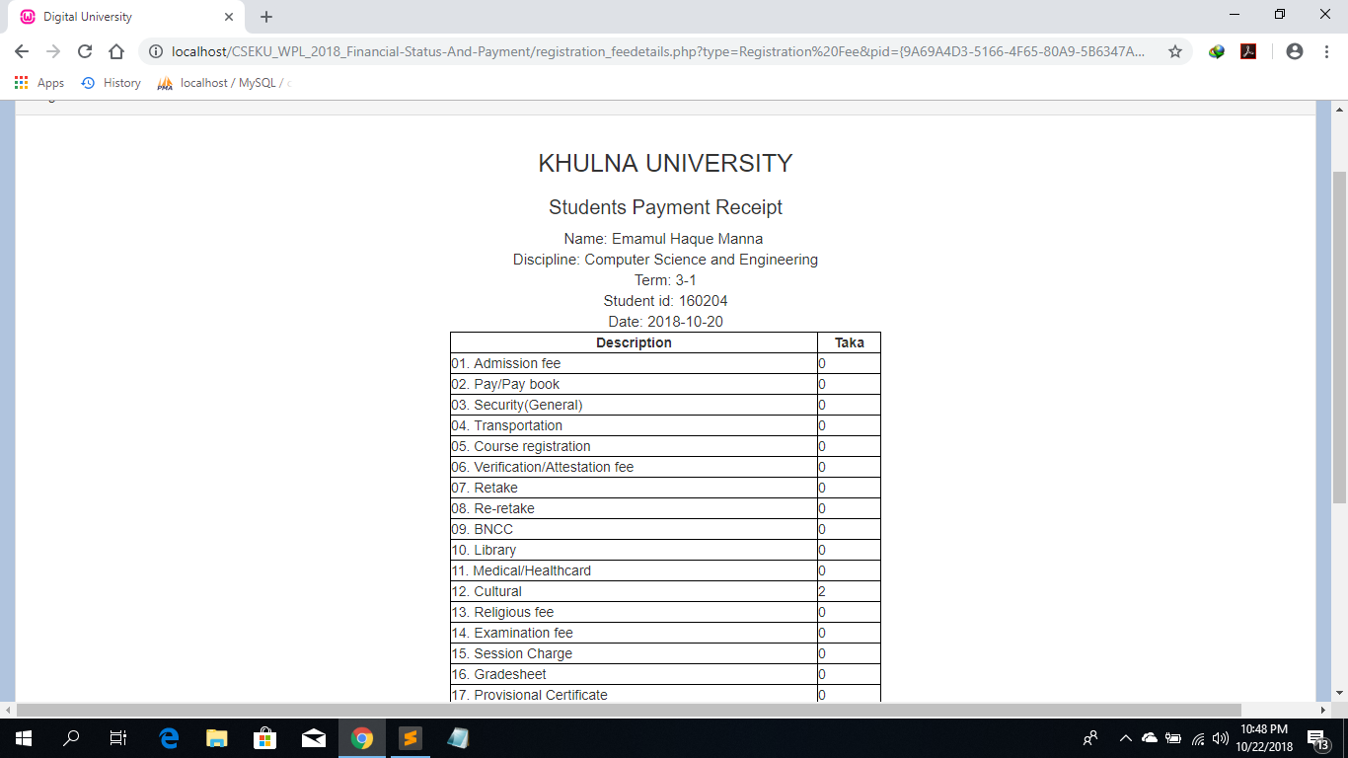

By clicking on view details on my account details of the particular payment will appear.

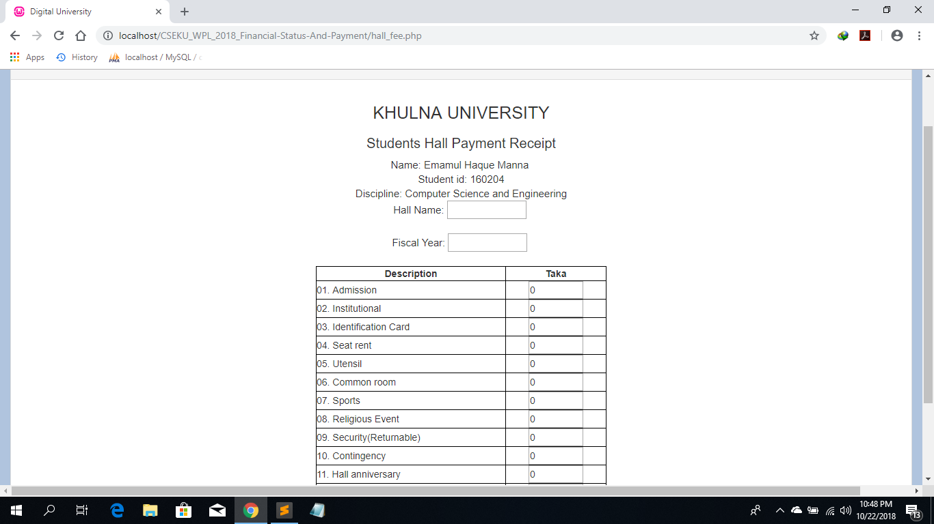

In the homepage by clicking on hall fee in the payment module this page will appear. Here students can input the hall fee.And pay the fee.

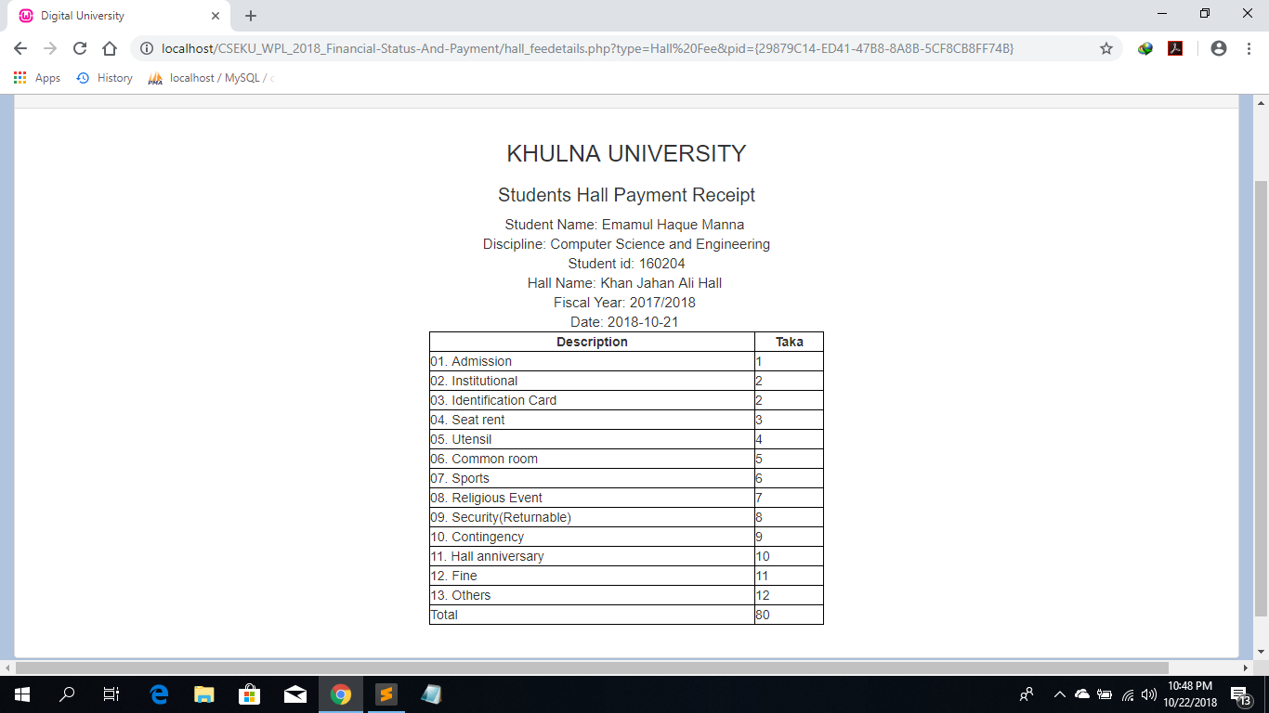

Here is the hall payment receipt.

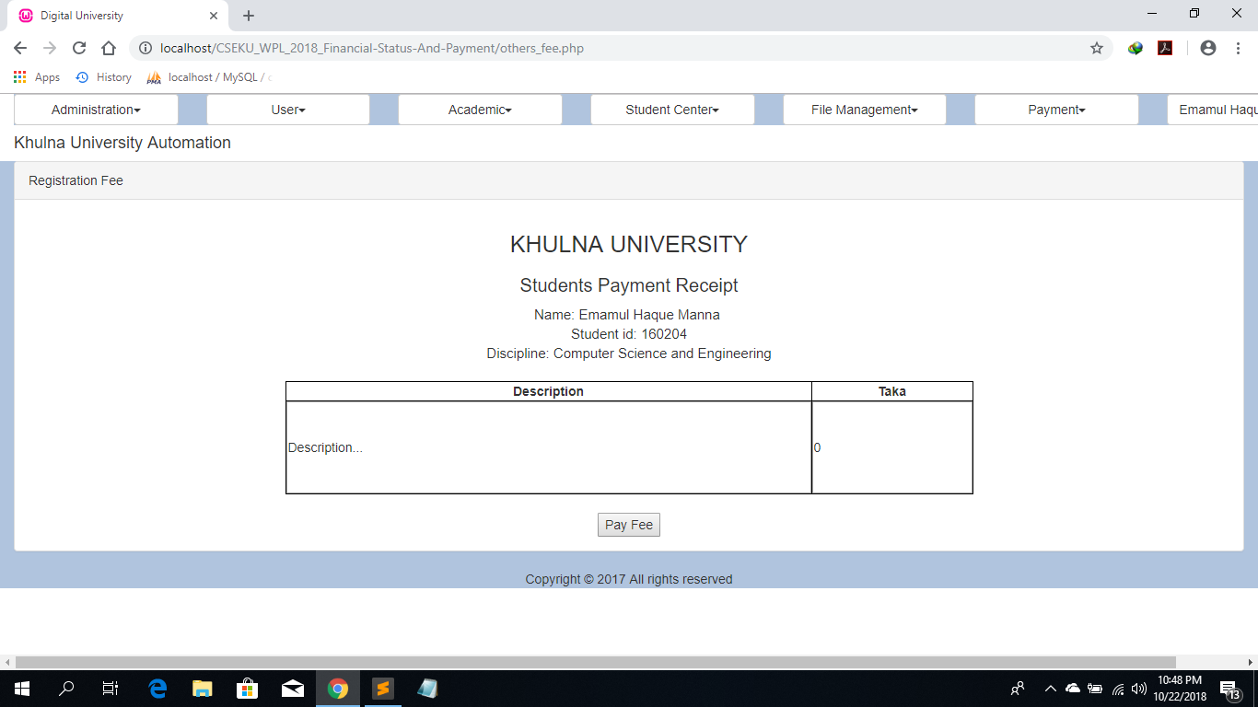

In the homepage by clicking on others fee in the payment module the account details will appear.Here students can enter the others fee.And pay the fee.

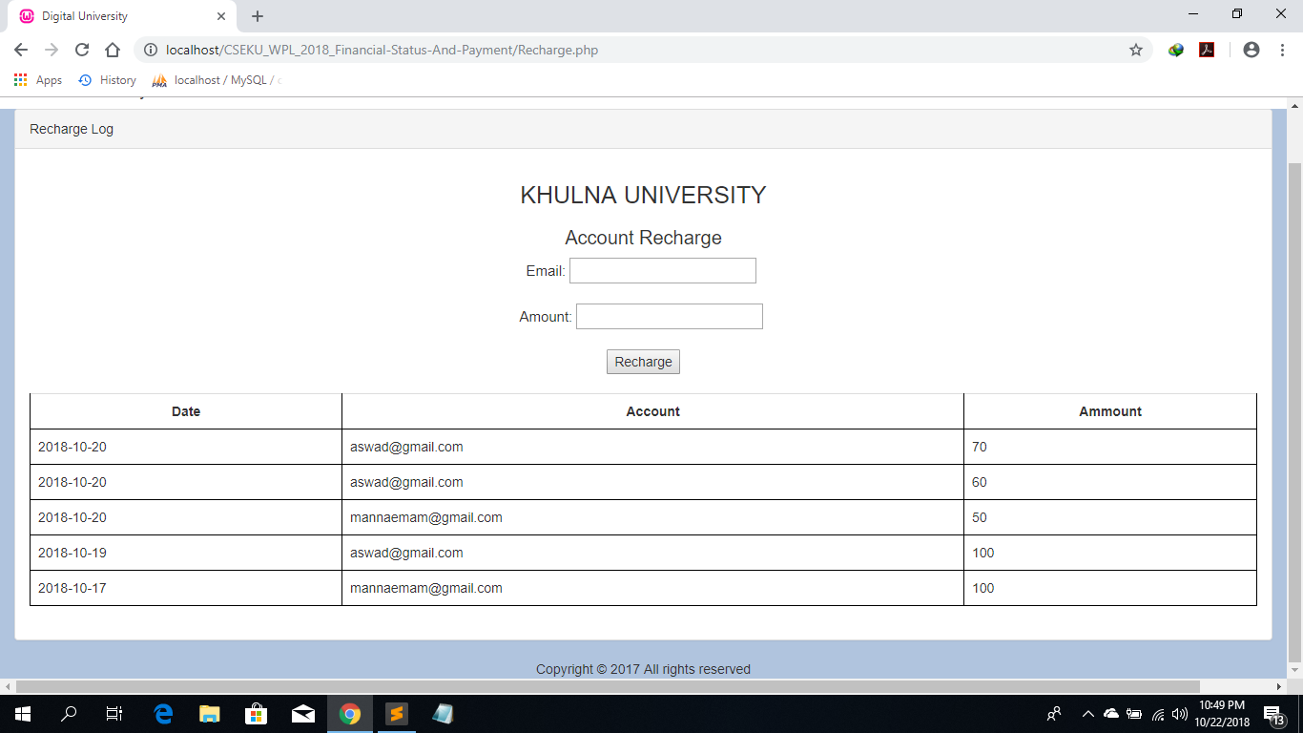

By clicking on recharge in the payment module Account recharge page will appear.Here admin can recharge any account, through email id.

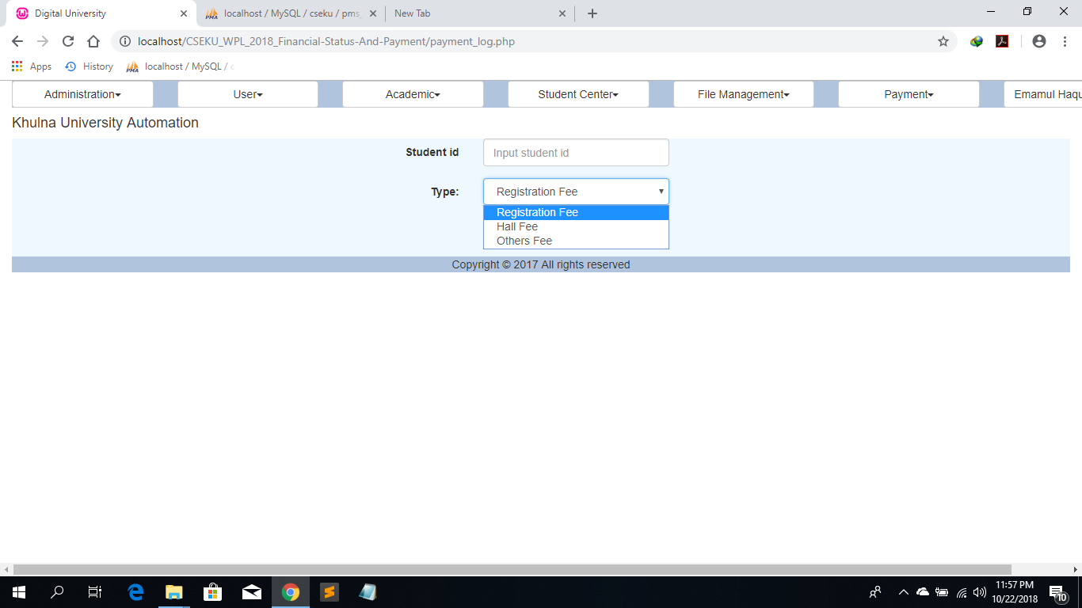

In this section admin can find the payment log by clicking on Payment log.Here admin can search any student pay ment history through selecting payment type and giving the student id.