A Comprehensive Review of Sustainable and Renewable Energy Sources for Future Power Systems

Mannan Puri  Dept. of Computer Science Engg.  Chitkara University  Punjab, India  mannan1886.be22@chitkara.edu.in | Ayush Rana  Dept. of Computer Science Engg.  Chitkara University  Punjab, India  ayush1429.be22@chitkara.edu.in | Muskan Rehni  Dept. of Computer Science Engg.  Chitkara University  Punjab, India  muskan591.be22@chitkara.edu.in

Abstract—As the demand for energy continues to rise around the world and the pollution of the environment with the use of fossil fuels becomes louder, many countries around the world are looking to renewable sources of energy to meet their power demands. The pressure of industrialization and the rise of the world population have stretched the traditional sources of power to their limits, which is why the search for alternative sources of power is becoming quite urgent. This paper is a broad discussion of the different sources of renewable energy, such as solar power, wind power, hydro power, biomass power, and geothermal power, and how each of these sources can be integrated into the power systems of the future. We compare the different sources of power along different parameters such as their efficiency, cost, effect on the environment, ease of scale-up, and the state of the technology involved. We also delve deeper into the importance of storage systems as well as grid systems to the integration of the different sources of power into the power system as a whole. What we have learned is that solar power and wind power have come a long way with the advent of technology and the decrease in cost, while hydropower and biomass power ensure the stability of the power supply system, and geothermal power is the steady power supply system. However, the problem is the fact that the sun does not always shine, the wind does not always blow, and the grid was not built to accommodate the changes with the advent of the different sources of power. What we have learned is that no single source of power can meet the demands of the power system of the future; however, the right combination of the different sources of power with the advent of storage systems as well as grid systems can meet the demands of the power system of the future while being sustainable and reliable
Keywords—Renewable energy, Sustainable power systems, Solar energy, Wind energy, Energy storage, Smart grids

Introduction
The way the world uses and generates energy is undergoing one of the greatest transformations in history. At the same time, electricity demand is growing exponentially, and there is an urgent need to address the environmental damage caused by using conventional energy resources such as coal, oil, and gas over the last few decades. Though these resources have been the driving force behind the progress of the world, they have also contributed to climate change and polluted the air we breathe. On top of this, there is also the issue of depleting resources, which is making long-term energy planning an increasingly precarious task.
Renewable energy is no longer a niche topic but an integral part of the mainstream conversation on energy and the environment. This is partly because the technology has become significantly better and partly because the costs have fallen more rapidly than almost anybody predicted. Solar and wind power, which were once seen as costly and experimental technologies, have become more competitive with or even cheaper than traditional energy sources.
But integrating these new sources of energy with the traditional infrastructure is not an easy task. For instance, many of these new sources of energy depend on the weather and can fluctuate dramatically from one minute to the next. This is making it an urgent task for the authorities to ensure that supply and demand match each other at all times. This is not an easy task and requires more than just more and better sources of renewable energy.This paper sets out to offer a thorough, grounded look at where the main renewable technologies stand today, what role they are likely to play in future power systems, and what it will genuinely take to overcome the barriers that still hold them back.

RELATED WORK
There has been a considerable increase in research regarding the concept of renewable energy and its integration into the power grid over the past few decades, largely driven by the surge of environmental concerns and the overall move towards sustainable development. A number of researchers have focused on various forms of renewable energy sources, assessing their practical potential in reducing the overall dependence on non-renewable sources of energy.
A significant portion of the literature focuses specifically on solar and wind power, and it is easy to see why: both forms of energy have seen tremendous advancements in recent years, making them two of the most dominant forms of power generation around the world. While the literature is largely positive about the practical potential of solar power, it is also quick to highlight one of the biggest problems facing the world of renewable energy: the fact that the sun doesn’t follow a schedule, making it difficult to predict exactly when it will be shining.
Hydro power and bio mass have also seen a significant amount of attention in various forms of literature, but not necessarily for the same reasons as solar or wind power. Hydro power is one of the more established forms of renewable energy, offering one of the higher efficiencies of any power source while also being one of the more established forms of power generation in terms of its overall lifespan. Bio mass, while still offering many of the benefits of hydropower, has also seen a significant amount of attention in the past due to its practical applications in waste management as well as its use as a power source.
Geothermal power has established its own research tradition as a reliable provider of base-load power. Emission rates are low and power output is steady, features which make the power supply particularly appealing to grid operators. However, the availability of geothermal power is less than uniform around the world, and the cost of exploration is considerable.
In addition to the above technological research, a significant number of research works have addressed the problem of integration head-on. Grid instability, storage capacity, as well as the problem of transmission capacity, have been repeatedly identified as the core obstacles to the integration process. Smart grids as well as enhanced storage systems have been identified as the primary solutions to the problem, although the majority of the research works focus on these as theoretical solutions as opposed to actual ones.
Despite the considerable research efforts made to date, there is still a gap to be filled. The majority of the research works focus on a single technology or a single set of challenges, whereas few works have made efforts to present a comprehensive view of the issue as a whole. This paper attempts to present such a view.

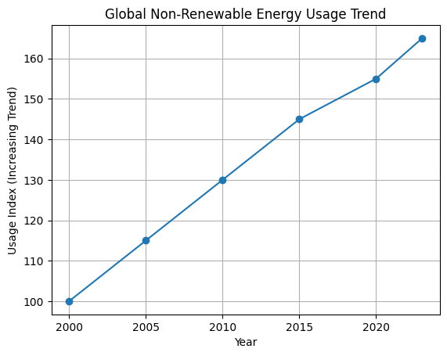

RENEWABLE ENERGY SOURCES OVERVIEW
At the center of the push for clean and sustainable energy sources are the so-called renewable energy sources. Unlike the nonrenewable energy sources, these energy sources do not pollute the environment. The five energy sources that have been the subject of the greatest study and development to date are solar energy, wind energy, hydropower, biomass, and geothermal energy. Each has its advantages and disadvantages, and to think about the future of energy, we need to be aware of the advantages and disadvantages of each

Solar Energy
One of the advantages of solar energy is that it is readily available. The sun shines on the earth, and its energy is readily available. The energy may be obtained either by the use of solar cells, whose function is to produce electricity, or by the use of solar thermostats. The technology has improved over the last decade, and the price has fallen to the point that solar energy is now among the cheapest ways to produce electricity.
One of the strengths of solar energy is the flexibility it provides. While a few solar panels can be used to power a single house, a solar farm can be used to power a city. It also does not emit any direct greenhouse gases during the process, which is a major advantage. However, the major disadvantage of solar energy is that it only works when the sun is shining. This means that there is a need for a backup system so that the energy generated is continuous. It does not work during the night or when it is cloudy.One of solar energy's real strengths is how flexibly it can be deployed. A handful of rooftop panels can power a single home; a sprawling solar farm can supply a city. It produces no direct emissions during operation, which is a meaningful environmental advantage. The well-known limitation is that solar output depends entirely on whether the sun is shining—overcast days and nighttime hours bring generation to a halt, making storage or backup capacity a necessity rather than a luxury.

Wind Energy
Wind energy is a form of energy that is produced through the utilization of wind. In the last two decades, wind energy has developed into a major form of electricity generation. Wind turbines have been built around the world, both onshore and offshore. Wind turbines have also become much more efficient in the last two decades. Wind energy is a major form of energy because of its cost-effectiveness. Once the wind turbine is built, it does not require much maintenance. It also does not emit any greenhouse gases. However, the major disadvantage of wind energy is that it is only available in a few geographic corridors. Wind energy is also dependent on the availability of wind. This means that the area must have wind that is strong enough to generate the required electricity. In addition, there have also been social problems related to wind energy. While wind energy is a major form of energy, it also creates noise.The economics of wind power are actually rather appealing, as once the wind farm is up, the operating costs are relatively low, and there is no emissions issue. The drawback, however, lies in the fact that wind power is location-dependent, as wind speeds are generally concentrated along specific geographic routes. Moreover, not all places can boast wind speeds fast enough to make a wind farm economically viable. Like solar, wind power is dependent upon prevailing weather conditions, which poses the same issue as with solar power.

Hydropower
The first hydropower plant was developed over a century ago, and today, hydropower is the largest source of renewable energy globally. The process involves harnessing the energy from flowing or falling water, whether from a river, dam, or tidal source, and converting this into electricity. The process is efficient, mature, and can provide continuous power, which is a major factor in making hydropower a valuable source.
The unique factor associated with hydropower lies in the fact that, as a form of renewable energy, hydropower can serve as a form of energy storage. Water can be pumped from a lower location to a higher location, which can be released as a form of electricity when there is a surge in demand. The drawback lies in the fact that, as a form of renewable energy, hydropower often requires the construction of dams, which often have devastating effects on the environment, as a river gets disrupted, and sometimes, human settlements have to be relocated. The drawback lies in the fact that hydropower construction is rather expensive, which limits the scope for developing hydropower plants.

Biomass Energy
Biomass energy utilizes biological material, like agricultural waste, wood, and crops, and burns the material to produce energy. The fact that the material used for energy production is readily available and can be produced in large quantities makes biomass energy a form of renewable energy. This, however, is provided that the energy cycle is carefully managed. The advantage of biomass energy is that it utilizes waste material, thus reducing the amount of waste and the problems associated with waste. It is a reliable form of energy, and its production does not depend on the weather. This is advantageous, especially when the energy is to be produced on a large scale. The disadvantages, however, include the fact that biomass energy produces greenhouse gases and the fact that its production requires large tracts of land, which could be used for the production of food crops..

Geothermal Energy
Geothermal energy utilizes the heat from the Earth's core to produce energy. The fact that the energy produced by geothermal plants does not depend on the weather, like solar and wind energy, makes geothermal energy a reliable form of energy. The fact that the plants operate on a continuous basis, seven days a week, makes geothermal energy the best form of energy for the production of electricity. The fact that the environmental impact is small, land usage is small, and the fact that the energy produced by geothermal plants is inexhaustible make geothermal energy a clean and environmental-friendly form of energy. The fact that geothermal energy requires large tracts of land and that the land has to be drilled to access the energy makes geothermal energy not very practical. The fact that the land has to be drilled and the fact that the land has to be in an active geologic zone makes geothermal energy not very practical.

ROLE IN FUTURE POWER SYSTEMS
Renewable energy isn’t merely increasing in scale; it’s also fundamentally changing the way in which power systems are organized. The model that was so prevalent for most of the last century—the few large power plants sending their energy outward through a one-way grid—is increasingly giving way to something more distributed, more flexible, and considerably more complex.
One of the most obvious changes is the growth of distributed power production, where power is generated much closer to where it will actually be consumed. This phenomenon of rooftop solar and small-scale wind farms is making ordinary consumers into what’s called a ‘prosumer’—a consumer of power and a producer of power at the same time. This has the obvious benefit of reducing power transmission costs; it also has a more significant effect on making the system more robust and less prone to cascading failures should one element of it go down.
Smart grids are what allow all this to happen on a large scale. Smart grids are networks of advanced sensors, communications networks, and computer programs that can monitor power flows in real-time and react to changes in supply and demand. They can also reroute power if something goes wrong. Smart grids also allow for demand response programs to happen on a large scale—in other words, industrial consumers can agree to reduce their power consumption during peak times in exchange for a lower rate. This flexibility is precisely what a grid with so many variable power inputs will need.
The other side of this equation is energy storage. Without this, a system that relies on solar and wind power will always be at the mercy of the elements. Lithium-ion batteries are now ubiquitous for short-term storage, and their costs have been dramatically lowered. For longer-term storage—through cloudy skies or calm winds that may last for days rather than hours—hydrogen and compressed air are also in development and attracting serious investment.
Another option that may become increasingly attractive in the future is a system of hybrid energy production. Rather than relying on a single form of alternative energy production, a hybrid system will often combine two or more types of production—such as solar and wind power, which complement rather than compete with one another—along with a system of energy storage. This allows for a system that will be more productive and less susceptible to the flaws of a single system.
The role of policy in all of this should also not be forgotten. International agreements on climate change, national policies on clean energy production and consumption, and subsidies for alternative energy development and research have all played a role in moving this sector forward. Without these, it seems unlikely that economics alone would have been enough to propel this movement.
The cumulative effect of all these changes seems to be that while renewable energy production may replace traditional energy production in many ways, it also seems to be creating a fundamentally new system of energy production and consumption—one that will be more decentralized, more interactive, and more conducive to meeting the challenges of a changing future.
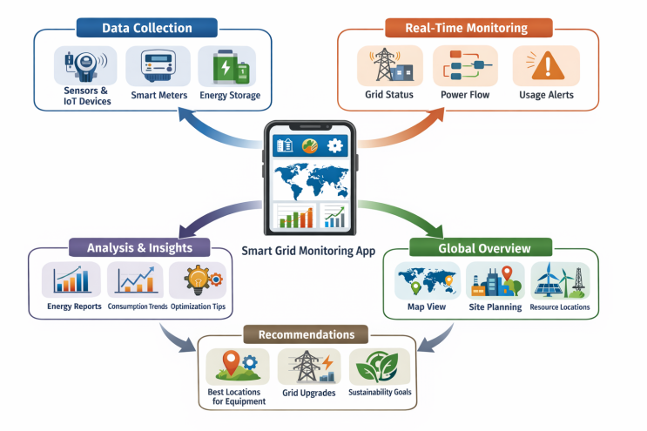

CHALLENGES IN RENEWABLE ENERGY INTEGRATION
Renewable energy sources have made tremendous progress, but the difficulties of integrating renewable energy into the power grid remain very real. There are a few challenges that can be considered to be very hard—not just engineering challenges to be overcome, but the tension between what these technologies can deliver and what a power system needs.

Intermittency and Variability
Perhaps the greatest challenge is the fundamental fact that the output of solar and wind power is not available when you want it to be available—it is available when the sun is shining and the wind is blowing. And the output can be quite variable—in fact, quite volatile. A solar power plant can be shut off by clouds in a matter of minutes, or the wind can die off over a wide region for days at a time. This creates a problem for the operators of the power grid, which must balance supply and demand at all times. The solution is typically to have backup power ready to go at a moment's notice—a problem which undercuts the original purposes of going renewable in the first place.

Energy Storage Limitations
The obvious solution to this problem of intermittency is to provide storage. This problem has been solved to a considerable degree with advances in battery technology. Lithium-ion batteries are a major beneficiary of these advances. However, there are limits to these solutions. For one thing, these batteries are made of costly and scarce materials. In addition, there are limits to their life and a problem of disposal when their life runs out. More significantly, however, the level of storage required to accommodate long periods of low levels of solar and wind power—such as cloudy and calm days in a row—far exceeds what can be done with current technology.

Grid Stability and Infrastructure Issues
The traditional power grid was designed with a number of predictable and controllable power plants. Adding a lot of intermittent power to these grids challenges many of these underlying assumptions. This can impact voltage and frequency stability and their ability to react to sudden changes in power output. Upgrading these grids to accommodate this issue can involve a number of costly solutions. This can include new transmission lines and more advanced technology and real-time monitoring. In many countries, these upgrades are well behind the level of development of renewable power.

High Initial Investment Costs
Renewable energy may be a low-cost solution to our energy future in the long run, but in the short run, it can be a costly solution. This can involve a number of costly investments in solar panels, wind turbines, and storage. This may not be a problem for more developed countries with access to cheap capital. For less developed countries that need more energy and need it now, this could be a problem.

Environmental and Land Use Concerns
It would be a mistake, however, to assume that renewable energy is benign in all its forms. Solar farms and wind farms, for example, need a lot of space. Getting the location wrong can cause problems for wildlife, stir up opposition, and cause other difficulties. Hydropower plants, on the other hand, have the potential to completely alter a river and force people to relocate. This does not mean that the problems identified above are reasons to dismiss the idea of using more renewable energy. What it does mean is that the shift to more renewables needs to be done well, not just fast

Policy and Regulatory Challenges
It's worth remembering that technology and finance have limits. Without a stable regulatory framework, the shift to more renewables will continue to be difficult. In some places, the rules governing the connection to the grid, the price of energy, and the trading of electricity across borders have simply not kept pace with what the technology is now able to offer. Getting the regulatory framework right is less glamorous than building a new wind farm, but it may be just as important

EMERGING TECHNOLOGIES AND SOLUTIONS
The problems identified above may be real, but so too is the ingenuity being applied to solve them. There are a number of different technologies being developed that have the potential to make a real contribution to a future where more renewable energy is used.

Energy Storage Technologies
Storage is perhaps the area where the greatest technological innovation is happening right now. Lithium-ion batteries remain the primary choice for shorter-duration storage, and improvements in manufacturing scale have helped lower costs considerably. However, the next generation of storage technologies is already being developed. Solid-state batteries have the potential to store more energy than the lithium-ion batteries currently deployed and last longer than their lithium-based counterparts. Hydrogen-based storage technologies have the potential to store energy for days or even weeks, as opposed to the hours afforded by lithium-ion batteries. The common factor here is the realization that the variability of renewable sources will require multiple storage technologies with different timescales to match the variable output.

Smart Grid Technologies
Smart grids are moving from the concept to the operational reality stage in a variety of markets around the world. They utilize the power of sensors, two-way communication systems, and sophisticated control algorithms to allow grid operators to see everything that is happening on their grid in real-time. This enables demand response systems to be implemented easily, where large consumers of power can be incentivized to reduce their usage as required by the grid operators. The result is a grid system that is far more robust and can handle the variable output of renewable sources with greater ease than traditional grid systems.

Hybrid Energy Systems
The concept of hybrid systems is quite simple: why use just one form of renewable energy when you can use two or more in such a way that the disadvantage of each is canceled out? The two best candidates to be paired together are solar and wind power, as these tend to be at their best at different times of day or night and under different weather conditions. The addition of storage to the list of hybrid systems is also a good idea to help balance things out. Hybrid systems can be set up to be off-grid or grid-connect, and represent a compromise between putting all your eggs in the basket of a single technology or the complexity of managing dozens of different sources.

Advanced Grid Infrastructure
Finally, the problem of moving the power generated from where the renewable sources are to where the people are can be solved with the help of high-voltage direct current transmission technology, which reduces losses to a tiny fraction of what they would be with traditional alternating current lines. Flexible AC transmission systems can be thought of as a refinement of the above technology, allowing grid operators to control the flow of power with greater precision. Together, these technologies allow us to consider the possibility of a grid of renewable energy sources on a continental scale

Artificial Intelligence and IoT in Energy Management
Artificial intelligence and IoT devices are becoming increasingly common tools in modern energy management. Artificial intelligence algorithms can increasingly be found making predictions regarding both demand and renewable energy output, predicting how much solar power can be expected tomorrow, or predicting demand increases tomorrow. The ability to make these kinds of predictions allows for more efficient operation and reduces the need for expensive back-up power. IoT devices, placed strategically throughout the grid, provide real-time information that can be used to more efficiently operate the assets that are already available. As these technologies continue to advance, they will increasingly be a part of making variable renewable energy sources more compatible with a reliable grid operation.

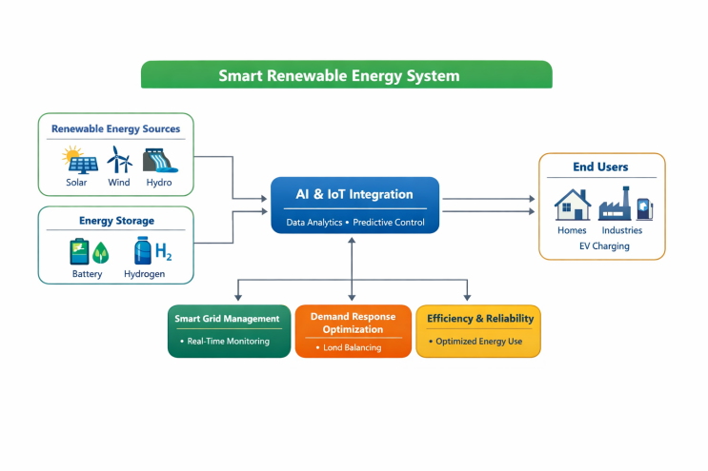

CONCLUSION
The case for renewable energy has never been more compelling, or more pressing. The increasing global demand for energy, the growing cost of global climate change, and the finite supply of fossil fuels all argue in favor of a quick and lasting change to more environmentally friendly sources of power. The goal of this paper has been to survey the state of the major forms of renewable energy, what they might realistically be expected to provide, and what still needs to be worked out.
Solar and wind have clearly emerged as major contributors to global electric power production, driven by advances and reductions in costs that have clearly outstripped most analysts’ ability to predict. Hydro power continues to provide a stable, reliable electric power supply for a number of countries. Biomass can provide a flexible and useful application for what would otherwise be wasted resources. Geothermal can provide a reliable, stable electric power supply for those regions that have access to this valuable resource. All of these technologies have a role to play, and all of them, by themselves, are not sufficient.
These challenges are as real as the opportunities. For instance, intermittency, storage, infrastructure, capital, and policy fragmentation need to be addressed, but not sequentially, as each issue is related to the others. Energy storage is closely related to the issue of intermittency. Smart grids have a close relationship with the efficiency of using diverse forms of renewable energy. On the other hand, policy stability is closely related to the availability of private capital.
The technologies discussed in this paper—advanced energy storage, smart grids, hybrid energy, HVDC transmission, and AI-based technologies—are the state-of-the-art solutions to the challenges associated with the increased use of renewable energy. Although these technologies are not yet fully developed and their deployment will take some time and investment, the direction is clear. A diversified mix of renewable energy, facilitated by smart grids and backed by policy stability, is the only viable solution to a sustainable and reliable source of energy.

Acknowledgment
The authors would like to thank Chitkara University Institute of Engineering and Technology for the institutional support and academic environment to undertake this research. We would also like to thank the faculty members for their support and guidance throughout the research and paper-writing process. They have significantly influenced the direction and quality of this paper..
.
REFERENCES

[1] International Energy Agency (IEA), “World Energy Outlook 2023,” IEA Publications, 2023.

[2] REN21, “Renewables 2024 Global Status Report,” Renewable Energy Policy Network for the 21st Century, 2024.

[3] T. Ackermann, “Wind Power in Power Systems,” 2nd ed., John Wiley & Sons, 2012.

[4] J. A. Duffie and W. A. Beckman, “Solar Engineering of Thermal Processes,” 4th ed., Wiley, 2013.

[5] B. K. Sovacool, “The Dirty Energy Dilemma: What’s Blocking Clean Power in the United States,” Praeger, 2008.

[6] M. Z. Jacobson and M. A. Delucchi, “Providing all global energy with wind, water, and solar power,” Energy Policy, vol. 39, no. 3, pp. 1154–1169, 2011.

[7] N. S. Lewis, “Research opportunities to advance solar energy utilization,” Science, vol. 351, no. 6271, 2016.

[8] A. Lund, B. V. Mathiesen, and D. Connolly, “Smart energy systems for coherent 100% renewable energy and transport solutions,” Applied Energy, vol. 145, pp. 139–154, 2015.

[9] H. Lund, “Renewable energy systems: A smart energy systems approach to the choice and modeling of 100% renewable solutions,” Academic Press, 2014.

[10] S. A. Kalogirou, “Solar Energy Engineering: Processes and Systems,” 2nd ed., Academic Press, 2014

