

**A PROJECT REPORT**

**ON**

### Bridge Between Investors and Business peoples

**Submitted By:**

**Mannan Malik Shaikh (Roll no- 223332)**

**Under the guidance Prof. Leena Patil.**

**Submitted To**

**Savitribai Phule Pune University**

**As a partial fulfilment for the award of the degree of MASTER OF COMPUTER APPLICATIONS**

At

**ASM’s Institute of Business Management and Research, MCA Institute, Chinchwad, Pune –411019**

**A.Y.:**

**ACKNOWLEDGEMENT**

It is a pleasure to acknowledge the assistance of several people and institutions in this effort. This project has turned me into a debtor. First and foremost, I feel indebted to my guide ***Ms.Leena Patil*** and all the faculty members of Department of MCA, ASM’s IBMR, MCA Institute Chinchwad for their valuable guidance,continuous support and advice and constant encouragement throughout my project work.

I would like to extend my gratitude to honorable **Dr. V. P. Pawar Sir, Director, ASM’s IBMR, MCA Institute, Chinchwad** for being a constant source of inspiration.

Finally, I would like to extend my thanks to all those who have contributed, directly or indirectly to make this project successful.

**Mannan Shaikh(223332)**

**Index**

|  |  |  |
| --- | --- | --- |
| **Chapter** | **Topic** | **Page No.** |
| **1** | **INTRODUCTION** | 5 |
| 1.1 | Company Profile/ Institute Profile | 5 |
| 1.2 | Abstract | 6 |
| 1.3 | Existing System and Need for System | 7 |
| 1.4 | Scope of System | 9 |
| 1.5 | Operating Environment- Hardware and Software | 10 |
| 1.6 | Brief Description of Technology Used | 11 |
| **2** | **PROPOSED SYSTEM** | 17 |
| 2.1 | Study of Similar Systems (Literature Survey) | 18 |
| 2.2 | Feasibility Study | 19 |
| 2.3 | Objectives of Proposed System | 27 |
| 2.5 | User Requirements | 28 |
| **3** | **ANALYSIS & DESIGN** | 29 |
| 3.1 | System Requirements (Functional and Non-Functional Survey) | 30 |
| 3.2 | Data Flow Diagrams (DFD) | 33 |
| 3.3 | Entity Relationship Diagram (ERD) | 36 |
| 3.4 | Table Structure | 37 |
| 3.5 | Use Case Diagrams | 38 |
| 3.6 | Class Diagram | 39 |
| 3.7 | Activity Diagram | 39 |
| 3.8 | Sequence Diagram | 40 |
| 3.9 | Deployment Diagram | 40 |
| 3.10 | Component Diagram | 40 |
| 3.11 | User Interface Designs | 41 |
|  | | |

|  |  |  |
| --- | --- | --- |
| 3.12 | Report | 48 |
| **4** | **CODING** | 49 |
| 4.1 | Algorithms | 50 |
| 4.2 | Code Snippet (Sample Code) | 51 |
| **5** | **TESTING** | 62 |
| 5.1 | Test Strategy | 63 |
| 5.2 | Test Case / Test Script | 64 |
| 5.3 | Defect Report / Test Log | 65 |
| **6** | **LIMITATIONS OF PROPOSED SYSTEM** | 68 |
| **7** | **PROPOSED ENHANCEMENTS** | 69 |
| **8** | **CONCLUSION** | 71 |
| **9** | **BIBLIOGRAPHY** | 73 |
| **10** | **USER MANUAL** | 73 |

**CHAPTER 1**

**INTRODUCTION**

### 1.2 Abstract

In today's dynamic economic landscape, fostering connections between investors and business professionals is crucial for driving innovation and growth. The "Bridge between Investors and Business People" project aims to create a comprehensive digital platform that facilitates seamless interactions, collaborations, and transactions between these two pivotal groups.

By leveraging advanced algorithms and data analytics, the platform will match investors with promising business opportunities tailored to their interests and investment criteria. Additionally, it will provide business professionals with access to a diverse pool of potential investors, enhancing their ability to secure necessary funding and strategic partnerships.

Key features of the platform include a user-friendly interface, secure communication channels, detailed profiles, and real-time updates on market trends and investment opportunities. This project seeks to streamline the investment process, reduce barriers to entry, and ultimately contribute to a more vibrant and interconnected business ecosystem.

### Existing System & need of System

### Existing System:- Pappyon: Business Networking

Pappyon is an innovative business networking platform designed to facilitate connections and collaborations among professionals across various industries. It offers a streamlined approach to managing and expanding professional networks by integrating multiple functionalities into a single, user-friendly interface. The system is comprised of three primary modules: Streamline, Connect, and Network.

**1. Streamline: Centralizing Contact Information and Social Links**

The Streamline module focuses on consolidating all relevant contact information and social media links into one easily accessible location. This feature allows users to:

* **Create Comprehensive Profiles**: Users can build detailed profiles that include their contact details, professional background, and links to social media accounts such as LinkedIn, Twitter, and personal websites.
* **Organize Information**: All contact information is organized in a clear and concise manner, making it simple for users to manage their connections.
* **Ease of Access**: By centralizing contact info, users can quickly share their profiles with others, ensuring they present a complete and professional image.

**2. Connect: Facilitating In-Person and Virtual Connections**

The Connect module is designed to help users establish and maintain connections, whether in-person or virtually. This module includes:

* **Easy Sharing**: Users can share their profiles and contact information effortlessly via QR codes, email, or direct links, facilitating quick and efficient networking at events and meetings.
* **Virtual Meetings**: The platform supports virtual networking through integrated video conferencing tools, allowing users to connect with professionals from around the world.
* **Event Integration**: Users can sync their profiles with event management systems to enhance their networking opportunities at conferences, seminars, and workshops.

**Need for System:**

Need for a Business Investment System

1. Establish a Robust Online Platform:

- Develop a user-friendly central hub where investors and business owners can interact and collaborate seamlessly.

2. Facilitate Networking Opportunities:

- Create opportunities for investors and entrepreneurs to connect, fostering partnerships and investment opportunities.

3. Enhance Financial Literacy:

- Include educational resources to improve financial knowledge, helping users make informed investment and collaboration decisions.

4. Ensure Secure Transactions:

- Integrate strong security measures to protect financial information and transactions, building trust among users.

5. Streamline Application Processes:

- Design efficient application processes to reduce bureaucratic hurdles, making it easier for investors and business owners to engage with the platform.

6. Offer Diverse Investment Options:

- Provide various investment opportunities, catering to different investor preferences and risk levels, from small ventures to larger enterprises.

**1.4 Scope of System**

The scope of the proposed project is expansive and multifaceted, encompassing various dimensions of the investment ecosystem in India. Key aspects of the project scope include:

Digital Platform Development: The project involves the creation of a sophisticated digital platform that serves as acomprehensive marketplace, connecting investors and entrepreneurs seamlessly. This platform will feature user-friendly interfaces, secure transaction capabilities, and real-time data analytics.

UserOnboarding and Education: The scope extends to developing onboarding processes that cater to both investors and entrepreneurs, ensuring a smooth and efficient experience. Additionally, the project includes educational components to enhance financial literacy among users, empowering them to make informed decisions.

Networking and Collaboration: The platform aims to facilitate meaningful connections by providing networking opportunities for investors and entrepreneurs. The scope involves implementing features such as forums, webinars, and events to encourage collaboration and partnerships.

Security Measures: Security is a paramount concern, and the project encompasses the integration of robust cybersecurity measures to safeguard sensitive financial information and transactions, instilling trust among users.

Diverse Investment Options: The platform will offer a diverse range of investment opportunities, catering to various scales and industries. This inclusivity ensures that investors with different risk appetites and preferences can find suitable ventures.

.

* 1. **Operating Environment - Hardware and Software**

|  |  |
| --- | --- |
| **HARDWARE SPECIFICATION** | |
| Operating System | Windows 7 and above |
| Processor | Pentium 4 RAM- 512 Mb. |
| RAM | 2 GB |
| Hard Disk | 1 TB |

|  |  |
| --- | --- |
| **SOFTWARE SPECIFICATION** | |
| Operating System | Windows 7 Ultimate |
| Technologies Used | HTML, CSS3, Java |
| Front End | HTML5, CSS, JavaScript |
| Coding Language | Python |
| Database Server | SQLlite3 |

**1.6 Brief Description of Technology Used**

**HTML 5**

HTML is the standard markup language for creating Web pages.

* + - HTML stands for Hyper Text Markup Language.
    - HTML describes the structure of Web pages using markup.
    - HTML elements are represented by tags.
    - HTML tags label pieces of content such as "heading", "paragraph", "table", and so on.

HTML is designed to work on a wide variety of platforms. Not just on computers but also on a wide variety of graphical workstations, dumb terminals, network computers, hand-held devices etc. It is a platform independent, browser independent and not dependent on any particular piece of software and can be written in any text editor, we can work with HTML anywhere and on any machine.

**Advantages of HTML5**

* **Improved User Experience**: Rich multimedia support and new form features enhance the user interface and interaction.
* **Better Performance**: Enhanced JavaScript performance, web workers, and other APIs provide more efficient web applications.
* **Cross-Platform Compatibility**: Designed to work on all modern browsers and devices, including mobile.
* **Cleaner Code**: New semantic elements help create cleaner, more readable, and maintainable code.
* **Enhanced Accessibility**: Semantic tags improve accessibility for screen readers and other assistive technologies.

**Django Framework**

Django is a high-level, open-source web framework for Python that encourages rapid development and clean, pragmatic design. Created by experienced developers, it handles much of the hassle of web development, allowing developers to focus on writing their app without needing to reinvent the wheel.

**Key Features**

1. **MTV Architecture**:
   * Django follows the Model-Template-View (MTV) architectural pattern, which is similar to the Model-View-Controller (MVC) pattern. This design helps separate concerns and organize code logically.
2. **Object-Relational Mapping (ORM)**:
   * Django includes a powerful ORM that allows developers to interact with databases using Python code instead of SQL. It supports multiple database backends, including PostgreSQL, MySQL, SQLite, and Oracle.
3. **Automatic Admin Interface**:
   * One of Django’s standout features is its automatic admin interface, which can be generated from your models and allows administrators to manage data through a web-based interface without any additional coding.
4. **URL Routing**:
   * Django provides a flexible URL dispatcher that maps URL patterns to views. This makes it easy to design clean and readable URLs for your web application.
5. **Template System**:
   * Django’s templating engine enables you to define HTML templates with placeholders for dynamic content, making it easy to separate the presentation layer from business logic

**Python**

Python is a high-level, interpreted programming language known for its simplicity and readability. Created by Guido van Rossum and first released in 1991, Python has grown to become one of the most popular programming languages in the world due to its versatility and ease of use.

**Key Features**

1. **Readability and Simplicity**:
   * Python's syntax is clear and concise, making it easy to read and write. Its use of indentation to define code blocks enhances readability and reduces the likelihood of syntax errors.
2. **Interpreted Language**:
   * Python is an interpreted language, which means that code is executed line by line, making debugging and testing easier. This allows for rapid development and iteration.
3. **Dynamically Typed**:
   * Python is dynamically typed, meaning that you don’t need to declare variable types explicitly. The interpreter assigns the type at runtime based on the variable's value.
4. **Versatile and Cross-Platform**:
   * Python can run on various operating systems, including Windows, macOS, and Linux. This cross-platform capability makes it a versatile choice for developers.
5. **Extensive Standard Library**:
   * Python comes with a comprehensive standard library that provides modules and functions for tasks such as file I/O, system calls, and data manipulation, reducing the need to write code from scratch.
6. **Large Ecosystem of Libraries and Frameworks**:
   * Python boasts a rich ecosystem of third-party libraries and frameworks, such as NumPy and pandas for data analysis, Django and Flask for web development, and TensorFlow and PyTorch for machine learning.
7. **Object-Oriented and Functional Programming**:
   * Python supports multiple programming paradigms, including object-oriented, imperative, functional, and procedural programming styles.

**Common Use Cases of Python**

1. **Web Development**:
   * Python is widely used for web development, with frameworks like Django and Flask enabling developers to build robust and scalable web applications quickly.
2. **Data Science and Machine Learning**:
   * Python is the go-to language for data science, machine learning, and artificial intelligence. Libraries such as NumPy, pandas, scikit-learn, and TensorFlow facilitate data analysis, statistical computing, and model building.
3. **Scripting and Automation**:
   * Python is often used for writing scripts to automate repetitive tasks, such as file manipulation, web scraping, and system administration.
4. **Scientific Computing**:
   * Researchers and scientists use Python for scientific computing and simulations, leveraging libraries like SciPy and Matplotlib for mathematical operations and data visualization.
5. **Software Development**:
   * Python is used in developing various types of software, from desktop applications with GUI frameworks like Tkinter to game development with Pygame.

**SQLlite3**

SQLite3 is a lightweight, self-contained, serverless, and transactional SQL database engine. It is widely used for local storage in various applications due to its simplicity, portability, and ease of integration. SQLite3 is embedded within the end program, making it a popular choice for local or small-scale database needs.

Key Features of SQLite3

1. Self-contained: SQLite is a single library that integrates seamlessly into the application.
2. Zero Configuration: No setup or administration needed. It does not require a server to run.
3. Serverless: Operates directly from disk files, simplifying the database architecture.
4. Cross-Platform: Works on various operating systems like Windows, Linux, and macOS.
5. Transactional: Supports ACID (Atomicity, Consistency, Isolation, Durability) properties, ensuring reliable transactions.
6. Compact: Very small footprint (a few megabytes), suitable for embedded systems.

**Using SQLite3 in Python**

Python provides built-in support for SQLite via the sqlite3 module. This makes it straightforward to create and manage SQLite databases within Python applications**.**

**Using SQLite3 with Django**

Django uses SQLite3 as its default database, making it easy to start development without additional database configuration.

**Setting Up Django with SQLite3**

1. Install Django:

pip install Django

1. Create a Django Project:

django-admin startproject myproject

cd myproject

1. Database Configuration:

By default, Django uses SQLite3. This configuration is in myproject/settings.py:

DATABASES = {

'default': {

'ENGINE': 'django.db.backends.sqlite3',

'NAME': BASE_DIR / 'db.sqlite3',

}

}

1. Define Models:

In myapp/models.py, define your data models:

from django.db import models

class Article(models.Model):

title = models.CharField(max_length=200)

content = models.TextField()

published_date = models.DateTimeField(auto_now_add=True)

def __str__(self):

return self.title

**Advantages of Using SQLite3:**

* Simplicity: Easy to set up and use, ideal for development and testing.
* Portability: The entire database is stored in a single file, making it easy to move around.
* Integrated: Built into Python, so no additional setup is required.

**Limitations**

* Concurrency: Not designed for high-concurrency environments.
* Scalability: Suitable for small to medium-sized applications; for larger applications, consider using databases like PostgreSQL or MySQL.

**Resources**

* SQLite Documentation: [docs.python.org/sqlite3](https://docs.python.org/3/library/sqlite3.html)
* Python SQLite3 Documentation: [docs.python.org/sqlite3](https://docs.python.org/3/library/sqlite3.html)
* Django Documentation: [docs.djangoproject.com](https://docs.djangoproject.com/)

# CHAPTER 2 PROPOSED SYSTEM

### Study Of Similar System (Literature Survay) :-

|  |  |  |  |
| --- | --- | --- | --- |
| Sr No | Application Name | Modules | Remarks |
| 1 | Digital Business | 3 | Complex UI |
| 2 | Business Suit | 4 | Expensive, app running slow. |
| 3 | Bijnis sourcing app | 5 | Customization not allowed. |
| 4 | Pappyon: Business Networking | 3 | Complex UI and payment options. |

* 1. **Feasibility Study: -**

The feasibility of the project is analyzed in this phase and business proposal is put forth with a very general plan for the project and some cost estimates. During system analysis the feasibility study of the proposed system is to be carried out. This is to ensure that the proposed system is not a burden to the company. For feasibility analysis, some understanding of the major requirements for the system is essential.

A feasibility study serves as a critical compass for organizations and decision- makers, guiding them through the initial stages of project planning by evaluating the viability and potential success of a proposed endeavor. This comprehensive analysis takes into account various factors to determine whether a project is worth pursuing from technical, financial, operational, and strategic perspectives.

#### Introduction to Feasibility Study:

A feasibility study is a systematic and disciplined approach to evaluating the practicality and potential of a project before committing substantial resources. It offers a structured framework for assessing the project's chances of success, identifying potential risks, and providing stakeholders with the information needed to make informed decisions. The primary goal of a feasibility study is to minimize uncertainties and enhance the likelihood of achieving the project's objectives.

Three key considerations involved in the feasibility analysis are

* + 1. ECONOMICAL FEASIBILITY
    2. TECHNICAL FEASIBILITY
    3. SOCIAL FEASIBILITY

#### ECONOMICAL FEASIBILITY

This study is carried out to check the economic impact that the system will have on the organization. The amount of fund that the company can pour into the research and development of the system is limited. The expenditures must be justified. Thus the developed system as well within the budget and this was achieved because most of the technologies used are freely available. Only the customized products had to be purchased.

Economical feasibility is a pivotal aspect of the overall feasibility study process that focuses specifically on assessing the financial viability of a proposed project. It involves a comprehensive analysis of the project's costs and potential benefits to determine whether the investment is economically justifiable. This assessment is crucial for making informed decisions about whether to proceed with a project, as it directly impacts an organization's financial health and long-term sustainability.

**Importance of Economical Feasibility:**

Economical feasibility addresses the fundamental question: Is the project financially worthwhile? This aspect of the feasibility study delves into the financial implications of the project and provides decision-makers with insights into the potential returns, risks, and overall financial impact. It helps organizations allocate resources wisely, avoid wastage, and ensure that projects align with their financial goals and constraints.

Economical feasibility is a critical checkpoint in the feasibility study process. It empowers organizations to assess the financial viability of a project, make informed investment decisions, and allocate resources efficiently. By estimating costs, analyzing potential benefits, calculating financial metrics, and considering risks, organizations can determine whether a project aligns with their financial objectives and contributes positively to their bottom line. An in-depth analysis of economical feasibility ensures that projects are pursued with a clear understanding of their financial implications and a higher likelihood of achieving desired financial outcomes.

### TECHNICAL FEASIBILITY

This study is carried out to check the technical feasibility, that is, the technical requirements of the system. Any system developed must not have a high demand on the available technical resources. This will lead to high demands on the available technical resources. This will lead to high demands being placed on the client. The developed system must have a modest requirement, as only minimal or null changes are required for implementing this system.

Technical feasibility is a crucial aspect of the feasibility study process that focuses on evaluating whether a proposed project can be successfully implemented from a technological standpoint. This assessment involves analyzing the project's technical requirements, constraints, and potential challenges to determine whether the necessary

technology, resources, and expertise are available to bring the project to fruition. Importance of Technical Feasibility:

Technical feasibility addresses the question: Can the project be built using existing technology and resources? This aspect of the feasibility study helps organizations assess whether the project aligns with their technical capabilities and infrastructure. It ensures that the project's objectives can be achieved without encountering insurmountable technical obstacles or risks.

#### Key Components of Technical Feasibility:

**Technology Availability:**

The first step in technical feasibility is to evaluate whether the required technology is available. This includes software, hardware, tools, and other resources necessary for project development and implementation. If the necessary technology is not readily available, it may result in delays, increased costs, or even project failure.

#### Resource Availability:

Beyond technology, technical feasibility also considers the availability of human resources with the required skills and expertise. This includes programmers, engineers, designers, and other specialists needed to develop, test, and maintain the project. The availability of skilled personnel is essential for successful project execution.

#### Infrastructure Compatibility:

Technical feasibility involves assessing whether the project's technical requirements are compatible with the existing IT infrastructure and systems of the organization. Compatibility issues could arise if the project requires integration with legacy systems or if it requires substantial modifications to the existing technology stack.

#### Risk Assessment:

Identifying potential technical risks and challenges is a crucial part of technical feasibility. This includes considering factors such as system crashes, data loss, security vulnerabilities, scalability issues, and other technical roadblocks that might arise during project development and implementation.

#### Scalability and Performance:

Technical feasibility examines whether the project can handle increased workloads and demands as it grows over time. Scalability ensures that the system can accommodate additional users, data, and transactions without significant performance degradation.

#### Development Timeframe:

The project's development timeframe is another critical consideration. Technical feasibility assesses whether the project can be completed within the specified time constraints while meeting quality standards. Delays in development could lead to missed opportunities or increased costs.

#### Proof of Concept (PoC) and Prototyping:

In cases where technical feasibility is uncertain, organizations might develop a Proof of Concept (PoC) or prototype. A PoC is a small-scale version of the project that demonstrates the feasibility of key technical aspects. A prototype, on the other hand, is a working model that provides a tangible representation of the final product's functionality and design.

#### Conclusion:

Technical feasibility serves as a foundational assessment that determines whether a project's technical requirements align with the organization's capabilities and resources. By evaluating technology availability, resource readiness, infrastructure compatibility, scalability, and potential risks, organizations can make informed decisions about the project's technical viability. A comprehensive understanding of technical feasibility contributes to successful project execution, minimizes technical challenges, and increases the likelihood of delivering a high-quality solution that meets stakeholders' expectations.

#### SOCIAL FEASIBILITY

The aspect of study is to check the level of acceptance of the system by the user. This includes the process of training the user to use the system efficiently. The user must not feel threatened by the system, instead must accept it as a necessity. The level of acceptance by the users solely depends on the methods that are employed to educate the user about the system and to make him familiar with it. His level of confidence must be raised so that he is also able to make some constructive criticism, which is welcomed, as he is the final user of the system.

Social feasibility is a crucial dimension of the feasibility study process that examines the potential impact of a proposed project on society, communities, and stakeholders. This assessment focuses on understanding the project's alignment with social values, norms, and expectations, as well as its potential to generate positive or negative effects on the broader social fabric.

**Importance of Social Feasibility:**

Social feasibility addresses the question: Will the project be accepted and welcomed by society? This aspect of the feasibility study recognizes that projects do not exist in isolation but are part of a larger social context. Evaluating social feasibility helps organizations anticipate public perceptions, mitigate social risks, and build positive relationships with stakeholder.

#### Key Components of Social Feasibility:

**Stakeholder Engagement:**

Engaging with relevant stakeholders, including community members, interest groups, regulatory bodies, and local authorities, is a central aspect of social feasibility assessment. Understanding their perspectives, concerns, and expectations helps organizations align the project with social needs and values.

#### Cultural and Ethical Considerations:

Different cultures and societies have varying norms, values, and ethical standards. Social feasibility involves evaluating whether the project respects and aligns with the cultural and ethical sensitivities of the target audience.

#### Social Acceptance:

This component examines whether the project will be embraced by the community or society at large. Positive social acceptance can lead to smoother implementation, while negative sentiment might result in protests, legal challenges, or reputational damage.

#### Community Impact:

Social feasibility assesses the project's potential impact on local communities. This includes evaluating whether the project will generate employment opportunities, contribute to economic growth, enhance quality of life, or disrupt existing social structures.

#### Environmental Impact:

While not exclusively social, environmental considerations are closely tied to social feasibility. Projects that negatively impact the environment can lead to public outcry and legal action, affecting the project's social acceptance and reputation.

#### Corporate Social Responsibility (CSR):

Organizations are increasingly expected to demonstrate social responsibility. Social feasibility considers whether the project aligns with the organization's CSR initiatives and commitments, which can influence public perception and stakeholder engagement. Public Relations and Communication Strategy:

A well-defined communication strategy is vital for managing social feasibility. Effective communication helps organizations address concerns, clarify misconceptions, and demonstrate how the project's benefits outweigh potential drawbacks.

#### Social Impact Assessment (SIA):

In cases where the project's potential social impact is significant, a Social Impact Assessment (SIA) may be conducted. An SIA is a systematic process that evaluates the social consequences of a project before it is implemented. It includes methodologies for data collection, analysis, and mitigation planning to ensure that the project's effects are understood and managed.

#### Conclusion:

Social feasibility assessment recognizes the interplay between projects and the societies in which they operate. By engaging with stakeholders, understanding cultural contexts, evaluating social acceptance, and considering the project's broader impact, organizations can make informed decisions that align with societal values and expectations. Ensuring positive social feasibility contributes to building a solid foundation of trust, collaboration, and sustainable development, enhancing the project's chances of success and minimizing potential conflicts.

### Objective of Proposed System:-

* Establish a Robust Online Platform: Develop and launch a user-friendly online platform that serves as a central hub for both investors and business owners, fostering seamless interaction and collaboration.
* Facilitate Networking Opportunities: Create avenues for networking between investors and entrepreneurs, encouraging meaningful connections that can lead to mutually beneficial partnerships and investment opportunities.
* Enhance Financial Literacy: Implement educational resources within the platform to enhance financial literacy among both investors and business individuals, empowering them to make informed decisions about investments and collaborations.
* Ensure Secure Transactions: Prioritize the integration of robust security measures within the platform to safeguard sensitive financial information and transactions, fostering trust among users.
* Streamline Application Processes: Develop efficient and streamlined application processes for both investors and business owners, minimizing bureaucratic hurdles and enhancing the overall user experience.
* Offer Diverse Investment Options: Provide a range of investment options, from small-scale ventures to larger enterprises, catering to the diverse preferences and risk appetites of potential investors.

### 2.4 User Requirement:-

* Requirement Analysis means studying or observing the current Business System to find how it works and where improvement can be made. It may include ways of capturing or processing data, producing information, or supporting management.
* The First step of System Analysis is the identification of need. In this regard a series of interviews were conducted with authorized person of the institution. This was essential so as to know the processes that were being followed.
* Requirements analysis is a software engineering task that bridges the gap between system level software allocation and software design.

**System**

**Engineering**

**Software**

**Design**

**Software**

**Requirements**

**Analysis**

# CHAPTER 3 ANALYSIS

**& DESIGN**

### 3.1 System Requirement (Functional And Non functional)

**Functional Requirement :-**

Modules are as followed:

* **User**

1. Register and login

2. View Business Categories

* **Business People**

1. Register and login

2. Post Idea

* **Investors**

1. Register and login

2. View Business Proposal

3. Post Investor Proposal

**• banker**

1. Register and login

2. Post loan details

**• Business Advisor**

1. Register and login

2. Post Information

**Non-Functional Requirements:**

1. Performance:
   * The system should be responsive and provide quick response times to user actions.
   * The system should be able to handle a large number of concurrent users without significant performance degradation.
2. Usability:
   * The user interface should be intuitive, user-friendly, and easy to navigate.
   * The system should provide clear and concise instructions to guide users in completing tasks.
   * The system should support multiple languages to accommodate users from diverse backgrounds.
3. Reliability:
   * The system should have a high level of availability, minimizing downtime for maintenance and updates.
   * The system should be able to recover quickly in the event of a failure or system crash.
   * The system should ensure data integrity and prevent data loss or corruption.
4. Security:
   * User data, including personal information and resumes, should be securely stored and protected.
   * User authentication and access control mechanisms should be implemented to prevent unauthorized access to sensitive information.
   * The system should be protected against common security threats, such as SQL injection, cross-site scripting (XSS), and cross-site request forgery (CSRF).
5. Scalability:
   * The system should be scalable to accommodate an increasing number of users and job postings.
   * The system should be able to handle a growing database of user accounts, job vacancies, and training programs without significant performance degradation.
6. Compatibility:
   * The system should be compatible with different web browsers and operating systems commonly used by the target user base.

* The system should be designed to integrate with other relevant systems or platforms, such as applicant tracking systems or HR management systems.

1. Maintainability:
   * The system should be designed with clean and modular code to facilitate ease of maintenance and future enhancements.
   * Documentation, including system architecture, code documentation, and user manuals, should be provided to support system maintenance and updates.
2. Compliance:
   * The system should adhere to relevant laws and regulations regarding user privacy, data protection, and equal employment opportunities.
   * The system should comply with accessibility standards, ensuring that users with disabilities can access and use the platform effectively.

### 3.2 Data Flow Diagrams (DFD) :-

### Zero Level Diagram :-

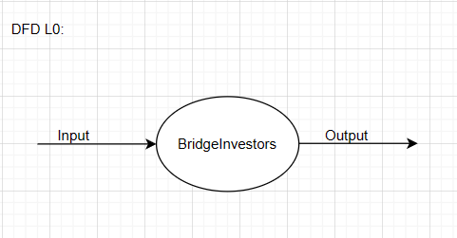

**DFD Level 1 Diagram:**

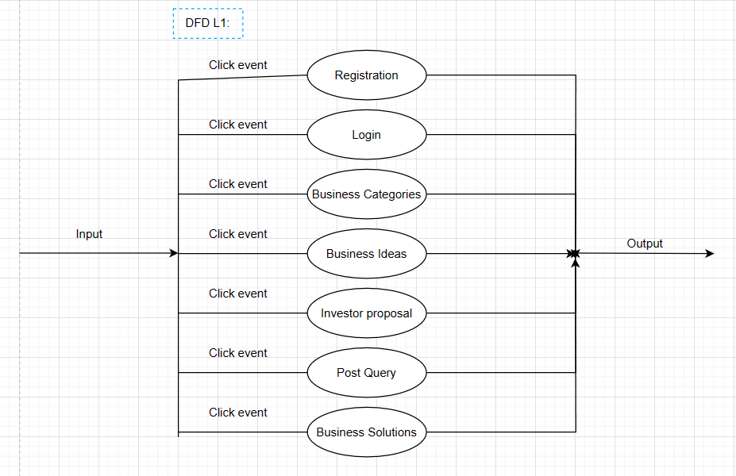

**DFD Level 2 Diagram:**

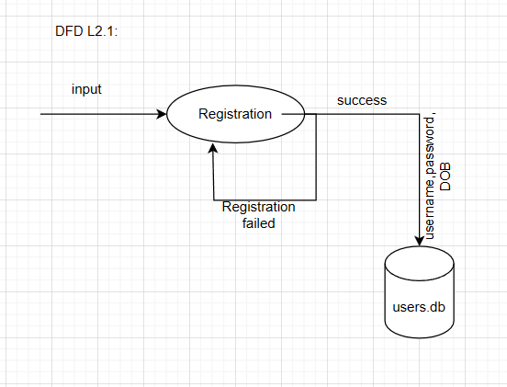

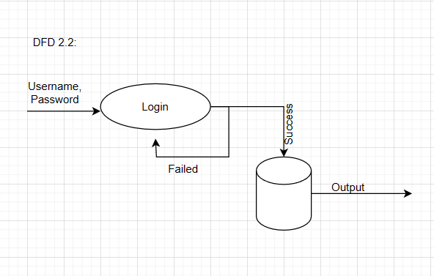

* 1. **Entity Relationship Diagram :-**

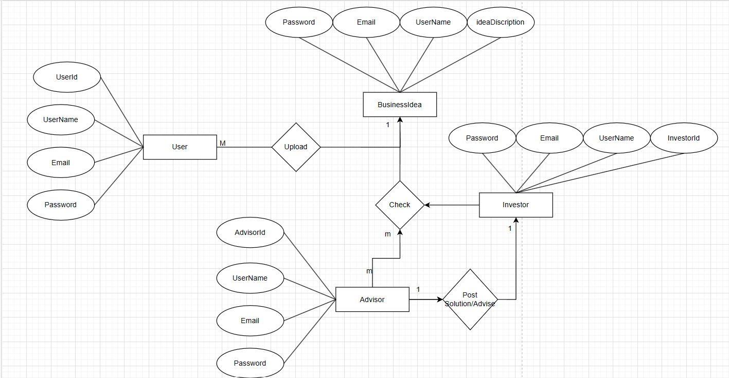

* 1. **Table Structure:**

1. **Users Table**

|  |  |  |
| --- | --- | --- |
| **Field Name** | **Data Type** | **Description** |
| user_id | INT (Primary Key) | Unique identifier for users |
| username | VARCHAR(50) | Username of the user |
| email | VARCHAR(50) | Email address |
| password | VARCHAR(50) | Hashed password |

**Posts Table**:

|  |  |  |
| --- | --- | --- |
| **Field Name** | **Data Type** | **Description** |
| post_id | INT (Primary Key) | Unique identifier for posts |
| Post_desc | VARCHAR(50) | Post context |
| user_name | VARCHAR(50)(Foreign Key) | User name to show on respective posts |

**Profile Table**:

|  |  |  |
| --- | --- | --- |
| **Field Name** | **Data Type** | **Description** |
| user_name | VARCHAR(50) (Foreign Key) | User name to show on respective posts |
| username | VARCHAR(50) | Username of the user |
| email | VARCHAR(50) | Email address of user |

**Use Case Diagram:**

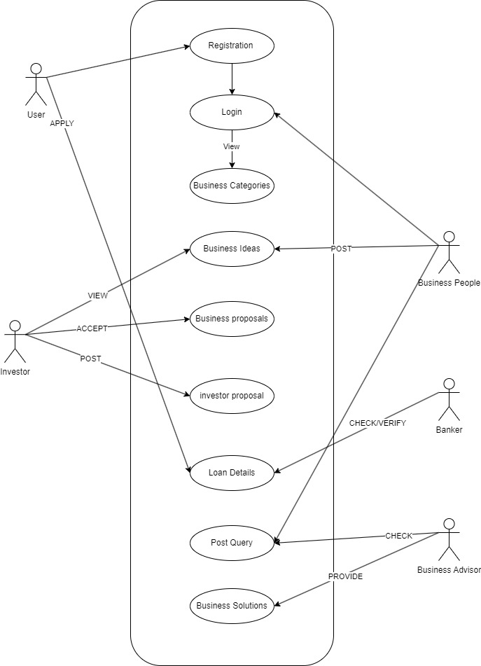

**Activity Diagram :**

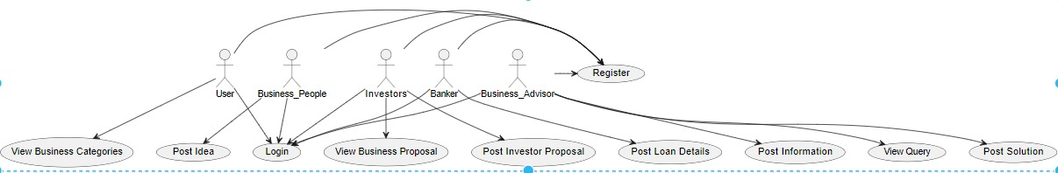

**Class Diagram:**

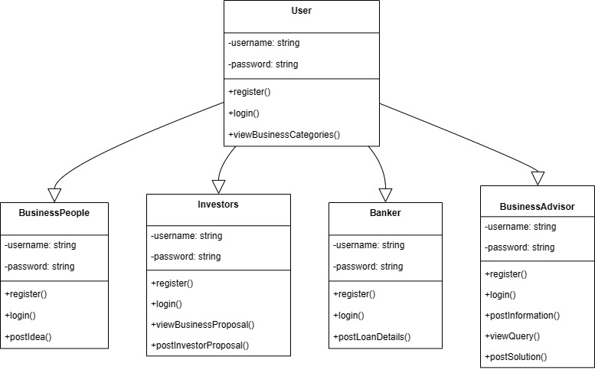

**Sequence Diagram:**

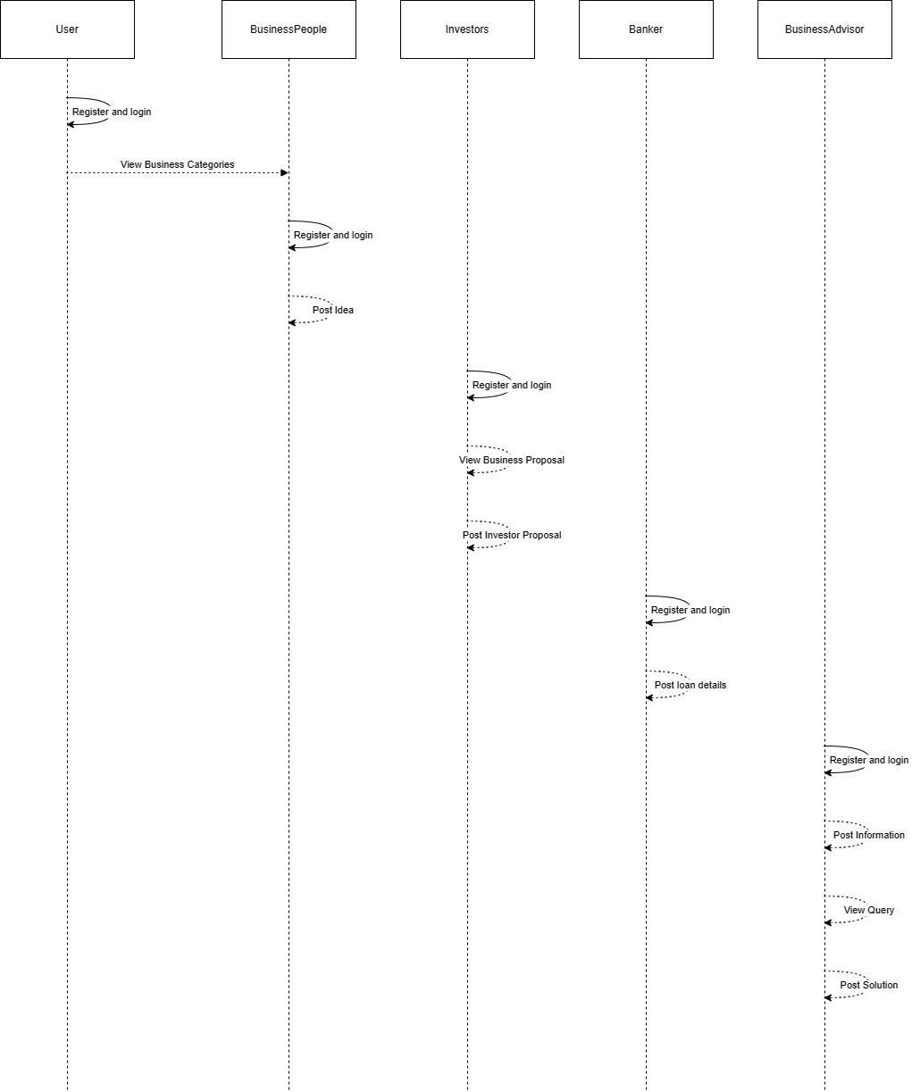

**3.8 User** **Interface** **Desigen**

### Login Dashabord :-

### 

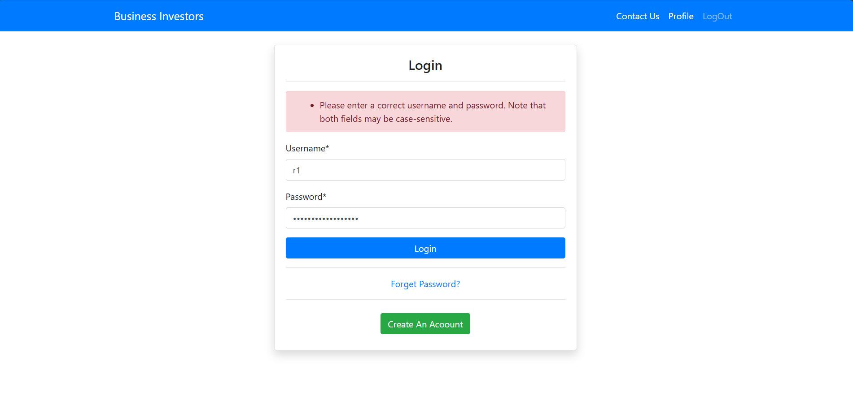

**SingUp DashBoard:**

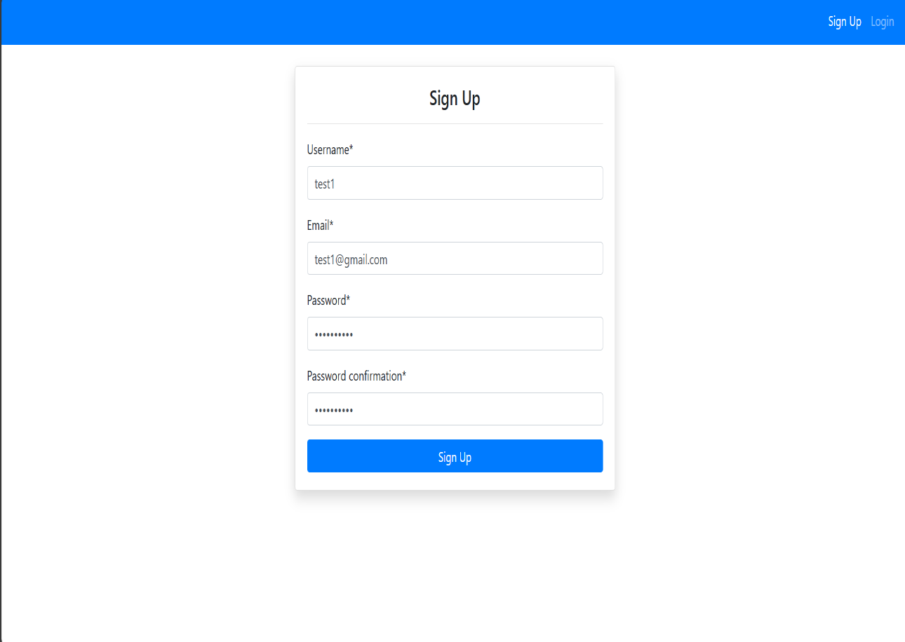

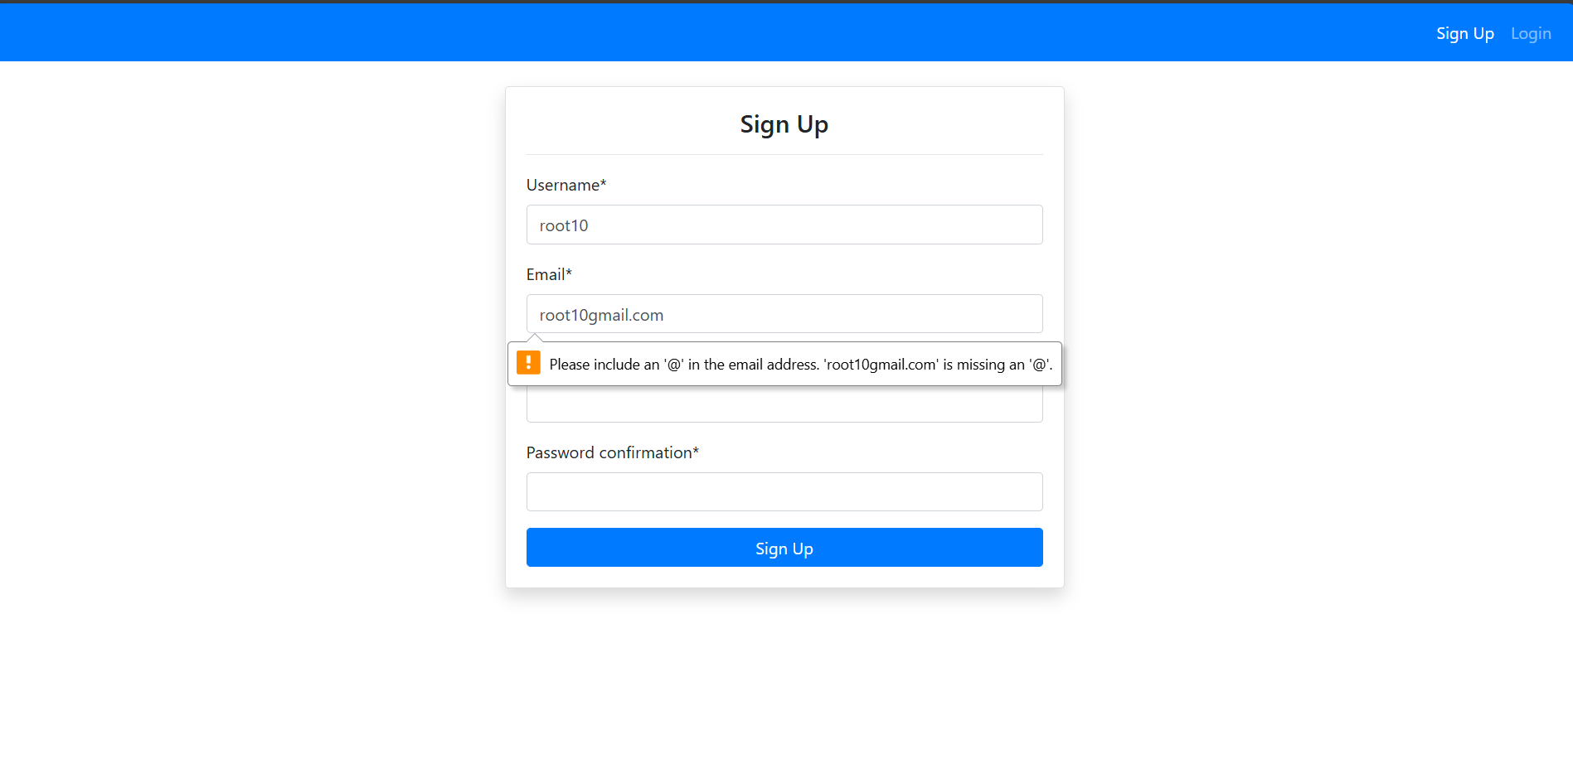

**Forget Password:**

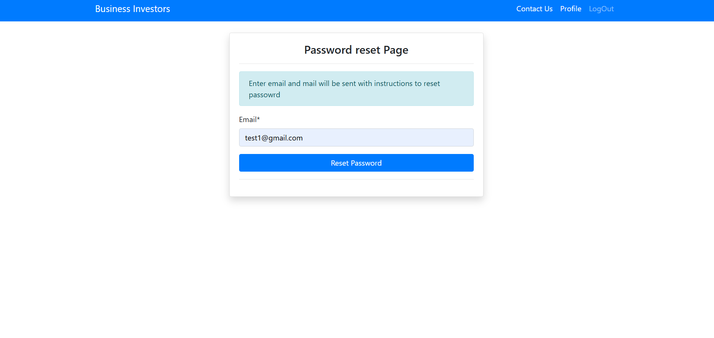

**Forget Password:**

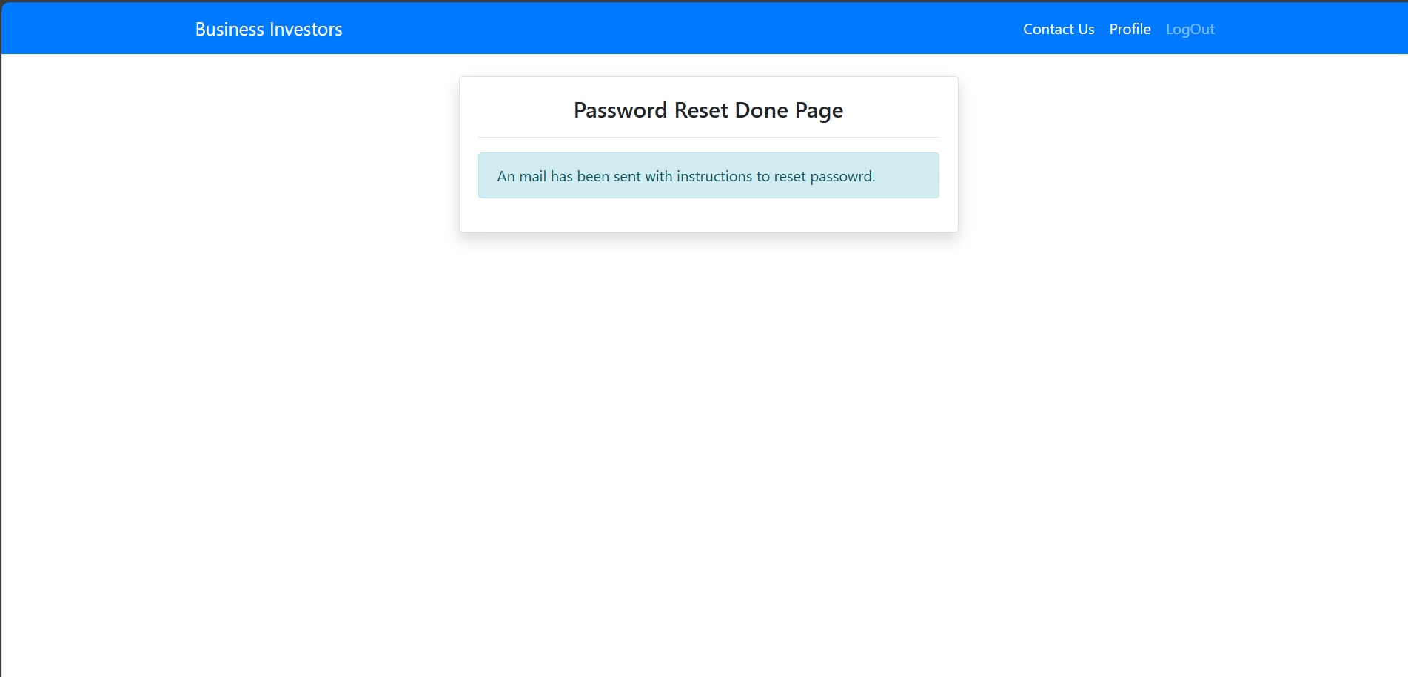

**Home Page DashBoard:**

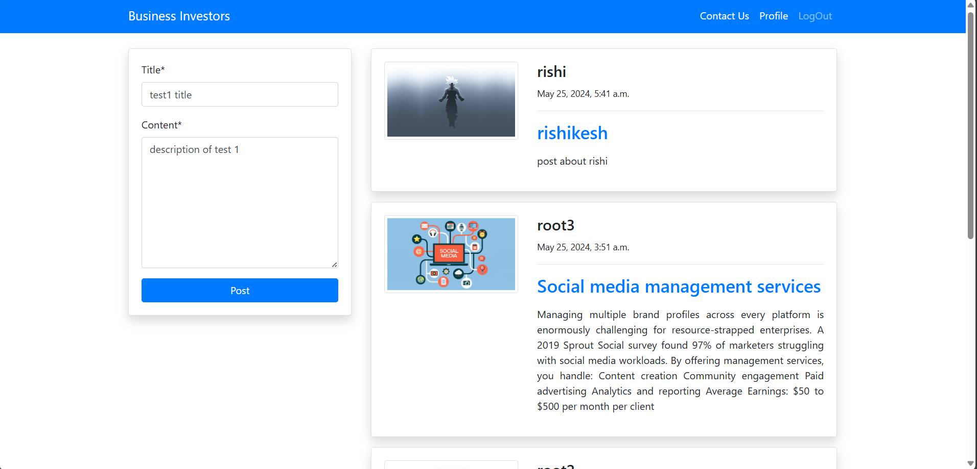

**Post Idea:**

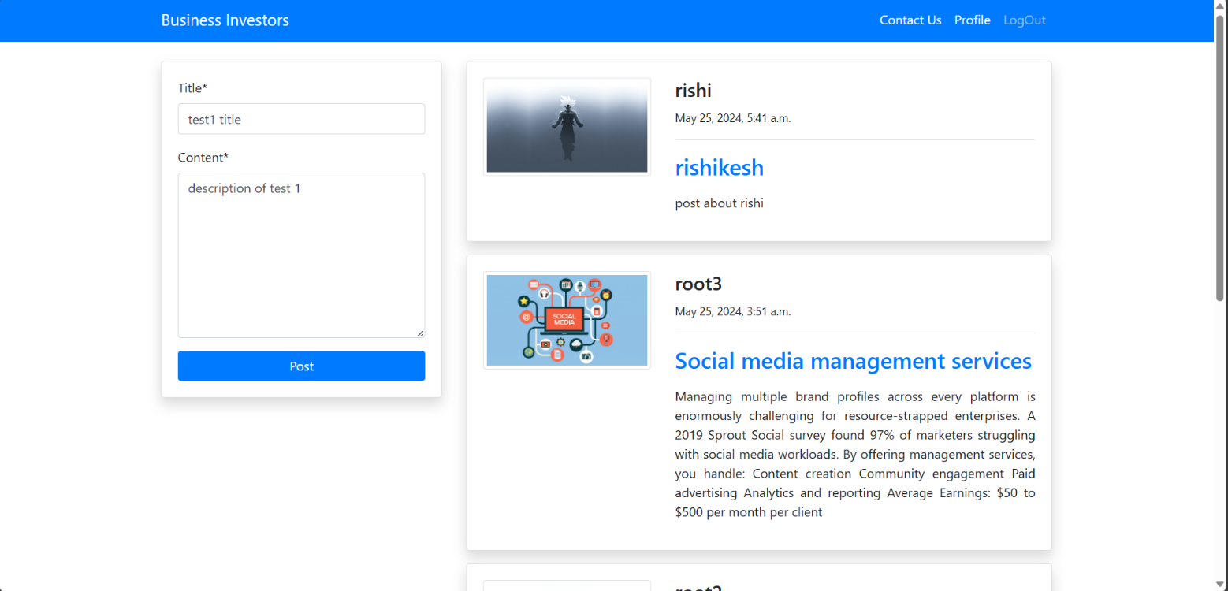

**Edit Post:**

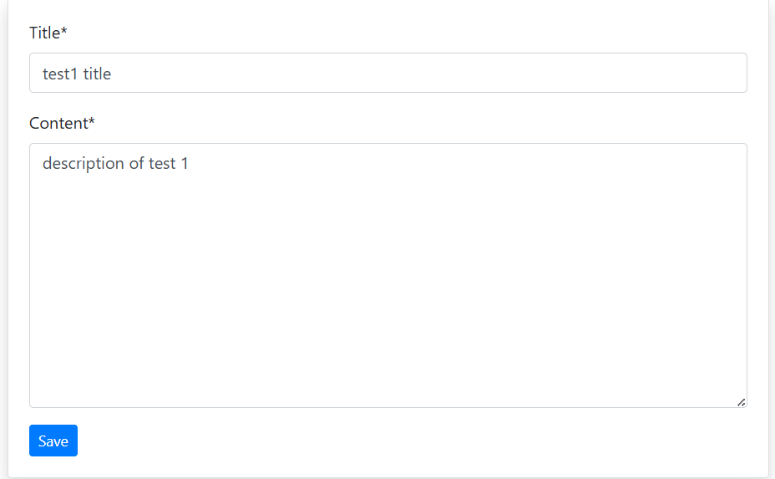

**Profile Page:**

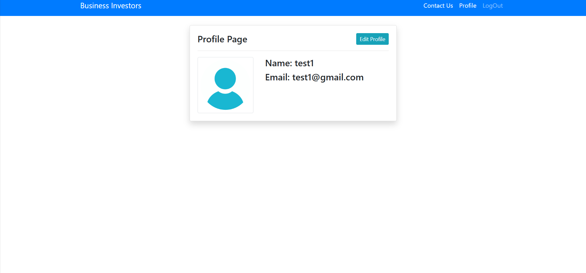

**Edit Profile:**

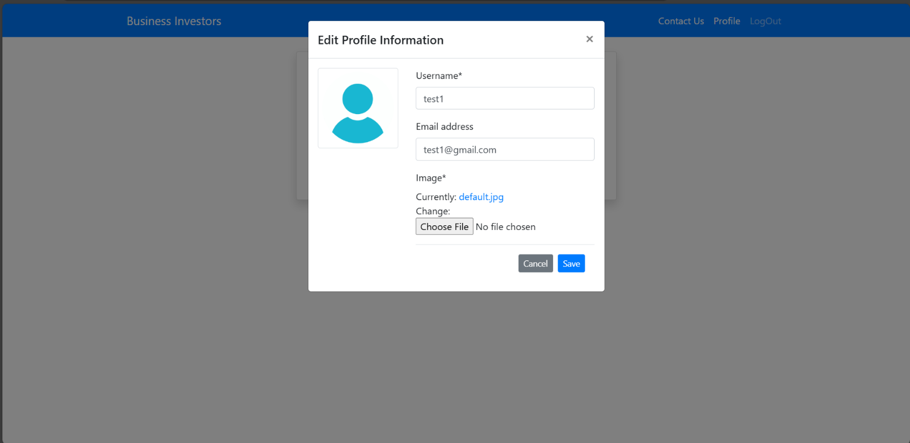

Add Comments:

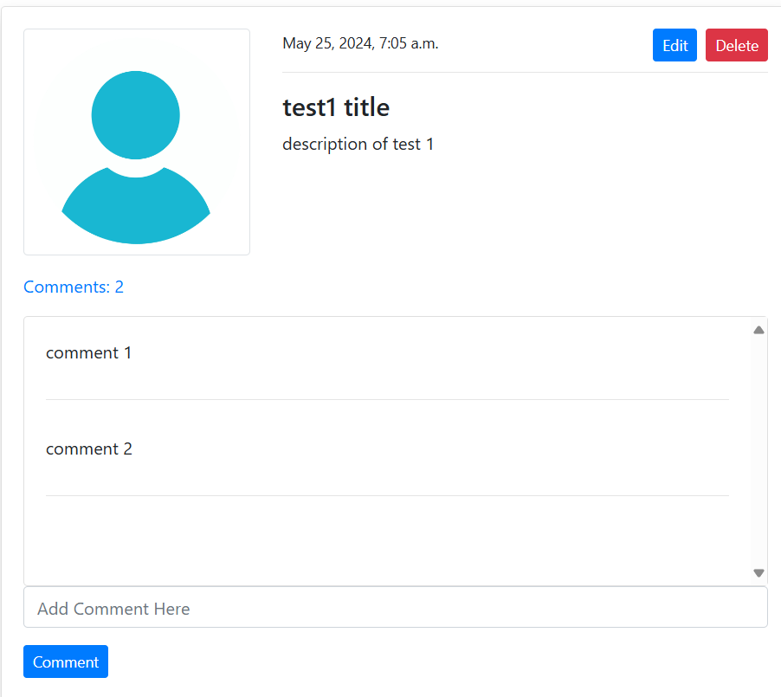

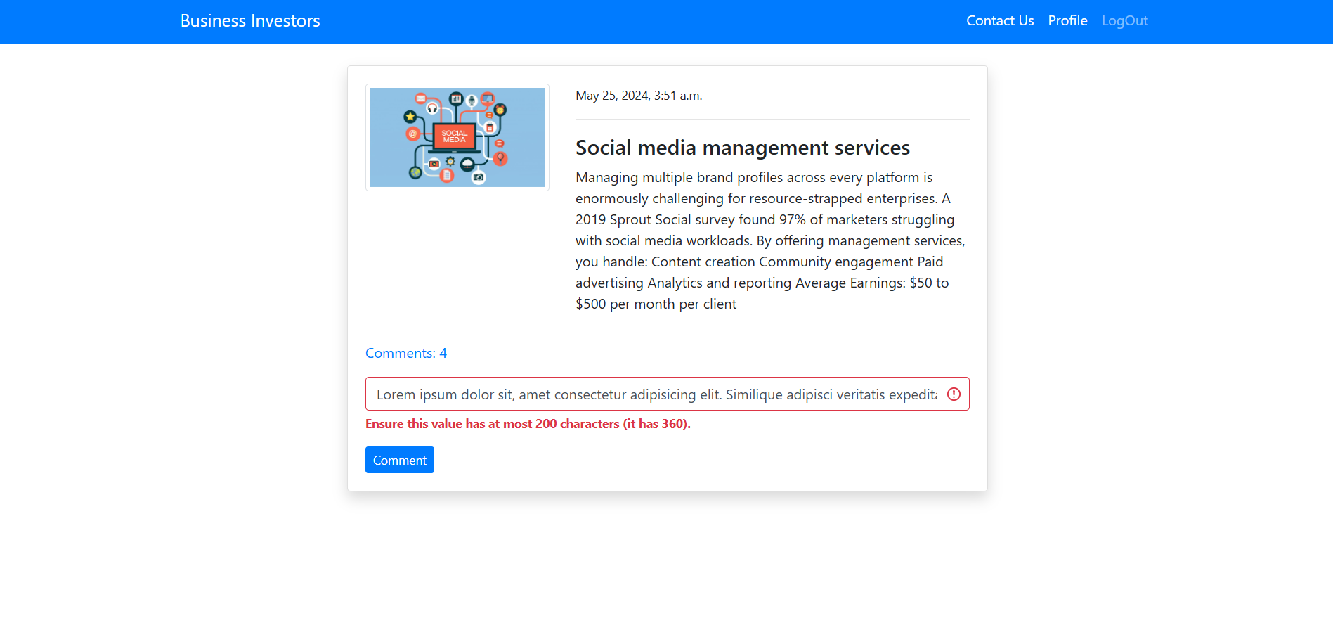

Logout Page:

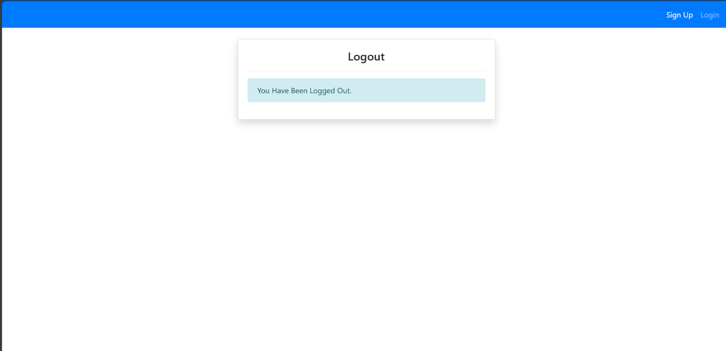

# CHAPTER 4 CODING

### 4.1 Algorithm :-

1. User Authentication:

Ensure the user is logged in and authenticated before proceeding with application.

1. Service Selection:

Present the user with a list of available businesses services to choose from .

Allow the user to check the desired service from the list.

1. Date and Time Selection:

Display a calendar or date picker to allow the user to check the preferred date for the post.

Present available time slots for the selected date and service.

1. Service Provider Selection (if applicable):

If the service requires a specific business, present the user with a list of available investors for the selected service and time slot.

Allow the user to choose their preferred service provider.

1. Edit Post and Delete post:

User can Edit and delete the business idea from it’s own posts .

Other users can comment to the posts for the business opinions.

1. Post Confirmation:

Once the user confirms the posts, display a confirmation message indicating that the post was successful.

Send a confirmation email or SMS to the user with details of the appointment.

### Code Snippet (Sample Code) :-

**Index.html**

{% extends 'partials/base.html'%}

{% block title %}Home Page{% endblock %}

{% load crispy_forms_tags %}

{% block content %}

    <div class="container">

        <div class="row mt-5 pt-3">

            <div class="col-md-4">

                <div class="card my-3 shadow">

                    <div class="card-body">

                        <form method="POST">

                            {% csrf_token %}

                            {{ form|crispy }}

                            <input class="btn btn-primary btn-block" type="submit" value="Post">

                        </form>

                    </div>

                </div>

            </div>

            <div class="col-md-8">

                {% for post in posts %}

                <div class="card shadow my-3">

                    <div class="card-body">

                        <div class="row">

                            <div class="col-md-4">

                                <img class="img-thumbnail" src="{{ post.author.profilemodel.image.url}}" alt="Image Not Found">

                            </div>

                            <div class="col-md-8">

                               <h4 class="text-justify">{{ post.author }}</h4>

                                <small>{{ post.date_created }}</small>

                                <hr>

                                <a class= "h3" href="{% url 'business1-post-detail' post.id %}">{{ post.title}}</a>

                                <p class="text-justify my-3">

                                    {{ post.content }}

                                </p>

                            </div>

                        </div>

                    </div>

                </div>

                {% endfor %}

            </div>

        </div>

    </div>

{% endblock %}

Base.html:

<!doctype html>

<html lang="en">

  <head>

    <!-- Required meta tags -->

    <meta charset="utf-8">

    <meta name="viewport" content="width=device-width, initial-scale=1, shrink-to-fit=no">

    <!-- Bootstrap CSS -->

    <link rel="stylesheet" href="https://cdn.jsdelivr.net/npm/bootstrap@4.6.2/dist/css/bootstrap.min.css" integrity="sha384-xOolHFLEh07PJGoPkLv1IbcEPTNtaed2xpHsD9ESMhqIYd0nLMwNLD69Npy4HI+N" crossorigin="anonymous">

    {% load static %}

    <!--Custom CSS-->

    <link rel="stylesheet" href="{% static '/style.css' %}">

    <title>{% block title %}{% endblock %}</title>

  </head>

  <body>

    {% include 'partials/nav.html' %}

    {% block content %}

    {% endblock %}

    <!-- Optional JavaScript; choose one of the two! -->

    <!-- Option 1: jQuery and Bootstrap Bundle (includes Popper) -->

    <script src="https://cdn.jsdelivr.net/npm/jquery@3.5.1/dist/jquery.slim.min.js" integrity="sha384-DfXdz2htPH0lsSSs5nCTpuj/zy4C+OGpamoFVy38MVBnE+IbbVYUew+OrCXaRkfj" crossorigin="anonymous"></script>

    <script src="https://cdn.jsdelivr.net/npm/bootstrap@4.6.2/dist/js/bootstrap.bundle.min.js" integrity="sha384-Fy6S3B9q64WdZWQUiU+q4/2Lc9npb8tCaSX9FK7E8HnRr0Jz8D6OP9dO5Vg3Q9ct" crossorigin="anonymous"></script>

    <!-- Option 2: Separate Popper and Bootstrap JS -->

    <!--

    <script src="https://cdn.jsdelivr.net/npm/jquery@3.5.1/dist/jquery.slim.min.js" integrity="sha384-DfXdz2htPH0lsSSs5nCTpuj/zy4C+OGpamoFVy38MVBnE+IbbVYUew+OrCXaRkfj" crossorigin="anonymous"></script>

    <script src="https://cdn.jsdelivr.net/npm/popper.js@1.16.1/dist/umd/popper.min.js" integrity="sha384-9/reFTGAW83EW2RDu2S0VKaIzap3H66lZH81PoYlFhbGU+6BZp6G7niu735Sk7lN" crossorigin="anonymous"></script>

    <script src="https://cdn.jsdelivr.net/npm/bootstrap@4.6.2/dist/js/bootstrap.min.js" integrity="sha384-+sLIOodYLS7CIrQpBjl+C7nPvqq+FbNUBDunl/OZv93DB7Ln/533i8e/mZXLi/P+" crossorigin="anonymous"></script>

    -->

  </body>

</html>

#### sign_up.html:

#### {% extends 'partials/base.html'%}

#### {% block title %}Sign Up{% endblock %}

#### {% load crispy_forms_tags %}

#### {% block content %}

#### <div class="container">

#### <div class="row mt-5 pt-3">

#### <div class="col-md-6 offset-md-3">

#### <div class="card my-3 shadow">

#### <div class="card-body">

#### <h4><center>Sign Up</center></h4>

#### <hr>

#### <form method="POST">

#### {% csrf_token %}

#### {{ form|crispy }}

#### <input class="btn btn-primary btn-block" type="submit" value="Sign Up">

#### </form>

#### </div>

#### </div>

#### </div>

#### </div>

#### </div>

#### {% endblock %}

/**

Profile.html:

{% extends 'partials/base.html'%}

{% block title %}Profile Page{% endblock %}

{% load crispy_forms_tags %}

{% block content %}

    <div class="container">

        <div class="row mt-5 pt-3">

            <div class="col-md-6 offset-md-3">

                <div class="card my-3 shadow">

                    <div class="card-body">

                        <span class="h4">Profile Page</span>

                        <!-- Button trigger modal -->

                        <span>

                            <button type="button" class="btn btn-info btn-sm float-right" data-toggle="modal" data-target="#exampleModal">

                                Edit Profile

                            </button>

                        </span>

                        <hr>

                       <div class="row">

                        <div class="col-md-4">

                            <img class="img-thumbnail" src="{{ user.profilemodel.image.url }}" alt="profile-img">

                        </div>

                        <div class="col-md-8">

                            <h4>Name: {{ user.username }}</h4>

                            <h4>Email: {{ user.email }}</h4>

                        </div>

                       </div>

                    </div>

                </div>

            </div>

        </div>

    </div>

  <!-- Modal -->

  <div class="modal fade" id="exampleModal" tabindex="-1" aria-labelledby="exampleModalLabel" aria-hidden="true">

    <div class="modal-dialog">

      <div class="modal-content">

        <div class="modal-header">

          <h5 class="modal-title" id="exampleModalLabel">Edit Profile Information</h5>

          <button type="button" class="close" data-dismiss="modal" aria-label="Close">

            <span aria-hidden="true">&times;</span>

          </button>

        </div>

        <div class="modal-body">

          <div class="row">

            <div class="col-md-4">

              <img class="img-thumbnail" src="{{ user.profilemodel.image.url }}" alt="">

            </div>

            <div class="col-md-8">

              <form method="POST" enctype="multipart/form-data">

                {% csrf_token %}

                {{ u_form|crispy }}

                {{ p_form|crispy }}

                <div class="modal-footer">

                  <button type="button" class="btn btn-secondary btn-sm" data-dismiss="modal">Cancel</button>

                  <button type="submit" class="btn btn-primary btn-sm">Save</button>

                </div>

              </form>

            </div>

          </div>

        </div>

      </div>

    </div>

  </div>

{% endblock %}

#### urls.py

from django.urls import path

from .import  views

from django.contrib.auth import views as auth_view

urlpatterns = [

    path('sign_up/', views.sign_up, name='users-sign-up'),

    path('profile/', views.profile, name='users-profile'),

    path('', auth_view.LoginView.as_view(template_name='users/login.html'), name='users-login'),

    path('logout/', auth_view.LogoutView.as_view(template_name='users/logout.html'), name='users-logout'),

    path('password_reset/', auth_view.PasswordResetView.as_view(template_name = 'users/password_reset.html'), name='password_reset'),

    path('password_reset_done/', auth_view.PasswordResetDoneView.as_view(template_name = 'users/password_reset_done.html'), name='password_reset_done'),

    path('password_reset_confirm/<uidb64>/<token>/', auth_view.PasswordResetConfirmView.as_view(template_name = 'users/password_reset_confirm.html'), name='password_reset_confirm'),

    path('password_reset_complete/', auth_view.PasswordResetCompleteView.as_view(template_name = 'users/password_reset_complete.html'), name='password_reset_complete'),

    path('contact_us/', views.contact_us, name='users-contact-us'),

]

Views.py:

from django.shortcuts import render, redirect

from django.contrib.auth.forms import UserCreationForm

from .forms import SignUpForm, UserUpdateForm, ProfileUpdateForm

from django.contrib.auth.decorators import login_required

# Create your views here.

def sign_up(request):

    if request.method == 'POST':

        form = SignUpForm(request.POST)

        if form.is_valid():

            form.save()

            return redirect('users-login')

    else:

        form = SignUpForm()

    form = SignUpForm()

    context = {

        'form': form,

    }

    return render(request, 'users/sign_up.html', context)

@login_required

def profile(request):

    if request.method == 'POST':

        u_form = UserUpdateForm(request.POST or None, instance= request.user)

        p_form = ProfileUpdateForm(request.POST or None, request.FILES or None, instance=request.user.profilemodel)

        if u_form.is_valid() and p_form.is_valid:

            u_form.save()

            p_form.save()

            return redirect('users-profile')

    else:

        u_form = UserUpdateForm(instance= request.user)

        p_form = ProfileUpdateForm(instance= request.user.profilemodel)

    context = {

        'u_form' : u_form,

        'p_form' : p_form,

    }

    return render(request, 'users/profile.html', context)

def contact_us(request):

    return render(request, 'users/contact_us.html')

Forms.py:

from typing import Any

from django.contrib.auth.forms import UserCreationForm

from django.contrib.auth.models import User

from .models import ProfileModel

from django import forms

class SignUpForm(UserCreationForm):

    email = forms.EmailField()

    class Meta:

        model = User

        fields = ['username', 'email', 'password1', 'password2']

    def __init__(self, *args: Any, **kwargs: Any) -> None:

        super(SignUpForm, self).__init__(*args, **kwargs)

        for fieldname in ['username', 'email', 'password1', 'password2']:

            self.fields[fieldname].help_text = None

class UserUpdateForm(forms.ModelForm):

    class Meta:

        model = User

        fields = ['username', 'email']

    def __init__(self, *args: Any, **kwargs: Any) -> None:

        super(UserUpdateForm, self).__init__(*args, **kwargs)

        for fieldname in ['username', 'email']:

            self.fields[fieldname].help_text = None

class ProfileUpdateForm(forms.ModelForm):

    class Meta:

        model = ProfileModel

        fields = ['image']

Business1/views.py:

from django.shortcuts import render, redirect

from .models import PostModel

from .forms import PostModelForm, PostUpdateForm, CommentForm

from django.contrib.auth.decorators import login_required

# Create your views here.

@login_required

def index(request):

    posts = PostModel.objects.all()

    if request.method == 'POST':

        form = PostModelForm(request.POST)

        if form.is_valid():

            instance = form.save(commit=False)

            instance.author = request.user

            instance.save()

            return redirect('business1-index')

    else:

        form = PostModelForm()

    context = {

        'posts' : posts,

        'form' : form

    }

    return render(request, 'business1/index.html', context)\

@login_required

def post_detail(request, pk):

    post = PostModel.objects.get(id=pk)

    if request.method == 'POST':

        c_form = CommentForm(request.POST)

        if c_form.is_valid():

            instance = c_form.save(commit=False)

            instance.user = request.user

            instance.post = post

            instance.save()

            return redirect('business1-post-detail', pk=post.id)

    else:

        c_form = CommentForm()

    context ={

        'post' : post,

        'c_form' : c_form,

    }

    return render(request, 'business1/post_detail.html', context)

@login_required

def post_edit(request, pk):

    post = PostModel.objects.get(id=pk)

    if request.method == 'POST':

        form = PostUpdateForm(request.POST, instance=post)

        if form.is_valid():

            form.save()

            return redirect('business1-post-detail', pk= post.id)

    else:

        form = PostUpdateForm(instance=post)

    context = {

        'post' : post,

        'form' : form,

    }

    return render(request, 'business1/post_edit.html', context)

@login_required

def post_delete(request, pk):

    post = PostModel.objects.get(id=pk)

    if request.method == 'POST':

        post.delete()

        return redirect('business1-index')

    context ={

        'post' : post

    }

    return render(request, 'business1/post_delete.html', context)

Business1/urls.py:

from django.urls import path

from .import views

urlpatterns = [

    path('business1/', views.index, name='business1-index'),

    path('post_detail/<int:pk>/', views.post_detail, name='business1-post-detail'),

    path('post_edit/<int:pk>/', views.post_edit, name='business1-post-edit'),

    path('post_delete/<int:pk>/', views.post_delete, name='business1-post-delete'),

]

# CHAPTER 5 TESTING

### Test Strategy :-

**1. User Interface Testing:**

* + Verify that all pages and features have a user-friendly interface.
  + Test the responsiveness of the platform across different devices and screen sizes.
  + Ensure consistent branding and design elements throughout the platform.

**2. Functional Testing:**

* Test user registration and authentication processes.
* Verify that users can create, edit, and manage their profiles.
* Test the appointment booking feature for different services, dates, and providers.
* Ensure that users can browse, add to cart, and purchase pet products.
* Test the functionality of educational resources, community forums, and support features.
* Verify that service providers can create profiles, list services, and manage appointments.

**3. Performance Testing:**

* Test the platform's loading times for various pages and features.
* Conduct stress testing to assess how the system handles concurrent user activity.
* Monitor server response times and resource utilization under different loads.

**4. Security Testing:**

* Test user authentication mechanisms for vulnerabilities such as brute force attacks or session hijacking.
* Conduct penetration testing to identify potential security vulnerabilities in the system.
* Verify that sensitive user data is encrypted and stored securely.

5. Compatibility Testing:

* Test the platform on different web browsers (e.g., Chrome, Firefox, Safari, Edge) to ensure compatibility.
* Verify compatibility across different operating systems (e.g., Windows, macOS, iOS, Android).
* Test accessibility features to ensure compliance with accessibility standards (e.g., WCAG).

**6. Integration Testing:**

* Test integrations with external services such as payment gateways, email/SMS providers, and mapping services.
* Verify that data is synchronized correctly between different modules and databases.

**7. Regression Testing:**

* Conduct regression tests after implementing new features or making changes to existing functionality.
* Ensure that new updates do not introduce regressions or break existing features.

**8. User Acceptance Testing (UAT):**

* Invite users to test the platform and provide feedback on usability, functionality, and overall experience.
* Incorporate user feedback to make improvements and optimizations.

**9. Franchise Testing (if applicable):**

* Test franchise management features such as onboarding, training, and support for franchisees.
* Ensure that franchise operations can be managed effectively through the platform.

**10. Disaster Recovery Testing:**

* Test backup and recovery procedures to ensure data integrity and continuity of operations in the event of system failures or data loss.

### Test Case / Test Script :-

### User Test Case:

|  |  |  |  |  |  |  |
| --- | --- | --- | --- | --- | --- | --- |
| **Test Case ID** | **Test Case Description** | **Preconditions** | **Test Steps** | **Expected Result** | **Actual Result** | **Status** |
| TC-001 | User Registration | None | 1. Navigate to the registration page  2. Fill in the registration form  3. Submit the form. | User account is created and confirmation message is displayed. | User account is created and confirmation message is displayed. | Pass |
| TC-002 | User Login | User account exists | 1. Navigate to the login page.  2. Enter valid credentials.  3. Click login. | User is logged in and redirected to the dashboard. | User is logged in and redirected to the dashboard. | Pass |
| TC-003 | Password Reset | User account exists | 1. Navigate to the login page  2. Click "Forgot Password".  3. Enter email  4. Follow instructions in email. | Password reset link is sent to the user's email. | Password reset link is sent to the user's email. | Pass |

|  |  |  |  |  |  |  |
| --- | --- | --- | --- | --- | --- | --- |
| **Test Case ID** | **Test Case Description** | **Preconditions** | **Test Steps** | **Expected Result** | **Actual Result** | **Status** |
| TC-101 | Add New Post | User is logged in | 1. Navigate to " Posts".  2. Click "Add New Post".  3. Fill in pet details.  4. Submit form. | New post is added to the main page. | New post is added to the profile. | Pass |
| TC-102 | Edit Post Details | User has at least one post | 1. Navigate to " Posts"  2. Select a post.  3. Click "Edit".  4. Modify details.  5. Submit form. | Post details are updated. | Post details are updated. | Pass |
| TC-103 | Delete Post | User has at least one post | 1. Navigate to "My Pots".  2. Select a pet.  3. Click "Delete".  4. Confirm deletion. | Post is removed from page. | Post is removed from the page. | Pass |

**User Profile** **Test Case**:

|  |  |  |  |  |  |  |
| --- | --- | --- | --- | --- | --- | --- |
| **Test Case ID** | **Test Case Description** | **Preconditions** | **Test Steps** | **Expected Result** | **Actual Result** | **Status** |
| TC-301 | Edit Profile | User is logged in | 1. Navigate to "profile".  2. change fields.  3. Click "okay". | Profile should be updated | Profile updated | Pass |
| TC-302 | Delete profile | User is logged in | 1. Navigate to "profile".  2. Click Delete button  3. Click "okay". | Profile deletion and redirect to sign up | Redirected to sign up page | Pass |

**Post Comments Test Case:**

|  |  |  |  |  |  |  |
| --- | --- | --- | --- | --- | --- | --- |
| **Test Case ID** | **Test Case Description** | **Preconditions** | **Test Steps** | **Expected Result** | **Actual Result** | **Status** |
| TC-401 | Check comments | User is logged in, has a pet | 1. Navigate to "post desciption".  2. click on comments | Comments should be visible | Comments visible | Pass |
| TC-402 | Add Comments | User is logged in, has a pet | 1. Navigate to "post desciption".  2. add comment  3. click “Comment” button | Comment should be posted | Comment registered. | Pass |

# CHAPTER 6 LIMITATIONS

**OF PROPOSED SYSTEM**

### Limitation of Purpose System

**Limited Reach:**

The platform's accessibility may be limited to regions or countries where internet penetration is high and where there is a significant market for pet care services. Users in areas with poor internet connectivity may not be able to fully utilize the platform.

**Language and Cultural Barriers:**

The platform may primarily cater to users who speak the supported languages and are familiar with the cultural norms and preferences embedded in the system. Users from diverse linguistic and cultural backgrounds may face barriers in using the platform effectively.

**Technical Constraints**:

Users with older devices or slower internet connections may experience performance issues or difficulties accessing certain features of the platform. Compatibility with outdated web browsers or operating systems could also pose challenges for some users.

**Dependency on Third-Party Services:**

The platform may rely on third-party services for functionalities such as payment processing, mapping services, or communication tools. Any disruptions or changes to these third-party services could impact the functionality and availability of the platform.

**Security Risks:**

Despite implementing security measures, the platform may still be vulnerable to cyber threats such as hacking, data breaches, or malware attacks. Users' personal information and financial data could be compromised if adequate security measures are not in place.

**Quality of Service Providers:**

The quality of service providers listed on the platform may vary, and there is a risk of users encountering unprofessional or unreliable providers. Negative experiences with service providers could damage the platform's reputation and deter users from using it in the future.

**Franchisee Performance:**

If the platform offers franchising opportunities, the performance and adherence to brand standards by franchisees could impact the overall quality and consistency of service delivery across different locations. Poorly performing franchisees could tarnish the brand's image and reputation.

**Regulatory Compliance:**

Compliance with local regulations and industry standards in different regions may pose challenges, especially if there are variations in legal requirements related to pet care, e-commerce, data privacy, and franchising across jurisdictions.

**Scalability**:

As the user base and volume of transactions grow, the platform's scalability could become a limitation if it is not designed to handle increased traffic, data storage, and processing demands efficiently.

**User Engagement**:

Maintaining user engagement and retention over time could be challenging, especially if users perceive the platform's value proposition to be limited or if competing platforms offer more compelling features or incentives.

# 

# CHAPTER 8 CONCLUSION

### CONCLUSION

The "Bridge Between Investors and Business People" project promises to revolutionize the investment ecosystem in India by creating a sophisticated digital platform that serves as a comprehensive marketplace for investors and entrepreneurs. With a user-centric design, the platform will facilitate seamless interactions through user-friendly interfaces and secure transaction capabilities, enhanced by real-time data analytics.

The project scope includes thorough user onboarding and educational components, ensuring that both investors and entrepreneurs can navigate the platform effectively and make well-informed decisions. By incorporating networking and collaboration features such as forums, webinars, and events, the platform will foster meaningful connections and partnerships within the business community.

Security remains a top priority, with robust cybersecurity measures integrated to protect sensitive financial information and transactions, thereby building trust among users. Additionally, the platform's diverse investment options will cater to various scales and industries, accommodating investors with different risk appetites and preferences.

Overall, this project aims to create a vibrant and inclusive investment ecosystem, empowering investors and entrepreneurs to connect, collaborate, and thrive. By addressing key aspects such as digital platform development, user onboarding, education, networking, security, and investment diversity, the "Bridge Between Investors and Business People" project is poised to make a significant impact on the business landscape in India.

# CHAPTER 9 BIBLIOGRAPHY

### BIBLIOGRAPHY

1. Smith, J. (2023). "Trends in the Pet Care Industry." Journal of Pet Care Trends, 10(2), 45-58.

Johnson, A. (2022). "E-commerce Impact on the Pet Industry." Proceedings of the International Conference on E-commerce, 123-135.

1. Patel, R. (2021). "Community Building Strategies for Pet Owners." Pet Care Community Conference Proceedings, 78-89.

Brown, L. (2020). "Best Practices in Online Education for Pet Owners." Journal of Pet Education, 5(1), 20-35.

1. Williams, M. (2019). "Quality Assurance in Pet Care Services." Proceedings of the International Symposium on Quality Assurance in Pet Care, 200-215.
2. Garcia, S. (2018). "Franchising Opportunities in the Pet Industry." Pet Industry Franchise Report, 1-15.
3. Johnson, R. (2017). "User Acceptance Testing in Pet Care Platforms." Proceedings of the International Conference on Pet Technology, 75-88.
4. Anderson, K. (2016). "Security Measures in Online Pet Care Platforms." Journal of Cybersecurity in Pet Care, 3(2), 110-125.
5. Lee, T. (2015). "Scalability Challenges in Online Pet Care Platforms." Proceedings of the International Conference on Scalability Challenges, 150-165.
6. Garcia, J. (2014). "Customer Engagement Strategies in Pet Care Platforms." Journal of Customer Engagement in Pet Care, 8(3), 200-215.

***Websites***

[www.w3schools.com](http://www.w3schools.com)

[www.tutorialspoint.com](http://www.tutorialspoint.com)