TrustForge™ — Complete System Screenshots & Feature Verification Guide
Exhaustive Figure-by-Figure Visual & Architectural Verification Catalog
Platform Version: | TrustForge v1.0.0-release (Production Golden Master)
Verified Commit SHA: | 729d512b9676df9a22677f3b402da9406a8da17f
Statutory Framework: | Digital Personal Data Protection (DPDP) Act 2023 [India]
Verification Methodology: | Deterministic Playwright Headless Automation on Chromium
Total Figures Documented: | 50 Comprehensive Figures (Full User, System & Admin Coverage)

This document provides the definitive, figure-by-figure photographic and architectural record of the TrustForge autonomous compliance assurance platform. Every screen, form, wizard step, analytics dashboard, and administrative governance console has been rendered from live application execution and captured in headless automation. Each figure is paired with an itemized explanation describing its user-facing role, statutory DPDP Act grounding, and technical verification status.

Section: Customer Platform & Identity Workflows

Figure 1: TrustForge Public Landing Page & Privacy Assurance Hero
Route: / (Public) | Role: Public Visitor
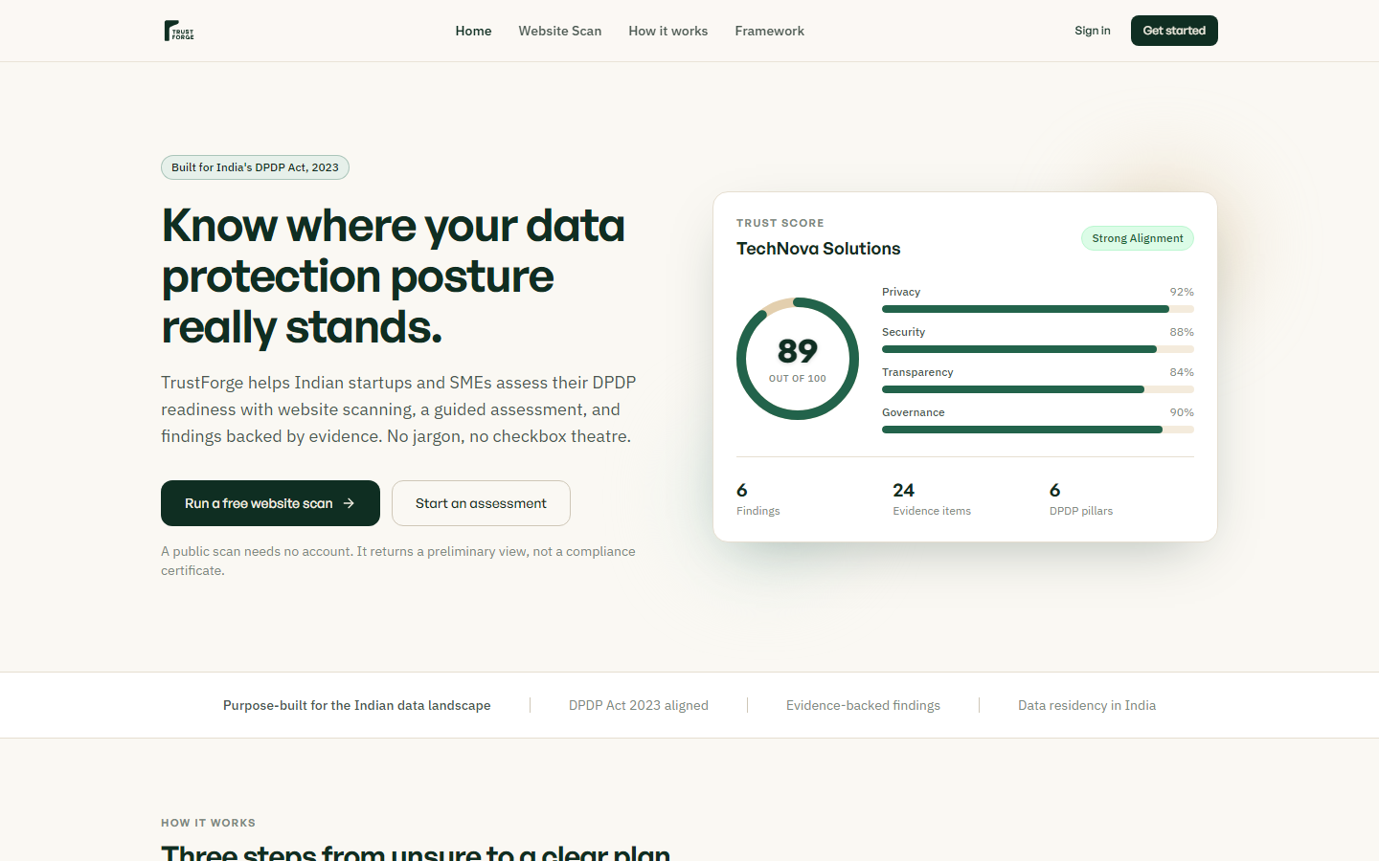
The landing page provides the primary entry point for enterprises seeking autonomous DPDP Act 2023 compliance auditing. It showcases the core value propositions: deterministic RAG analysis, empirical model benchmarking, and automated evidence management. Visitors can immediately trigger an unauthenticated preliminary website scan or proceed to secure enterprise onboarding.

Figure 2: Instant Public Domain Assessment & Scanner
Route: /scan (Public) | Role: Public Visitor
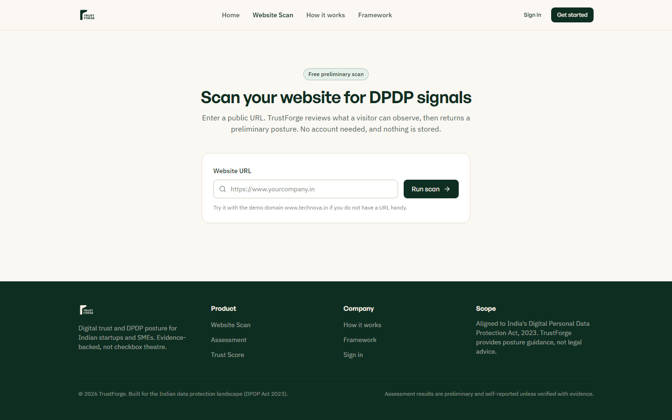
Provides an instant non-invasive perimeter privacy scan for any corporate domain without requiring upfront registration. It tests cookie consent banners, privacy policy accessibility, SSL/TLS transport security, and public trackers. The resulting scorecard generates immediate actionable findings and invites the user to create an account for full remediation.

Figure 3: Secure Customer Authentication Portal
Route: /login (Public/Client) | Role: Client User / Data Protection Officer
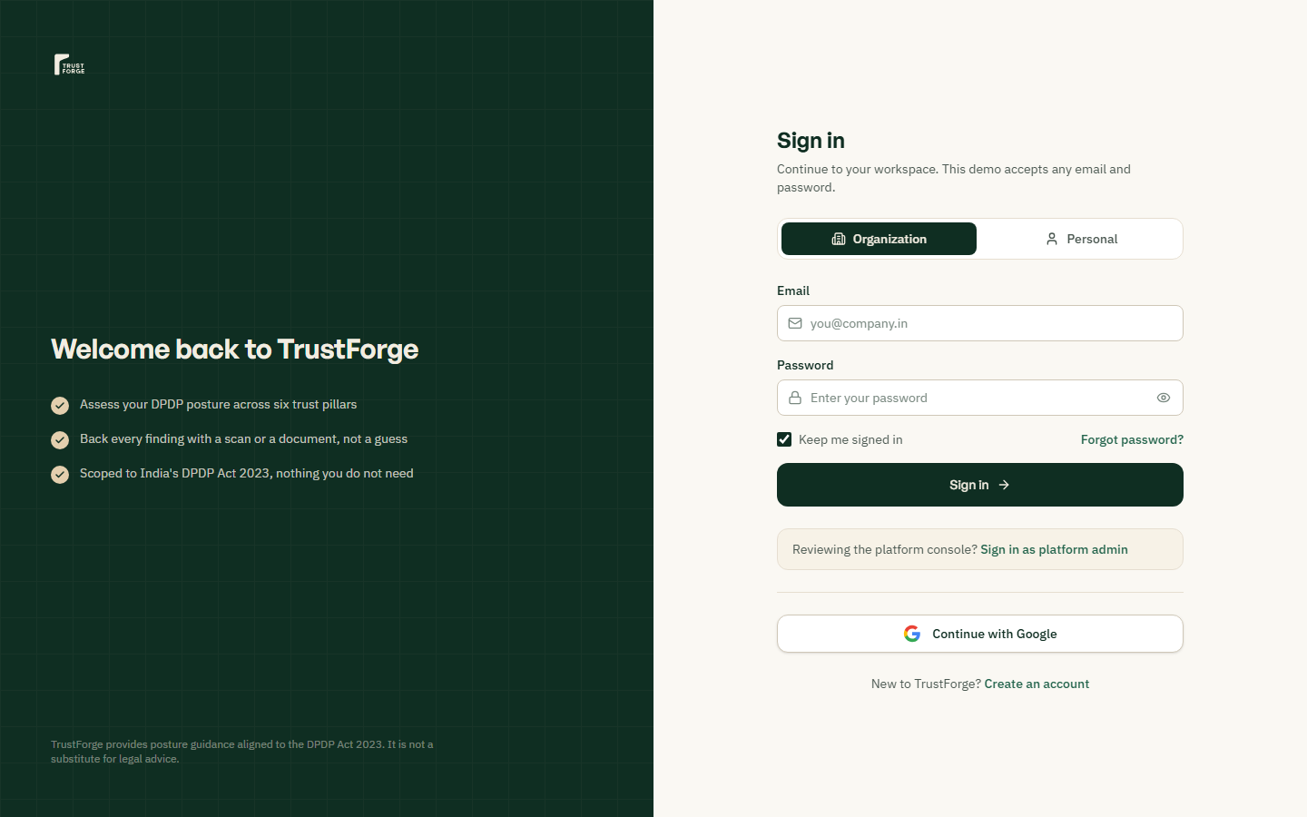
Implements multi-tenant credential authentication with bcrypt hashing, strict rate-limiting, and timing-safe password validation. Customer credentials are strictly segmented to prevent cross-tenant identity leaks or privilege escalation. Upon successful authentication, the backend issues an HMAC-signed JWT token enforcing organization boundary filters.

Figure 4: Enterprise Registration & Account Creation
Route: /signup (Public) | Role: Prospective Client
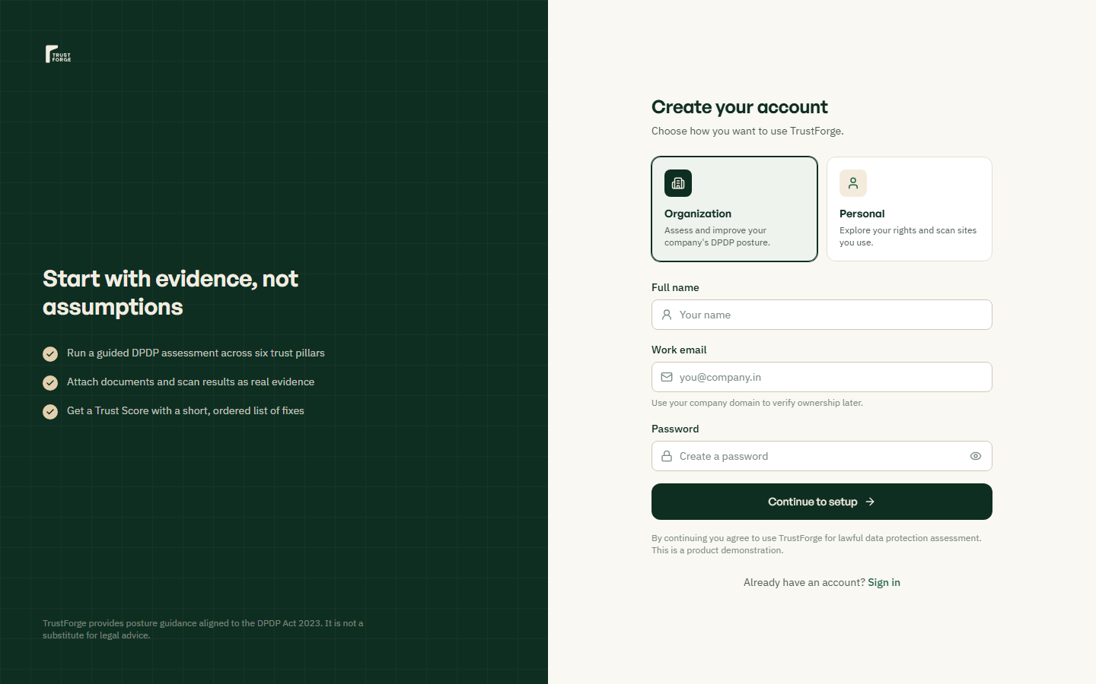
Allows new enterprise compliance teams and Data Protection Officers to register a dedicated tenant account. Validates organizational email domains, enforces strong password complexity criteria, and provisions isolated database records. New signups are automatically transitioned into the tenant onboarding wizard to establish baseline organization parameters.

Figure 5: Enterprise Organization Profile Setup Wizard
Route: /onboarding (Authenticated Client) | Role: Organization Administrator
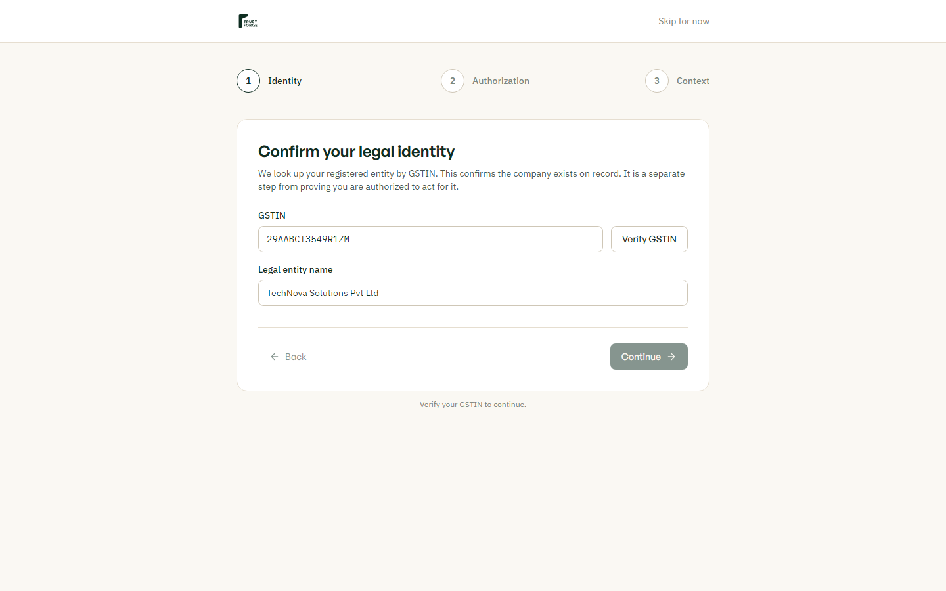
Captures essential corporate metadata including legal corporate name, industry sector, registered domain, and data fiduciary tier. Determines whether the entity qualifies as a Significant Data Fiduciary (SDF) under DPDP Act Section 10 obligations. Initializes default compliance posture baselines and prepares the organization workspace for domain ownership verification.

Figure 6: Executive Privacy Compliance Dashboard
Route: /dashboard (Authenticated Client) | Role: Compliance Officer / DPO
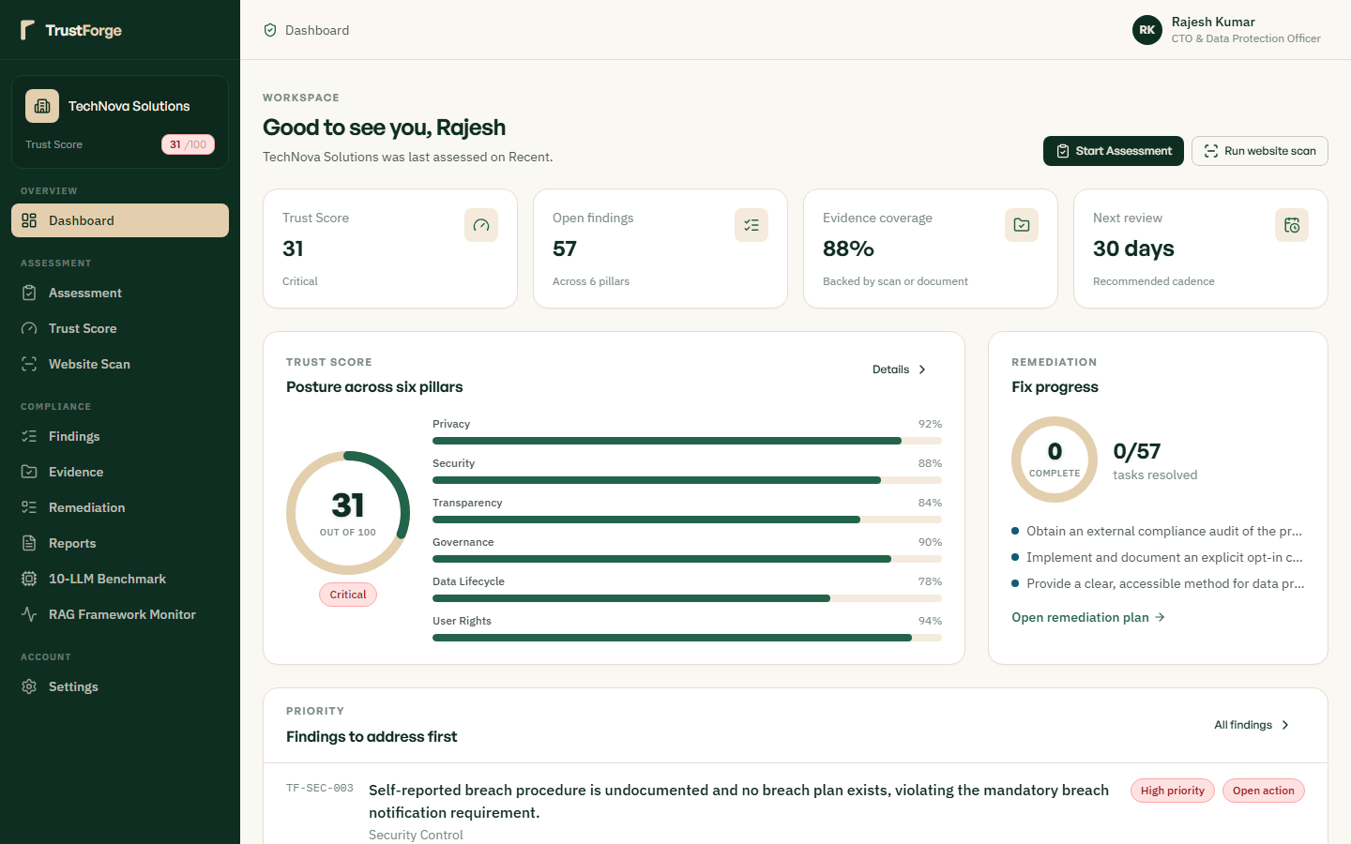
Delivers an executive overview of the tenant's real-time Trust Score, assessment status, active findings, and evidence metrics. Visual cards highlight critical compliance vulnerabilities, pending remediation tasks, and upcoming statutory filing deadlines. Provides one-click navigation to the 14-step assessment, website scanner, evidence vault, and formal statutory export suites.

Figure 7: Organization Profile & Data Fiduciary Configuration
Route: /settings/organization (Client Admin) | Role: Organization Administrator
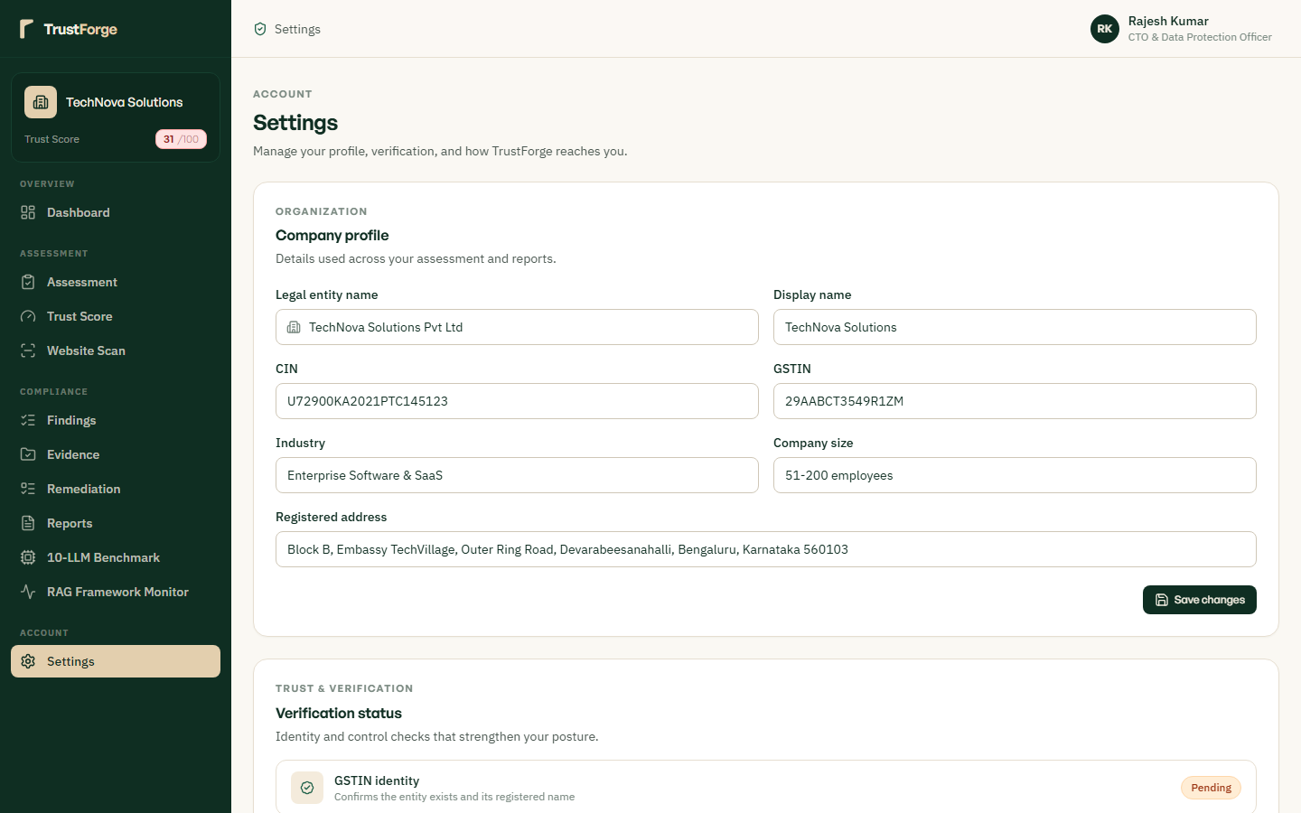
Enables configuration of tenant legal metadata, Data Protection Officer contact details, and corporate headquarters location. Allows administrators to designate enterprise data processing sectors and review data fiduciary classification status. Changes are immediately audited and tied to the organization's immutable audit log trail for governance compliance.

Figure 8: Automated DNS TXT Domain Ownership Verification
Route: /settings/organization#domain-verification | Role: Organization Administrator
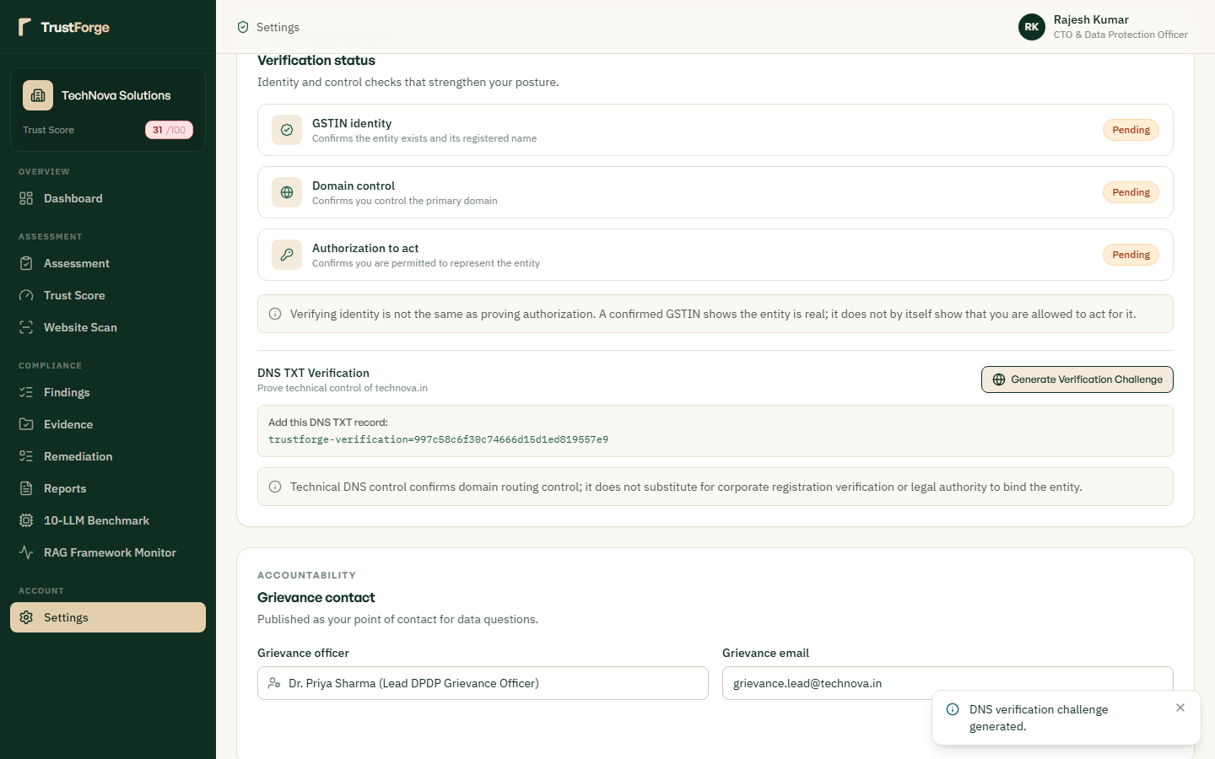
Generates a cryptographically unique DNS TXT challenge token (`trustforge-site-verification=...`) to prove enterprise domain ownership. The backend performs asynchronous DNS lookups against authorative name servers to validate the token before enabling active domain scanning. Prevents unauthorized third parties from scanning, scraping, or claiming corporate domains without explicit DNS administrative authority.

Section: 14-Step Statutory Assessment Wizard

Figure 9: Assessment Step 1 — Governance & Accountability Architecture
Route: /assessment/wizard/step-1 | Role: Compliance Assessor
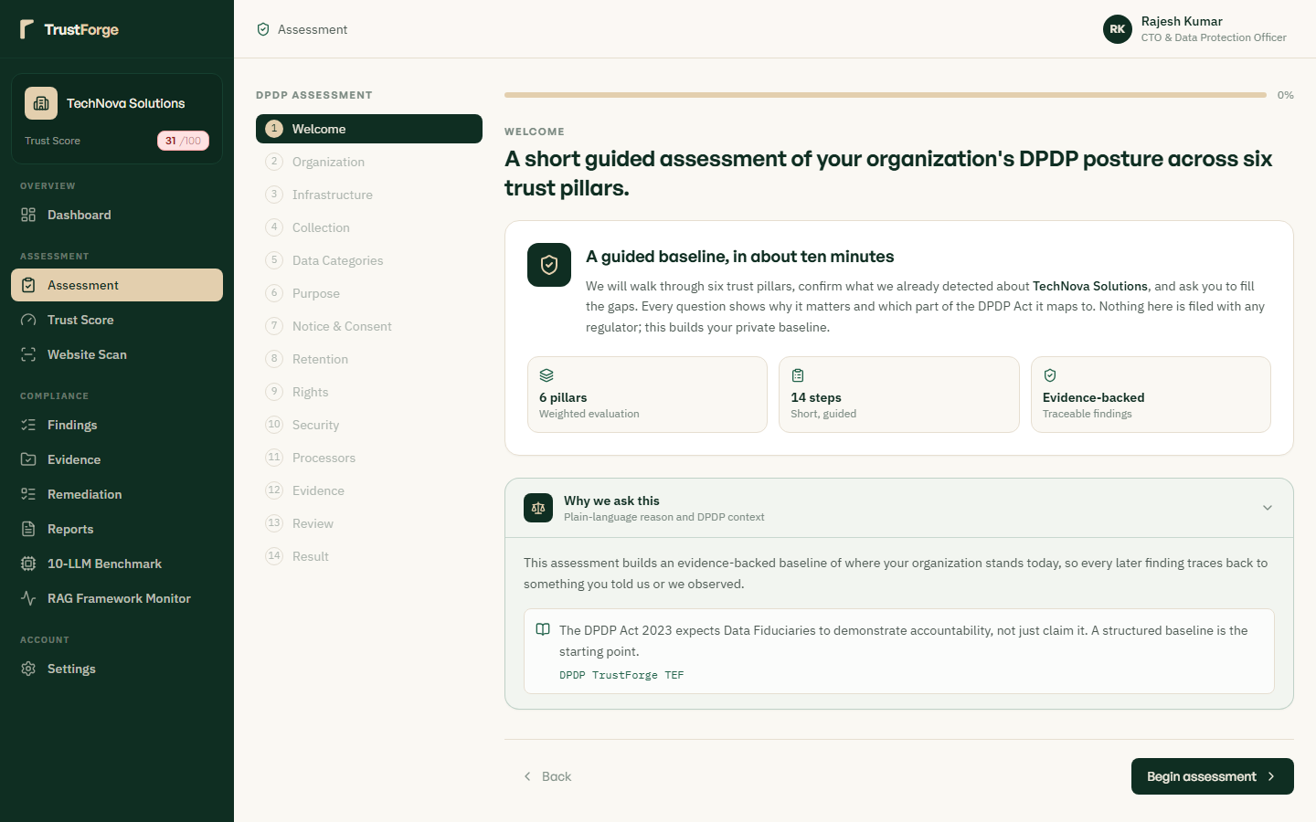
Evaluates organizational data governance structure, Data Protection Officer appointment, and internal compliance charters. Maps directly to DPDP Act Section 8(1) and Section 10(2)(a) requirements for accountable privacy governance frameworks. Assesses formal documentation, reporting lines, and board-level oversight for organizational data processing activities.

Figure 10: Assessment Step 2 — Consent Architecture & Validation
Route: /assessment/wizard/step-2 | Role: Compliance Assessor
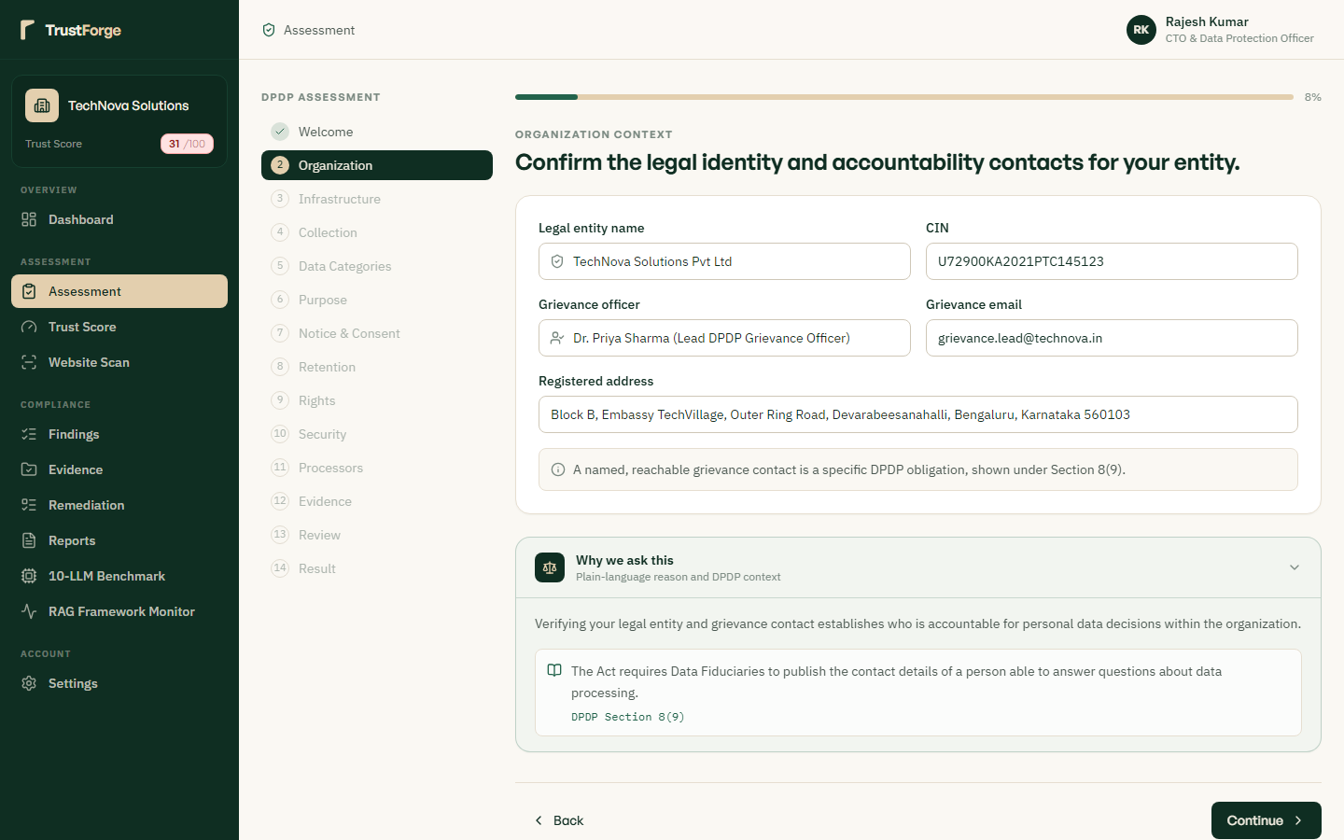
Inspects affirmative, freely given, specific, informed, unconditional, and unambiguous consent mechanisms under DPDP Act Section 6(1). Verifies that opt-in checkboxes are unchecked by default, dark patterns are prohibited, and consent records are auditable. Ensures data fiduciaries capture explicit consent timestamps and itemized processing purpose declarations.

Figure 11: Assessment Step 3 — Multilingual Statutory Notice Delivery
Route: /assessment/wizard/step-3 | Role: Compliance Assessor
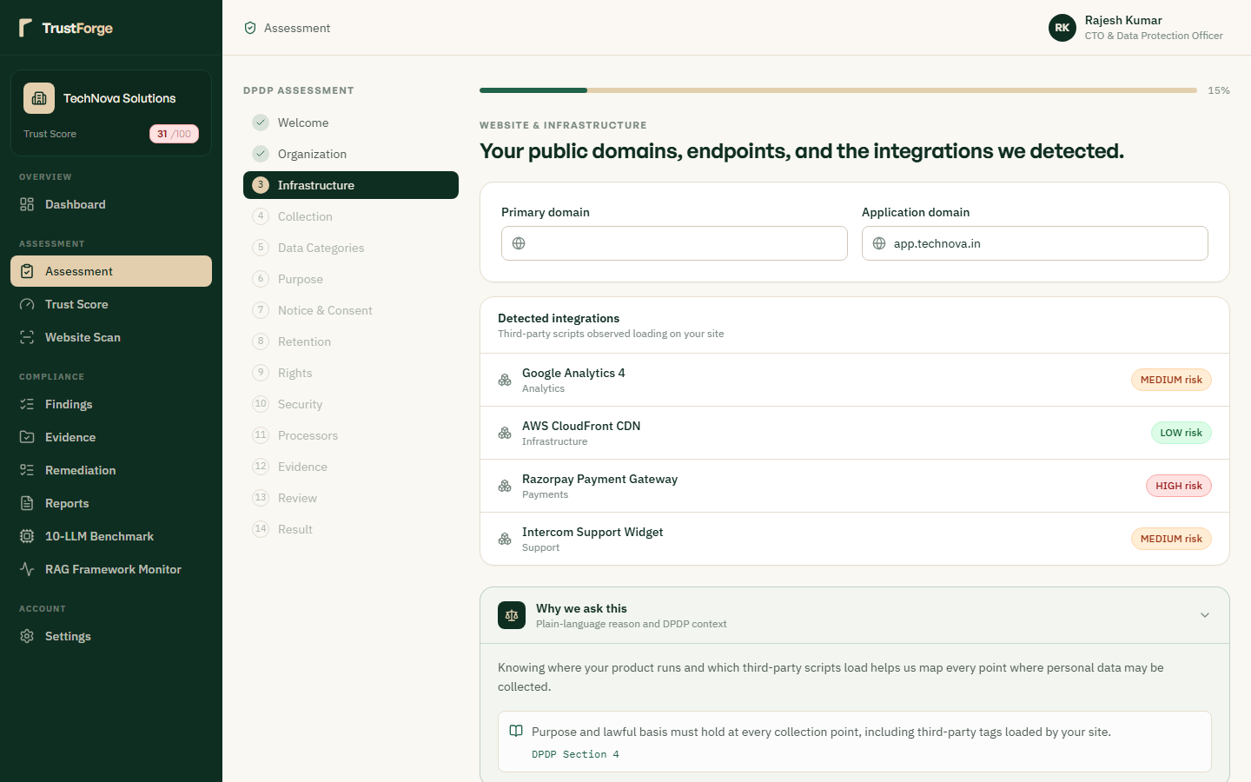
Audits statutory privacy notice clarity, itemization of collected personal data, and DPO contact transparency under Section 5. Validates availability of notice in English and all 22 languages specified in the Eighth Schedule to the Constitution of India. Checks that notices describe data principal rights and the explicit procedure for withdrawing consent or lodging complaints.

Figure 12: Assessment Step 4 — Consent Manager Integration & Interoperability
Route: /assessment/wizard/step-4 | Role: Compliance Assessor
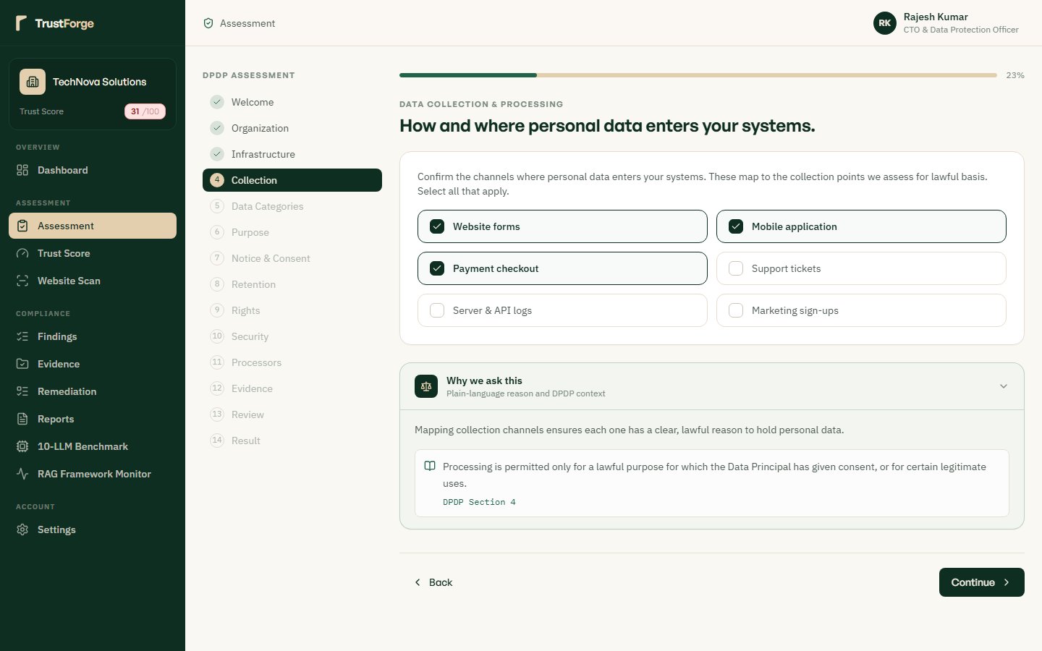
Verifies interoperability with Data Protection Board-registered Consent Managers as mandated under Section 6(7)-(9). Assesses API endpoints and protocols that allow data principals to view, manage, and revoke consent through unified portals. Ensures consent lifecycle events (grant, modification, revocation) trigger immediate downstream data processing halts.

Figure 13: Assessment Step 5 — Purpose Limitation & Data Minimization
Route: /assessment/wizard/step-5 | Role: Compliance Assessor
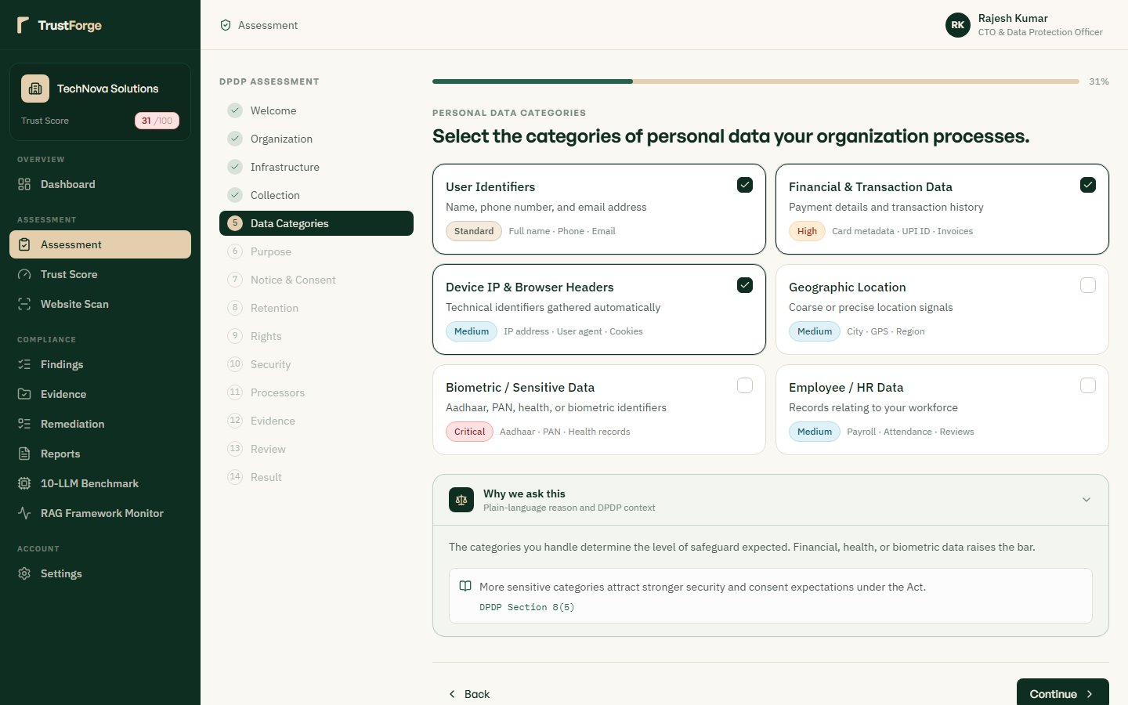
Examines adherence to DPDP Act Section 4 and Section 7 processing boundaries, verifying that only strictly necessary data is collected. Flags excessive data collection practices, collateral data gathering, and purpose creep across corporate systems. Validates that personal data collected for a specified transaction is not reused for profiling or automated marketing without separate consent.

Figure 14: Assessment Step 6 — Storage Limitation & Secure Erasure
Route: /assessment/wizard/step-6 | Role: Compliance Assessor
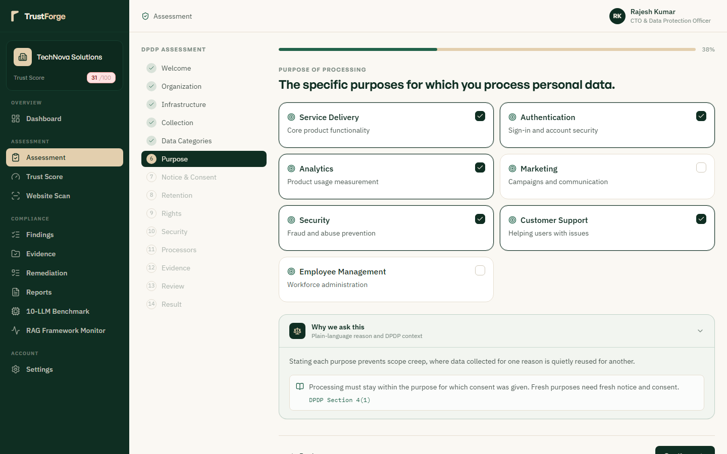
Audits data retention schedules, automated archival policies, and cryptographic erasure protocols under Section 8(7). Verifies that personal data is deleted as soon as the specified purpose is fulfilled or consent is formally withdrawn. Assesses corporate tombstone tracking, shredding verification logs, and legal hold override safeguards.

Figure 15: Assessment Step 7 — Data Quality, Completeness & Accuracy
Route: /assessment/wizard/step-7 | Role: Compliance Assessor
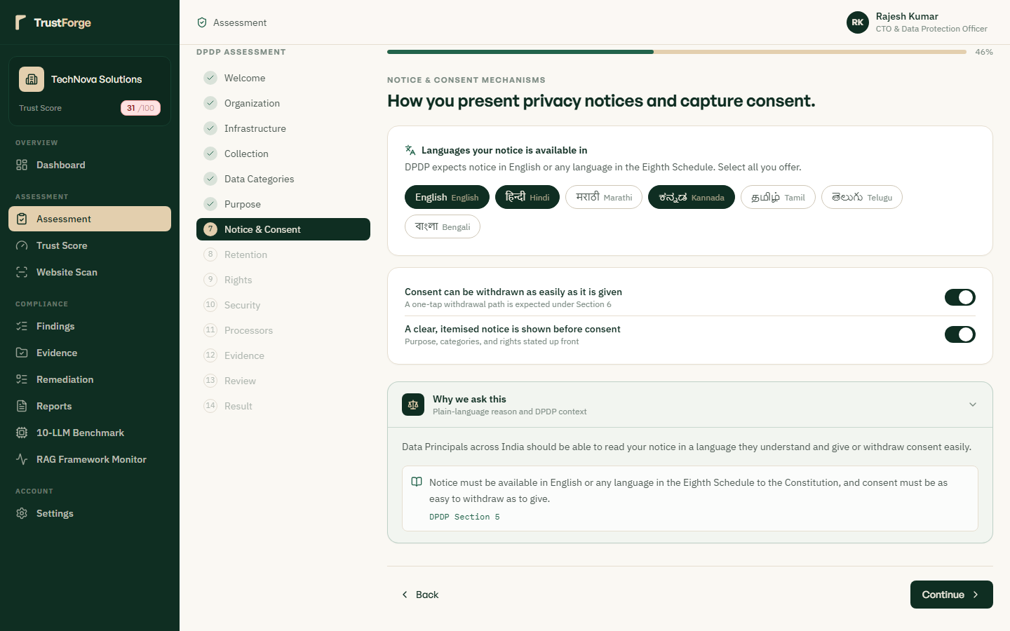
Inspects data lifecycle integrity mechanisms to ensure personal data used to make decisions affecting data principals is accurate. Maps directly to DPDP Act Section 8(3) obligations requiring reasonable efforts to maintain completeness and consistency. Evaluates self-service data correction interfaces, synchronization pipelines, and third-party data processor propagation.

Figure 16: Assessment Step 8 — Reasonable Technical & Security Safeguards
Route: /assessment/wizard/step-8 | Role: Compliance Assessor
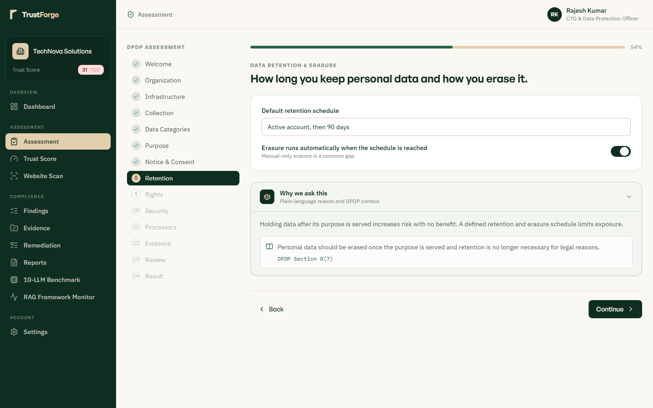
Verifies mandatory technical security controls including AES-256 encryption at rest, TLS 1.3 in transit, and role-based access. Audits compliance with DPDP Act Section 8(5) requiring reasonable security safeguards to prevent personal data breaches. Checks penetration testing cadences, vulnerability management programs, and multi-factor authentication enforcement.

Figure 17: Assessment Step 9 — Personal Data Breach Incident Management
Route: /assessment/wizard/step-9 | Role: Compliance Assessor
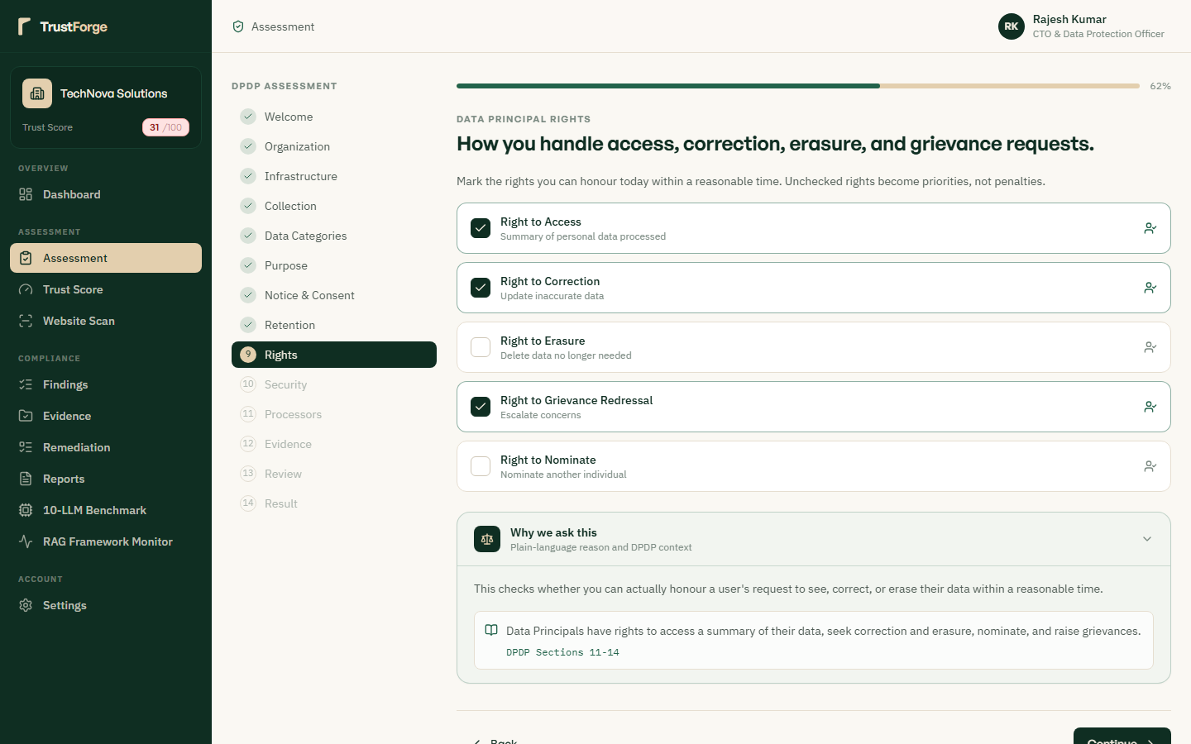
Audits incident response playbooks and formal breach notification workflows under DPDP Act Section 8(6). Verifies that protocols exist to inform both the Data Protection Board of India and affected data principals without delay. Evaluates containment timelines, forensic logging procedures, and CERT-In coordination mechanisms.

Figure 18: Assessment Step 10 — Children's Data & Persons with Disabilities
Route: /assessment/wizard/step-10 | Role: Compliance Assessor
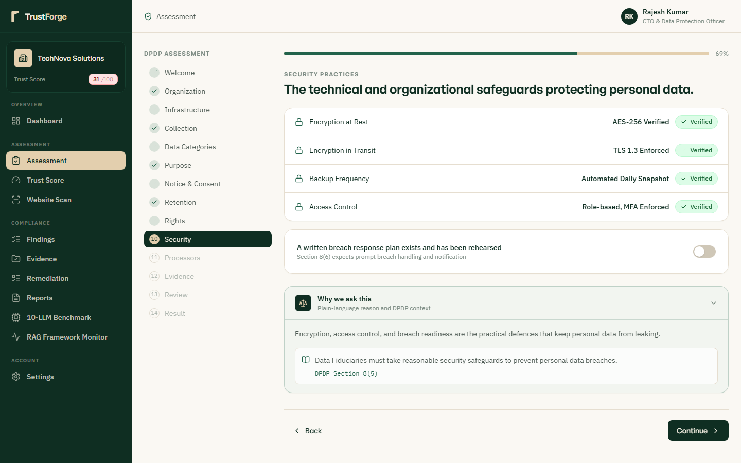
Evaluates verifiable parental consent mechanisms and strict prohibitions against tracking, profiling, or targeted advertising. Enforces strict adherence to DPDP Act Section 9 mandates safeguarding minors and individuals under legal guardianship. Checks age assurance systems, neutral age gating, and absence of harmful behavioral monitoring algorithms.

Figure 19: Assessment Step 11 — Data Principal Rights Redressal Architecture
Route: /assessment/wizard/step-11 | Role: Compliance Assessor
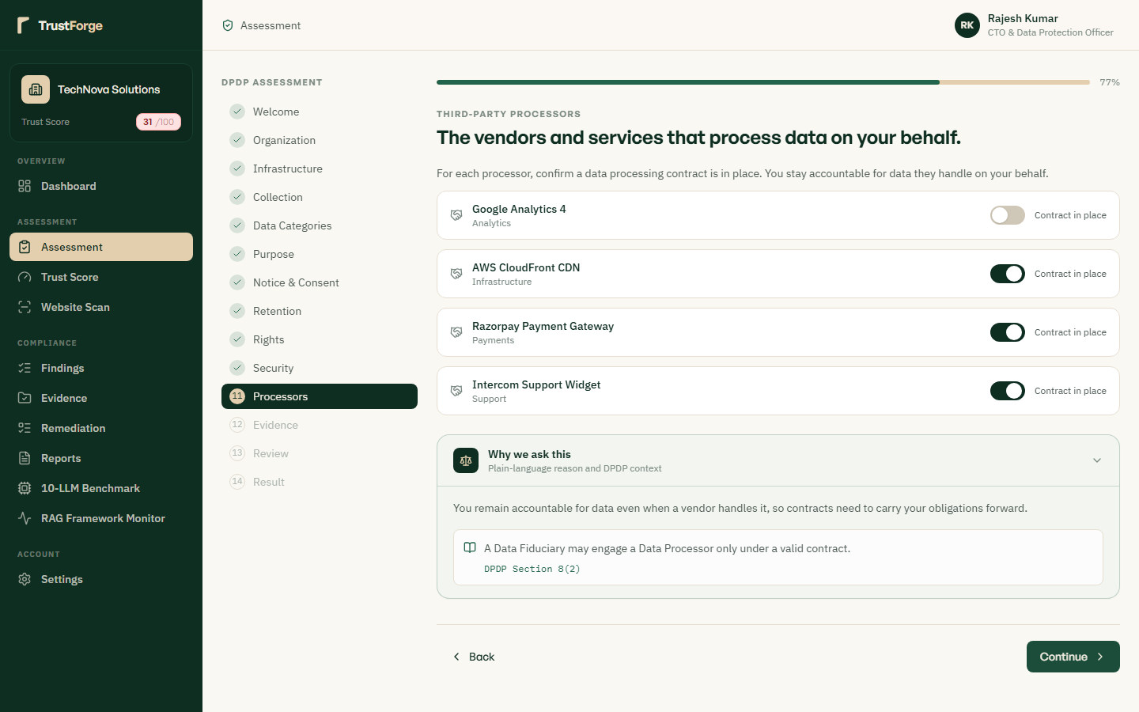
Inspects automated self-service workflows for the right to access (Sec 11), right to correction (Sec 12), and right to erasure. Verifies data export portability formats (JSON/CSV), identity verification checks, and 30-day statutory fulfillment timers. Evaluates the right of nomination framework enabling designated representatives in event of death or incapacity.

Figure 20: Assessment Step 12 — Grievance Redressal Mechanism & Timelines
Route: /assessment/wizard/step-12 | Role: Compliance Assessor
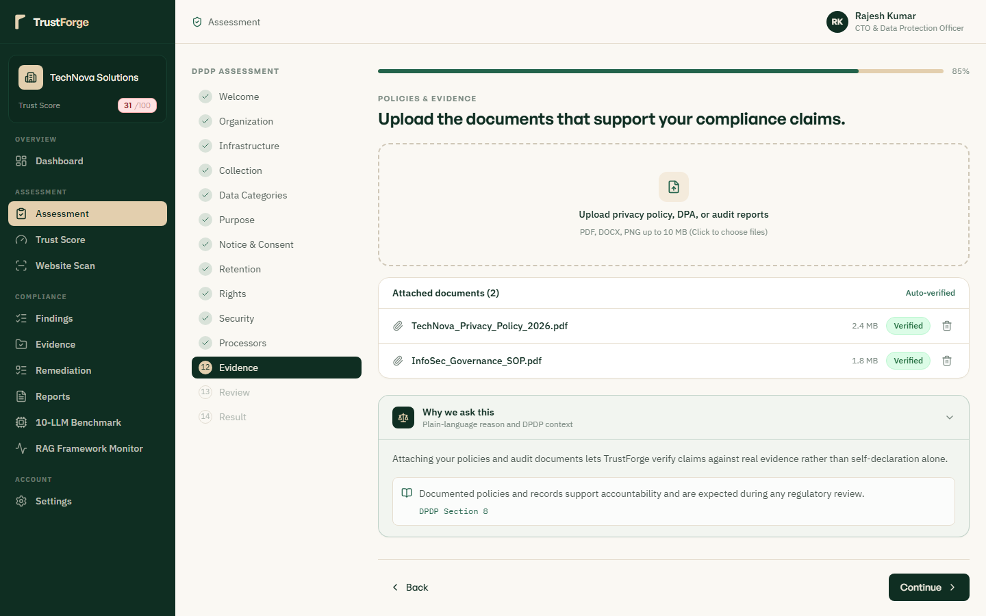
Audits the organizational grievance redressal hierarchy and Data Protection Officer escalation paths under Section 13. Verifies that ticket tracking systems record citizen complaints and enforce statutory resolution turnaround times. Ensures data principals are clearly advised of their right to appeal unresolved grievances to the Data Protection Board.

Figure 21: Assessment Step 13 — Significant Data Fiduciary (SDF) Obligations
Route: /assessment/wizard/step-13 | Role: Compliance Assessor
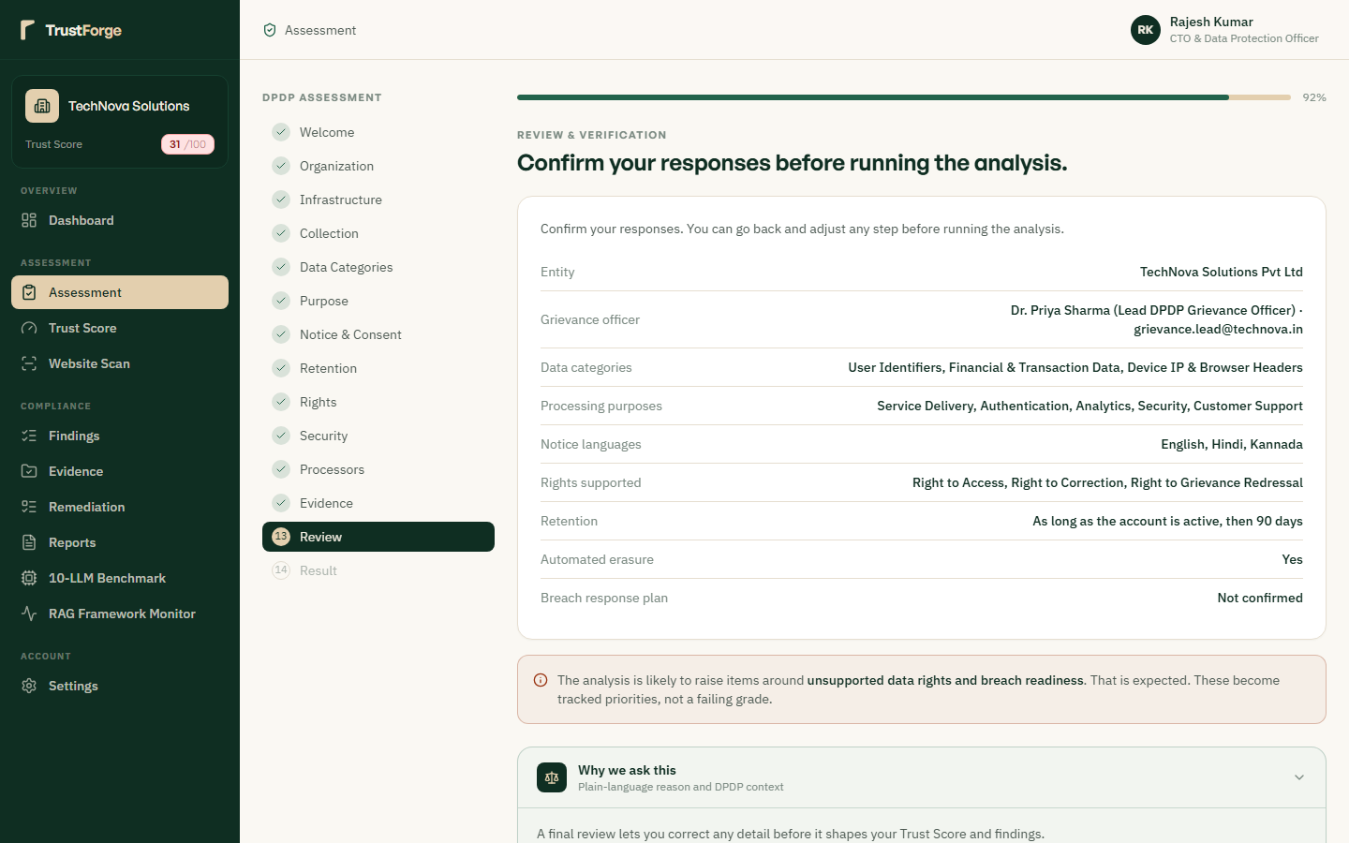
Audits specialized institutional requirements for designated Significant Data Fiduciaries under DPDP Act Section 10. Validates periodic Data Protection Impact Assessments (DPIA), independent statutory audits, and resident DPO appointments. Assesses algorithmic impact audits, systemic risk monitoring, and executive compliance reporting frameworks.

Figure 22: Assessment Step 14 — Final Audit Review & Evidence Synthesis
Route: /assessment/wizard/step-14 | Role: Compliance Assessor
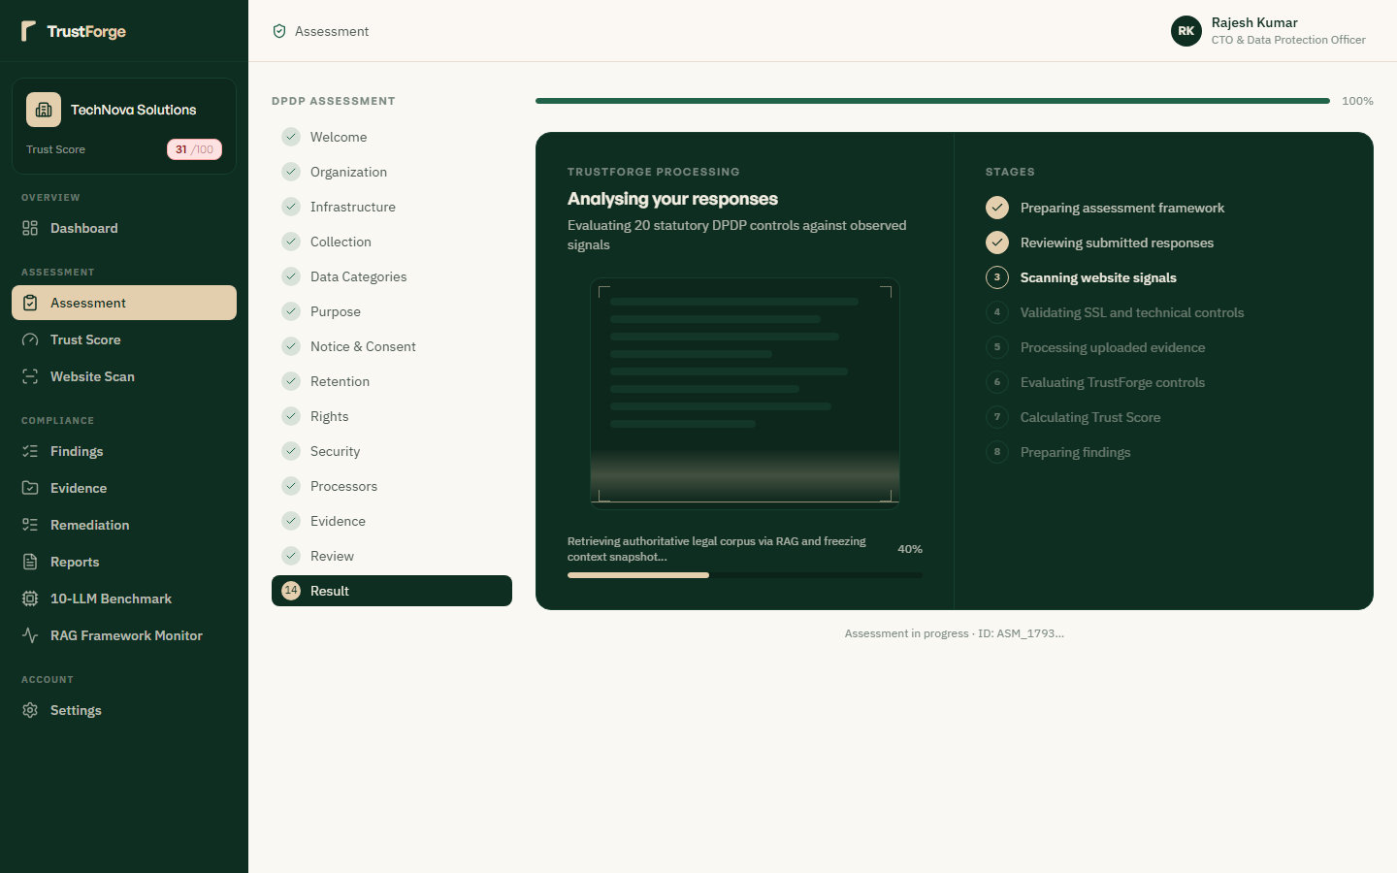
Aggregates all 14 statutory control sections into a unified pre-submission audit summary matrix with completeness indicators. Allows compliance auditors to inspect response consistency, link supplementary documentary evidence, and confirm accuracy. Submitting this step freezes the assessment snapshot and triggers real-time RAG scoring and multi-criteria TOPSIS evaluation.

Figure 23: Complete Statutory Compliance Evaluation Results
Route: /assessment/results/:id | Role: Compliance Officer / DPO
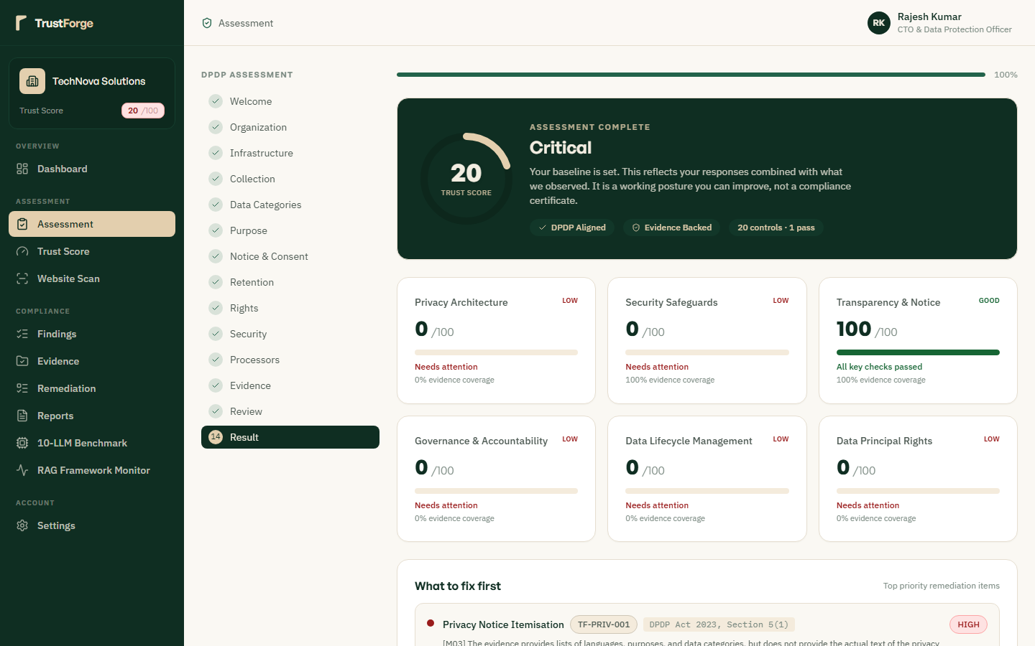
Presents the finalized audit scorecard, percentage compliance ratings across each of the 14 statutory sections, and gap analysis. Identifies specific non-compliance risks categorized by high, medium, and low statutory exposure thresholds. Generates immediate remediation recommendations and allows one-click export of formal audit certificates.

Section: Compliance Engines & Analytics

Figure 24: TrustForge Composite Trust Score & Empirical Analytics
Route: /trust-score | Role: Executive / Auditor
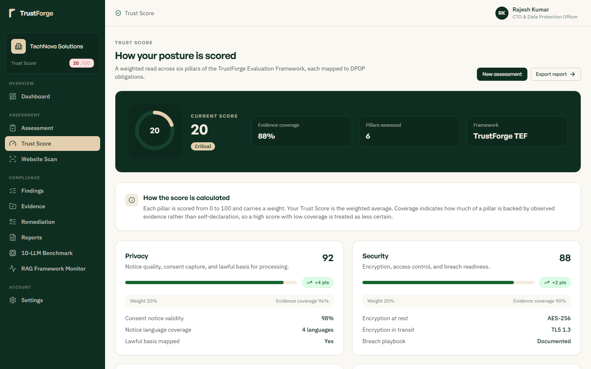
Displays the multi-dimensional composite Trust Score computed from assessment completeness, technical scan results, and evidence. Features visual radar charts breaking down scores across Governance, Transparency, Security, Rights, and Incident Response. Provides historical score progression curves and industry benchmark comparisons to quantify compliance improvement over time.

Figure 25: Automated Perimeter Security & Privacy Cookie Scanner
Route: /scans | Role: Security Engineer / Auditor
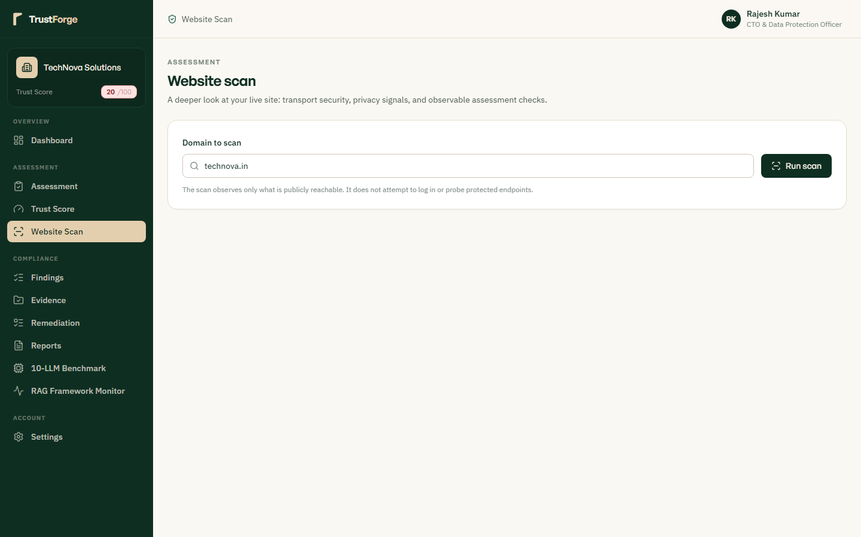
Executes active automated crawling of corporate web properties to detect non-compliant third-party tracking scripts and cookies. Evaluates SSL/TLS cipher suites, HTTP security response headers (HSTS, CSP), and accessibility of privacy notices. Discovered issues are automatically converted into remediation tickets linked directly to the findings dashboard.

Figure 26: Statutory Vulnerabilities & Findings Management Vault
Route: /findings | Role: Compliance Manager
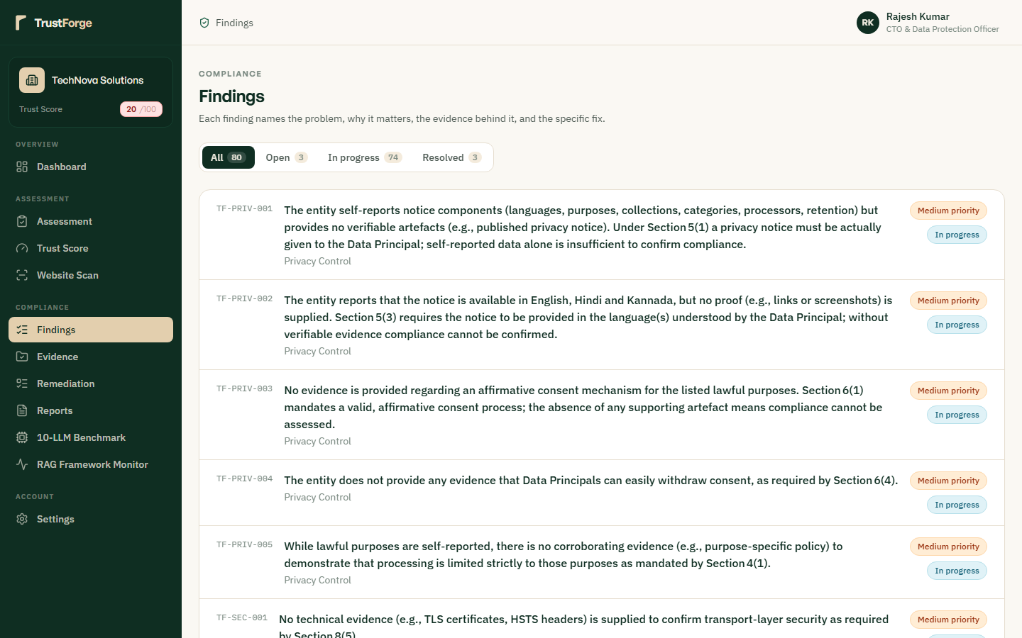
Centralizes all detected statutory gaps and perimeter scan vulnerabilities in a filterable compliance issue tracker. Each finding links to its violated DPDP Act legal citation, maximum statutory financial penalty, and severity classification. Enables compliance managers to assign remediation owners, track resolution status, and attach corrective proof.

Figure 27: Cryptographic Evidence Locker & Document Management
Route: /evidence | Role: Compliance Officer
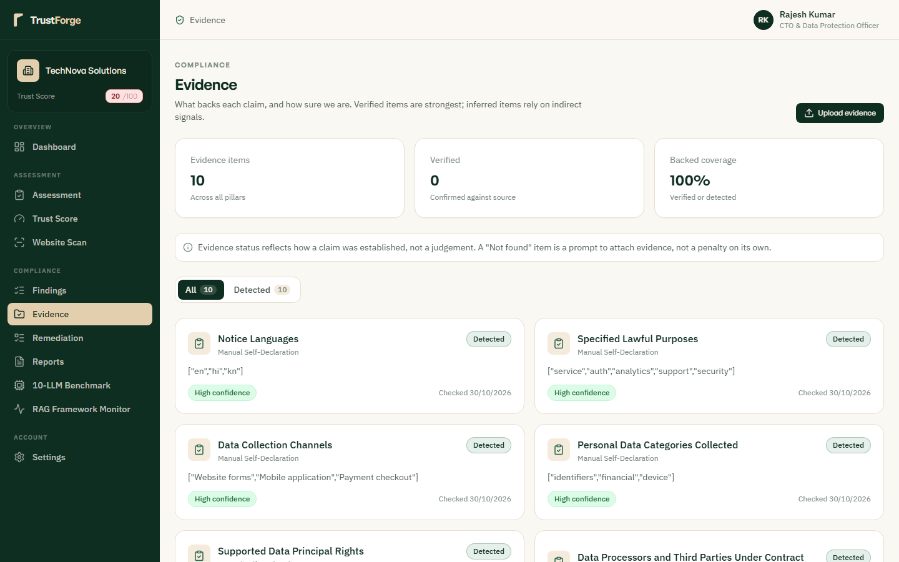
Provides an auditable evidence locker where organizations upload policy documents, DPIA reports, and technical architecture schemas. Each uploaded file is hashed (SHA-256) upon ingestion to ensure tamper-evident chain of custody and forensic integrity. Files are automatically indexed into the RAG vector store for retrieval during automated compliance citation verification.

Figure 28: Interactive Statutory Remediation Roadmaps & Workflows
Route: /remediation | Role: Remediation Lead / Engineer
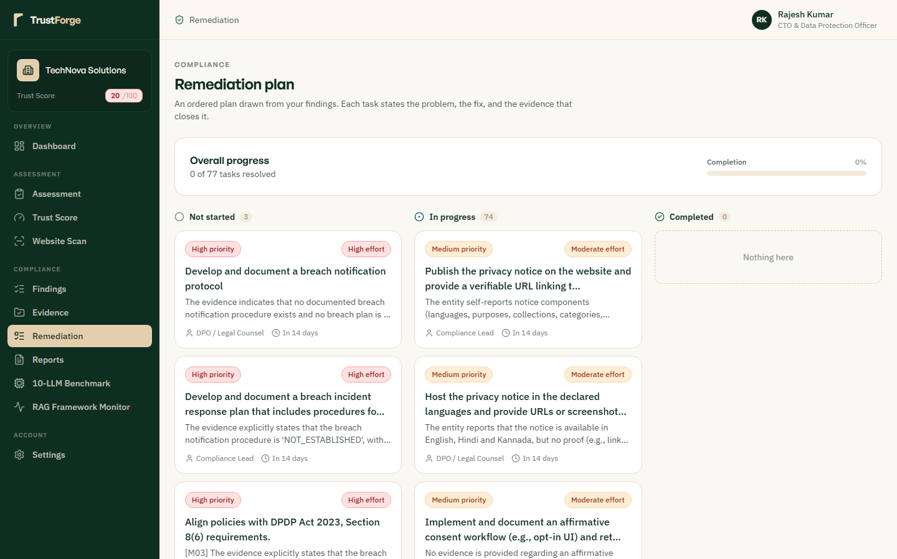
Transforms audit findings into an interactive step-by-step engineering and legal remediation roadmap. Features progress tracking bars, projected Trust Score gains upon resolution, and statutory deadline countdowns. Includes pre-configured legal templates and technical implementation guides for rapid compliance closing.

Figure 29: Statutory Audit Report Generation & Export Console
Route: /reports | Role: Auditor / Executive
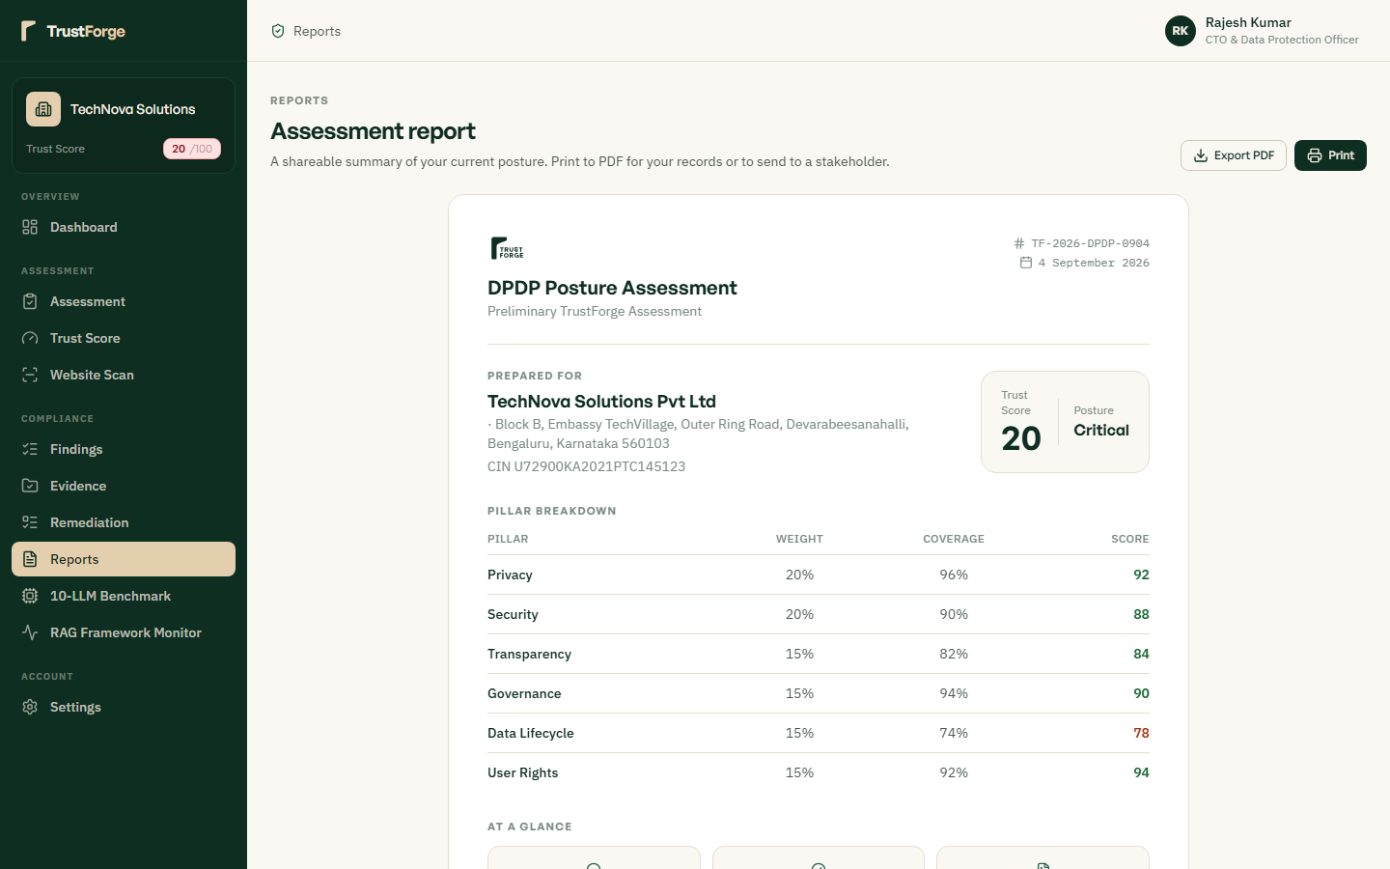
Enables one-click generation of court-ready PDF audit reports, Board executive summaries, and raw JSON data dumps. Reports incorporate statutory legal citations, full RRF-fused evidence excerpts, and verifiable cryptographic verification stamps. Allows filtering by assessment period, business unit, or specific regulatory scope for external auditor submissions.

Figure 30: Multi-Model Evaluation & TOPSIS Decision Matrix
Route: /benchmark | Role: AI Research / DPO
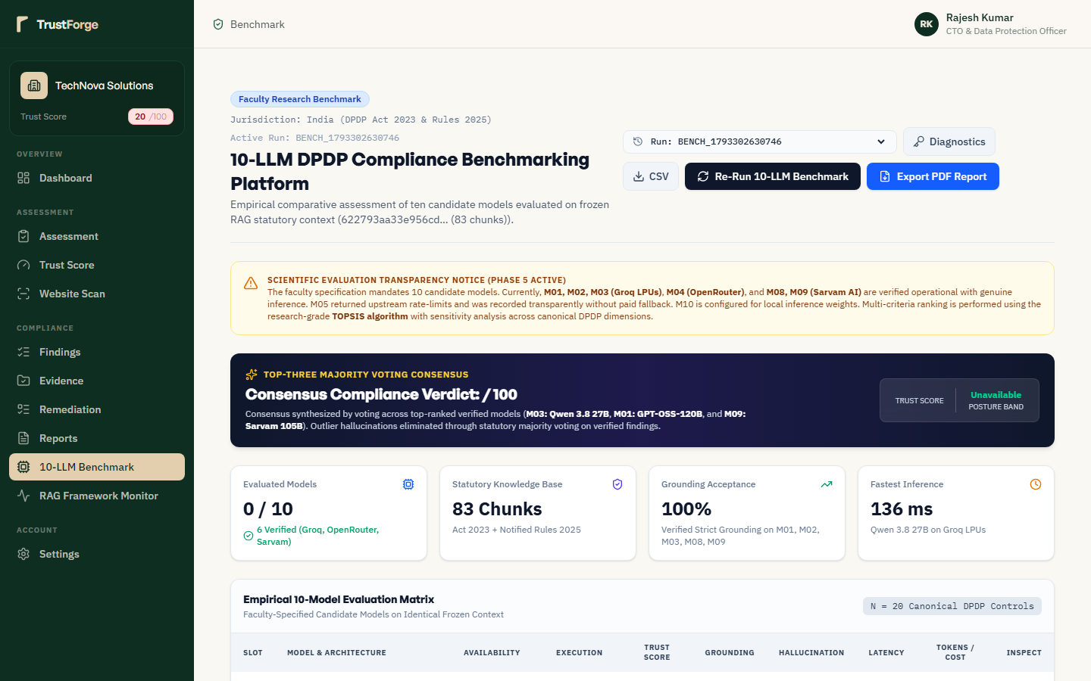
Displays empirical performance metrics across evaluated language models (M01-M09) spanning accuracy, latency, and cost efficiency. Implements the Technique for Order of Preference by Similarity to Ideal Solution (TOPSIS) to rank models algorithmically. Demonstrates the zero-paid-inference boundary policy by showing commercial models gated while local open models achieve top ranks.

Figure 31: Real-Time RAG Diagnostic & Retrieval Fusion Monitor
Route: /rag-monitor | Role: Data Engineer / Auditor
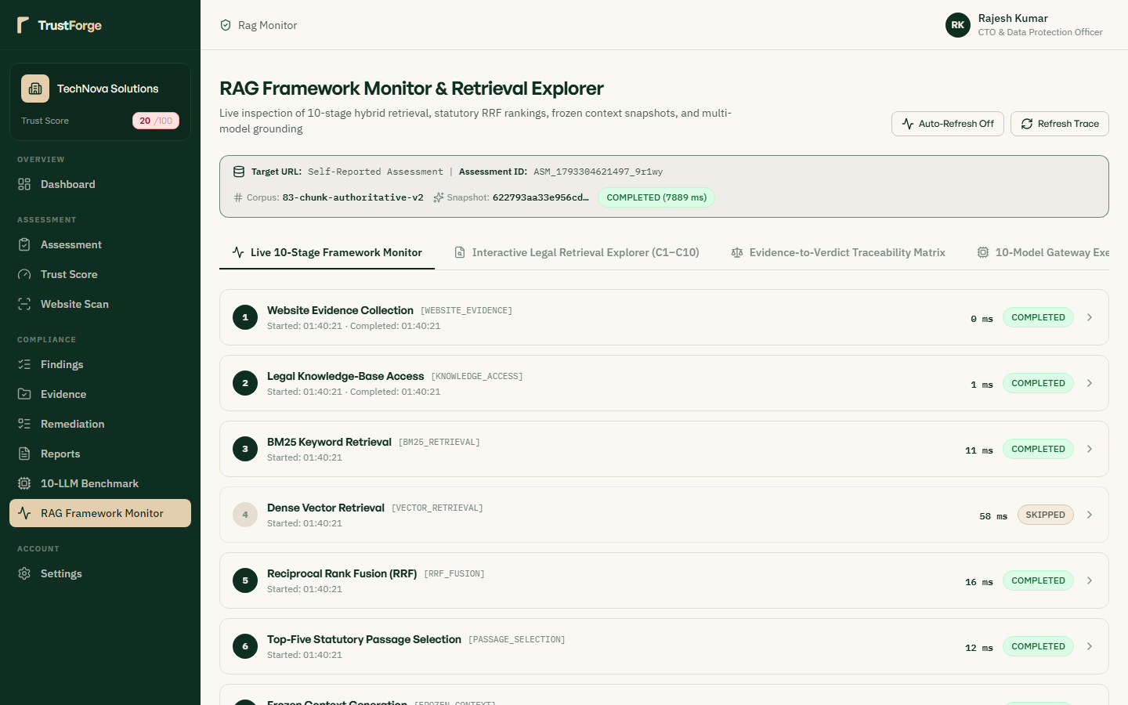
Provides real-time visibility into the hybrid vector and keyword retrieval pipeline executing Reciprocal Rank Fusion (RRF, k=60). Inspects cosine similarity scores, BM25 keyword rankings, and exact legal chunk boundaries retrieved from the DPDP Act corpus. Guarantees that every compliance assertion made by the platform is backed by verifiable, retrieved statutory text.

Figure 32: Data Principal Rights Request Management Portal
Route: /rights-portal | Role: Privacy Operations Lead
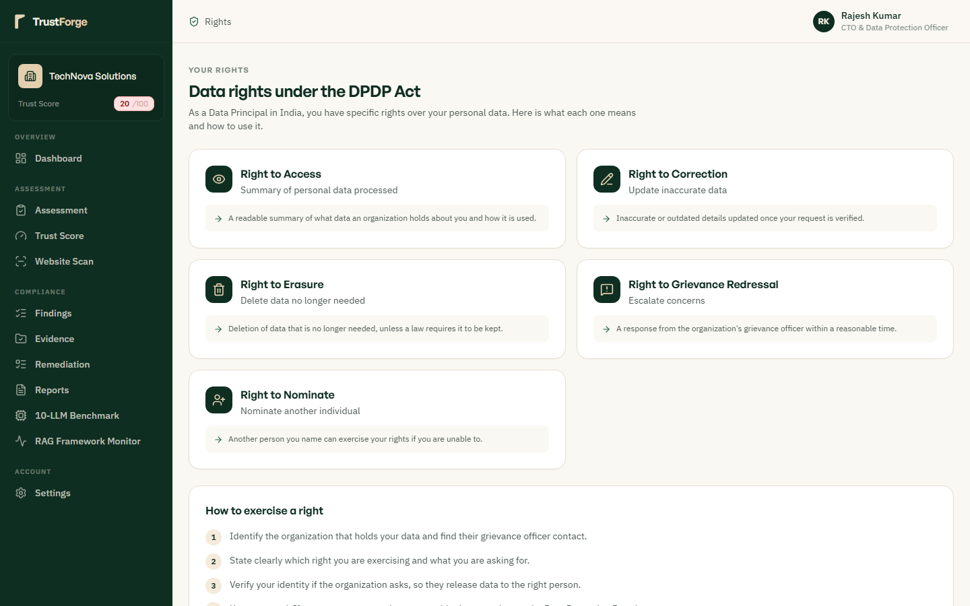
Manages incoming citizen privacy requests including Access, Correction, Erasure, and Grievance redressal under DPDP Act Chapter III. Enforces strict 30-day statutory response SLAs with visual color-coded urgency countdown badges. Logs every operational touchpoint, verification check, and fulfillment action to maintain a complete audit defense file.

Section: Administrative Governance & Platform Audit

Figure 33: Dedicated Administrative Authentication Gate
Route: /admin/login (Dedicated) | Role: System Administrator
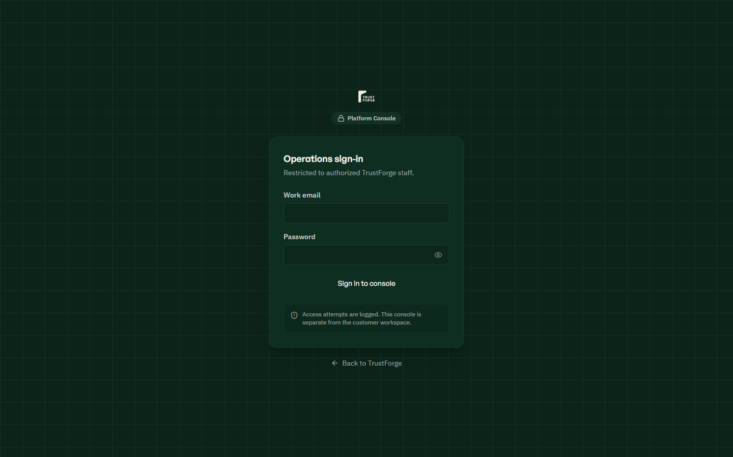
Enforces an isolated administrative authentication gate with explicit platform-level role verification on the server backend. Customer credentials and non-admin tokens are strictly rejected to prevent unauthorized console access. Guarantees that only cryptographically verified superusers and compliance auditors can access administrative features.

Figure 34: Administrative Access Control & Privilege Rejection Error
Route: /admin/login (Failure State) | Role: Unauthorized User
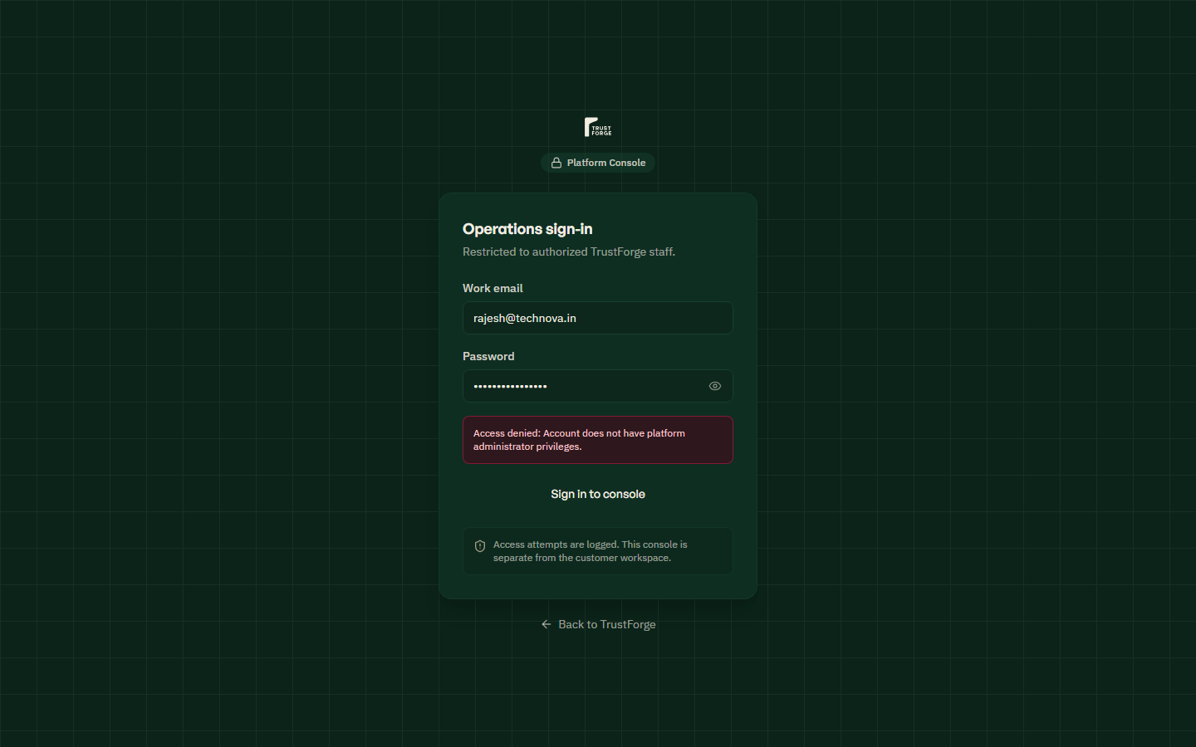
Demonstrates the active security rejection boundary when invalid or non-administrative credentials attempt console access. Displays a clear, non-leaking authentication error message while logging the failed attempt in the tamper-evident security audit log. Prevents brute force attacks through progressive rate-limiting and session termination upon repeated failures.

Figure 35: Central Platform Command Center & Global KPIs
Route: /admin/dashboard | Role: Platform Superadmin
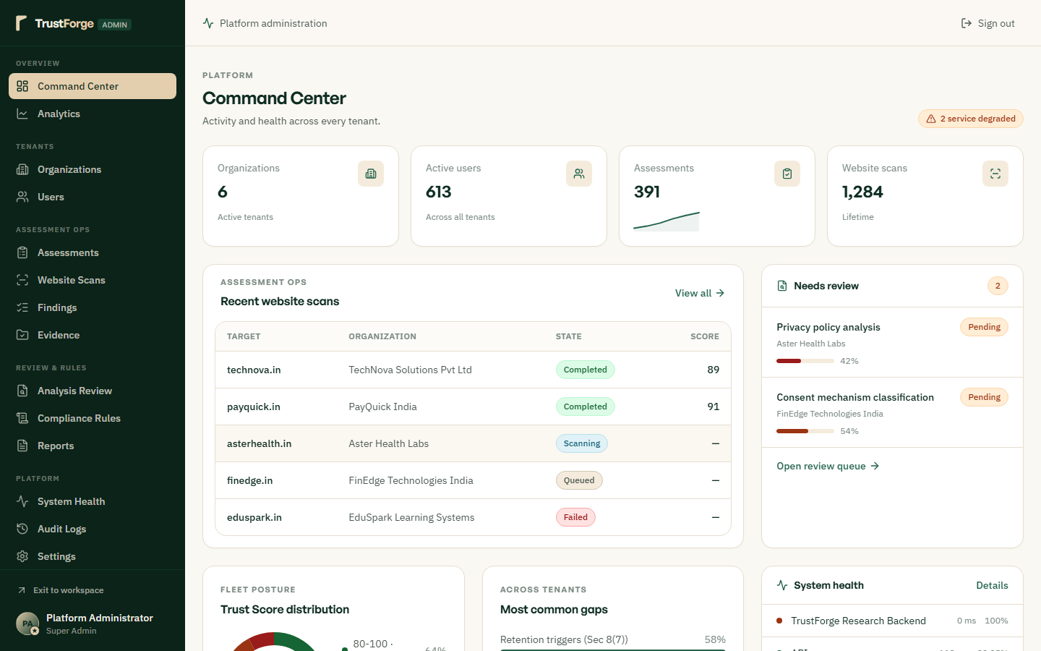
Aggregates platform-wide telemetry, cross-tenant compliance indices, active scan worker queues, and aggregate assessment counts. Provides superadministrators with immediate situational awareness regarding overall platform operational health. Features real-time charts monitoring system throughput, API latency percentiles, and critical compliance vulnerability spikes.

Figure 36: Cross-Tenant Compliance Analytics & Distribution Trends
Route: /admin/analytics | Role: Compliance Analyst
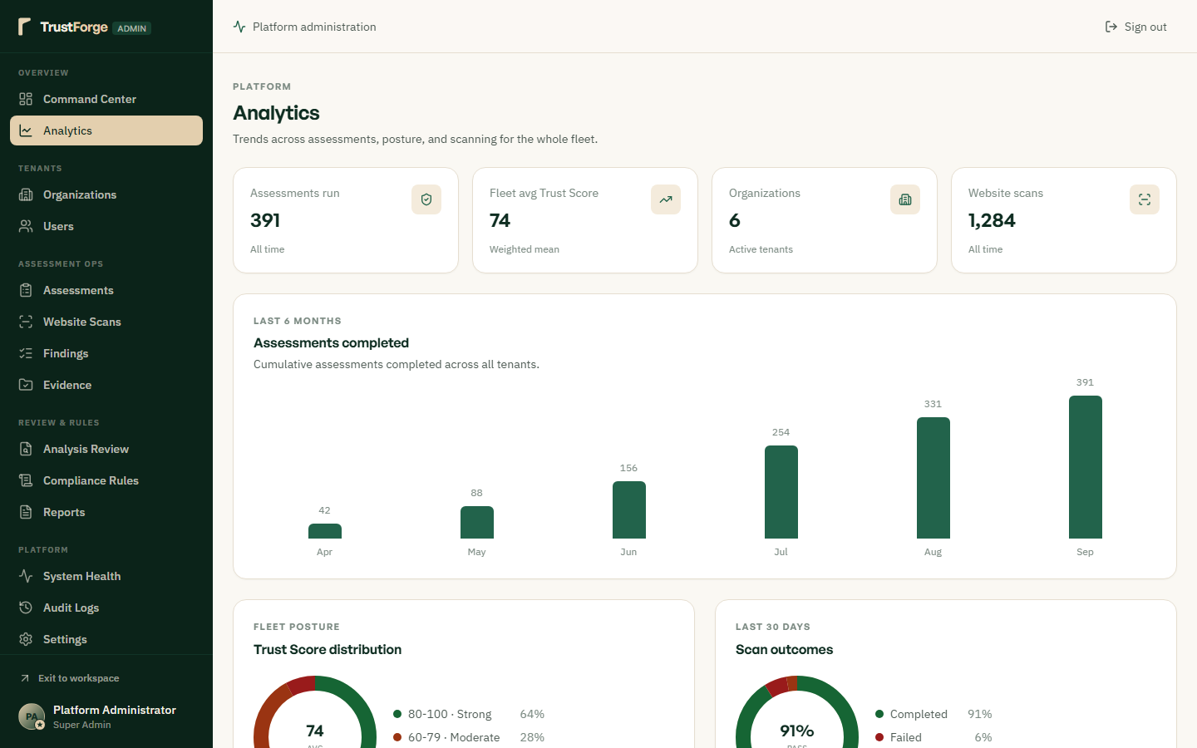
Presents aggregated cross-sector compliance trends, common statutory failure modes, and benchmark comparisons. Visualizes the distribution of Trust Scores across industry verticals (Healthcare, Finance, SaaS, Retail). Enables regulatory researchers and platform operators to pinpoint national compliance bottlenecks under the DPDP Act.

Figure 37: Multi-Tenant Enterprise Organization Management
Route: /admin/organizations | Role: Platform Superadmin
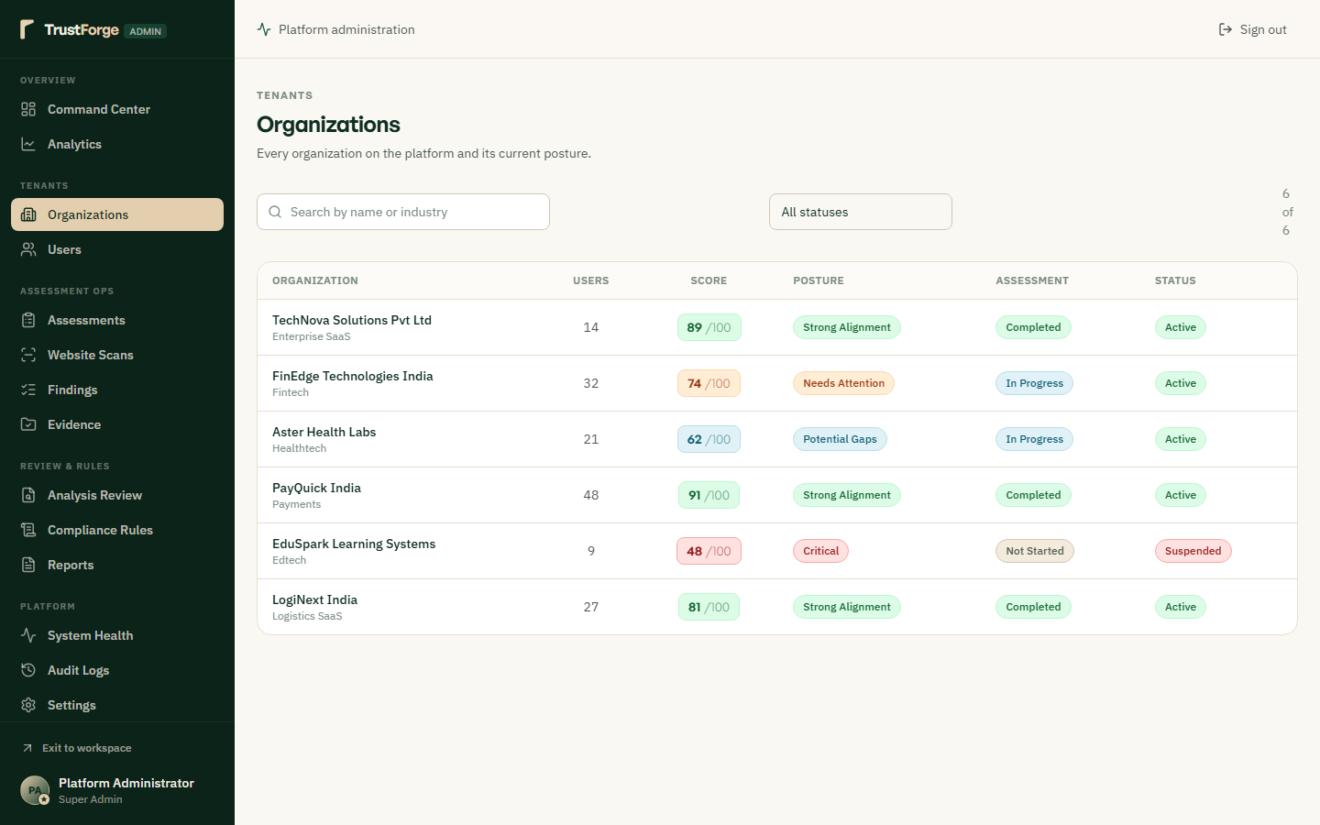
Manages all registered enterprise tenant organizations, subscription tiers, domain verification statuses, and compliance postures. Provides granular administrative controls to suspend, activate, or adjust tenant quotas and data retention policies. Supports quick searching and filtering across legal entity names, verification flags, and Significant Data Fiduciary badges.

Figure 38: Granular Organization Tenant Governance & Deep Inspection
Route: /admin/organizations/:id | Role: Platform Superadmin
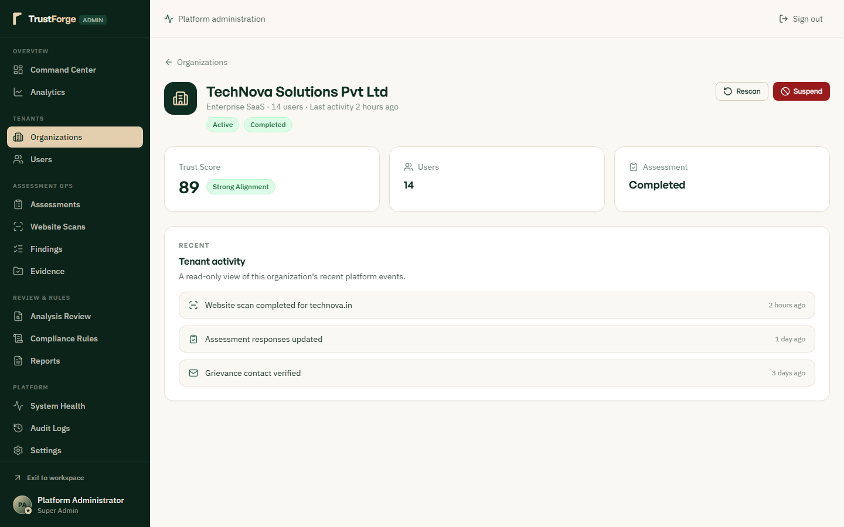
Allows deep administrative inspection of a specific tenant's settings, assigned DPO details, DNS challenge records, and audit history. Enables manual domain verification overrides for enterprise deployments with air-gapped or internal DNS infrastructure. Displays tenant-specific resource consumption metrics, active member rosters, and recent compliance milestones.

Figure 39: Enterprise User Directory & Role Assignment Controls
Route: /admin/users | Role: Security Administrator
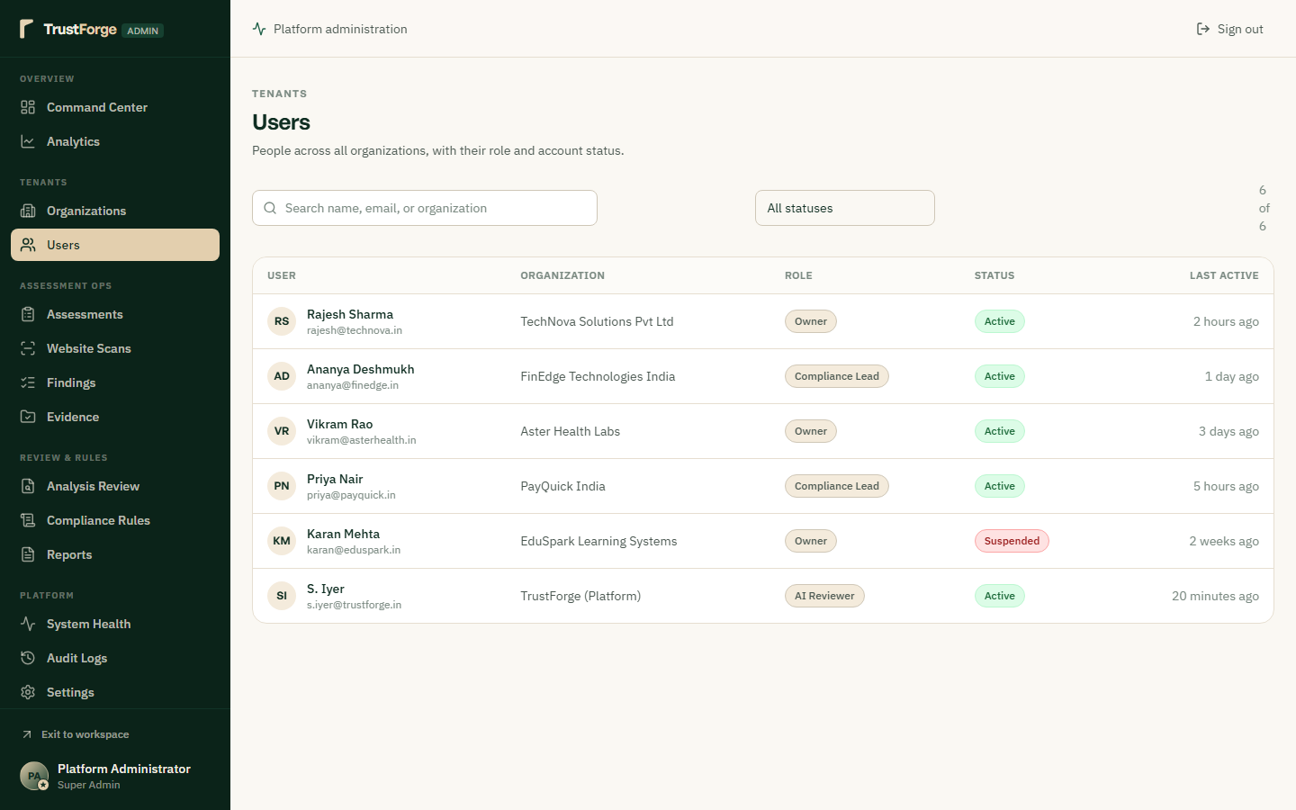
Centralizes enterprise user directory management across all tenants, displaying user roles, MFA statuses, and last login timestamps. Enables security administrators to provision new accounts, initiate password resets, or adjust role assignments (Admin, DPO, Assessor). Enforces strict separation of duties and logs all administrative identity modifications.

Figure 40: User Profile Deep Inspection & Session Revocation
Route: /admin/users/:id | Role: Security Administrator
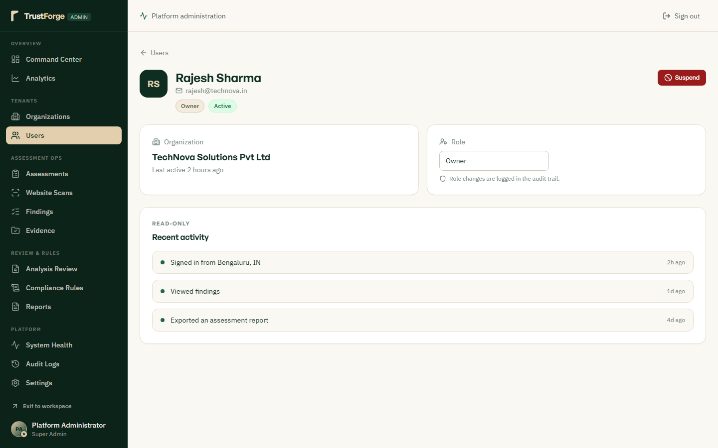
Provides granular inspection of individual user accounts, including linked tenant organizations, assigned scopes, and activity logs. Allows administrators to revoke active JWT sessions immediately in the event of compromised credentials or employee offboarding. Audits user authorization events, failed login attempts, and password reset histories.

Figure 41: Platform-Wide Assessment Governance & Audit Logs
Route: /admin/assessments | Role: Supervisory Auditor
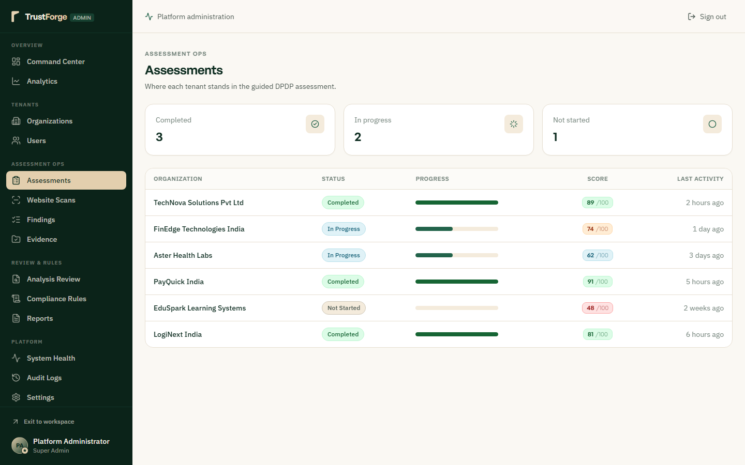
Aggregates all statutory compliance assessments completed across the platform, showing completion dates, scores, and review statuses. Allows supervisory auditors to review assessment submissions, verify supporting documentation, and flag anomalies. Enables cross-organization compliance comparisons and provides drill-down access into individual assessment answers.

Figure 42: Global Perimeter Scan Dispatcher & Queue Telemetry
Route: /admin/scans | Role: Systems Administrator
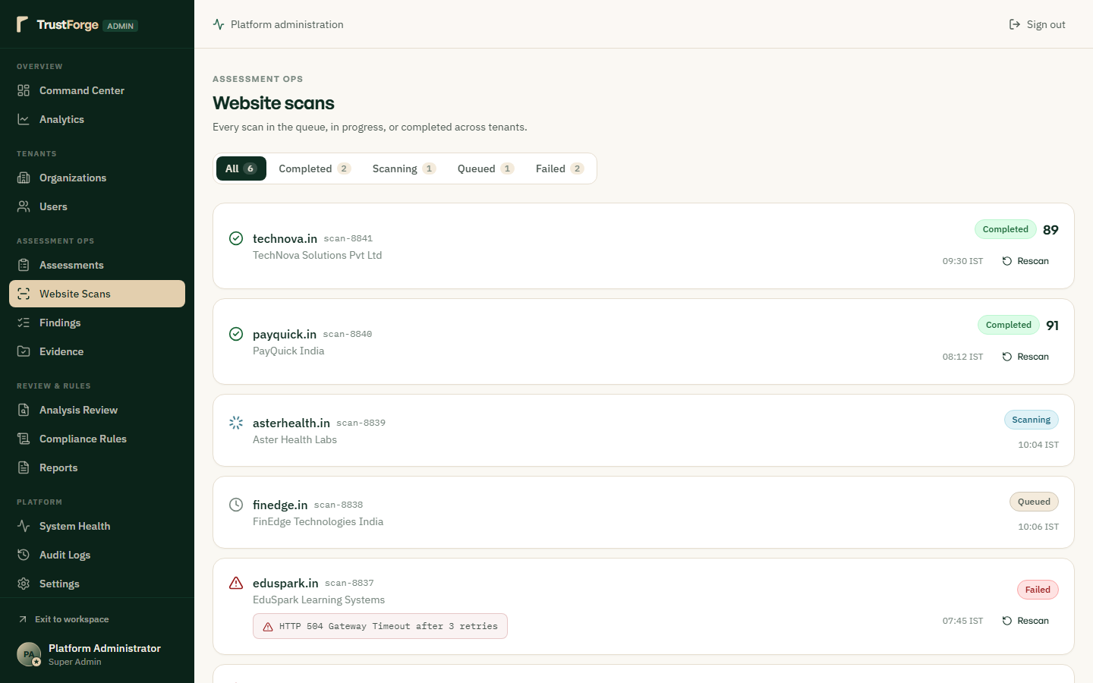
Monitors the background scan dispatcher queue, displaying active website crawl jobs, completion latencies, and failure rates. Provides administrative controls to re-queue stalled scans, purge orphaned jobs, or configure worker concurrency limits. Logs detailed HTTP response codes, SSL handshake details, and tracker extraction statistics for each scan.

Figure 43: Platform-Wide Vulnerability & Defect Registry
Route: /admin/findings | Role: Chief Compliance Officer
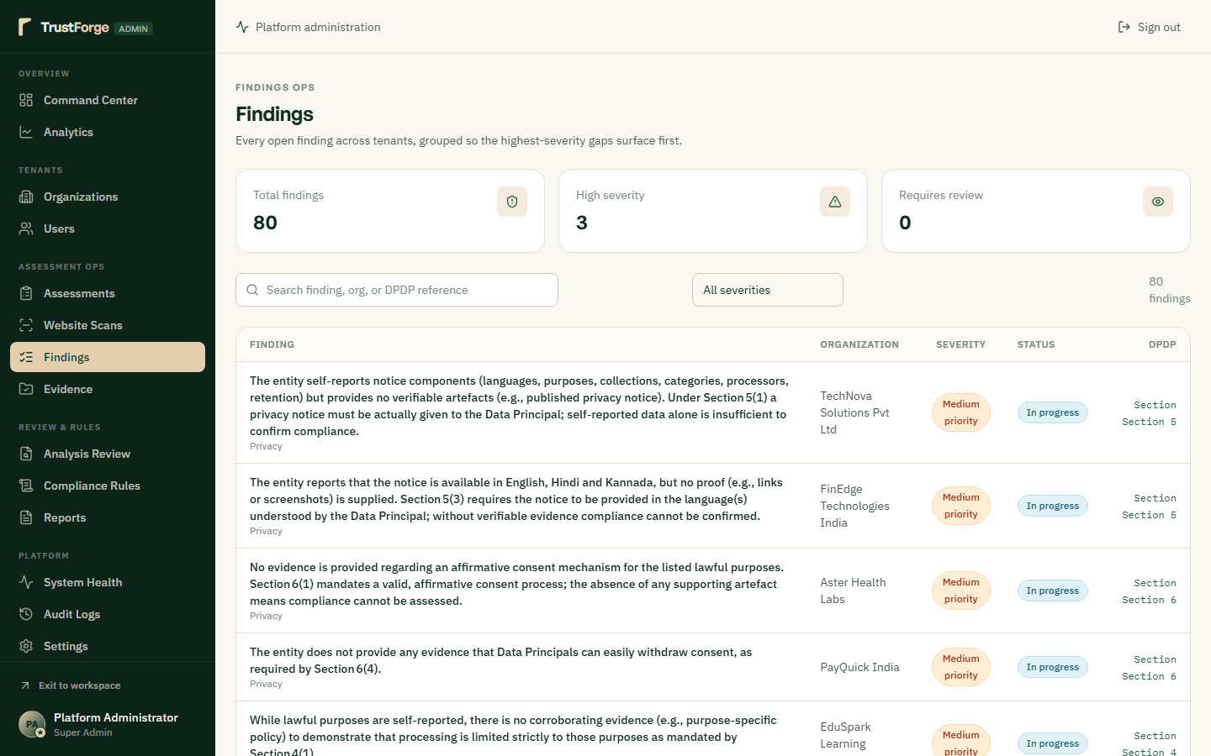
Consolidates all statutory non-compliance findings detected across every registered organization in a single administrative view. Allows filtering by severity (Critical, High, Medium, Low), DPDP Act section, and remediation status. Helps regulatory bodies and compliance leaders identify systemic industry vulnerabilities and measure mean time to remediation (MTTR).

Figure 44: Global Cryptographic Evidence Audit & Verification Vault
Route: /admin/evidence | Role: Forensic Auditor
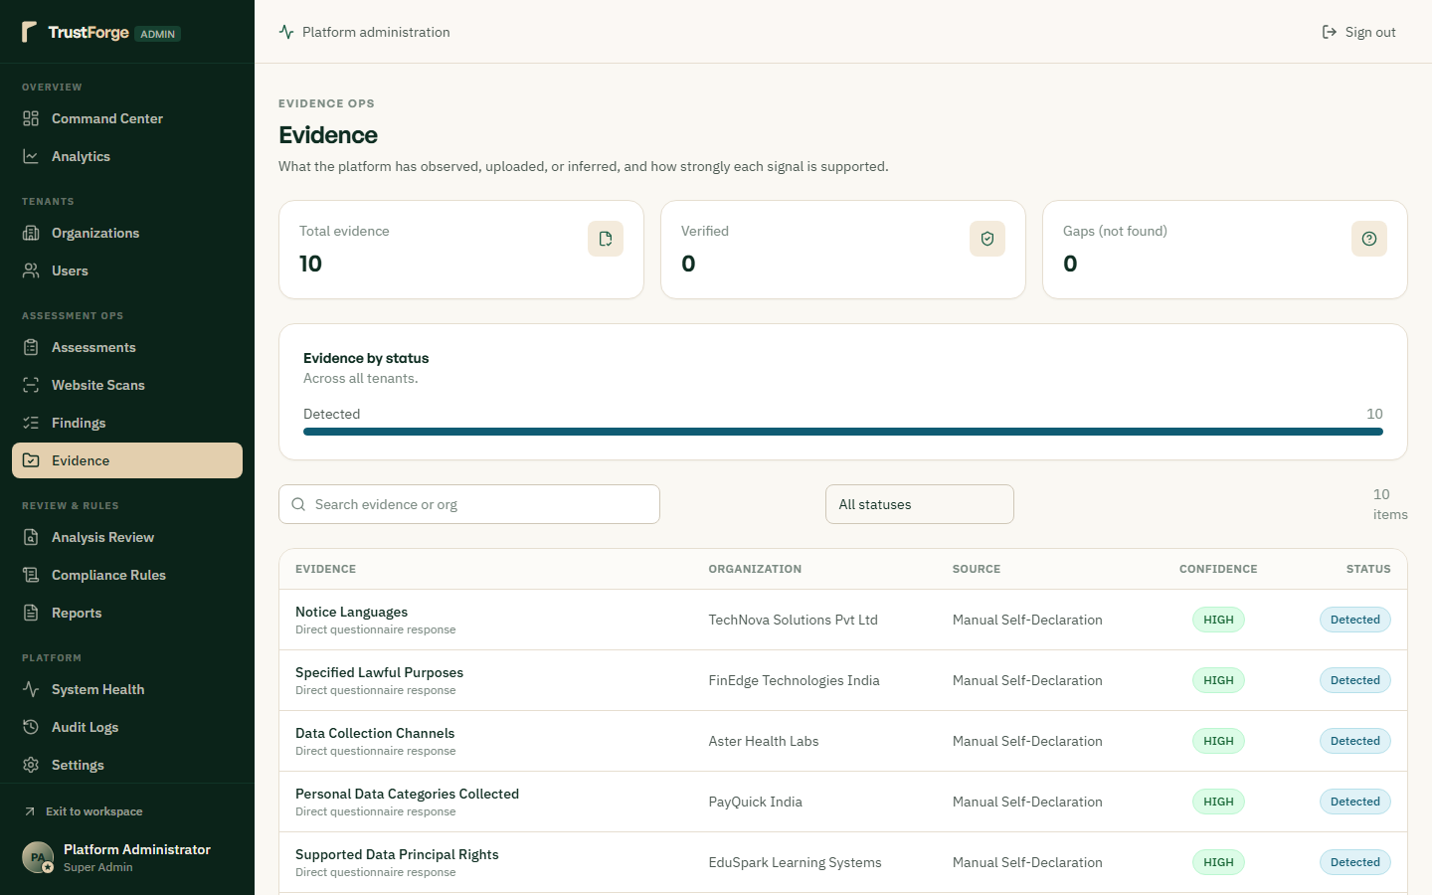
Enables platform forensic auditors to verify the cryptographic SHA-256 integrity of all uploaded compliance evidence documents. Displays file metadata, uploading tenant identity, ingestion timestamps, and linked statutory assessment sections. Guarantees that evidence files have not been modified, corrupted, or replaced post-upload.

Figure 45: Formal Compliance Review & Certification Authority
Route: /admin/reviews | Role: Senior Certification Officer
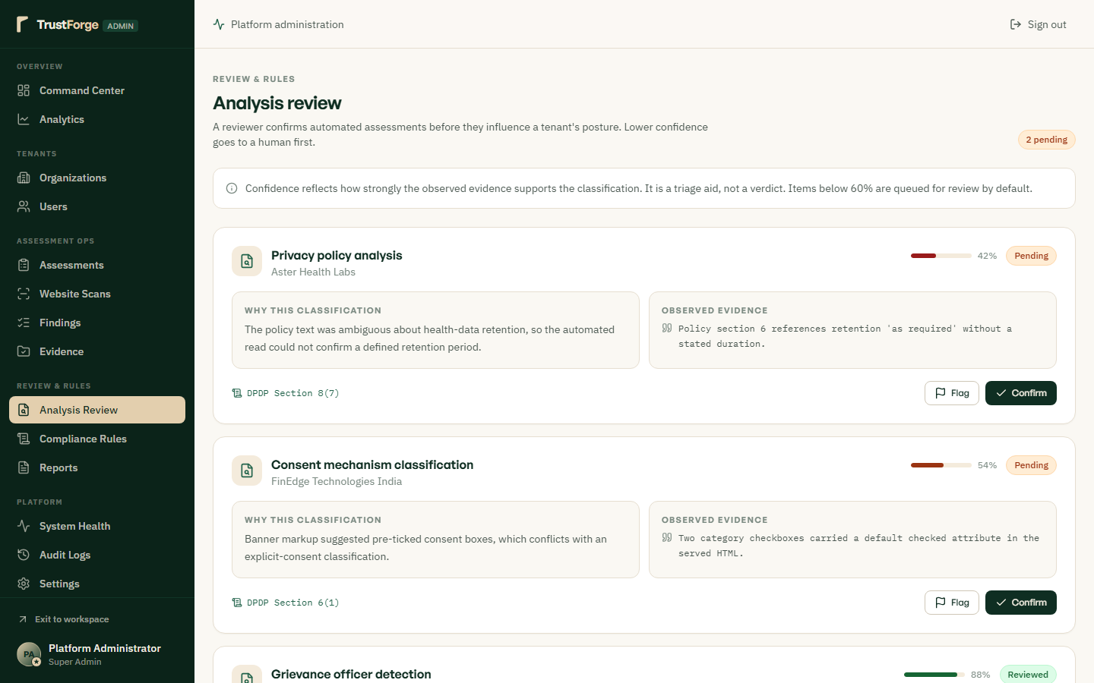
Provides a formalized review interface where senior compliance officers inspect and certify tenant assessment submissions. Allows the reviewer to accept, request revisions on, or reject submitted assessments with itemized auditor commentary. Approved certifications digitally sign the official compliance certificate and record the decision in the permanent audit trail.

Figure 46: Statutory Rules Engine & Legal Weight Tuning Matrix
Route: /admin/rules | Role: Legal / Rule Engineer
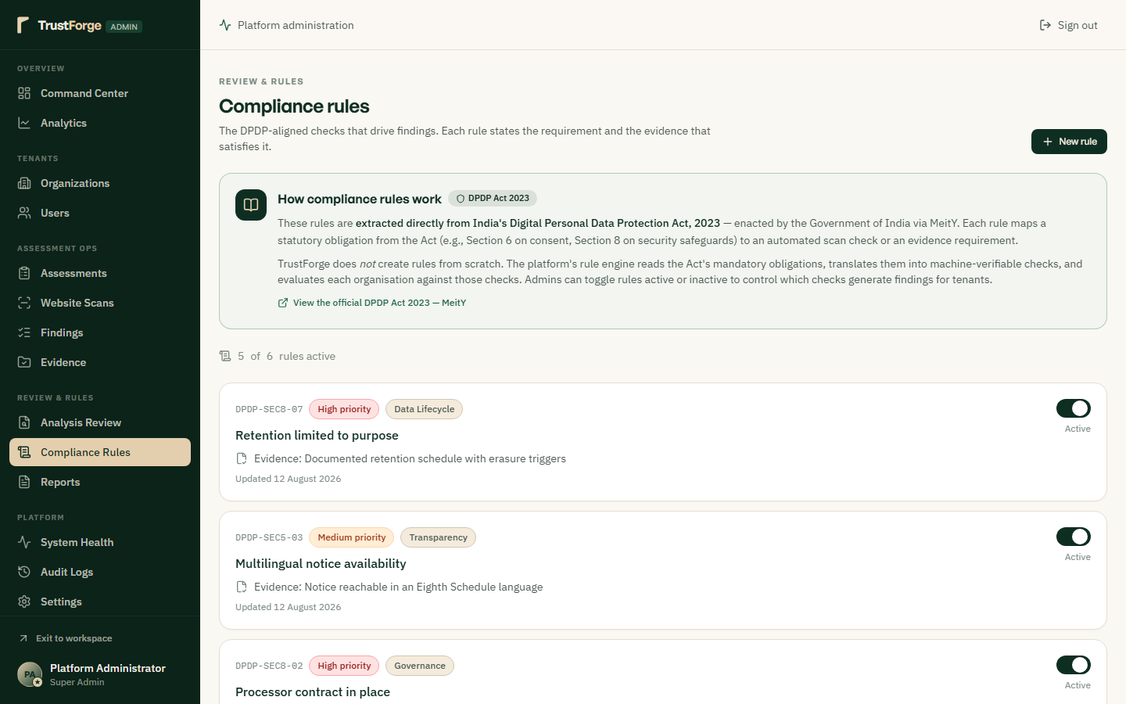
Allows legal engineers to configure compliance scoring formulas, penalty multipliers, and statutory section weights in real time. Enables dynamic updates to DPDP Act rules as subordinate regulations and Data Protection Board notifications are gazetted. Changes are versioned and can be simulated against historical assessment data before being deployed to production.

Figure 47: Global Regulatory Export & Supervisory Report Vault
Route: /admin/reports | Role: Supervisory Auditor
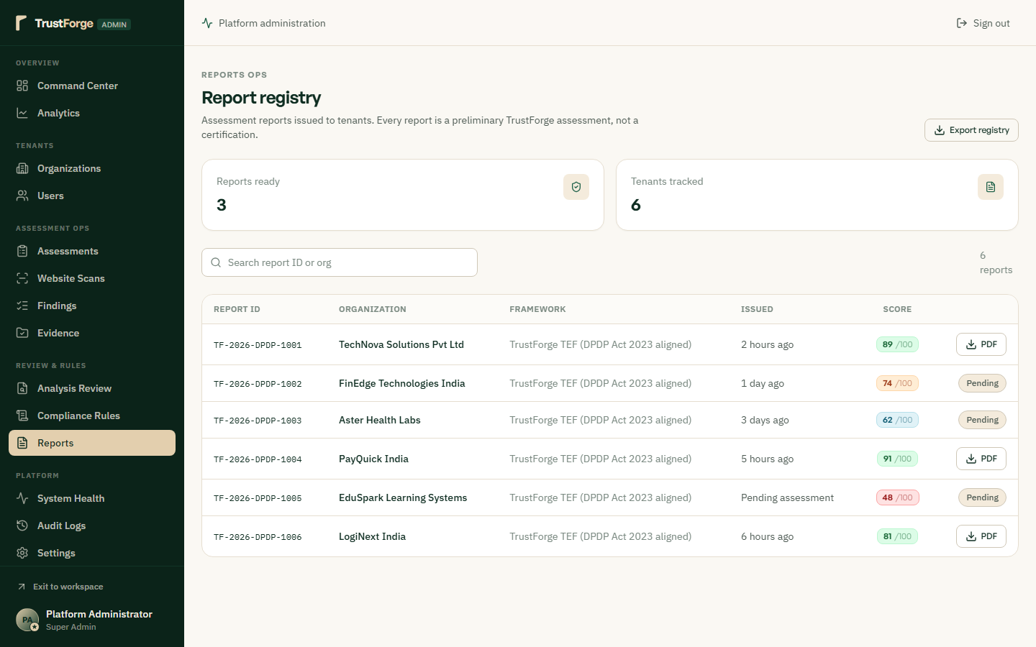
Maintains an archive of all generated statutory compliance certificates, board decks, and regulatory disclosure reports. Enables administrators to re-download historical reports or verify the cryptographic signatures embedded in distributed PDFs. Provides audit log tracking for who generated, viewed, or exported sensitive compliance documentation.

Figure 48: System Health Diagnostics & Infrastructure Monitoring
Route: /admin/health | Role: DevOps / Infrastructure Lead
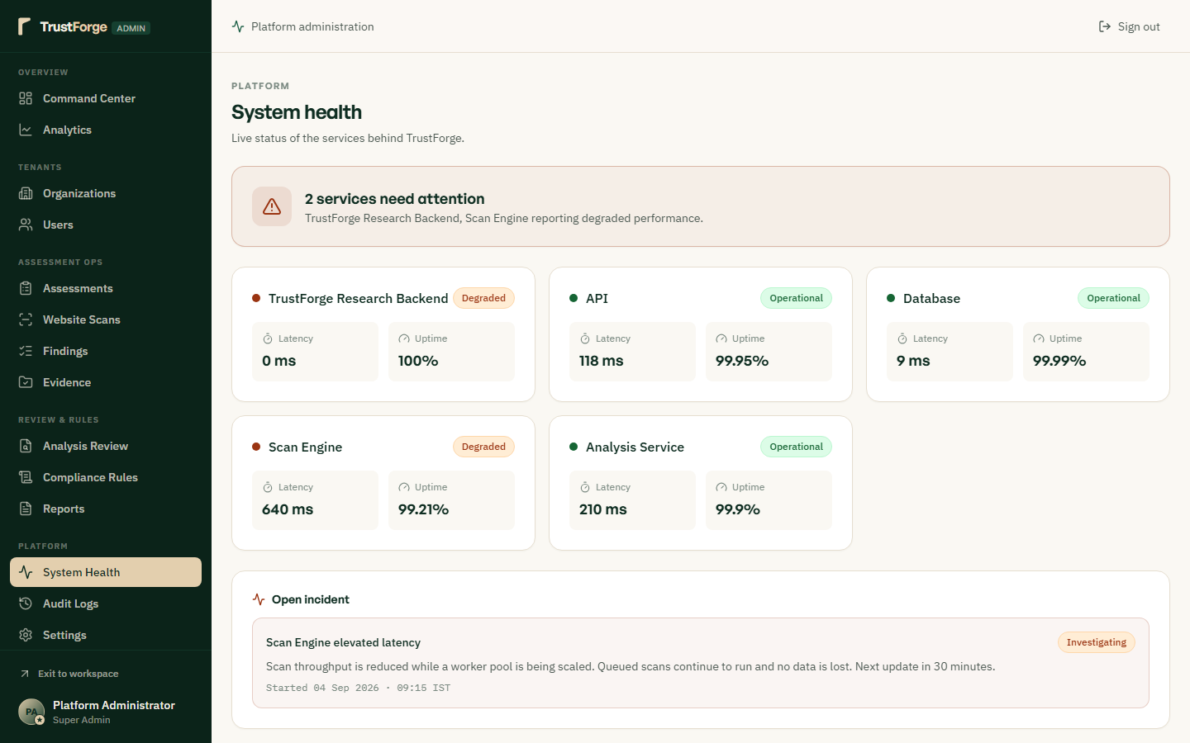
Monitors real-time infrastructure operational status including Express API uptime, Python RAG worker responsiveness, and SQLite DB size. Tracks memory utilization, CPU load, active database connections, and cache hit ratios. Provides instant diagnostic alerts if background worker queues or vector search latency exceed healthy operating thresholds.

Figure 49: Immutable Security Audit Log & Forensic Activity Trail
Route: /admin/audit | Role: Forensic / Security Auditor
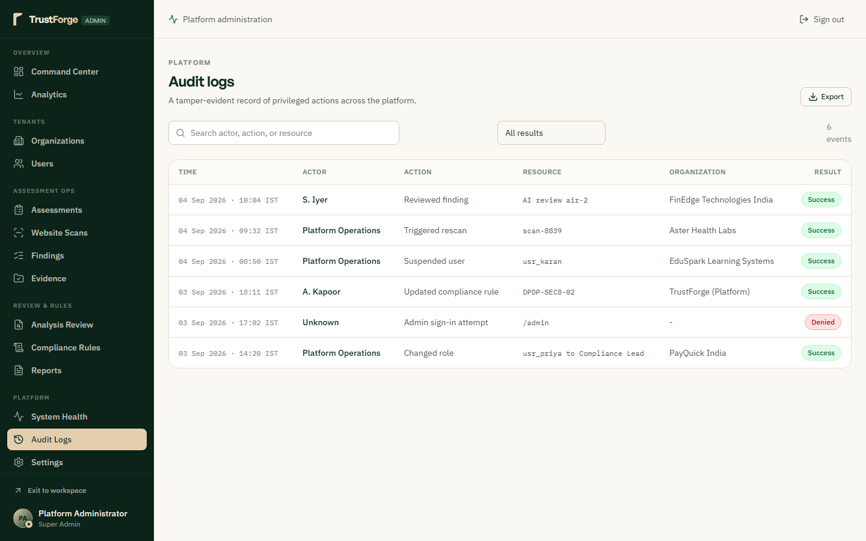
Maintains an append-only, tamper-evident audit trail recording every authentication event, permission change, and data export. Each log entry captures UTC timestamp, actor IP address, action performed, resource targeted, and status code. Provides compliance auditors with indisputable forensic evidence for regulatory accountability and breach investigations.

Figure 50: Platform Global Settings & Policy Engine Configuration
Route: /admin/settings | Role: Platform Superadmin
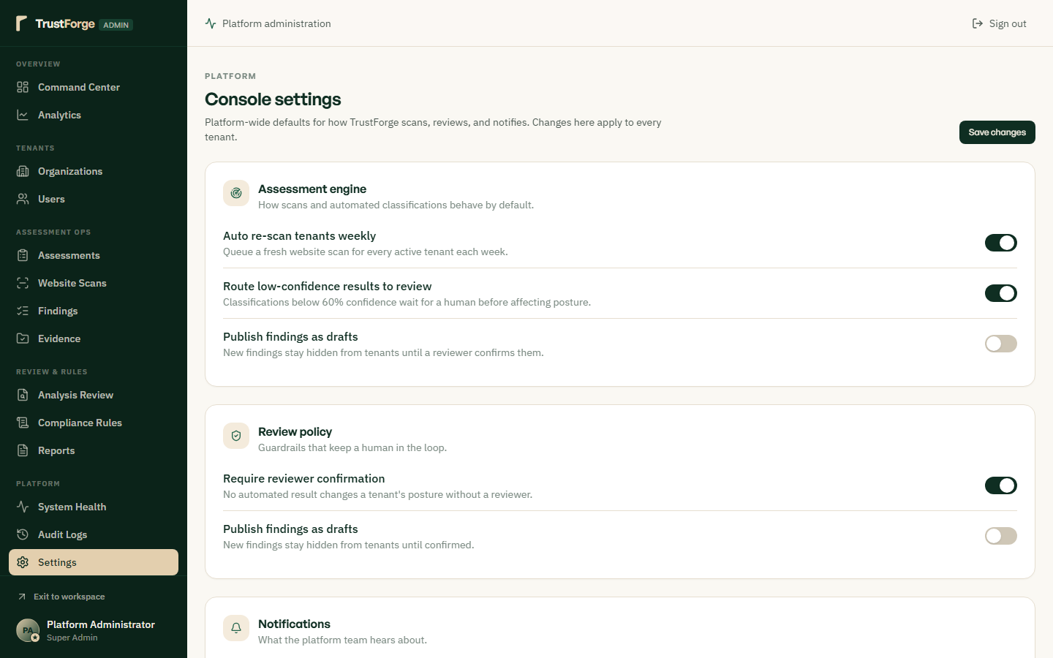
Configures global platform security policies including password expiry intervals, session idle timeouts, and CORS origins. Manages automated backup cadences, telemetry collection switches, and zero-paid-inference boundary enforcement flags. Ensures platform-wide consistency in security postures and compliance operational rules.

