CHAPTER 4
SYSTEM DESIGN
Chapter 3 established what TrustForge is required to do, through its functional and non-functional requirements and its preliminary module description. This chapter now works out how the system will actually be built. It begins by breaking the application down into its individual functional modules using a divide-and-conquer approach, examining the specific responsibility, inputs, processing, and outputs of each one. It then moves into the data design, where the relational structure of the Supabase PostgreSQL database is worked out in detail, including every table, its fields, keys, and the integrity constraints that keep the data consistent and secure. It then turns to the procedural design of the platform, mapping out the relationships between its data entities, the interactions between its actors and use cases, the sequence of operations in its core assessment workflow, and the flow of data through the system. Finally, it presents the interface design of the platform's major screens, the security measures applied to protect its data, and the formal test cases used to validate its functional correctness.

4.1 Basic Modules
The architecture of TrustForge is organised using the divide-and-conquer principle of system design, in which the overall application is broken down into a set of smaller, independent, and cohesive functional modules. Each module encapsulates a well-defined responsibility within the compliance assessment workflow and communicates with other modules through the Node.js / Express.js application layer. The module boundaries described below are consistent with the functional requirements and the preliminary module description presented in Chapter 3 (Table 3.6), and are further decomposed here into their constituent sub-modules to support detailed system design.
As Figure 4.1 shows, the complete set of modules is grouped into three categories: user-facing modules that support the organisation's compliance assessment journey, an intelligence module that performs AI-assisted analysis, and administrative modules that support platform oversight.

4.1.1 Basic Modules Diagram
Figure 4.1 shows the module structure chart, and Figure 4.2 shows the same modules arranged by architectural layer.
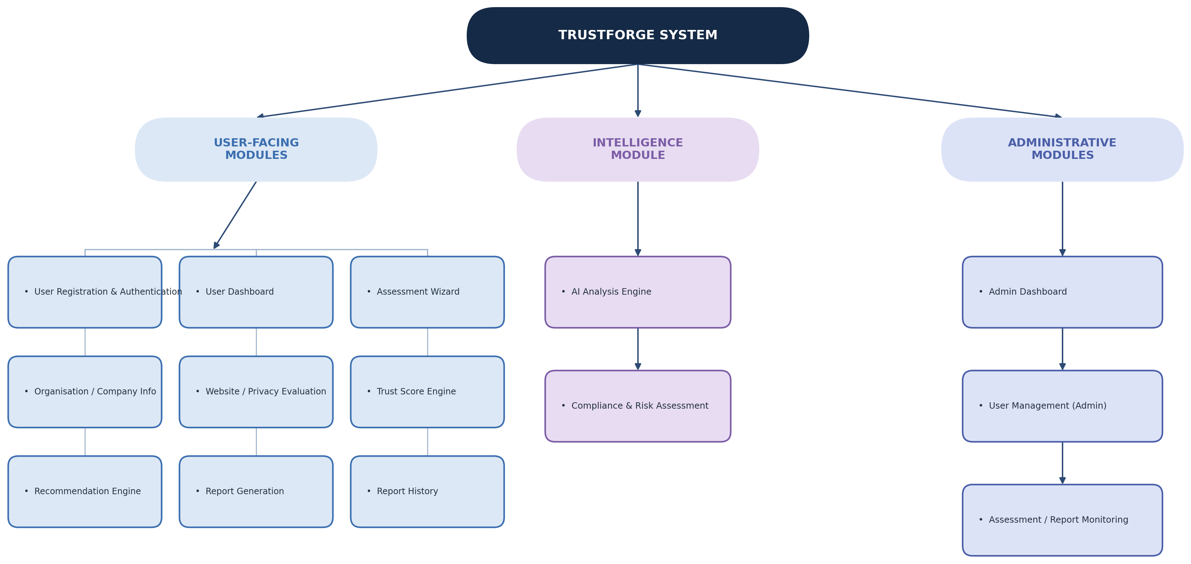
Figure 4.1 -Module Structure Chart
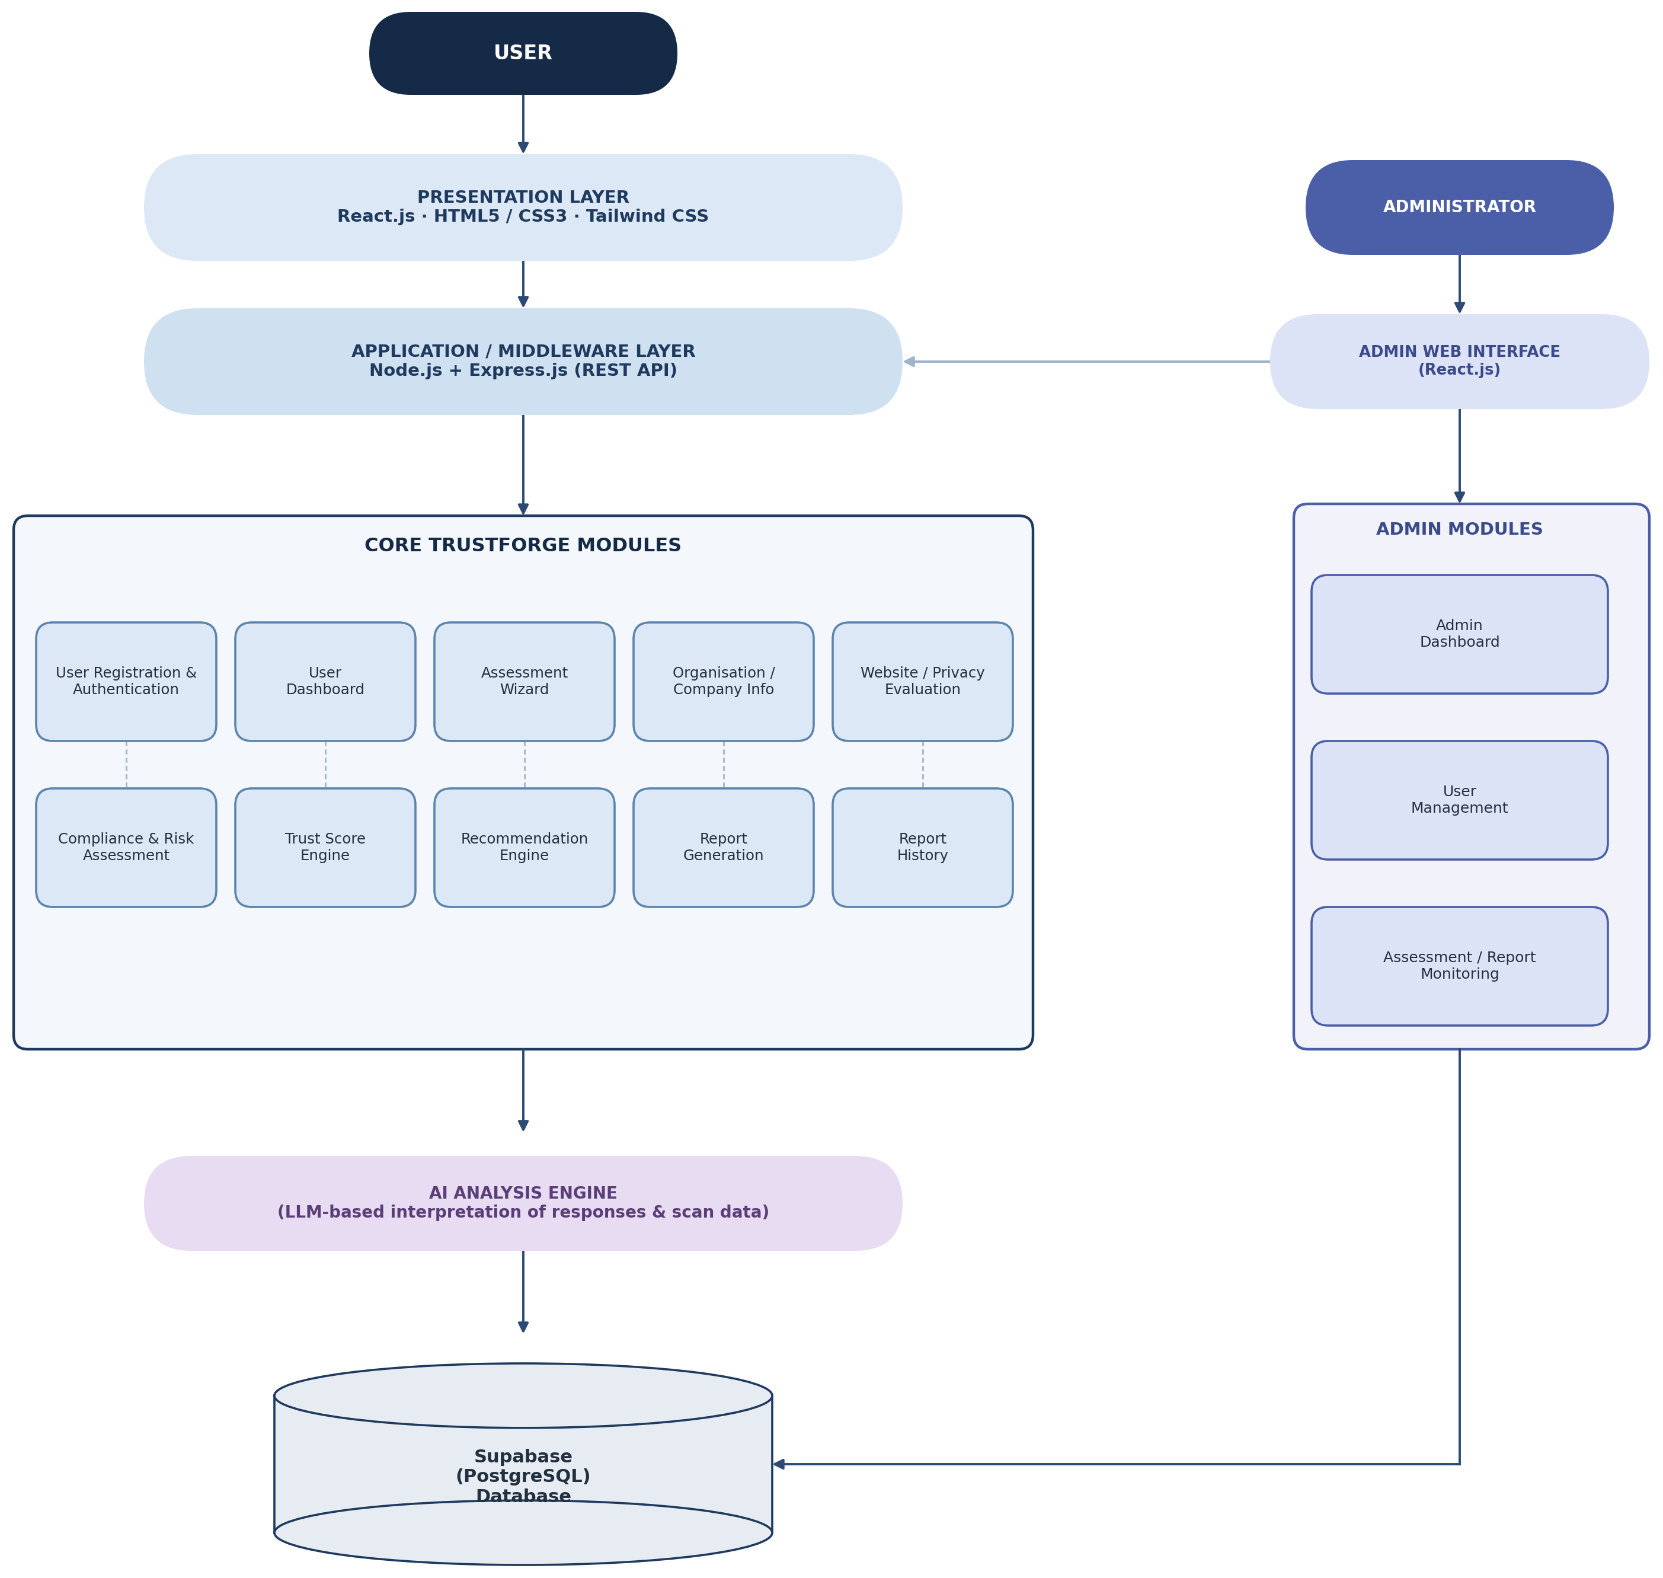
Figure 4.2 -Module Architecture Diagram

4.1.2 Working Details of Each Module
Each module below is described in terms of its purpose, main functions, inputs, processing, and outputs.

Table 4.1: Module Purpose, Functions, and Interactions
Module | Purpose | Main Functions | Interacts With
User Registration & Authentication | Allows an organisation to create an account and enables registered users to securely access the platform. | Account registration; login; password recovery; session management. | User Dashboard; Admin User Management.
User Dashboard | Provides a consolidated view of the organisation's compliance status. | Display trust score, recent assessments, pending recommendations. | Trust Score Engine; Report History; Assessment Wizard.
Assessment Wizard | Guides the user through a structured, multi-step DPDP compliance questionnaire. | Step-wise question presentation; response capture; draft saving. | Organisation / Company Info; Compliance & Risk Assessment; Database.
Organisation / Company Info | Captures and maintains organisational profile details used throughout an assessment. | Add / edit organisation profile; view organisation history. | Assessment Wizard; Website / Privacy Evaluation.
Website / Privacy Evaluation | Evaluates the organisation's publicly accessible website for observable privacy implementation gaps. | Submit website URL; permitted evaluation of cookie consent, trackers, and privacy policy presence. | AI Analysis Engine; Compliance & Risk Assessment.
AI Analysis Engine | Interprets assessment responses and website evaluation findings using an AI / LLM-based model. | Contextual interpretation of responses; gap identification support; recommendation drafting support. | Compliance & Risk Assessment; Recommendation Engine.
Compliance & Risk Assessment | Identifies specific DPDP compliance gaps and evaluates their associated risk. | Gap identification; risk severity classification. | Trust Score Engine; Recommendation Engine.
Trust Score Engine | Computes an objective, normalised compliance trust score for the organisation. | Score aggregation; score-band mapping; score history tracking. | User Dashboard; Report Generation; Platform Analytics.
Recommendation Engine | Produces actionable, prioritised recommendations to remediate identified gaps. | Map findings to guidance; prioritise recommendations. | Report Generation; User Dashboard.
Report Generation | Compiles assessment outcomes into a structured, downloadable compliance report. | Report compilation; PDF export. | Report History; Trust Score Engine; Recommendation Engine.
Report History | Maintains a searchable historical record of an organisation's past assessments and reports. | List past assessments; view / download a past report. | User Dashboard; Report Generation.
Admin Dashboard | Provides administrators with a platform-wide operational overview. | Display total organisations, average trust score, active scans. | User Management (Admin); Platform Analytics; System Monitoring.
User Management (Admin) | Allows administrators to oversee registered user and organisation accounts. | View accounts; edit roles / permissions; suspend / reactivate accounts. | User Registration & Authentication; Database.
Assessment / Report Monitoring | Tracks platform-wide assessment and scan activity for operational oversight. | View scan job queue; review failed scans / error logs; trigger rescan. | Website / Privacy Evaluation; Admin Dashboard.
Table 4.1 : Module Purpose, Functions, and Interactions

Table 4.2: Module Inputs, Processing, and Outputs
Module | Inputs | Processing | Outputs
User Registration & Authentication | Organisation details, email, password. | Validates input; delegates credential verification and session issuance to Supabase Authentication. | Authenticated session token or validation error.
User Dashboard | Authenticated session; organisation ID. | Retrieves latest trust score, assessment, and recommendation records. | Dashboard summary view.
Assessment Wizard | User responses to structured questions. | Validates each step; persists responses; tracks completion progress. | Completed (or draft) assessment response set.
Organisation / Company Info | Organisation name, industry, website URL, contact details. | Validates and stores organisational metadata. | Organisation profile record.
Website / Privacy Evaluation | Website URL submitted by the user. | Performs a permitted, read-only review of publicly available website content relevant to privacy practices. | Structured website evaluation findings.
AI Analysis Engine | Assessment responses; website evaluation findings. | Sends structured input to the AI model service and processes the structured output returned. | AI-derived compliance insights consumed by downstream modules.
Compliance & Risk Assessment | Assessment responses; AI analysis output; website evaluation findings. | Evaluates findings against DPDP-relevant criteria and classifies each into a risk category. | Classified list of risk findings.
Trust Score Engine | Classified risk findings. | Aggregates findings into a normalised score (0-100) and determines the corresponding trust band. | Trust score value and score band.
Recommendation Engine | Classified risk findings; AI analysis output. | Generates recommendation text and assigns a priority level to each recommendation. | Prioritised recommendation list.
Report Generation | Trust score; risk findings; recommendations; organisation info. | Assembles a structured report document and renders it as a downloadable PDF file. | Downloadable PDF compliance report.
Report History | Organisation ID. | Retrieves stored assessment and report records in chronological order. | Assessment / report history list.
Admin Dashboard | Administrator session. | Aggregates platform-wide statistics from stored records. | Administrative summary view.
User Management (Admin) | Administrator actions on a selected account. | Applies role-based access changes and account status updates. | Updated account status / permissions.
Assessment / Report Monitoring | Administrator session; system logs. | Reads scan and assessment job status from the database and surfaces failures. | Monitoring view; rescan trigger.
Table 4.2 : Module Inputs, Processing, and Outputs

4.2 Data Design
TrustForge stores clearly structured, strongly related data: organisations, their assessments, assessment responses, risk findings, trust scores, recommendations, and generated reports, all of which reference one another through well-defined relationships. A relational database is therefore appropriate for TrustForge because it enforces these relationships through primary and foreign keys, supports transactional consistency when an assessment is submitted and scored, and allows compliance data to be queried and aggregated efficiently for dashboards, history views, and administrative analytics. Supabase, built on PostgreSQL, was selected as the primary data store because it provides a managed relational database together with row-level security and integrated authentication, directly satisfying the data integrity, security, and privacy requirements identified in Section 3.2.2 (NFR-06, NFR-07, NFR-11).

4.2.1 Schema Design
The logical schema of each table used by TrustForge is described below, table by table. The relationships between these tables are presented as an Entity Relationship (ER) Diagram in Section 4.4.1.

Users Table
Column | Data Type | Constraint | Description
User_ID | UUID | PRIMARY KEY, NOT NULL | Uniquely identifies each registered user
Full_Name | VARCHAR(100) | NOT NULL | Name of the registered user
Email | VARCHAR(150) | NOT NULL, UNIQUE | Login email address
Role | VARCHAR(20) | NOT NULL, CHECK (Role IN ('user','admin')) | Access role of the user
Created_At | TIMESTAMPTZ | NOT NULL | Account creation timestamp

Organizations Table
Column | Data Type | Constraint | Description
Org_ID | UUID | PRIMARY KEY, NOT NULL | Uniquely identifies each organisation
Owner_User_ID | UUID | FOREIGN KEY, NOT NULL | References the owning user
Org_Name | VARCHAR(150) | NOT NULL | Registered name of the organisation
Industry | VARCHAR(100) | NULL | Industry / sector of the organisation
Website_URL | VARCHAR(255) | NULL | Website submitted for evaluation
Created_At | TIMESTAMPTZ | NOT NULL | Profile creation timestamp

Assessments Table
Column | Data Type | Constraint | Description
Assessment_ID | UUID | PRIMARY KEY, NOT NULL | Uniquely identifies each assessment
Org_ID | UUID | FOREIGN KEY, NOT NULL | Organisation the assessment belongs to
Status | VARCHAR(20) | NOT NULL, CHECK (Status IN ('draft','submitted','completed')) | Current assessment status
Started_At | TIMESTAMPTZ | NOT NULL | Time the assessment was started
Submitted_At | TIMESTAMPTZ | NULL | Time the assessment was submitted

Assessment_Responses Table
Column | Data Type | Constraint | Description
Response_ID | UUID | PRIMARY KEY, NOT NULL | Uniquely identifies each response record
Assessment_ID | UUID | FOREIGN KEY, NOT NULL | Assessment the response belongs to
Question_Key | VARCHAR(100) | NOT NULL | Identifier of the wizard question answered
Response_Value | JSONB | NOT NULL | Structured answer value for the question
Answered_At | TIMESTAMPTZ | NOT NULL | Time the response was recorded

Website_Scans Table
Column | Data Type | Constraint | Description
Scan_ID | UUID | PRIMARY KEY, NOT NULL | Uniquely identifies each scan record
Assessment_ID | UUID | FOREIGN KEY, NOT NULL | Assessment the scan belongs to
Target_URL | VARCHAR(255) | NOT NULL | Website URL submitted for evaluation
Scan_Status | VARCHAR(20) | NOT NULL, CHECK (Scan_Status IN ('pending','completed','failed')) | Current status of the evaluation
Raw_Findings | JSONB | NULL | Structured evaluation output
Scanned_At | TIMESTAMPTZ | NULL | Time the evaluation completed

Risk_Findings Table
Column | Data Type | Constraint | Description
Finding_ID | UUID | PRIMARY KEY, NOT NULL | Uniquely identifies each finding
Assessment_ID | UUID | FOREIGN KEY, NOT NULL | Assessment the finding belongs to
Category | VARCHAR(100) | NOT NULL | DPDP obligation category (e.g. consent, retention)
Severity | VARCHAR(20) | NOT NULL, CHECK (Severity IN ('Low','Medium','High','Critical')) | Risk classification of the finding
Description | VARCHAR(255) | NOT NULL | Description of the identified gap
Source | VARCHAR(20) | NOT NULL, CHECK (Source IN ('wizard','scan')) | Origin of the finding

Trust_Scores Table
Column | Data Type | Constraint | Description
Score_ID | UUID | PRIMARY KEY, NOT NULL | Uniquely identifies each score record
Assessment_ID | UUID | FOREIGN KEY, NOT NULL | Assessment the score was computed for
Score_Value | INT | NOT NULL, CHECK (Score_Value BETWEEN 0 AND 100) | Trust score value
Score_Band | VARCHAR(20) | NOT NULL | Descriptive band (Low / Moderate / Good / Strong)
Computed_At | TIMESTAMPTZ | NOT NULL | Time the score was computed

Recommendations Table
Column | Data Type | Constraint | Description
Recommendation_ID | UUID | PRIMARY KEY, NOT NULL | Uniquely identifies each recommendation
Finding_ID | UUID | FOREIGN KEY, NOT NULL | Finding the recommendation addresses
Title | VARCHAR(150) | NOT NULL | Short recommendation title
Priority | VARCHAR(20) | NOT NULL, CHECK (Priority IN ('High','Medium','Low')) | Priority level of the recommendation
Guidance_Text | VARCHAR(500) | NOT NULL | Actionable remediation guidance

Reports Table
Column | Data Type | Constraint | Description
Report_ID | UUID | PRIMARY KEY, NOT NULL | Uniquely identifies each report
Assessment_ID | UUID | FOREIGN KEY, NOT NULL | Assessment the report was generated for
Report_URL | VARCHAR(255) | NOT NULL | Storage location of the generated PDF
Generated_At | TIMESTAMPTZ | NOT NULL | Time the report was generated
Format | VARCHAR(10) | NOT NULL, CHECK (Format = 'PDF') | Report file format

Admin_Audit_Logs Table
Column | Data Type | Constraint | Description
Log_ID | UUID | PRIMARY KEY, NOT NULL | Uniquely identifies each log entry
Admin_User_ID | UUID | FOREIGN KEY, NOT NULL | Administrator who performed the action
Action | VARCHAR(150) | NOT NULL | Description of the administrative action
Target_Entity | VARCHAR(100) | NOT NULL | Entity affected by the action
Logged_At | TIMESTAMPTZ | NOT NULL | Time the action was logged

4.3 Data Integrity and Constraints
Data integrity ensures that the information stored in the TrustForge database remains accurate, consistent, and reliable. Constraints are applied at the column level for each table described in Section 4.2.1, and are enforced by the Supabase PostgreSQL database together with validation performed at the application layer.

4.3.1 Constraints Applied to Various Columns
Constraint | Purpose | Examples
PRIMARY KEY | Uniquely identifies every record in a table. | User_ID, Org_ID, Assessment_ID, Finding_ID, Score_ID, Report_ID, etc.
FOREIGN KEY | Connects a record to a valid record in another table. | Owner_User_ID, Org_ID, Assessment_ID, Finding_ID, Admin_User_ID
NOT NULL | Prevents essential fields from being left empty. | Email, Org_Name, Question_Key, Response_Value, Severity
UNIQUE | Prevents duplicate values where uniqueness is required. | User Email
CHECK | Restricts values to valid ranges or conditions. | Score_Value BETWEEN 0 AND 100, Severity IN ('Low','Medium','High','Critical'), Status IN ('draft','submitted','completed')
NULL | Allows optional information where it is not mandatory. | Industry, Website_URL, Submitted_At, Raw_Findings
Referential integrity is additionally maintained through cascading rules: ON DELETE CASCADE is applied from Assessments to its dependent records (Responses, Scans, Findings, Trust Score, Recommendations, and Report), so that deleting an assessment consistently removes its associated data, and ON UPDATE CASCADE is applied to foreign key references so that a change to a parent identifier is automatically reflected in dependent rows.
Access to all tables is additionally scoped through Supabase Row Level Security (RLS): an organisation's users may read and write only the rows associated with their own Org_ID, and administrative endpoints are restricted to users whose Role is 'admin'. The Trust Score is constrained to the range 0 to 100, where a higher value indicates a stronger observed compliance posture; the precise weighting formula used to derive the score from risk findings is a proposed design element to be finalised and calibrated during implementation, rather than a fixed mathematical formula presented here as final.

4.4 Procedural Design
Procedural design describes how the Organisation User, the Administrator, and the internal AI Analysis Engine interact within TrustForge. The diagrams below represent the logical relationships between data entities, the actors and use cases of the system, the chronological sequence of the core assessment workflow, and the flow of data through the system at increasing levels of detail.

4.4.1 ER Diagram
The ER diagram represents the logical relationships among the users, organizations, assessments, assessment responses, website scans, risk findings, trust scores, recommendations, reports, and admin audit log entities described in Section 4.2.1.
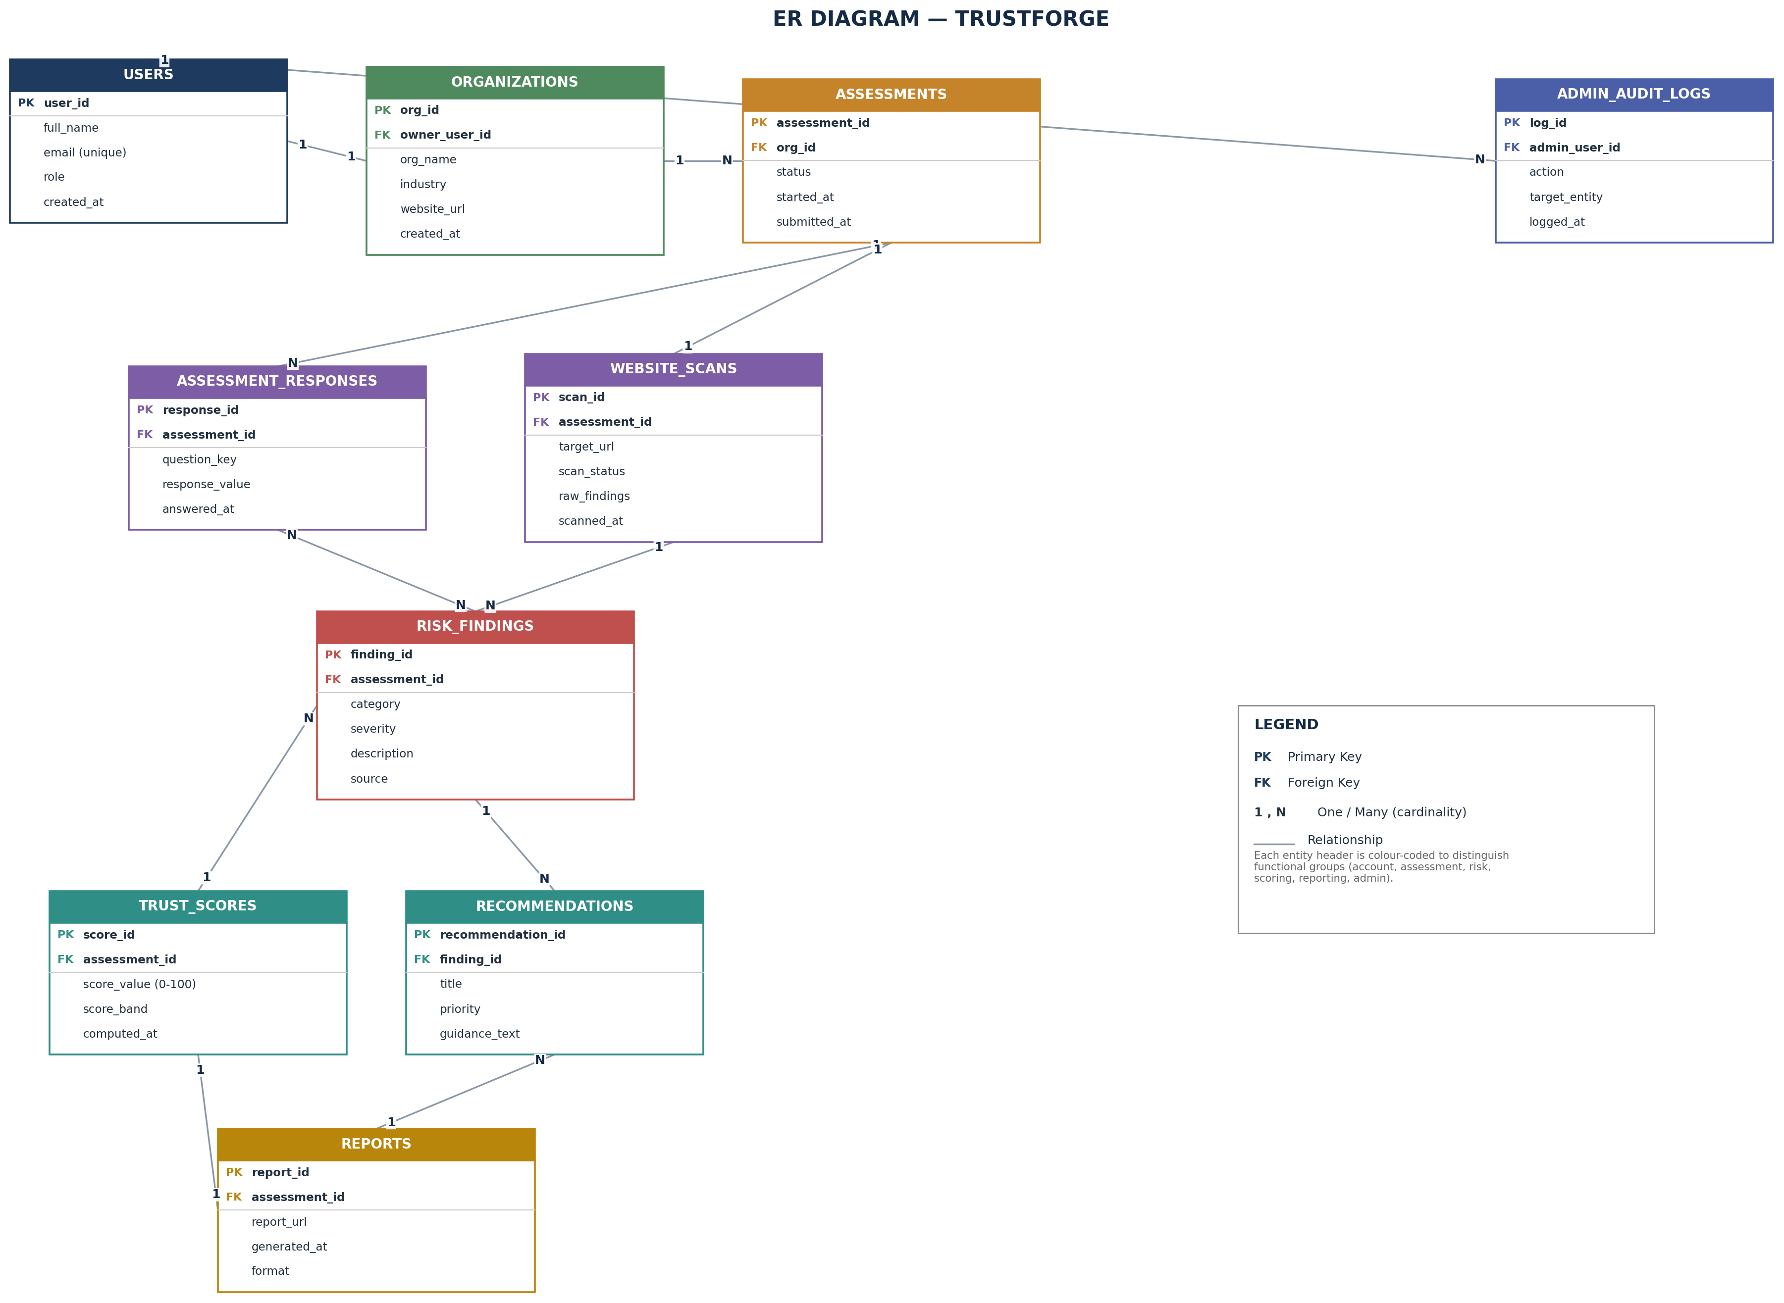
Figure 4.3 -ER Diagram
Main logical relationships:
• User → Organisation → Assessment → Assessment Responses / Website Scans
• Assessment Responses & Website Scans → Risk Findings
• Risk Findings → Trust Score and Recommendations
• Trust Score & Recommendations → Report
• User → Admin Audit Logs

4.4.2 Use Case Diagram
The use case diagram identifies the two actors and the activities each performs. The Organisation User interacts with the assessment workflow, while the Administrator oversees platform-wide accounts, monitoring, and analytics. The AI-assisted analysis and trust-score generation are shown as system-internal use cases included automatically as part of the assessment wizard and website evaluation use cases.
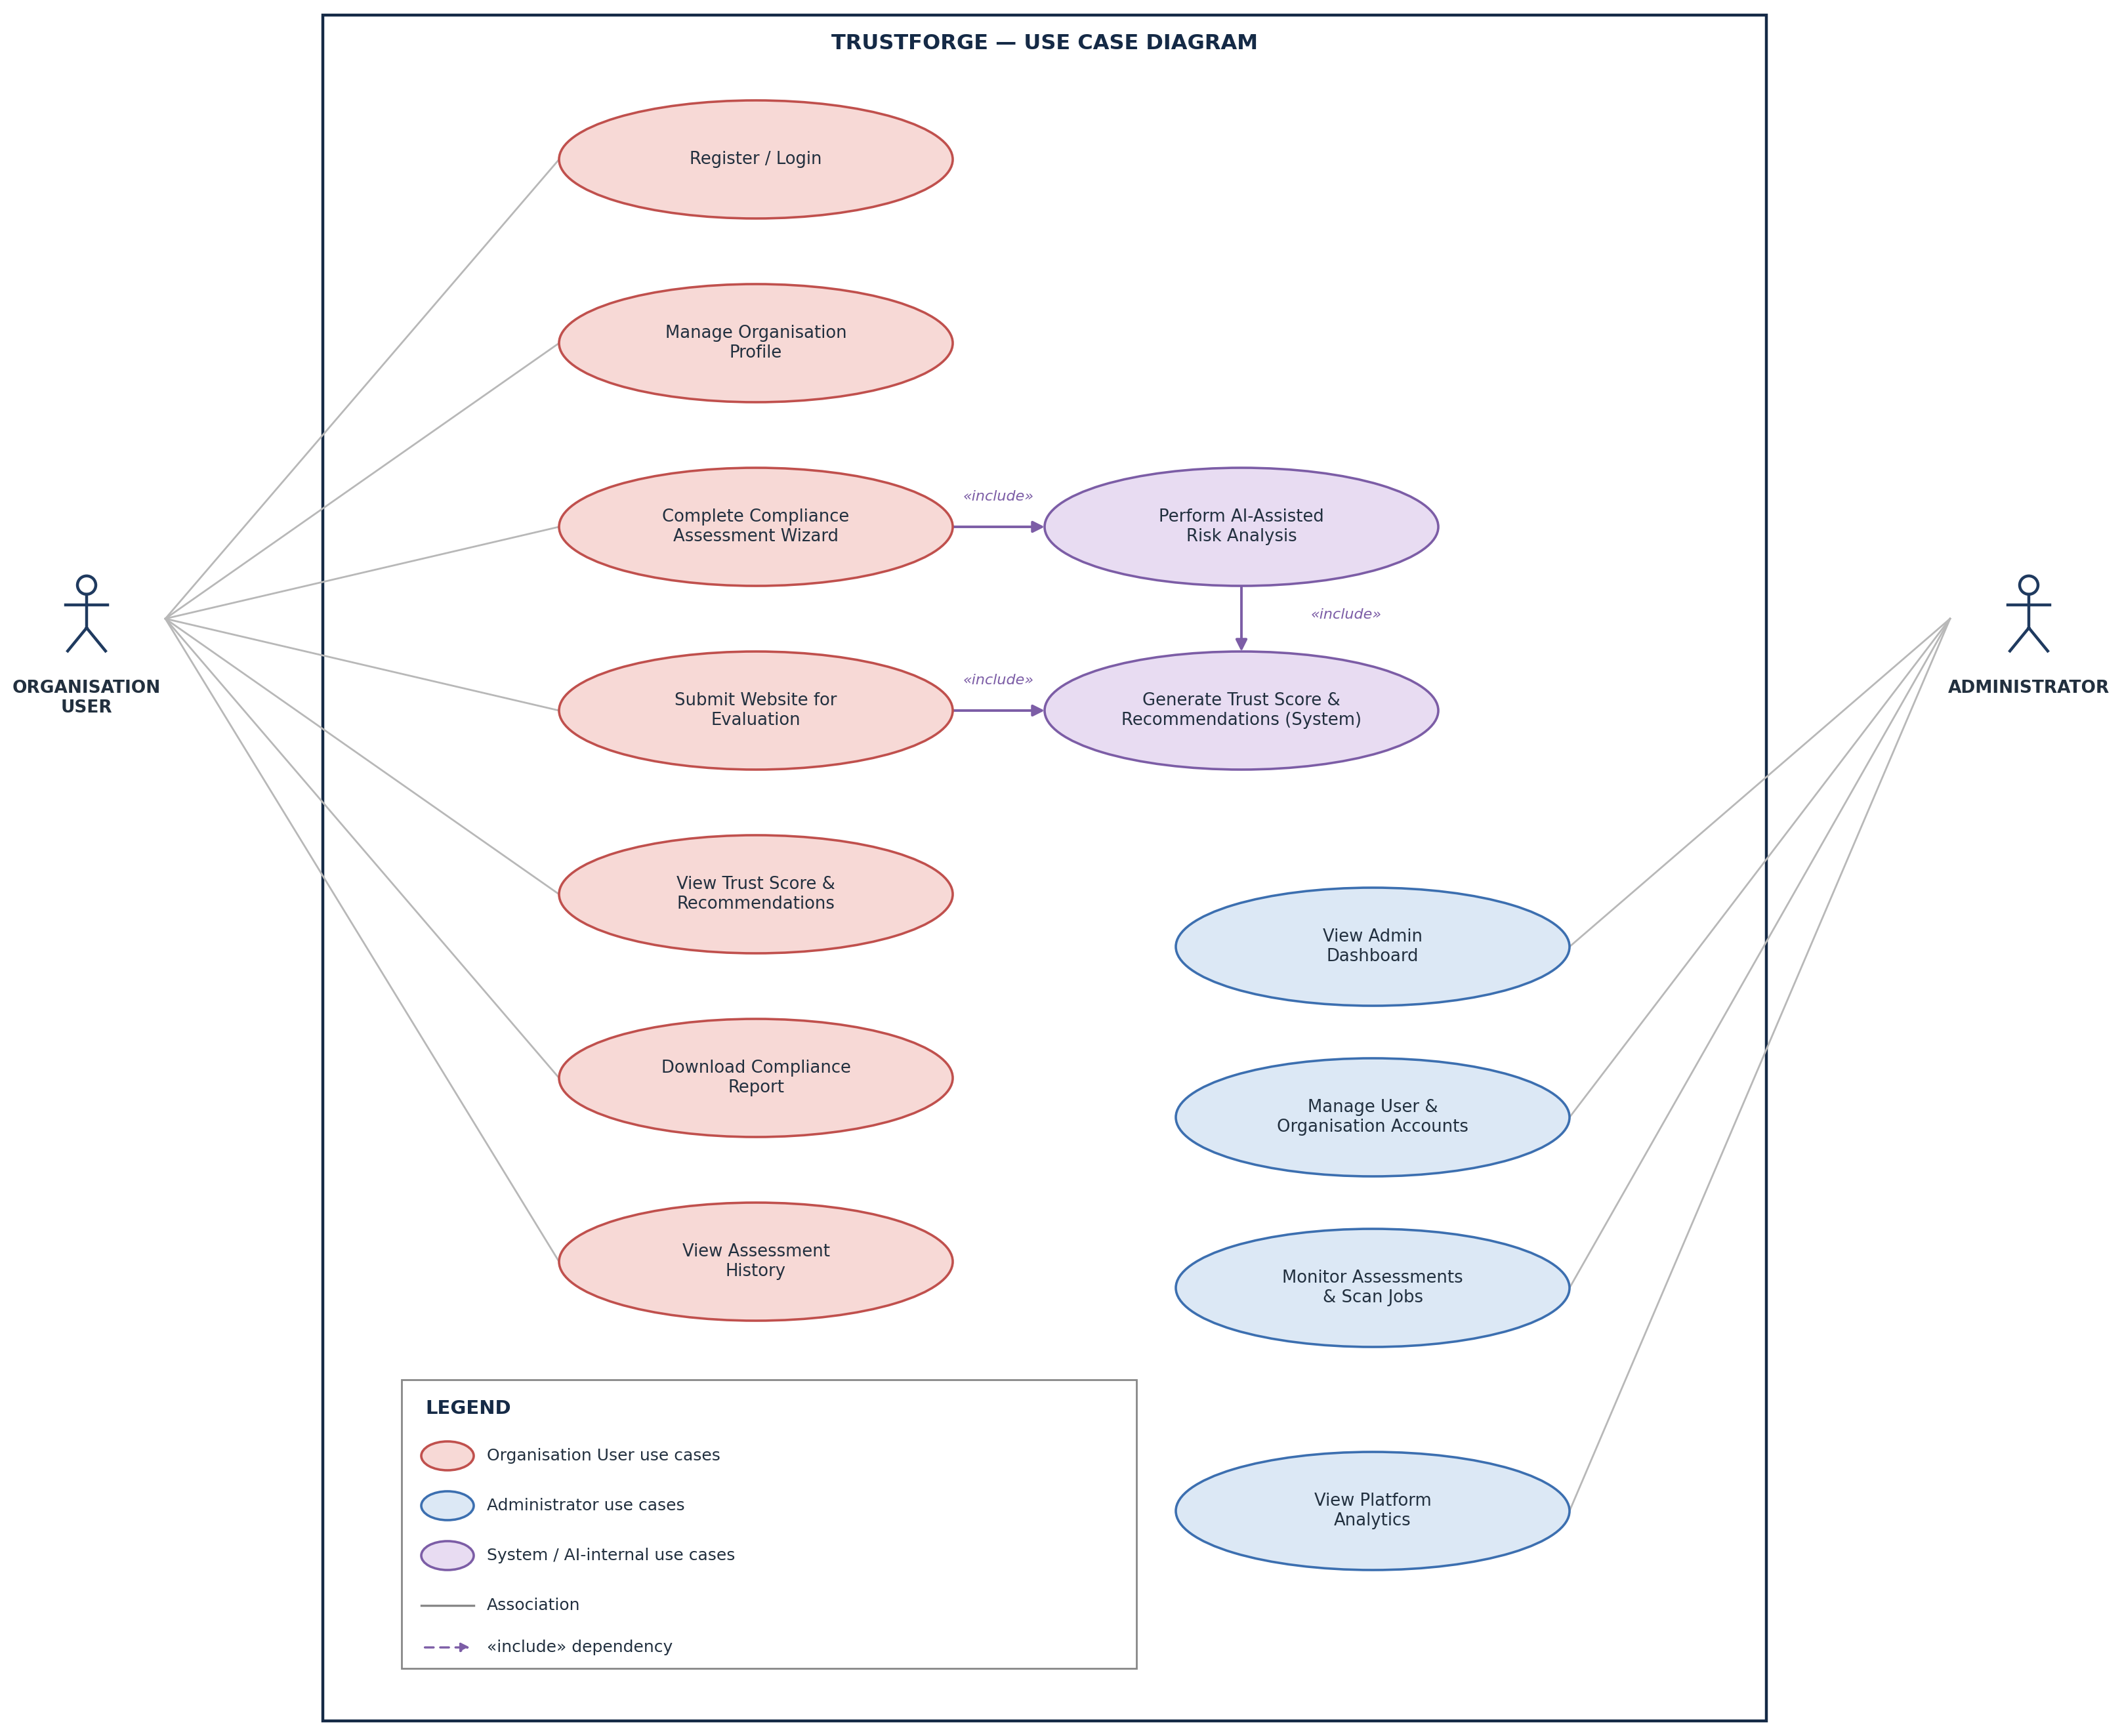
Figure 4.4 -Use Case Diagram

4.4.3 Sequence Diagram
The sequence diagram shows the chronological flow of the core compliance assessment process, from the point the Organisation User submits the assessment wizard through to the trust score and report being returned.
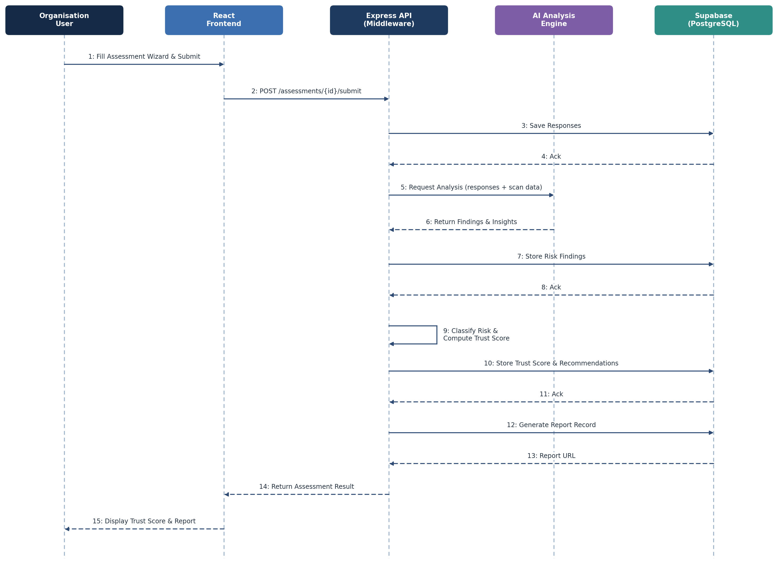
Figure 4.5 -Sequence Diagram

4.4.4 Data Flow Diagram

DFD Level 0 -Context Diagram
At Level 0, the complete TrustForge platform is represented as one central process. The Organisation User provides registration, organisation, and assessment data, while the Administrator exchanges management actions and analytics with the system.
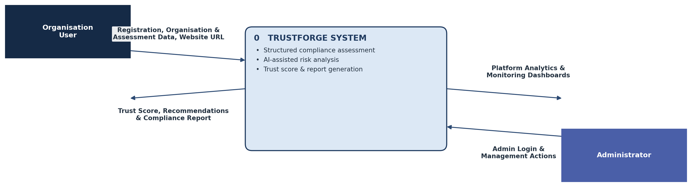
Figure 4.6 -DFD Level 0 Context Diagram

DFD Level 1
At Level 1, the platform is divided into seven main processes: Manage Authentication, Manage Assessment & Organisation Info, Perform Website / Privacy Evaluation, AI Analysis & Risk Classification, Generate Trust Score & Recommendations, Generate Report, and Admin Management, together with the Supabase data store each process reads from or writes to.
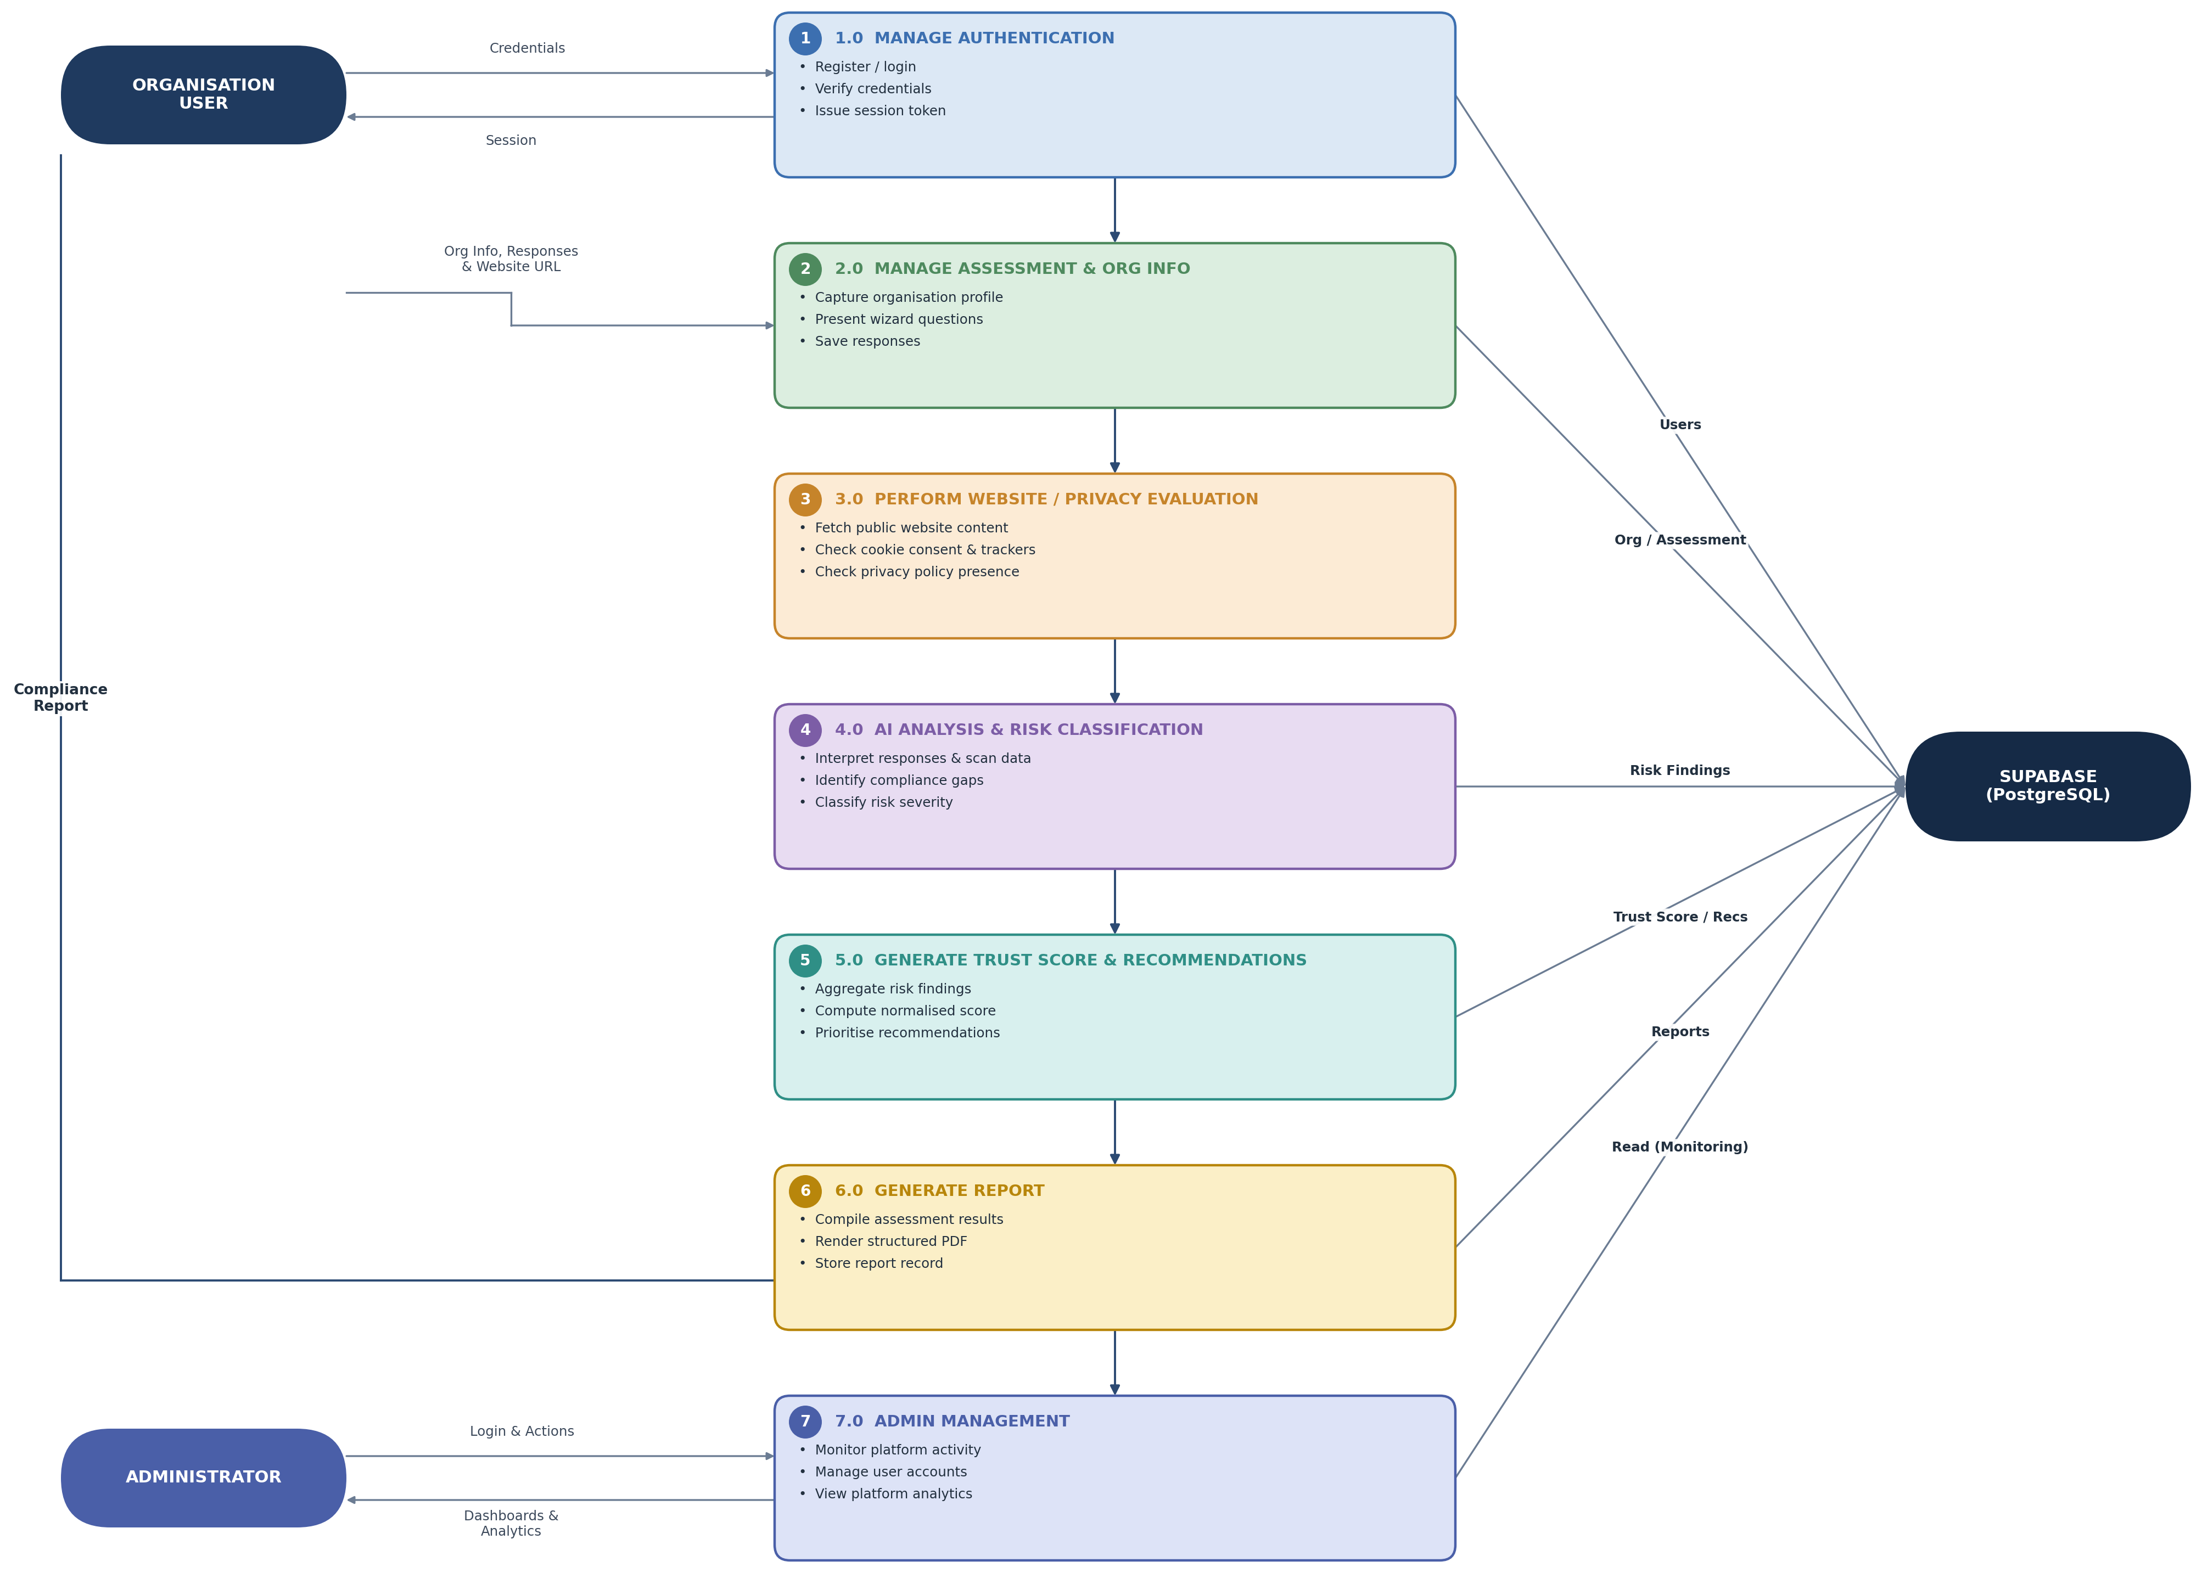
Figure 4.7 -DFD Level 1

DFD Level 2
At Level 2, the AI Analysis & Risk Classification process together with trust score generation is expanded into its four constituent sub-processes, numbered 4.1 to 4.4 for the modules shown at this level.
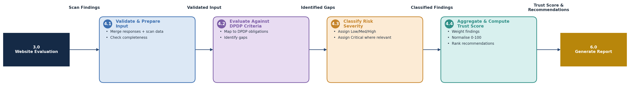
Figure 4.8 -DFD Level 2

4.4.5 User Interface Design
The TrustForge web application is designed to give Indian startups and SMEs a simple, guided, and trustworthy path through a DPDP compliance assessment. The interface focuses on clear step-by-step data entry, an easily interpreted trust score, and actionable recommendations, while maintaining a consistent visual identity across the user-facing and administrative sides of the platform. The interface is designed primarily for desktop use by business owners and compliance-responsible staff, while remaining usable on tablet and mobile screens. The major screens of the TrustForge platform are described below; for each screen, the Design and Description are explained separately.

4.4.5.1 Login / Registration Screen

Design
The Login / Registration screen presents a centred card layout with the TrustForge logo at the top, followed by tabs or a toggle for switching between Login and Register. The login form contains email and password fields with a clearly visible Sign In button and a Forgot Password link. The registration form additionally captures the organisation name and a confirm-password field. Validation errors are displayed inline beneath the relevant field rather than in a separate area of the page.

Description
This screen is the entry point to TrustForge for a returning or new organisation. It authenticates returning users via Supabase Authentication and allows a new organisation to create an account before beginning a compliance assessment. A clear, uncluttered layout reduces friction for a business user who may not be technical.

4.4.5.2 User Dashboard

Design
The Dashboard uses a card-based layout with the current Trust Score prominently displayed at the top, shown as a large numeric value together with a colour-coded band (for example, red for Low, amber for Moderate, green for Good / Strong). Below the score, summary cards show the number of completed assessments, outstanding recommendations, and the date of the last assessment. A navigation sidebar provides access to the Assessment Wizard, Report History, and account settings.

Description
The Dashboard is the organisation's home screen after login. It gives an at-a-glance view of the organisation's current compliance posture and guides the user towards the next action, whether that is starting a new assessment, reviewing recommendations, or downloading a past report.

4.4.5.3 Assessment Wizard Screen

Design
The Assessment Wizard uses a multi-step form layout with a progress indicator across the top showing the current step out of the total number of steps (for example, Consent Management, Purpose Limitation, Data Retention, Breach Readiness). Each step displays a focused set of related questions with radio buttons, checkboxes, or short text fields as appropriate. Back and Next buttons are positioned at the bottom of each step, and a Save Draft option allows the user to leave and resume later.

Description
The Assessment Wizard is the primary data-capture screen of the platform. It breaks a potentially long and technical compliance questionnaire into manageable steps, reducing drop-off and making the underlying DPDP obligations easier for a non-legal user to answer accurately.

4.4.5.4 Organisation Profile Screen

Design
The Organisation Profile screen presents a simple form with fields for organisation name, industry, website URL, and contact details, grouped under a single card. A Save button persists changes, and a read-only summary of when the profile was last updated is shown beneath the form.

Description
This screen allows an organisation to maintain the profile information referenced throughout its assessments and reports. Keeping this information accurate ensures that generated reports and the website evaluation feature reference the correct organisation details.

4.4.5.5 Website Evaluation Results Screen

Design
The Website Evaluation Results screen displays the submitted website URL at the top, followed by a checklist-style layout showing the status of each evaluated item: cookie consent banner detected, third-party trackers identified, and privacy policy presence, each marked with a clear status icon (present, absent, or needs review). A short summary paragraph beneath the checklist highlights the most significant findings.

Description
This screen presents the outcome of the permitted, read-only evaluation of the organisation's public website. It translates technical scan output into a format a non-technical user can interpret, and feeds directly into the risk classification and recommendation steps of the assessment.

4.4.5.6 Trust Score & Recommendations Screen

Design
This screen displays the Trust Score using a large circular gauge or progress-ring visual, with the numeric score and score band shown at its centre. Below the gauge, a table or card list presents each risk finding together with its severity (Low, Medium, High, Critical) and a paired, prioritised recommendation. Recommendations are grouped by priority, with High-priority items shown first.

Description
This is the most important results screen of the platform: it converts the assessment and website evaluation findings into an easily interpreted score and a concrete action list, directly supporting the platform's goal of reducing dependency on expensive external legal consultation.

4.4.5.7 Compliance Report / Download Screen

Design
The Report screen shows a preview of the structured compliance report, including the organisation name, assessment date, trust score, key findings, and recommendations, laid out to match the generated PDF. A prominent Download PDF button sits above the preview, along with a Share or Export option where applicable.

Description
This screen allows the organisation to review and download a structured, shareable compliance report summarising a completed assessment, which can be used internally or shared with customers and partners as evidence of the organisation's compliance posture.

4.4.5.8 Assessment History Screen

Design
The Assessment History screen presents a reverse-chronological table of past assessments, showing the assessment date, trust score at the time, and status. Each row includes a View and a Download action. A simple search or date filter sits above the table for organisations with a longer history.

Description
This screen allows an organisation to track how its compliance posture has changed over time, supporting the trust-score history requirement (FR-14) and allowing past reports to be revisited without repeating an assessment.

4.4.5.9 Admin Dashboard Screen

Design
The Admin Dashboard uses a wide card-grid layout showing platform-wide metrics: total registered organisations, average trust score across the platform, and the number of active or recent website scans. A activity feed lists recent assessments and flagged issues, and a sidebar provides navigation to User Management, Assessment Monitoring, and Platform Analytics.

Description
This screen is the entry point for administrators and gives an operational overview of the platform, supporting FR-20 (Admin Dashboard) and helping administrators quickly identify organisations or issues that may need attention.

4.4.5.10 User Management Screen (Admin)

Design
This screen presents a searchable, sortable table of registered users and organisations, showing name, email, role, and account status. Row-level actions allow an administrator to suspend, reactivate, or edit the role of an account, with a confirmation dialog shown before any destructive action.

Description
This screen supports FR-21 and FR-23, allowing administrators to manage user and organisation accounts and enforce role-based access control, while a confirmation step reduces the risk of accidental account changes.

4.4.5.11 Platform Analytics Screen (Admin)

Design
The Platform Analytics screen uses a dashboard layout with charts showing assessment volume over time, a distribution of trust scores across all organisations, and the most common compliance gap categories identified platform-wide. Filters allow the administrator to narrow the view by date range.

Description
This screen supports FR-22, giving administrators aggregated insight into platform usage and common compliance gaps, which can inform future improvements to the assessment wizard and recommendation content.

4.4.5.12 Responsive Design

Design
All screens described above are built with a responsive layout using Tailwind CSS utility breakpoints. On narrower (tablet and mobile) viewports, sidebar navigation collapses into a hamburger menu, multi-column card grids reflow into a single column, and the assessment wizard steps stack vertically with enlarged touch targets for form controls.

Description
Responsive design ensures that an organisation user can complete an assessment, review their trust score, and download a report comfortably from a desktop computer, tablet, or mobile device, supporting the accessibility and usability requirements identified in Section 3.2.2 (NFR-09, NFR-12, NFR-13).

4.5 Security Issues
Security is an important part of the TrustForge platform because the system handles organisational profile data, DPDP assessment responses, website evaluation findings, and AI-derived compliance insights. The following security measures help protect the platform and its users' information from unauthorized access, misuse, and data loss.

4.5.1 Protection of the Web Application from Attacks
The TrustForge web application should be protected from unauthorized access and common web attacks. Administrative access should be provided only to authorized users, and the Node.js / Express.js API should validate and sanitise all incoming requests before processing. Unnecessary endpoints and integrations should be avoided to reduce the attack surface, and platform activity should be monitored regularly to identify unusual behaviour. These measures help protect assessment data, organisation profiles, and generated reports.

4.5.2 Encryption of Data Sent to the Server
All data transferred between the React.js frontend and the Node.js / Express.js backend should use HTTPS / TLS encryption. Encryption helps protect information while it is in transit, which is particularly important during account registration, assessment submission, and website URL submission. Secure communication reduces the possibility of unauthorized users intercepting transmitted data and provides users with a safer browsing experience throughout the assessment process.

4.5.3 Secure Storage of Organisational and Personal Data
TrustForge handles organisational information such as organisation name, website URL, and assessment responses, together with the personal account details of registered users. This information should be securely stored in Supabase PostgreSQL and accessed only by authorized users. Supabase Row Level Security (RLS) policies should restrict an organisation's users to their own records, so that one organisation cannot access another organisation's assessment data. Proper data protection helps maintain customer trust and supports the DPDP-aligned handling of the platform's own data (NFR-07).

4.5.4 Security of AI Analysis Data
Assessment responses and website evaluation findings sent to the AI Analysis Engine should be limited to the information required to generate compliance insights. Sensitive data should not be unnecessarily included in requests to the external AI model service, and AI-generated responses should be validated before being persisted or displayed. Access to AI analysis logs and outputs should be restricted to authorized administrators, reducing the risk of exposing organisational information through the AI integration.

4.5.5 Admin Access Control
Only authorized administrators should have access to the Admin Dashboard, User Management, and Platform Analytics modules. Role-based access control, enforced through the Role field on the Users table and validated at the API layer, ensures that administrative endpoints are unreachable to standard organisation users (FR-23). Administrative permissions should be reviewed periodically, and accounts that no longer require administrative access should have that access removed promptly.

4.5.6 Password and Account Security
User authentication is handled through Supabase Authentication, which enforces secure password storage and session management. Strong passwords should be required at registration, and multi-factor authentication (MFA) should be enabled for administrator accounts wherever available. Session tokens should expire after a reasonable period of inactivity, and inactive or unnecessary accounts should be reviewed and removed to reduce the platform's exposure to unauthorized account access.

4.5.7 Backup and Data Recovery
Assessment records, trust scores, recommendations, and generated reports represent important business information for the organisations using TrustForge and should have suitable backup arrangements. Supabase's managed backup capabilities help protect information from accidental deletion and technical failure, and backup availability should be checked periodically to confirm that data can be restored if required, supporting the recoverability requirement identified in Section 3.2.2 (NFR-15).

4.5.8 Third-Party Integration Security
TrustForge integrates with third-party services, principally Supabase (database and authentication) and an external AI model API. Only trusted, necessary integrations should be used, and API keys and access tokens for these services should be stored securely as environment variables rather than in source code or client-side bundles. Permissions granted to each integration should be reviewed periodically, and unused credentials or integrations should be revoked, reducing the risk of unauthorized access through a compromised third-party dependency.

Security Summary
The above security measures provide a baseline security approach appropriate for a student-led compliance assessment platform in its early stages of development. HTTPS encryption protects data in transit, Supabase Row Level Security and role-based access control protect data at rest and restrict administrative functions, and careful handling of AI and third-party integration credentials reduces the risk introduced by external dependencies. Backup arrangements and password / account security practices provide further protection against data loss and unauthorized account access. These measures should be reviewed and strengthened as the platform moves from a student project towards production use.

4.6 Test Cases
This section defines the formal test cases used to validate the functional correctness of TrustForge. Test cases are organised by functional module, with ten test cases per module across the eight modules identified below, giving a total of eighty test cases. Each test case specifies the scenario under test, a description, the test input or action, the expected result, and the pass / fail criteria used to judge the outcome.

4.6.1 User Registration & Authentication
Test ID | Test Scenario | Test Description | Test Input / Action | Expected Result | Pass / Fail Criteria
AUTH-01 | Organisation Registration | Verify that a new organisation can register using a valid email and password. | Enter organisation name, valid email, and password on the Register form and submit. | A new account is created and the user is redirected to the dashboard. | PASS: Account is created and dashboard loads. FAIL: Registration fails or no redirect occurs.
AUTH-02 | Duplicate Email Registration | Verify that registration is rejected when the email is already in use. | Attempt to register using an email already associated with an existing account. | A clear duplicate-account error is displayed and no new account is created. | PASS: Error is shown and no duplicate account is created. FAIL: A duplicate account is created or no error is shown.
AUTH-03 | Valid Login | Verify that a registered user can log in with correct credentials. | Enter a valid registered email and correct password, then submit. | The user is authenticated and redirected to the User Dashboard. | PASS: Login succeeds and dashboard loads. FAIL: Login fails despite correct credentials.
AUTH-04 | Invalid Login | Verify that login is rejected for incorrect credentials. | Enter a valid email with an incorrect password and submit. | An authentication error is displayed and no session is created. | PASS: Error message is shown and access is denied. FAIL: User is logged in despite incorrect password.
AUTH-05 | Empty Field Validation | Verify that the login form validates empty required fields. | Submit the login form with the email and/or password fields left blank. | Inline validation errors are shown and the form is not submitted. | PASS: Validation errors appear and no request is sent. FAIL: Form submits with empty fields.
AUTH-06 | Password Recovery Request | Verify that a user can request a password reset link. | Enter a registered email on the Forgot Password screen and submit. | A password reset email is sent to the registered address. | PASS: Reset email is sent and confirmation is shown. FAIL: No email is sent or an error occurs.
AUTH-07 | Session Persistence | Verify that an authenticated session persists across page refreshes. | Log in successfully, then refresh the browser page. | The user remains logged in and the dashboard is displayed without re-authentication. | PASS: Session persists and dashboard remains accessible. FAIL: User is logged out or redirected to login unexpectedly.
AUTH-08 | Session Logout | Verify that a user can securely terminate an active session. | Click the Logout option from an authenticated session. | The session is terminated and the user is redirected to the login screen. | PASS: Session ends and protected pages become inaccessible. FAIL: Session remains active after logout.
AUTH-09 | Unauthorized Access Redirect | Verify that unauthenticated users cannot access protected pages directly. | Attempt to navigate directly to the Dashboard URL without logging in. | The user is redirected to the Login screen. | PASS: Redirect to login occurs for unauthenticated access. FAIL: Protected page loads without authentication.
AUTH-10 | Role-Based Redirect | Verify that administrator accounts are directed to the Admin Dashboard on login. | Log in using an account with the Administrator role. | The user is redirected to the Admin Dashboard rather than the standard User Dashboard. | PASS: Admin Dashboard loads for administrator accounts. FAIL: Administrator is shown the standard user dashboard instead.

4.6.2 Assessment Wizard & Organisation Info
Test ID | Test Scenario | Test Description | Test Input / Action | Expected Result | Pass / Fail Criteria
ASM-01 | Start New Assessment | Verify that a user can create a new compliance assessment. | Select 'New Assessment' from the User Dashboard. | A new assessment record is created and the wizard's first step is displayed. | PASS: Assessment is created and Step 1 loads. FAIL: No assessment is created or wizard fails to load.
ASM-02 | Organisation Info Entry | Verify that organisation profile details can be entered and saved. | Enter organisation name, industry, and website URL, then save. | The organisation profile is stored and reflected in later steps. | PASS: Profile is saved and displayed correctly. FAIL: Profile fails to save or displays incorrect data.
ASM-03 | Wizard Step Navigation | Verify that a user can move forward and backward between wizard steps. | Complete Step 1 and click Next, then click Back. | The wizard moves to Step 2 and correctly returns to Step 1 with prior answers retained. | PASS: Navigation works and answers are retained. FAIL: Navigation fails or previously entered answers are lost.
ASM-04 | Mandatory Question Validation | Verify that a wizard step cannot be submitted with mandatory questions unanswered. | Leave a mandatory question blank and attempt to click Next. | An inline validation message is shown and the wizard does not advance. | PASS: Validation message appears and step does not advance. FAIL: Wizard advances despite missing mandatory answers.
ASM-05 | Save Draft Assessment | Verify that an in-progress assessment can be saved as a draft. | Complete some wizard steps, then select Save Draft and exit. | The assessment is stored with a 'draft' status and can be resumed later. | PASS: Draft is saved and resumable from Assessment History. FAIL: Draft is not saved or progress is lost.
ASM-06 | Resume Draft Assessment | Verify that a saved draft assessment can be resumed. | Open a previously saved draft assessment from Assessment History. | The wizard reopens at the last incomplete step with previous answers pre-filled. | PASS: Wizard resumes correctly with saved answers. FAIL: Wizard restarts from the beginning or loses saved answers.
ASM-07 | Submit Complete Assessment | Verify that a fully answered assessment can be submitted. | Complete all mandatory wizard steps and click Submit Assessment. | The assessment status changes to 'submitted' and proceeds to AI analysis. | PASS: Assessment is submitted and status updates correctly. FAIL: Submission fails or status does not update.
ASM-08 | Prevent Duplicate Submission | Verify that an already-submitted assessment cannot be submitted again. | Attempt to resubmit an assessment that has already been submitted. | The system blocks the duplicate submission and displays an appropriate message. | PASS: Duplicate submission is blocked with a message. FAIL: Assessment is submitted a second time without warning.
ASM-09 | Website URL Format Validation | Verify that an invalid website URL is rejected during organisation info entry. | Enter a malformed URL (e.g. missing domain) in the Website URL field and submit. | A validation error is shown and the malformed URL is not saved. | PASS: Validation error appears and invalid URL is rejected. FAIL: Malformed URL is accepted and saved.
ASM-10 | Wizard Progress Indicator | Verify that the step progress indicator accurately reflects wizard progress. | Advance through several wizard steps and observe the progress indicator. | The indicator updates to reflect the current step out of the total number of steps. | PASS: Progress indicator matches the current step accurately. FAIL: Progress indicator is incorrect or does not update.

4.6.3 Website / Privacy Evaluation
Test ID | Test Scenario | Test Description | Test Input / Action | Expected Result | Pass / Fail Criteria
WEB-01 | Submit Website for Evaluation | Verify that a user can submit a website URL for evaluation. | Enter a valid website URL in the Website Evaluation step and submit. | The evaluation is triggered and a 'pending' scan status is recorded. | PASS: Evaluation is triggered and status is recorded as pending. FAIL: No evaluation is triggered or status is not recorded.
WEB-02 | Cookie Consent Detection | Verify that the evaluation correctly identifies a visible cookie consent banner. | Submit a website known to display a cookie consent banner. | The results screen marks the cookie consent item as 'Present'. | PASS: Cookie consent is correctly marked as present. FAIL: Cookie consent is marked absent despite being present.
WEB-03 | Missing Cookie Banner Detection | Verify that the evaluation flags the absence of a cookie consent banner. | Submit a website with no visible cookie consent mechanism. | The results screen marks the cookie consent item as 'Absent' or 'Needs Review'. | PASS: Absence of cookie banner is correctly flagged. FAIL: Missing cookie banner is not flagged.
WEB-04 | Third-Party Tracker Identification | Verify that known third-party tracking scripts are identified. | Submit a website that includes a recognisable third-party analytics or advertising script. | The evaluation lists the detected tracker in the findings. | PASS: Tracker is correctly identified and listed. FAIL: Tracker is missed or incorrectly reported.
WEB-05 | Privacy Policy Presence Check | Verify that the evaluation detects the presence of a privacy policy page. | Submit a website that includes a linked privacy policy page. | The results screen marks the privacy policy item as 'Present'. | PASS: Privacy policy presence is correctly detected. FAIL: Existing privacy policy is reported as missing.
WEB-06 | Missing Privacy Policy Detection | Verify that the evaluation flags a website with no privacy policy. | Submit a website with no discoverable privacy policy page. | The results screen marks the privacy policy item as 'Absent'. | PASS: Missing privacy policy is correctly flagged. FAIL: Missing privacy policy is not flagged.
WEB-07 | Scan Failure Handling | Verify that an unreachable website is handled gracefully. | Submit a website URL that cannot be reached (e.g. domain does not resolve). | The scan status is set to 'failed' and a descriptive message is shown to the user. | PASS: Failure is reported clearly with an appropriate message. FAIL: System error occurs or failure is silent.
WEB-08 | Evaluation Summary Generation | Verify that a plain-language summary is generated from the evaluation findings. | Complete a website evaluation with a mix of present and absent items. | A short summary paragraph highlighting the most significant findings is displayed. | PASS: Summary accurately reflects the underlying findings. FAIL: Summary is missing, generic, or inaccurate.
WEB-09 | Re-Evaluation on Resubmission | Verify that resubmitting an updated website URL triggers a fresh evaluation. | Submit a corrected or updated website URL for an existing assessment. | A new scan record is created and prior findings are not silently reused. | PASS: New scan is triggered and recorded separately. FAIL: Old findings are reused without a fresh evaluation.
WEB-10 | Evaluation Feeds AI Analysis | Verify that website evaluation findings are passed to the AI Analysis Engine. | Complete a website evaluation as part of a full assessment submission. | The AI Analysis Engine receives and reflects the website findings in its output. | PASS: AI analysis output reflects the website evaluation findings. FAIL: AI analysis omits or ignores website evaluation data.

4.6.4 AI Analysis & Risk Classification
Test ID | Test Scenario | Test Description | Test Input / Action | Expected Result | Pass / Fail Criteria
AI-01 | AI Analysis Triggered on Submission | Verify that submitting an assessment triggers the AI Analysis Engine. | Submit a fully completed assessment. | A request is sent to the AI Analysis Engine containing responses and scan data. | PASS: AI Analysis Engine is invoked with the correct input. FAIL: AI Analysis Engine is not invoked or receives incomplete input.
AI-02 | Compliance Gap Identification | Verify that the AI analysis identifies a known compliance gap from responses. | Submit an assessment containing a response indicating a missing consent mechanism. | The corresponding gap is included in the identified findings. | PASS: The relevant gap is correctly identified. FAIL: The gap is missed or misclassified as compliant.
AI-03 | Risk Severity Classification | Verify that identified findings are classified into a risk severity category. | Submit an assessment producing at least one finding. | Each finding is labelled Low, Medium, High, or Critical. | PASS: Each finding receives a valid severity classification. FAIL: A finding is left unclassified or given an invalid severity.
AI-04 | Critical Finding Flagging | Verify that a severe compliance gap is classified as Critical. | Submit an assessment containing a response indicating a serious, high-impact gap (e.g. no breach-notification process). | The finding is classified as 'Critical' severity. | PASS: Severe gap is correctly classified as Critical. FAIL: Severe gap is under-classified as Low or Medium.
AI-05 | No False Findings on Fully Compliant Input | Verify that a fully compliant response set does not generate spurious findings. | Submit an assessment where all responses indicate full compliance with DPDP obligations. | No (or minimal) risk findings are generated. | PASS: No incorrect findings are generated for compliant input. FAIL: Findings are incorrectly generated despite compliant responses.
AI-06 | AI Service Timeout Handling | Verify that a delayed or unavailable AI service response is handled gracefully. | Submit an assessment while the AI Analysis Engine is unreachable or slow to respond. | The user is shown a clear pending/error message rather than an indefinite blank screen. | PASS: Timeout is handled with a clear message to the user. FAIL: Application hangs or crashes without explanation.
AI-07 | Findings Persisted to Database | Verify that AI-derived findings are saved to the Risk_Findings table. | Complete an assessment that produces at least one finding. | Corresponding rows are created in Risk_Findings, linked to the assessment. | PASS: Findings are correctly persisted and linked. FAIL: Findings are not saved or are linked incorrectly.
AI-08 | Category Tagging of Findings | Verify that each finding is tagged with a relevant DPDP obligation category. | Submit an assessment covering multiple DPDP obligation areas. | Each finding is tagged with an appropriate category (e.g. consent, retention). | PASS: Findings are correctly categorised. FAIL: Findings are miscategorised or left uncategorised.
AI-09 | Consistency Across Repeated Analysis | Verify that re-analysing the same input produces consistent classifications. | Submit the same assessment responses and scan data twice in separate assessments. | Both runs produce materially consistent findings and severity classifications. | PASS: Results are consistent across repeated runs. FAIL: Results vary significantly for identical input.
AI-10 | Source Attribution of Findings | Verify that each finding correctly records whether it originated from the wizard or the website scan. | Submit an assessment with findings arising from both wizard responses and website scan results. | Each finding's Source field correctly reflects 'wizard' or 'scan'. | PASS: Source is correctly attributed for every finding. FAIL: Source attribution is missing or incorrect.

4.6.5 Trust Score & Recommendations
Test ID | Test Scenario | Test Description | Test Input / Action | Expected Result | Pass / Fail Criteria
TSR-01 | Trust Score Calculation | Verify that a trust score is computed after risk classification completes. | Complete an assessment through to risk classification. | A trust score between 0 and 100 is generated and stored. | PASS: A valid trust score in the range 0-100 is produced. FAIL: No score is generated or the score falls outside 0-100.
TSR-02 | Score Decreases with Critical Findings | Verify that Critical-severity findings reduce the trust score noticeably. | Compare a submission with no Critical findings against one with a Critical finding, all else equal. | The submission containing the Critical finding receives a visibly lower trust score. | PASS: Score reflects the added Critical-severity finding. FAIL: Score is unaffected by the Critical finding.
TSR-03 | Score Band Mapping | Verify that the numeric score is mapped to the correct descriptive band. | Generate scores in different ranges (e.g. 30, 55, 75, 92). | Each score is mapped to the correct band (Low, Moderate, Good, Strong). | PASS: Score bands match the defined numeric ranges. FAIL: Score is mapped to an incorrect or missing band.
TSR-04 | Score Floor at Zero | Verify that the trust score does not fall below zero regardless of the number of findings. | Submit an assessment with an unusually high number of Critical findings. | The computed score is clamped to a minimum of 0. | PASS: Score is correctly floored at 0. FAIL: Score is negative or calculation errors out.
TSR-05 | Recommendation Generated per Finding | Verify that each risk finding produces at least one corresponding recommendation. | Submit an assessment that generates multiple risk findings. | Each finding has at least one linked, relevant recommendation. | PASS: Every finding has an associated recommendation. FAIL: One or more findings have no recommendation.
TSR-06 | Recommendation Priority Assignment | Verify that recommendations are assigned a priority consistent with the finding's severity. | Review recommendations linked to findings of different severities. | High-severity findings produce High-priority recommendations, and so on. | PASS: Recommendation priority aligns with finding severity. FAIL: Priority assignment is inconsistent with severity.
TSR-07 | Recommendations Sorted by Priority | Verify that recommendations are displayed in priority order on the results screen. | View the Trust Score & Recommendations screen for an assessment with mixed-priority recommendations. | High-priority recommendations are listed before Medium and Low. | PASS: Recommendations are correctly ordered by priority. FAIL: Recommendations are displayed in an unordered or incorrect sequence.
TSR-08 | Trust Score History Tracking | Verify that trust scores from successive assessments are retained for history. | Complete two assessments for the same organisation on different dates. | Both trust scores are retained and viewable in the organisation's history. | PASS: Both historical scores remain accessible. FAIL: An earlier score is overwritten or lost.
TSR-09 | Score Display on Dashboard | Verify that the User Dashboard reflects the most recent trust score. | Complete a new assessment and return to the Dashboard. | The Dashboard's displayed trust score updates to the latest value. | PASS: Dashboard shows the latest computed score. FAIL: Dashboard shows a stale or incorrect score.
TSR-10 | Recommendation Guidance Text Quality | Verify that each recommendation includes actionable guidance text rather than a placeholder. | Review the guidance text of several generated recommendations. | Each recommendation includes specific, actionable guidance related to its finding. | PASS: Guidance text is specific and actionable. FAIL: Guidance text is empty, generic, or unrelated to the finding.

4.6.6 Report Generation & History
Test ID | Test Scenario | Test Description | Test Input / Action | Expected Result | Pass / Fail Criteria
RPT-01 | Generate Compliance Report | Verify that a structured report is generated after an assessment completes. | Complete an assessment through to trust score and recommendation generation. | A structured report record is created, including score, findings, and recommendations. | PASS: Report is generated with complete, accurate content. FAIL: Report generation fails or omits key sections.
RPT-02 | Download Report as PDF | Verify that the generated report can be downloaded as a PDF file. | Click the Download PDF button on the Report screen. | A PDF file downloads containing the same information shown in the on-screen preview. | PASS: PDF downloads successfully and matches the preview. FAIL: Download fails or PDF content does not match the preview.
RPT-03 | Report Reflects Latest Assessment Data | Verify that the report accurately reflects the most recently submitted assessment. | Generate a report immediately after submitting a new assessment. | The report content matches the just-submitted assessment's score and findings. | PASS: Report content is accurate and current. FAIL: Report shows outdated or incorrect data.
RPT-04 | Report History Listing | Verify that all previously generated reports appear in Assessment History. | Navigate to the Assessment History screen after completing multiple assessments. | Every completed assessment's report appears in the history list, in reverse-chronological order. | PASS: All reports are listed correctly and in order. FAIL: A report is missing from the history or listed out of order.
RPT-05 | View Past Report | Verify that a previously generated report can be reopened and viewed. | Select View on a past assessment entry in Assessment History. | The historical report opens and displays correctly. | PASS: Past report opens and displays as originally generated. FAIL: Past report fails to open or displays incorrect content.
RPT-06 | Download Past Report | Verify that a previously generated report can be re-downloaded. | Select Download on a past assessment entry in Assessment History. | The PDF for that specific historical assessment downloads correctly. | PASS: Correct historical PDF downloads. FAIL: Wrong report downloads or download fails.
RPT-07 | Report Includes Organisation Details | Verify that the report correctly includes the organisation's profile information. | Generate a report for an organisation with a complete profile. | The report header includes the correct organisation name and relevant profile details. | PASS: Organisation details are correctly included. FAIL: Organisation details are missing or incorrect.
RPT-08 | Report Generation Failure Handling | Verify that a report generation failure is communicated clearly to the user. | Simulate a failure during report generation (e.g. missing required data). | A clear error message is shown and the user is not left with a blank or broken screen. | PASS: Failure is communicated clearly with guidance. FAIL: Failure is silent or produces a broken screen.
RPT-09 | Assessment History Search / Filter | Verify that assessment history can be searched or filtered by date. | Apply a date filter on the Assessment History screen with multiple past assessments. | Only assessments within the selected range are displayed. | PASS: Filter correctly narrows the displayed results. FAIL: Filter has no effect or returns incorrect results.
RPT-10 | Data Export of Raw Assessment Data | Verify that raw assessment data can be exported for internal record-keeping. | Select the Export Data option for a completed assessment. | A structured data export (e.g. JSON or CSV) is produced containing the assessment's raw data. | PASS: Export is produced with complete, correctly structured data. FAIL: Export fails or omits required data.

4.6.7 Admin Dashboard & User Management
Test ID | Test Scenario | Test Description | Test Input / Action | Expected Result | Pass / Fail Criteria
ADM-01 | Admin Dashboard Load | Verify that the Admin Dashboard loads platform-wide summary statistics. | Log in with an administrator account and open the Admin Dashboard. | Total organisations, average trust score, and active scan counts are displayed correctly. | PASS: Dashboard loads with accurate summary statistics. FAIL: Dashboard fails to load or shows incorrect statistics.
ADM-02 | Standard User Cannot Access Admin Dashboard | Verify that a standard organisation user cannot access administrative screens. | Attempt to navigate directly to the Admin Dashboard URL while logged in as a standard user. | Access is denied and the user is redirected appropriately. | PASS: Access is blocked for non-admin roles. FAIL: Standard user is able to view the Admin Dashboard.
ADM-03 | View All User Accounts | Verify that administrators can view a list of all registered user accounts. | Open the User Management screen as an administrator. | A complete, accurate list of registered users and organisations is displayed. | PASS: All accounts are listed accurately. FAIL: Accounts are missing or displayed incorrectly.
ADM-04 | Suspend User Account | Verify that an administrator can suspend a user account. | Select Suspend on an active user account and confirm the action. | The account status changes to Suspended and the user can no longer log in. | PASS: Account is suspended and login is blocked. FAIL: Account remains active or login is still possible.
ADM-05 | Reactivate Suspended Account | Verify that an administrator can reactivate a previously suspended account. | Select Reactivate on a suspended account and confirm. | The account status changes back to Active and the user can log in again. | PASS: Account is reactivated and login succeeds. FAIL: Account remains suspended or reactivation fails.
ADM-06 | Edit User Role / Permissions | Verify that an administrator can change a user's role. | Change a user's role from 'user' to 'admin' (or vice versa) and save. | The role update is saved and takes effect on the user's next session. | PASS: Role change is saved and enforced correctly. FAIL: Role change fails to save or is not enforced.
ADM-07 | Confirmation Before Destructive Action | Verify that a confirmation prompt appears before suspending or deleting an account. | Select Suspend or Delete on a user account. | A confirmation dialog appears before the action is carried out. | PASS: Confirmation dialog appears prior to the action. FAIL: Action is carried out immediately without confirmation.
ADM-08 | Assessment / Scan Job Monitoring | Verify that administrators can view the status of assessment and scan jobs. | Open the Assessment / Report Monitoring screen. | A list of recent assessment and scan jobs with their status (pending, completed, failed) is displayed. | PASS: Job statuses are displayed accurately. FAIL: Job list is missing, incomplete, or inaccurate.
ADM-09 | Trigger Rescan of Failed Job | Verify that an administrator can trigger a rescan for a failed website evaluation. | Select Rescan on a job with a 'failed' status. | A new scan attempt is triggered and the job status updates accordingly. | PASS: Rescan is triggered and status updates correctly. FAIL: Rescan option fails or status does not update.
ADM-10 | Audit Log Entry on Admin Action | Verify that administrative actions are recorded in the audit log. | Perform an administrative action, such as suspending a user account. | A corresponding entry is created in Admin_Audit_Logs recording the action, actor, and target. | PASS: Audit log entry is created accurately. FAIL: No audit log entry is created for the action.

4.6.8 Platform Monitoring & Analytics
Test ID | Test Scenario | Test Description | Test Input / Action | Expected Result | Pass / Fail Criteria
MON-01 | Platform Analytics Load | Verify that the Platform Analytics screen loads aggregated statistics. | Open the Platform Analytics screen as an administrator. | Charts and figures for assessment volume, score distribution, and common gaps load correctly. | PASS: Analytics screen loads with correct aggregated data. FAIL: Analytics screen fails to load or shows incorrect data.
MON-02 | Assessment Volume Trend | Verify that the assessment volume chart reflects the actual number of assessments over time. | Compare the assessment volume chart against the known number of assessments submitted in a given period. | The chart accurately reflects the actual submission volume for that period. | PASS: Chart data matches actual assessment volume. FAIL: Chart shows a discrepancy from actual volume.
MON-03 | Trust Score Distribution | Verify that the trust score distribution chart reflects current scores across organisations. | Compare the score distribution chart against the known scores of test organisations. | The distribution chart accurately groups organisations into the correct score bands. | PASS: Distribution accurately reflects underlying scores. FAIL: Distribution is inaccurate or fails to update.
MON-04 | Common Compliance Gap Reporting | Verify that the most frequently identified compliance gaps are surfaced correctly. | Submit several assessments sharing a common compliance gap, then view analytics. | The shared gap category appears prominently in the common-gaps view. | PASS: Common gap is correctly surfaced in analytics. FAIL: Common gap is omitted or under-represented.
MON-05 | Analytics Date Range Filter | Verify that analytics can be filtered by a custom date range. | Apply a specific date range filter on the Platform Analytics screen. | Displayed figures update to reflect only data within the selected range. | PASS: Filtered data is accurate for the selected range. FAIL: Filter has no effect or returns incorrect data.
MON-06 | System Health / Scan Queue Visibility | Verify that administrators can view the current scan job queue length. | Open the Assessment / Report Monitoring screen while scans are pending. | The current number of pending scan jobs is displayed accurately. | PASS: Pending job count is accurate and up to date. FAIL: Pending job count is missing or incorrect.
MON-07 | Error Log Review | Verify that failed assessment or scan jobs are visible in an error / failure log. | Trigger a scan failure (e.g. unreachable website) and check the monitoring screen. | The failed job appears in the monitoring view with a relevant error indication. | PASS: Failed job is visible with a clear error indication. FAIL: Failed job does not appear or lacks error detail.
MON-08 | Analytics Export | Verify that an administrator can export platform analytics data. | Select the Export Analytics Report option on the Platform Analytics screen. | A structured export (e.g. PDF or CSV) of the current analytics view is produced. | PASS: Export is produced accurately and completely. FAIL: Export fails or omits data shown on screen.
MON-09 | Real-Time Update After New Assessment | Verify that platform-wide analytics reflect a newly submitted assessment promptly. | Submit a new assessment, then reload the Platform Analytics screen. | Assessment volume and related figures update to include the new submission. | PASS: Analytics reflect the new assessment without excessive delay. FAIL: New assessment is not reflected in analytics.
MON-10 | Access Restriction on Analytics | Verify that platform analytics are accessible only to administrators. | Attempt to access the Platform Analytics screen while logged in as a standard user. | Access is denied and the user is redirected appropriately. | PASS: Access is correctly restricted to administrators. FAIL: Standard user is able to view platform-wide analytics.

4.6.9 Test Case Summary
Table 4.14 summarises the number of test cases defined for each functional module of TrustForge.
Section | Module | No. of Test Cases
4.6.1 | User Registration & Authentication | 10
4.6.2 | Assessment Wizard & Organisation Info | 10
4.6.3 | Website / Privacy Evaluation | 10
4.6.4 | AI Analysis & Risk Classification | 10
4.6.5 | Trust Score & Recommendations | 10
4.6.6 | Report Generation & History | 10
4.6.7 | Admin Dashboard & User Management | 10
4.6.8 | Platform Monitoring & Analytics | 10
— | Total | 80
A total of 80 test cases have been defined across the eight functional modules of TrustForge, covering authentication, the assessment workflow, website evaluation, AI-driven risk analysis, trust score and recommendation generation, reporting, and platform administration and monitoring. These test cases will be executed during the testing phase of the project, and results will be recorded against the pass / fail criteria defined above.

