

Shri Vile Parle Kelavani Mandal’s
USHA PRAVIN GANDHI COLLEGE OF ARTS, SCIENCE
AND COMMERCE(Autonomous)

TRUSTFORGE: AI-POWERED GOVERNANCE, RISK & COMPLIANCE (GRC) PLATFORM

A Field Project Report
Submitted in Partial Fulfillment
For Assessment in Third Year
BACHELOR OF SCIENCE (INFORMATION TECHNOLOGY)
By
NAME: Mannan Shah
Div: B
Roll no: C050
SAP no: 53013240055

Under the esteemed guidance of

Dr. Neelam Naik

Shri Vile Parle Kelavani Mandal’s
USHA PRAVIN GANDHI COLLEGE OF ARTS, SCIENCE AND COMMERCE
(Autonomous Affiliated to University of Mumbai)
Bhaktivedanta Swami Marg, Juhu Scheme, Vile Parle (West), Mumbai – 400 056.
Tel.: 42332041/42/43/44/45/46 ● Website: www.upgcm.ac.in ● Email: info@upgcm.ac.in
NAAC RE-ACCREDITED “A+” GRADE WITH CGPA 3.27

CERTIFICATE
This is to certify that Mr. Mannan Shah has worked and completed his Field Project Work in B.Sc.IT Semester V under the Department of Information Technology in the subject of “Field Project” and his project is entitled, “TRUSTFORGE: AI-POWERED GOVERNANCE, RISK & COMPLIANCE (GRC) PLATFORM” under my supervision Dr. Neelam Naik. I further certify that the entire work has been done by the learner under my guidance and that no part of it has been submitted previously for any Degree or Diploma of any University.
It is his own work and facts reported by his personal findings and investigations.

Name and Signature of Guiding Teacher: _________________________

Date of submission: _________________________

External Examiner: _________________ | Internal Examiner: _________________
Head of Department: ________________ | Principal: ________________________

DECLARATION
I the undersigned Mr. Mannan Shah hereby declare that the work embodied in this project work titled “TRUSTFORGE: AI-POWERED GOVERNANCE, RISK & COMPLIANCE (GRC) PLATFORM”, forms my own contribution to the project work carried out under the guidance of Dr. Neelam Naik Ma’am. It has not been previously submitted to any other University for any other Degree/ Diploma to this or any other University.
Wherever reference has been made to previous works of others, it has been clearly indicated as such and included in the bibliography.
I hereby further declare that all information of this document has been obtained and presented in accordance with academic rules and ethical conduct.
Name and Signature of the learner: _________________________

Certified by:

Name and Signature of the Guiding Teacher: _________________________

ACKNOWLEDGEMENT
To list who all have helped me is difficult because they are so numerous and the depth is so enormous.
I would like to acknowledge the following as being idealistic channels and fresh dimensions in the completion of this project.
I take this opportunity to thank SVKM's Usha Pravin Gandhi College of Arts, Science and Commerce for giving us chance to do this project.
I would like to thank Principal, for providing the necessary facilities required for completion of this project.
I take this opportunity to thank the Head of the Department, for her moral support and guidance.
I would also like to express my sincere gratitude towards my project guide Dr. Neelam Naik whose guidance and care made the project successful.
I would like to thank College Library, for having provided various reference books and magazines related to our project.
Lastly, I would like to thank each and every person who directly or indirectly helped us in the completion of the project especially my Parents and Peers who supported us throughout our project.

Signature of Student: ______________

LOG BOOK
Field Project 60 hours
Semester V Academic Year 2026-27
Project Title |  | TrustForge: AI-Powered Governance, Risk & Compliance (GRC) Platform
Name of the student | Class & Div. |  | Roll No. / SAP No.
Mannan Shah | TY BscIT - B |  | C050 / 53013240055
Date | No. of Hour(s) Spent |  | Name of the Activity
15/06/2026 | 6 |  | Project Selection, Problem Definition & DPDP Act 2023 Analysis
22/06/2026 | 6 |  | Literature Review & Survey of Compliance & Cybersecurity Frameworks
05/07/2026 | 8 |  | Requirement Analysis (Functional & Non-Functional Requirements Definition)
18/07/2026 | 8 |  | System Architecture & Database Schema Design (Supabase PostgreSQL)
02/08/2026 | 8 |  | Frontend Interface Development (React, Vite, TailwindCSS UI Components)
15/08/2026 | 8 |  | Backend API Development & AI Assessment Engine Integration (Node.js/Express)
28/08/2026 | 6 |  | Website Privacy Evaluation Scanner & Risk Findings Calculation Engine
05/09/2026 | 6 |  | Test Cases Formulation, System Validation & Verification
12/09/2026 | 4 |  | Final Documentation & Field Project Report Compilation
Total | 60 Hours |  | Field Project Completed Successfully

Name & Signature of Student Signature & Name of Project Guide: Dr. Neelam Naik

TABLE OF CONTENTS
SR No. | PARTICULARS | PAGE NO.
1 | Title Page | i
2 | Certificate Page | ii
3 | Declaration | iii
4 | Acknowledgement | iv
Chapter 1: Introduction | CHAPTER 1: INTRODUCTION | 1
1.1 | Background | 1
1.2 | Objectives | 2
1.3 | Purpose, Scope and Applicability | 2
 | 1.3.1 Purpose | 2
 | 1.3.2 Scope | 3
 | 1.3.3 Applicability | 3
1.4 | Achievements | 4
1.5 | Organization of Report | 4
Chapter 2: Survey of Technologies | CHAPTER 2: SURVEY OF TECHNOLOGIES | 5
2.1 | Available Technologies | 5
 | 2.1.1 Front End Technologies (React.js, TailwindCSS) | 5
 | 2.1.2 Back End Technologies (Node.js, Express.js) | 6
 | 2.1.3 Database Technologies (Supabase, PostgreSQL) | 7
 | 2.1.4 AI / Large Language Models (OpenAI, Gemini) | 8
2.2 | Technology Selection & Justification | 9
Chapter 3: Requirements and Analysis | CHAPTER 3: REQUIREMENTS AND ANALYSIS | 11
3.1 | Problem Definition | 11
 | 3.1.1 Problems in Existing System | 11
 | 3.1.2 Problem Statement | 12
 | 3.1.3 Proposed Solution | 12
3.2 | Requirement Specification | 13
 | 3.2.1 Functional Requirements | 13
 | 3.2.2 Non-Functional Requirements | 15
3.3 | Planning and Scheduling | 17
 | 3.3.1 Agile SDLC Model | 17
 | 3.3.2 Project Gantt Chart | 18
3.4 | Software and Hardware Requirements | 19
3.5 | Preliminary Product Description | 20
3.6 | Conceptual Model | 21
 | 3.6.1 User Flow Diagram | 21
 | 3.6.2 Admin Flow Diagram | 22
Chapter 4: System Design | CHAPTER 4: SYSTEM DESIGN | 23
4.1 | Basic Modules | 23
 | 4.1.1 Module Structure Chart & Architecture Diagram | 23
 | 4.1.2 Working Details of Each Module | 25
4.2 | Data Design | 28
 | 4.2.1 Schema Design (Database Tables) | 28
4.3 | Data Integrity and Constraints | 32
4.4 | Procedural Design | 34
 | 4.4.1 ER Diagram | 34
 | 4.4.2 Use Case Diagram | 36
 | 4.4.3 Sequence Diagram | 37
 | 4.4.4 Data Flow Diagram (DFD Level 0, 1, 2) | 38
 | 4.4.5 User Interface Design | 42
4.5 | Security Issues | 48
4.6 | Test Cases | 51
4.7 | Journey of Work Getting Done from AI Tool | 58
LIST OF TABLES
Table No. | Title | Page No.
Table 3.1 | Functional Requirements of TrustForge | 13
Table 3.2 | Non-Functional Requirements of TrustForge | 15
Table 3.4 | Software Requirements | 19
Table 3.5 | Hardware Requirements | 19
Table 3.6 | Module Description | 20
Table 4.1 | Module Purpose, Functions, and Interactions | 25
Table 4.2 | Module Inputs, Processing, and Outputs | 26
Table 4.3 | Users Table Schema | 28
Table 4.4 | Organizations Table Schema | 28
Table 4.5 | Assessments Table Schema | 29
Table 4.6 | Assessment_Responses Table Schema | 29
Table 4.7 | Website_Scans Table Schema | 30
Table 4.8 | Risk_Findings Table Schema | 30
Table 4.9 | Trust_Scores Table Schema | 31
Table 4.10 | Recommendations Table Schema | 31
Table 4.11 | Reports Table Schema | 31
Table 4.12 | Admin_Audit_Logs Table Schema | 32
Table 4.13 | Constraints Applied to Various Columns | 32
Table 4.14 | Test Case Summary by Module | 51
Table 4.15 - 4.22 | Detailed Test Cases (Authentication, Assessment, Privacy, AI, Trust Score, Reports, Admin, Analytics) | 51-57
Table 4.23 | Journey of Work Getting Done from AI Tool | 58

LIST OF GRAPHS / FIGURES
Figure No. | Title | Page No.
Figure 3.1 | Agile SDLC Process adopted for TrustForge | 17
Figure 3.2 | TrustForge Project Gantt Chart | 18
Figure 3.3 | TrustForge User Flow Diagram | 21
Figure 3.4 | TrustForge Admin Flow Diagram | 22
Figure 4.1 | Module Structure Chart | 23
Figure 4.2 | Module Architecture Diagram | 24
Figure 4.3 | ER Diagram | 34
Figure 4.4 | Use Case Diagram | 36
Figure 4.5 | Sequence Diagram | 37
Figure 4.6 | DFD Level 0 Context Diagram | 38
Figure 4.7 | DFD Level 1 | 39
Figure 4.8 | DFD Level 2 | 40

ABBREVIATIONS USED
Abbreviation | Full Form
AI | Artificial Intelligence
AI/ML | Artificial Intelligence / Machine Learning
API | Application Programming Interface
CRO | Conversion Rate Optimization
DFD | Data Flow Diagram
DPDP | Digital Personal Data Protection Act, 2023
ER | Entity Relationship
GRC | Governance, Risk, and Compliance
HTML | HyperText Markup Language
HTTPS | HyperText Transfer Protocol Secure
JSON | JavaScript Object Notation
LLM | Large Language Model
MFA | Multi-Factor Authentication
NFR | Non-Functional Requirement
PCI-DSS | Payment Card Industry Data Security Standard
REST | Representational State Transfer
SDLC | Software Development Life Cycle
SSL | Secure Sockets Layer
TLS | Transport Layer Security
UI | User Interface
UX | User Experience

Chapter 1 Introduction

Introduction
TrustForge is an AI-powered Governance, Risk, Compliance (GRC) and Cybersecurity platform developed to help organizations evaluate their compliance with the Digital Personal Data Protection (DPDP) Act, 2023. The platform uses Artificial Intelligence to guide organizations through compliance assessments, analyze documents, identify possible privacy risks and generate easy-to-understand reports with practical recommendations. The main aim of the project is to make compliance simple, affordable and accessible for organizations of all sizes.

Background
In today's digital world, almost every organization collects personal information such as names, email addresses, phone numbers, employee records and customer details. With the introduction of the DPDP Act, organizations are expected to handle this information responsibly and securely. However, many startups and small businesses do not have dedicated legal or cybersecurity teams to understand these requirements.
TrustForge was proposed to solve this problem by combining Artificial Intelligence with cybersecurity and compliance. Instead of manually checking policies and regulations, organizations can use the platform to assess their current compliance status, identify missing requirements and receive AI-generated suggestions for improvement. This saves time, reduces manual effort and helps organizations build digital trust.

Objectives
The main objectives of TrustForge are:

- Develop an AI-powered platform for DPDP compliance assessment.
- Help organizations identify privacy, security and compliance gaps.
- Generate a Trust Score and detailed compliance reports.
- Provide AI-based recommendations to improve compliance.
- Build a scalable platform that can be extended to standards such as ISO 27001, SOC 2 and GDPR in the future.

Purpose, Scope, and Applicability

Purpose
The purpose of TrustForge is to simplify compliance management by providing organizations with an intelligent assistant that evaluates their current practices and guides

them towards better privacy and cybersecurity standards. The platform aims to reduce dependency on lengthy manual assessments while improving awareness of data protection requirements.

Scope
The scope of the proposed system includes AI-assisted DPDP assessment, website privacy evaluation, document analysis, compliance scoring, Trust Score generation and automated report creation. The project focuses on providing a practical solution that can be used by organizations during their compliance journey. Future versions can include ISO 27001 readiness, vendor risk management, AI governance, cloud security and continuous compliance monitoring.

Applicability
TrustForge can be used by startups, IT companies, hospitals, educational institutions, e-commerce businesses, financial organizations and any organization that collects or processes personal data. The platform is designed to be simple enough for small businesses while remaining useful for larger organizations.

Achievements
The proposed system is expected to reduce manual compliance efforts, improve awareness of DPDP requirements, generate professional compliance reports and help organizations identify privacy and security risks. It will also introduce a Trust Score that provides an overall view of an organization's compliance readiness. In the future, TrustForge can evolve into a complete Governance, Risk and Compliance platform.

Organization of Report
This report is organized into the following chapters given below as follows:
Chapter 1: Introduction -Explains the background, objectives, purpose, scope, applicability and expected achievements of TrustForge.
Chapter 2: Survey of Technologies -Reviews the technologies, frameworks, AI models, databases and software tools used for the development of TrustForge.
Chapter 3: Requirements and Analysis -Defines the problem statement, functional and non-functional requirements, feasibility study, project planning and scheduling.
Chapter 4: System Design -Describes the architecture, module design, database design, workflow diagrams and user interface of the TrustForge platform.
Chapter 5: Implementation and Testing -Explains the implementation process, technologies used, testing methodologies and evaluation of the platform's performance.
Chapter 6: Results and Discussion -Presents the developed system, screenshots, generated reports, testing results and discussion of the project outcomes.
Chapter 7: Conclusions -Summarizes the project, discusses its significance, limitations and possible future enhancements.

Chapter 2: SURVEY OF TECHNOLOGIES

Introduction
The selection of an appropriate technology stack plays a vital role in the successful development of any software application. Before finalizing the technology stack for the TrustForge project, various frontend technologies, middleware frameworks, database management systems, and deployment platforms were studied and compared.
This chapter presents a comparative study of the available technologies and provides the justification for selecting the technologies used in the development of TrustForge.

Frontend Technologies
The frontend is the presentation layer of the application. It provides the graphical user interface (GUI) through which users interact with the system.

Survey of Frontend Technologies

Technology | Description | Advantages | Limitations
HTML5 | Standard markup language for web pages | Universal browser support, semantic structure | Requires CSS and JavaScript for complete functionality
CSS3 | Styling language | Responsive layouts, animations | Difficult to maintain in large projects without frameworks
JavaScript | Client-side scripting language | Dynamic and interactive web pages | Complex applications require frameworks
React.js | JavaScript library for UI development | Component-based architecture, Virtual DOM, reusable components | Requires additional libraries for routing and state management
Angular | Complete frontend | Powerful architecture and TypeScript support | Higher learning curve and larger bundle size
Vue.js | Progressive JavaScript framework | Lightweight and easy to learn | Smaller ecosystem than react

Bootstrap | CSS framework | Rapid responsive UI development | Limited customization
Tailwind CSS | Utility-first CSS framework | Highly customizable, faster UI development | Large number of utility classes
Material UI | React component library | Professional pre-built components | Limited design flexibility
Next.js | React framework | Server-side rendering and SEO support | Additional complexity for smaller projects

Technology Selected
- HTML5
- CSS3
- JavaScript (ES6+)
- React.js
- Tailwind CSS

Justification
React.js was selected because it follows a component-based architecture, making the application modular, reusable, and easier to maintain. Tailwind CSS enables rapid development of modern, responsive, and customizable user interfaces without writing extensive custom CSS. HTML5, CSS3, and JavaScript provide the foundation for building an interactive web application.

Middleware Technologies
Technology | Description | Advantages | Limitations
Node.js | JavaScript runtime environment | Fast, asynchronous, scalable | Single-threaded execution model
Express.js | Web application framework for Node.js | Lightweight, REST API development, middleware support | Requires additional packages for advanced features
Java Servlet | Java server technology | Reliable and high performance | Requires more configuration
JSP | Java Server Pages | Good Java integration | Older technology
Spring Boot | Java framework | Enterprise-grade applications | Steeper learning curve
PHP | Server-side scripting language | Easy to learn and deploy | Less suitable for modern scalable applications
Laravel | PHP framework | Rich features and MVC architecture | Performance overhead
Flask | Lightweight Python framework | Flexible and easy to develop | Additional packages needed for large applications
Fast API | Modern Python framework | High performance and automatic API documentation | Smaller ecosystem

Technology Selected
- Node.js
- Express.js

Justification
Node.js was selected because it provides high performance using its event-driven, non-blocking architecture. It allows JavaScript to be used for both frontend and backend development, simplifying development and maintenance. Express.js provides a lightweight framework for creating RESTful APIs, routing requests, handling middleware, and integrating with external services efficiently.

Backend Database Technologies
The backend database is responsible for securely storing and retrieving application data.

Survey of Database Technologies

Technology | Database Type | Advantages | Limitations
PostgreSQL | Relational (RDBMS) | Highly reliable, ACID compliant, scalable | Slightly complex administration
MySQL | Relational (RDBMS) | Open source and widely used | Fewer advanced SQL features than PostgreSQL
Oracle Database | Relational (RDBMS) | Enterprise-grade performance and security | Expensive licensing
SQL Server | Relational (RDBMS) | Strong enterprise integration | Licensing costs
SQLite | Relational (RDBMS) | Lightweight and serverless | Not suitable for large concurrent systems
MariaDB | Relational (RDBMS) | High performance and open source | Smaller ecosystem
MongoDB | NoSQL | Flexible schema and horizontal scalability | Less suitable for complex relational data
Firebase Firestore | NoSQL | Real-time synchronization | Vendor lock-in
Cassandra | NoSQL | Massive scalability | Complex data modeling
Redis | NoSQL | Extremely fast caching | Not intended as a primary database

Technology Selected
- Supabase (PostgreSQL)

Justification
Supabase was selected because it is built on PostgreSQL, providing the reliability of a relational database while offering modern backend services such as authentication, row-level security, storage, real-time features, and REST API. It reduces backend complexity.

Deployment & Cloud Technologies
Deployment platforms host the application and make it accessible over the internet.

Survey of Deployment Technologies

Technology | Purpose | Advantages | Limitations
Vercel | Frontend Hosting | Fast deployment, CDN, automatic builds | Best suited for frontend applications
Render | Backend Hosting | Easy deployment, automatic scaling, free tier | Limited free resources
Netlify | Frontend Hosting | Continuous deployment and CDN | Limited backend support
Railway | Full-stack deployment | Easy setup and database hosting | Limited free usage
Heroku | Cloud Platform | Easy deployment | Reduced free-tier availability
AWS | Cloud Computing | Highly scalable and reliable | Complex configuration
Microsoft Azure | Cloud Platform | Enterprise-grade cloud services | Higher learning curve
Google Cloud Platform | Cloud Computing | Global infrastructure | Complex pricing model

Technologies Selected
- Vercel
- Render

Justification
Vercel was selected for hosting the frontend because it offers fast deployment, automatic builds from GitHub, global CDN support, and excellent performance for React applications. Render was selected for hosting the middleware because it provides an easy deployment process, automatic SSL, continuous deployment, and reliable hosting for Node.js applications.

Justification of Selected Technology Stack
The selected technology stack for TrustForge consists of React.js, Tailwind CSS, Node.js, Express.js, Supabase (PostgreSQL), Vercel, and Render.
This combination was chosen because it provides:
- A responsive and modern user interface using React.js and Tailwind CSS.
- Efficient server-side processing and REST API development through Node.js and Express.js.
- A secure and scalable PostgreSQL database with integrated authentication, storage, and security features provided by Supabase.
- Fast and reliable cloud deployment using Vercel for the frontend and Render for the backend.
- Easy collaboration and version control through Git and GitHub.
The selected technologies satisfy the functional and non-functional requirements of the TrustForge project, including scalability, maintainability, security, performance, and ease of future enhancement.

Chapter 3: REQUIREMENTS AND ANALYSIS

3.1 Problem Definition

3.1.1 Existing System
The Digital Personal Data Protection (DPDP) Act, 2023 requires all organisations operating in India to follow defined rules for collecting, processing, storing, and disposing of personal data. While the law applies uniformly, compliance is considerably harder for startups and SMEs, which rarely have dedicated legal or compliance teams, than for large corporations. In the absence of an accessible, technology-driven mechanism to evaluate compliance posture, most Indian startups and SMEs continue to rely on manual, ad-hoc, and fragmented approaches to data protection, exposing them to regulatory, financial, and reputational risk.
The existing system suffers from several interconnected weaknesses. Compliance records are typically maintained in spreadsheets or physical files that are updated irregularly and rarely cross-verified against the organisation's actual website or application behaviour, making the process time-consuming, error-prone, and difficult to scale. This is compounded by a widespread lack of awareness of specific DPDP obligations, such as purpose limitation, data minimisation, and data principal rights, among founders and engineering teams who often mistake a generic privacy policy for full compliance.
Engaging a data protection consultant to conduct a proper audit is expensive for early-stage startups, so many organisations either postpone compliance work indefinitely or obtain only a superficial one-time review that quickly falls out of date as the underlying technical implementation changes. Compliance-relevant information is also scattered across privacy policies, vendor contracts, and informal communication channels, leaving no single source of truth for stakeholders such as founders, investors, or auditors to reference.
Furthermore, existing approaches provide no objective, quantifiable trust score that organisations can use to benchmark their compliance maturity or communicate their standing to customers and partners, and there is an almost complete absence of AI assistance in the evaluation process itself. Finally, evaluating a website's actual privacy implementation, including cookie banners, third-party trackers, and consent mechanisms, remains a manual and technically demanding task that few startups are equipped to perform, meaning many privacy gaps go undetected until they result in a compliance failure.

3.1.2 Problem Statement
Indian startups and SMEs face significant difficulty in assessing and maintaining compliance with the Digital Personal Data Protection (DPDP) Act, 2023, due to a lack of accessible, affordable, and technically informed tools. Existing compliance practices rely on manual checklists, fragmented documentation, and expensive legal consultations that are neither scalable nor continuously verifiable against an organisation's actual technical implementation. There is currently no unified platform that combines automated website privacy scanning, AI-assisted compliance analysis, and an objective trust score into a single, easy-to-use system. As a result, organisations struggle to identify compliance gaps proactively, to generate credible evidence of their compliance posture for stakeholders, and to remediate issues before they escalate into regulatory or reputational risk. There is a clear need for an intelligent, automated, and centralised platform that can guide organisations through DPDP compliance assessment in a structured, transparent, and cost-effective manner.

3.1.3 Proposed Solution
TrustForge is proposed as an AI-powered DPDP Compliance Assessment Platform that addresses these challenges by combining structured self-assessment, automated website scanning, and AI-driven analysis into a single accurate, actionable, and continuously updatable view of an organisation's compliance status, in place of manual audits or generic static checklists.
At the core of the platform is an AI-assisted assessment engine. Organisations complete a structured wizard covering key DPDP obligations such as consent management, purpose limitation, and data retention, and instead of a simple pass or fail result, the AI component interprets the responses in context and generates recommendations that reduce dependency on expensive external legal consultation. An automated website scanning module complements this by inspecting a submitted URL for cookie consent mechanisms, third-party trackers, data collection forms, and privacy policy accessibility, combining technical findings with the wizard responses to produce a holistic, verifiable view of compliance.
These outputs are consolidated into a single, objective trust score that organisations can track over time and share with customers, investors, and partners as credible evidence of their compliance posture. All activity is available through a centralised dashboard that replaces fragmented documentation, and each completed assessment produces a downloadable PDF compliance report. The platform is secured using Supabase Authentication and deployed on scalable cloud infrastructure, with the frontend on Vercel and the backend on Render, positioning TrustForge as an accessible and continuously available alternative to the manual, fragmented, and expensive compliance practices that currently dominate the Indian startup and SME ecosystem.

3.2 Requirement Specification

3.2.1 Functional Requirements
The functional requirements define the specific behaviours, features, and services that the TrustForge platform must provide in order to fulfil its intended purpose. These requirements are summarised in Table 3.1.
Table 3.1: Functional Requirements of TrustForge
ID | Requirement | Description
FR-01 | User Registration | The system shall allow a new user to register an organisational account using an email address and password.
FR-02 | User Login | The system shall allow a registered user to log in using valid credentials.
FR-03 | Authentication | The system shall authenticate all user sessions using Supabase Authentication and secure session tokens.
FR-04 | Password Recovery | The system shall allow users to reset a forgotten password through a verified email link.
FR-05 | Dashboard | The system shall display a centralised dashboard summarising trust score, recent assessments, and pending action items.
FR-06 | Assessment Wizard | The system shall provide a step-by-step wizard to capture organisational responses relevant to DPDP obligations.
FR-07 | Save Draft Assessment | The system shall allow a user to save an in-progress assessment and resume it at a later time.
FR-08 | Website URL Submission | The system shall allow a user to submit a website URL for automated privacy scanning.
FR-09 | Website Scan Execution | The system shall scan the submitted website for cookie consent, trackers, forms, and privacy policy presence.
FR-10 | AI Compliance Analysis | The system shall use an AI model to analyse assessment responses and scan results against DPDP requirements.
FR-11 | Gap Identification | The system shall identify and list specific compliance gaps discovered during assessment and scanning.
FR-12 | Recommendation Generation | The system shall generate prioritised, actionable recommendations to remediate identified gaps.
FR-13 | Trust Score Calculation | The system shall compute an objective trust score based on assessment and scan outcomes.
FR-14 | Trust Score History | The system shall maintain a historical record of trust score changes over successive assessments.
FR-15 | Report Generation | The system shall generate a structured compliance report summarising findings and recommendations.
FR-16 | PDF Download | The system shall allow the generated compliance report to be downloaded in PDF format.
FR-17 | Assessment History | The system shall maintain a searchable history of all previous assessments for a given organisation.
FR-18 | User Profile Management | The system shall allow a user to view and update organisational and account profile details.
FR-19 | Notifications | The system shall notify users of assessment completion, scan results, and recommended follow-up actions.
FR-20 | Admin Dashboard | The system shall provide an administrator dashboard to monitor platform-wide usage and health.
FR-21 | User Management (Admin) | The system shall allow administrators to view, suspend, or manage registered user accounts.
FR-22 | Analytics | The system shall provide administrators with analytics on assessment volume, common gaps, and score trends.
FR-23 | Role-Based Access Control | The system shall restrict access to administrative functions to users holding an administrator role.
FR-24 | Data Export | The system shall allow a user to export raw assessment data for internal record-keeping.
FR-25 | Session Logout | The system shall allow a user to securely terminate an active session.

3.2.2 Non-Functional Requirements
In addition to the functional capabilities described above, TrustForge must satisfy a set of non-functional requirements that govern the quality, usability, and operational characteristics of the system. These are summarised in Table 3.2.

Table 3.2: Non-Functional Requirements of TrustForge
ID | Requirement | Description
NFR-01 | Performance | The system shall complete a standard website scan within 30 seconds under normal load conditions.
NFR-02 | Response Time | The system shall render dashboard and report pages within 3 seconds on a broadband connection.
NFR-03 | Reliability | The system shall maintain consistent and accurate results across repeated assessments of the same input.
NFR-04 | Availability | The system shall maintain a minimum uptime of 99 percent, excluding scheduled maintenance windows.
NFR-05 | Scalability | The system shall support a growing number of concurrent users without significant degradation in performance.
NFR-06 | Security | The system shall encrypt data in transit using HTTPS and protect stored data using Supabase security policies.
NFR-07 | Privacy | The system shall process organisational data strictly for the purpose of compliance assessment, consistent with DPDP principles.
NFR-08 | Maintainability | The system shall be structured using modular components to allow future updates with minimal disruption.
NFR-09 | Portability | The system shall be accessible from any modern operating system through a standard web browser.
NFR-10 | Compatibility | The system shall function correctly across major browsers, including Chrome, Firefox, and Edge.
NFR-11 | Data Integrity | The system shall ensure that assessment and scan data remain accurate and unaltered during storage and retrieval.
NFR-12 | Accessibility | The system shall follow accessible design practices to support users with varying levels of technical proficiency.
NFR-13 | Usability | The system shall provide an intuitive interface requiring minimal training for first-time users.
NFR-14 | Auditability | The system shall maintain logs of key user and administrative actions for audit purposes.
NFR-15 | Recoverability | The system shall support periodic data backups to enable recovery in the event of data loss.
NFR-16 | Interoperability | The system shall expose well-documented APIs to enable future integration with third-party tools.

3.2.3 Technical Requirements
The technology stack was chosen to directly satisfy the functional and non-functional requirements above while remaining realistic for a student-led development effort. React.js, HTML5, CSS3, and Tailwind CSS form the frontend, supporting a modular, responsive interface for the assessment wizard, dashboard, and report viewer, and directly addressing the usability and compatibility requirements. Node.js and Express.js form the middleware, providing a lightweight runtime for asynchronous operations such as website scanning and AI service calls, and exposing clean RESTful endpoints that satisfy the interoperability and maintainability requirements.
Supabase, built on PostgreSQL, serves as the primary database and authentication provider, satisfying the data integrity, security, and privacy requirements through its relational structure, row-level security, and managed backups. For deployment, the frontend is hosted on Vercel and the backend on Render, both offering managed, auto-scaling infrastructure that supports the scalability and availability requirements. Git and GitHub provide version control and maintainability, while the AI integration component connects to an external AI model API to power the compliance analysis and recommendation functionality that differentiates TrustForge from traditional, non-intelligent compliance checklists.

3.3 Planning and Scheduling
The TrustForge project adopts the Agile Software Development Life Cycle (SDLC) methodology, using short, time-boxed sprints as the guiding framework for planning, executing, and delivering the system. Agile was selected over sequential models such as Waterfall because the project involves evolving requirement understanding, particularly around interpreting DPDP Act provisions and tuning the AI-assisted analysis engine, which are difficult to fully specify at the outset.
Each sprint delivers a working increment of the system, such as the authentication module, assessment wizard, or scanning engine, allowing the team to validate assumptions early and adjust subsequent iterations rather than discovering issues only after the full system is built. This is especially valuable given the platform's multiple interdependent components, frontend, backend, database, and an external AI service, where Agile's short feedback cycles make integration issues easier to detect and resolve. Regular sprint-end reviews further provide the transparency and adaptability needed to manage the project within a fixed academic timeline, while allowing course correction as the trust score algorithm and AI prompt strategy are refined through iterative testing.

3.3.1 SDLC Process Diagram
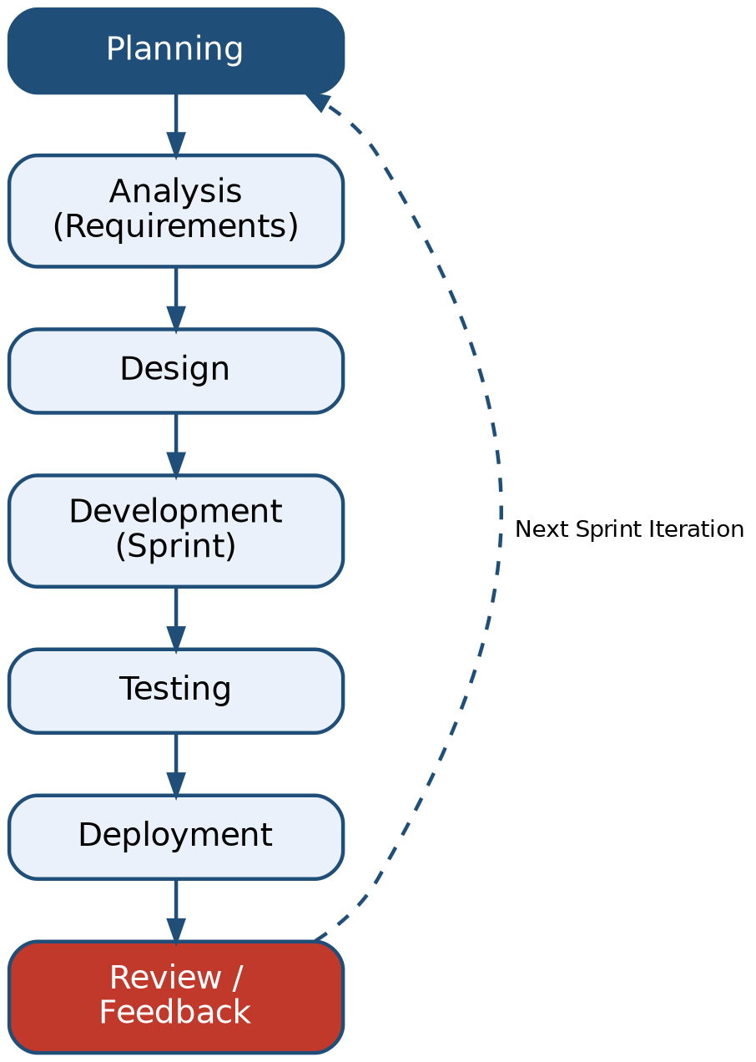
Figure 3.1: Agile SDLC Process adopted for TrustForge

3.3.2 Project Schedule
The project is scheduled over a period of nine months, from June 2026 to February 2027, structured into distinct but overlapping activity streams with the Agile approach. 3.2 presents the project schedule as a Gantt chart, indicating the duration of each major activity.
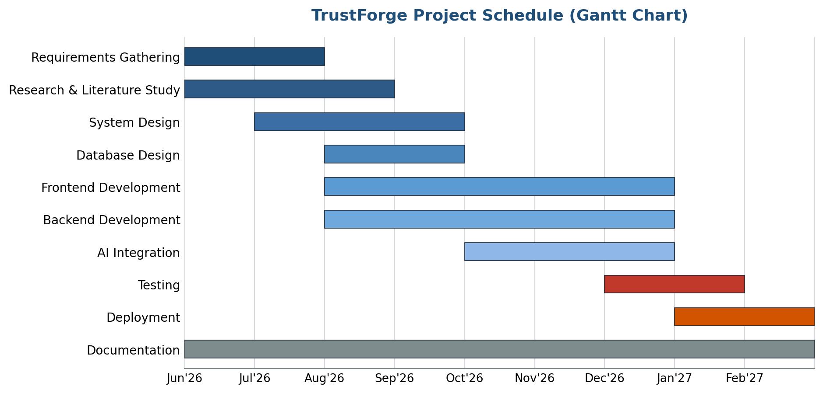

Figure 3.2: TrustForge Project Gantt Chart (June 2026 -February 2027)

3.4 Software and Hardware Requirements
The successful development and deployment of TrustForge requires a defined set of software tools and hardware resources.
Table 3.4: Software Requirements
S. No. | Software / Tool | Purpose
1 | Windows 11/10 | Development operating system
2 | Visual Studio Code | Integrated development environment
3 | Node.js | JavaScript runtime for backend and tooling
4 | React.js | Frontend library for building the user interface
5 | Tailwind CSS | Utility-first CSS framework for styling
6 | Express.js | Backend web application framework
7 | GitHub | Remote repository hosting and collaboration
8 | Supabase | Managed PostgreSQL database and authentication service
9 | Google Chrome | Primary browser for testing and debugging
Table 3.5: Hardware Requirements
S. No. | Component | Minimum Specification
1 | Processor | Intel Core i5 (or equivalent)
2 | RAM | 8 GB
3 | Storage | 256 GB SSD
4 | Network | Stable broadband internet connection
5 | Input Devices | Keyboard and mouse

3.5 Preliminary Product Description
Table 3.6: Module Description
Module | Description
Registration | Enables a new organisation to create an account by providing organisational and contact details along with secure login credentials.
Login | Authenticates returning users through Supabase Authentication, granting access to the organisation's dashboard and assessment history.
Dashboard | Presents a consolidated view of the organisation's current trust score, recent assessments, and outstanding recommendations.
Assessment Wizard | Guides the user through a structured, multi-step questionnaire covering the key obligations of the DPDP Act.
Website Scan | Automatically inspects a submitted website URL for cookie consent mechanisms, trackers, data collection forms, and privacy policy presence.
Trust Score | Computes and displays an objective compliance score derived from assessment responses and website scan results.
Reports | Generates a structured, downloadable PDF report summarising findings, the trust score, and prioritised recommendations.
Settings | Allows a user to configure account preferences, notification options, and organisational details.
Profile | Displays and allows editing of user and organisational profile information.
Admin Dashboard | Provides administrators with a platform-wide view of registered organisations, assessment volume, and system health.
Analytics | Presents aggregated statistics on common compliance gaps, score distributions, and platform usage trends.
User Management | Allows administrators to view, suspend, or otherwise manage registered user accounts.
System Monitoring | Tracks platform performance, scan job status, and error logs to support ongoing maintenance.

3.6 Conceptual Model
The conceptual model of TrustForge describes the logical flow of activity through the system from the perspective of both the end user and the platform administrator, shown in Figures 3.3 and 3.4.

3.6.1 System Flow Diagram (User)
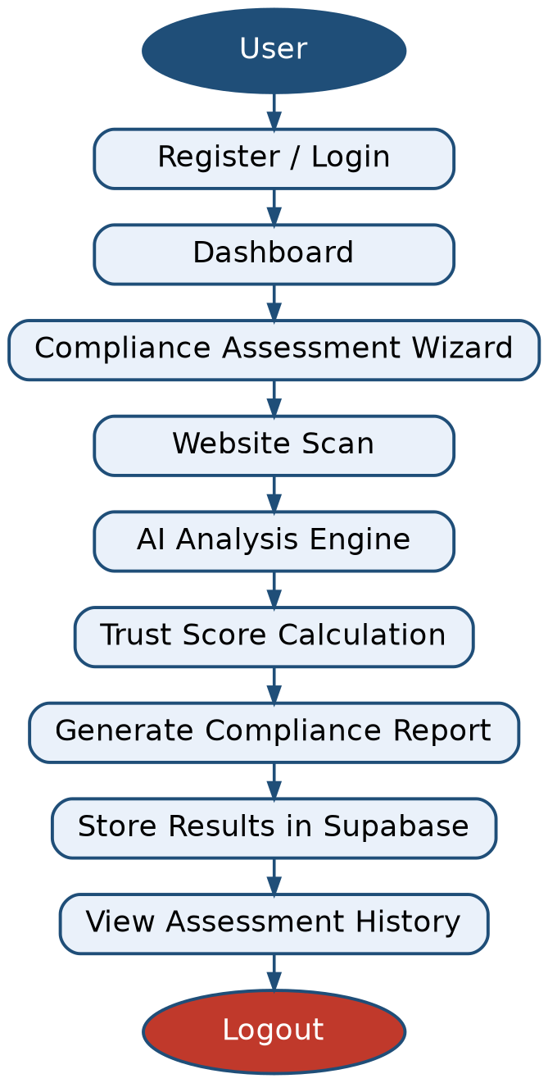
Figure 3.3: TrustForge User Flow Diagram

3.6.2 System Flow Diagram (Administrator)
In addition to the end-user flow, TrustForge defines a separate administrative flow that allows platform administrators to oversee registered organisations, monitor system-wide analytics, and maintain the operational health of the platform, as shown in Figure 3.4.
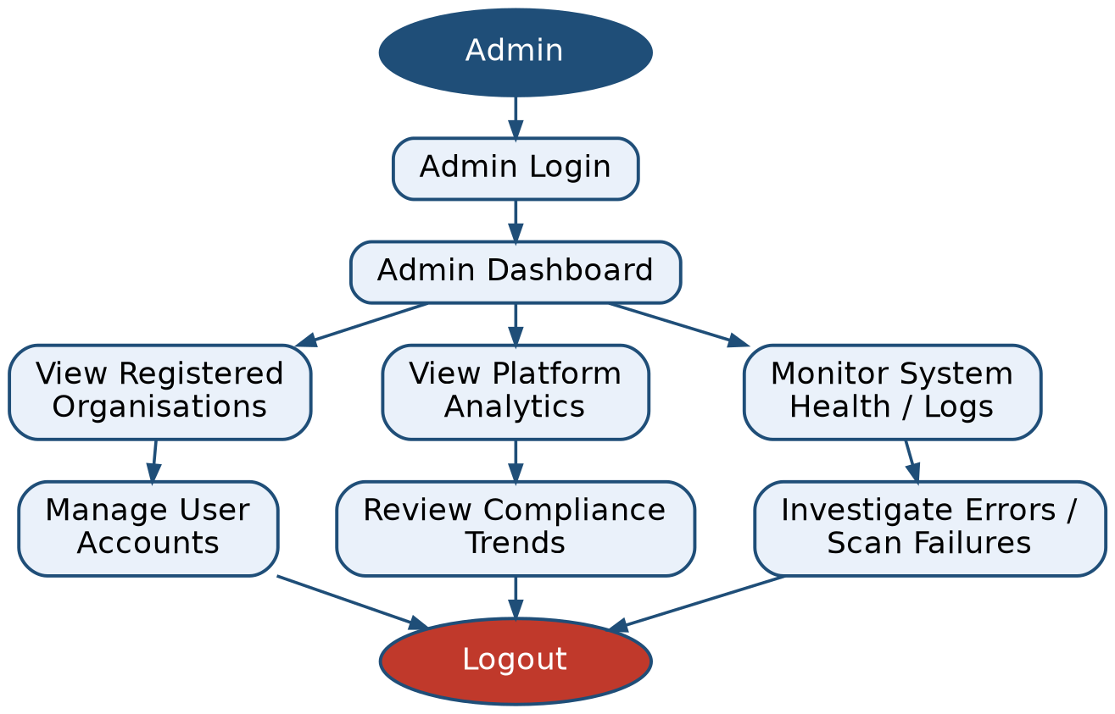
Figure 3.4: TrustForge Admin Flow Diagram
Together, the user flow and administrator flow illustrate how TrustForge separates the day-to-day compliance assessment activity performed by organisations from the oversight and monitoring responsibilities performed by platform administrators, while both flows converge on the same underlying Supabase data store, ensuring a single, consistent source of truth for the platform.

CHAPTER 4: SYSTEM DESIGN
Chapter 3 established what TrustForge is required to do, through its functional and non-functional requirements and its preliminary module description. This chapter now works out how the system will actually be built. It also presents the interface design of the platform's major screens, the security measures applied to protect its data, and the formal test cases used to validate its functional correctness.

4.1 Basic Modules
The architecture of TrustForge is organised using the divide-and-conquer principle of system design, in which the overall application is broken down into a set of smaller, independent, and cohesive functional modules. Each module encapsulates a well-defined responsibility within the compliance assessment workflow and communicates with other modules through the Node.js / Express.js application layer. The module boundaries described below are consistent with the functional requirements and the preliminary module description presented in Ch3. (Table 3.6), and are further decomposed here into their constituent sub-modules to support detailed system design. As Figure 4.1 shows, the complete set of modules is grouped into three categories: user-facing modules that support the organisation's compliance assessment journey, an intelligence module that performs AI-assisted analysis, and administrative modules that support platform oversight.

4.1.1 Basic Modules Diagram
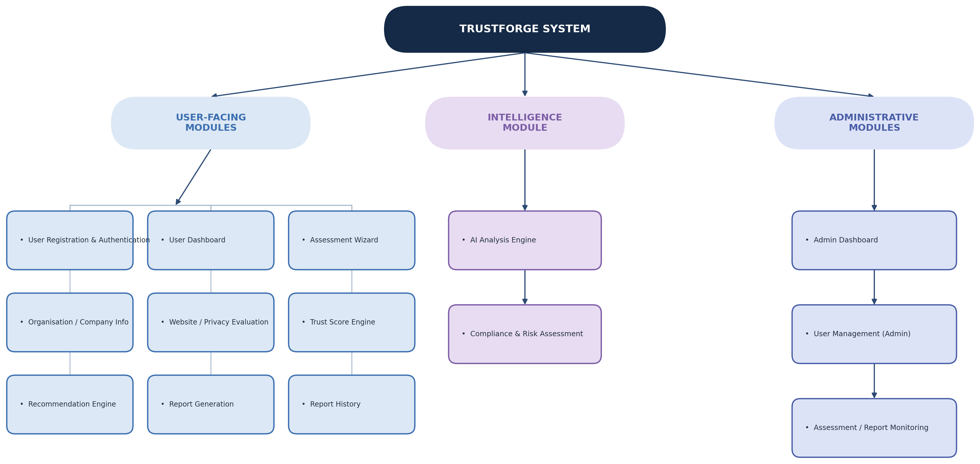
Figure 4.1 -Module Structure Chart
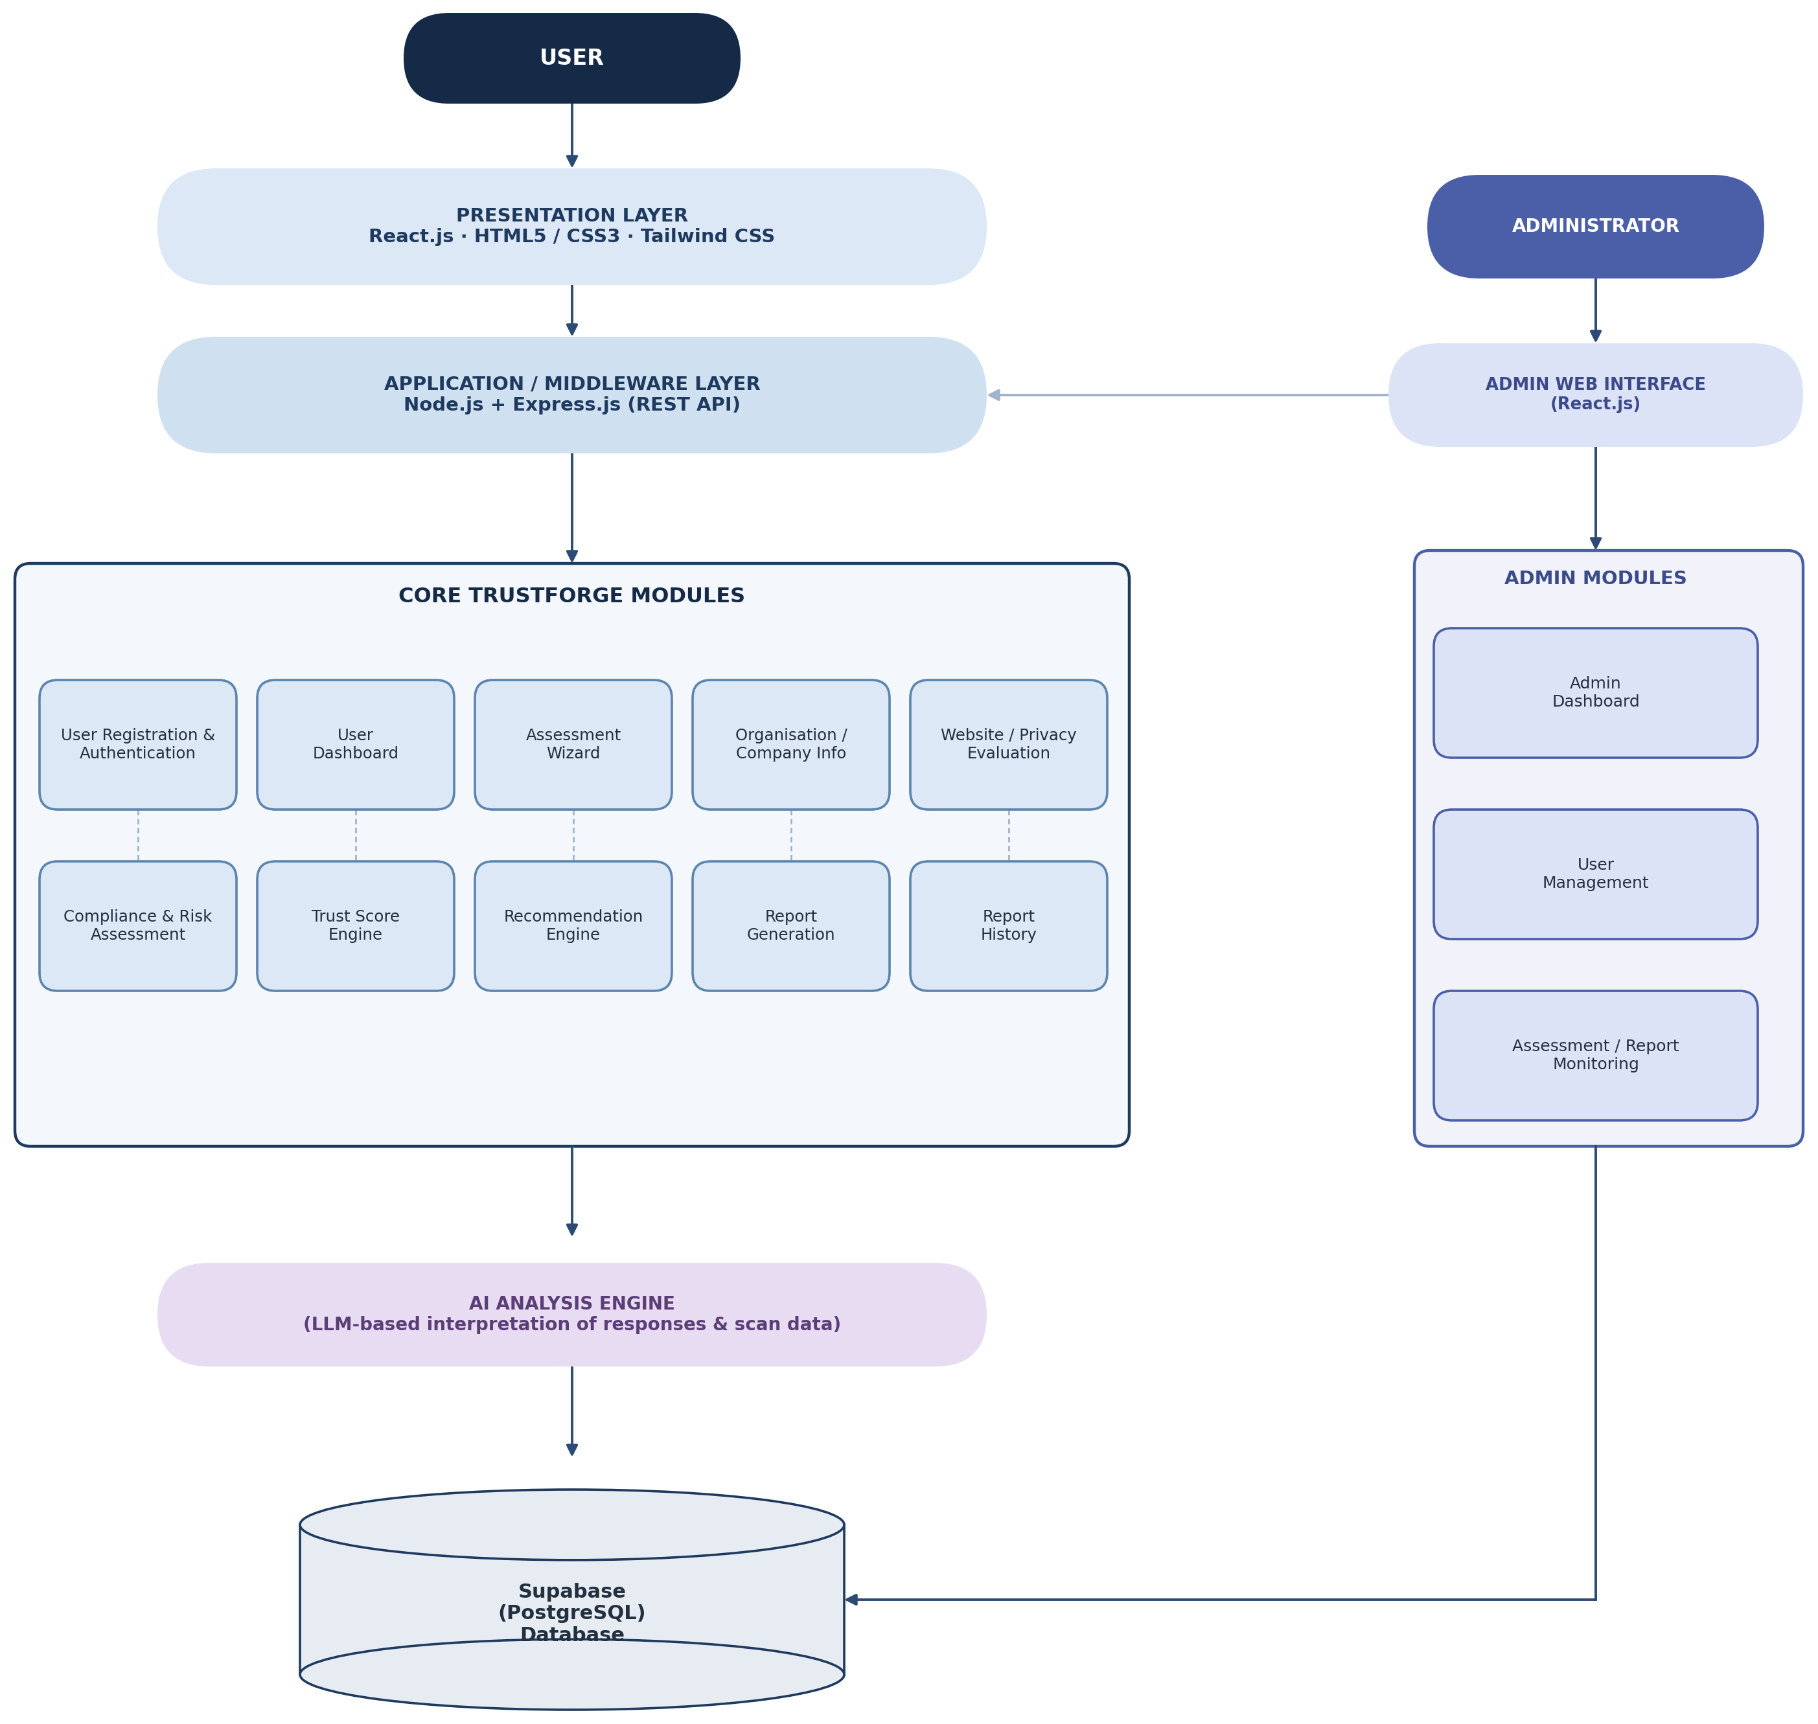
Figure 4.2 -Module Architecture Diagram

4.1.2 Working Details of Each Module
Each module below is described in terms of its purpose, main functions, inputs, processing, and outputs.

Table 4.1: Module Purpose, Functions, and Interactions
Module | Purpose | Main Functions | Interacts With
User Registration & Authentication | Allows an organisation to create an account and enables registered users to securely access the platform. | Account registration; login; password recovery; session management. | User Dashboard; Admin User Management.
User Dashboard | Provides a consolidated view of the organisation's compliance status. | Display trust score, recent assessments, pending recommendations. | Trust Score Engine; Report History; Assessment Wizard.
Assessment Wizard | Guides the user through a structured, multi-step DPDP compliance questionnaire. | Step-wise question presentation; response capture; draft saving. | Organisation / Company Info; Compliance & Risk Assessment; Database.
Organisation / Company Info | Captures and maintains organisational profile details used throughout an assessment. | Add / edit organisation profile; view organisation history. | Assessment Wizard; Website / Privacy Evaluation.
Website / Privacy Evaluation | Evaluates the organisation's publicly accessible website for observable privacy implementation gaps. | Submit website URL; permitted evaluation of cookie consent, trackers, and privacy policy presence. | AI Analysis Engine; Compliance & Risk Assessment.
AI Analysis Engine | Interprets assessment responses and website evaluation findings using an AI / LLM-based model. | Contextual interpretation of responses; gap identification support; recommendation drafting support. | Compliance & Risk Assessment; Recommendation Engine.
Compliance & Risk Assessment | Identifies specific DPDP compliance gaps and evaluates their associated risk. | Gap identification; risk severity classification. | Trust Score Engine; Recommendation Engine.
Trust Score Engine | Computes an objective, normalised compliance trust score for the organisation. | Score aggregation; score-band mapping; score history tracking. | User Dashboard; Report Generation; Platform Analytics.
Recommendation Engine | Produces actionable, prioritised recommendations to remediate identified gaps. | Map findings to guidance; prioritise recommendations. | Report Generation; User Dashboard.
Report Generation | Compiles assessment outcomes into a structured, downloadable compliance report. | Report compilation; PDF export. | Report History; Trust Score Engine; Recommendation Engine.
Report History | Maintains a searchable historical record of an organisation's past assessments and reports. | List past assessments; view / download a past report. | User Dashboard; Report Generation.
Admin Dashboard | Provides administrators with a platform-wide operational overview. | Display total organisations, average trust score, active scans. | User Management (Admin); Platform Analytics; System Monitoring.
User Management (Admin) | Allows administrators to oversee registered user and organisation accounts. | View accounts; edit roles / permissions; suspend / reactivate accounts. | User Registration & Authentication; Database.
Assessment / Report Monitoring | Tracks platform-wide assessment and scan activity for operational oversight. | View scan job queue; review failed scans / error logs; trigger rescan. | Website / Privacy Evaluation; Admin Dashboard.
Table 4.1: Module Purpose, Functions, and Interactions

Table 4.2: Module Inputs, Processing, and Outputs
Module | Inputs | Processing | Outputs
User Registration & Authentication | Organisation details, email, password. | Validates input; delegates credential verification and session issuance to Supabase Authentication. | Authenticated session token or validation error.
User Dashboard | Authenticated session; organisation ID. | Retrieves latest trust score, assessment, and recommendation records. | Dashboard summary view.
Assessment Wizard | User responses to structured questions. | Validates each step; persists responses; tracks completion progress. | Completed (or draft) assessment response set.
Organisation / Company Info | Organisation name, industry, website URL, contact details. | Validates and stores organisational metadata. | Organisation profile record.
Website / Privacy Evaluation | Website URL submitted by the user. | Performs a permitted, read-only review of publicly available website content relevant to privacy practices. | Structured website evaluation findings.
AI Analysis Engine | Assessment responses; website evaluation findings. | Sends structured input to the AI model service and processes the structured output returned. | AI-derived compliance insights consumed by downstream modules.
Compliance & Risk Assessment | Assessment responses; AI analysis output; website evaluation findings. | Evaluates findings against DPDP-relevant criteria and classifies each into a risk category. | Classified list of risk findings.
Trust Score Engine | Classified risk findings. | Aggregates findings into a normalised score (0-100) and determines the corresponding trust band. | Trust score value and score band.
Recommendation Engine | Classified risk findings; AI analysis output. | Generates recommendation text and assigns a priority level to each recommendation. | Prioritised recommendation list.
Report Generation | Trust score; risk findings; recommendations; organisation info. | Assembles a structured report document and renders it as a downloadable PDF file. | Downloadable PDF compliance report.
Report History | Organisation ID. | Retrieves stored assessment and report records in chronological order. | Assessment / report history list.
Admin Dashboard | Administrator session. | Aggregates platform-wide statistics from stored records. | Administrative summary view.
User Management (Admin) | Administrator actions on a selected account. | Applies role-based access changes and account status updates. | Updated account status / permissions.
Assessment / Report Monitoring | Administrator session; system logs. | Reads scan and assessment job status from the database and surfaces failures. | Monitoring view; rescan trigger.
Table 4.2: Module Inputs, Processing, and Outputs

4.2 Data Design
TrustForge stores clearly structured, strongly related data: organisations, their assessments, assessment responses, risk findings, trust scores, recommendations, and generated reports, all of which reference one another through well-defined relationships. A relational database is therefore appropriate for TrustForge because it enforces these relationships through primary and foreign keys, supports transactional consistency when an assessment is submitted and scored, and allows compliance data to be queried and aggregated efficiently for dashboards, history views, and administrative analytics. Supabase, built on PostgreSQL, was selected as the primary data store because it provides a managed relational database together with row-level security and integrated authentication, directly satisfying the data integrity, security, and privacy requirements identified in Section 3.2.2 (NFR-06, NFR-07, NFR-11).

4.2.1 Schema Design
The logical schema of each table used by TrustForge is described below, table by table. The relationships between these tables are presented as an Entity Relationship (ER) Diagram in 4.4.1.

Users Table
Column | Data Type | Constraint | Description
User_ID | UUID | PRIMARY KEY, NOT NULL | Uniquely identifies each registered user
Full_Name | VARCHAR (100) | NOT NULL | Name of the registered user
Email | VARCHAR (150) | NOT NULL, UNIQUE | Login email address
Role | VARCHAR (20) | NOT NULL, CHECK (Role IN ('user','admin')) | Access role of the user
Created_At | TIMESTAMPTZ | NOT NULL | Account creation timestamp

Organizations Table
Column | Data Type | Constraint | Description
Org_ID | UUID | PRIMARY KEY, NOT NULL | Uniquely identifies each organisation
Owner_User_ID | UUID | FOREIGN KEY, NOT NULL | References the owning user
Org_Name | VARCHAR (150) | NOT NULL | Registered name of the organisation
Industry | VARCHAR (100) | NULL | Industry / sector of the organisation
Website_URL | VARCHAR (255) | NULL | Website submitted for evaluation
Created_At | TIMESTAMPTZ | NOT NULL | Profile creation timestamp

Assessments Table
Column | Data Type | Constraint | Description
Assessment_ID | UUID | PRIMARY KEY, NOT NULL | Uniquely identifies each assessment
Org_ID | UUID | FOREIGN KEY, NOT NULL | Organisation the assessment belongs to
Status | VARCHAR (20) | NOT NULL, CHECK (Status IN ('draft','submitted','completed')) | Current assessment status
Started_At | TIMESTAMPTZ | NOT NULL | Time the assessment was started
Submitted_At | TIMESTAMPTZ | NULL | Time the assessment was submitted

Assessment_Responses Table
Column | Data Type | Constraint | Description
Response_ID | UUID | PRIMARY KEY, NOT NULL | Uniquely identifies each response record
Assessment_ID | UUID | FOREIGN KEY, NOT NULL | Assessment the response belongs to
Question_Key | VARCHAR (100) | NOT NULL | Identifier of the wizard question answered
Response_Value | JSONB | NOT NULL | Structured answer value for the question
Answered_At | TIMESTAMPTZ | NOT NULL | Time the response was recorded

Website_Scans Table
Column | Data Type | Constraint | Description
Scan_ID | UUID | PRIMARY KEY, NOT NULL | Uniquely identifies each scan record
Assessment_ID | UUID | FOREIGN KEY, NOT NULL | Assessment the scan belongs to
Target_URL | VARCHAR (255) | NOT NULL | Website URL submitted for evaluation
Scan_Status | VARCHAR (20) | NOT NULL, CHECK (Scan_Status IN ('pending','completed','failed')) | Current status of the evaluation
Raw_Findings | JSONB | NULL | Structured evaluation output
Scanned_At | TIMESTAMPTZ | NULL | Time the evaluation completed

Risk_Findings Table
Column | Data Type | Constraint | Description
Finding_ID | UUID | PRIMARY KEY, NOT NULL | Uniquely identifies each finding
Assessment_ID | UUID | FOREIGN KEY, NOT NULL | Assessment the finding belongs to
Category | VARCHAR (100) | NOT NULL | DPDP obligation category (e.g. consent, retention)
Severity | VARCHAR (20) | NOT NULL, CHECK (Severity IN ('Low','Medium','High','Critical')) | Risk classification of the finding
Description | VARCHAR (255) | NOT NULL | Description of the identified gap
Source | VARCHAR (20) | NOT NULL, CHECK (Source IN ('wizard','scan')) | Origin of the finding

Trust_Scores Table
Column | Data Type | Constraint | Description
Score_ID | UUID | PRIMARY KEY, NOT NULL | Uniquely identifies each score record
Assessment_ID | UUID | FOREIGN KEY, NOT NULL | Assessment the score was computed for
Score_Value | INT | NOT NULL, CHECK (Score_Value BETWEEN 0 AND 100) | Trust score value
Score_Band | VARCHAR (20) | NOT NULL | Descriptive band (Low / Moderate / Good / Strong)
Computed_At | TIMESTAMPTZ | NOT NULL | Time the score was computed

Recommendations Table
Column | Data Type | Constraint | Description
Recommendation_ID | UUID | PRIMARY KEY, NOT NULL | Uniquely identifies each recommendation
Finding_ID | UUID | FOREIGN KEY, NOT NULL | Finding the recommendation addresses
Title | VARCHAR(150) | NOT NULL | Short recommendation title
Priority | VARCHAR(20) | NOT NULL, CHECK (Priority IN ('High','Medium','Low')) | Priority level of the recommendation
Guidance_Text | VARCHAR(500) | NOT NULL | Actionable remediation guidance

Reports Table
Column | Data Type | Constraint | Description
Report_ID | UUID | PRIMARY KEY, NOT NULL | Uniquely identifies each report
Assessment_ID | UUID | FOREIGN KEY, NOT NULL | Assessment the report was generated for
Report_URL | VARCHAR(255) | NOT NULL | Storage location of the generated PDF
Generated_At | TIMESTAMPTZ | NOT NULL | Time the report was generated
Format | VARCHAR(10) | NOT NULL, CHECK (Format = 'PDF') | Report file format

Admin_Audit_Logs Table
Column | Data Type | Constraint | Description
Log_ID | UUID | PRIMARY KEY, NOT NULL | Uniquely identifies each log entry
Admin_User_ID | UUID | FOREIGN KEY, NOT NULL | Administrator who performed the action
Action | VARCHAR(150) | NOT NULL | Description of the administrative action
Target_Entity | VARCHAR(100) | NOT NULL | Entity affected by the action
Logged_At | TIMESTAMPTZ | NOT NULL | Time the action was logged

4.3 Data Integrity and Constraints
Data integrity ensures that the information stored in the TrustForge database remains accurate, consistent, and reliable. Constraints are applied at the column level for each table described in Section 4.2.1, and are enforced by the Supabase PostgreSQL database together with validation performed at the application layer.

4.3.1 Constraints Applied to Various Columns
Constraint | Purpose | Examples
PRIMARY KEY | Uniquely identifies every record in a table. | User_ID, Org_ID, Assessment_ID, Finding_ID, Score_ID, Report_ID, etc.
FOREIGN KEY | Connects a record to a valid record in another table. | Owner_User_ID, Org_ID, Assessment_ID, Finding_ID, Admin_User_ID
NOT NULL | Prevents essential fields from being left empty. | Email, Org_Name, Question_Key, Response_Value, Severity
UNIQUE | Prevents duplicate values where uniqueness is required. | User Email
CHECK | Restricts values to valid ranges or conditions. | Score_Value BETWEEN 0 AND 100, Severity IN ('Low','Medium','High','Critical'), Status IN ('draft','submitted','completed')
NULL | Allows optional information where it is not mandatory. | Industry, Website_URL, Submitted_At, Raw_Findings

4.4 Procedural Design
Procedural design describes how the Organisation User, the Administrator, and the internal AI Analysis Engine interact within TrustForge. The diagrams below represent the logical relationships between data entities, the actors and use cases of the system, the chronological sequence of the core assessment workflow, and the flow of data through the system at increasing levels of detail.

4.4.1 ER Diagram
The ER diagram represents the logical relationships among the users, organizations, assessments, assessment responses, website scans, risk findings, trust scores, recommendations, reports, and admin audit log entities described in Section 4.2.1.
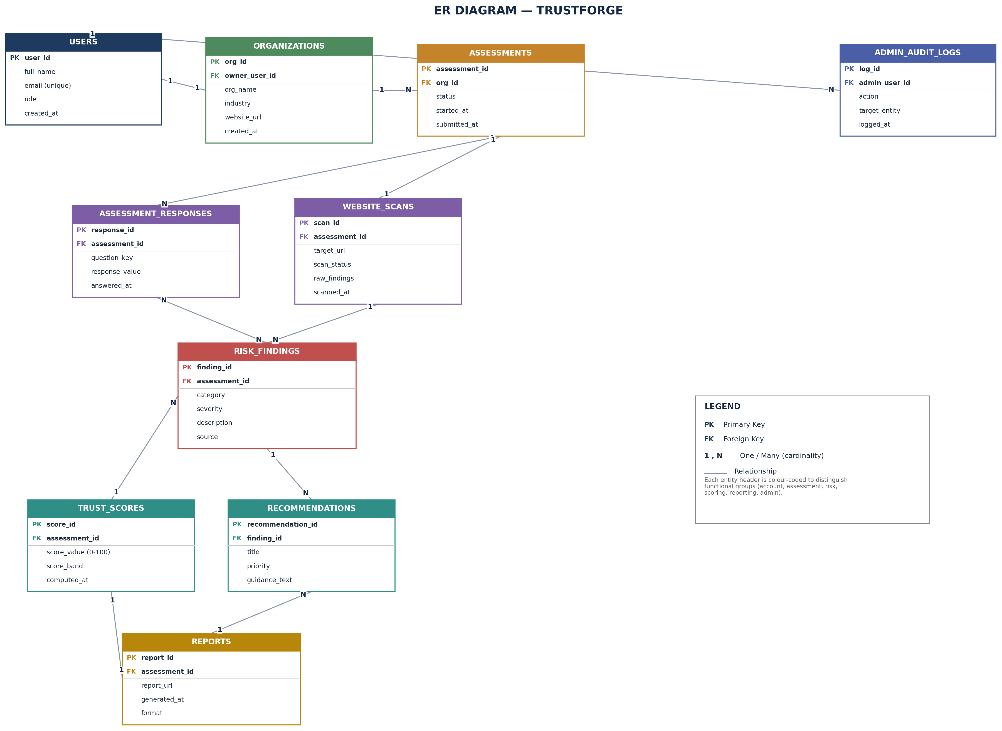
Figure 4.3 -ER Diagram
Main logical relationships:
• User → Organisation → Assessment → Assessment Responses / Website Scans
• Assessment Responses & Website Scans → Risk Findings
• Risk Findings → Trust Score and Recommendations
• Trust Score & Recommendations → Report
• User → Admin Audit Logs

4.4.2 Use Case Diagram
The use case diagram identifies the two actors and the activities each performs. The Organisation User interacts with the assessment workflow, while the Administrator oversees platform-wide accounts, monitoring, and analytics. The AI-assisted analysis and trust-score generation are shown as system-internal use cases included automatically as part of the assessment wizard and website evaluation use cases.
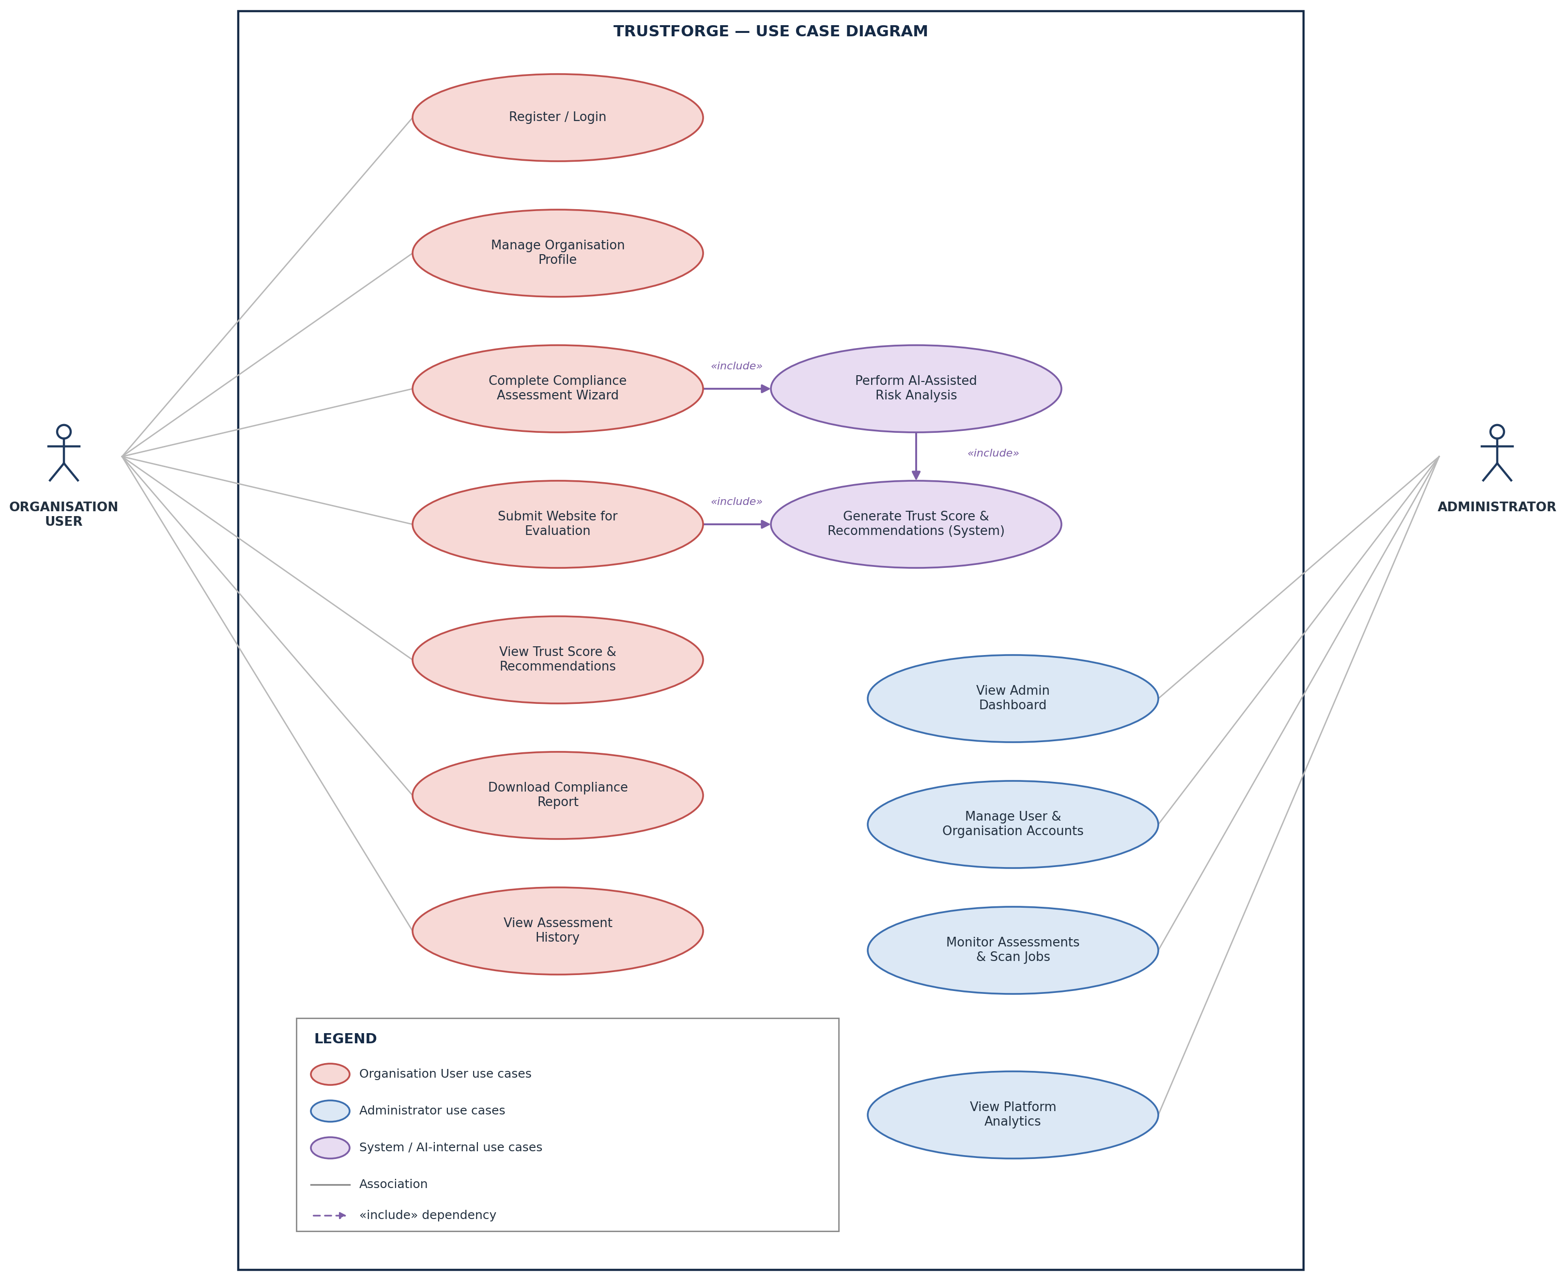
Figure 4.4 -Use Case Diagram

4.4.3 Sequence Diagram
The sequence diagram shows the chronological flow of the core compliance assessment process; from the point the Organisation User submits the assessment wizard through to the trust score and report being returned.
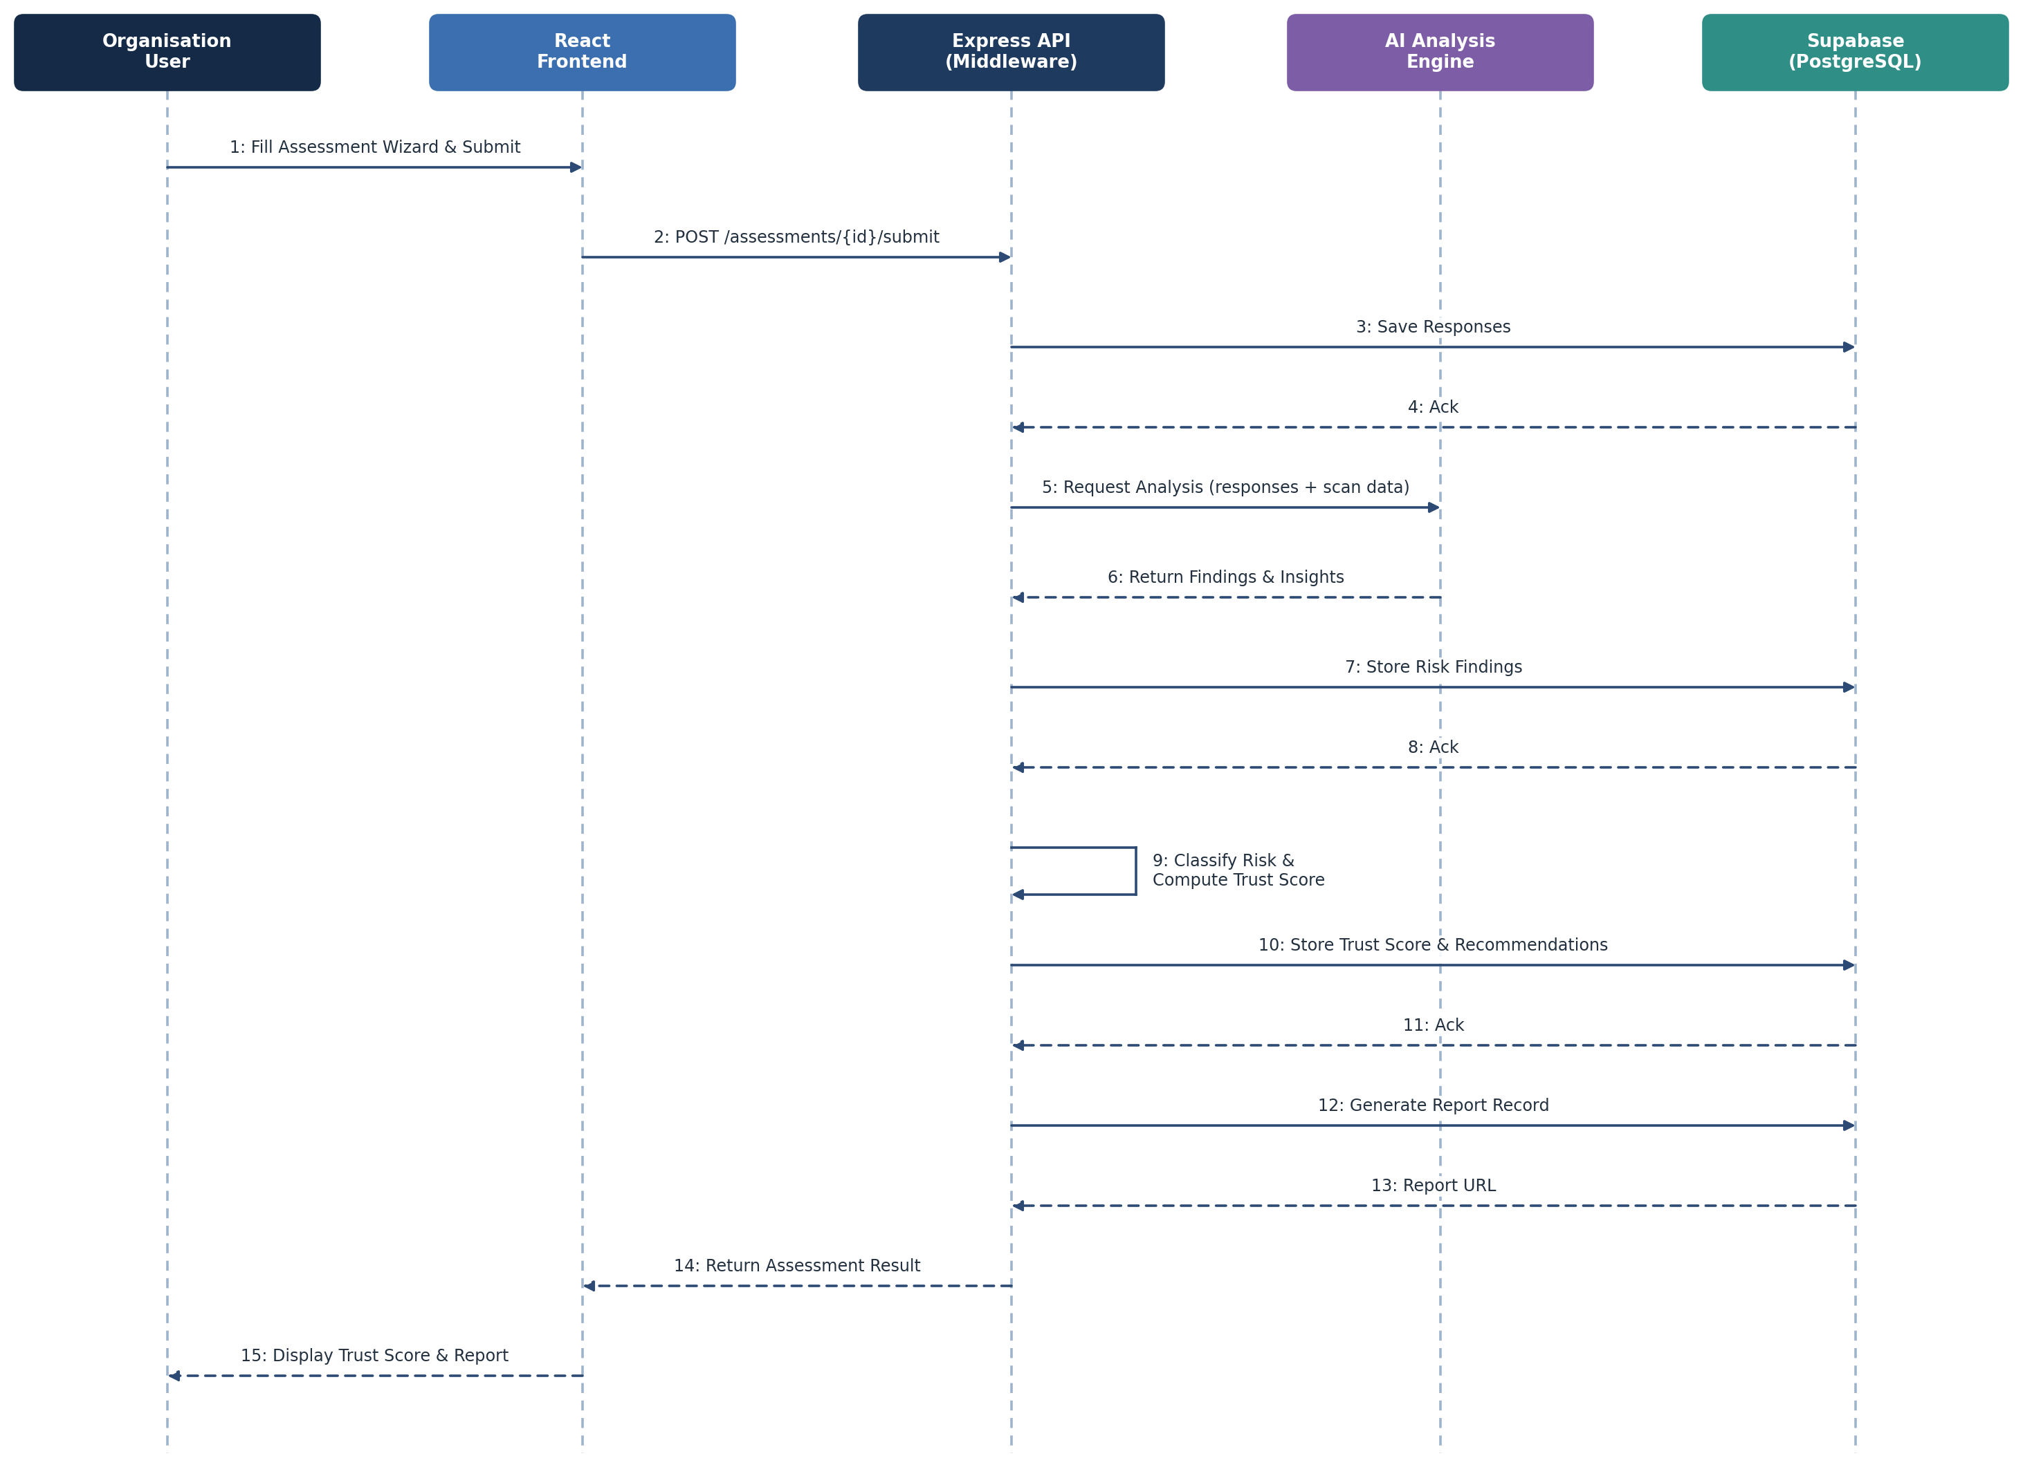
Figure 4.5 -Sequence Diagram

4.4.4 Data Flow Diagram

DFD Level 0 -Context Diagram
At Level 0, the complete TrustForge platform is represented as one central process. The Organisation User provides registration, organisation, and assessment data, while the Administrator exchanges management actions and analytics with the system.

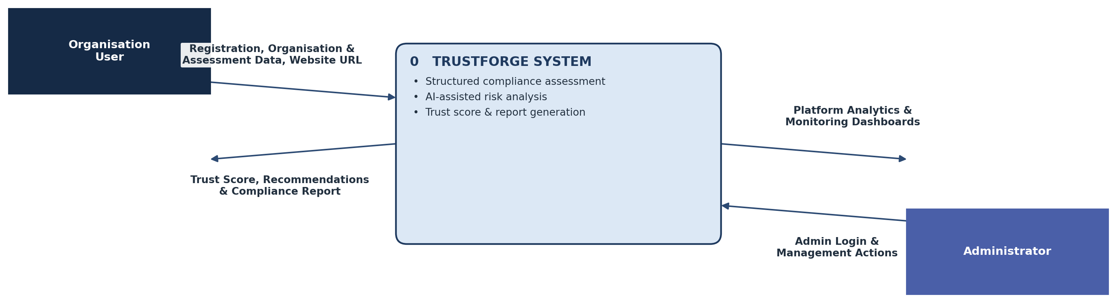

Figure 4.6 -DFD Level 0 Context Diagram

DFD Level 1
At Level 1, the platform is divided into seven main processes: Manage Authentication, Manage Assessment & Organisation Info, Perform Website / Privacy Evaluation, AI Analysis & Risk Classification, Generate Trust Score & Recommendations, Generate Report, and Admin Management, together with the Supabase data store each process reads from or writes to.
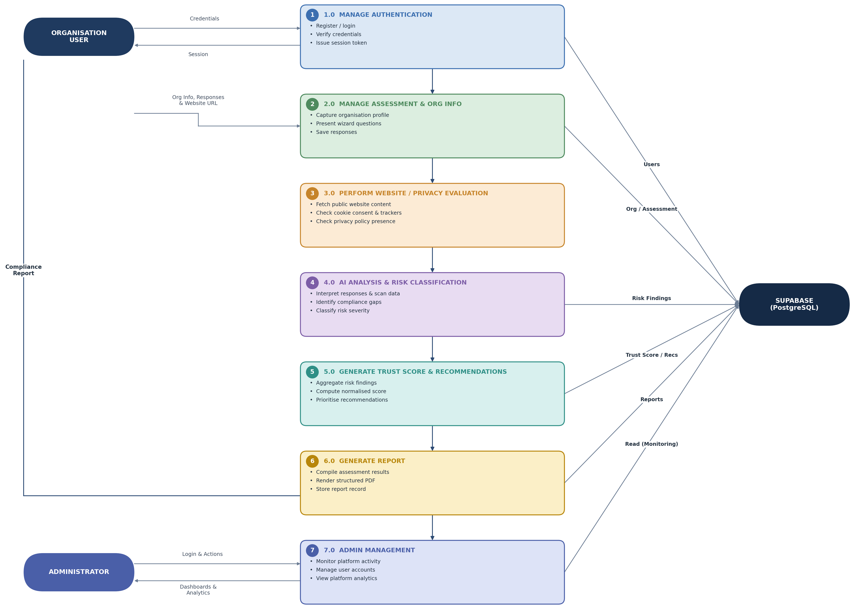
Figure 4.7 -DFD Level 1

DFD Level 2
At Level 2, the AI Analysis & Risk Classification process together with trust score generation is expanded into its four constituent sub-processes, numbered 4.1 to 4.4 for the modules shown below.
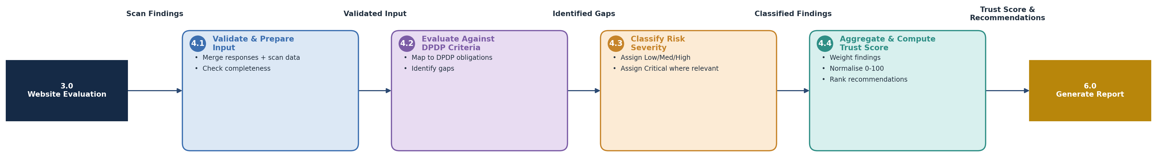
Figure 4.8 -DFD Level 2

4.4.5 User Interface Design
The TrustForge web application is designed to give Indian startups and SMEs a simple, guided, and trustworthy path through a DPDP compliance assessment. The interface focuses on clear step-by-step data entry, an easily interpreted trust score, and actionable recommendations, while maintaining a consistent visual identity across the user-facing and administrative sides of the platform. The interface is designed primarily for desktop use by business owners and compliance-responsible staff, while remaining usable on tablet and mobile screens. The major screens of the TrustForge platform are described below.
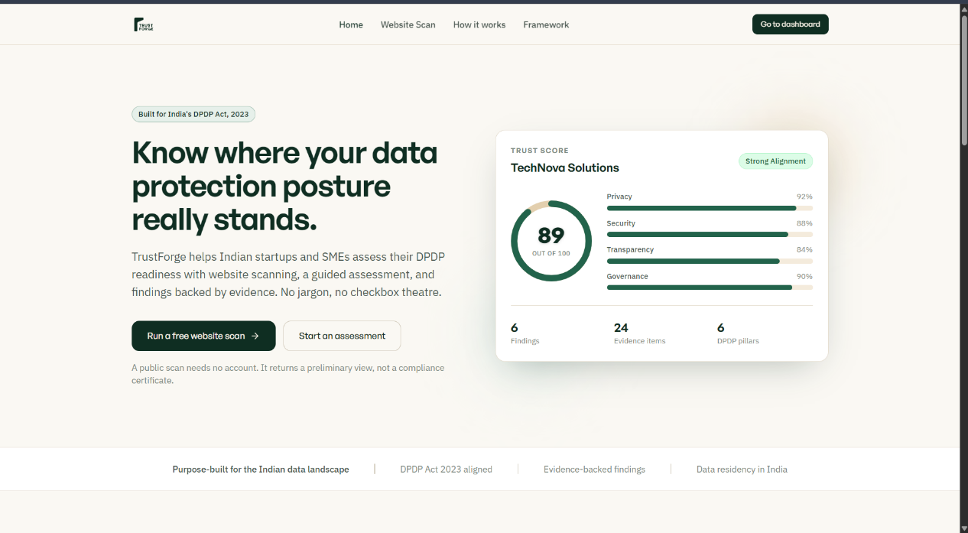

Figure 4.9 Landing Screen
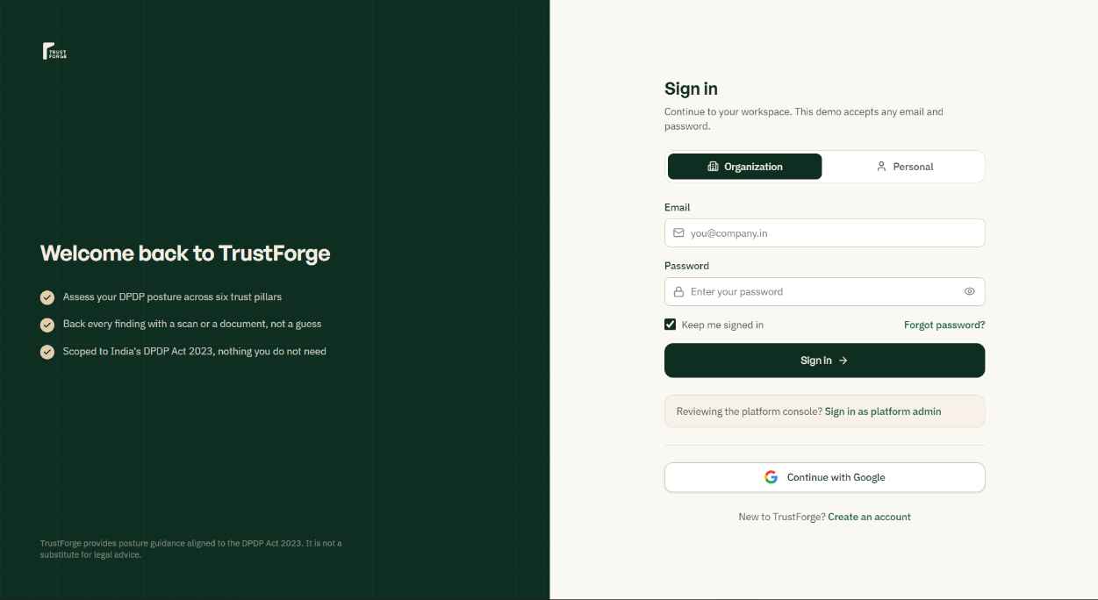
Figure 5.0 Login / Registration Screen
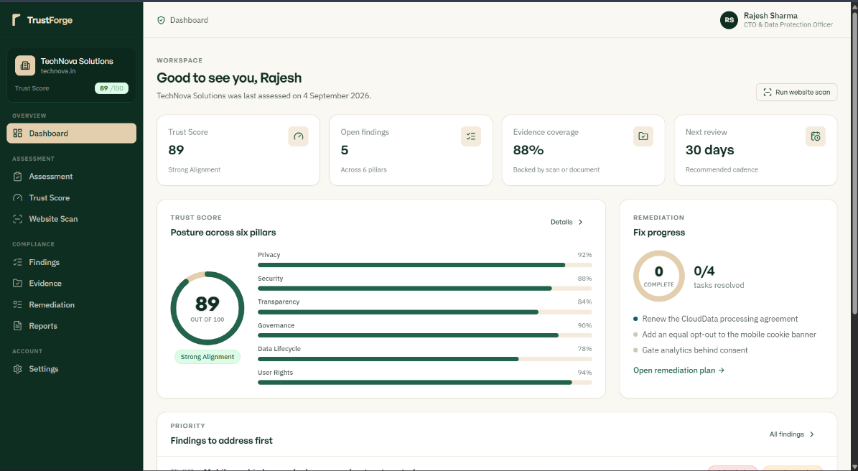

Figure 5.1 User Dashboard
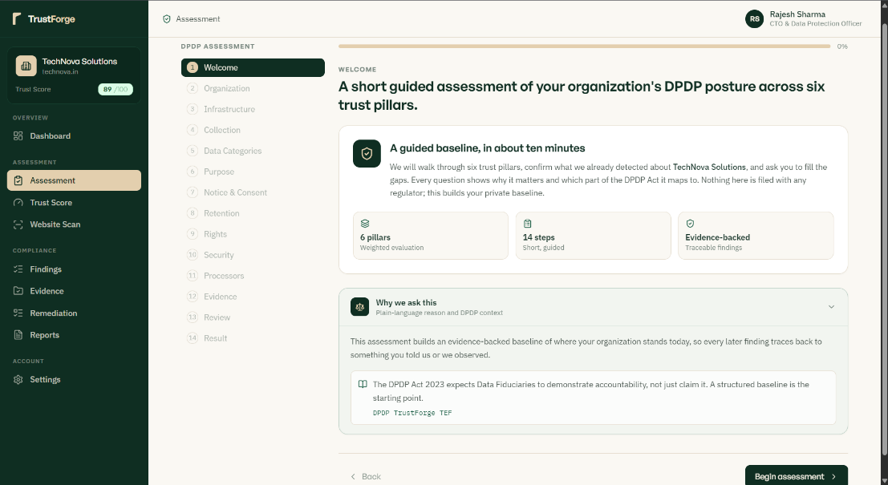
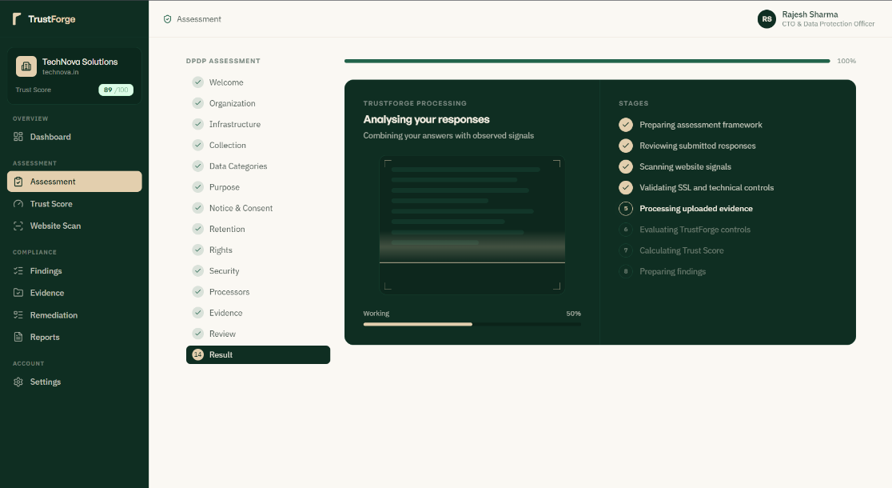
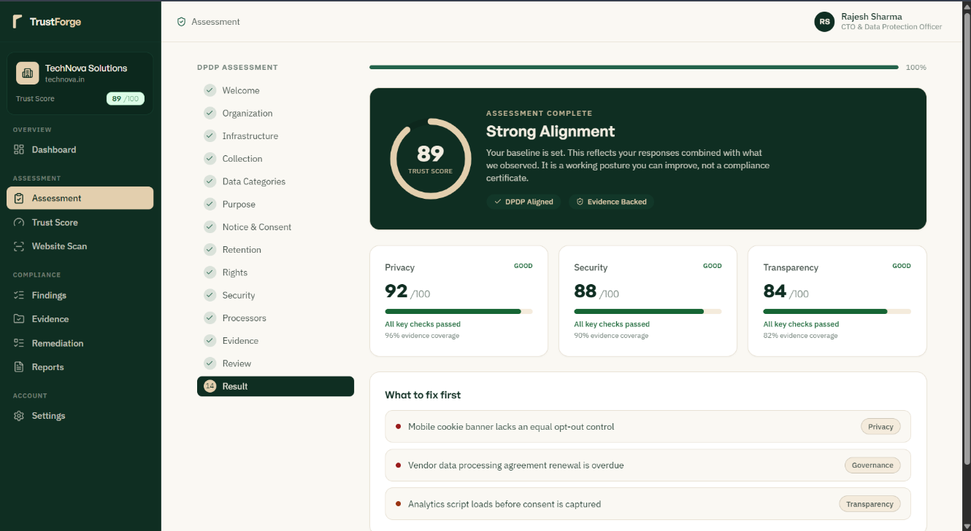

Figure 5.2 Assessment Wizard Screen
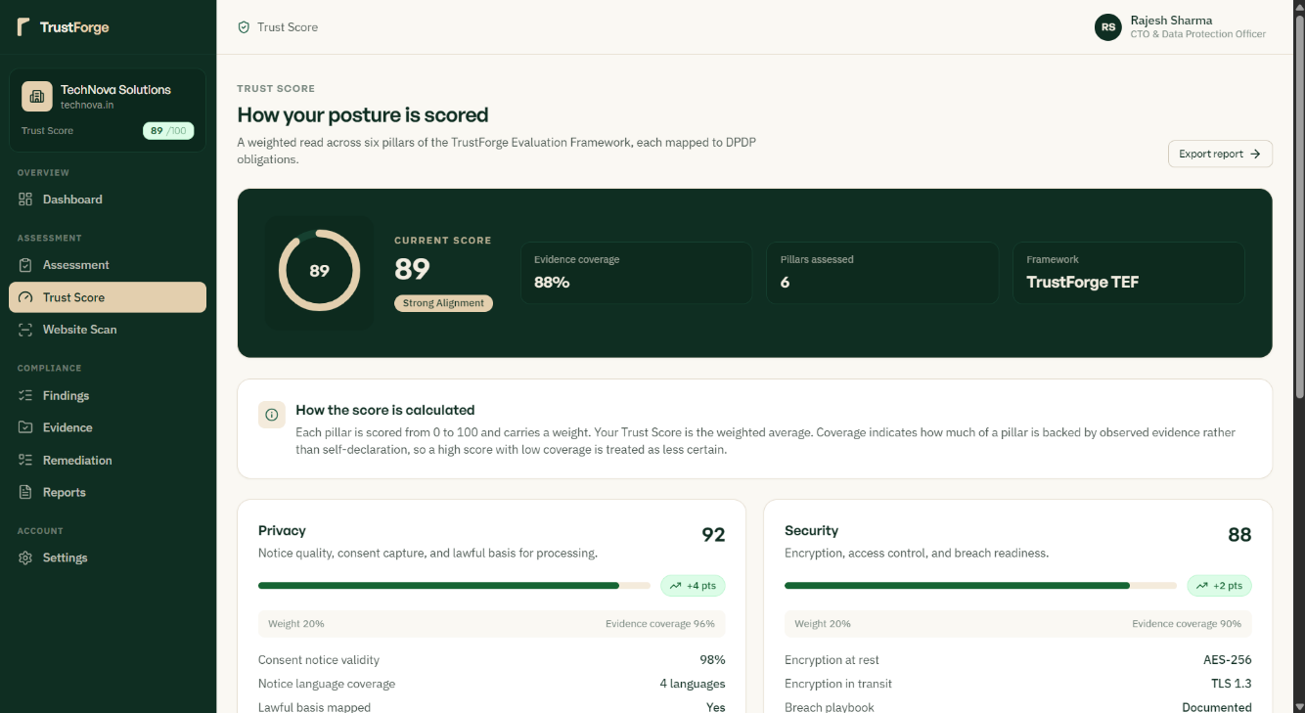

Figure 5.3 Website Evaluation Results Screen

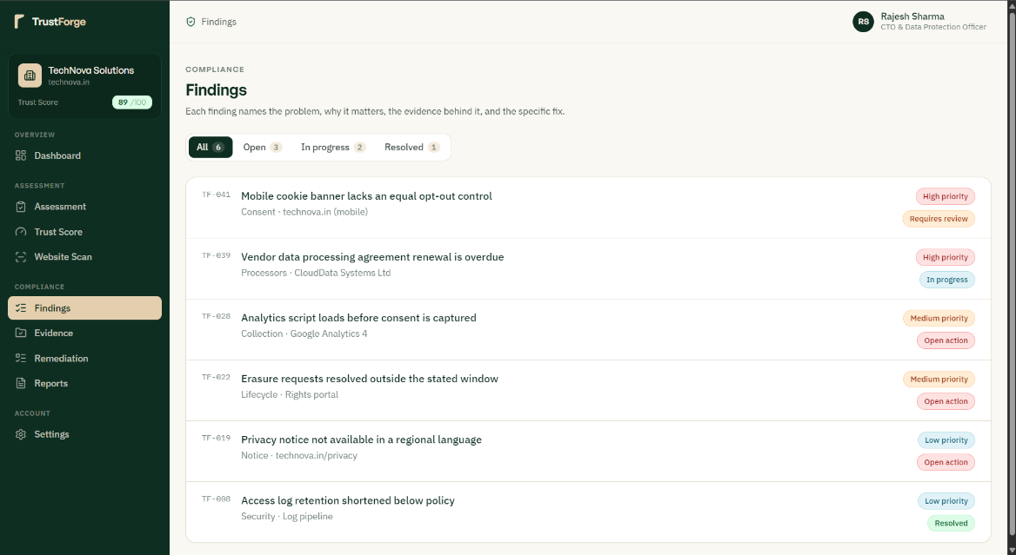
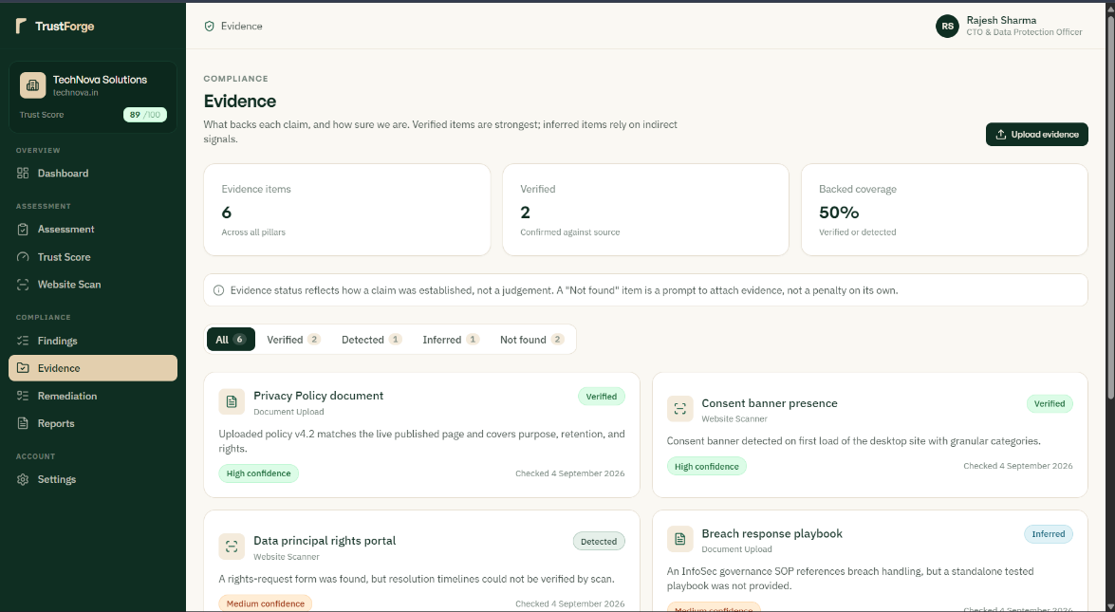

Figure 5.4 Findings and Evidence Screens
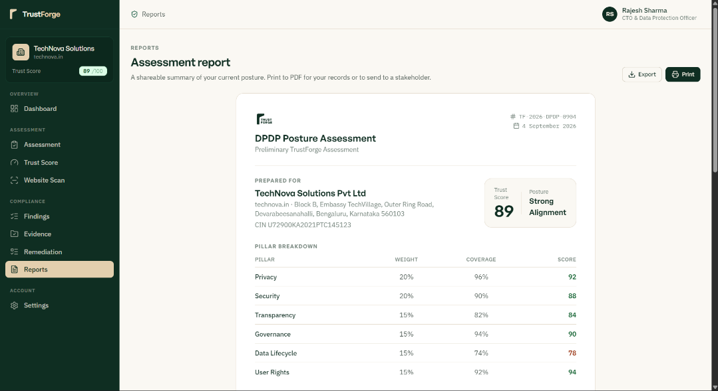
Figure 5.5 Compliance Report / Download Screen

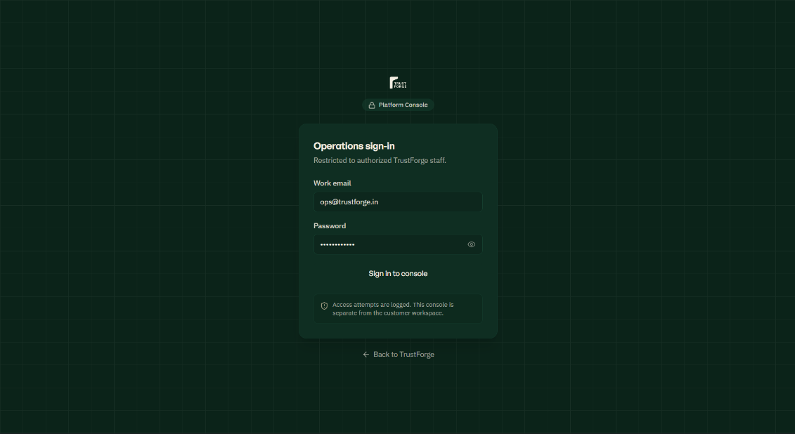
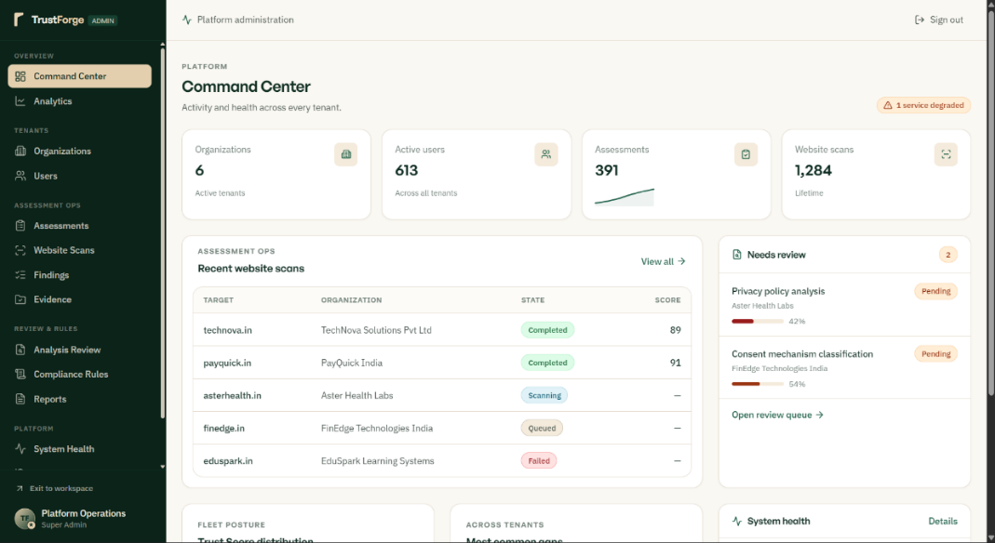
Figure 5.6 Admin Login & Dashboard Screen
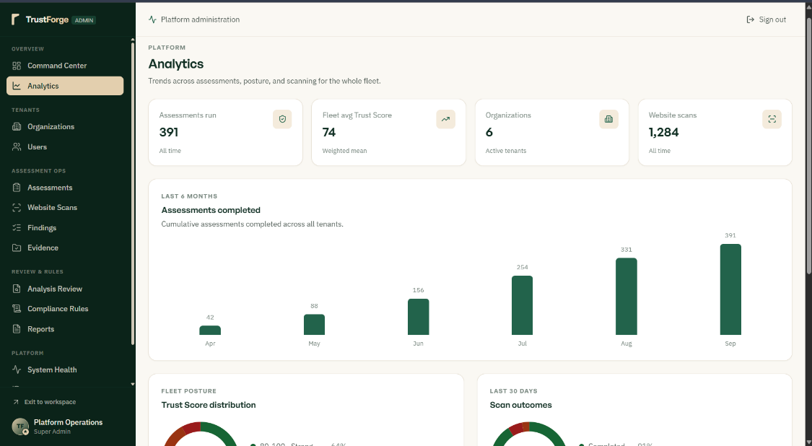

Figure 5.7 Platform Analytics Screen (Admin)

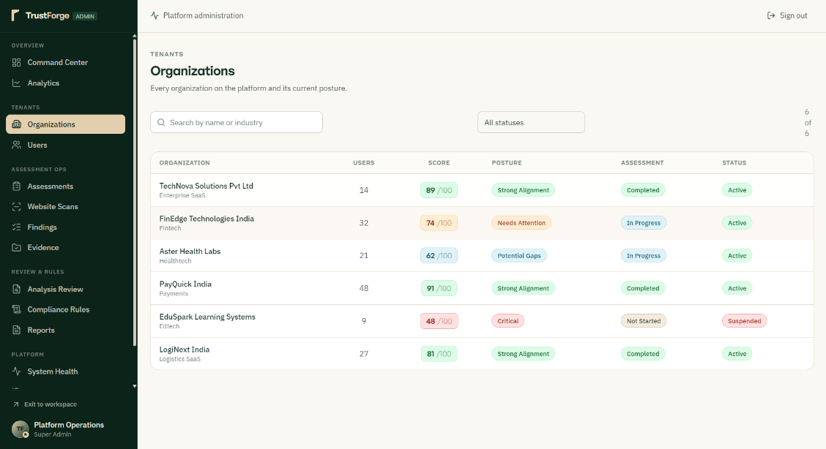
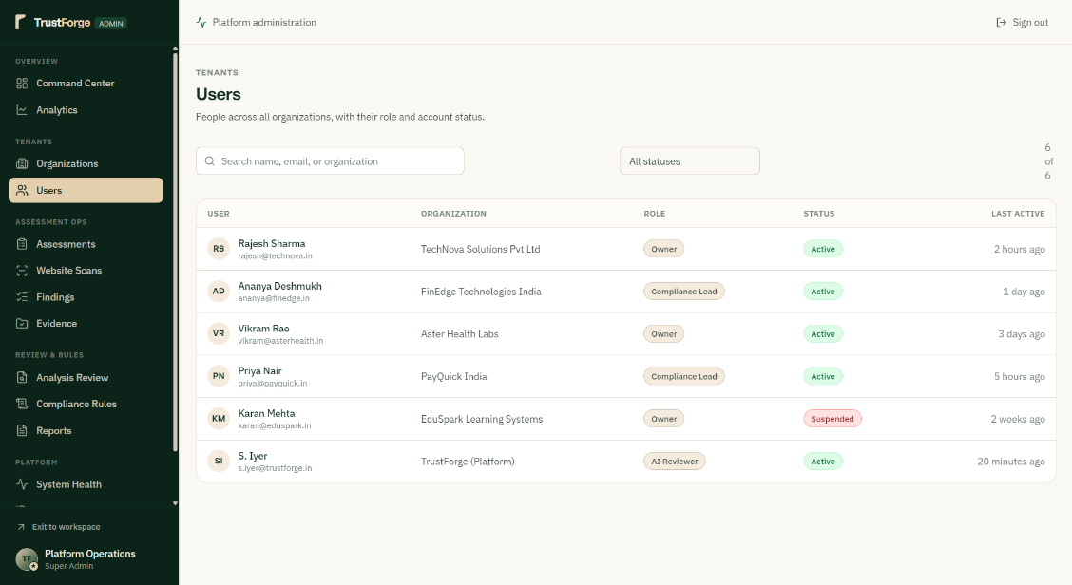

Figure 5.8 Users and Organizations Screen (Admin)

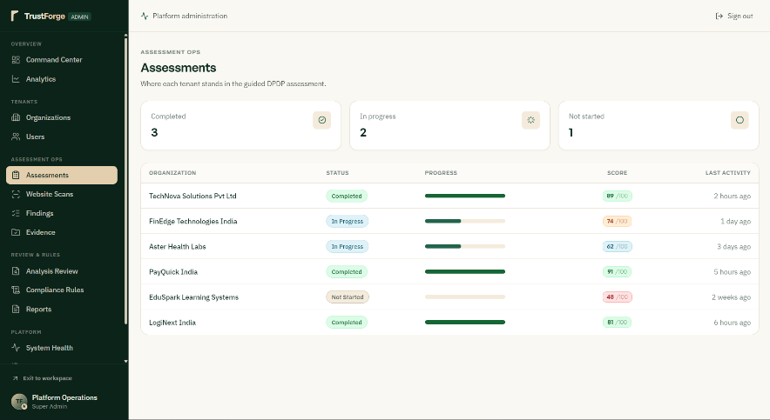 | 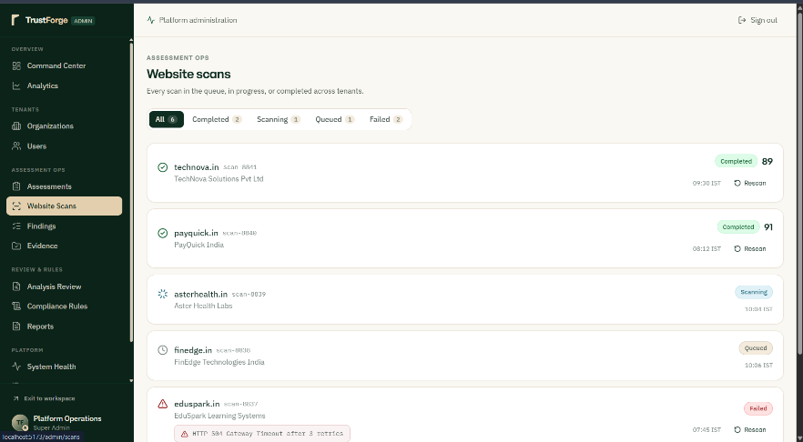
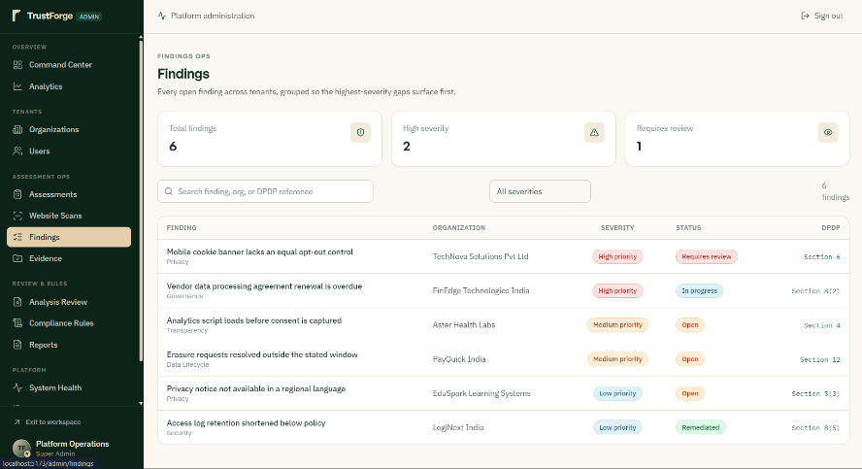 | 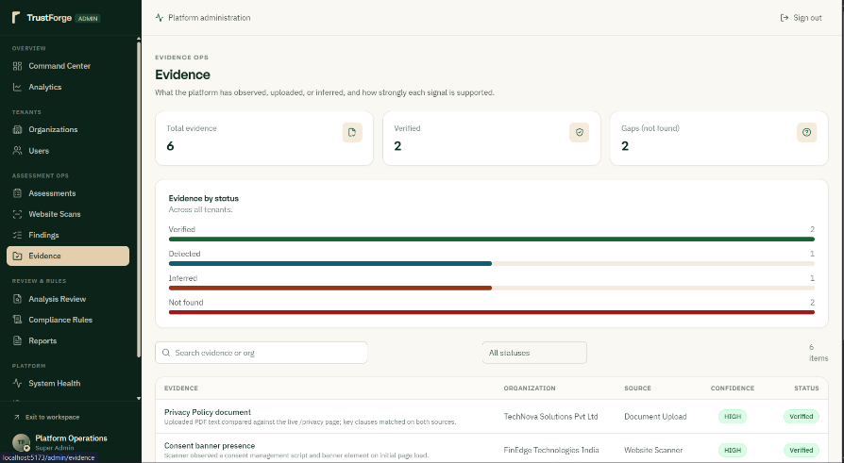

Figure 5.9 Assessment and Operation Screens (Admin)
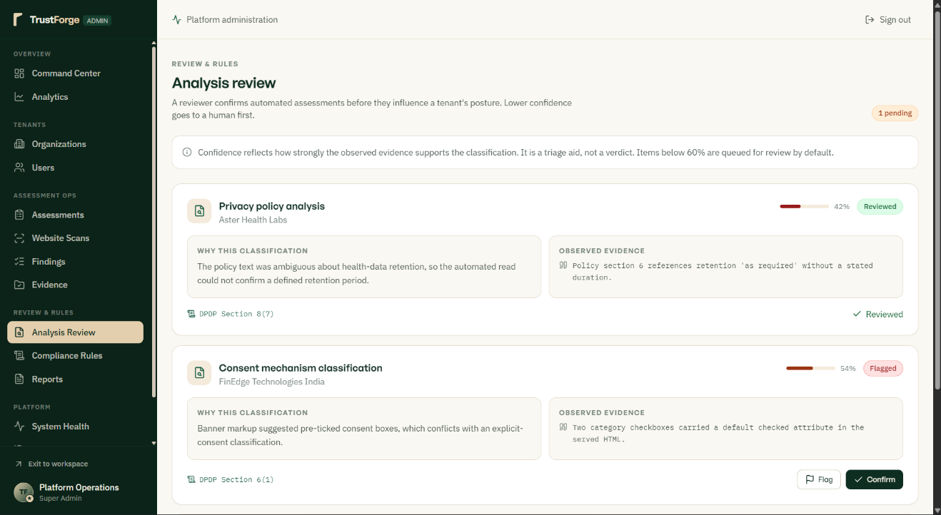
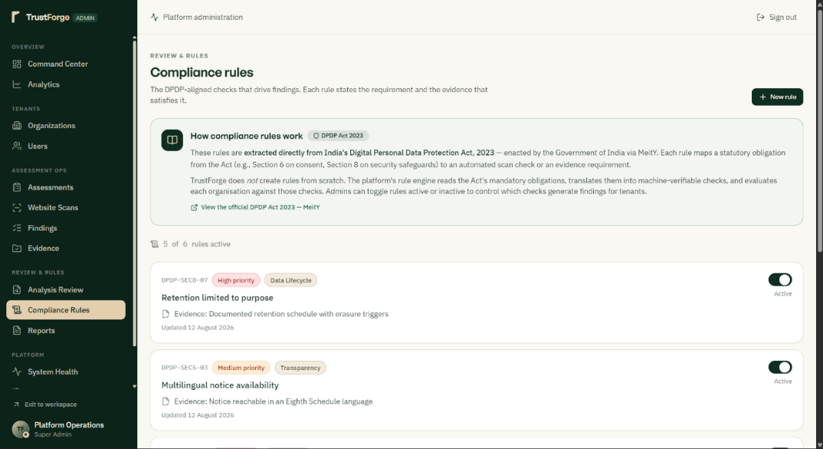

Figure 6.0 Analysis Review and Rules Screen (Admin)
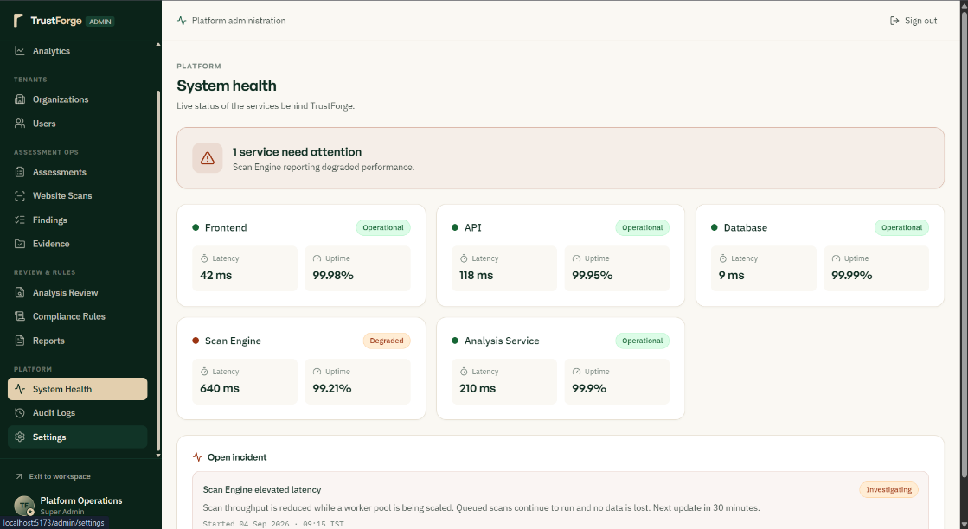
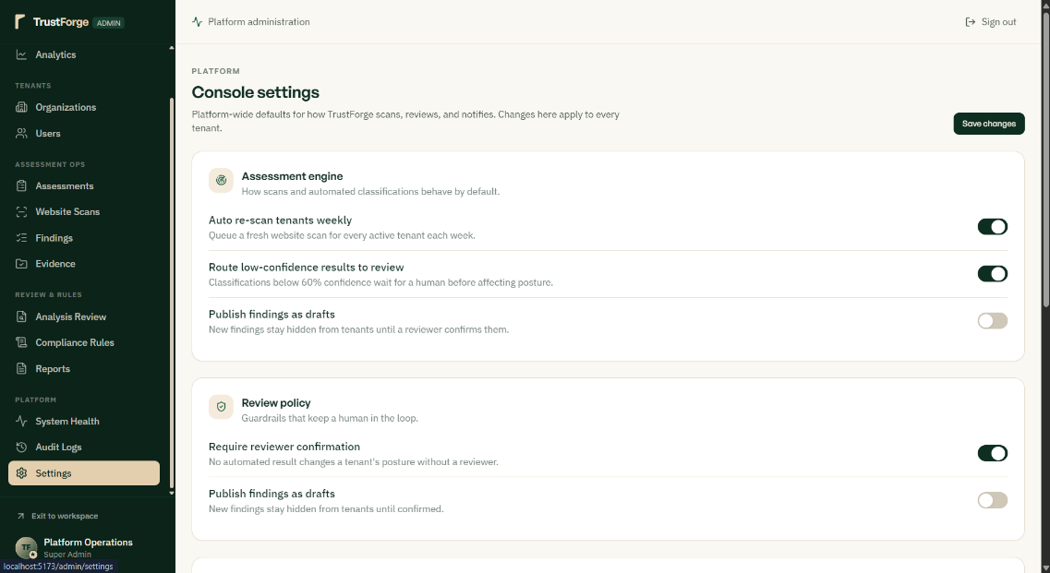

Figure 6.1 Platform Analytics Screen (Admin)

4.5 Security Issues
Security is an important part of the TrustForge platform because the system handles organisational profile data, DPDP assessment responses, website evaluation findings, and AI-derived compliance insights. The following security measures help protect the platform and its users' information from unauthorized access, misuse, and data loss.

4.5.1 Protection of the Web Application from Attacks
The TrustForge web application should be protected from unauthorized access and common web attacks. Administrative access should be provided only to authorized users, and the Node.js / Express.js API should validate and sanitise all incoming requests before processing. Unnecessary endpoints and integrations should be avoided to reduce the attack surface, and platform activity should be monitored regularly to identify unusual behaviour. These measures help protect assessment data, organisation profiles, and generated reports.

4.5.2 Encryption of Data Sent to the Server
All data transferred between the React.js frontend and the Node.js / Express.js backend should use HTTPS / TLS encryption. Encryption helps protect information while it is in transit, which is important during account registration, assessment submission, and website URL submission. Secure communication reduces the possibility of unauthorized users intercepting transmitted data and provides users with a safer browsing experience throughout the assessment process.

4.5.3 Secure Storage of Organisational and Personal Data
TrustForge handles organisational information such as organisation name, website URL, and assessment responses, together with the personal account details of registered users. This information should be securely stored in Supabase PostgreSQL and accessed only by authorized users. Supabase Row Level Security (RLS) policies should restrict an organisation's users to their own records, so that one organisation cannot access another organisation's assessment data. Proper data protection helps maintain customer trust and supports the DPDP-aligned handling of the platform's own data (NFR-07).

4.5.4 Security of AI Analysis Data
Assessment responses and website evaluation findings sent to the AI Analysis Engine should be limited to the information required to generate compliance insights. Sensitive data should not be unnecessarily included in requests to the external AI model service, and AI-generated responses should be validated before being persisted or displayed. Access to AI analysis logs and outputs should be restricted to authorized administrators, reducing the risk of exposing organisational information through the AI integration.

4.5.5 Admin Access Control
Only authorized administrators should have access to the Admin Dashboard, User Management, and Platform Analytics modules. Role-based access control, enforced through the Role field on the Users table and validated at the API layer, ensures that administrative endpoints are unreachable to standard organisation users. Administrative permissions should be reviewed periodically, and accounts that no longer require administrative access should have that access removed promptly.

4.5.6 Password and Account Security
User authentication is handled through Supabase Authentication, which enforces secure password storage and session management. Strong passwords should be required at registration, and multi-factor authentication (MFA) should be enabled for administrator accounts wherever available. Session tokens should expire after a reasonable period of inactivity, and inactive or unnecessary accounts should be reviewed and removed to reduce the platform's exposure to unauthorized account access.

4.5.7 Backup and Data Recovery
Assessment records, trust scores, recommendations, and generated reports represent important business information for the organisations using TrustForge and should have suitable backup arrangements. Supabase's managed backup capabilities help protect information from accidental deletion and technical failure, and backup availability should be checked periodically to confirm that data can be restored if required, supporting the recoverability requirement.

4.5.8 Third-Party Integration Security
TrustForge integrates with third-party services, principally Supabase (database and authentication) and an external AI model API. Only trusted, necessary integrations should be used, and API keys and access tokens for these services should be stored securely as environment variables rather than in source code or client-side bundles. Permissions granted to each integration should be reviewed periodically, and unused credentials or integrations should be revoked, reducing the risk of unauthorized access through a compromised third-party dependency.

4.6 Test Cases
This section defines the formal test cases used to validate the functional correctness of TrustForge. Test cases are organised by functional module, with ten test cases per module across the eight modules identified below, giving a total of eighty test cases. Each test case specifies the scenario under test, a description, the test input or action, the expected result, and the pass / fail criteria used to judge the outcome.

4.6.1 User Registration & Authentication
Test ID | Test Scenario | Test Description | Test Input / Action | Expected Result | Pass / Fail Criteria
AUTH-01 | Organisation Registration | Verify that a new organisation can register using a valid email and password. | Enter organisation name, valid email, and password on the Register form and submit. | A new account is created and the user is redirected to the dashboard. | PASS: Account is created and dashboard loads. FAIL: Registration fails or no redirect occurs.
AUTH-02 | Duplicate Email Registration | Verify that registration is rejected when the email is already in use. | Attempt to register using an email already associated with an existing account. | A clear duplicate-account error is displayed and no new account is created. | PASS: Error is shown and no duplicate account is created. FAIL: A duplicate account is created or no error is shown.
AUTH-03 | Valid Login | Verify that a registered user can log in with correct credentials. | Enter a valid registered email and correct password, then submit. | The user is authenticated and redirected to the User Dashboard. | PASS: Login succeeds and dashboard loads. FAIL: Login fails despite correct credentials.
AUTH-04 | Invalid Login | Verify that login is rejected for incorrect credentials. | Enter a valid email with an incorrect password and submit. | An authentication error is displayed and no session is created. | PASS: Error message is shown and access is denied. FAIL: User is logged in despite incorrect password.
AUTH-05 | Empty Field Validation | Verify that the login form validates empty required fields. | Submit the login form with the email and/or password fields left blank. | Inline validation errors are shown and the form is not submitted. | PASS: Validation errors appear and no request is sent. FAIL: Form submits with empty fields.
AUTH-06 | Password Recovery Request | Verify that a user can request a password reset link. | Enter a registered email on the Forgot Password screen and submit. | A password reset email is sent to the registered address. | PASS: Reset email is sent and confirmation is shown. FAIL: No email is sent or an error occurs.
AUTH-07 | Session Persistence | Verify that an authenticated session persists across page refreshes. | Log in successfully, then refresh the browser page. | The user remains logged in and the dashboard is displayed without re-authentication. | PASS: Session persists and dashboard remains accessible. FAIL: User is logged out or redirected to login unexpectedly.
AUTH-08 | Session Logout | Verify that a user can securely terminate an active session. | Click the Logout option from an authenticated session. | The session is terminated and the user is redirected to the login screen. | PASS: Session ends and protected pages become inaccessible. FAIL: Session remains active after logout.
AUTH-09 | Unauthorized Access Redirect | Verify that unauthenticated users cannot access protected pages directly. | Attempt to navigate directly to the Dashboard URL without logging in. | The user is redirected to the Login screen. | PASS: Redirect to login occurs for unauthenticated access. FAIL: Protected page loads without authentication.
AUTH-10 | Role-Based Redirect | Verify that administrator accounts are directed to the Admin Dashboard on login. | Log in using an account with the Administrator role. | The user is redirected to the Admin Dashboard rather than the standard User Dashboard. | PASS: Admin Dashboard loads for administrator accounts. FAIL: Administrator is shown the standard user dashboard instead.

4.6.2 Assessment Wizard & Organisation Info
Test ID | Test Scenario | Test Description | Test Input / Action | Expected Result | Pass / Fail Criteria
ASM-01 | Start New Assessment | Verify that a user can create a new compliance assessment. | Select 'New Assessment' from the User Dashboard. | A new assessment record is created and the wizard's first step is displayed. | PASS: Assessment is created and Step 1 loads. FAIL: No assessment is created or wizard fails to load.
ASM-02 | Organisation Info Entry | Verify that organisation profile details can be entered and saved. | Enter organisation name, industry, and website URL, then save. | The organisation profile is stored and reflected in later steps. | PASS: Profile is saved and displayed correctly. FAIL: Profile fails to save or displays incorrect data.
ASM-03 | Wizard Step Navigation | Verify that a user can move forward and backward between wizard steps. | Complete Step 1 and click Next, then click Back. | The wizard moves to Step 2 and correctly returns to Step 1 with prior answers retained. | PASS: Navigation works and answers are retained. FAIL: Navigation fails or previously entered answers are lost.
ASM-04 | Mandatory Question Validation | Verify that a wizard step cannot be submitted with mandatory questions unanswered. | Leave a mandatory question blank and attempt to click Next. | An inline validation message is shown and the wizard does not advance. | PASS: Validation message appears and step does not advance. FAIL: Wizard advances despite missing mandatory answers.
ASM-05 | Save Draft Assessment | Verify that an in-progress assessment can be saved as a draft. | Complete some wizard steps, then select Save Draft and exit. | The assessment is stored with a 'draft' status and can be resumed later. | PASS: Draft is saved and resumable from Assessment History. FAIL: Draft is not saved or progress is lost.
ASM-06 | Resume Draft Assessment | Verify that a saved draft assessment can be resumed. | Open a previously saved draft assessment from Assessment History. | The wizard reopens at the last incomplete step with previous answers pre-filled. | PASS: Wizard resumes correctly with saved answers. FAIL: Wizard restarts from the beginning or loses saved answers.
ASM-07 | Submit Complete Assessment | Verify that a fully answered assessment can be submitted. | Complete all mandatory wizard steps and click Submit Assessment. | The assessment status changes to 'submitted' and proceeds to AI analysis. | PASS: Assessment is submitted and status updates correctly. FAIL: Submission fails or status does not update.
ASM-08 | Prevent Duplicate Submission | Verify that an already-submitted assessment cannot be submitted again. | Attempt to resubmit an assessment that has already been submitted. | The system blocks the duplicate submission and displays an appropriate message. | PASS: Duplicate submission is blocked with a message. FAIL: Assessment is submitted a second time without warning.
ASM-09 | Website URL Format Validation | Verify that an invalid website URL is rejected during organisation info entry. | Enter a malformed URL (e.g. missing domain) in the Website URL field and submit. | A validation error is shown and the malformed URL is not saved. | PASS: Validation error appears and invalid URL is rejected. FAIL: Malformed URL is accepted and saved.
ASM-10 | Wizard Progress Indicator | Verify that the step progress indicator accurately reflects wizard progress. | Advance through several wizard steps and observe the progress indicator. | The indicator updates to reflect the current step out of the total number of steps. | PASS: Progress indicator matches the current step accurately. FAIL: Progress indicator is incorrect or does not update.

4.6.3 Website / Privacy Evaluation
Test ID | Test Scenario | Test Description | Test Input / Action | Expected Result | Pass / Fail Criteria
WEB-01 | Submit Website for Evaluation | Verify that a user can submit a website URL for evaluation. | Enter a valid website URL in the Website Evaluation step and submit. | The evaluation is triggered and a 'pending' scan status is recorded. | PASS: Evaluation is triggered and status is recorded as pending. FAIL: No evaluation is triggered or status is not recorded.
WEB-02 | Cookie Consent Detection | Verify that the evaluation correctly identifies a visible cookie consent banner. | Submit a website known to display a cookie consent banner. | The results screen marks the cookie consent item as 'Present'. | PASS: Cookie consent is correctly marked as present. FAIL: Cookie consent is marked absent despite being present.
WEB-03 | Missing Cookie Banner Detection | Verify that the evaluation flags the absence of a cookie consent banner. | Submit a website with no visible cookie consent mechanism. | The results screen marks the cookie consent item as 'Absent' or 'Needs Review'. | PASS: Absence of cookie banner is correctly flagged. FAIL: Missing cookie banner is not flagged.
WEB-04 | Third-Party Tracker Identification | Verify that known third-party tracking scripts are identified. | Submit a website that includes a recognisable third-party analytics or advertising script. | The evaluation lists the detected tracker in the findings. | PASS: Tracker is correctly identified and listed. FAIL: Tracker is missed or incorrectly reported.
WEB-05 | Privacy Policy Presence Check | Verify that the evaluation detects the presence of a privacy policy page. | Submit a website that includes a linked privacy policy page. | The results screen marks the privacy policy item as 'Present'. | PASS: Privacy policy presence is correctly detected. FAIL: Existing privacy policy is reported as missing.
WEB-06 | Missing Privacy Policy Detection | Verify that the evaluation flags a website with no privacy policy. | Submit a website with no discoverable privacy policy page. | The results screen marks the privacy policy item as 'Absent'. | PASS: Missing privacy policy is correctly flagged. FAIL: Missing privacy policy is not flagged.
WEB-07 | Scan Failure Handling | Verify that an unreachable website is handled gracefully. | Submit a website URL that cannot be reached (e.g. domain does not resolve). | The scan status is set to 'failed' and a descriptive message is shown to the user. | PASS: Failure is reported clearly with an appropriate message. FAIL: System error occurs or failure is silent.
WEB-08 | Evaluation Summary Generation | Verify that a plain-language summary is generated from the evaluation findings. | Complete a website evaluation with a mix of present and absent items. | A short summary paragraph highlighting the most significant findings is displayed. | PASS: Summary accurately reflects the underlying findings. FAIL: Summary is missing, generic, or inaccurate.
WEB-09 | Re-Evaluation on Resubmission | Verify that resubmitting an updated website URL triggers a fresh evaluation. | Submit a corrected or updated website URL for an existing assessment. | A new scan record is created and prior findings are not silently reused. | PASS: New scan is triggered and recorded separately. FAIL: Old findings are reused without a fresh evaluation.
WEB-10 | Evaluation Feeds AI Analysis | Verify that website evaluation findings are passed to the AI Analysis Engine. | Complete a website evaluation as part of a full assessment submission. | The AI Analysis Engine receives and reflects the website findings in its output. | PASS: AI analysis output reflects the website evaluation findings. FAIL: AI analysis omits or ignores website evaluation data.

4.6.4 AI Analysis & Risk Classification
Test ID | Test Scenario | Test Description | Test Input / Action | Expected Result | Pass / Fail Criteria
AI-01 | AI Analysis Triggered on Submission | Verify that submitting an assessment triggers the AI Analysis Engine. | Submit a fully completed assessment. | A request is sent to the AI Analysis Engine containing responses and scan data. | PASS: AI Analysis Engine is invoked with the correct input. FAIL: AI Analysis Engine is not invoked or receives incomplete input.
AI-02 | Compliance Gap Identification | Verify that the AI analysis identifies a known compliance gap from responses. | Submit an assessment containing a response indicating a missing consent mechanism. | The corresponding gap is included in the identified findings. | PASS: The relevant gap is correctly identified. FAIL: The gap is missed or misclassified as compliant.
AI-03 | Risk Severity Classification | Verify that identified findings are classified into a risk severity category. | Submit an assessment producing at least one finding. | Each finding is labelled Low, Medium, High, or Critical. | PASS: Each finding receives a valid severity classification. FAIL: A finding is left unclassified or given an invalid severity.
AI-04 | Critical Finding Flagging | Verify that a severe compliance gap is classified as Critical. | Submit an assessment containing a response indicating a serious, high-impact gap (e.g. no breach-notification process). | The finding is classified as 'Critical' severity. | PASS: Severe gap is correctly classified as Critical. FAIL: Severe gap is under-classified as Low or Medium.
AI-05 | No False Findings on Fully Compliant Input | Verify that a fully compliant response set does not generate spurious findings. | Submit an assessment where all responses indicate full compliance with DPDP obligations. | No (or minimal) risk findings are generated. | PASS: No incorrect findings are generated for compliant input. FAIL: Findings are incorrectly generated despite compliant responses.
AI-06 | AI Service Timeout Handling | Verify that a delayed or unavailable AI service response is handled gracefully. | Submit an assessment while the AI Analysis Engine is unreachable or slow to respond. | The user is shown a clear pending/error message rather than an indefinite blank screen. | PASS: Timeout is handled with a clear message to the user. FAIL: Application hangs or crashes without explanation.
AI-07 | Findings Persisted to Database | Verify that AI-derived findings are saved to the Risk_Findings table. | Complete an assessment that produces at least one finding. | Corresponding rows are created in Risk_Findings, linked to the assessment. | PASS: Findings are correctly persisted and linked. FAIL: Findings are not saved or are linked incorrectly.
AI-08 | Category Tagging of Findings | Verify that each finding is tagged with a relevant DPDP obligation category. | Submit an assessment covering multiple DPDP obligation areas. | Each finding is tagged with an appropriate category (e.g. consent, retention). | PASS: Findings are correctly categorised. FAIL: Findings are miscategorised or left uncategorised.
AI-09 | Consistency Across Repeated Analysis | Verify that re-analysing the same input produces consistent classifications. | Submit the same assessment responses and scan data twice in separate assessments. | Both runs produce materially consistent findings and severity classifications. | PASS: Results are consistent across repeated runs. FAIL: Results vary significantly for identical input.
AI-10 | Source Attribution of Findings | Verify that each finding correctly records whether it originated from the wizard or the website scan. | Submit an assessment with findings arising from both wizard responses and website scan results. | Each finding's Source field correctly reflects 'wizard' or 'scan'. | PASS: Source is correctly attributed for every finding. FAIL: Source attribution is missing or incorrect.

4.6.5 Trust Score & Recommendations
Test ID | Test Scenario | Test Description | Test Input / Action | Expected Result | Pass / Fail Criteria
TSR-01 | Trust Score Calculation | Verify that a trust score is computed after risk classification completes. | Complete an assessment through to risk classification. | A trust score between 0 and 100 is generated and stored. | PASS: A valid trust score in the range 0-100 is produced. FAIL: No score is generated or the score falls outside 0-100.
TSR-02 | Score Decreases with Critical Findings | Verify that Critical-severity findings reduce the trust score noticeably. | Compare a submission with no Critical findings against one with a Critical finding, all else equal. | The submission containing the Critical finding receives a visibly lower trust score. | PASS: Score reflects the added Critical-severity finding. FAIL: Score is unaffected by the Critical finding.
TSR-03 | Score Band Mapping | Verify that the numeric score is mapped to the correct descriptive band. | Generate scores in different ranges (e.g. 30, 55, 75, 92). | Each score is mapped to the correct band (Low, Moderate, Good, Strong). | PASS: Score bands match the defined numeric ranges. FAIL: Score is mapped to an incorrect or missing band.
TSR-04 | Score Floor at Zero | Verify that the trust score does not fall below zero regardless of the number of findings. | Submit an assessment with an unusually high number of Critical findings. | The computed score is clamped to a minimum of 0. | PASS: Score is correctly floored at 0. FAIL: Score is negative or calculation errors out.
TSR-05 | Recommendation Generated per Finding | Verify that each risk finding produces at least one corresponding recommendation. | Submit an assessment that generates multiple risk findings. | Each finding has at least one linked, relevant recommendation. | PASS: Every finding has an associated recommendation. FAIL: One or more findings have no recommendation.
TSR-06 | Recommendation Priority Assignment | Verify that recommendations are assigned a priority consistent with the finding's severity. | Review recommendations linked to findings of different severities. | High-severity findings produce High-priority recommendations, and so on. | PASS: Recommendation priority aligns with finding severity. FAIL: Priority assignment is inconsistent with severity.
TSR-07 | Recommendations Sorted by Priority | Verify that recommendations are displayed in priority order on the results screen. | View the Trust Score & Recommendations screen for an assessment with mixed-priority recommendations. | High-priority recommendations are listed before Medium and Low. | PASS: Recommendations are correctly ordered by priority. FAIL: Recommendations are displayed in an unordered or incorrect sequence.
TSR-08 | Trust Score History Tracking | Verify that trust scores from successive assessments are retained for history. | Complete two assessments for the same organisation on different dates. | Both trust scores are retained and viewable in the organisation's history. | PASS: Both historical scores remain accessible. FAIL: An earlier score is overwritten or lost.
TSR-09 | Score Display on Dashboard | Verify that the User Dashboard reflects the most recent trust score. | Complete a new assessment and return to the Dashboard. | The Dashboard's displayed trust score updates to the latest value. | PASS: Dashboard shows the latest computed score. FAIL: Dashboard shows a stale or incorrect score.
TSR-10 | Recommendation Guidance Text Quality | Verify that each recommendation includes actionable guidance text rather than a placeholder. | Review the guidance text of several generated recommendations. | Each recommendation includes specific, actionable guidance related to its finding. | PASS: Guidance text is specific and actionable. FAIL: Guidance text is empty, generic, or unrelated to the finding.

4.6.6 Report Generation & History
Test ID | Test Scenario | Test Description | Test Input / Action | Expected Result | Pass / Fail Criteria
RPT-01 | Generate Compliance Report | Verify that a structured report is generated after an assessment completes. | Complete an assessment through to trust score and recommendation generation. | A structured report record is created, including score, findings, and recommendations. | PASS: Report is generated with complete, accurate content. FAIL: Report generation fails or omits key sections.
RPT-02 | Download Report as PDF | Verify that the generated report can be downloaded as a PDF file. | Click the Download PDF button on the Report screen. | A PDF file downloads containing the same information shown in the on-screen preview. | PASS: PDF downloads successfully and matches the preview. FAIL: Download fails or PDF content does not match the preview.
RPT-03 | Report Reflects Latest Assessment Data | Verify that the report accurately reflects the most recently submitted assessment. | Generate a report immediately after submitting a new assessment. | The report content matches the just-submitted assessment's score and findings. | PASS: Report content is accurate and current. FAIL: Report shows outdated or incorrect data.
RPT-04 | Report History Listing | Verify that all previously generated reports appear in Assessment History. | Navigate to the Assessment History screen after completing multiple assessments. | Every completed assessment's report appears in the history list, in reverse-chronological order. | PASS: All reports are listed correctly and in order. FAIL: A report is missing from the history or listed out of order.
RPT-05 | View Past Report | Verify that a previously generated report can be reopened and viewed. | Select View on a past assessment entry in Assessment History. | The historical report opens and displays correctly. | PASS: Past report opens and displays as originally generated. FAIL: Past report fails to open or displays incorrect content.
RPT-06 | Download Past Report | Verify that a previously generated report can be re-downloaded. | Select Download on a past assessment entry in Assessment History. | The PDF for that specific historical assessment downloads correctly. | PASS: Correct historical PDF downloads. FAIL: Wrong report downloads or download fails.
RPT-07 | Report Includes Organisation Details | Verify that the report correctly includes the organisation's profile information. | Generate a report for an organisation with a complete profile. | The report header includes the correct organisation name and relevant profile details. | PASS: Organisation details are correctly included. FAIL: Organisation details are missing or incorrect.
RPT-08 | Report Generation Failure Handling | Verify that a report generation failure is communicated clearly to the user. | Simulate a failure during report generation (e.g. missing required data). | A clear error message is shown and the user is not left with a blank or broken screen. | PASS: Failure is communicated clearly with guidance. FAIL: Failure is silent or produces a broken screen.
RPT-09 | Assessment History Search / Filter | Verify that assessment history can be searched or filtered by date. | Apply a date filter on the Assessment History screen with multiple past assessments. | Only assessments within the selected range are displayed. | PASS: Filter correctly narrows the displayed results. FAIL: Filter has no effect or returns incorrect results.
RPT-10 | Data Export of Raw Assessment Data | Verify that raw assessment data can be exported for internal record-keeping. | Select the Export Data option for a completed assessment. | A structured data export (e.g. JSON or CSV) is produced containing the assessment's raw data. | PASS: Export is produced with complete, correctly structured data. FAIL: Export fails or omits required data.

4.6.7 Admin Dashboard & User Management
Test ID | Test Scenario | Test Description | Test Input / Action | Expected Result | Pass / Fail Criteria
ADM-01 | Admin Dashboard Load | Verify that the Admin Dashboard loads platform-wide summary statistics. | Log in with an administrator account and open the Admin Dashboard. | Total organisations, average trust score, and active scan counts are displayed correctly. | PASS: Dashboard loads with accurate summary statistics. FAIL: Dashboard fails to load or shows incorrect statistics.
ADM-02 | Standard User Cannot Access Admin Dashboard | Verify that a standard organisation user cannot access administrative screens. | Attempt to navigate directly to the Admin Dashboard URL while logged in as a standard user. | Access is denied and the user is redirected appropriately. | PASS: Access is blocked for non-admin roles. FAIL: Standard user is able to view the Admin Dashboard.
ADM-03 | View All User Accounts | Verify that administrators can view a list of all registered user accounts. | Open the User Management screen as an administrator. | A complete, accurate list of registered users and organisations is displayed. | PASS: All accounts are listed accurately. FAIL: Accounts are missing or displayed incorrectly.
ADM-04 | Suspend User Account | Verify that an administrator can suspend a user account. | Select Suspend on an active user account and confirm the action. | The account status changes to Suspended and the user can no longer log in. | PASS: Account is suspended and login is blocked. FAIL: Account remains active or login is still possible.
ADM-05 | Reactivate Suspended Account | Verify that an administrator can reactivate a previously suspended account. | Select Reactivate on a suspended account and confirm. | The account status changes back to Active and the user can log in again. | PASS: Account is reactivated and login succeeds. FAIL: Account remains suspended or reactivation fails.
ADM-06 | Edit User Role / Permissions | Verify that an administrator can change a user's role. | Change a user's role from 'user' to 'admin' (or vice versa) and save. | The role update is saved and takes effect on the user's next session. | PASS: Role change is saved and enforced correctly. FAIL: Role change fails to save or is not enforced.
ADM-07 | Confirmation Before Destructive Action | Verify that a confirmation prompt appears before suspending or deleting an account. | Select Suspend or Delete on a user account. | A confirmation dialog appears before the action is carried out. | PASS: Confirmation dialog appears prior to the action. FAIL: Action is carried out immediately without confirmation.
ADM-08 | Assessment / Scan Job Monitoring | Verify that administrators can view the status of assessment and scan jobs. | Open the Assessment / Report Monitoring screen. | A list of recent assessment and scan jobs with their status (pending, completed, failed) is displayed. | PASS: Job statuses are displayed accurately. FAIL: Job list is missing, incomplete, or inaccurate.
ADM-09 | Trigger Rescan of Failed Job | Verify that an administrator can trigger a rescan for a failed website evaluation. | Select Rescan on a job with a 'failed' status. | A new scan attempt is triggered and the job status updates accordingly. | PASS: Rescan is triggered and status updates correctly. FAIL: Rescan option fails or status does not update.
ADM-10 | Audit Log Entry on Admin Action | Verify that administrative actions are recorded in the audit log. | Perform an administrative action, such as suspending a user account. | A corresponding entry is created in Admin_Audit_Logs recording the action, actor, and target. | PASS: Audit log entry is created accurately. FAIL: No audit log entry is created for the action.

4.6.8 Platform Monitoring & Analytics
Test ID | Test Scenario | Test Description | Test Input / Action | Expected Result | Pass / Fail Criteria
MON-01 | Platform Analytics Load | Verify that the Platform Analytics screen loads aggregated statistics. | Open the Platform Analytics screen as an administrator. | Charts and figures for assessment volume, score distribution, and common gaps load correctly. | PASS: Analytics screen loads with correct aggregated data. FAIL: Analytics screen fails to load or shows incorrect data.
MON-02 | Assessment Volume Trend | Verify that the assessment volume chart reflects the actual number of assessments over time. | Compare the assessment volume chart against the known number of assessments submitted in a given period. | The chart accurately reflects the actual submission volume for that period. | PASS: Chart data matches actual assessment volume. FAIL: Chart shows a discrepancy from actual volume.
MON-03 | Trust Score Distribution | Verify that the trust score distribution chart reflects current scores across organisations. | Compare the score distribution chart against the known scores of test organisations. | The distribution chart accurately groups organisations into the correct score bands. | PASS: Distribution accurately reflects underlying scores. FAIL: Distribution is inaccurate or fails to update.
MON-04 | Common Compliance Gap Reporting | Verify that the most frequently identified compliance gaps are surfaced correctly. | Submit several assessments sharing a common compliance gap, then view analytics. | The shared gap category appears prominently in the common-gaps view. | PASS: Common gap is correctly surfaced in analytics. FAIL: Common gap is omitted or under-represented.
MON-05 | Analytics Date Range Filter | Verify that analytics can be filtered by a custom date range. | Apply a specific date range filter on the Platform Analytics screen. | Displayed figures update to reflect only data within the selected range. | PASS: Filtered data is accurate for the selected range. FAIL: Filter has no effect or returns incorrect data.
MON-06 | System Health / Scan Queue Visibility | Verify that administrators can view the current scan job queue length. | Open the Assessment / Report Monitoring screen while scans are pending. | The current number of pending scan jobs is displayed accurately. | PASS: Pending job count is accurate and up to date. FAIL: Pending job count is missing or incorrect.
MON-07 | Error Log Review | Verify that failed assessment or scan jobs are visible in an error / failure log. | Trigger a scan failure (e.g. unreachable website) and check the monitoring screen. | The failed job appears in the monitoring view with a relevant error indication. | PASS: Failed job is visible with a clear error indication. FAIL: Failed job does not appear or lacks error detail.
MON-08 | Analytics Export | Verify that an administrator can export platform analytics data. | Select the Export Analytics Report option on the Platform Analytics screen. | A structured export (e.g. PDF or CSV) of the current analytics view is produced. | PASS: Export is produced accurately and completely. FAIL: Export fails or omits data shown on screen.
MON-09 | Real-Time Update After New Assessment | Verify that platform-wide analytics reflect a newly submitted assessment promptly. | Submit a new assessment, then reload the Platform Analytics screen. | Assessment volume and related figures update to include the new submission. | PASS: Analytics reflect the new assessment without excessive delay. FAIL: New assessment is not reflected in analytics.
MON-10 | Access Restriction on Analytics | Verify that platform analytics are accessible only to administrators. | Attempt to access the Platform Analytics screen while logged in as a standard user. | Access is denied and the user is redirected appropriately. | PASS: Access is correctly restricted to administrators. FAIL: Standard user is able to view platform-wide analytics.

4.6.9 Test Case Summary
Table 4.14 summarises the number of test cases defined for each functional module of TrustForge.
Section | Module | No. of Test Cases
4.6.1 | User Registration & Authentication | 10
4.6.2 | Assessment Wizard & Organisation Info | 10
4.6.3 | Website / Privacy Evaluation | 10
4.6.4 | AI Analysis & Risk Classification | 10
4.6.5 | Trust Score & Recommendations | 10
4.6.6 | Report Generation & History | 10
4.6.7 | Admin Dashboard & User Management | 10
4.6.8 | Platform Monitoring & Analytics | 10
— | Total | 80
A total of 80 test cases have been defined across the eight functional modules of TrustForge, covering authentication, the assessment workflow, website evaluation, AI-driven risk analysis, trust score and recommendation generation, reporting, and platform administration and monitoring. These test cases will be executed during the testing phase of the project, and results will be recorded against the pass / fail criteria defined above.

4.7 Journey of Work Getting Done from AI Tool
The table below documents the iterative process of using AI tools, ChatGPT, Claude, and Antigravity, during the development of this project, including the work assigned, prompts used, outputs received, problems identified, and the resulting decisions taken to refine prompts or project design. ChatGPT is used for complete project development , Antigravity is used for the Frontend Development and UI/UX designing , Claude is used for the complete project’s Documentation of all the chapters.
Canva AI was to Design the Logo of TRUSTFORGE.
Date | Work Assigned to AI Tool | AI Tool Used | Prompt Given | Output Received | Identified Problems in Output | Decision / Update to Prompt or Design
16/07/2026 | Initial final-year project exploration | ChatGPT (GPT) | Suggest a strong, practical and high-mark final-year B.Sc. IT project that is more substantial than a basic CRUD application. | Multiple project directions and problem areas were explored, including AI-assisted systems. | Many early ideas were either already common, too small, or did not have a convincing real-world problem gap. | Rejected generic ideas and continued exploring a more original, industry-relevant problem.
16/07/2026 | Problem and project concept exploration | ChatGPT (GPT) | Explore a project where AI can help organisations understand whether they are following data-privacy requirements. | Concept of an AI-assisted privacy/compliance platform that evaluates an organisation and provides actionable findings. | The idea was initially broad and could become too large if multiple countries and regulations were included. | Selected privacy compliance as the core direction and decided that the scope must be narrowed.
17/07/2026 | India-specific scope definition | ChatGPT (GPT) | Make the compliance project practical for an Indian final-year project and identify the most relevant privacy law/framework. | India-focused concept centred on the Digital Personal Data Protection (DPDP) Act and compliance readiness. | Supporting several regulations would make rules, scoring and recommendations difficult to implement reliably. | Made Indian DPDP compliance the primary focus for version 1.
18/07/2026 | Target-user and problem-statement definition | ChatGPT (GPT) | Define who would use the platform and exactly what problem it should solve. | Target users identified mainly as Indian startups and SMEs; core problem defined as businesses not knowing their DPDP compliance/readiness position. | The concept could easily become a generic legal-information chatbot. | Decided the system must perform structured assessment and evaluation instead of only answering questions.
19/07/2026 | Core feature brainstorming | ChatGPT (GPT) | Suggest useful features that directly help a company determine its DPDP compliance readiness. | Assessment questionnaire, website scan, compliance findings, Trust Score, recommendations and downloadable report were proposed. | Some ideas were basic toggles/checklists and did not provide enough project depth. | Kept features that create an end-to-end assessment workflow and removed weak standalone ideas.
21/07/2026 | Website scanning feature planning | ChatGPT (GPT) | Explain what a website scan can realistically check for a DPDP compliance platform without claiming full legal compliance automatically. | Website scanning concept for observable signals such as privacy-policy presence, consent/cookie-related elements and relevant website practices. | A website alone cannot prove an organisation's complete internal compliance. | Defined scanning as supporting evidence only; final readiness must combine assessment answers and scan findings.
22/07/2026 | Trust Score concept | ChatGPT (GPT) | Design a simple way to communicate compliance readiness after assessment and scanning. | A Trust Score/readiness score with findings grouped by severity and recommended actions. | A single unexplained score could appear arbitrary or misleading. | Kept the Trust Score but required it to be supported by transparent findings and recommendations.
24/07/2026 | Project naming | ChatGPT (GPT) | Generate modern names for an AI-assisted privacy and compliance platform that communicates trust, verification and reliability. | Several names were explored, including SentinelQ and TrustForge. | Some names sounded generic, security-only, or did not clearly fit the intended brand. | Selected TrustForge as the final project name.
25/07/2026 | Brand message and tagline exploration | ChatGPT (GPT) | Generate premium taglines for TrustForge that communicate earned trust rather than generic cybersecurity. | Options including 'Every Decision Starts With Trust.' and 'Trust isn’t claimed. It’s forged.' | Some suggestions sounded like ordinary security-company taglines. | Shortlisted the stronger trust/forge-based lines and retained a professional compliance identity.
26/07/2026 | Technology-stack planning | ChatGPT (GPT) | Recommend a modern stack for TrustForge that can be developed and demonstrated with no paid subscriptions. | Modern frontend/backend/database/deployment options using free tiers and open-source tooling were proposed. | Some services could introduce costs or limits beyond the free tier. | Established a no-budget constraint and prioritised free/open-source tools and free deployment tiers.
27/07/2026 | Project architecture planning | ChatGPT (GPT) | Define how frontend, backend, database, scanning, assessment and AI evaluation components should work together. | High-level modular architecture and flow between UI, APIs, compliance logic, scanner, AI evaluator and reporting. | Architecture risked becoming over-engineered for a student project. | Kept modules logically separated while avoiding unnecessary enterprise infrastructure.
28/07/2026 | Repository and development workflow planning | ChatGPT (GPT) | Suggest a clean GitHub structure for frontend, backend, database, documentation and scripts. | Repository organisation with frontend/, backend/, database/, docs/ and scripts/ directories. | Needed a structure that would remain manageable while AI tools generated different project parts. | Adopted a structured GitHub repository and preserved separate prototype/version folders.
30/07/2026 | UI inspiration and UX direction | ChatGPT (GPT) | Define a premium SaaS UI style for TrustForge inspired by products such as Linear, Vanta and Apple. | Minimal layout, strong typography, restrained cards, clean navigation and professional compliance-dashboard direction. | Some generated concepts were visually heavy and looked like typical AI dashboards. | Specified a cleaner, calmer interface with fewer decorative elements and better hierarchy.
31/07/2026 | Design-system definition | ChatGPT (GPT) | Prepare a design system covering colours, typography, buttons, cards, sidebar, charts and icons. | Reusable design-system guidance for consistent implementation across all TrustForge screens. | Early colour directions did not fully match the desired modern premium feel. | Continued iterating colour palettes while keeping the interface minimal and consistent.
01/08/2026 | Feature research and validation | Claude | Review the TrustForge concept and propose a small number of high-value features that make the project stronger than a basic compliance checklist. | Deeper feature suggestions and reasoning around assessment, evaluation, evidence and reporting. | Some suggestions expanded the product beyond what could reasonably be completed for v1. | Used the research to strengthen existing features rather than continuously adding new modules.
03/08/2026 | TIE refinement | Claude | Develop the TrustForge Intelligent Evaluator concept so it adds AI value but remains feasible and explainable. | Refined evaluator responsibilities: analyse structured inputs, explain gaps, prioritise findings and suggest remediation. | Initial versions could imply that AI itself certifies legal compliance. | Positioned TIE as an assistive evaluator, not a legal authority or automatic certification engine.
05/08/2026 | Prototype master-prompt preparation | ChatGPT (GPT) | Create a detailed prompt for an AI development tool to build the complete TrustForge website/prototype with all required screens and flows. | A consolidated implementation prompt specifying features, routes, UI behaviour, architecture and visual requirements. | Smaller fragmented prompts risked producing inconsistent pages and missing requirements. | Moved toward consolidated master prompts containing the full project context and constraints.
08/08/2026 | Alternative logo exploration | CANVA | Generate alternative TrustForge logo directions with a modern premium SaaS identity and different colour approaches. | Alternative branding concepts and visual directions. | Some alternatives were still too generic or visually complex for a small app icon/logo. | Refined the requirement toward a minimal mark with strong readability at small sizes.
09/08/2026 | Initial full website prototype | Antigravity | Build the TrustForge prototype with Landing, Login, Dashboard, Assessment Wizard, Scan Results, Trust Score and Report Preview. | A working local prototype containing the main TrustForge screens. | The Dashboard opened by default; Landing/Login were not the correct entry flow and several alignment issues appeared. | Updated the implementation prompt to enforce Landing → Login → Dashboard routing and correct layout consistency.
11/08/2026 | Prototype correction | Antigravity | Apply the approved UI corrections to the existing TrustForge prototype while preserving all functional screens. | Improved routing, alignment, layout consistency and navigation. | Some implementation choices still differed between pages and needed stronger design-system enforcement. | Updated the prompt to reuse the same components, spacing rules and design tokens across all pages.
12/08/2026 | Feature and workflow review | Claude | Critically review the TrustForge workflow and identify missing connections between assessment, scan, score and report. | Recommendations for connecting collected evidence to findings and final report output. | Risk of treating each feature as an isolated demo instead of one connected system. | Reframed the product as one linear workflow: assess → scan/evaluate → score → explain → report.
14/08/2026 | TrustForge Certified future concept | ChatGPT (GPT) | Explore whether TrustForge can later provide a recognisable trust/compliance seal for organisations. | Future concept of a 'TrustForge Certified' style seal based on defined verification requirements. | Using a certification claim too early could overstate what the student system verifies. | Moved the seal to future scope rather than making it a core v1 claim.
18/08/2026 | Technology survey preparation | Claude | Prepare detailed technology alternatives for frontend, backend, server side and AI/ML, suitable for comparison in the TrustForge report. | Comparative technology material for the Survey of Technologies chapter. | Too many technologies could make the chapter descriptive rather than justify the actual selection. | Kept alternatives for academic comparison while clearly distinguishing the selected implementation stack.
20/08/2026 | Requirements and analysis chapter | Claude | Generate a detailed Requirements and Analysis chapter for TrustForge covering functional, non-functional, user and system requirements. | Structured chapter content suitable for the project report. | Some requirements were broader than the agreed v1 implementation. | Removed or reworded requirements that implied multi-region compliance or unsupported functionality.
22/08/2026 | System Design Chapter 4 | Claude | Generate Chapter 4 System Design up to section 4.3.3 for TrustForge, including accurate architecture, workflow and UML/system diagrams. | Detailed system-design content and diagram specifications. | Some generated diagrams/content required stronger consistency in actors, module names and data flow. | Refined the prompt to enforce one consistent architecture and naming convention across every diagram.
25/08/2026 | Documentation consistency review | Claude | Review TrustForge documentation for consistency between problem statement, objectives, requirements, architecture and features. | Suggested corrections to terminology and repeated/inconsistent descriptions. | Different chapters had been generated independently, creating risk of naming and scope mismatches. | Standardised key terminology and kept the same v1 scope throughout all chapters.
30/08/2026 | Website/project version refinement planning | ChatGPT (GPT) | Prepare a consolidated improvement prompt based on all issues identified in earlier TrustForge prototype versions. | A master correction prompt covering functionality, UI, routing, features, scope and preservation of existing versions. | Directly editing old versions could remove working features or make comparison/recovery difficult. | Required new versions to be built in separate folders and explicitly instructed the AI not to modify previous versions.
31/08/2026 | New prototype version | Antigravity | Build the revised TrustForge version in a new folder, preserve previous versions, and implement all approved corrections and feature decisions. | A new isolated prototype version incorporating the latest requirements. | AI development tools may silently change working sections while correcting unrelated issues. | Added explicit instructions to preserve approved functionality and change only identified problem areas.
01/09/2026 | Final UI behaviour refinement | Antigravity | Improve TrustForge interactions, animations and page transitions while keeping the design minimal and professional. | Refined interactions and presentation across the prototype. | Overly large animations, decorative AI-style elements and unconventional separators reduced the professional feel. | Specified restrained animations, normal typography/punctuation and no unnecessary generative-AI visual motifs.

