CHAPTER 3
REQUIREMENTS AND ANALYSIS

3.1 Problem Definition

3.1.1 Existing System
The Digital Personal Data Protection (DPDP) Act, 2023 requires all organisations operating in India to follow defined rules for collecting, processing, storing, and disposing of personal data. While the law applies uniformly, compliance is considerably harder for startups and SMEs, which rarely have dedicated legal or compliance teams, than for large corporations. In the absence of an accessible, technology-driven mechanism to evaluate compliance posture, most Indian startups and SMEs continue to rely on manual, ad-hoc, and fragmented approaches to data protection, exposing them to regulatory, financial, and reputational risk.
The existing system suffers from several interconnected weaknesses. Compliance records are typically maintained in spreadsheets or physical files that are updated irregularly and rarely cross-verified against the organisation's actual website or application behaviour, making the process time-consuming, error-prone, and difficult to scale. This is compounded by a widespread lack of awareness of specific DPDP obligations, such as purpose limitation, data minimisation, and data principal rights, among founders and engineering teams who often mistake a generic privacy policy for full compliance.
Engaging a data protection consultant to conduct a proper audit is expensive for early-stage startups, so many organisations either postpone compliance work indefinitely or obtain only a superficial one-time review that quickly falls out of date as the underlying technical implementation changes. Compliance-relevant information is also scattered across privacy policies, vendor contracts, and informal communication channels, leaving no single source of truth for stakeholders such as founders, investors, or auditors to reference.
Furthermore, existing approaches provide no objective, quantifiable trust score that organisations can use to benchmark their compliance maturity or communicate their standing to customers and partners, and there is an almost complete absence of AI assistance in the evaluation process itself. Finally, evaluating a website's actual privacy implementation, including cookie banners, third-party trackers, and consent mechanisms, remains a manual and technically demanding task that few startups are equipped to perform, meaning many privacy gaps go undetected until they result in a compliance failure.

3.1.2 Problem Statement
Indian startups and SMEs face significant difficulty in assessing and maintaining compliance with the Digital Personal Data Protection (DPDP) Act, 2023, due to a lack of accessible, affordable, and technically informed tools. Existing compliance practices rely on manual checklists, fragmented documentation, and expensive legal consultations that are neither scalable nor continuously verifiable against an organisation's actual technical implementation. There is currently no unified platform that combines automated website privacy scanning, AI-assisted compliance analysis, and an objective trust score into a single, easy-to-use system. As a result, organisations struggle to identify compliance gaps proactively, to generate credible evidence of their compliance posture for stakeholders, and to remediate issues before they escalate into regulatory or reputational risk. There is a clear need for an intelligent, automated, and centralised platform that can guide organisations through DPDP compliance assessment in a structured, transparent, and cost-effective manner.

3.1.3 Proposed Solution
TrustForge is proposed as an AI-powered DPDP Compliance Assessment Platform that addresses these challenges by combining structured self-assessment, automated website scanning, and AI-driven analysis into a single accurate, actionable, and continuously updatable view of an organisation's compliance status, in place of manual audits or generic static checklists.
At the core of the platform is an AI-assisted assessment engine. Organisations complete a structured wizard covering key DPDP obligations such as consent management, purpose limitation, and data retention, and instead of a simple pass or fail result, the AI component interprets the responses in context and generates specific, prioritised recommendations that reduce dependency on expensive external legal consultation. An automated website scanning module complements this by inspecting a submitted URL for cookie consent mechanisms, third-party trackers, data collection forms, and privacy policy accessibility, combining technical findings with the wizard responses to produce a holistic, verifiable view of compliance.
These outputs are consolidated into a single, objective trust score that organisations can track over time and share with customers, investors, and partners as credible evidence of their compliance posture. All activity is available through a centralised dashboard that replaces fragmented documentation, and each completed assessment produces a downloadable PDF compliance report summarising findings, the trust score, and remediation steps. The platform is secured using Supabase Authentication and deployed on scalable cloud infrastructure, with the frontend on Vercel and the backend on Render, positioning TrustForge as an accessible and continuously available alternative to the manual, fragmented, and expensive compliance practices that currently dominate the Indian startup and SME ecosystem.

3.2 Requirement Specification

3.2.1 Functional Requirements
The functional requirements define the specific behaviours, features, and services that the TrustForge platform must provide in order to fulfil its intended purpose. These requirements are summarised in Table 3.1.
Table 3.1: Functional Requirements of TrustForge
ID | Requirement | Description
FR-01 | User Registration | The system shall allow a new user to register an organisational account using an email address and password.
FR-02 | User Login | The system shall allow a registered user to log in using valid credentials.
FR-03 | Authentication | The system shall authenticate all user sessions using Supabase Authentication and secure session tokens.
FR-04 | Password Recovery | The system shall allow users to reset a forgotten password through a verified email link.
FR-05 | Dashboard | The system shall display a centralised dashboard summarising trust score, recent assessments, and pending action items.
FR-06 | Assessment Wizard | The system shall provide a step-by-step wizard to capture organisational responses relevant to DPDP obligations.
FR-07 | Save Draft Assessment | The system shall allow a user to save an in-progress assessment and resume it at a later time.
FR-08 | Website URL Submission | The system shall allow a user to submit a website URL for automated privacy scanning.
FR-09 | Website Scan Execution | The system shall scan the submitted website for cookie consent, trackers, forms, and privacy policy presence.
FR-10 | AI Compliance Analysis | The system shall use an AI model to analyse assessment responses and scan results against DPDP requirements.
FR-11 | Gap Identification | The system shall identify and list specific compliance gaps discovered during assessment and scanning.
FR-12 | Recommendation Generation | The system shall generate prioritised, actionable recommendations to remediate identified gaps.
FR-13 | Trust Score Calculation | The system shall compute an objective trust score based on assessment and scan outcomes.
FR-14 | Trust Score History | The system shall maintain a historical record of trust score changes over successive assessments.
FR-15 | Report Generation | The system shall generate a structured compliance report summarising findings and recommendations.
FR-16 | PDF Download | The system shall allow the generated compliance report to be downloaded in PDF format.
FR-17 | Assessment History | The system shall maintain a searchable history of all previous assessments for a given organisation.
FR-18 | User Profile Management | The system shall allow a user to view and update organisational and account profile details.
FR-19 | Notifications | The system shall notify users of assessment completion, scan results, and recommended follow-up actions.
FR-20 | Admin Dashboard | The system shall provide an administrator dashboard to monitor platform-wide usage and health.
FR-21 | User Management (Admin) | The system shall allow administrators to view, suspend, or manage registered user accounts.
FR-22 | Analytics | The system shall provide administrators with analytics on assessment volume, common gaps, and score trends.
FR-23 | Role-Based Access Control | The system shall restrict access to administrative functions to users holding an administrator role.
FR-24 | Data Export | The system shall allow a user to export raw assessment data for internal record-keeping.
FR-25 | Session Logout | The system shall allow a user to securely terminate an active session.

3.2.2 Non-Functional Requirements
In addition to the functional capabilities described above, TrustForge must satisfy a set of non-functional requirements that govern the quality, usability, and operational characteristics of the system. These are summarised in Table 3.2.
Table 3.2: Non-Functional Requirements of TrustForge
ID | Requirement | Description
NFR-01 | Performance | The system shall complete a standard website scan within 30 seconds under normal load conditions.
NFR-02 | Response Time | The system shall render dashboard and report pages within 3 seconds on a broadband connection.
NFR-03 | Reliability | The system shall maintain consistent and accurate results across repeated assessments of the same input.
NFR-04 | Availability | The system shall maintain a minimum uptime of 99 percent, excluding scheduled maintenance windows.
NFR-05 | Scalability | The system shall support a growing number of concurrent users without significant degradation in performance.
NFR-06 | Security | The system shall encrypt data in transit using HTTPS and protect stored data using Supabase security policies.
NFR-07 | Privacy | The system shall process organisational data strictly for the purpose of compliance assessment, consistent with DPDP principles.
NFR-08 | Maintainability | The system shall be structured using modular components to allow future updates with minimal disruption.
NFR-09 | Portability | The system shall be accessible from any modern operating system through a standard web browser.
NFR-10 | Compatibility | The system shall function correctly across major browsers, including Chrome, Firefox, and Edge.
NFR-11 | Data Integrity | The system shall ensure that assessment and scan data remain accurate and unaltered during storage and retrieval.
NFR-12 | Accessibility | The system shall follow accessible design practices to support users with varying levels of technical proficiency.
NFR-13 | Usability | The system shall provide an intuitive interface requiring minimal training for first-time users.
NFR-14 | Auditability | The system shall maintain logs of key user and administrative actions for audit purposes.
NFR-15 | Recoverability | The system shall support periodic data backups to enable recovery in the event of data loss.
NFR-16 | Interoperability | The system shall expose well-documented APIs to enable future integration with third-party tools.

3.2.3 Technical Requirements
The technology stack was chosen to directly satisfy the functional and non-functional requirements above while remaining realistic for a student-led development effort. React.js, HTML5, CSS3, and Tailwind CSS form the frontend, supporting a modular, responsive interface for the assessment wizard, dashboard, and report viewer, and directly addressing the usability and compatibility requirements. Node.js and Express.js form the middleware, providing a lightweight runtime for asynchronous operations such as website scanning and AI service calls, and exposing clean RESTful endpoints that satisfy the interoperability and maintainability requirements.
Supabase, built on PostgreSQL, serves as the primary database and authentication provider, satisfying the data integrity, security, and privacy requirements through its relational structure, row-level security, and managed backups. For deployment, the frontend is hosted on Vercel and the backend on Render, both offering managed, auto-scaling infrastructure that supports the scalability and availability requirements. Git and GitHub provide version control and maintainability, while the AI integration component connects to an external AI model API to power the compliance analysis and recommendation functionality that differentiates TrustForge from traditional, non-intelligent compliance checklists.

3.3 Planning and Scheduling
The TrustForge project adopts the Agile Software Development Life Cycle (SDLC) methodology, using short, time-boxed sprints as the guiding framework for planning, executing, and delivering the system. Agile was selected over sequential models such as Waterfall because the project involves evolving requirement understanding, particularly around interpreting DPDP Act provisions and tuning the AI-assisted analysis engine, which are difficult to fully specify at the outset.
Each sprint delivers a working increment of the system, such as the authentication module, assessment wizard, or scanning engine, allowing the team to validate assumptions early and adjust subsequent iterations rather than discovering issues only after the full system is built. This is especially valuable given the platform's multiple interdependent components, frontend, backend, database, and an external AI service, where Agile's short feedback cycles make integration issues easier to detect and resolve. Regular sprint-end reviews further provide the transparency and adaptability needed to manage the project within a fixed academic timeline, while allowing course correction as the trust score algorithm and AI prompt strategy are refined through iterative testing.

3.3.1 SDLC Process Diagram
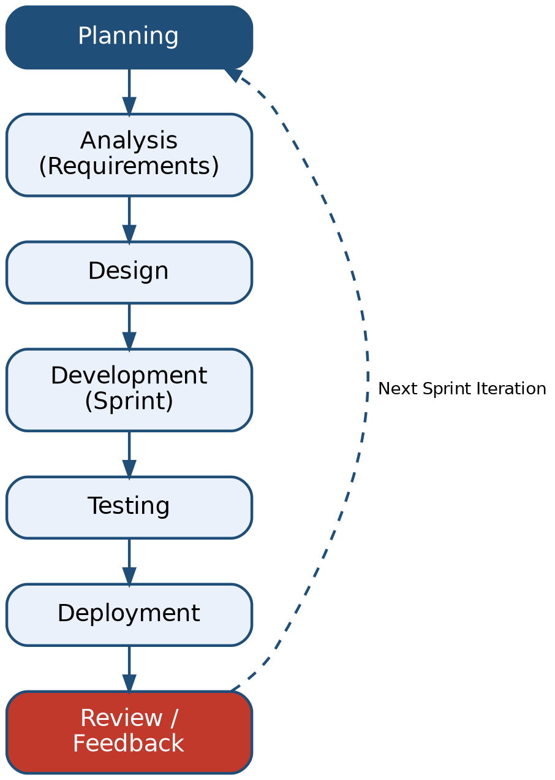
Figure 3.1: Agile SDLC Process adopted for TrustForge

3.3.2 Project Schedule
The project is scheduled over a period of nine months, from June 2026 to February 2027, structured into distinct but overlapping activity streams consistent with the Agile approach. Figure 3.2 presents the project schedule as a Gantt chart, indicating the duration of each major activity.
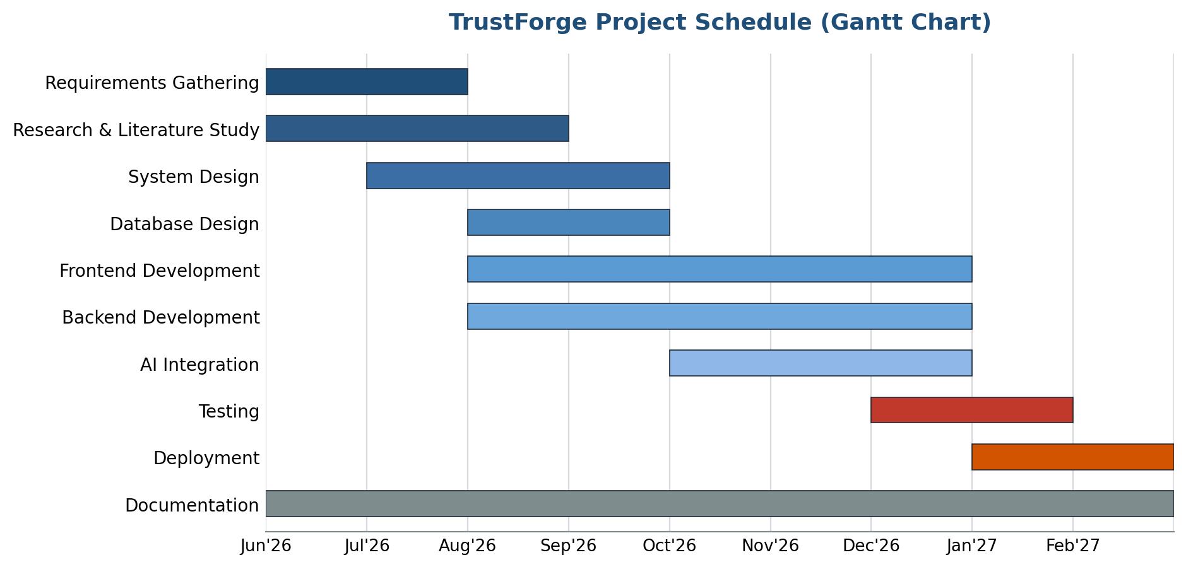
Figure 3.2: TrustForge Project Gantt Chart (June 2026 – February 2027)

3.4 Software and Hardware Requirements
The successful development and deployment of TrustForge requires a defined set of software tools and hardware resources. These requirements are summarised in Tables 3.4 and 3.5.
Table 3.4: Software Requirements
S. No. | Software / Tool | Purpose
1 | Windows 11 | Development operating system
2 | Visual Studio Code | Integrated development environment
3 | Node.js | JavaScript runtime for backend and tooling
4 | React.js | Frontend library for building the user interface
5 | Tailwind CSS | Utility-first CSS framework for styling
6 | Express.js | Backend web application framework
7 | Git | Distributed version control system
8 | GitHub | Remote repository hosting and collaboration
9 | Supabase | Managed PostgreSQL database and authentication service
10 | Postman | API testing and documentation tool
11 | Google Chrome | Primary browser for testing and debugging
Table 3.5: Hardware Requirements
S. No. | Component | Minimum Specification
1 | Processor | Intel Core i5 (or equivalent)
2 | RAM | 8 GB
3 | Storage | 256 GB SSD
4 | Network | Stable broadband internet connection
5 | Input Devices | Keyboard and mouse

3.5 Preliminary Product Description
TrustForge is organised into a set of well-defined functional modules, each responsible for a specific aspect of the compliance assessment workflow. Table 3.6 lists these modules along with a description of their purpose within the system.
Table 3.6: Module Description
Module | Description
Registration | Enables a new organisation to create an account by providing organisational and contact details along with secure login credentials.
Login | Authenticates returning users through Supabase Authentication, granting access to the organisation's dashboard and assessment history.
Dashboard | Presents a consolidated view of the organisation's current trust score, recent assessments, and outstanding recommendations.
Assessment Wizard | Guides the user through a structured, multi-step questionnaire covering the key obligations of the DPDP Act.
Website Scan | Automatically inspects a submitted website URL for cookie consent mechanisms, trackers, data collection forms, and privacy policy presence.
Trust Score | Computes and displays an objective compliance score derived from assessment responses and website scan results.
Reports | Generates a structured, downloadable PDF report summarising findings, the trust score, and prioritised recommendations.
Settings | Allows a user to configure account preferences, notification options, and organisational details.
Profile | Displays and allows editing of user and organisational profile information.
Admin Dashboard | Provides administrators with a platform-wide view of registered organisations, assessment volume, and system health.
Analytics | Presents aggregated statistics on common compliance gaps, score distributions, and platform usage trends.
User Management | Allows administrators to view, suspend, or otherwise manage registered user accounts.
System Monitoring | Tracks platform performance, scan job status, and error logs to support ongoing maintenance.

3.6 Conceptual Model
The conceptual model of TrustForge describes the logical flow of activity through the system from the perspective of both the end user and the platform administrator, as shown in Figures 3.3 and 3.4.

3.6.1 System Flow Diagram (User)
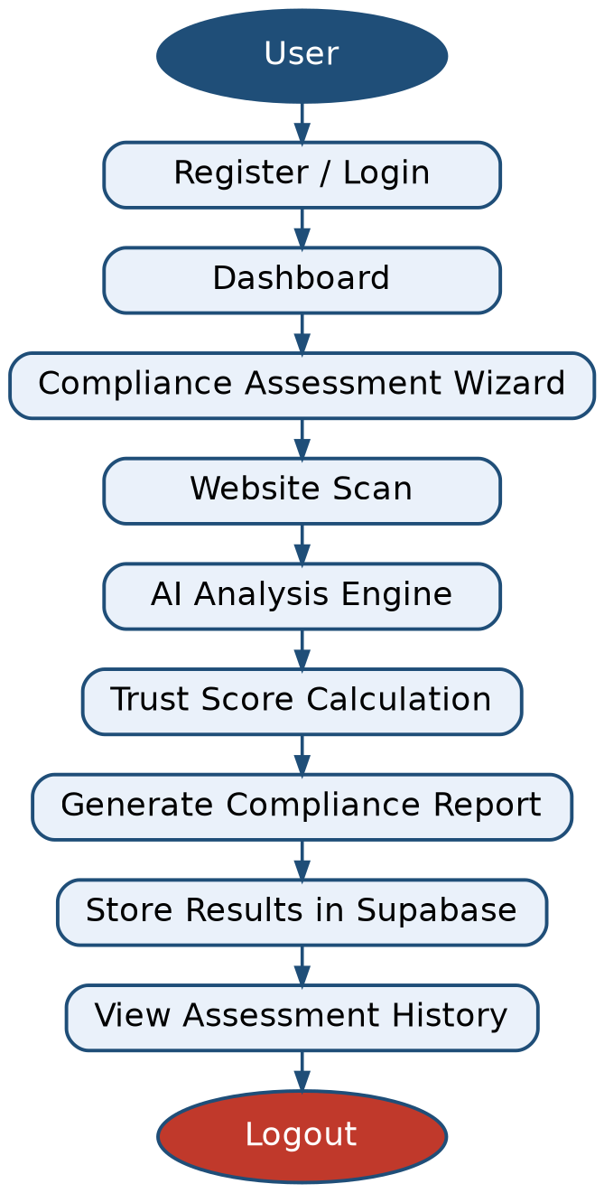
Figure 3.3: TrustForge User Flow Diagram

3.6.2 System Flow Diagram (Administrator)
In addition to the end-user flow, TrustForge defines a separate administrative flow that allows platform administrators to oversee registered organisations, monitor system-wide analytics, and maintain the operational health of the platform, as shown in Figure 3.4.
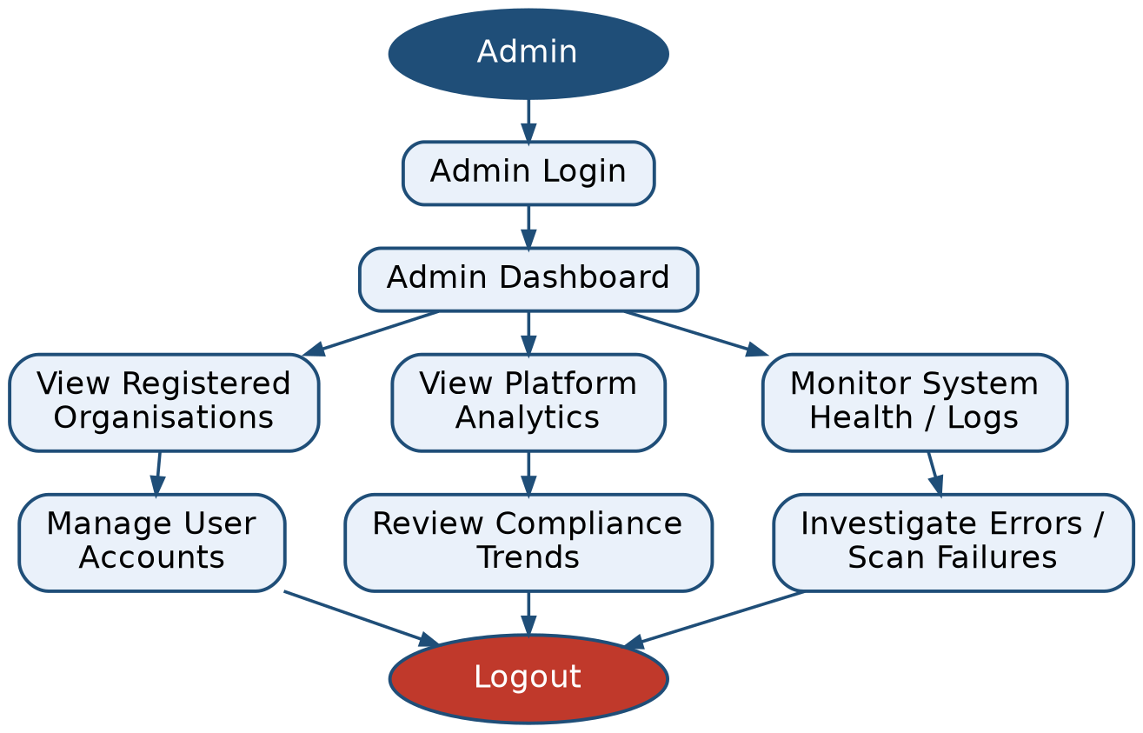
Figure 3.4: TrustForge Admin Flow Diagram
Together, the user flow and administrator flow illustrate how TrustForge separates the day-to-day compliance assessment activity performed by organisations from the oversight and monitoring responsibilities performed by platform administrators, while both flows converge on the same underlying Supabase data store, ensuring a single, consistent source of truth for the platform.

