GLA UNIVERSITY
Department of Computer Science & Engineering

TOPIC: MINI PROJECT SYNOPSIS ON
PAWCARE — PET ADOPTION & SERVICES PLATFORM (MERN STACK)
Submitted By | Submitted To
Name: Priya Chauhan | Faculty Name: Mr. Akash Kumar Choudhary
Id: 2415001192 | Master Trainer
Name: Prakhar Chaurasia
Id: 2415001130
Name: Mannat Rai (Leader)
Id: 2415000942
Name: Om Pathak
Id: 2415001072
Name: Prince Kumar Sharma
Id: 2415001187

DECLARATION
We, the undersigned students, hereby declare that the mini project titled “PawCare — Pet Adoption & Services Platform (MERN Stack)” is an original piece of work carried out by us as part of our academic curriculum, under the guidance of Mr. Akash Kumar Choudhary, Master Trainer. The work presented in this synopsis has not been submitted, in part or full, to any other institute or university for the award of any degree or diploma. All sources of information and assistance used in the preparation of this synopsis have been duly acknowledged.

Priya Chauhan (Roll No. 2415001192)
Prakhar Chaurasia (Roll No. 2415001130)
Mannat Rai (Roll No. 2415000942)
Prince Kumar Sharma (Roll No. 2415001187)
Om Pathak (Roll No. 2415001072)

ACKNOWLEDGEMENT
We would like to express our sincere gratitude to our faculty guide, Mr. Akash Kumar Choudhary, Master Trainer, for his valuable guidance, constant encouragement, and constructive feedback throughout the course of this mini project. His insights on clean coding practices, REST API design, and MERN stack development have been instrumental in shaping this synopsis.
We also extend our thanks to our institution for providing the resources and environment necessary to carry out this project, and to our peers for their support and helpful discussions during the planning of this work.

INDEX

S.NO | Topic
1 | Introduction / Abstract / Title
2 | System Requirements
3 | Hardware Requirements
4 | Front End and Back End
5 | Idea
6 | Objective
7 | Module Description
8 | Availability
9 | DFD 0 Level, 1 Level and 2 Level
10 | Bibliography
11 | References
1.1 Introduction / Abstract / Title

Project Title
PawCare – Pet Adoption & Services Platform (MERN Stack)

Animal shelters and independent rescuers across India care for large numbers of abandoned and stray animals every year, yet most of them rely on word-of-mouth, social media posts, or physical visits to connect an adoptable pet with a suitable home. At the same time, pet owners looking for grooming, vaccination, boarding, or training services for their animals often have no single trusted place to discover and book such services online. PawCare is proposed as a full-stack MERN (MongoDB, Express.js, React.js, Node.js) web application that brings pet adoption listings and pet-care service bookings together on one platform, built for an animal welfare startup.
1.2 About the Project
PawCare is a full-stack web platform built on the MERN stack (MongoDB, Express.js, React, and Node.js) designed for an animal welfare startup. The platform serves two core purposes: showcasing pets that are available for adoption, and enabling users to browse and book pet-care services such as grooming, veterinary check-ups, boarding, and training. The goal is to bridge the gap between shelters/rescuers and prospective pet owners, while also giving the organization a channel to promote its paid services and generate revenue that supports its welfare mission.
The application will feature a public-facing website where visitors can view adoptable pets with photos, breed, age, and health details, submit adoption requests, and book available services through an online scheduling system. An admin/staff dashboard will allow the organization to manage pet listings, track adoption applications, and manage service bookings. The system will be built following clean coding standards, RESTful API design principles, and will use Git/GitHub for version control and collaborative development across the team.

2. Primary Reason to Choose This Project
Animal welfare is a socially relevant cause, and many shelters still rely on manual, offline processes (phone calls, physical visit registers, and word-of-mouth) to manage adoptions and bookings, which limits their outreach. We chose this project because it combines a meaningful real-world problem with an opportunity to apply full-stack MERN development, REST API design, authentication, and database modelling in a single cohesive application. It also allows the team to practice collaborative software development using Git/GitHub, mirroring how real engineering teams work.

3. The Main Objective of the Project
The main objectives of the PawCare platform are to:
- Provide a centralized, easy-to-use website where adoptable pets can be listed with complete details and photographs.
- Allow visitors to search and filter pets by species, breed, age, size, and location.
- Enable users to submit and track adoption requests online instead of in person or over the phone.
- Allow users to discover and book pet-care services (grooming, vaccination, boarding, training) with a simple scheduling interface.
- Give shelter staff/admins a dashboard to manage pet listings, adoption applications, and service bookings efficiently.
- Build the system using REST API principles, secure authentication, and a clean, maintainable MERN codebase managed through Git/GitHub.
4. Scope of the Project

The scope of PawCare covers the design and development of a responsive web application usable by three types of users: general visitors/adopters, registered users, and administrators/staff. Visitors can browse pets and services without logging in, while registered users can submit adoption requests, book services, and track the status of their requests from a personal dashboard. Administrators can add, edit, or remove pet listings, manage service offerings, review and approve/reject adoption applications, and view booking schedules.
The current scope is limited to the web platform (desktop and mobile browsers) and does not include a native mobile application, though the responsive design will make the site usable on mobile devices. Payment gateway integration for paid services and real-time chat support are identified as potential future enhancements beyond the initial mini-project scope.

5. Working Methodology of the Project
The project will be developed using an iterative, module-wise approach. The team will first design the database schema in MongoDB for pets, users, adoption requests, and service bookings. Next, RESTful APIs will be built using Node.js and Express.js to handle CRUD operations, authentication, and business logic. The React front end will then be developed to consume these APIs, starting with the public pet-listing and service pages, followed by user authentication, the adoption/booking flow, and finally the admin dashboard.
The team will follow a modular folder structure separating client (React) and server (Node/Express) code, use environment variables for configuration, and maintain version control through a shared GitHub repository with feature branches and pull requests. Testing will be carried out at both the API level (using tools such as Postman) and the UI level, before the modules are integrated and deployed.

6. Details About the Hardware and the Software
System Requirements: -
Supported Operating System: -
- Windows
Software Required:
- Node.js (LTS version) and npm
- MongoDB / MongoDB Atlas
- Visual Studio Code
- Git and a GitHub account for version control
- Postman (for API testing)
- A modern web browser
Hardware Requirements: -
For Lighter Editors (e.g., VS Code/Eclipse-class workloads): -
- Processor: Intel core or equivalent
Listing Out Testing Technology
Frontend and Backend: -
Frontend:
- React.js, React Router, Axios, CSS/Tailwind for styling
Backend:
- Node.js, Express.js, MongoDB with Mongoose, JWT for authentication, REST APIs

7. Module Description

- User Module: Registration, login, profile management, and viewing adoption/booking history.
- Pet Listing Module: Displays adoptable pets with photos, breed, age, and health information; supports search and filters.
- Adoption Module: Allows users to submit adoption requests and enables admins to review, approve, or reject them.
- Services Module: Lists pet-care services (grooming, vaccination, boarding, training) with descriptions and pricing.
- Booking Module: Enables users to schedule service appointments and view booking status.
- Admin Module: Dashboard for managing pets, services, adoption requests, and bookings.
- Authentication & Authorization Module: Secures routes using JWT-based authentication, distinguishing between regular users and admins.

8. Availability
The PawCare platform will be made available as a web application accessible through any modern browser, targeted for deployment on a cloud hosting service (such as Render, Vercel, or Netlify for the frontend, and Render/Railway for the backend, with MongoDB Atlas for the database). This ensures the platform is available to shelters and adopters without requiring any local installation.

9. Data Flow Diagrams
DFD: - A data flow diagram (DFD) illustrates how data is processed by a system in terms of inputs and outputs. As its name indicates, its focus is on the flow of information — where data comes from, where it goes, and how it gets stored.

0 Level DFD (Context Diagram): - Represents the PawCare system as a single process interacting with external entities — Visitor/Adopter and Admin — exchanging data such as adoption requests, service bookings, and pet/service

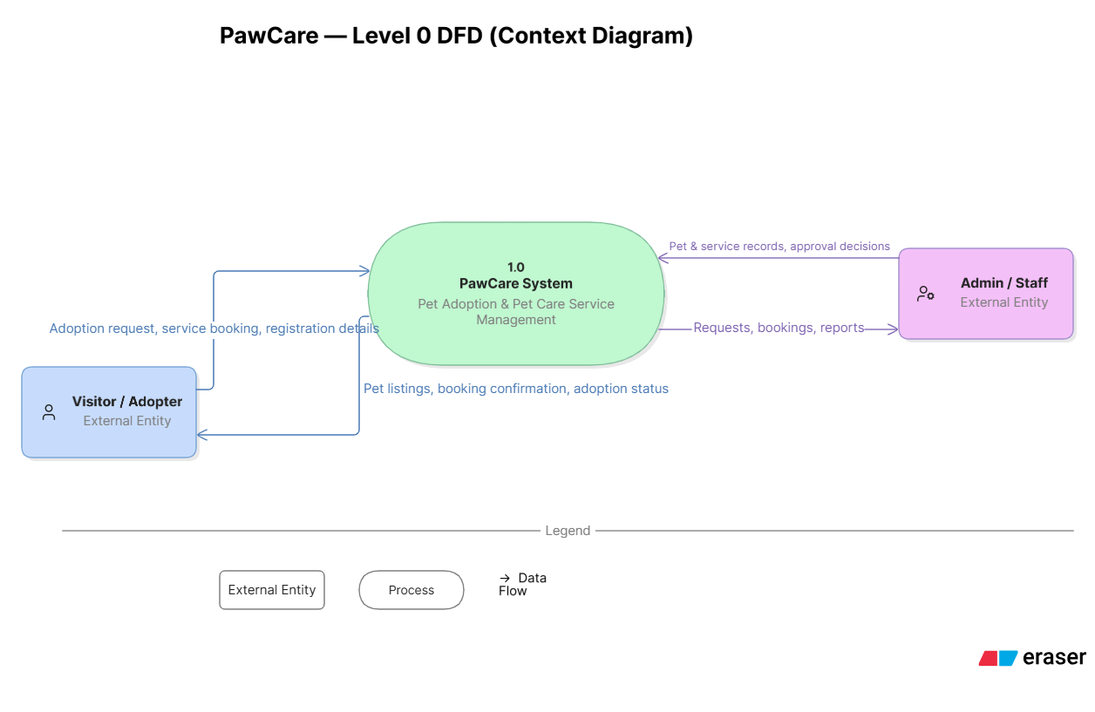

1 Level DFD: - Breaks the system down into major processes — User Authentication (1.0), Pet Listing Management (2.0), Adoption Request Handling (3.0), and Service Booking Management (4.0) — each reading from and writing to its own data store (D1 Users, D2 Pets, D3 Adoption Requests, D4 Services/Bookings).
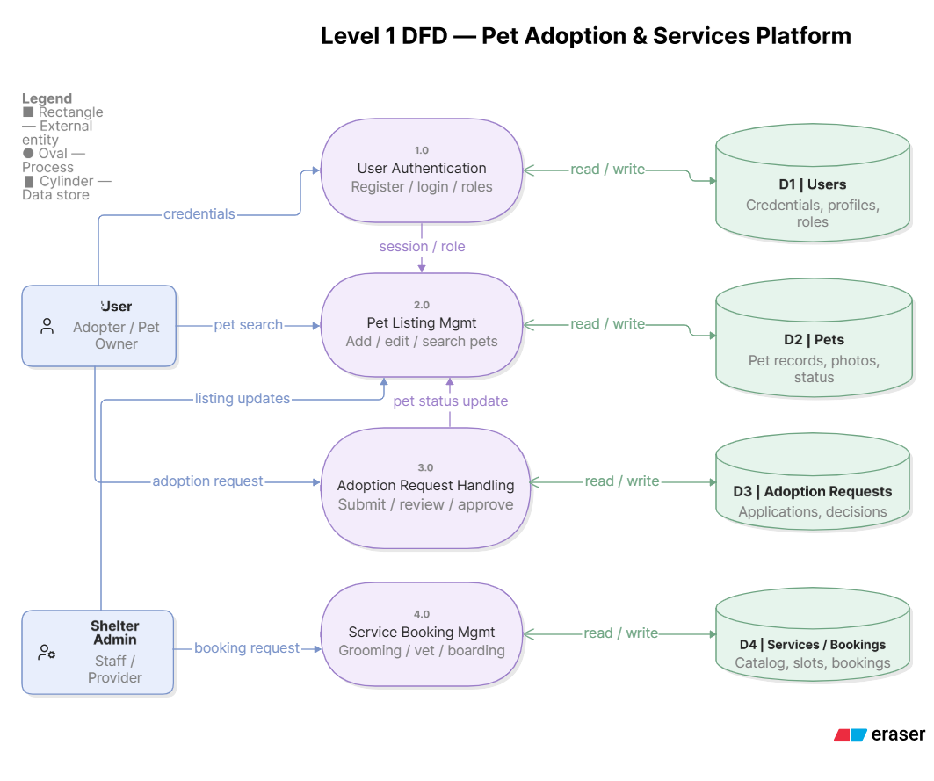

2 Level DFD: - Further decomposes the Adoption Request Handling process (3.0) into detailed sub-processes: Submit Request (3.1), Validate Request (3.2), Admin Review (3.3), and Status Notification (3.4), showing the precise flow of data between the visitor, the server logic, the data stores, and the admin.
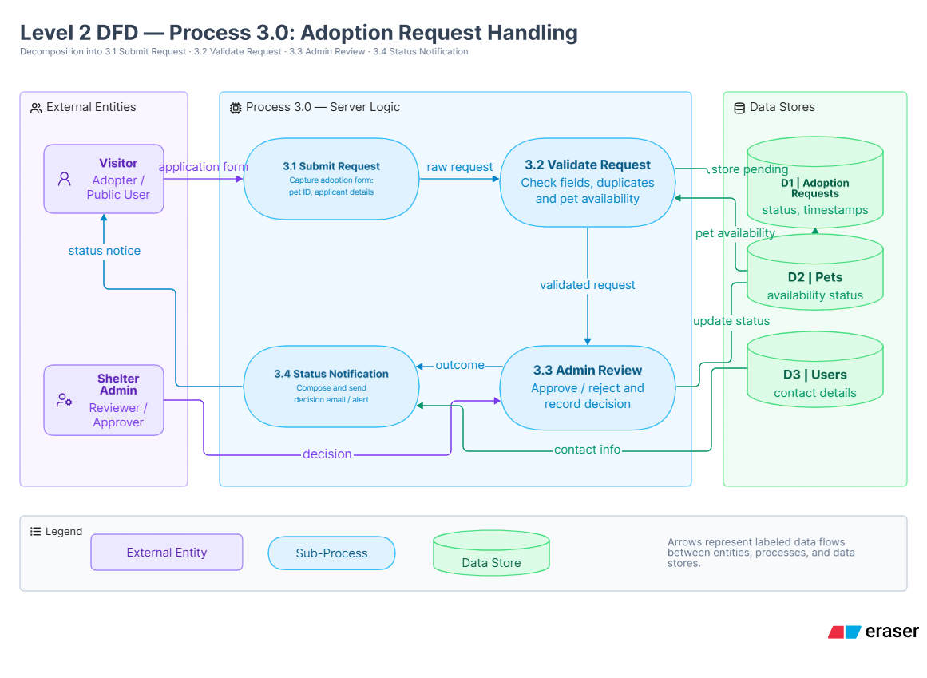

10. Bibliography
- MongoDB, Express.js, React, and Node.js official documentation
- Course materials and lecture notes on full-stack web development

11. References
- MongoDB Documentation — https://www.mongodb.com/docs/
- Express.js Documentation — https://expressjs.com/
- React Documentation — https://react.dev/
- Node.js Documentation — https://nodejs.org/en/docs/
- Mozilla Developer Network (MDN) — https://developer.mozilla.org/

