Analysis of Student Stress Before and During COVID-19

Mannat Rana and Benjamin Levine

# Table of Contents

**Introduction** **3**

**Literature Review** **3**

The Perceived Stress Scale 3

Stress at Universities 4

**Methodology** **5**

Survey Creation 5

Survey Distribution 5

Survey Questions 6

Survey Considerations 7

**Results** **7**

PSS Before and During COVID-19 7

Demographics 8

ASU Demographics 12

Social Experiences 15

Campus Involvement 18

Resource Utilization 21

**Discussion** **22**

**Conclusion** **24**

**Bibliography** **25**

**Appendix** **27**

Appendix A - Entry of Survey in the Barrett Polytechnic Digest 27

Appendix B - Entry of Survey in Barrett Newsletter 28

Appendix C - Survey Questionnaire 29

University and demographic information 29

November 2020 29

General one-month period before the pandemic 29

Appendix D - Full Results 31

PSS Before and During COVID-19 31

Demographics 32

ASU Demographics 45

Social Experiences 76

Campus Involvement 94

Resource Utilization 110

# Introduction

We present our findings on the result of the novel coronavirus (COVID-19) pandemic on the mental health of university students. University students have been affected by the pandemic financially and mentally, and, from our observations, this has resulted in elevated stress levels. We seek to determine if these stress changes are significant and if there are any strong correlating factors for perceived stress elevation. The basis of our study is consistent with the Perceived Stress Scale (Cohen, 1994) to provide a grounded analysis against an existing metric. This study seeks to answer the following research questions:

1. Is there a statistically significant stress differential in university students before and during the COVID-19 pandemic?
2. What factors are correlated to any stress changes?

To answer these questions, we conducted a survey with questions that would enable us to gain an understanding of student backgrounds and their associated stresses. As mentioned earlier, some of the questions were taken from the Perceived Stress Scale Questionnaire and used to calculate objectively the stress of students before and during COVID-19. Along with collecting demographic data, we were able to reach 228 students and obtain demographic information as well as their stress levels. We recruited participants through personal relationships, the local Barrett Polytechnic Digest, and the general Barrett Digest. The data was analyzed in SPSS and significant statistical relationships were found at a 95% confidence level.

# Literature Review

## The Perceived Stress Scale

To be able to measure stress levels on an objective scale, we selected the Perceived Stress Scale (PSS) as a way to be able to understand someone’s stress level using a simple 10 question survey (Cohen, 1994). The PSS scale is useful for two main reasons. Firstly, it is the primary scale used across existing literature that is focused around observing stress. Secondly, it provides a concise method for gauging stress levels with only 10 questions. The 10 questions are on a scale from 0 to 4 where 0 means never and 4 means very often. One example question is “In the last month, how often have you felt that things were going your way?” For someone who feels occasionally that things are not going their way, they could put a 2. Six out of the 10 questions are negatively coded, while 4 are positive. Once all 10 questions are answered, a summation formula can be used to calculate their score on the scale. The formula is to reverse the scores on the positive questions (4 becomes 0, 3 becomes 1, etc.), and then sum the numbers across each question. The maximum score someone can receive on the PSS is 40. While it does not encapsulate all mental health issues, the PSS provides an objective measure of stress that is consistent across subjects. A higher score means the subject is more stressed while a lower score means the subject is less stressed.

Scores on the Perceived Stress Scale have been noted to be higher for people of color (Sellers et al., 2003). When compared to White Americans, African Americans, Latino Americans, and Native Americans consistently score higher on the scale. On the other hand, Asian Americans perform similarly to White Americans on the scale. PSS Scores for Whites were averaged at 12.8, while Hispanics scored at 14.0 and Blacks scores at 14.7. Another deviation on the Perceived Stress Scale is with gender. Women consistently are observed to score higher on the Perceived Stress Scale than men (Barbosa-Leiker et al., 2012). Males averaged at 12.1 whereas women scored at 13.7. This difference occurs as women receive more negative feedback when compared to men, and are more likely to be impacted by global events than men (Nayak et al., 2019). We kept these differences in mind during our own research and were looking to see if these same patterns would hold true in our investigation.

## Stress at Universities

Since we were looking to perform the study on university students, we were looking for patterns in this group that have been observed on the Perceived Stress Scale. As a whole, university students were found to be higher on the Perceived Stress Scale than non-university adults of the same age (Denovan et al., 2017). Furthering our understanding of PSS Scores in the current environment, we also did research to see if we could find a pattern of people being more stressed since the beginning of the COVID-19 pandemic than beforehand. At least one early study indicated that PSS scores have gone up among universally all demographics (AlAteeq et al., 2020).

There appears to be a link between increased perceived stress with loneliness and depression (Besharat et al., 2020), as well as mental burnout (Guruprakash et al., 2018). Undergraduate students’ level of stress, anxiety, loneliness, and depression increased when compared to students who did not experience the COVID-19 pandemic (Elmer et al., 2020). We expect to see a correlation between increased perceived stress levels and students who utilized university resources to manage mental health.

Many colleges and universities developed online learning methods to accommodate students to COVID-19. Heading into the Fall 2020 semester, presidents from over half of public four-year institutions indicated their institutions had student mental health services and planned to invest more in such services as a result of the pandemic (Turk & Vigil, 2020). Access to mental health resources appears to have increased during the COVID-19 pandemic (Seidel et al., 2020). With universities investing more in student mental health services and access to such services increasing, we expect to see a higher rate of resource utilization for students to help manage elevated stress levels.

We see student involvement as a way to reduce perceived stress because it encompasses the recreational activities students are more likely to be invested in. Astin (1999) defines student involvement as the physical or psychological energy put into the academic experience (p. 522). He looks at how students use time as a resource and can lead to the behavioral development of students. Because there is a finite amount of time, students must define their time between recreation and academia. Institutional policies (course schedules, office hours, etc.) and nonacademic administrative decisions (building locations, on-campus employment opportunities, extracurricular activities, etc.) can impact the way students spend their time (p. 523). It is important to find a balance between both academic and nonacademic factors to maximize student time. If students focus too heavily on academia, they will spend less time doing recreational activities, or vice versa.

# Methods

## Survey Creation

Since we had no experience with survey creation, time had to be taken to learn proper survey methods such as question writing, distribution mediums, and invitational strategies. We paid attention to important question writing considerations such as avoiding bias, keeping a short length, and keeping the timeframe relevant (Dillman, 2008).

For our survey, keeping the timeframe relevant was crucial. Since we needed to make sure the “before” and “during” timeframes were the same length and were still within a reasonable memory retention range, we ultimately decided on November of 2020 as the “during” period since the survey was to be distributed in January of 2021. November of 2020 was the last full month of a semester during the pandemic. Since the survey was deployed January of 2021, we felt it would be best to ask about November 2020 as it would still be relatively fresh in the minds of respondents. We decided the “before” period would best be encapsulated by a general one-month period. Because the pandemic began almost a year before the survey’s distribution, we did not ask about a specific month because of how far it would be from someone’s memory. Instead, we ask for an approximation of what they did during a typical month before the pandemic began.

The questions were divided into 3 main categories. First was demographic information that included questions regarding semesters enrolled, school, and gender. Second were the ten questions that are used to calculate someone’s Perceived Stress Score. The survey questions concluded with a series of questions that explored the student's involvement in events, social life quantity, and use of campus resources.

Dillman (2008) noted that a survey’s distribution is vital for maximizing responses. Dillman emphasized that a survey needs to be quick, easy to take, easy to distribute, and friendly in order to garner as many respondents as possible as these features make it much more likely for someone to respond to the survey. As a result, much time was invested in looking at the best method of survey distribution for our application and population. After much deliberation, Google Forms was decided to be the best medium to support our survey distribution. There were a variety of arguments in favor of it. Google Forms has been used by Barrett Students conducting surveys quite consistently. We felt like it was a credible survey platform since we had noticed its effectiveness in other Barrett Students’ surveys. Another advantage is that it allowed us to limit the ability to respond since it had the ability to prevent a responder from responding by checking their email domain which allows us to restrict access to only ASU students. Finally, we observed that Google Forms has an effective conversion to an excel sheet which was critical to the success of our statistical analysis. As a result of these arguments, Google Forms was chosen as the survey medium.

## Survey Distribution

Regarding the distribution of the survey, the survey was distributed through three methods. First was using personal relationships, and this method involved mailing and texting close friends and peers to take the survey. This method allowed us to access students who were not necessarily members of the honors college (Barrett). The second method of distribution was through its placement in the ASU Polytechnic Barrett Digest. This method involved sending out an invitation message and attaching the survey link so that students could find it in the digest and take it when convenient to them. An image of the entry in the ASU Polytechnic Barrett Digest is in Appendix A.

The survey was in the ASU Polytechnic Barrett Digest for three consecutive weeks which were sent out on the following dates: January 11th, January 18th, and January 25th. Many of the responses gained from this method were students enrolled in Barrett who had Polytechnic as their main campus for their program.

The final method of survey deployment was the Barrett Digest that goes out to Barrett students on all campuses. An image of the entry is located in Appendix B. The entry was featured in the digest for two consecutive weeks that were deployed on January 18th and January 25th. Through this method we were able to reach students across all of the ASU campuses, and the main concentration of them were Barrett students.

## Survey Questions

The Questionnaire can be found in Appendix C.

This survey was split into five sections: (1) Introduction, (2) University and demographic information, (3) November 2020, (4) General one-month period before the pandemic, and (5) Conclusion. The Introduction section explains how the survey would be used to help understand how students’ mental health has been impacted by the pandemic and identifies the structure of the remaining sections. The university and demographic information section asks questions about the participant’s age, gender, and race, in addition to questions more specific to Arizona State University, like the number of semesters they have been enrolled at the university, whether or not they are a transfer or graduate student, their primary campus, and the schools or colleges they are affiliated with. The November 2020 section asks questions about student perceived stress and university/social involvement in the final month of the Fall 2020 semester. The general one-month period before the pandemic section includes many of the same questions as the previous section, but asks for approximate values before the pandemic. This section allows us to set a control measurement for average stress. This section allows students to reflect on how stressed they were before the pandemic as opposed to during it. The conclusion section thanks participants for their time and provides the researchers’ contact information for further questions or comments.

Beyond the Perceived Stress Scale, we asked short-answer questions in both sections to measure student involvement. These questions include how many friends the participant saw in-person, the number of friends seen over the internet, and the amount of events a participant attended. For the November 2020 section, we also ask how often video was on for events and classes (in cases where classes or events were held over Zoom). The final questions in these sections ask participants to indicate their familiarity with university resources that help students cope with stress (1-5 scale) and the amount of times they have used these resources (short answer).

## Survey Considerations

There are important considerations when creating the demographic questions for this survey. Options for gender included “Female”, “Male”, “Prefer not to say”, and “Other” to allow for all people to be represented. Race included checkboxes to allow for mixed-race participants, as well as “Prefer not to say” and “Other” to allow for all participants to feel comfortable answering this survey. Races were derived from the United States Census questionnaire (United States Census, 2020). Consistent with the United States Census, “Middle Eastern” is considered “White” for the purposes of this study. The schools and colleges of Arizona State University are consistent with the university’s website (Arizona State University, 2021) and participants checked all the schools they are affiliated with.

We sought to compare stress levels before and during the coronavirus pandemic to determine the status of mental health. Stress measurement is consistent with the Perceived Stress Scale (Cohen, 1994) and presented on a 1-5 Likert scale, with 1 associated with “Never” and 5 associated with “All the time”. We determined that this scaling might be more intuitive than the 0-4 system used in the initial reference. Since this scale is coded differently than the original version of the PSS scale, we made sure to shift the scale back when we began analyzing results.

# Results

We received responses from 228 participants from Arizona State University. Many tests were run across many variables to determine the difference in student stresses as a result of COVID-19 as well as attempting to find relationships and correlations that may suggest categories of groups that were more affected. All tests were conducted at a 95% confidence level. Short-answer responses needed to be filtered into numerical values in order to conduct these tests. Objective short-answer responses (i.e., “None”, “Two or three”, etc.) were converted to their numerical quantity, rounding to the highest number if given a range. Subjective short-answer responses (i.e., “A lot”, “A few”, etc.) were removed because they do not have a corresponding numerical value.

We outline five sections for these results: Demographics, ASU Demographics, Social Experiences, Campus Involvement, and Resource Utilization. The Demographics section discusses tests run based on general demographic information like gender and race. The ASU Demographics section discusses demographic information pertinent to ASU, such as time at the university, primary campus affiliation, and Honors involvement. The Social Experiences section discusses the correlation of friends with stress. The Campus Involvement section discusses the correlation of university events with perceived stress. The Resource Utilization section discusses the correlation between using campus resources for stress management and perceived stress. For a list of all findings, please see Appendix D.

## PSS Before and During COVID-19

We began by conducting a paired t-test between PSS before and during COVID-19 to determine if there was a significant difference in stress levels. Table 1 below shows the mean scores and standard deviations for the perceived stress levels before and during the coronavirus pandemic. We noticed that participants had an average stress of 15.1 in a typical one-month period before the pandemic and an average stress of 22.7 during November 2020. The mean difference of 7.5 is significant, indicating that there has been a difference in perceived stress as seen in Table 2 below. At a 95% confidence level, we expect perceived stress to increase by approximately 6.5 to 8.6 points.

### Table 1

#### Mean PSS scores before and during COVID-19

|  |  |  |  |
| --- | --- | --- | --- |
|  | **N** | **Mean** | **Std. Deviation** |
| **PSS Before COVID** | 228 | 15.1316 | 7.25556 |
| **PSS During COVID** | 228 | 22.6754 | 5.60052 |

### Table 2

#### Mean difference between PSS scores before COVID-19 and PSS during COVID-19

|  |  |  |  |  |
| --- | --- | --- | --- | --- |
|  | **Mean Difference** | **Std. Deviation** | **95% Confidence Interval** | **Significance** |
| **PSS Before vs. During COVID-19** | 7.54386 | 8.22925 | 6.46996 - 8.61776 | <0.001 |

## Demographics

We first look at the perceived stress of participants who identified as male and female in a typical one-month period before COVID-19, shown in Table 3. We omitted those who did not identify as male or female as their sample size was too small. Females had an average stress score of 15.6 and Males had an average stress of 13.6. This difference of 2.0 points is significant. At a 95% confidence level, females are between 0.2 and 3.8 points higher than males. During the pandemic, we see the perceived stress of females increase to 23.2 points and the score of males increase to 20.6, as shown in Table 4. The average difference between stress of females and males during the pandemic was 2.6, which was significant at a 95% confidence level.

### Table 3

#### Means between PSS scores before COVID-19 and PSS during COVID-19 for males and females

|  |  |  |  |  |  |
| --- | --- | --- | --- | --- | --- |
|  |  | **Before COVID-19** | | **During COVID-19** | |
|  | **N** | **Mean** | **Std. Deviation** | **Mean** | **Std. Deviation** |
| **Female** | 171 | 15.5789 | 5.54855 | 23.1871 | 6.85652 |
| **Male** | 47 | 13.5532 | 5.33165 | 20.5745 | 8.23235 |

### 

### Table 4

#### Mean difference between PSS scores before COVID-19 and PSS during COVID-19 for males and females

|  |  |  |  |
| --- | --- | --- | --- |
|  | **Mean Difference** | **95% Confidence Interval** | **Significance** |
| **Before COVID-19** | 2.02576 | 0.23937-3.81214 | 0.026 |
| **During COVID-19** | 2.61267 | 0.28463-4.9407 | 0.028 |

We present the results of ANOVA tests between Race and perceived stress before and during the coronavirus pandemic, as shown in Table 5 and Figure 1. Table 6 shows the mean PSS values for each race before and during COVID-19. At a 95% confidence level, we do not see a significant difference in perceived stress between race groups before or during COVID-19.

### Table 5

#### Means between PSS scores before COVID-19 and PSS during COVID-19 for racial groups

|  |  |  |  |
| --- | --- | --- | --- |
|  | **N** | **Mean Before COVID-19** | **Mean During COVID-19** |
| **White** | 133 | 14.4091 | 21.8421 |
| **Asian** | 36 | 14.7895 | 22.8333 |
| **Hispanic or Latino** | 22 | 16.0278 | 23.8333 |
| **Black or African American** | 6 | 17.3333 | 24.0455 |
| **Significance** |  | 0.45 | 0.82 |

### Figure 1

#### Means between PSS scores before COVID-19 and PSS during COVID-19 for racial groups

##### 

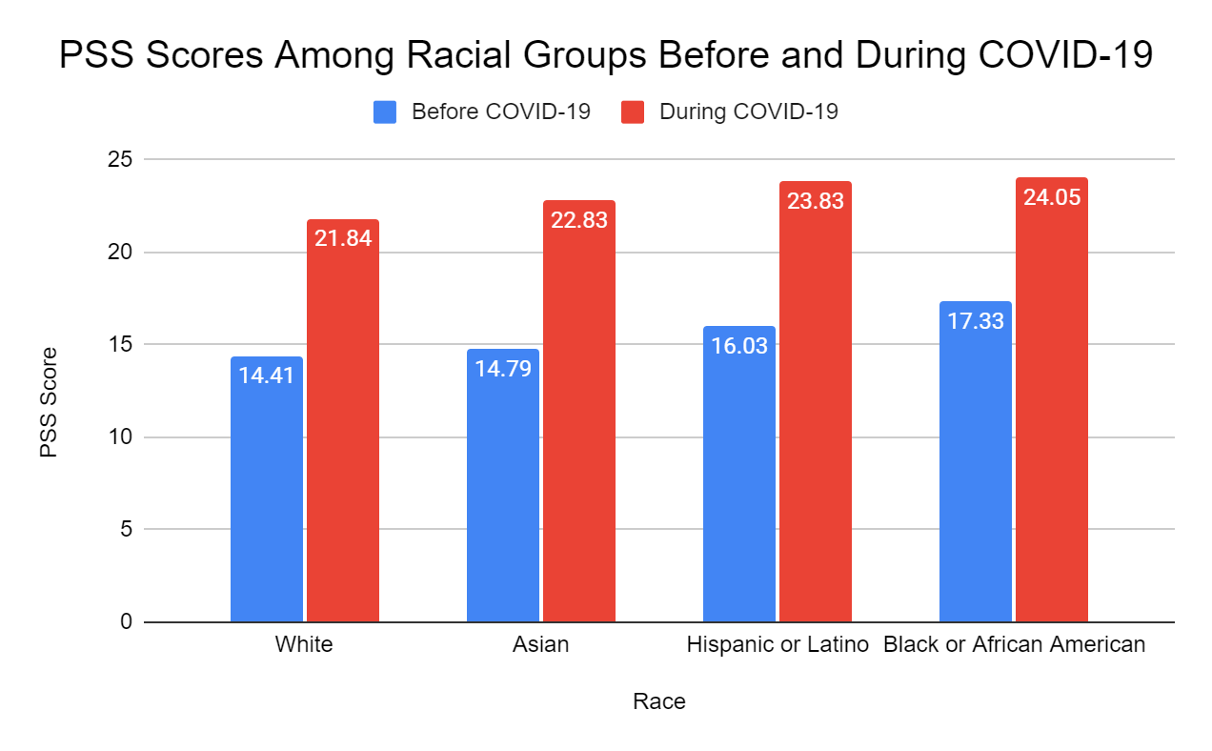

### 

### Table 6

#### Mean differences between PSS scores before and during COVID-19 for racial groups

|  |  |  |  |  |
| --- | --- | --- | --- | --- |
| **Race A** | **Race B** | **Mean Difference (A-B)** | **95% Confidence Interval** | **Sig.** |
| **Before COVID-19** | | | | |
| **White** | **Asian** | -1.2383 | -3.9578 - 1.4912 | 0.643 |
| **Hispanic or Latino** | 0.3804 | -2.9635 - 3.7243 | 0.991 |
| **Black or African American** | -2.5439 | -8.6074 - 3.5197 | 0.698 |
| **Asian** | **White** | 1.2383 | -1.4912 - 3.9678 | 0.643 |
| **Hispanic or Latino** | 1.6187 | -2.3130 - 5.5503 | 0.710 |
| **Black or African American** | -1.3056 | -7.7121 - 5.1009 | 0.952 |
| **Hispanic or Latino** | **White** | -0.3804 | -3.7243 - 2.9635 | 0.991 |
| **Asian** | -1.6187 | -5.5503 - 2.3130 | 0.710 |
| **Black or African American** | -2.9242 | -9.6156 - 3.7671 | 0.670 |
| **Black or African American** | **White** | 2.5439 | -3.5197 - 8.6074 | 0.698 |
| **Asian** | 1.3056 | -5.1009 - 7.7121 | 0.952 |
| **Hispanic or Latino** | 2.9242 | -3.7671 - 9.6156 | 0.670 |
| **During COVID-19** | | | | |
| **White** | **Asian** | -0.9912 | -4.4981 - 2.5156 | 0.884 |
| **Hispanic or Latino** | -2.2034 | -6.4995 - 2.0928 | 0.546 |
| **Black or African American** | -1.9912 | -9.7816 - 5.7991 | 0.911 |
| **Asian** | **White** | 0.9912 | -2.5156 - 4.4987 | 0.884 |
| **Hispanic or Latino** | -1.2121 | -6.2634 - 3.8391 | 0.925 |
| **Black or African American** | -1.0000 | -9.2310 - 7.2310 | 0.989 |
| **Hispanic or Latino** | **White** | 2.2034 | -2.0928 - 6.4995 | 0.546 |
| **Asian** | 1.2121 | -3.8392 - 6.2634 | 0.925 |
| **Black or African American** | 0.2121 | -8.3848 - 8.8091 | 1.000 |
| **Black or African American** | **White** | 1.9912 | -5.7991 - 9.7816 | 0.911 |
| **Asian** | 1.0000 | -7.2310 - 9.2310 | 0.989 |
| **Hispanic or Latino** | -0.2121 | -8.8091 - 8.3848 | 1.000 |

We also group Hispanic or Latino with Black or African American to conduct an independent t-test against White participants before and during COVID-19 shown in Tables 7 and 8. Asians were omitted as they are not considered a minority when it comes to college enrollment (National Center of Education Statistics, 2020). At a 95% confidence level, we do not see a significant difference in either timeframe even though their averages vary.

### Table 7

#### Mean PSS scores before and during COVID-19 for Whites vs Hispanics or Latinos and Blacks or African Americans

|  |  |  |  |  |  |
| --- | --- | --- | --- | --- | --- |
|  |  | **Before COVID-19** | | **During COVID-19** | |
|  | **N** | **Mean** | **Std. Deviation** | **Mean** | **Std. Deviation** |
| **White** | 133 | 14.7895 | 5.7182 | 21.8421 | 7.45577 |
| **Hispanic or Latino and Black or African American** | 28 | 15.0357 | 5.32974 | 24.0000 | 7.20082 |

### Table 8

#### Mean differences between PSS scores before and during COVID-19 for Whites vs Hispanics or Latinos and Blacks or African Americans

|  |  |  |  |
| --- | --- | --- | --- |
|  | **Mean Difference** | **95% Confidence Interval** | **Significance** |
| **Before COVID-19** | -0.24624 | -2.56812 - 2.07563 | 0.834 |
| **During COVID-19** | 2.61267 | -5.20210 - 0.88631 | 0.163 |

## ASU Demographics

We look at a quadratic relationship between perceived stress and semesters enrolled at ASU. For this test, we round all free responses indicating that a participant was beginning a semester to the last completed semester. At a 95% confidence level, we see a significant quadratic relationship between semester enrollment and perceived stress during COVID-19 which can be seen in Figure 2. The low r-squared value (0.036) indicates that this is a weaker relationship. This relationship is not statistically significant at a 95% confidence level before COVID-19.

### Figure 2

#### Quadratic correlation between semesters enrolled and PSS during COVID-19

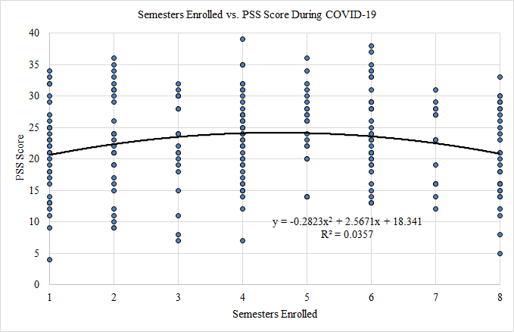

We also group semesters into years at ASU, with two semesters equating one academic year and note a quadratic relationship. At a 95% confidence level, we do not see a significant relationship before COVID-19 and see a significant relationship during the pandemic. Figure 10 shows the quadratic relationship between years and PSS during COVID-19. The low r-squared value (0.026) indicates that this is a weaker relationship as seen in Figure 3.

### Figure 3

#### Quadratic correlation between years enrolled and PSS during COVID-19

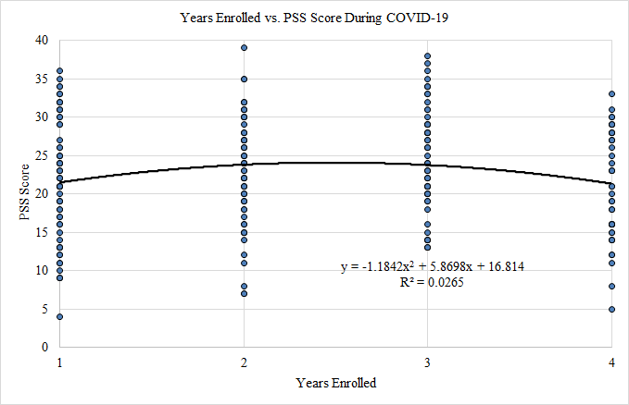

In a typical one-month period before the pandemic, average stress at the larger campus was 15.1 points and average stress at the smaller campuses was 15.3 points as seen in Table 9. When differentiating between campus size, “larger campus” category represents the Tempe campus as it holds a majority of on-campus ASU students. The “smaller campus” category is a collection of the less populated campuses at ASU which comprises the Polytechnic, West, and Downtown campuses. This difference of 0.2 points is not significant at a 95% confidence level. During COVID-19, the average stress was 22.1 points at the larger campus and 23.9 points at the smaller campuses as seen in Table 10. This difference of 1.8 points is not significant at a 95% confidence level, but its p-value of 0.09 could be significant at a lower confidence level.

### Table 9

#### Mean PSS scores for larger and smaller campuses before and during COVID-19

|  |  |  |  |  |  |
| --- | --- | --- | --- | --- | --- |
|  |  | **Before COVID-19** | | **During COVID-19** | |
|  | **N** | **Mean** | **Std. Deviation** | **Mean** | **Std. Deviation** |
| **Large Campus** | 156 | 15.0641 | 5.51090 | 22.1218 | 6.92387 |
| **Smaller Campuses** | 72 | 15.2778 | 5.82666 | 23.8750 | 7.84343 |

### 

### Table 10

#### Mean differences between PSS scores for larger and smaller campuses before and during COVID-19

|  |  |  |  |
| --- | --- | --- | --- |
|  | **Mean Difference** | **95% Confidence Interval** | **Significance** |
| **Before COVID-19** | -0.21368 | -1.78925 - 1.36189 | 0.79 |
| **During COVID-19** | -1.75321 | -3.88657 - 0.38016 | 0.09 |

We see the mean stress of non-Honors students as 15.5 points and Honors students as 15.0 points before the pandemic as seen in Table 11. This difference of 0.5 points is not significant at a 95% confidence level. During the pandemic, we see the perceived stress of non-Honors students as 23.6 points and the perceived stress of Honors students as 22.3 points as seen in Table 12. This difference of 1.3 points is not significant at a 95% confidence level.

### Table 11

#### Mean PSS scores for non-Honors and Honors students before and during COVID-19

|  |  |  |  |  |  |
| --- | --- | --- | --- | --- | --- |
|  |  | **Before COVID-19** | | **During COVID-19** | |
|  | **N** | **Mean** | **Std. Deviation** | **Mean** | **Std. Deviation** |
| **Non-Honors** | 62 | 15.4677 | 6.06175 | 23.5968 | 8.51125 |
| **Honors** | 166 | 15.0060 | 5.43222 | 22.3313 | 6.72344 |

### Table 12

#### Mean difference in PSS scores for non-Honors and Honors students before and during COVID-19

|  |  |  |  |
| --- | --- | --- | --- |
|  | **Mean Difference** | **95% Confidence Interval** | **Significance** |
| **Before COVID-19** | 0.46172 | -1.18338 - 2.10681 | 0.581 |
| **During COVID-19** | 1.20030 | -1.11883 - 3.64973 | 0.295 |

## Social Experiences

We first present the results of a linear correlation between friends seen in-person and its relationship to perceived stress before and during the pandemic. An outlier of 200 friends in a typical one-month period before the pandemic was removed because it is twice as high as the next closest responses. We see a p-value of 0.06, which is not statistically significant at a 95% confidence level. The graph can be seen in Figure 4. However, if we include this outlier or reduce the confidence level, it could be considered significant. Despite a low p-value, we also notice an r-squared value of 0.02, which shows a low correlation between friends seen in-person and perceived stress. During the pandemic, we see a p-value of 0.06, which is not statistically significant at a 95% confidence level but could be considered significant at a lower confidence level. This graph can be seen in Figure 5. The r-squared value for this correlation is 0.015, which indicates the data does not fit the linear model well. Both graphs show a negative slope, indicating that interacting with more friends in-person may lead to reduced stress.

### Figure 4

#### Linear correlation between Friends Seen In-Person and PSS before COVID-19

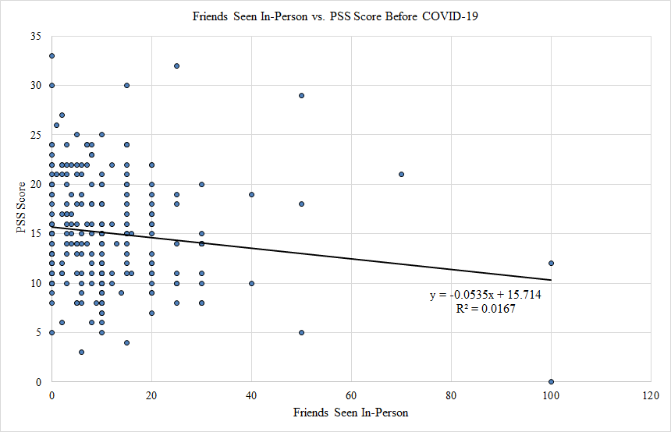

### Figure 5

#### Linear correlation between Friends Seen In-Person and PSS during COVID-19

##### 

We see five friends as a threshold both before and during COVID-19. Participants who saw fewer than five friends in-person before the pandemic had an average stress of 17.4 points while those who saw at least five friends averaged 14.5 points as seen in table 13. This difference of 2.9 points is significant at a 95% confidence level. At a 95% confidence level, we can expect that participants who saw at least five friends in-person are between 0.7 and 5.0 points less stressed than those who see fewer than five friends. Participants who saw fewer than five friends in-person during the pandemic averaged 23.4 points while those who saw at least five friends averaged 21.6 points as seen in Table 13. This difference of 1.8 points has a p-value of 0.08 as seen in Table 14 and is not statistically significant at a 95% confidence level but could be considered significant at a lower threshold. We are 95% confident that the mean difference in stress is reduced between -0.2 and 3.7 points if participants saw at least five friends in-person during the coronavirus pandemic.

### 

### Table 13

#### Mean PSS scores before and during COVID-19 for friends seen in-person

|  |  |  |  |
| --- | --- | --- | --- |
|  | **N** | **Mean** | **Std. Deviation** |
|  | **Before COVID-19** | | |
| **Fewer than 5 Friends** | 31 | 17.3871 | 5.20050 |
| **At least 5 Friends** | 151 | 14.5166 | 5.62714 |
|  | **During COVID-19** | | |
| **Fewer than 5 Friends** | 140 | 23.3857 | 7.24155 |
| **At least 5 Friends** | 85 | 21.6353 | 7.25036 |

### Table 14

#### Mean difference in PSS scores before and during COVID-19 for friends seen in-person

|  |  |  |  |
| --- | --- | --- | --- |
|  | **Mean Difference** | **95% Confidence Interval** | **Significance** |
| **Before COVID-19** | 2.87054 | 0.70789 - 5.03319 | 0.010 |
| **During COVID-19** | 1.75042 | -0.21276 - 3.7136 | 0.080 |

## Campus Involvement

This section will discuss the correlation between event attendance and perceived stress. We first present the findings of independent t-tests between event attendance and perceived stress before and during the coronavirus pandemic. We then look at how video may be correlated with perceived stress during the pandemic, as online events were considered negligible before COVID-19.

We again see 5 as a threshold for event attendance before and during the coronavirus pandemic, with 0 representing the participants who attended fewer than five events and 1 representing the participants who attended at least five events. Before the pandemic, we see participants who attended fewer than five events in a one-month period had an average stress of 15.8 points while those who attended at least five events had an average of 14.1 as seen in Table 15. This difference of 1.7 points is not considered significant at a 95% confidence level but its p-value of 0.06 as seen in Table 16 could be significant at a lower confidence. At a 95% confidence interval, the participants who attended at least five events had a reduced stress between 0.0 and 3.5 points. During the pandemic, participants who attended fewer than five events had an average stress of 23.1 points while those who attended at least five had an average stress of 20.5 points as seen in Table 15. This difference of 2.6 points is statistically significant at a 95% confidence level. At a 95% confidence interval, participants who attended at least five events during November 2020 reduced their stress between 0.0 and 5.3 points.

### 

### Table 15

#### Means of PSS scores before and during COVID-19 for events attended for less than and at least 5

|  |  |  |  |
| --- | --- | --- | --- |
|  | **N** | **Mean** | **Std. Deviation** |
| **Before COVID-19** | | | |
| **Did not use Resources** | 188 | 14.8085 | 5.76598 |
| **Used Resources** | 26 | 17.1538 | 4.49615 |
| **During COVID-19** | | | |
| **Did not use Resources** | 189 | 21.9365 | 7.16271 |
| **Used Resources** | 31 | 25.8065 | 6.06311 |

### Table 16

#### Mean Difference of PSS scores before and during COVID-19 for events attended for less than and at least 5

|  |  |  |  |
| --- | --- | --- | --- |
|  | **Mean Difference** | **95% Confidence Interval** | **Significance** |
| **Before COVID-19** | 1.72445 | -0.04950 - 3.49839 | 0.057 |
| **During COVID-19** | 2.67135 | 0.00909 - 5.33361 | 0.049 |

##### 

We now look at correlation between video at events and perceived stress during COVID-19. Removing outliers of 80 and 100, we see a linear correlation between the quantity of events where participants had their video on and perceived stress levels as seen in Figure 6. This line is significant at a 95% confidence level, though the r-squared value of 0.026 indicates that there is very weak correlation in this relationship.

### Figure 6

#### Linear correlation between Video Events Attended and PSS during COVID-19

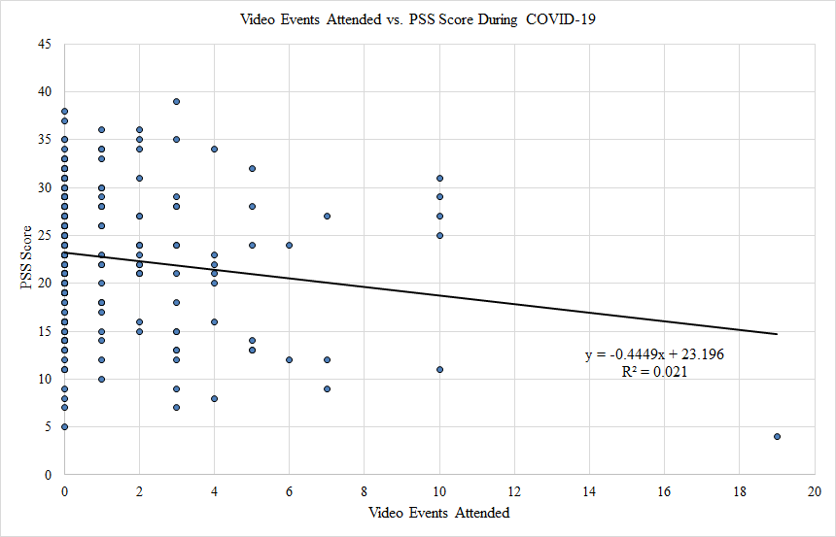

We also conducted an independent t-test to determine how the quantity of events participants had their video on correlates with stress levels. In the following results, 0 refers to participants who had their video on for fewer than three events and 1 refers to those who had their video on for at least three events. The average stress for participants who had their video on for fewer than three events was 23.3 and the average stress for those who had their video on for at least three events was 20.3 as seen in Table 17. This difference of 3.0 points is significant at a 95% confidence level. At a 95% confidence interval, participants who had their video on for at least three events reduced their stress 0.5 and 5.5 points as seen in Table 18.

### Table 17

#### Mean PSS scores during COVID-19 for video events attended for less than and at least 3

|  |  |  |  |
| --- | --- | --- | --- |
|  | **N** | **Mean** | **Std. Deviation** |
| **Fewer than 3 Video Events** | 145 | 23.3241 | 6.83220 |
| **At least 3 Video Events** | 42 | 20.3095 | 8.77215 |

### 

### Table 18

#### Mean Difference of PSS scores during COVID-19 for video events attended for less than and at least 3

|  |  |  |  |
| --- | --- | --- | --- |
|  | **Mean Difference** | **95% Confidence Interval** | **Significance** |
| **PSS for at least 3 Video Events** | 3.01461 | 0.07471 - 5.95452 | 0.045 |

## Resource Utilization

This section will discuss how resource utilization for stress management relates to perceived stress levels. For the following tests, 0 refers to participants who did not use campus resources and 1 refers to those who used campus resources. Before the pandemic, we see students who did not use resources had an average stress of 14.8 points and those that used resources had an average stress of 17.2 points as seen in Table 19. This difference of 2.4 points is significant at a 95% confidence level. At a 95% confidence interval, we notice participants who used campus resources tended to be between 0.0 and 4.7 points higher than those who did not use resources. During COVID-19, participants who did not use resources had an average stress of 21.9 points and those who used resources had an average stress of 25.8 points as seen in Table 19. This difference of 3.9 points is significant at a 95% confidence level. At a 95% confidence interval, participants who used campus resources tended to be between 1.2 and 6.5 points higher than those who did not use resources as seen in Table 20.

### Table 19

#### Mean PSS scores before and during COVID-19 for use and no use of campus resources

|  |  |  |  |
| --- | --- | --- | --- |
|  | **N** | **Mean** | **Std. Deviation** |
|  | **Before COVID-19** | | |
| **Did not use Resources** | 188 | 14.8085 | 5.76598 |
| **Used Resources** | 26 | 17.1538 | 4.49615 |
|  | **During COVID-19** | | |
| **Did not use Resources** | 189 | 21.9365 | 7.16271 |
| **Used Resources** | 31 | 25.8065 | 6.06311 |

### Table 20

#### Mean Difference of PSS scores before and during COVID-19 for use and no use of campus resources

|  |  |  |  |
| --- | --- | --- | --- |
|  | **Mean Difference** | **95% Confidence Interval** | **Significance** |
| **Before COVID-19** | -2.34534 | -4.66793 - .0.02274 | 0.048 |
| **During COVID-19** | -3.86994 | -6.55160 - -1.18829 | 0.005 |

# Discussion

The data are able to show the presence of patterns already discussed in literature while finding patterns that exist in more niche areas that are lesser known such as the parabolic relationship between enrollment time and stress as well as the higher levels of stress with students who use campus resources. We can say that COVID-19 has had a negative mental impact on students because we have shown that there is a statistically significant difference in Perceived Stress Scale responses from before and during the pandemic. The interesting note about this data point is the size of the increase. The average increase in stress during the pandemic was 7.5 points at a 95% confidence level. Considering the average student’s stress was 15 points before the pandemic, the increase of stress is around 50%, which is unexpected. This point possibly illustrates the magnitude of the spike in stress and mental health problems that are arising in students as a result of the pandemic. Many students have had to move back home, lost jobs, and dealt with the lackluster ability to connect with professors over the internet. These problems may have had an impact on mental stress, and can be observed in the above results. This further supports existing research that demonstrates the elevated levels of stress among university students (Denovan et al., 2017) as well as elevated levels of stress with the presence of the COVID-19 pandemic (AlAteeq et al., 2020).

The differences in PSS scores between genders further reinforces the difference in stress experienced by women when compared to men. Since the PSS difference was significant both before and during the pandemic, it can be assumed that women, regardless of time period, are more stressed than men. A noticeable option is while women were continuously less stressed than men, the difference was exaggerated by the pandemic by 0.6 points. Since the pre-existing differences were around 2 points, the increase in the difference in stress between the genders increased nearly 30%. This data point could argue that women were harder hit by the pandemic, supporting the concept that women are more impacted by global events (Nayak et al., 2019).

We found no significant differences between racial stress which has been observed in previous studies (Sellers et al., 2003). Neither the ANOVA test or the t-test showed any significant difference in PSS among the different racial groups before or during COVID-19. However, we believe this to be due to the small sample size of the minority groups. For example, Black or African American and Native American responses each group had a sample size less than 10, which leads us to believe that the small sample size is a primary reason for inconsistency with existing literature. With a larger sample size, we expect to see some significance in PSS scores between White and minority groups. The reason for this is that the analysis performed utilized an independent t-test. The equation for independent t-test involves the sample size. By having a smaller sample size, the results of the t-test cause the p values to increase resulting in less significant results. By having a larger sample size, we can decrease the value of p and cause our results to be more significant.

The parabolic correlation between the time spent in the university and PSS score is an interesting point. It shows that the second and third year of university is most stressful as opposed to first and fourth. Furthermore, we were able to show that this parabolic relationship is statistically significant as a 95% confidence level. We believe that this pattern occurs as a result of the depth of the classes generally covered each year. First year students usually take general classes that cover surface-level material of a subject, while having more development support systems. Many first year students live in residence halls where friends are only doors away, and finding other students with similar issues is much easier. Second and third year classes take a much deeper dive at the niches that exist in subjects which is much more complex. Finally, fourth year students are generally enrolled in lesser class loads and are taking more multidisciplinary courses. As a result, it is common belief on the ASU campuses that the second and third year is the hardest. Being able to see this pattern in the data thus reinforces that belief.

We did not see a significant difference in PSS scores between campus size or Honors students. One of the smaller campuses had an apparent increase in average PSS score, but the sample size was less than 10 and the responses could be the result of such a small sample. We also consider that campus affiliation has no impact on stress. Although Honors students appear to be more likely to have higher levels of student involvement (Astin, 1999), we do not see a significant stress difference between Honors and non-Honors students. This shows that honors enrollment does not appear to have an impact on perceived stress before or during COVID-19.

Another relationship that was hypothesized would exist but was not statistically significant was the amount of friends seen in-person versus PSS. We predicted that seeing friends would result in decreased stress, so we should see a negative correlation between these two variables. While it was not statistically significant at a 95% level, it is at a 90% level. We believe that there is a high likelihood that a repeated trial could find this relationship significant at a 95% level because much of the sample size for this relationship had to be eliminated because of subjective short-answer responses (i.e., “A lot”, “A few”, etc.). Therefore, we believe that this relationship most likely does exist, and could be found in a better phrased questionnaire.

We also note that increased student involvement appears to result in decreased PSS scores. Furthermore, since video was also seen to correlate to a decrease in stress, being involved in campus activities engaged with video corresponded to reduced stress scores even further than just the attendance. During COVID-19, many students were unable to meet with their friends in-person, and as a result many people have felt isolated (AlAteeq et al., 2020). Attending events presents many students with the ability to interact with friends while creating new ones. Furthermore, having a video on can help increase the amount of interaction or engagement one may have in an online setting.

Finding a difference in stress between students who used campus resources for stress management and those who didn’t was able to lead to two arguments regarding stress levels of those who use these resources. The arguments are that either (1) students are more stressed and thus using these resources or (2) that the use of the resources is giving them added stress. We are not stating that elevated levels of stress are caused by using campus resources, we are only stating that using campus resources is correlated with higher levels of stress. We believe that the increased funding and greater access to mental health resources has allowed more students to seek help if they experience higher levels of stress.

# 

# Conclusion

Through our research, we were able to prove many of the relationships and trends that have been observed in stress levels such as gender and university stress. We were also able to uncover more relationships that have not been as noticed in literature, such as the parabolic relationship between academic standing and stress as well as the use of video presence in university events having an effect on stress levels. We also were unable to prove well known relationships such as the enhanced stress levels that are observed with minority racial groups.

In a future study we would like to work on increasing sample sizes among several categories. The two main categories that would have yielded potential results is primary campus and race. In the future, reaching out to more students in minorities by attending minority coalition meetings or reaching out to minority clubs would be beneficial in potentially achieving more significant results. Furthermore, trying to access more localized newsletters for each campus would help in bringing in larger samples for each campus where a potential stress difference could be discovered.

In terms of survey design, several changes could be made to improve the usefulness of the data collected. A major problem that was encountered was that some questions had short answer inputs. As a result, many respondents used subjective terms in their responses. For example, some responses for questions asking for the amount of friends seen in-person were “Most”, “only those in my sorority”, and “some.” As these are too subjective to put a numerical value to, we had to omit them during the analysis. This loss of data may have reduced the amount of potential relationships we could have discovered due to the decreased sample size.

# 

# Bibliography

AlAteeq, D. A., Aljhani, S., & AlEesa, D. (2020, October). Perceived stress among students in virtual classrooms during the COVID-19 outbreak in KSA. *Journal of Taibah University Medical Sciences*, *15*(5), 398-403. https://doi.org/10.1016/j.jtumed.2020.07.004

Arizona State University. (2021). *Schools and Colleges*. admissions.asu.edu. https://admission.asu.edu/academics/schools

Astin, A. W. (1999). Student involvement: A developmental theory for higher education. *Journal of College Student Development*, *40*(5), 518-529.

Barbosa-Leiker, C., Kostick, M., Lei, M., McPherson, S., Roper, V., Hoekstra, T., & Wright, B. (2012, October 2). Measurement Invariance of the Perceived Stress Scale and Latent Mean Differences across Gender and Time. *Stress & Health*, *29*(3), 253-260. https://doi.org/10.1002/smi.2463

Besharat, M.-A., Khadem, H., Zarei, V., & Momtaz, A. (2020, January). Mediating role of perceived stress in the relationship between facing existential issues and symptoms of depression and anxiety. *Iranian Journal of Psychiatry*, *15*(1), 80-87. US National Library of Medicine. https://www.ncbi.nlm.nih.gov/pmc/articles/PMC7193236/

Cohen, S. (1994). *Perceived Stress Scale*. North Ottawa Wellness Foundation. Retrieved March 18, 2021, from https://www.northottawawellnessfoundation.org/wp-content/uploads/2018/04/PerceivedStressScale.pdf

Denovan, A., Dagnall, N., Dhingra, K., & Grogan, S. (2017, June 22). Evaluating the Perceived Stress Scale among UK university students: implications for stress measurement and management. *Studies in Higher Education*, *44*(1), 120-133. https://doi.org/10.1080/03075079.2017.1340445

Dillman, D. A. (2008). *Internet, Mail, and Mixed-Mode Surveys: The Tailored Design Method* (3rd ed.). Wiley.

Elmer, T., Mepham, K., & Stadtfeld, C. (2020, July 23). Students under lockdown: Comparisons of students' social networks and mental health before and during the COVID-19 crisis in Switzerland. *PLoS ONE*, *15*(7). https://doi.org/10.1371/journal.pone.0236337

Guruprakash, K. V., Mehta, S. G., Atul, B., Prakash, J., Divinakumar, K. J., Khan, S. A., & Patra, P. (2018). A study of the relationship between perceived stress, coping pattern, burnout, and general psychopathology among the postgraduate medical students. *Industrial Psychiatry Journal*, *27*(1), 141-146. US National Library of Medicine. 10.4103/ipj.ipj_20_18

National Center of Education Statistics. (2020, May 19). College Enrollment Rates. *The Condition of Education 2020*, 1-3. <https://nces.ed.gov/programs/coe/pdf/coe_cpb.pdf>

Nayak, A. S., Parkar, S. R., Nachane, H. B., Sangoi, B. A., & Shinde, R. G. (2019). Gender variability of perceived stress and negative inferential feedback in depression. *Indian Journal of Psychological Medicine*, *41*(1), 331-337. US National Library of Medicine. https://dx.doi.org/10.4103%2FIJPSYM.IJPSYM_343_18

Seidel, E. J., Mohlman, J., Basch, C. H., Fera, J., Cosgrove, A., & Ethan, D. (2020, August 7). Communicating mental health support to college strudents during COVID-19: An exploration of website messaging. *Journal of Community Health*, *45*, 1259-1262. https://doi.org/10.1007/s10900-020-00905-w

Sellers, R. M., Caldwell, C. H., Schmeelk-Cone, K. H., & Zimmerman, M. A. (2003). Racial Identity, Racial Discrimination, Perceived Stress, and Psychological Distress among African American Young Adults. *Journal of Health and Social Behavior*, *44*(3), 302-317. https://doi.org/10.2307/1519781

Turk, J., & Vigil, D. (2020, April 23). *College and university presidents respond to COVID-19: April 2020 survey*. American Council on Education. https://www.acenet.edu/Research-Insights/Pages/Senior-Leaders/College-and-University-Presidents-Respond-to-COVID-19-April-2020.aspx

United States Census. (2020, October 16). *About Race*. census.gov. https://www.census.gov/topics/population/race/about.html

# 

# Appendices

## Appendix A - Entry of Survey in the Barrett Polytechnic Digest

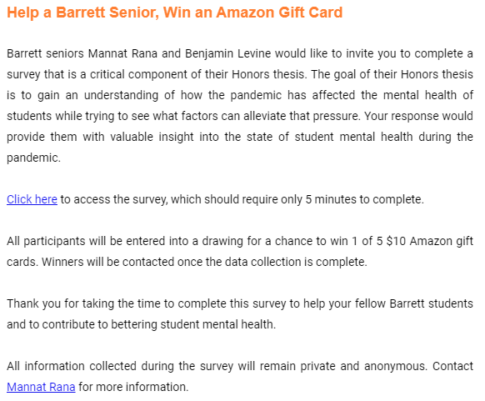

## Appendix B - Entry of Survey in Barrett Newsletter

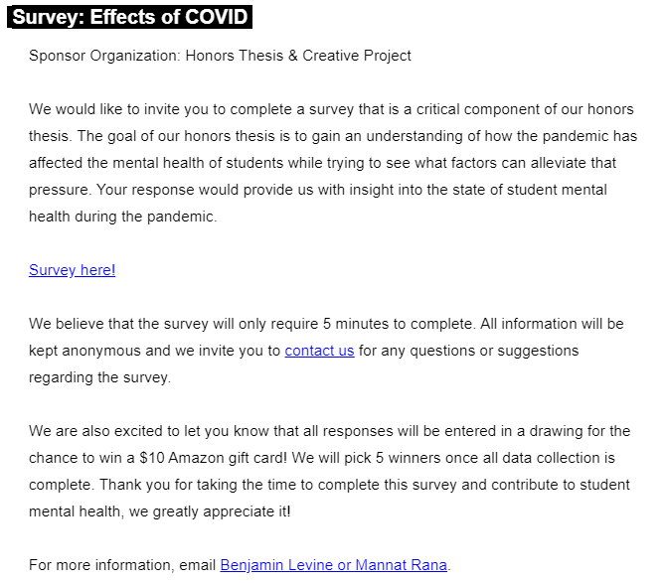

## 

## Appendix C - Survey Questionnaire

### University and Demographic Information

1. What is your age?
2. How many semesters have you been studying at ASU?
3. Are you a transfer student?
4. Are you a graduate student?
5. What is your primary campus?
6. What schools/colleges at ASU are you a part of? Check all that apply.
7. What is your gender?
8. What is your race?

### November 2020

1. How often did you feel upset because of something that happened unexpectedly?
2. How often did you feel that you were unable to control the important things in your life?
3. How often did you feel nervous and “stressed”?
4. How often did you feel confident about your ability to handle your personal problems?
5. How often did you feel that things were going your way?
6. How often did you find that you could not cope with all the things that you had to do?
7. How often could you control irritations in your life?
8. How often did you feel that you were on top of things?
9. How often were you angered because of things that were outside of your control?
10. How often did you feel difficulties were piling up so high that you could not overcome them?
11. How many friends did you see in-person?
12. How many friends did you see over the internet?
13. How many university-sponsored events did you attend?
14. How many times did you have your video on for events?
15. How many times did you have your video on for class?
16. How familiar were you about university resources that help students cope with stress and anxiety?
17. How many times did you use university resources to help you with stress and anxiety?

### General one-month period before the pandemic

1. How often did you feel upset because of something that happened unexpectedly?
2. How often did you feel that you were unable to control the important things in your life?
3. How often did you feel nervous and “stressed”?
4. How often did you feel confident about your ability to handle your personal problems?
5. How often did you feel that things were going your way?
6. How often did you find that you could not cope with all the things that you had to do?
7. How often could you control irritations in your life?
8. How often did you feel that you were on top of things?
9. How often were you angered because of things that were outside of your control?
10. How often did you feel difficulties were piling up so high that you could not overcome them?
11. How many friends did you see in-person?
12. How many friends did you see over the internet?
13. How many university-sponsored events did you attend?
14. How familiar were you about university resources that help students cope with stress and anxiety?
15. How many times did you use university resources to help you with stress and anxiety?

## 

## Appendix D - Full Results

### PSS Before and During COVID-19

Paired T-Test Between PSS Before vs. During COVID-19

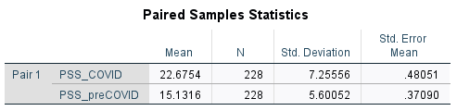

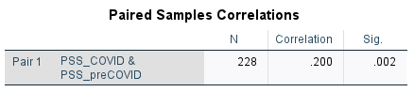

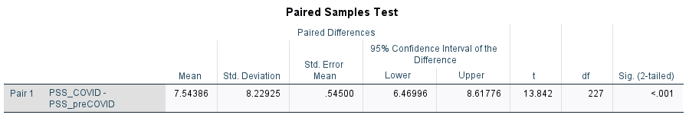

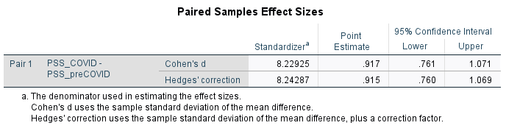

### 

### Demographics

Independent T-Test Between Female vs. Male Students and PSS Before COVID-19

0 refers to Female; 1 refers to Male

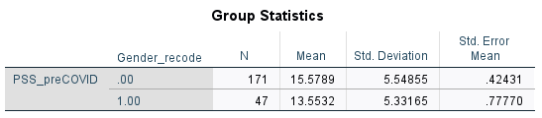

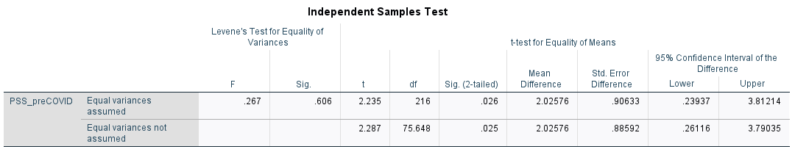

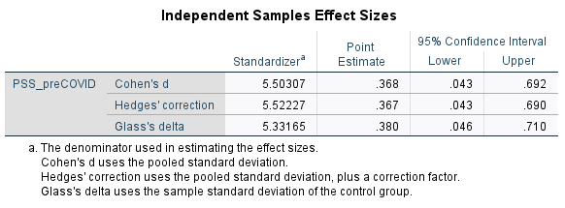

Independent T-Test Between Female vs. Male Students and PSS During COVID-19

0 refers to Female; 1 refers to Male

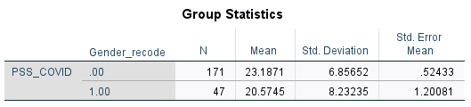

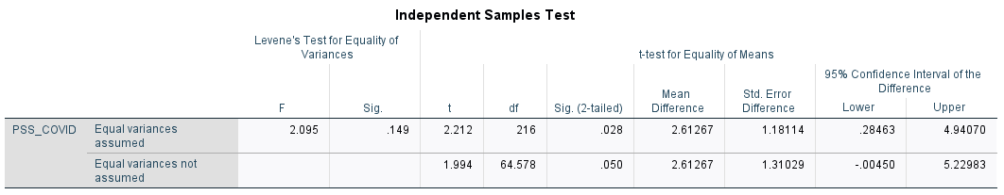

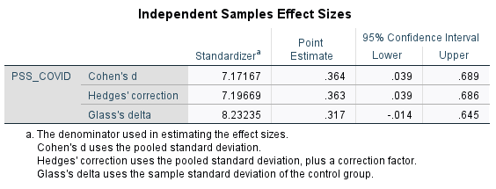

For age, 28 and 45 considered outliers and removed from calculation

Linear Correlation between Age and PSS Before COVID-19

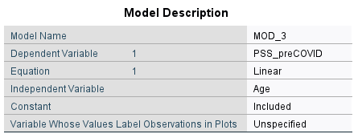

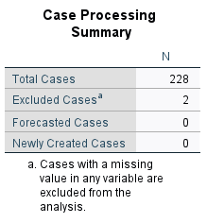

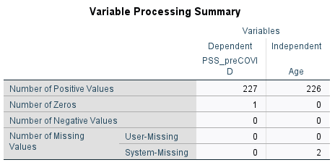

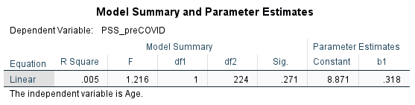

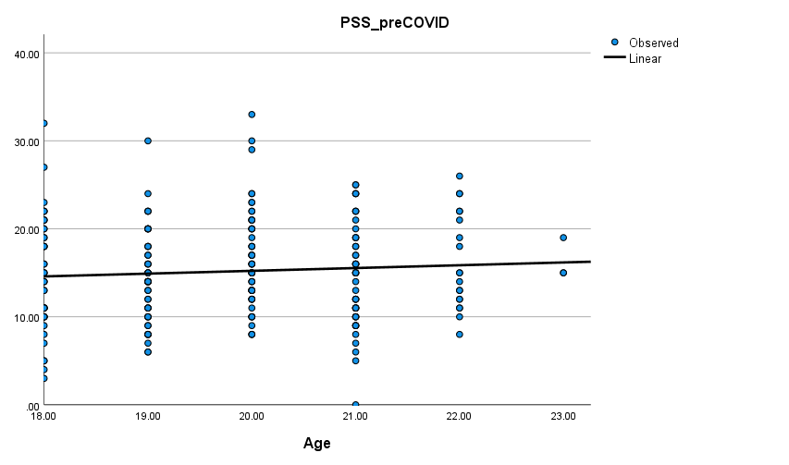

Parabolic Correlation between Age and PSS Before COVID-19

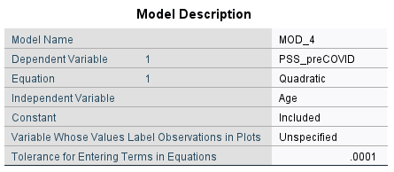





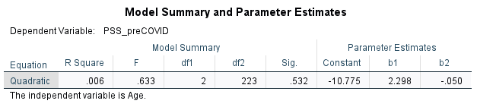

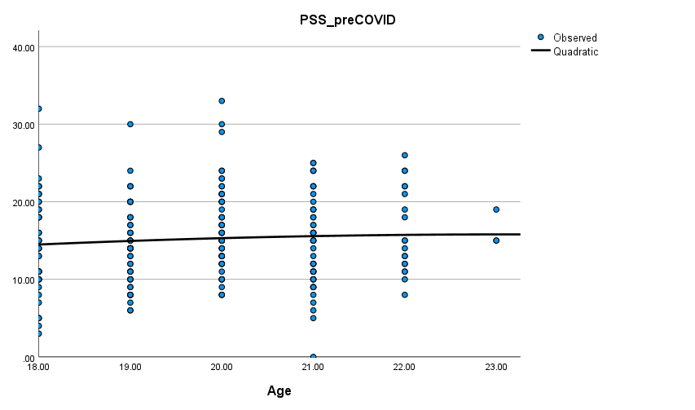

Linear Correlation between Age and PSS During COVID-19

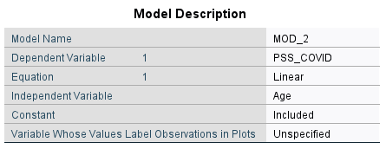



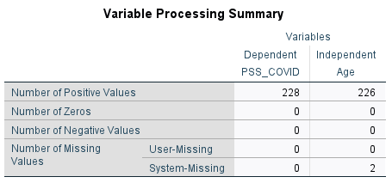

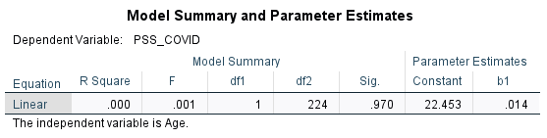

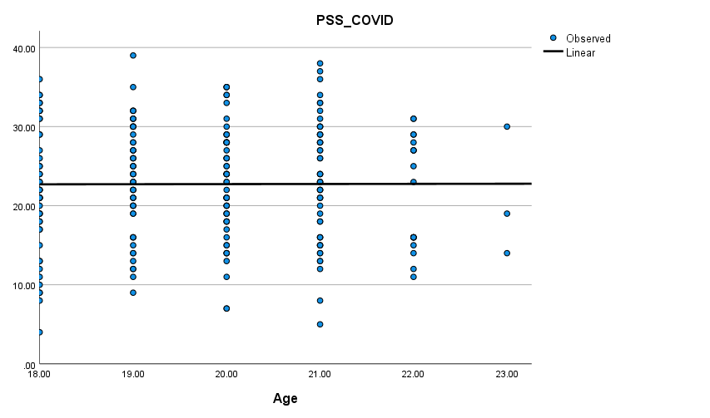

Parabolic Correlation between Age and PSS During COVID-19

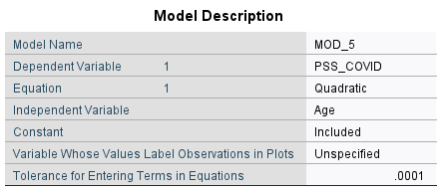





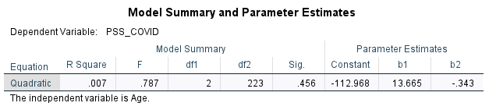

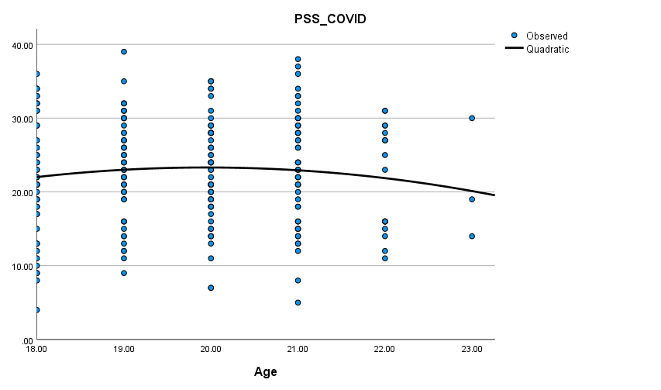

ANOVA between Race and PSS Before COVID-19

0 refers to White, 1 refers to Asian, 2 refers to Hispanic, 3 refers to Black

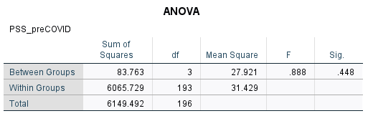

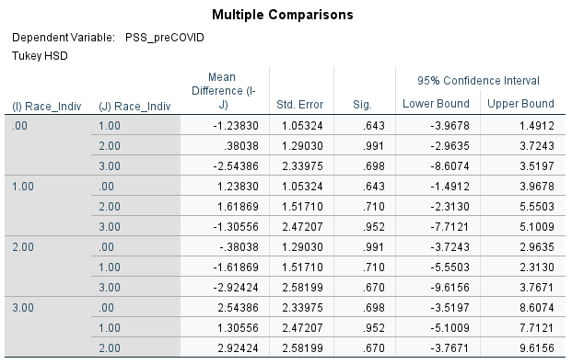

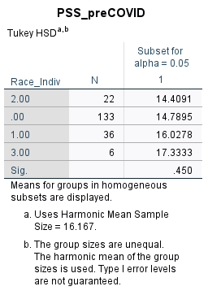

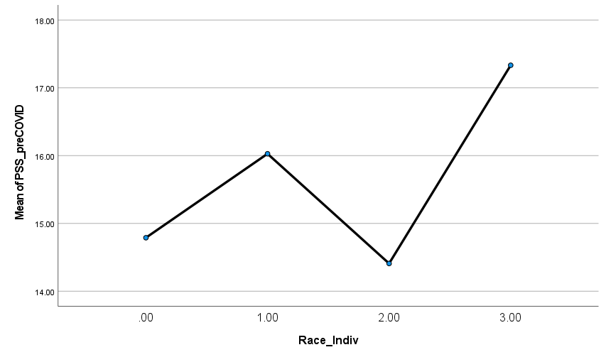

ANOVA between Race and PSS During COVID-19

0 refers to White, 1 refers to Asian, 2 refers to Hispanic, 3 refers to Black

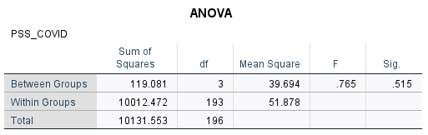

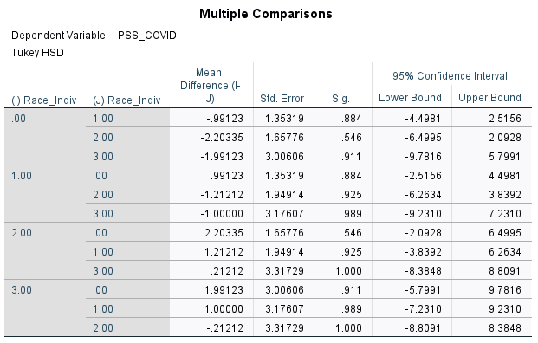

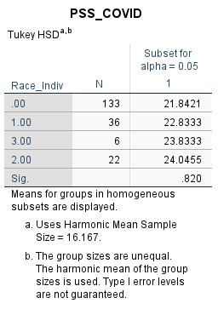

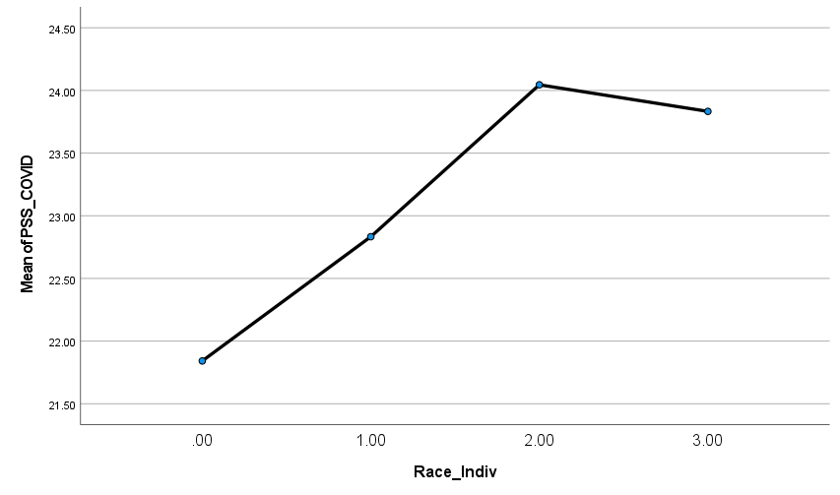

Independent T-Test Between White vs. Hispanic/Black Students and PSS Before COVID-19

0 refers to White; 1 refers to Hispanic/Black students

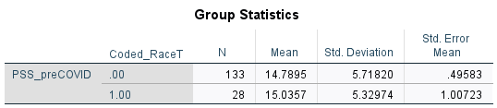

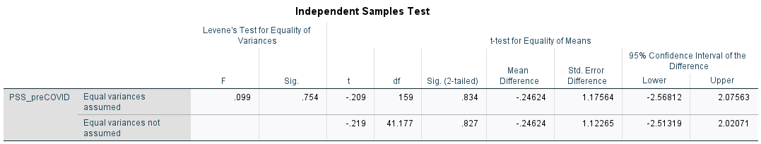

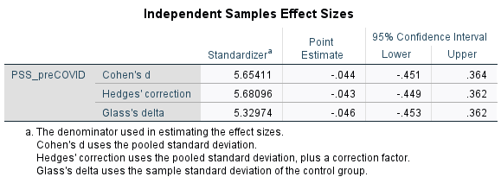

Independent T-Test Between White vs. Hispanic/Black Students and PSS During COVID-19

0 refers to White; 1 refers to Hispanic/Black students

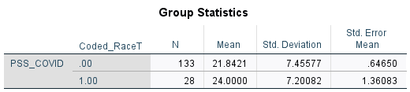

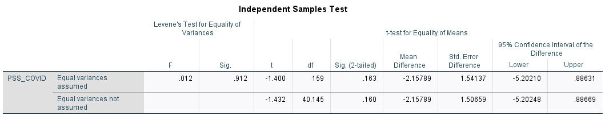

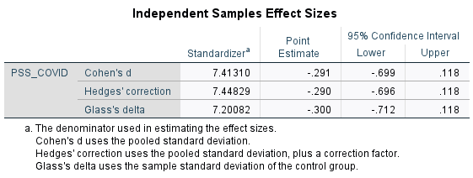

### 

### ASU Demographics

Linear Correlation between Semesters Enrolled and PSS Before COVID-19

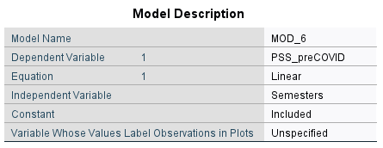

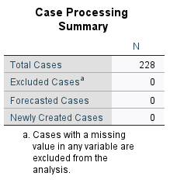

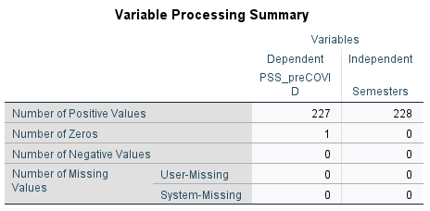

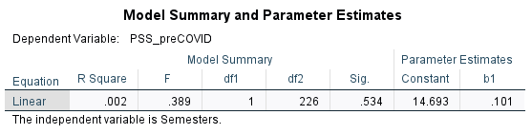

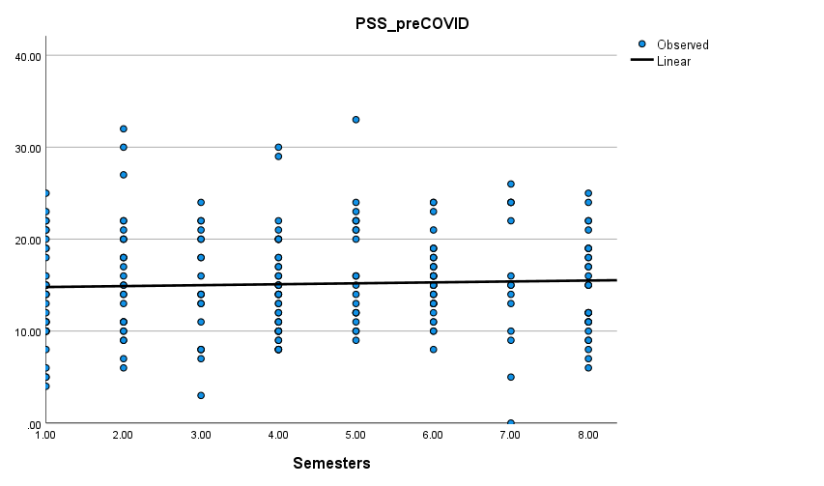

Parabolic Correlation between Semesters Enrolled and PSS Before COVID-19

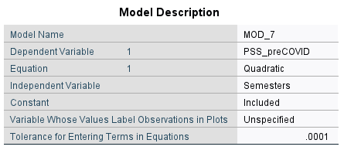





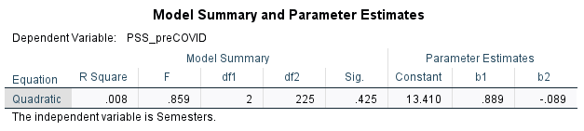

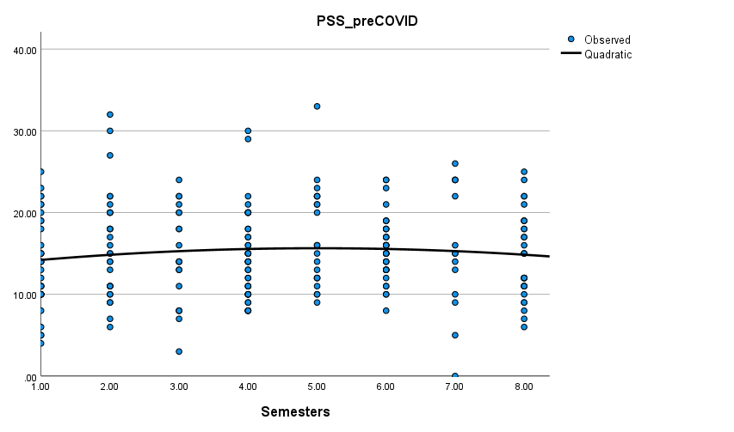

Linear Correlation between Semesters Enrolled and PSS During COVID-19

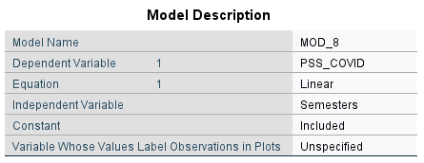



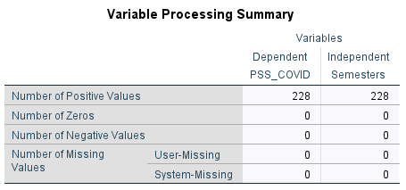

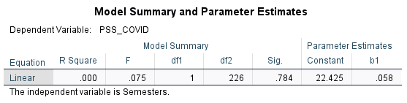

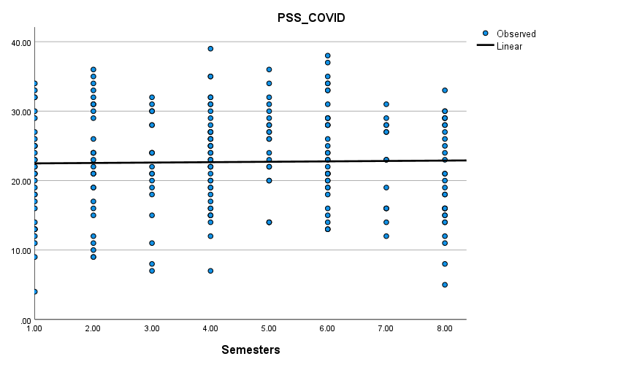

Parabolic Correlation between Semesters Enrolled and PSS During COVID-19

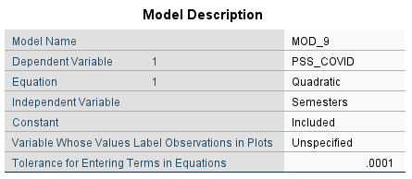





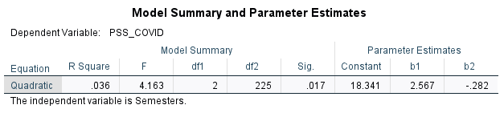

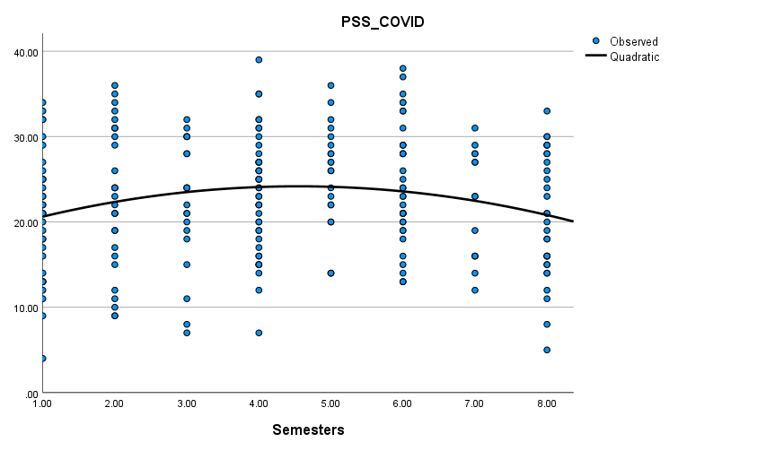

ANOVA between Semesters Enrolled and PSS Before COVID-19

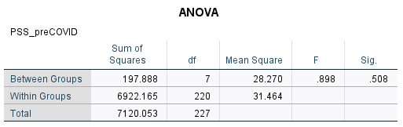

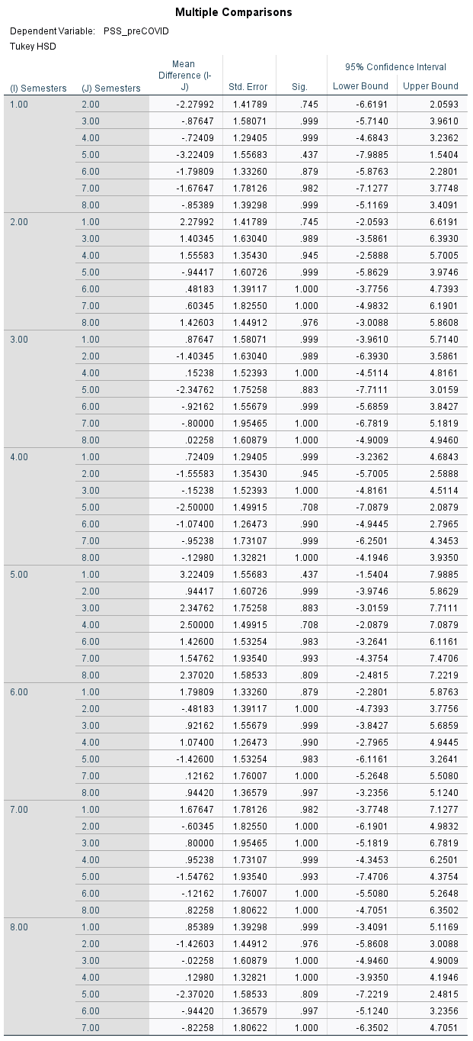



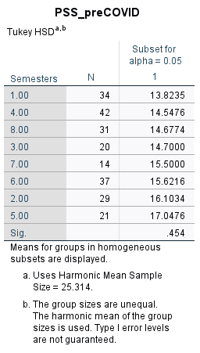

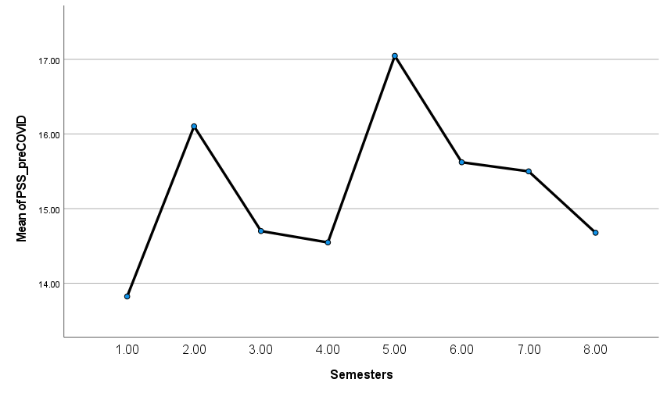

ANOVA between Semesters Enrolled and PSS During COVID-19

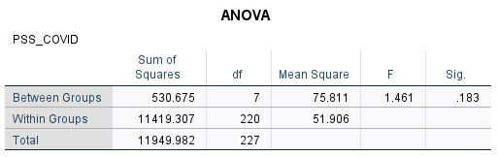

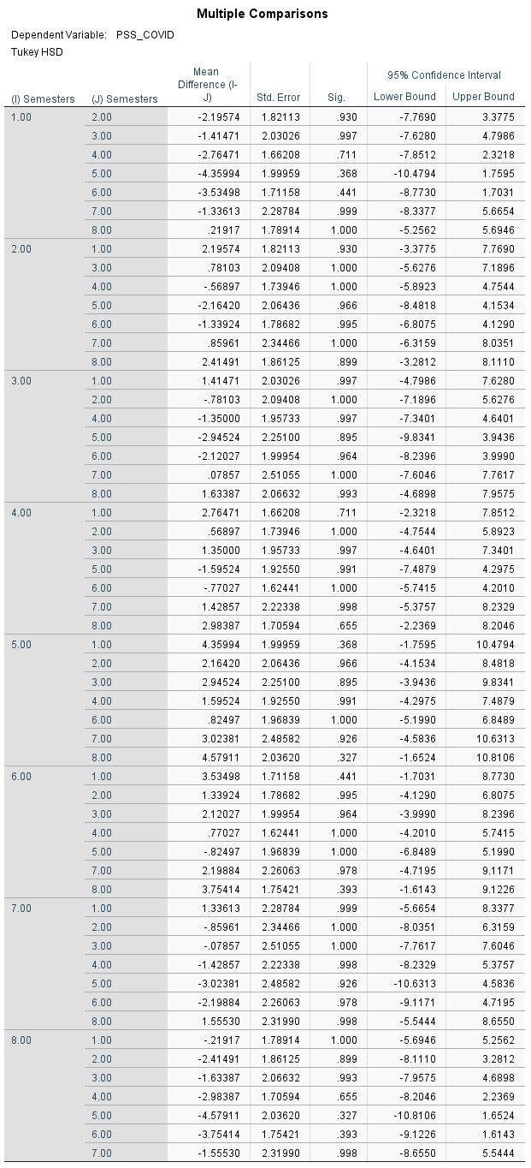



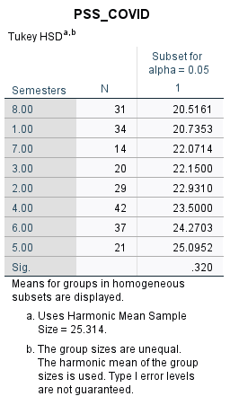

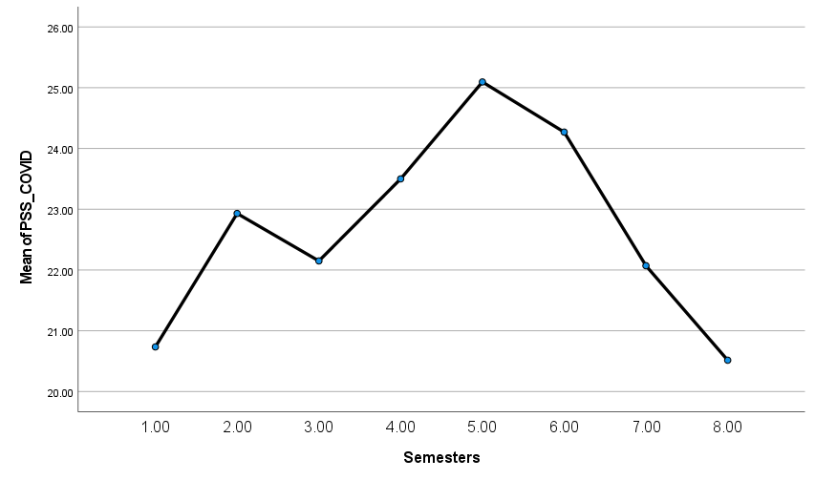

Linear Correlation between Years Enrolled and PSS Before COVID-19

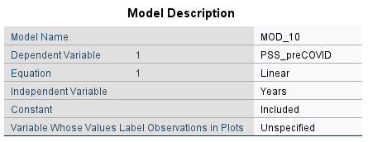



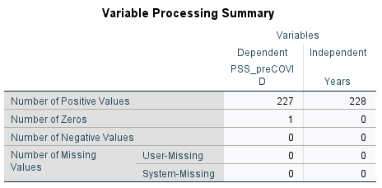

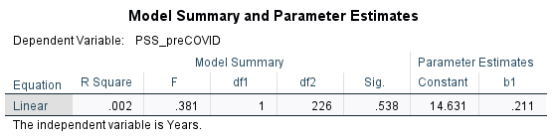

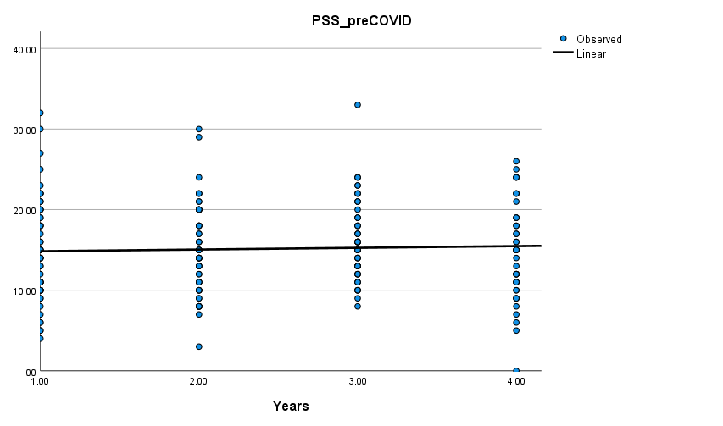

Parabolic Correlation between Years Enrolled and PSS Before COVID-19

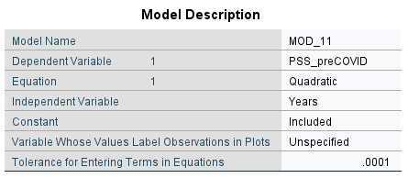





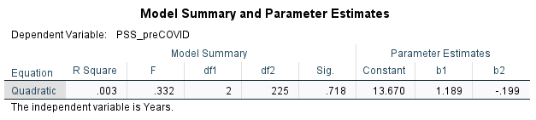

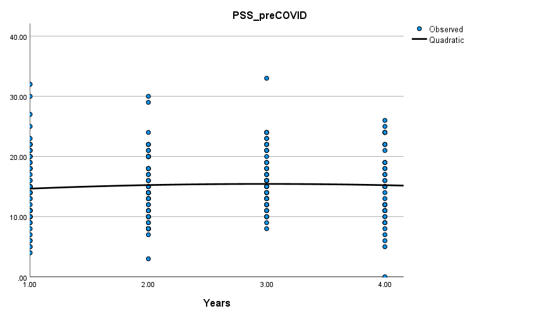

Linear Correlation between Years Enrolled and PSS During COVID-19

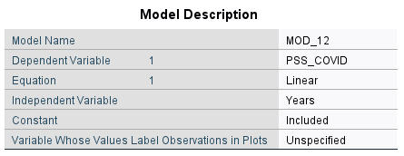



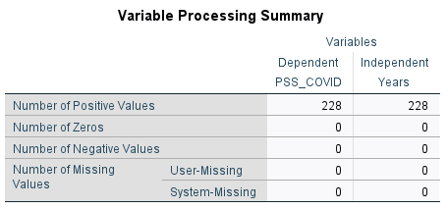

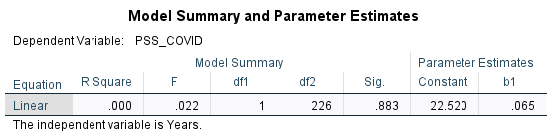

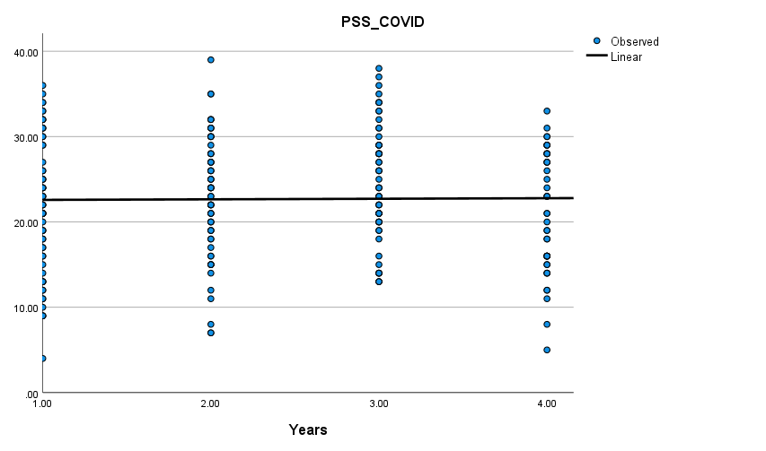

Parabolic Correlation between Years Enrolled and PSS During COVID-19

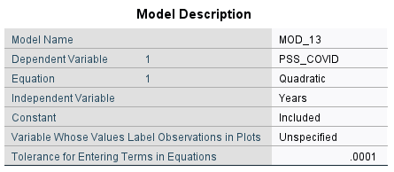





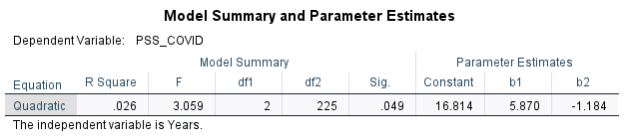

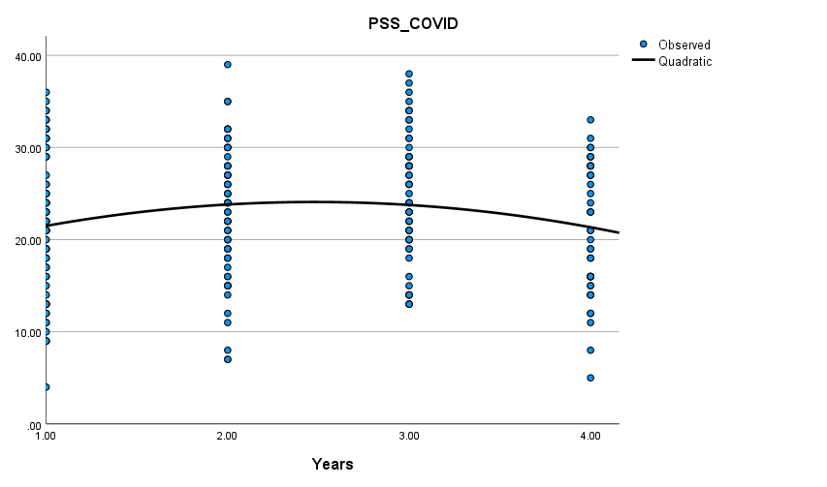

ANOVA between Years Enrolled and PSS Before COVID-19

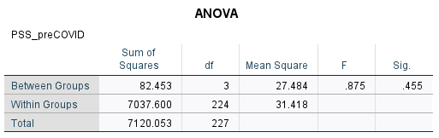

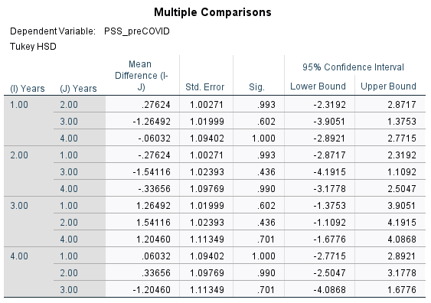

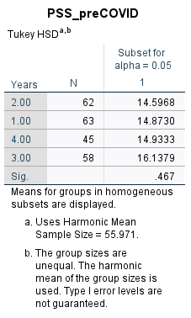

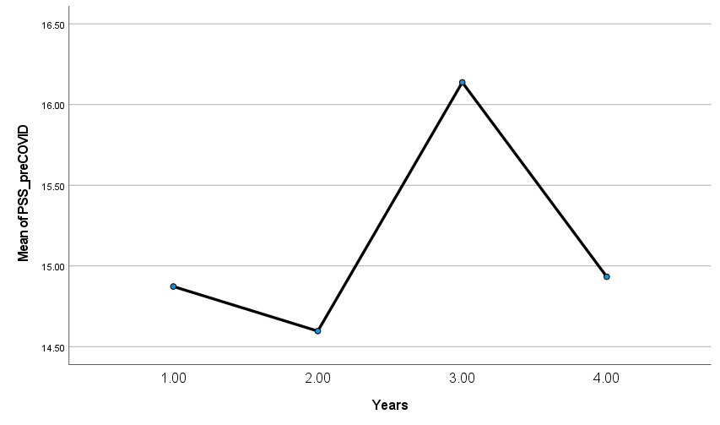

ANOVA between Years Enrolled and PSS During COVID-19

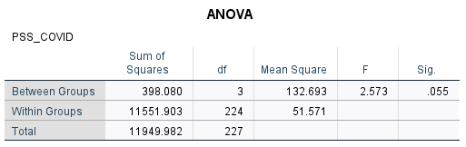

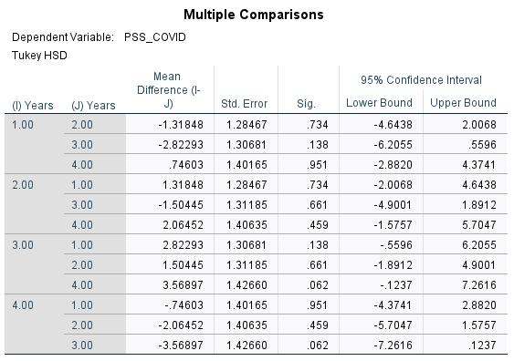

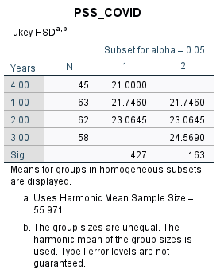

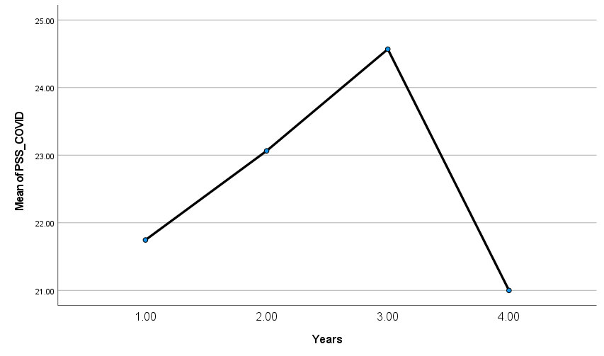

ANOVA between Campus and PSS Before COVID-19

0 refers to Tempe, 1 refers to Polytechnic, 2 refers to Downtown, 3 refers to West

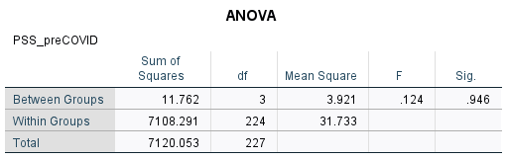

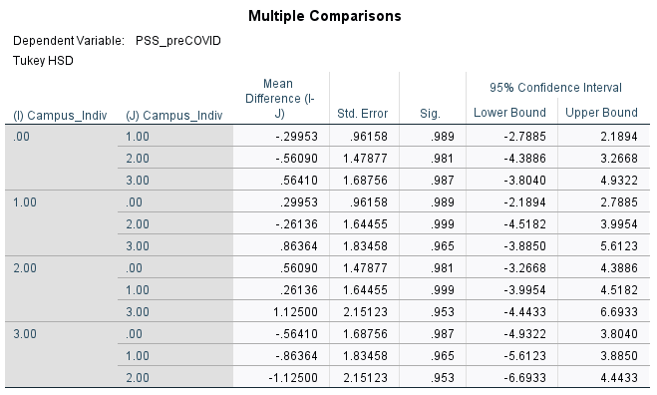

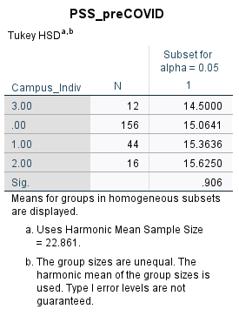

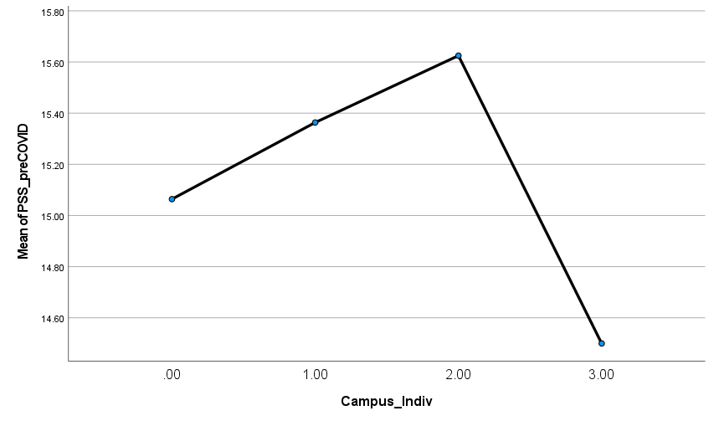

ANOVA between Campus and PSS During COVID-19

0 refers to Tempe, 1 refers to Polytechnic, 2 refers to Downtown, 3 refers to West

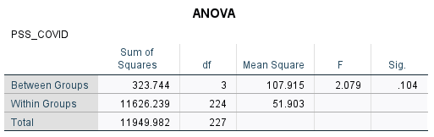

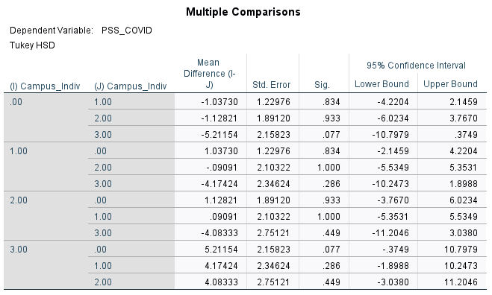

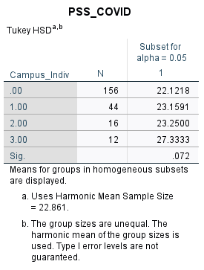

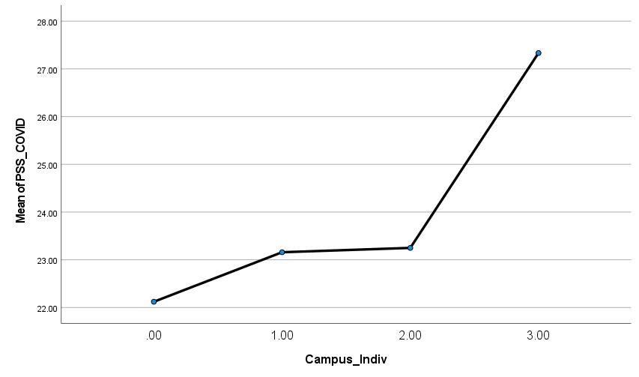

Independent T-Test Between Tempe Campus vs. Smaller Campuses and PSS Before COVID-19

0 refers to students from Tempe, 1 refers to students from smaller campuses

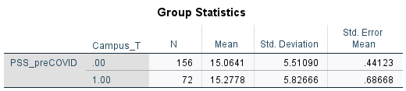

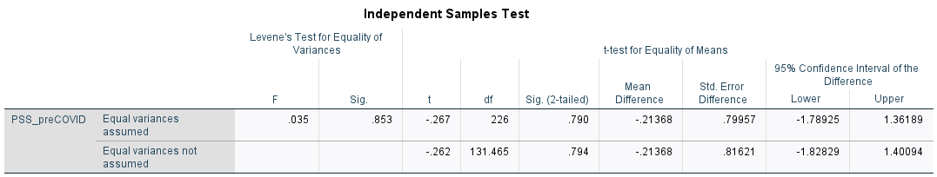

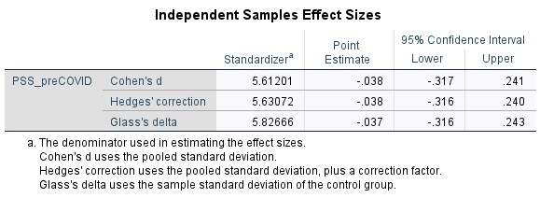

Independent T-Test Between Tempe Campus vs. Smaller Campuses and PSS During COVID-19

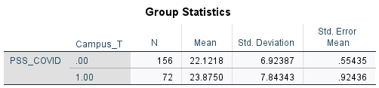

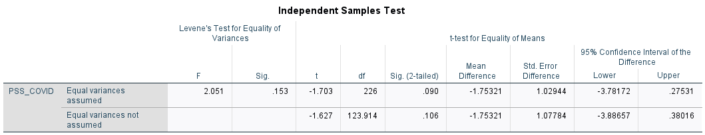

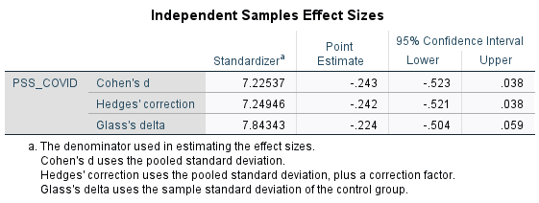

Independent T-Test Between Honors vs. Non-Honors Students and PSS Before COVID-19

0 refers to non-Honors students; 1 refers to Honors students

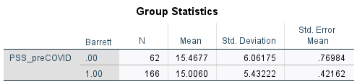

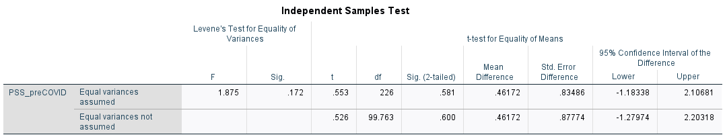

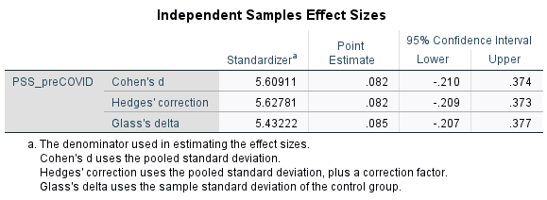

Independent T-Test Between Honors vs. Non-Honors Students and PSS During COVID-19

0 refers to non-Honors students; 1 refers to Honors students

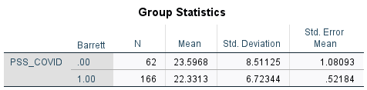

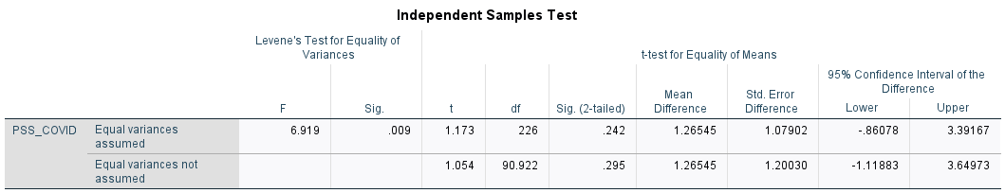

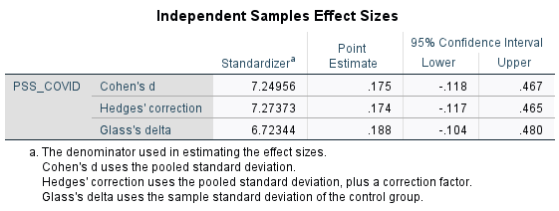

### 

### Social Experiences

Linear Correlation between Friends Seen In-Person and PSS Before COVID-19

With outlier of 200:

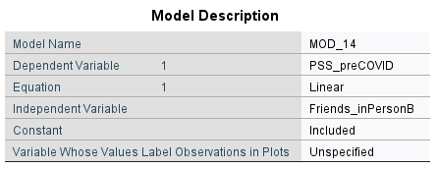

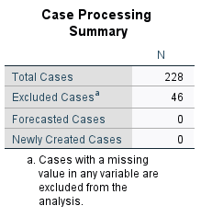

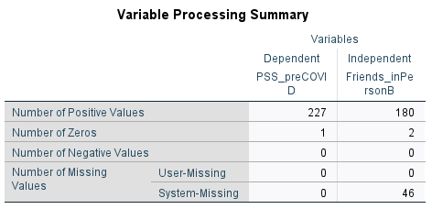

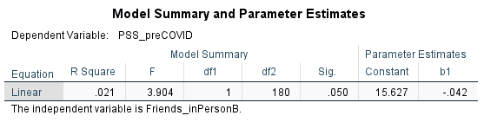

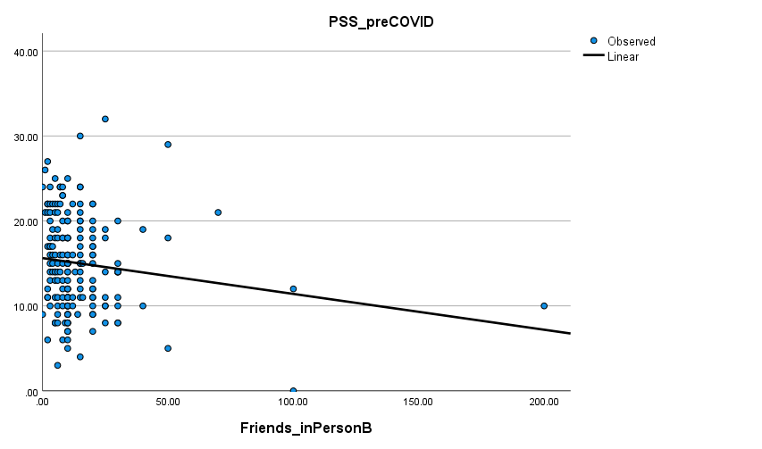

Without outlier of 200:

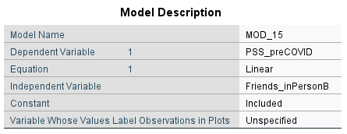

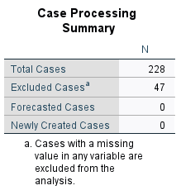

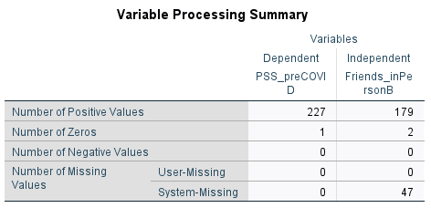

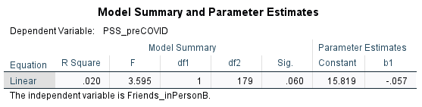

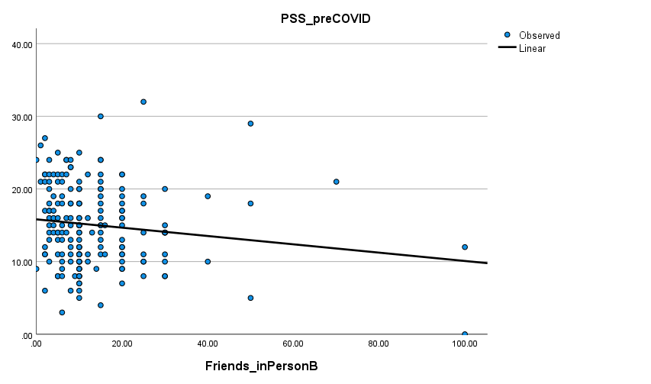

Parabolic Correlation between Friends Seen In-Person and PSS Before COVID-19

With outlier of 200:

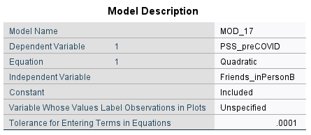





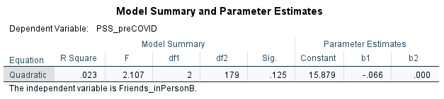

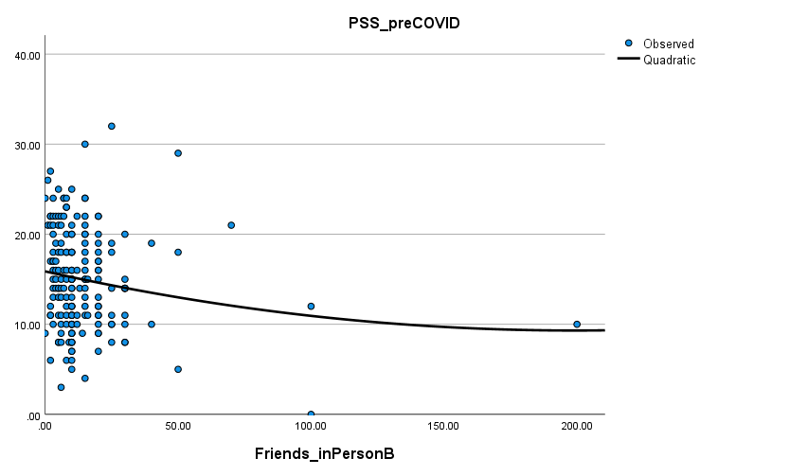

Without outlier of 200:

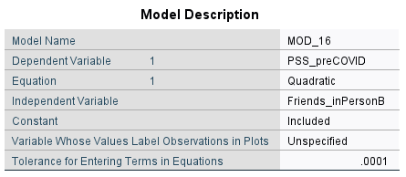





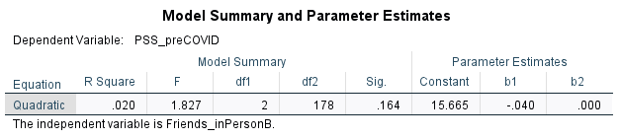

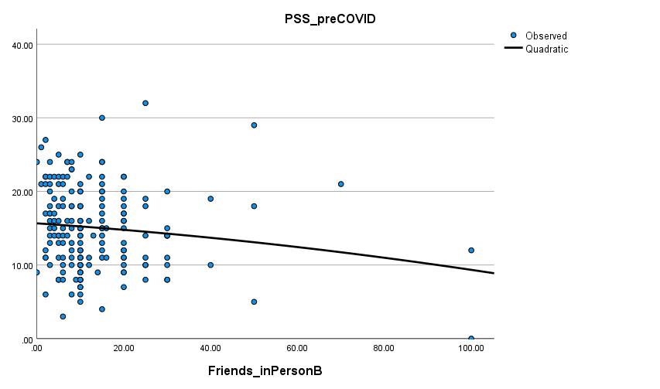

Linear Correlation between Friends Seen In-Person and PSS During COVID-19

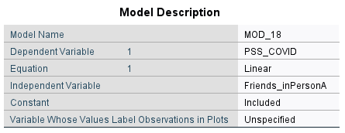

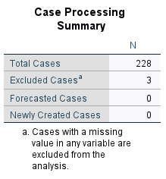

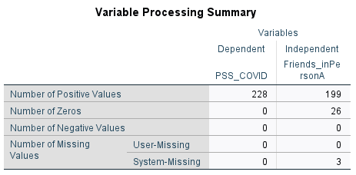

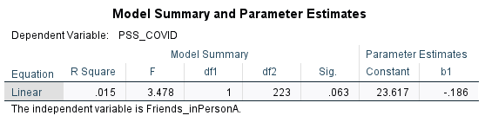

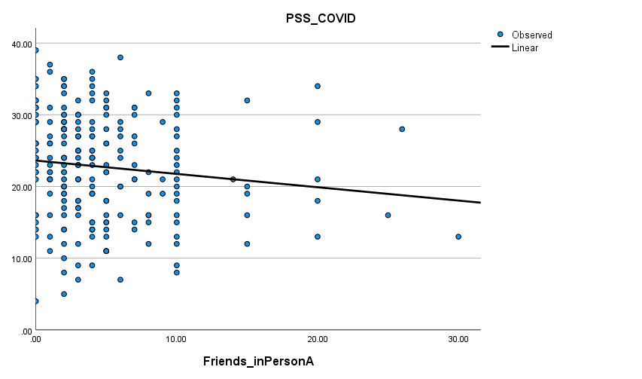

Parabolic Correlation between Friends Seen In-Person and PSS During COVID-19

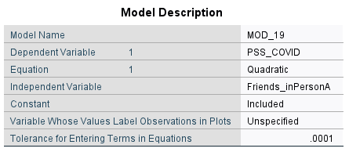





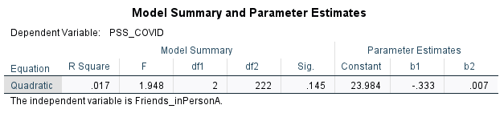

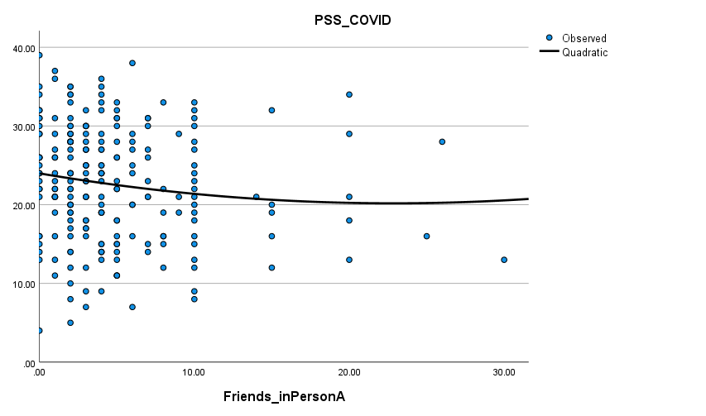

Independent T-Test Between Students Who Saw Fewer than 5 Friends In-Person vs at least 5 Friends In-Person and PSS Before COVID-19

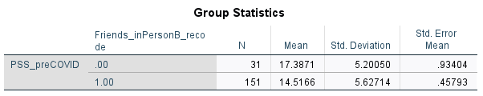

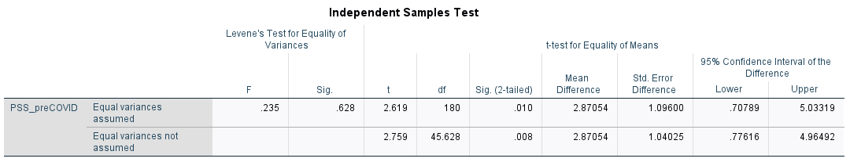

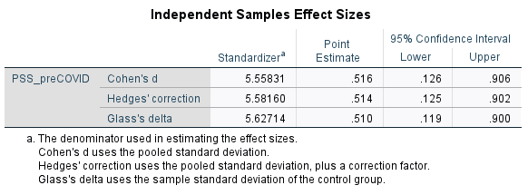

Independent T-Test Between Students Who Saw Fewer than 5 Friends In-Person vs at least 5 Friends In-Person and PSS During COVID-19

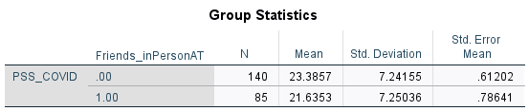

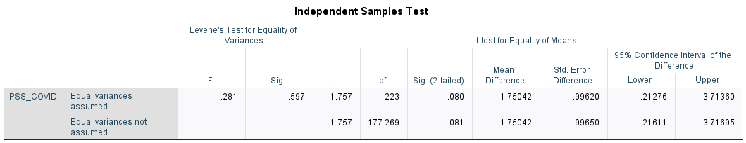

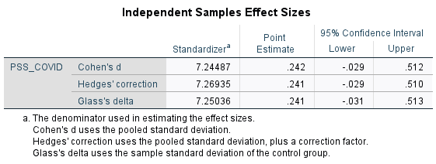

Linear Correlation between Friends Seen Online and PSS Before COVID-19

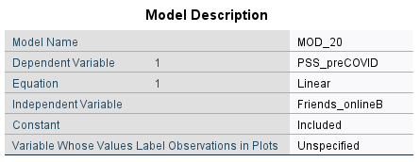

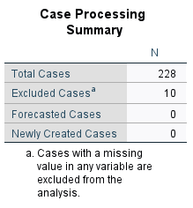

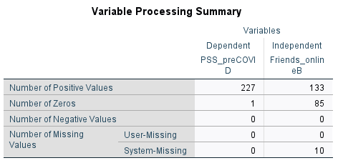

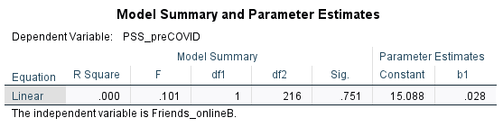

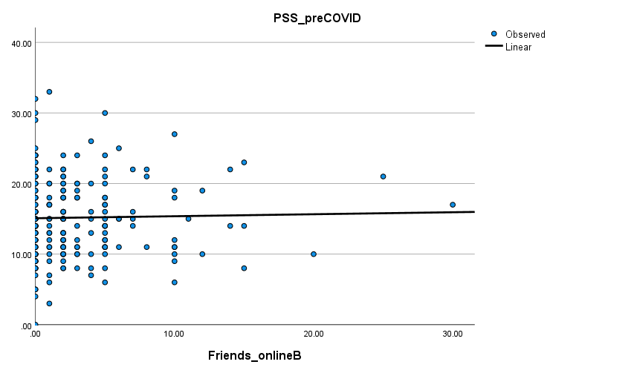

Parabolic Correlation between Friends Seen Online and PSS Before COVID-19

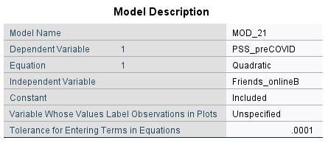





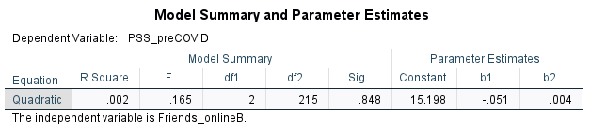

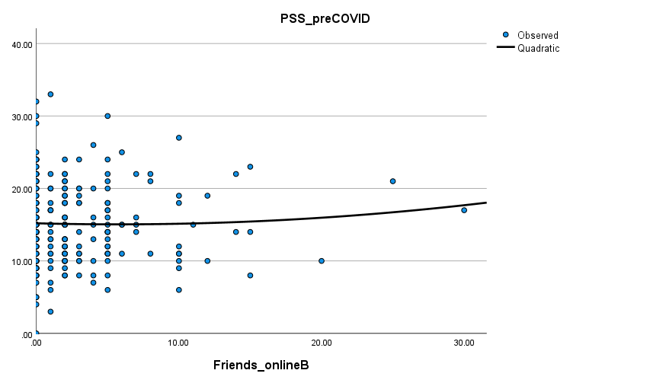

Linear Correlation between Friends Seen Online and PSS During COVID-19

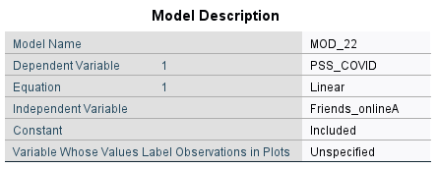

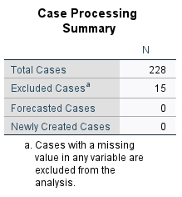

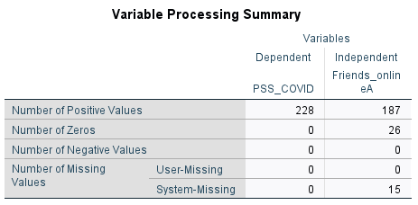

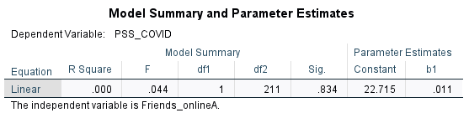

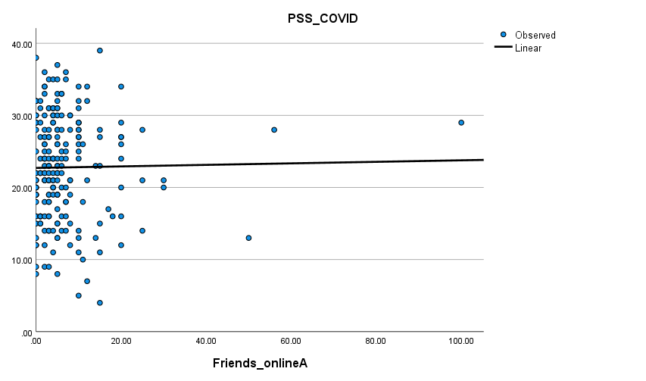

Parabolic Correlation between Friends Seen Online and PSS During COVID-19

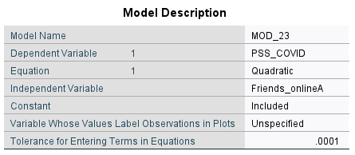





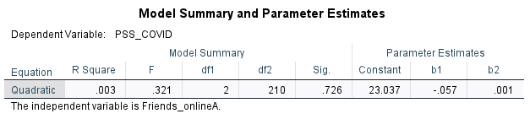

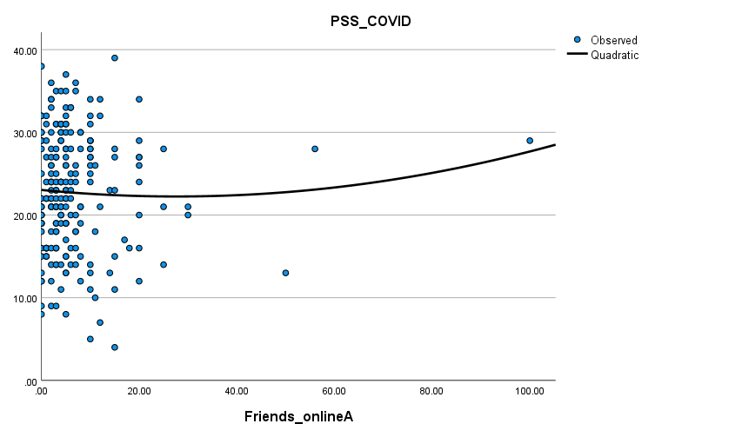

Independent T-Test Between Students Who Saw Fewer than 5 Friends Online vs at least 5 Friends Online and PSS Before COVID-19

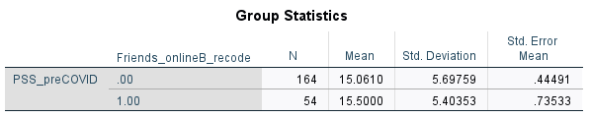

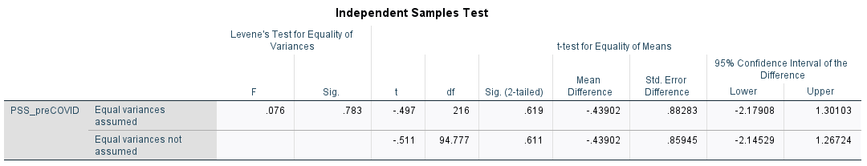

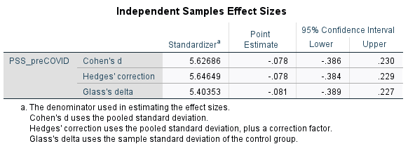

Independent T-Test Between Students Who Saw Fewer than 4 Friends Online vs at least 4 Friends Online and PSS During COVID-19

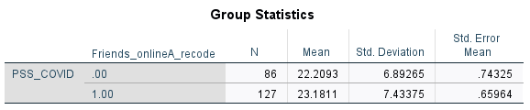

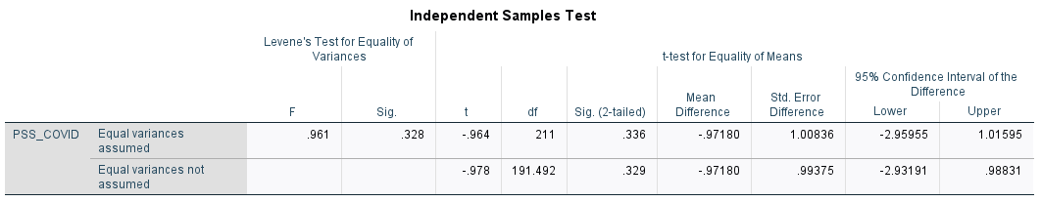

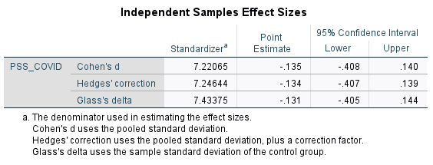

### Campus Involvement

Linear Correlation between University Events Attended and PSS Before COVID-19

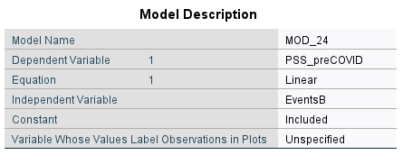

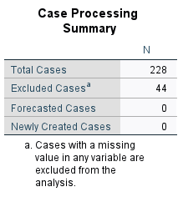

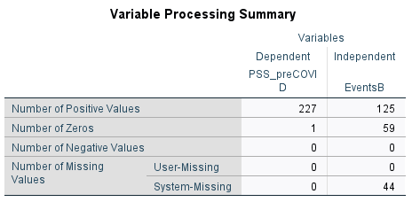

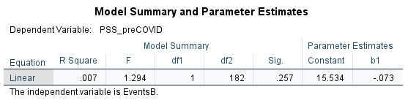

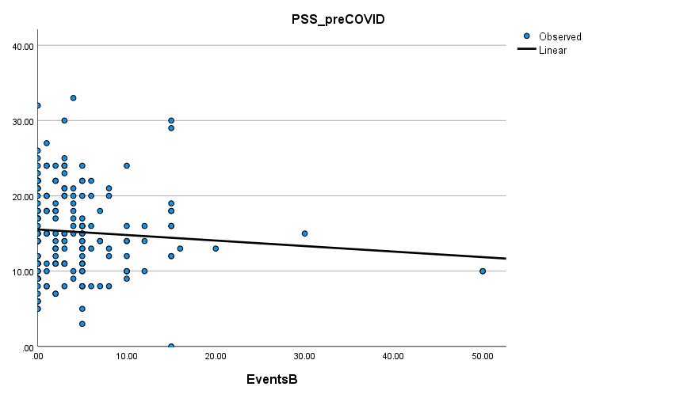

Parabolic Correlation between University Events Attended and PSS Before COVID-19

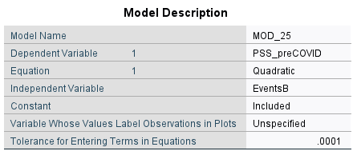





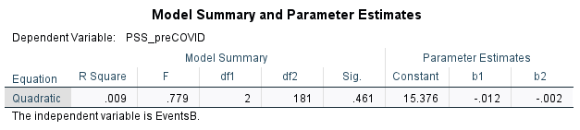

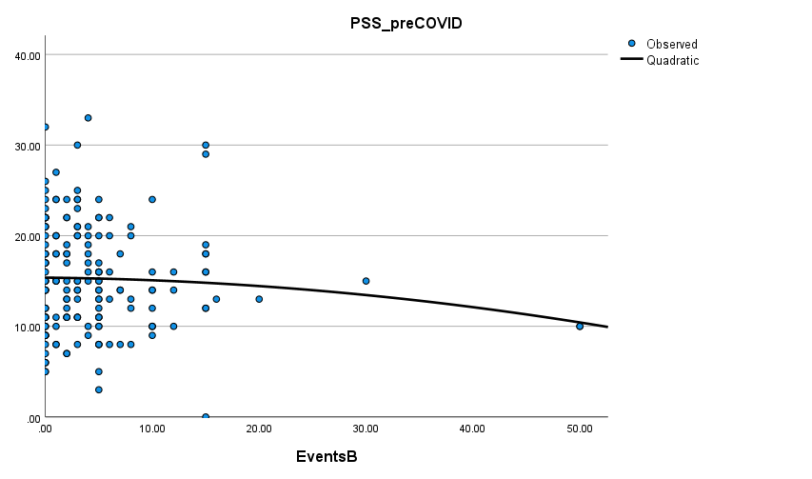

Independent T-Test Between Students Who Attended Fewer than 5 University Events vs. at least 5 University Events and PSS Before COVID-19

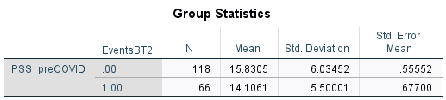

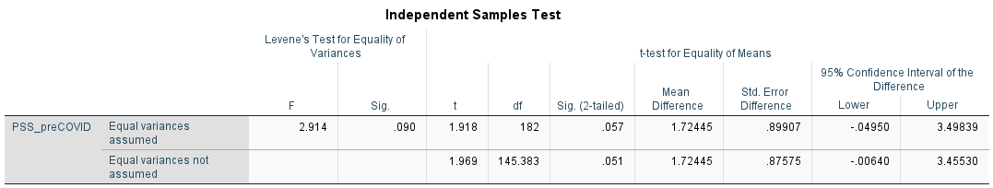

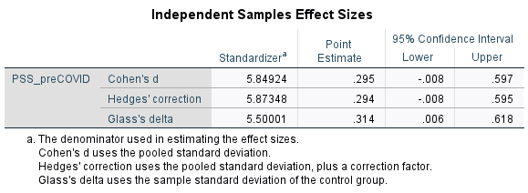

Linear Correlation between University Events Attended and PSS During COVID-19

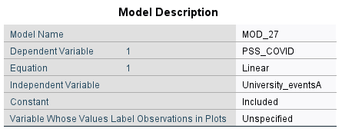

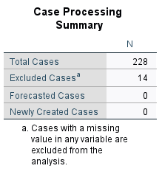

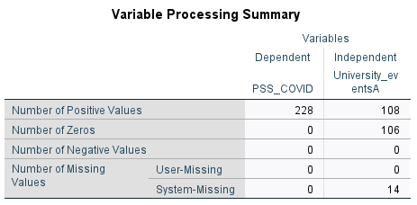

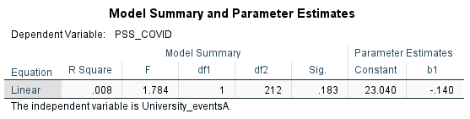

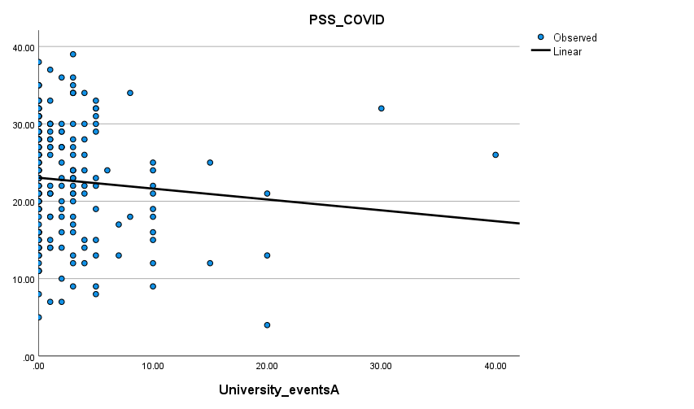

Parabolic Correlation between University Events Attended and PSS During COVID-19

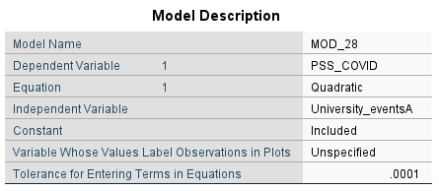





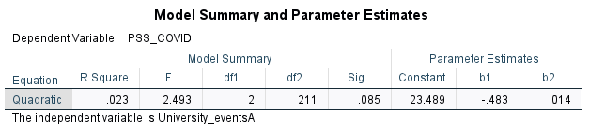

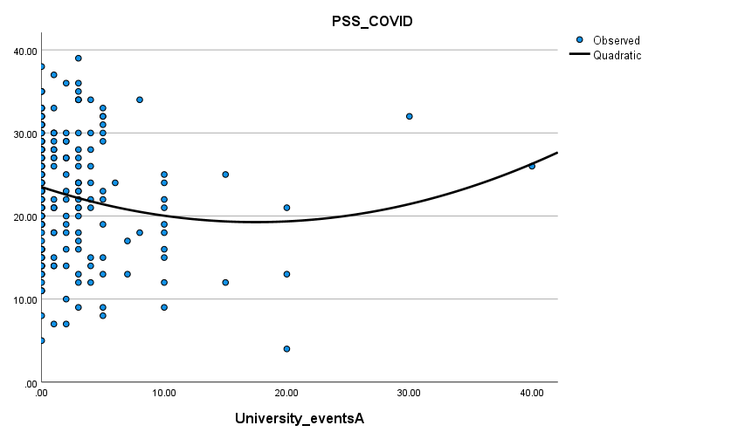

Independent T-Test Between Students Who Attended University Events vs. Who Didn’t and PSS During COVID-19

0 refers to fewer than 6; 1 refers to at least 6

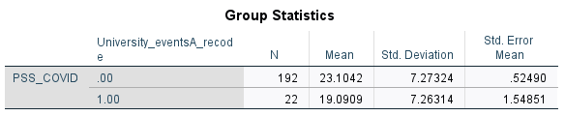

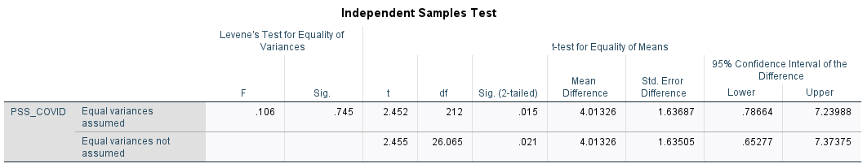

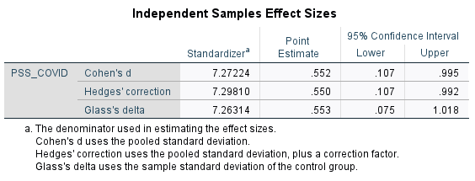

0 refers to fewer than 5; 1 refers to at least 5

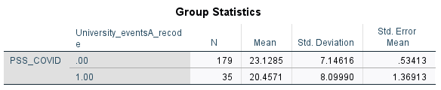

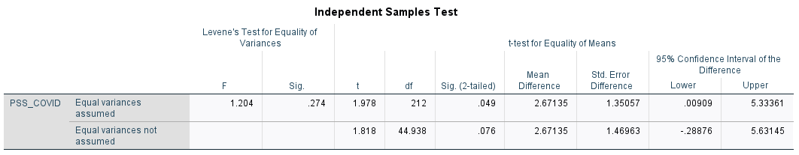

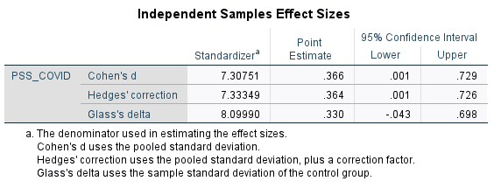

0 refers to fewer than 4; 1 refers to at least 4

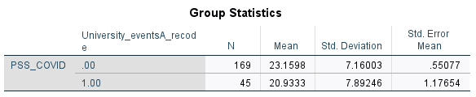

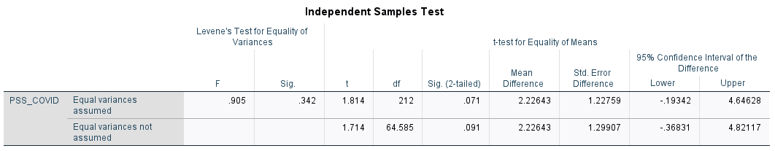

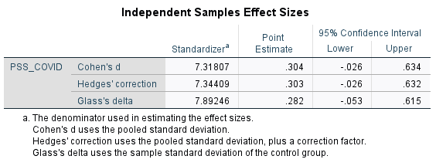

Linear Correlation between Having Video on for Events and PSS

With outliers of 80 and 100:

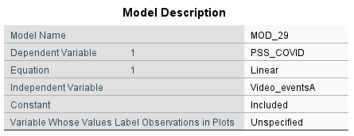

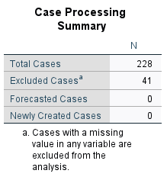

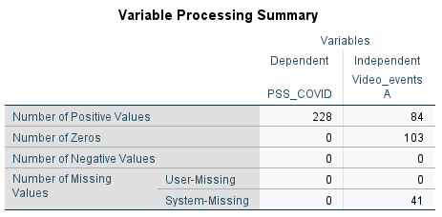

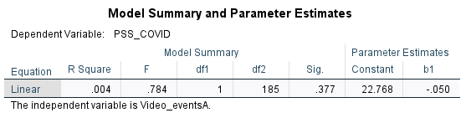

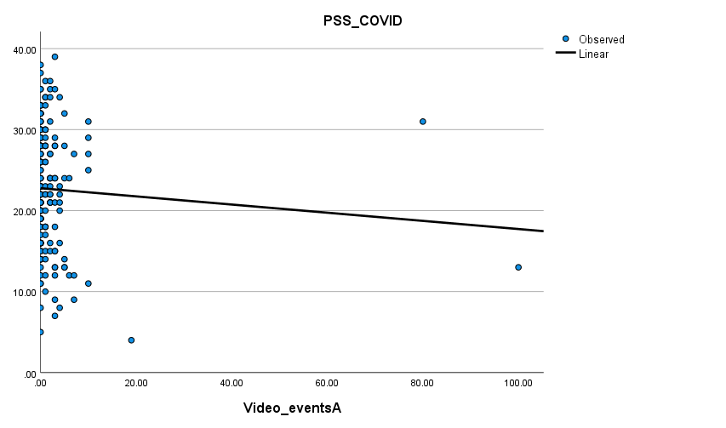

Without outliers of 80 and 100:

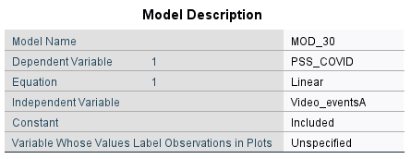

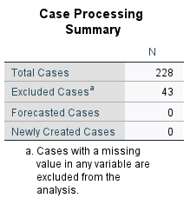

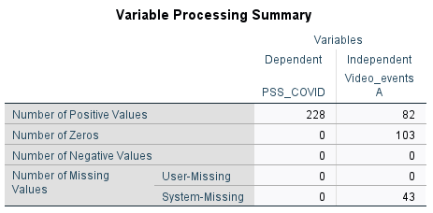

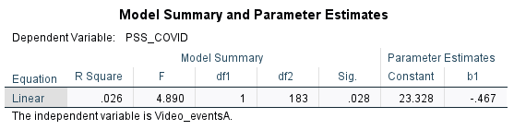

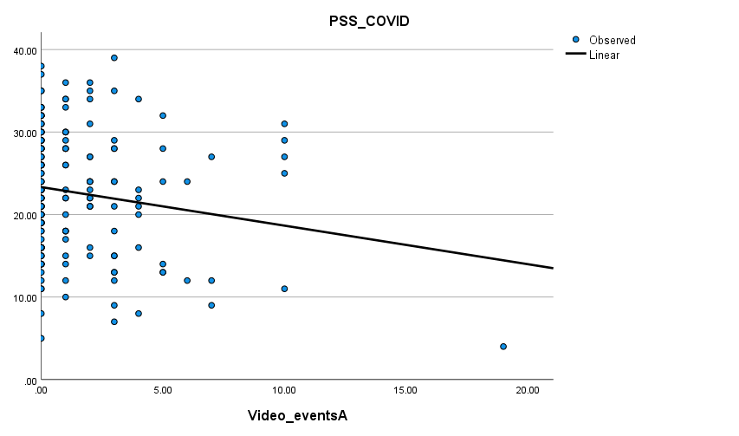

Parabolic Correlation between Having Video on for Events and PSS

With outliers of 80 and 100:

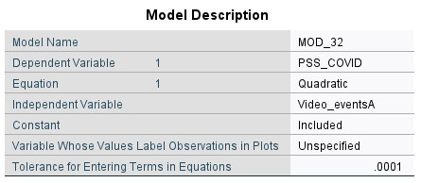





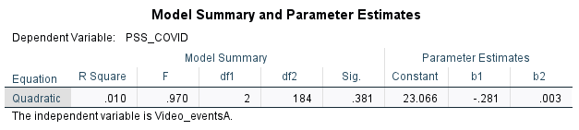

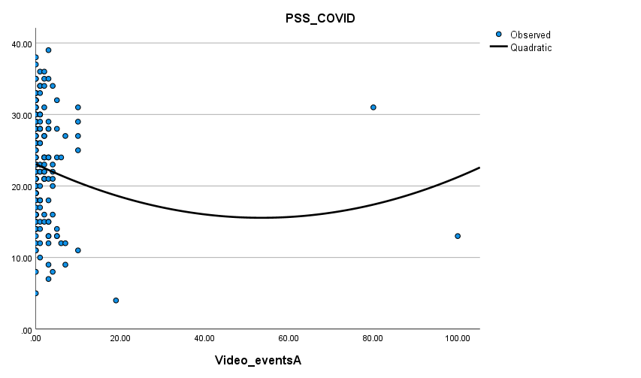

Without outliers of 80 and 100:

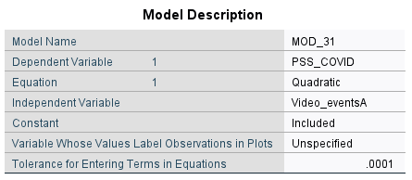





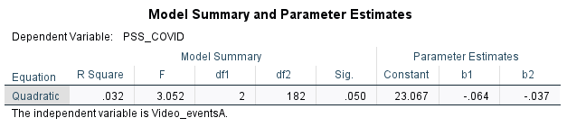

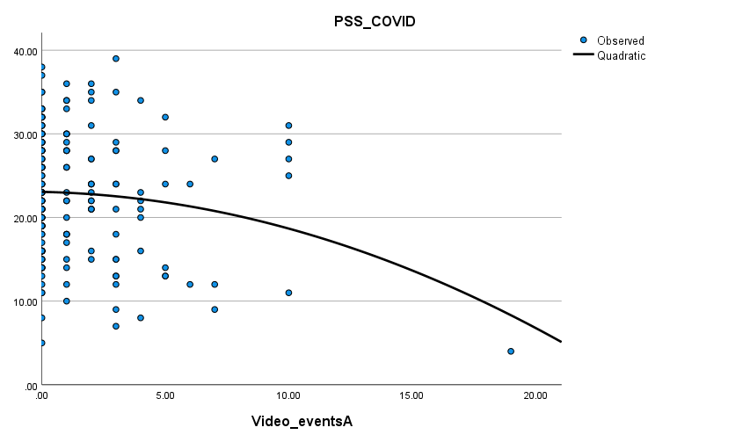

Independent T-Test Between Students Who had Videos on for Fewer than 3 Events vs. at least 3 Events and PSS

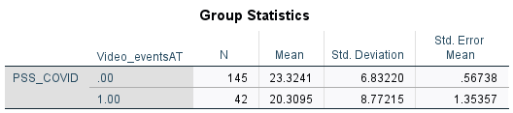

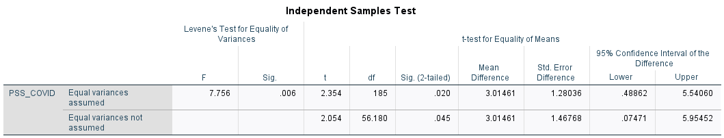

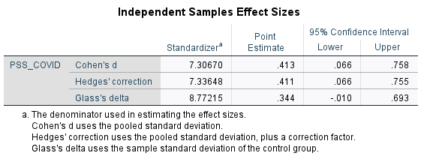

### Resource Utilization

Independent T-Test Between Students Used Campus Resources for Stress vs. Those Who Didn’t and PSS Before COVID-19

0 refers to no resource utilization; 1 refers to resource utilization

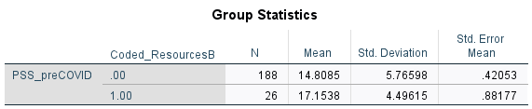

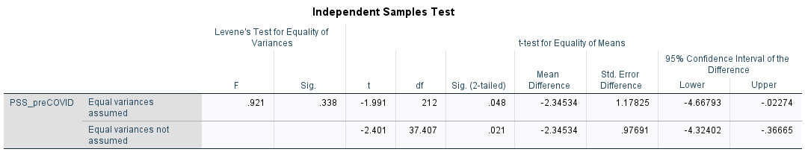

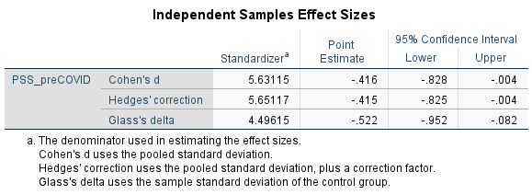

Independent T-Test Between Students Used Campus Resources for Stress vs. Those Who Didn’t and PSS During COVID-19

0 refers to no resource utilization; 1 refers to resource utilization

