CODEORBIT TECH
DATA ANALYST INTERNSHIP
TASK 2: SALES DATA ANALYSIS USING PYTHON AND PANDAS
Task | Task 2 – Sales Data Analysis
Platform | Google Colab / Jupyter Notebook
Technology Used | Python
Libraries Used | Pandas, NumPy, Matplotlib
Dataset | Task_2_Sales_Data_500_Rows.csv
Dataset Size | 500 Rows × 8 Columns

1. INTRODUCTION
This task was completed as part of the CodeOrbit Tech Data Analyst Internship. The objective of this task was to analyze a sales dataset using Python, Pandas, NumPy, and Matplotlib. The analysis includes dataset inspection, data-quality checking, sales verification, sales metrics, product-wise analysis, category analysis, region analysis, monthly analysis, visualization, key findings, and saving the analyzed dataset.

2. OBJECTIVES
- Load and inspect the sales dataset.
- Check missing values and duplicate records.
- Convert the Date column into datetime format.
- Verify that Sales values are correctly calculated.
- Calculate total sales, total orders, and average order value.
- Analyze sales by product, category, region, and month.
- Create charts for sales analysis.
- Identify key findings from the sales data.
- Save the analyzed dataset as a CSV file.

3. DATASET DESCRIPTION
Column | Description | Type
Order_ID | Unique order identifier | Integer
Date | Order date | Object → datetime
Product | Product name | Object
Category | Product category | Object
Region | Sales region | Object
Quantity | Number of units ordered | Integer
Unit_Price | Price per unit | Float
Sales | Sales amount | Float

4. TOOLS AND TECHNOLOGIES USED
- Python – programming language used for analysis
- Pandas – data loading, manipulation, grouping, and analysis
- NumPy – numerical calculations and sales verification
- Matplotlib – data visualization
- Google Colab / Jupyter Notebook – execution environment

5. IMPORT LIBRARIES AND UPLOAD DATASET
Python Code
# Import required libraries
import pandas as pd
import numpy as np
import matplotlib.pyplot as plt
# Upload dataset
from google.colab import files
uploaded = files.upload()

6. LOAD THE DATASET AND INSPECT THE DATA
Python Code
# Load the dataset
df = pd.read_csv("Task_2_Sales_Data_500_Rows.csv")
print("Dataset loaded successfully!")
print("Number of Rows:", df.shape[0])
print("Number of Columns:", df.shape[1])
print("\nColumn Names:")
print(df.columns.tolist())
print("\nFirst 5 Rows:")
display(df.head())
print("\nDataset Information:")
df.info()
Actual Notebook Output
Dataset loaded successfully!
Number of Rows: 500
Number of Columns: 8
Column Names:
['Order_ID', 'Date', 'Product', 'Category', 'Region', 'Quantity', 'Unit_Price', 'Sales']
First 5 Rows:
index | Unnamed: 0 | Order_ID | Date | Product | Category | Region | Quantity | Unit_Price | Sales
0 | 0 | 1001 | 21-04-2026 | Office Chair | Furniture | North | 2 | 7209.23 | 14418.46
1 | 1 | 1002 | 16-08-2026 | Mouse | Accessories | South | 6 | 760.21 | 4561.26
2 | 2 | 1003 | 21-04-2026 | Desk | Furniture | North | 5 | 11151.78 | 55758.9
3 | 3 | 1004 | 03-02-2026 | Headphones | Accessories | North | 5 | 2203.34 | 11016.7
4 | 4 | 1005 | 21-04-2026 | Office Chair | Furniture | South | 1 | 7570.15 | 7570.15

Dataset Information:
<class 'pandas.core.frame.DataFrame'>
RangeIndex: 500 entries, 0 to 499
Data columns (total 8 columns):
# Column Non-Null Count Dtype
--- ------ -------------- -----
0 Order_ID 500 non-null int64
1 Date 500 non-null object
2 Product 500 non-null object
3 Category 500 non-null object
4 Region 500 non-null object
5 Quantity 500 non-null int64
6 Unit_Price 500 non-null float64
7 Sales 500 non-null float64
dtypes: float64(2), int64(2), object(4)
memory usage: 31.4+ KB

7. CHECK MISSING VALUES, DUPLICATES, AND DATE TYPE
Python Code
# Check missing values and duplicate records
print("Missing Values:")
display(df.isnull().sum())
print("\nNumber of Duplicate Rows:")
print(df.duplicated().sum())
# Convert Date column to datetime
df["Date"] = pd.to_datetime(df["Date"])
print("\nDate column data type:")
print(df["Date"].dtype)
Actual Notebook Output
Missing Values:
index | Unnamed: 0 | 0
0 | Order_ID | 0
1 | Date | 0
2 | Product | 0
3 | Category | 0
4 | Region | 0
5 | Quantity | 0
6 | Unit_Price | 0
7 | Sales | 0

Number of Duplicate Rows:
0
Date column data type:
datetime64[ns]
/tmp/ipykernel_1363/2780751825.py:9: UserWarning: Parsing dates in %d-%m-%Y format when dayfirst=False (the default) was specified. Pass `dayfirst=True` or specify a format to silence this warning.
df["Date"] = pd.to_datetime(df["Date"])

8. VERIFY SALES CALCULATIONS
Python Code
# Calculate sales independently
df["Calculated_Sales"] = df["Quantity"] * df["Unit_Price"]
# Compare calculated sales with existing Sales column
df["Sales_Check"] = np.isclose(
df["Sales"],
df["Calculated_Sales"]
)
print("Sales calculation verification:")
print("All sales values are correct:", df["Sales_Check"].all())
print("\nSample Sales Calculation:")
display(
df[
["Product", "Quantity", "Unit_Price",
"Sales", "Calculated_Sales"]
].head()
)
Actual Notebook Output
Sales calculation verification:
All sales values are correct: True
Sample Sales Calculation:
index | Unnamed: 0 | Product | Quantity | Unit_Price | Sales | Calculated_Sales
0 | 0 | Office Chair | 2 | 7209.23 | 14418.46 | 14418.46
1 | 1 | Mouse | 6 | 760.21 | 4561.26 | 4561.26
2 | 2 | Desk | 5 | 11151.78 | 55758.9 | 55758.9
3 | 3 | Headphones | 5 | 2203.34 | 11016.7 | 11016.7
4 | 4 | Office Chair | 1 | 7570.15 | 7570.15 | 7570.15

9. CALCULATE KEY SALES METRICS
Python Code
# Total Sales
total_sales = df["Sales"].sum()
# Total number of orders
total_orders = df["Order_ID"].nunique()
# Average Order Value
average_order_value = total_sales / total_orders
print("KEY SALES METRICS")
print("-" * 35)
print(f"Total Sales: ₹{total_sales:,.2f}")
print(f"Total Orders: {total_orders}")
print(f"Average Order Value: ₹{average_order_value:,.2f}")
Actual Notebook Output
KEY SALES METRICS
-----------------------------------
Total Sales: ₹45,554,764.33
Total Orders: 500
Average Order Value: ₹91,109.53

10. PRODUCT-WISE SALES ANALYSIS
Python Code
# Product-wise sales summary
product_summary = df.groupby("Product").agg(
Total_Sales=("Sales", "sum"),
Total_Quantity=("Quantity", "sum"),
Number_of_Orders=("Order_ID", "nunique")
).sort_values(
by="Total_Sales",
ascending=False
)
print("Product-wise Sales Summary:")
display(product_summary)
# Top 5 products
top_products = product_summary.head(5)
print("\nTop 5 Products by Sales:")
display(top_products)
Actual Notebook Output
Product-wise Sales Summary:
('index', '') | ('Unnamed: 0_level_0', 'Product') | ('Total_Sales', 'Unnamed: 1_level_1') | ('Total_Quantity', 'Unnamed: 2_level_1') | ('Number_of_Orders', 'Unnamed: 3_level_1')
0 | Laptop | 20169801.79 | 367 | 62
1 | Smartphone | 8862771.69 | 278 | 54
2 | Tablet | 5575348.08 | 199 | 44
3 | Desk | 2918696.78 | 265 | 51
4 | Monitor | 2407479.57 | 200 | 41
5 | Office Chair | 2368827.03 | 318 | 55
6 | Printer | 1958942.57 | 208 | 39
7 | Headphones | 594728.72 | 270 | 49
8 | Keyboard | 482308.43 | 322 | 57
9 | Mouse | 215859.67 | 270 | 48

Top 5 Products by Sales:
('index', '') | ('Unnamed: 0_level_0', 'Product') | ('Total_Sales', 'Unnamed: 1_level_1') | ('Total_Quantity', 'Unnamed: 2_level_1') | ('Number_of_Orders', 'Unnamed: 3_level_1')
0 | Laptop | 20169801.79 | 367 | 62
1 | Smartphone | 8862771.69 | 278 | 54
2 | Tablet | 5575348.08 | 199 | 44
3 | Desk | 2918696.78 | 265 | 51
4 | Monitor | 2407479.57 | 200 | 41

11. CATEGORY AND REGION ANALYSIS
Python Code
# Category analysis
category_summary = df.groupby("Category").agg(
Total_Sales=("Sales", "sum"),
Total_Quantity=("Quantity", "sum"),
Number_of_Orders=("Order_ID", "nunique")
).sort_values(
by="Total_Sales",
ascending=False
)
print("SALES BY CATEGORY")
display(category_summary)
# Region analysis
region_summary = df.groupby("Region").agg(
Total_Sales=("Sales", "sum"),
Total_Quantity=("Quantity", "sum"),
Number_of_Orders=("Order_ID", "nunique")
).sort_values(
by="Total_Sales",
ascending=False
)
print("\nSALES BY REGION")
display(region_summary)
Actual Notebook Output
SALES BY CATEGORY
('index', '') | ('Unnamed: 0_level_0', 'Category') | ('Total_Sales', 'Unnamed: 1_level_1') | ('Total_Quantity', 'Unnamed: 2_level_1') | ('Number_of_Orders', 'Unnamed: 3_level_1')
0 | Electronics | 37015401.13 | 1044 | 201
1 | Furniture | 5287523.81 | 583 | 106
2 | Office Equipment | 1958942.57 | 208 | 39
3 | Accessories | 1292896.82 | 862 | 154

SALES BY REGION
('index', '') | ('Unnamed: 0_level_0', 'Region') | ('Total_Sales', 'Unnamed: 1_level_1') | ('Total_Quantity', 'Unnamed: 2_level_1') | ('Number_of_Orders', 'Unnamed: 3_level_1')
0 | South | 13752337.91 | 675 | 125
1 | West | 10963240.48 | 604 | 107
2 | North | 10896520.38 | 761 | 146
3 | East | 9942665.56 | 657 | 122

12. MONTHLY SALES ANALYSIS
Python Code
# Create Month column
df["Month"] = df["Date"].dt.to_period("M").astype(str)
# Monthly sales
monthly_sales = df.groupby("Month").agg(
Total_Sales=("Sales", "sum"),
Total_Quantity=("Quantity", "sum"),
Number_of_Orders=("Order_ID", "nunique")
)
print("MONTHLY SALES SUMMARY")
display(monthly_sales)
Actual Notebook Output
MONTHLY SALES SUMMARY
('index', '') | ('Unnamed: 0_level_0', 'Month') | ('Total_Sales', 'Unnamed: 1_level_1') | ('Total_Quantity', 'Unnamed: 2_level_1') | ('Number_of_Orders', 'Unnamed: 3_level_1')
0 | 2026-01 | 4264743.54 | 313 | 63
1 | 2026-02 | 5310519.45 | 317 | 48
2 | 2026-03 | 3810419.21 | 306 | 54
3 | 2026-04 | 6684316.12 | 313 | 62
4 | 2026-05 | 5597945.87 | 279 | 57
5 | 2026-06 | 5619118.02 | 333 | 60
6 | 2026-07 | 4220624.84 | 215 | 42
7 | 2026-08 | 6181159.45 | 377 | 62
8 | 2026-09 | 3865917.83 | 244 | 52

13. CREATE SALES VISUALIZATIONS
Python Code
# Category Sales Chart
plt.figure(figsize=(9, 5))
category_summary["Total_Sales"].plot(kind="bar")
plt.title("Sales by Category")
plt.xlabel("Category")
plt.ylabel("Total Sales")
plt.xticks(rotation=45)
plt.tight_layout()
plt.show()
# Region Sales Chart
plt.figure(figsize=(8, 5))
region_summary["Total_Sales"].plot(kind="bar")
plt.title("Sales by Region")
plt.xlabel("Region")
plt.ylabel("Total Sales")
plt.xticks(rotation=0)
plt.tight_layout()
plt.show()
Actual Notebook Output
<Figure size 900x500 with 1 Axes>
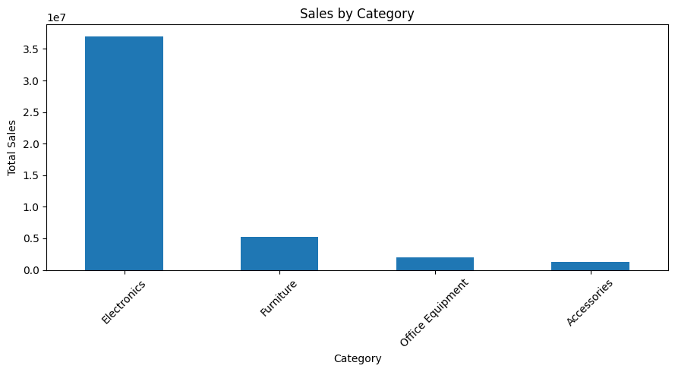

<Figure size 800x500 with 1 Axes>
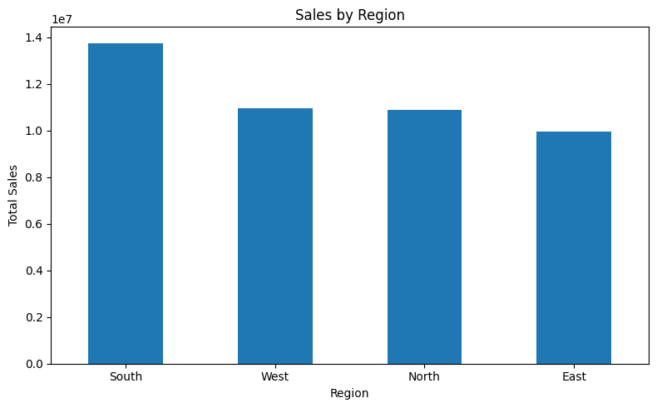

14. CREATE TOP 5 PRODUCT AND MONTHLY SALES CHARTS
Python Code
# Top 5 Products Chart
plt.figure(figsize=(9, 5))
top_products["Total_Sales"].plot(kind="bar")
plt.title("Top 5 Products by Sales")
plt.xlabel("Product")
plt.ylabel("Total Sales")
plt.xticks(rotation=45)
plt.tight_layout()
plt.show()
# Monthly Sales Chart
plt.figure(figsize=(10, 5))
plt.plot(
monthly_sales.index,
monthly_sales["Total_Sales"],
marker="o"
)
plt.title("Monthly Sales Trend")
plt.xlabel("Month")
plt.ylabel("Total Sales")
plt.xticks(rotation=45)
plt.grid(True)
plt.tight_layout()
plt.show()
Actual Notebook Output
<Figure size 900x500 with 1 Axes>
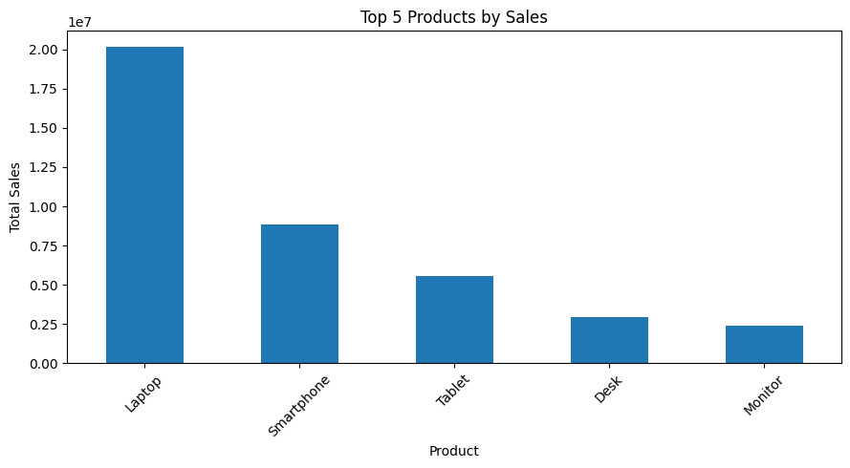

<Figure size 1000x500 with 1 Axes>
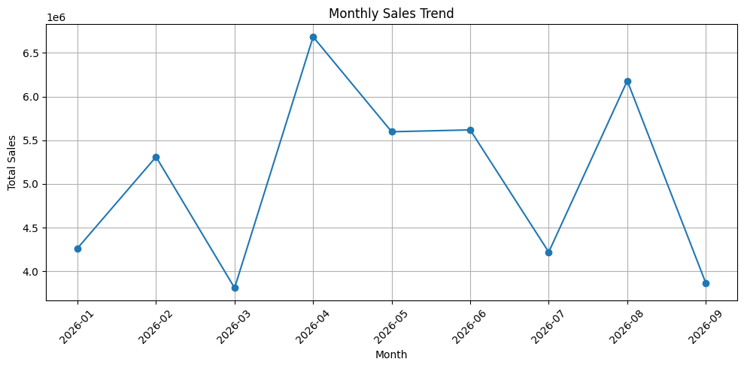

15. IDENTIFY KEY FINDINGS
Python Code
# Identify highest-performing items
top_product = product_summary.index[0]
top_product_sales = product_summary.iloc[0]["Total_Sales"]
top_category = category_summary.index[0]
top_category_sales = category_summary.iloc[0]["Total_Sales"]
top_region = region_summary.index[0]
top_region_sales = region_summary.iloc[0]["Total_Sales"]
top_month = monthly_sales["Total_Sales"].idxmax()
top_month_sales = monthly_sales["Total_Sales"].max()
print("KEY FINDINGS")
print("=" * 45)
print(f"1. Total Sales: ₹{total_sales:,.2f}")
print(f"2. Average Order Value: ₹{average_order_value:,.2f}")
print(
f"3. Top Product: {top_product} "
f"(₹{top_product_sales:,.2f})"
)
print(
f"4. Top Category: {top_category} "
f"(₹{top_category_sales:,.2f})"
)
print(
f"5. Top Region: {top_region} "
f"(₹{top_region_sales:,.2f})"
)
print(
f"6. Highest Sales Month: {top_month} "
f"(₹{top_month_sales:,.2f})"
)
Actual Notebook Output
KEY FINDINGS
=============================================
1. Total Sales: ₹45,554,764.33
2. Average Order Value: ₹91,109.53
3. Top Product: Laptop (₹20,169,801.79)
4. Top Category: Electronics (₹37,015,401.13)
5. Top Region: South (₹13,752,337.91)
6. Highest Sales Month: 2026-04 (₹6,684,316.12)

16. FINAL SUMMARY TABLE
Python Code
# Final summary table
summary = pd.DataFrame({
"Metric": [
"Total Orders",
"Total Sales",
"Average Order Value",
"Top Product",
"Top Category",
"Top Region",
"Best Sales Month"
],
"Value": [
total_orders,
f"₹{total_sales:,.2f}",
f"₹{average_order_value:,.2f}",
top_product,
top_category,
top_region,
top_month
]
})
display(summary)
Actual Notebook Output
index | Unnamed: 0 | Metric | Value
0 | 0 | Total Orders | 500
1 | 1 | Total Sales | ₹45,554,764.33
2 | 2 | Average Order Value | ₹91,109.53
3 | 3 | Top Product | Laptop
4 | 4 | Top Category | Electronics
5 | 5 | Top Region | South
6 | 6 | Best Sales Month | 2026-04

17. KEY FINDINGS
- Total Sales: ₹45,554,764.33
- Average Order Value: ₹91,109.53
- Top Product: Laptop (₹20,169,801.79)
- Top Category: Electronics (₹37,015,401.13)
- Top Region: South (₹13,752,337.91)
- Highest Sales Month: 2026-04 (₹6,684,316.12)

18. RESULT
The sales dataset was successfully analyzed using Python, Pandas, NumPy, and Matplotlib. The notebook confirmed 500 orders and ₹45,554,764.33 in total sales. The analysis verified the Sales values, generated product, category, region, and monthly summaries, and produced sales visualizations. The analyzed dataset was saved successfully with 500 rows and 10 columns.

19. CONCLUSION
This task provided practical experience in sales data analysis using Python and Pandas. The dataset was inspected, validated, analyzed, and visualized. The analysis identified the leading product, category, region, and sales month and prepared the analyzed dataset for further use.

