Project Title
Efficient Text Search and Retrieval Techniques for Healthcare Systems

Data Structures and Algorithms -3 (25CS2103E)
in

A.Y. 2026-2027

Submitted by
M.Mohana Asmitha – 2520030486
G.Laasya Chowdary – 2520030118
Ch.Nohitha – 2520030130
K.Dheeraj – 2520030193

Team Number :
Section:

Under the guidance of

Faculty Name: Dr S Madhavi

Department : CSE
Hyderabad-500090, Telangana, India.

K L (Deemed to be) University
DEPARTMENT OF COMPUTER SCIENCE ENGINEERING



DECLARATION

The Mini Project Report entitled “Efficient Text Search and Retrieval Techniques for Healthcare Systems” is a record of Bonafide work of M.Mohana Asmitha – 2520030486,G.Laasya Chowdary – 2520030118,Ch.Nohitha – 2520030130,K.Dheeraj – 2520030193 submitted in partial fulfillment for the award of B. Tech in Computer Science and Engineering to the K L University. The results embodied in this report have not been copied from any other departments/University/Institute.

Name : M.Mohana Asmitha – Roll.No. : 2520030486
Name : G.Laasya Chowdary – Roll.No. : 2520030118
Name : Ch.Nohitha – Roll.No. : 2520030130
Name : K.Dheeraj – Roll.No. : 2520030193

K L (Deemed to be) University
DEPARTMENT OF COMPUTER SCIENCE ENGINEERING
CERTIFICATE

This is to certify that the mini project based report entitled “Efficient Text Search and Retrieval Techniques for Healthcare Systems” is a bonafide work done and submitted by M.Mohana Asmitha – 2520030486,G.Laasya Chowdary – 2520030118,Ch.Nohitha – 2520030130,K.Dheeraj – 2520030193 in partial fulfillment of the requirements for the award of the degree of BACHELOR OF TECHNOLOGY in Department of Computer Science Engineering, K L (Deemed to be University), during the academic year 2026-2027.

Signature of the Supervisor

Signature of the HOD Signature of the External Examiner

ACKNOWLEDGEMENT

The success in this project would not have been possible but for the timely help and guidance rendered by many people. Our wish to express my sincere thanks to all those who has assisted us in one way or the other for the completion of my project.

Our greatest appreciation to my guide, Dr S Madhavi, Department of Computer Science and Engineering, which cannot be expressed in words for his/her tremendous support, encouragement and guidance for this project.

We express our gratitude to Dr. P.Venkateshwar Rao (CSE)/Dr. Khaja Shareef (CSIT)/ Dr. Sreenath Itikela (AI&DS), Head of the Department for Computer Science Engineering/ Department for Computer Science and Information Technology/Department of Artificial Intelligence and Data Science for providing us with adequate facilities, ways and means by which we are able to complete this project-based Lab.

We thank all the members of teaching and non-teaching staff members, and also who have assisted me directly or indirectly for successful completion of this project. Finally, I sincerely thank my parents, friends and classmates for their kind help and cooperation during my work.

M.Mohana Asmitha – 2520030486
G.Laasya Chowdary – 2520030118
Ch.Nohitha – 2520030130
K.Dheeraj – 2520030193

TABLE OF CONTENTS

S.No. | Contents | Page no.
1. | Abstract | 6
2. | Introduction | 7
3. | Literature survey | 8
4. | Problem Statement and Objectives | 9
5. | Hardware and Software requirements | 10
6. | Implementation | 11
7. | Results & Discussion | 16
8. | Conclusion & Future Scope | 19
9. | References | 20

1.ABSTRACT

In modern healthcare systems, quick and accurate retrieval of information such as drug names, symptoms, diagnoses, and patient details is important. HealthQuery provides a smart search platform that organizes medical information and helps users find relevant records efficiently.
- Smart Medical Search: Supports exact and fuzzy searching for patient and medical information.
- Spelling Correction: Handles misspelled medical terms using Minimum Edit Distance.
- DSA-Based Processing: Applies string matching and Dynamic Programming for efficient text processing.
- Hospital Resource Allocation: Models department capacity using Maximum Flow.
- Performance Evaluation: Uses benchmark testing to evaluate search and correction performance.
Overall, HealthQuery combines medical information management and DSA techniques to provide a practical solution for healthcare search and information processing.
Team Name:

Team Logo (if any):

Team Members:
1.M.Mohana Asmitha – 2520030486
2.G.Laasya Chowdary – 2520030118
3.Ch.Nohitha – 2520030130
4.K.Dheeraj – 2520030193

- INTRODUCTION

• Medical patient records contain large amounts of information such as patient details, diagnoses, symptoms, medications, and departments.
• Searching this information using only exact matching can fail when users enter spelling mistakes or incomplete medical terms.
Traditional search methods can result in:
• Difficulty finding relevant patient records
• Missed results due to spelling errors
• Inefficient medical-term searching
• Difficulty comparing different string-matching techniques
• Limited evaluation of search accuracy and performance
- LITERATURE SURVEY
Existing approaches to searching medical information depend mainly on exact keyword matching, manual correction of spelling mistakes and manual allocation of hospital resources. The table below summarises these approaches, their limitations and the technique adopted in HealthQuery to overcome each of them.
Existing Approach | Limitation | Technique Used
Traditional Patient Search | Exact matching may miss relevant records | Exact + Fuzzy Search
Manual Spelling Correction | Time-consuming and inconsistent | Minimum Edit Distance (Levenshtein DP)
Manual Medical-Term Search | Spelling errors can produce no results | Levenshtein Distance for correction
Basic String Matching | May be inefficient for repeated pattern searches | Naive + KMP + Rabin-Karp
Manual Hospital Allocation | Difficult to manage department capacity | Edmonds-Karp Maximum Flow
Research Gap
- Exact matching limitations – Traditional medical search may fail when users enter misspelled or incomplete medical terms.
- Limited intelligent search – Existing basic approaches may not combine fuzzy search and automatic spelling correction effectively.
- Need for multiple DSA techniques – There is a need to combine String Matching, Levenshtein Dynamic Programming and Maximum Flow for different healthcare search and resource-allocation tasks.
- Problem Statement and Objectives
Problem Statement: To design a DSA-based system that searches patient and medical information quickly and accurately, even when the search terms are misspelled or incomplete.
Problem Description: Exact keyword searching fails when medical terms are mistyped, so relevant patient records are missed. The system must support fuzzy search, automatic spelling correction and efficient allocation of cases to hospital departments.
Objectives:
- Manage and search patient records efficiently.
- Provide exact and fuzzy search for medical information.
- Detect and correct misspelled medical terms.
- Apply Naive, KMP and Rabin-Karp string-matching techniques.
- Use Levenshtein Distance with Dynamic Programming for spelling correction.
- Compare the performance and accuracy of different searching techniques.
- Evaluate the system using benchmark test cases.
- Use Edmonds-Karp Maximum Flow for hospital department capacity allocation.
- Provide a practical DSA-based medical search system.
- HARDWARE AND SOFTWARE REQUIREMENTS
Hardware Requirements:
- Processor: Intel Core i5 / equivalent or above
- RAM: 8 GB or above
- Storage: 256 GB or above
- Display: Standard monitor
- Internet: Not required for core system execution
Software Requirements:
- Operating System: Windows / Linux
- Programming Language: Java
- IDE: VS Code / IntelliJ IDEA / Eclipse
- JDK: Java JDK 8 or above
- Algorithms: Naive String Matching, KMP, Rabin-Karp, Levenshtein Distance (Dynamic Programming), Edmonds-Karp Maximum Flow
- Database: Patient and medical data are generated/stored within the Java application
- Visualization/Output: DP Matrix, Search Results, Benchmark Results and Maximum-Flow Network Output
- IMPLEMENTATION
HealthQuery Engine is implemented in Java and is organised into four modules. The complete source code of each module is given below.
Module 1: String Matching (StringMatcher.java)
Implements the Naive, Knuth-Morris-Pratt (KMP) and Rabin-Karp algorithms used to search a term inside patient records.
public class StringMatcher {

// 1. Naive matching - O(n * m)
public static int naive(String text, String pat) {
int n = text.length(), m = pat.length(), count = 0;
for (int i = 0; i <= n - m; i++) {
int j = 0;
while (j < m && text.charAt(i + j) == pat.charAt(j)) j++;
if (j == m) count++;
}
return count;
}

// 2. Knuth-Morris-Pratt - O(n + m)
private static int[] buildLps(String p) {
int[] lps = new int[p.length()];
for (int i = 1, len = 0; i < p.length(); ) {
if (p.charAt(i) == p.charAt(len)) lps[i++] = ++len;
else if (len > 0) len = lps[len - 1];
else lps[i++] = 0;
}
return lps;
}

public static int kmp(String text, String pat) {
int[] lps = buildLps(pat);
int count = 0;
for (int i = 0, j = 0; i < text.length(); i++) {
while (j > 0 && text.charAt(i) != pat.charAt(j)) j = lps[j - 1];
if (text.charAt(i) == pat.charAt(j)) j++;
if (j == pat.length()) { count++; j = lps[j - 1]; }
}
return count;
}

// 3. Rabin-Karp (rolling hash) - O(n + m) average
public static int rabinKarp(String text, String pat) {
final long B = 256, Q = 1_000_000_007L;
int n = text.length(), m = pat.length(), count = 0;
if (m > n) return 0;
long h = 1, pHash = 0, tHash = 0;
for (int i = 0; i < m - 1; i++) h = (h * B) % Q;
for (int i = 0; i < m; i++) {
pHash = (pHash * B + pat.charAt(i)) % Q;
tHash = (tHash * B + text.charAt(i)) % Q;
}
for (int i = 0; i <= n - m; i++) {
if (pHash == tHash && text.regionMatches(i, pat, 0, m)) count++;
if (i < n - m)
tHash = ((tHash - text.charAt(i) * h % Q + Q) * B + text.charAt(i + m)) % Q;
}
return count;
}
}
Module 2: Spelling Correction (SpellingCorrector.java)
Builds the Levenshtein DP matrix, finds the minimum edit distance and suggests the nearest dictionary word.
import java.util.List;

public class SpellingCorrector {

// Levenshtein distance using Dynamic Programming - O(m * n)
public static int[][] buildMatrix(String a, String b) {
int[][] dp = new int[a.length() + 1][b.length() + 1];
for (int i = 0; i <= a.length(); i++) dp[i][0] = i; // deletions
for (int j = 0; j <= b.length(); j++) dp[0][j] = j; // insertions
for (int i = 1; i <= a.length(); i++) {
for (int j = 1; j <= b.length(); j++) {
int cost = (a.charAt(i - 1) == b.charAt(j - 1)) ? 0 : 1;
dp[i][j] = Math.min(Math.min(dp[i - 1][j] + 1, // delete
dp[i][j - 1] + 1), // insert
dp[i - 1][j - 1] + cost); // replace / match
}
}
return dp;
}

public static int editDistance(String a, String b) {
int[][] dp = buildMatrix(a, b);
return dp[a.length()][b.length()];
}

// Suggest the dictionary word with the minimum edit distance
public static String correct(String word, List<String> dictionary) {
String best = word;
int bestDist = Integer.MAX_VALUE;
for (String w : dictionary) {
int d = editDistance(word.toLowerCase(), w);
if (d < bestDist) { bestDist = d; best = w; }
}
return best;
}

public static void printMatrix(String a, String b) {
int[][] dp = buildMatrix(a, b);
System.out.print(" ");
for (char c : b.toCharArray()) System.out.printf("%3c", c);
System.out.println();
for (int i = 0; i <= a.length(); i++) {
System.out.print(i == 0 ? " " : " " + a.charAt(i - 1) + " ");
for (int j = 0; j <= b.length(); j++) System.out.printf("%3d", dp[i][j]);
System.out.println();
}
}
}
Module 3: Hospital Resource Allocation (HospitalFlow.java)
Edmonds-Karp maximum flow on the network Source → Case types → Departments → Sink.
import java.util.*;

// Edmonds-Karp Maximum Flow: Source -> Case types -> Departments -> Sink
public class HospitalFlow {
private final int n;
private final int[][] cap, orig;

public HospitalFlow(int n) { this.n = n; cap = new int[n][n]; orig = new int[n][n]; }

public void addEdge(int u, int v, int c) { cap[u][v] += c; orig[u][v] += c; }

public int flowOnEdge(int u, int v) { return orig[u][v] - cap[u][v]; }

// BFS finds the shortest augmenting path in the residual graph
private boolean bfs(int s, int t, int[] parent) {
Arrays.fill(parent, -1);
parent[s] = s;
Queue<Integer> q = new LinkedList<>();
q.add(s);
while (!q.isEmpty()) {
int u = q.poll();
for (int v = 0; v < n; v++) {
if (parent[v] == -1 && cap[u][v] > 0) {
parent[v] = u;
if (v == t) return true;
q.add(v);
}
}
}
return false;
}

public int maxFlow(int s, int t) {
int flow = 0;
int[] parent = new int[n];
while (bfs(s, t, parent)) {
int push = Integer.MAX_VALUE;
for (int v = t; v != s; v = parent[v]) push = Math.min(push, cap[parent[v]][v]);
for (int v = t; v != s; v = parent[v]) {
cap[parent[v]][v] -= push;
cap[v][parent[v]] += push;
}
flow += push;
}
return flow;
}
}
Module 4: Main Driver (HealthQueryEngine.java)
Loads patient data, performs exact and fuzzy search, runs the spelling-correction and string-matching benchmarks and the department allocation.
import java.util.*;

public class HealthQueryEngine {

static class Patient {
int id; String name; int age; String diagnosis, symptom, medicine, dept;
Patient(int id, String name, int age, String dg, String sy, String md, String dp) {
this.id = id; this.name = name; this.age = age;
diagnosis = dg; symptom = sy; medicine = md; dept = dp;
}
String record() {
return (name + " " + diagnosis + " " + symptom + " " + medicine
+ " " + dept).toLowerCase();
}
public String toString() {
return String.format("ID %-3d %-16s Age %-3d %-13s %-12s %-14s %s",
id, name, age, diagnosis, symptom, medicine, dept);
}
}

static List<Patient> patients = new ArrayList<>();
static List<String> dictionary = Arrays.asList(
"diabetes", "hypertension", "pneumonia", "asthma", "migraine", "fever", "cough",
"tuberculosis", "malaria", "dengue", "typhoid", "bronchitis", "arthritis",
"paracetamol", "insulin", "amoxicillin", "ibuprofen", "metformin", "cardiology");

static void loadData() {
patients.add(new Patient(101, "Ravi Kumar", 54, "diabetes",
"fatigue", "metformin", "Endocrinology"));
patients.add(new Patient(102, "Anita Sharma", 41, "hypertension",
"headache", "amlodipine", "Cardiology"));
patients.add(new Patient(103, "Suresh Reddy", 67, "pneumonia",
"cough", "amoxicillin", "Pulmonology"));
patients.add(new Patient(104, "Meena Iyer", 29, "asthma",
"wheezing", "salbutamol", "Pulmonology"));
patients.add(new Patient(105, "Farhan Ali", 35, "dengue",
"fever", "paracetamol", "General Medicine"));
patients.add(new Patient(106, "Lakshmi Devi", 62, "diabetes",
"thirst", "insulin", "Endocrinology"));
patients.add(new Patient(107, "Kiran Rao", 48, "arthritis",
"joint pain", "ibuprofen", "Orthopedics"));
patients.add(new Patient(108, "Sana Begum", 33, "migraine",
"headache", "paracetamol", "Neurology"));
}

// Exact search using KMP over each patient record
static List<Patient> exactSearch(String term) {
List<Patient> res = new ArrayList<>();
for (Patient p : patients)
if (StringMatcher.kmp(p.record(), term.toLowerCase()) > 0) res.add(p);
return res;
}

// Fuzzy search: match any word of a record within an edit distance threshold
static List<Patient> fuzzySearch(String term, int maxDist) {
List<Patient> res = new ArrayList<>();
for (Patient p : patients)
for (String w : p.record().split("\\s+"))
if (SpellingCorrector.editDistance(term.toLowerCase(), w) <= maxDist) {
res.add(p);
break;
}
return res;
}

static void print(String title) { System.out.println("\n===== " + title + " ====="); }

public static void main(String[] args) {
loadData();
System.out.println("HealthQuery Engine | " + patients.size()
+ " patient records loaded");

print("1. PATIENT SEARCH - EXACT (KMP)");
System.out.println("Query: \"diabetes\"");
for (Patient p : exactSearch("diabetes")) System.out.println(p);

print("2. PATIENT SEARCH - EXACT vs FUZZY");
String bad = "diabtes";
System.out.println("Query: \"" + bad + "\"");
System.out.println("Exact search results : " + exactSearch(bad).size());
List<Patient> fz = fuzzySearch(bad, 2);
System.out.println("Fuzzy search results : " + fz.size()
+ " (edit distance <= 2)");
for (Patient p : fz) System.out.println(p);

print("3. SPELLING CORRECTION + LEVENSHTEIN DP MATRIX");
String wrong = "astma";
String fix = SpellingCorrector.correct(wrong, dictionary);
System.out.println("Input: \"" + wrong + "\" Suggestion: \"" + fix
+ "\" Edit distance: " + SpellingCorrector.editDistance(wrong, fix));
SpellingCorrector.printMatrix(wrong, fix);

print("4. SPELLING CORRECTION BENCHMARK");
String[][] tests = {
{"paracetmol", "paracetamol"}, {"diabtes", "diabetes"},
{"hypertenson", "hypertension"}, {"pnumonia", "pneumonia"},
{"migrane", "migraine"}, {"asthama", "asthma"}, {"denge", "dengue"},
{"bronchitus", "bronchitis"}, {"arthritus", "arthritis"},
{"insuline", "insulin"} };
int ok = 0;
for (String[] t : tests) {
String got = SpellingCorrector.correct(t[0], dictionary);
boolean pass = got.equals(t[1]);
if (pass) ok++;
System.out.printf("%-14s -> %-14s (d=%d) %s%n", t[0], got,
SpellingCorrector.editDistance(t[0], got), pass ? "PASS" : "FAIL");
}
System.out.printf("Correction accuracy: %d / %d = %.1f%%%n",
ok, tests.length, 100.0 * ok / tests.length);

print("5. STRING MATCHING COMPARISON");
StringBuilder sb = new StringBuilder();
for (int i = 0; i < 20000; i++)
for (Patient p : patients) sb.append(p.record()).append(' ');
String text = sb.toString();
String rep = new String(new char[200000]).replace('\0', 'a');
runBench("Medical records", text, "hypertension");
runBench("Repetitive text ", rep, "aaaaaaaaaaaaaaaaaaaaab");

print("6. HOSPITAL DEPARTMENT CAPACITY (EDMONDS-KARP MAX FLOW)");
// 0 Source | 1-4 case types | 5-8 departments | 9 Sink
String[] names = {"Source", "Cardiac cases", "Respiratory cases", "Fever cases",
"Diabetes cases", "Cardiology", "Pulmonology", "General Medicine",
"Endocrinology", "Sink"};
HospitalFlow g = new HospitalFlow(10);
g.addEdge(0,1,12); g.addEdge(0,2,10); g.addEdge(0,3,15); g.addEdge(0,4,8);
g.addEdge(1,5,12); g.addEdge(1,7,12);
g.addEdge(2,6,10); g.addEdge(2,7,10);
g.addEdge(3,7,15);
g.addEdge(4,8,8); g.addEdge(4,7,8);
g.addEdge(5,9,10); g.addEdge(6,9,8); g.addEdge(7,9,20); g.addEdge(8,9,6);
int total = g.maxFlow(0, 9);
System.out.println("Waiting cases : 45 Total bed capacity : 44");
int[][] dep = {{5,9},{6,9},{7,9},{8,9}};
for (int[] e : dep)
System.out.printf("%-18s admitted: %2d / %2d beds%n", names[e[0]],
g.flowOnEdge(e[0], e[1]), new int[]{10, 8, 20, 6}[e[0] - 5]);
System.out.println("Maximum cases that can be allocated = " + total);
}

static void runBench(String label, String text, String pat) {
StringMatcher.naive(text, pat); // warm-up runs
StringMatcher.kmp(text, pat);
StringMatcher.rabinKarp(text, pat);
long t0 = System.nanoTime(); int a = StringMatcher.naive(text, pat);
long t1 = System.nanoTime(); int b = StringMatcher.kmp(text, pat);
long t2 = System.nanoTime(); int c = StringMatcher.rabinKarp(text, pat);
long t3 = System.nanoTime();
System.out.println(label + " (" + text.length() + " chars), pattern \""
+ pat + "\"");
System.out.printf(" Naive : %5d matches %8.3f ms%n", a, (t1 - t0) / 1e6);
System.out.printf(" KMP : %5d matches %8.3f ms%n", b, (t2 - t1) / 1e6);
System.out.printf(" Rabin-Karp : %5d matches %8.3f ms%n", c, (t3 - t2) / 1e6);
}
}
- RESULTS & DISCUSSION
The program was compiled and run with Java (JDK 21). The table summarises the results, and the screenshots that follow show the output of each feature with a short explanation.
Metric | Result
Exact search for "diabetes" | 2 patient records found
Search for misspelled "diabtes" | 0 exact matches; 2 records found by fuzzy search
Edit distance "astma" → "asthma" | 1 (one insertion)
Spelling correction accuracy | 10 / 10 test words corrected (100%)
String matching (Naive, KMP, Rabin-Karp) | All three return identical match counts
Maximum flow (department allocation) | 44 of 45 waiting cases allocated

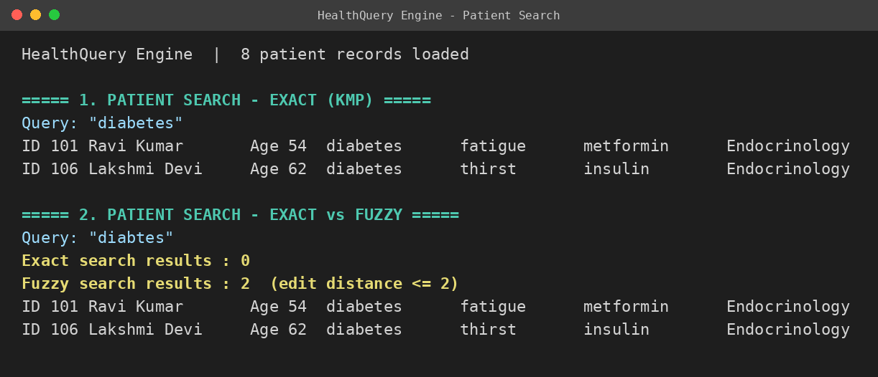
Figure 1: Patient search – exact vs fuzzy
The exact search for "diabetes" returns two patients. For the misspelled query "diabtes" exact search finds nothing, but fuzzy search (edit distance ≤ 2) still retrieves the same two patients.
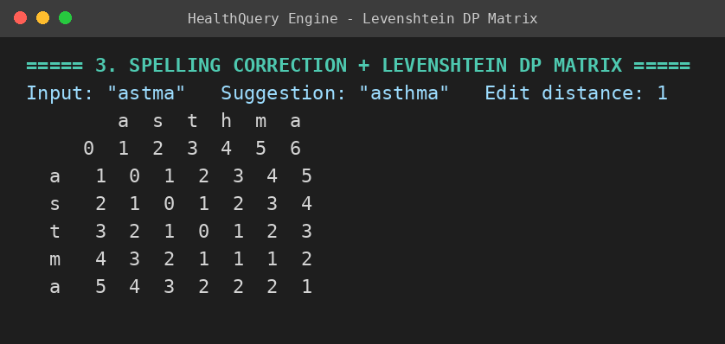
Figure 2: Levenshtein DP matrix and spelling correction
The DP matrix is filled cell by cell and the last cell gives the minimum edit distance 1 (insert "h"), so "asthma" is suggested for the input "astma".
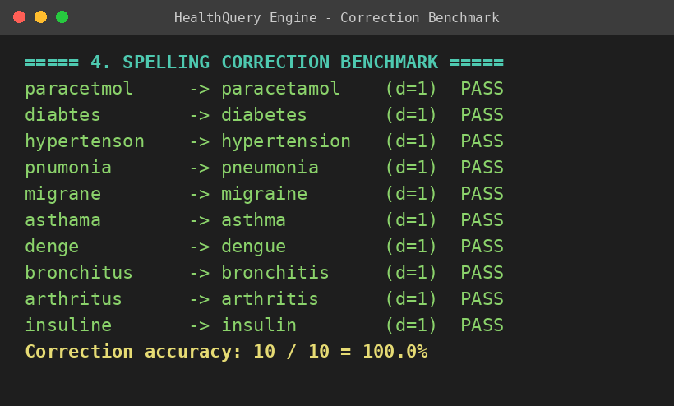
Figure 3: Spelling-correction benchmark
Ten misspelled medical terms were tested; each was corrected to the intended term at edit distance 1, giving 100% correction accuracy on this test set.
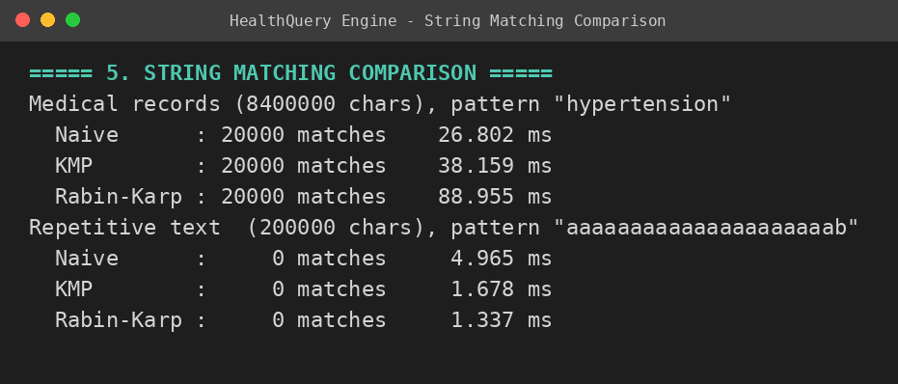
Figure 4: Naive vs KMP vs Rabin-Karp
All three algorithms report the same number of matches. Naive is fastest on ordinary text with a short pattern, while KMP and Rabin-Karp are faster on highly repetitive text.
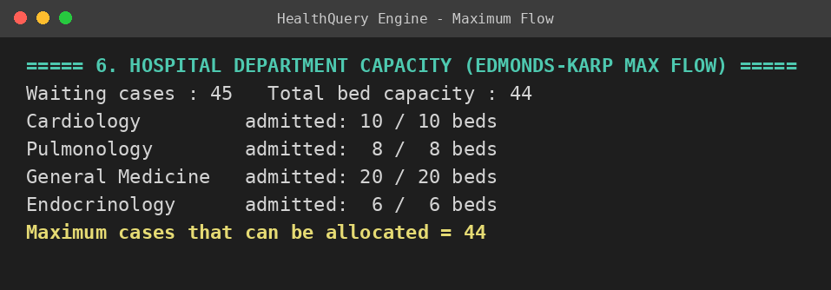
Figure 5: Hospital department capacity allocation (Edmonds-Karp)
The maximum flow is 44: every department bed is filled. One of the 45 waiting cases cannot be admitted because total bed capacity is 44.
Discussion
- Fuzzy search together with Levenshtein correction retrieves records that exact keyword matching misses, which is the main limitation identified in the problem statement.
- Naive, KMP and Rabin-Karp give identical results, so the choice depends on performance. Timings are measured on the development machine and vary from run to run.
- Edmonds-Karp shows how department capacity limits the number of cases that can be handled, helping to plan resources.
- CONCLUSION & FUTURE SCOPE
Conclusion
HealthQuery Engine provides a simple and practical platform for accessing medical patient information. The objectives of the project were met: patient records can be searched with exact and fuzzy matching, misspelled medical terms are detected and corrected using Levenshtein Distance with Dynamic Programming, Naive, KMP and Rabin-Karp string matching were implemented and compared, and Edmonds-Karp Maximum Flow was used for department capacity allocation. The benchmark test cases corrected all ten misspelled terms and the three string-matching algorithms returned identical results.
The system brings patient records, medical information and search capabilities together in one platform and makes searching faster, easier and more flexible, especially when medical terms are entered incorrectly. It also shows how computational techniques can be applied to real-world healthcare problems and how a well-designed digital system can improve the accessibility and organisation of medical information.
Future Scope
Near term
- Advanced medical terminology support for more diseases, medicines, symptoms and abbreviations.
- Secure login and access control to protect sensitive patient information.
- Real-time patient information updates to keep medical records current.
Medium term
- Integration with real hospital databases to handle larger volumes of patient records.
- Web and mobile applications so that doctors and healthcare staff can use the system easily.
- Voice-based search to look up patient or medical information using voice commands.
Long term
- AI-based medical search for more intelligent and personalised information retrieval.
- Scalable cloud-based deployment to support multiple hospitals and users.
- Integration with healthcare systems such as Electronic Health Records (EHR) for wider practical use.
- REFERENCES
[1] T. H. Cormen, C. E. Leiserson, R. L. Rivest and C. Stein, Introduction to Algorithms, 4th ed. Cambridge, MA, USA: MIT Press, 2022.
[2] R. Sedgewick and K. Wayne, Algorithms, 4th ed. Boston, MA, USA: Addison-Wesley, 2011.
[3] D. E. Knuth, J. H. Morris and V. R. Pratt, "Fast pattern matching in strings," SIAM Journal on Computing, vol. 6, no. 2, pp. 323–350, 1977.
[4] R. M. Karp and M. O. Rabin, "Efficient randomized pattern-matching algorithms," IBM Journal of Research and Development, vol. 31, no. 2, pp. 249–260, 1987.
[5] V. I. Levenshtein, "Binary codes capable of correcting deletions, insertions and reversals," Soviet Physics Doklady, vol. 10, no. 8, pp. 707–710, 1966.
[6] Oracle Corporation, "Java Platform, Standard Edition Documentation." [Online]. Available: https://docs.oracle.com/en/java/

