A CASE-STUDY BASED REPORT
ON
SOIL NUTRIENT ANALYSIS USING DATA CLEANING, FEATURE ENGINEERING AND PRINCIPAL COMPONENT ANALYSIS
submitted in partial fulfilment of the requirements for the Course
MACHINE LEARNING
BACHELOR OF TECHNOLOGY
in
A.Y.: 2026-27
by
M. Mohana Asmitha Roll No: 2520030486
D. Khyathi Saranya Roll No: 2520030488
R. Bhavitha Roll No: 2520030489
Under the Esteemed guidance of
Dr.Y.Lakshmi Prasanna
Asst.Professor, Dept. of CS&IT




INDEX
Abstract 3
Introduction 4
Background 4
Motivation for the Project 4
Overview of the Work Carried Out 4
Scope and Responsible-Use Statement 5
Problem Statement 6
Case-Study Scenario 6
Central Case-Study Question 6
Formal Problem Definition 6
Objectives that Guide the Study 6
Assumptions and Limitations 7
Dataset and Exploratory Data Analysis 8
About the Dataset 8
Purpose of EDA 8
Preparation Steps Actually Performed 8
EDA Exploration - Implementation 10
Summary of EDA Findings 11
Algorithm Selection and Implementation 12

Conclusion 17

Signature of the Team members

Abstract
Soil quality decides how well crops grow, yet the data used to describe it is hard to read. A single soil sample is described by several measurements at once: nitrogen (N), phosphorus (P), potassium (K), pH, temperature, humidity and rainfall. Many of these move together, so the same information is repeated in several columns and the overall pattern is difficult to see.
This case study takes a dataset of 470 soil and climate samples covering 22 crops and asks one question: can the correlated soil measurements be compressed into a few meaningful components without losing the important patterns, and what is the price of doing so? The work follows a clear pipeline. First, the data is cleaned (missing values, duplicates, invalid readings and outliers). Second, eight new agronomic features are engineered, such as a moisture index, nutrient ratios and a fertility index, and every selected feature is standardised with Z-scores. Third, Principal Component Analysis (PCA), coded from scratch with the Jacobi eigenvalue method, reduces seven features to a small number of components.
Three components keep 72.8% of the total variance and five keep 96.9%. The components can be explained in plain agronomic terms: water availability (31.8%), the potassium–phosphorus reserve (26.5%), a humidity–nitrogen balance (14.5%), soil acidity (13.3%) and nitrogen–phosphorus supply (10.8%). As a check, a k-nearest-neighbour classifier scores 90.4% accuracy on all seven features and 77.7% on three components, so reducing seven features to three costs 12.7 percentage points. The study is delivered with an interactive web dashboard, TerraPCA, that lets a user run every stage.
Keywords: soil nutrients; data cleaning; feature engineering; Principal Component Analysis; dimensionality reduction; standardisation; k-nearest neighbours; crop recommendation
Introduction
Background
Plants take water and nutrients from the soil. The three main nutrients are nitrogen (leaf and stem growth), phosphorus (roots, flowering and energy transfer) and potassium (water regulation and resistance to stress). Soil pH controls how easily plants can absorb these nutrients, while rainfall, humidity and temperature decide how much water is available. Because different crops prefer different combinations of these conditions, soil and climate measurements are widely used to recommend crops.
Modern crop-recommendation datasets record all of these measurements for every sample. The difficulty is that the measurements are related to each other. In our data, for example, rainfall and the derived moisture index are almost the same signal (correlation 0.91), and phosphorus and potassium rise together (correlation 0.74). Looking at seven columns one at a time hides these relationships.
In simple words: A soil sample is described by seven numbers. Several of those numbers tell the same story, so we can describe the sample with fewer, cleverer numbers.
Motivation for the Project
- Hard to read: seven or more dimensions cannot be plotted, so patterns between soils stay hidden.
- Dirty data: real data contain missing entries, duplicate rows, impossible readings (such as a pH above 14) and extreme values that distort any analysis.
- Repeated information: correlated columns make models heavier and harder to interpret without adding new information.
- Need for honesty: reducing features always loses something; a good study should measure how much is lost rather than only report the gains.
Overview of the Work Carried Out
The project was carried out as a pipeline, and each stage is implemented as a separate module in the TerraPCA application:
- Data cleaning: missing values filled with the median, duplicates removed, invalid readings corrected to valid ranges, and outliers flagged with the IQR rule.
- Feature engineering: eight derived features created and the selected features standardised with Z-scores.
- Correlation analysis: a correlation matrix identified which features carry overlapping information.
- PCA: the covariance matrix was decomposed with the Jacobi eigenvalue method to obtain components, explained variance and loadings.
- Interpretation: each component was explained from its loadings as a soil factor.
- Validation: a k-nearest-neighbour classifier compared accuracy on all features with accuracy on the components.
- Web application: the TerraPCA dashboard presents every stage, adds a crop yield predictor and accepts new CSV files.
Scope and Responsible-Use Statement
Scope. The study covers tabular soil and climate data: cleaning, feature engineering, standardisation, PCA, interpretation of components and a classification check. Non-linear reduction, deep learning and live field sensors are outside the scope.
Responsible use. The results describe patterns in one dataset and are intended for learning, exploration and decision support. They do not replace laboratory soil testing or the advice of an agronomist. The yield figures produced by the web application come from a rule-based comparison with crop profiles and have not been validated against measured field yields, so they must be read as indicative only. The data contain no personal information. Conclusions about a particular field should be made only after checking local soil tests.
Problem Statement
Case-Study Scenario
Imagine an agricultural advisory team that has collected 470 soil and climate samples, each labelled with the crop that grows well there. The data has seven measurements per sample and covers 22 crops, from rice and maize to apple, grapes and coffee. The team wants to answer two practical questions: which soil factors really separate one growing condition from another, and can a simpler summary of the soil be used for visualisation and later for classification?
The team finds the raw table difficult to use. Some cells are missing or out of range, several columns are strongly related, and the columns are measured in very different units (rainfall reaches almost 300 mm while pH stays between about 4 and 10). They need a repeatable method that cleans the data, builds more informative features and finds the few directions that explain most of the variation.
Central Case-Study Question
Can seven correlated soil and climate measurements be compressed into a small number of interpretable components that preserve most of the variation in the data, and how much ability to tell crops apart is lost in the process?
Formal Problem Definition
Let X be an n × p matrix of cleaned and standardised soil features, where n = 470 samples and p = 7 features (N, P, K, pH, moisture index, rainfall, humidity). The goal is to find a p × k projection matrix W, with k < p, such that the scores Z = XW are uncorrelated and capture as much of the total variance of X as possible. The quality of the solution is judged in two ways:
- Information retained: the cumulative explained variance, Σ λ₁…λₖ / Σ λ₁…λₚ.
- Class information retained: the test accuracy of a k-NN classifier trained on Z, compared with the accuracy of the same classifier trained on X.
Objectives that Guide the Study
- Clean the soil data by treating missing, duplicate, invalid and extreme values.
- Engineer agronomic features and put all selected features on one scale.
- Study the relationships between features using descriptive statistics and a correlation matrix.
- Apply PCA, implemented from first principles, and find the number of components worth keeping.
- Explain every important component as a soil factor using its loadings.
- Measure the cost of dimensionality reduction by comparing classification accuracy with and without PCA.
- Present the whole workflow in an interactive web application.
Assumptions and Limitations
Assumptions
- The 470 samples are representative of the conditions in which the 22 crops are grown.
- The relationships between features are mostly linear, which is the situation PCA is designed for.
- Extreme values are real soil conditions unless they are physically impossible, so outliers are flagged and kept.
- The crop label is correct for each sample.
Limitations
- The dataset is small: 20 samples for most crops (maize has 30 and rice 40), so per-crop results are uncertain.
- PCA is unsupervised and linear, so it does not aim to separate classes and may miss non-linear patterns.
- Only one fixed 80/20 train-test split was used; cross-validation was not performed.
- The data have no soil type, organic matter or micronutrients, and the yield predictor is rule-based rather than trained.
Dataset and Exploratory Data Analysis
About the Dataset
The study uses a crop-recommendation style dataset in which every row is one soil and climate sample labelled with the crop grown. The file bundled with the TerraPCA application contains 470 rows and 22 crops. Rice has 40 samples, maize has 30 and each of the other 20 crops has 20, so the classes are almost balanced. There are seven numerical inputs and one categorical label.
Table 1: Attributes of the dataset
Attribute | Meaning | Unit | Role
N | Nitrogen content of soil | kg/ha | Input
P | Phosphorus content of soil | kg/ha | Input
K | Potassium content of soil | kg/ha | Input
temperature | Air temperature | °C | Input
humidity | Relative humidity | % | Input
ph | Soil pH | pH scale | Input
rainfall | Rainfall | mm | Input
label | Crop name (22 classes) | – | Target label

The 22 crops are: rice, maize, chickpea, kidney beans, pigeon peas, moth beans, mung bean, black gram, lentil, pomegranate, banana, mango, grapes, watermelon, muskmelon, apple, orange, papaya, coconut, cotton, jute and coffee.
Purpose of EDA
Exploratory Data Analysis (EDA) means looking carefully at the data before modelling. In this project EDA answers four questions: Is the data clean enough to trust? How is each feature distributed? Which features move together? Are the classes balanced? The answers decide how the data must be prepared and show why PCA is a suitable method.
Preparation Steps Actually Performed
All numbers in this chapter come from running the project’s own processing modules on the 470-sample dataset.
Step 1: Data cleaning
Table 2: Cleaning methods and the rules used
Problem | Method used | Rule or parameter
Missing values | Median imputation | Median of the feature
Duplicate records | Removal | All seven values and crop label identical
Invalid values | Clamp to valid range | pH 3–10; humidity 0–100%; temperature −5 to 55 °C; N, P, K, rainfall ≥ 0
Outliers | Flag (not remove) | Outside Q1 − 1.5×IQR or Q3 + 1.5×IQR

Table 3: Cleaning audit
Item | Source data | Stress test (noise injected)
Records before cleaning | 470 | 470
Missing values imputed | 0 | 37
Duplicates removed | 0 | 0
Invalid values corrected | 0 | 43
Outliers flagged | 89 | 99
Records after cleaning | 470 | 470

The source file is already tidy, with no missing values, duplicates or invalid readings. To show that the cleaning steps work, the application can inject synthetic errors (the stress test): then 37 missing values were filled with medians and 43 impossible values (such as a pH of 14.8 or humidity of 135%) were clamped to valid limits.
In simple words: Cleaning is like checking an exam paper before marking it: fill the blanks sensibly, remove copies and fix impossible answers, but do not throw away genuine unusual answers.
Step 2: Feature engineering
Table 4: Features created from the cleaned data
Feature | Definition | What it tells us
Moisture index | rainfall × humidity / 100 | Water actually available
Total NPK | N + P + K | Overall nutrient load
N:P, N:K, P:K ratios | N/(P+0.001), N/(K+0.001), P/(K+0.001) | Balance between nutrients
Temperature–humidity index | 0.8T + H(T − 14.4)/100 + 46.4 | Combined heat and moisture stress
Fertility index | 100 × (0.3 nₛ + 0.3 pₛ + 0.3 kₛ + 0.1 phₛ) | Single fertility score (0–100)
pH category | Acidic < 6.0; Neutral 6.0–7.5; Alkaline > 7.5 | Soil reaction class

In the data, the fertility index averages 41.9 (range 13.0–78.4), the moisture index averages 80.5 (range 10.3–247.5) and total NPK averages 152.8 (range 26–377). By pH category there are 138 acidic, 294 neutral and 38 alkaline samples. Seven features are selected for PCA by default: N, P, K, pH, moisture index, rainfall and humidity. The total NPK and the ratios are left out because they are direct functions of N, P and K and would repeat information.
Step 3: Standardisation
PCA looks for directions of large variance, so a feature measured in large numbers (rainfall) would dominate one measured in small numbers (pH). Every selected feature is therefore converted to a Z-score:
z = (x − mean) / standard deviation
After this step every feature has mean 0 and standard deviation 1, so each one has an equal chance to influence the result.
EDA Exploration - Implementation
The EDA is implemented in the TypeScript modules of the application (dataCleaning, featureEngineering). In outline, the processing code does the following:
cleaned = cleanSoilData(raw, options) // impute, de-duplicate, clamp, flag outliers
engineered = engineerFeatures(cleaned) // 8 derived features
corr = correlationMatrix(engineered) // Pearson r for every feature pair
Z = zScore(engineered, selectedFeatures) // mean 0, std 1

Table 5: Descriptive statistics of the cleaned data (n = 470)
Feature | Mean | Std | Min | Median | Max | Skewness
N | 52.55 | 36.83 | 0.00 | 39.00 | 140.00 | 0.42
P | 52.88 | 31.89 | 5.00 | 51.00 | 145.00 | 1.06
K | 47.34 | 49.27 | 5.00 | 33.00 | 205.00 | 2.48
temperature | 25.76 | 4.97 | 8.83 | 25.61 | 42.92 | 0.26
humidity | 71.72 | 21.71 | 14.32 | 80.50 | 99.66 | -1.13
ph | 6.46 | 0.77 | 3.69 | 6.38 | 9.93 | 0.56
rainfall | 109.63 | 60.76 | 20.76 | 98.17 | 298.40 | 0.99

Table 6: Outliers flagged by the IQR rule (source data)
Feature | N | P | K | temperature | humidity | pH | rainfall
Values flagged | 0 | 39 | 40 | 21 | 10 | 9 | 18

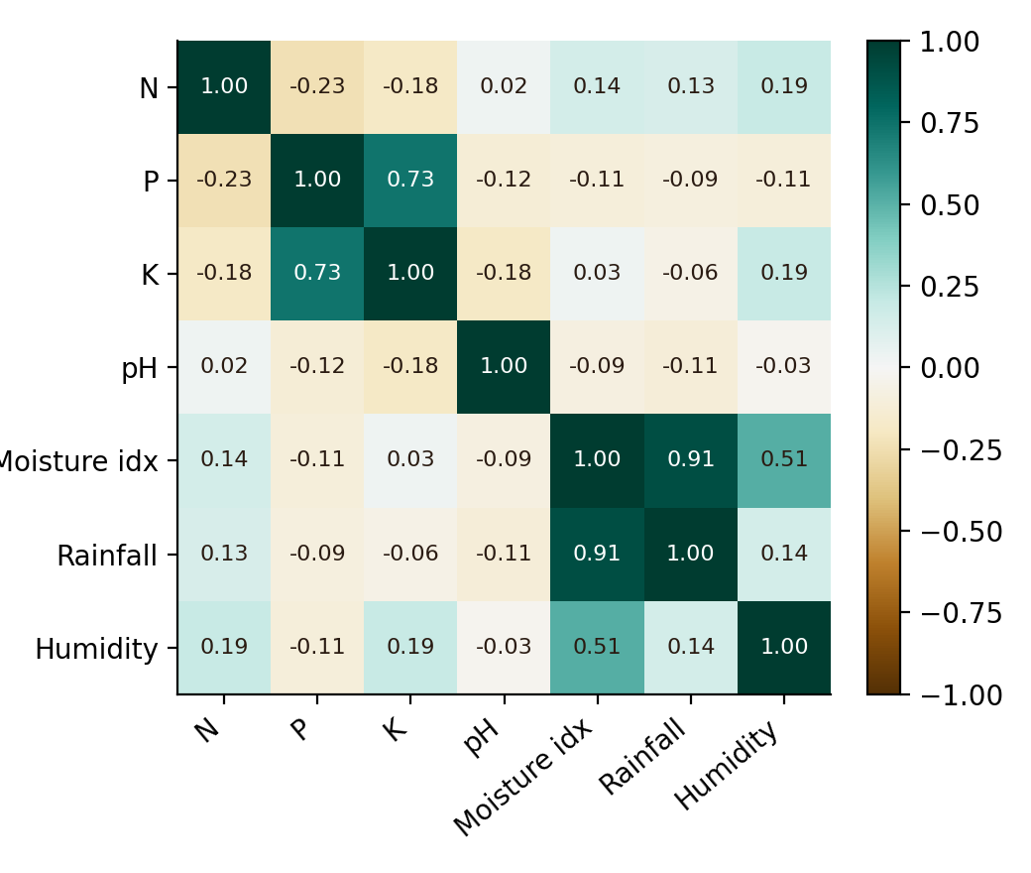
Figure 1: Correlation matrix of the seven selected features
Figure 1 shows the correlation between every pair of features. Two groups stand out: a water group (moisture index, rainfall and humidity, with moisture index–rainfall r = 0.91) and a potassium–phosphorus group (r = 0.74). All other pairs have an absolute correlation below 0.24, so nitrogen and pH are largely independent of the rest.
Summary of EDA Findings
- The data is clean: 470 records, no missing values and no duplicates; 89 samples contain at least one outlying value.
- Outliers are mostly in K (40), P (39), temperature (21) and rainfall (18). They reflect crops with unusual needs, so they are kept.
- Potassium is strongly right-skewed (skewness 2.48, maximum 205 kg/ha); phosphorus (1.06) and rainfall (0.99) are moderately skewed; humidity is left-skewed (−1.13).
- Rainfall, humidity and the moisture index form one correlated group; phosphorus and potassium form another.
- The 22 classes are almost balanced, so overall accuracy is a fair measure.
- Features have very different scales, so standardisation is necessary before PCA.
- Strong correlations mean the seven features hold repeated information, which is exactly what PCA can compress.
Algorithm Selection and Implementation
Why PCA was selected
Table 7: Options considered
Approach | Idea | Reason for / against
PCA (selected) | Linear, unsupervised; new axes that maximise variance | Fits correlated data; components are explainable through loadings; works for new samples
Linear discriminant analysis | Linear, uses class labels | Axes limited to (classes − 1); less about overall soil variation
Feature selection | Keep a subset of the original columns | Easy to explain, but correlated columns remain
t-SNE | Non-linear, for plots | Visualisation only; no loadings; cannot map new samples
Autoencoder | Neural-network compression | Needs more data; harder to explain

PCA was chosen because the correlations seen in EDA are mostly linear, the goal is to explain variation, and each component must be explained to an agronomist. The classifier used for validation is k-nearest neighbours (k = 5) because it makes no assumptions about the data and relies directly on distances, so it shows how much class information the new axes keep.
How PCA works (step by step)
- Standardise the selected features to get the matrix Z (470 × 7).
- Compute the covariance matrix C = ZᵀZ / (n − 1). For standardised data this is the correlation matrix.
- Find its eigenvalues λ and eigenvectors v, so that C v = λ v, using the Jacobi eigenvalue method.
- Sort the eigenvalues from large to small. Each eigenvalue is the variance carried by its component.
- Explained variance of a component (%) = λ / (sum of all λ) × 100.
- Loading = eigenvector element × √λ (how strongly a feature drives a component).
- Score of a sample = Z × v. These scores place every soil sample in the new component space.
In simple words: Imagine a cloud of soil samples in seven dimensions. PCA finds the direction in which the cloud is stretched the most (PC1), then the next most stretched direction at right angles (PC2), and so on. Keeping the first few directions keeps the shape of the cloud.
Implementation details
PCA was coded from scratch in TypeScript. The Jacobi method repeatedly picks the largest off-diagonal element of the symmetric matrix and applies a plane rotation that makes it zero; the rotations are accumulated into the eigenvectors. It stops when the largest off-diagonal element falls below 10⁻¹⁰ or the iteration limit is reached. As a self-check, the seven eigenvalues add up to 7.00, which equals the trace of the 7 × 7 correlation matrix, as it must.
For validation, the samples are shuffled with a fixed seed and split 80/20 into 376 training and 94 test samples. A k-NN classifier (k = 5, votes weighted by inverse distance) is trained twice on the same split: once on the seven standardised features and once on the first three principal components.
Results
Variance explained
Table 8: Eigenvalues and explained variance
Component | Eigenvalue | Variance (%) | Cumulative (%)
PC1 | 2.226 | 31.80 | 31.80
PC2 | 1.855 | 26.49 | 58.29
PC3 | 1.018 | 14.54 | 72.83
PC4 | 0.928 | 13.26 | 86.09
PC5 | 0.756 | 10.80 | 96.89
PC6 | 0.206 | 2.95 | 99.84
PC7 | 0.011 | 0.15 | 99.99

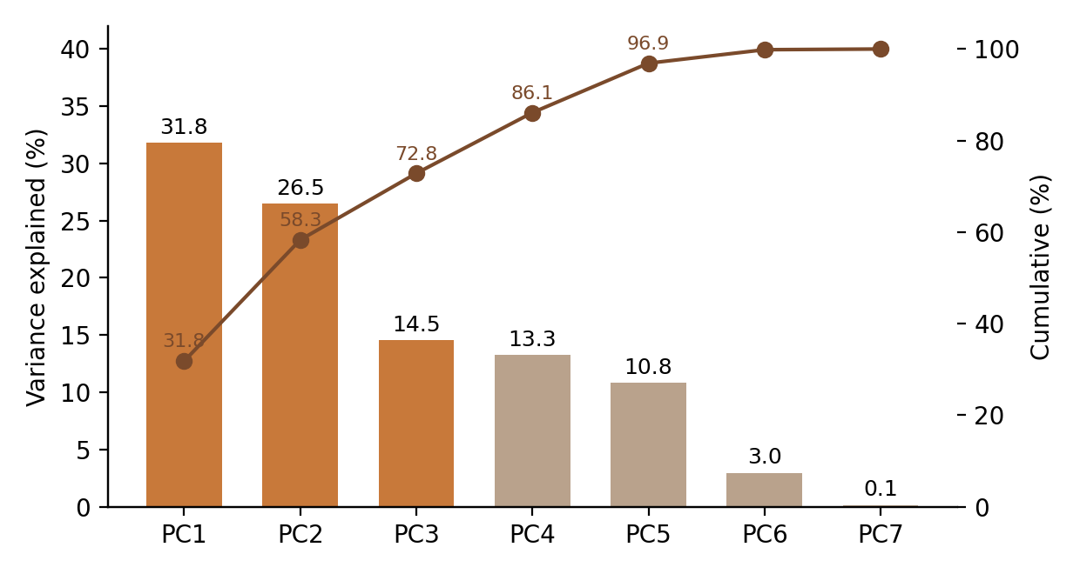
Figure 2: Scree plot and cumulative variance (components kept by default in orange)
PC1 and PC2 together explain 58.3% of the variance, three components explain 72.8% and five explain 96.9%. The last two components add only 3.1%, so they are mostly noise. Three eigenvalues are greater than 1 (2.23, 1.85, 1.02), which supports keeping three components under the Kaiser rule. Using three components reduces the number of features by 57%.
What the components mean
Table 9: Loadings of the first five components
Feature | PC1 | PC2 | PC3 | PC4 | PC5
N | 0.384 | -0.285 | 0.521 | -0.398 | 0.584
P | -0.384 | 0.808 | 0.013 | 0.111 | 0.311
K | -0.212 | 0.888 | 0.242 | 0.046 | 0.077
pH | -0.075 | -0.379 | 0.310 | 0.844 | 0.204
Moisture index | 0.934 | 0.286 | -0.125 | 0.159 | -0.007
Rainfall | 0.843 | 0.206 | -0.416 | 0.134 | 0.225
Humidity | 0.547 | 0.256 | 0.634 | 0.014 | -0.469

Table 10: Major factors behind soil nutrient variation
Component | Variance | Main drivers | Soil factor
PC1 | 31.8% | Moisture index, rainfall, humidity | Water availability
PC2 | 26.5% | Potassium, phosphorus | K–P nutrient reserve
PC3 | 14.5% | Humidity, nitrogen (against rainfall) | Humidity–nitrogen balance
PC4 | 13.3% | Soil pH | Soil acidity
PC5 | 10.8% | Nitrogen, phosphorus (against humidity) | N–P supply

PC1 is a water-availability factor, PC2 is the potassium–phosphorus reserve, PC3 contrasts humid, nitrogen-rich soils with high-rainfall ones, PC4 is almost purely soil pH and PC5 is nitrogen–phosphorus supply set against humidity. The sign of a loading is arbitrary in PCA; only the pattern within a component matters.
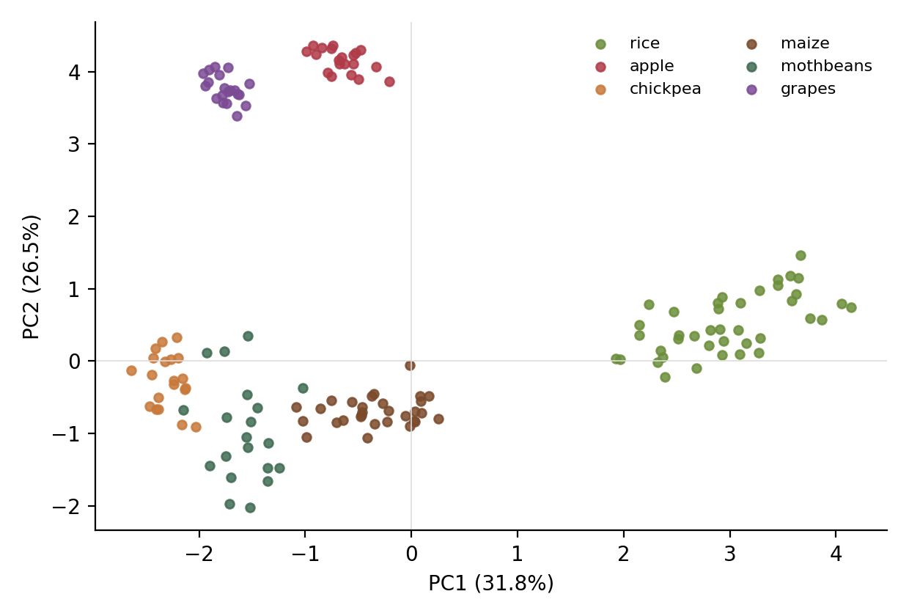
Figure 3: Samples of six crops on PC1 and PC2
Figure 3 shows the value of the reduced view. Rice sits far to the right because of high rainfall and humidity (PC1). Apple and grapes sit at the top because of very high potassium and phosphorus (PC2). Chickpea, mothbeans and maize sit together at low PC1, and chickpea and mothbeans overlap, which shows where two components are not enough.
Cost of reduction: k-NN validation
Table 11: k-NN accuracy on the 94 test samples
Feature set | Features | Source data (%) | Stress test (%)
All standardised features | 7 | 90.4 | 87.2
First 3 principal components | 3 | 77.7 | 75.5

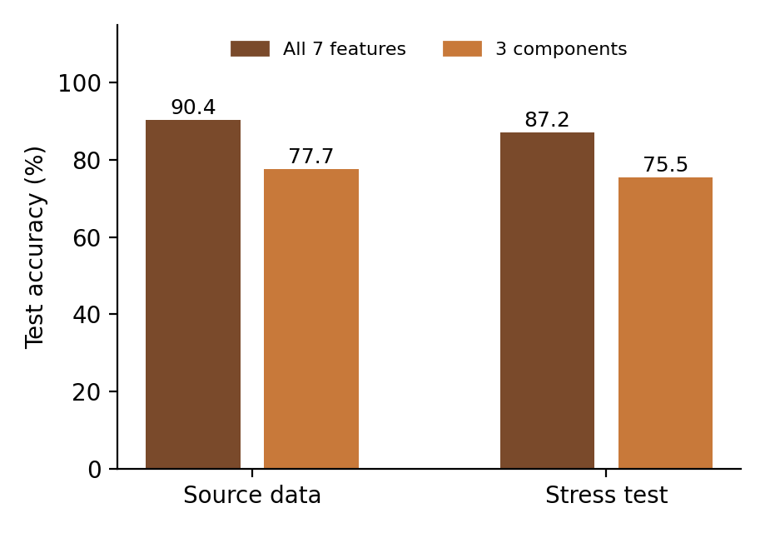
Figure 4: Accuracy with all features versus three components
With three components the classifier keeps about 86% of the full-feature accuracy (77.7 against 90.4) using 57% fewer features; the cost is 12.7 percentage points. This matches the variance figure: 27.2% of the variation is discarded, and some of it helps separate crops. The stress-test data shows the same pattern. Per crop, apple, chickpea, grapes and kidney beans are classified perfectly (F1 = 100%), while mothbeans, blackgram, coffee and jute are weakest. Each crop has only 1–10 test samples, so these per-crop values are indicative only.
Discussion
- PCA succeeded in its main aim: seven correlated features became three or five uncorrelated, explainable components.
- Three components are best for visualisation and interpretation; for the highest classification accuracy, more components or the original features should be used.
- Cleaning and standardisation are essential: without standardisation rainfall would dominate the components.
- The yield predictor in the web application is a rule-based estimate from crop profiles and is not a trained model.
Web application (TerraPCA)
The pipeline is delivered as TerraPCA, built with React, TypeScript, Vite and Tailwind CSS. It has a login screen and separate pages for data cleaning, feature engineering, PCA and major factors, and machine learning with the crop yield predictor, plus a data explorer, a project report page and a dataset manager that accepts new CSV files with automatic column mapping. All calculations run in the browser.
Conclusion
This case study showed how raw soil data can be turned into a clear, explainable summary. Data cleaning handled missing, duplicate and invalid values and flagged outliers; feature engineering added indicators such as the moisture index, nutrient ratios and a fertility index; and standardisation put all features on one scale. PCA then compressed seven correlated features into components that keep 72.8% of the variance with three components and 96.9% with five.
The components have clear agronomic meaning: water availability, the potassium–phosphorus reserve, a humidity–nitrogen balance, soil acidity and nitrogen–phosphorus supply. The k-NN check answered the central question honestly: three components give 77.7% accuracy against 90.4% for all features, so compression keeps most of the structure but not all of the class information.
Limitations and future work. The dataset is small and only one train-test split was used. Future work includes cross-validation, more soil properties and real field data, comparison with supervised and non-linear reduction (LDA, kernel PCA, autoencoders), trained models such as random forests on the components, a yield model trained on measured yields, and integration with live soil sensors.

Signature of the Team members
M. Mohana Asmitha (2520030486) ____________________
D. Khyathi Saranya (2520030488) ____________________
R. Bhavitha (2520030489) ____________________

