A PROJECT REPORT
ON
SOIL NUTRIENTS WITH PCA AND
FEATURE ENGINEERING
Submitted in partial fulfilment of the requirements for the Course
MACHINE LEARNING
BACHELOR OF TECHNOLOGY
A.Y.: 2026-27
By
Team 17
M. MOHANA ASMITHA – 2520030486
D. KHYATHI SARANYA – 2520030488
R. BHAVITHA – 2520030489
Under the Esteemed Guidance of
[Guide name : Mr G. Ravindra Gaddam]
[Department : CSE]
Department of Computer Science and Engineering
Koneru Lakshmaiah Education Foundation (Deemed to be University)
Bachupally–Gandimaisamma Road, Bowrampet, Hyderabad, Telangana – 500 043

Abstract
Soil nutrient analysis plays an important role in understanding soil quality and supporting effective agricultural practices. This project analyses soil nutrient data using data cleaning, feature engineering and Principal Component Analysis (PCA). The collected soil dataset is first cleaned by handling missing values, removing duplicate records and correcting inconsistent or invalid readings, so that later steps work on reliable data.
Feature engineering then transforms and selects relevant soil attributes, namely nitrogen, phosphorus, potassium, pH, moisture and other nutrient-related parameters, to obtain meaningful information from the data. Derived indicators such as a moisture index, total NPK pool, nutrient ratios and a soil fertility index are created, and every feature is standardised with Z-scores. PCA is then used as a dimensionality-reduction technique to transform multiple correlated soil features into a smaller set of principal components that preserve the important patterns and variation in the data.
The study uses a 470-sample, 22-crop soil dataset and seven standardised features. Three principal components retain 72.8% of the total variance and five retain 96.9%. The components are interpreted as agronomic factors: water availability (PC1, 31.8%), the potassium–phosphorus reserve (PC2, 26.5%), a humidity–nitrogen balance (PC3, 14.5%), soil acidity (PC4, 13.3%) and nitrogen–phosphorus supply (PC5, 10.8%). As a check on information retained, a k-nearest-neighbour classifier reaches 90.4% accuracy on all seven features and 77.7% on three components, a reduction from seven features to three at a cost of 12.7 percentage points.
The results identify the major factors behind soil nutrient variation and give a simpler representation of complex soil data. An interactive web dashboard, named TerraPCA, accompanies the analysis with sections for data cleaning, feature engineering, PCA, machine-learning validation and crop yield prediction. The approach supports visualisation and interpretation of soil characteristics and is a foundation for future soil classification and agricultural decision-making applications.
Keywords: soil nutrients; data cleaning; feature engineering; Principal Component Analysis; dimensionality reduction; standardisation; crop recommendation; precision agriculture

Chapter 1: Introduction

1.1 Background
Soil is the medium from which crops draw water and nutrients, and its condition strongly influences the yield and quality of what is grown. The three primary macronutrients, nitrogen (N), phosphorus (P) and potassium (K), support leaf growth, root and flower development, and water regulation and disease resistance respectively. Soil pH controls how available these nutrients and several micronutrients are, while rainfall, humidity and temperature determine how much water is present and how quickly nutrients are used or lost [8].
Modern soil surveys and crop-recommendation datasets record many such measurements for every sample. These measurements are not independent: rainfall and humidity move together, and high potassium often accompanies high phosphorus. Reading seven or more correlated variables at once is difficult, and the same underlying information is repeated in several columns. Data-driven methods are therefore needed to clean the data, build informative features and compress the correlated measurements into a small number of meaningful quantities.

1.2 Need for Soil Nutrient Analysis
Farmers, agronomists and researchers need to know which soil factors matter most and how soils differ from one another. Raw tables of nutrient values hide this structure. Real data also contain missing entries, duplicate records, impossible readings and extreme values, all of which distort any analysis built on them. A systematic pipeline of cleaning, feature engineering and dimensionality reduction turns such data into a form that can be visualised, interpreted and used for classification or crop-selection decisions.

1.3 Purpose of the Project
The purpose of this project is to design and describe a soil-analytics pipeline that cleans soil nutrient data, creates useful agronomic features, and applies PCA to reduce the number of features while preserving important information and patterns, and to present the outputs through an interactive web interface. The project aims to show how the pipeline can be built, how much information the reduced representation keeps, and how the principal components can be explained in agronomic terms.

1.4 Problem Statement
Given a soil dataset described by nitrogen, phosphorus, potassium, pH, temperature, humidity and rainfall, prepare the data and find a smaller set of features that explains most of the variation between samples. The solution must handle missing, duplicate and invalid data; create meaningful derived features; put features on a common scale; avoid redundancy among correlated variables; and provide results that an agronomist can interpret as soil factors.

1.5 Objectives
- To study soil nutrient parameters and the data-preparation and dimensionality-reduction methods relevant to them.
- To clean the data by handling missing values, removing duplicates and correcting inconsistent or invalid readings.
- To engineer features such as the moisture index, total NPK pool, nutrient ratios and a soil fertility index, and to standardise them.
- To apply Principal Component Analysis and identify the major factors contributing to soil nutrient variation.
- To validate the reduced representation by comparing a classifier trained on all features with one trained on the principal components.
- To provide an interactive website for cleaning, feature engineering, PCA, prediction and reporting.
- To discuss applications, limitations and future improvements.

1.6 Scope of the Project
The scope covers the workflow for tabular soil data: data understanding, cleaning, feature engineering, standardisation, correlation analysis, PCA, interpretation of components, a simple classification check, and a web dashboard that presents the outputs. The project concentrates on PCA as an unsupervised dimensionality-reduction method. Non-linear reduction methods, deep learning and integration with live field sensors are discussed as future extensions and are outside the present scope.

1.7 Importance of the Project
PCA is a well-established technique, and applying it to soil data gives a transparent way to see which factors dominate soil variation. Each component is a weighted combination of known soil variables, so its meaning can be read from its loadings. The approach is inexpensive to compute, runs on ordinary hardware and can be applied to any soil dataset that follows the same column structure.

Chapter 2: Literature Survey
This chapter reviews the methods relevant to the project, moving from data preparation to feature engineering, standardisation and PCA, and then to the classification check and the research gap addressed here.

2.1 Soil Nutrients and Crop Growth
Soil science texts describe nitrogen as the driver of vegetative growth, phosphorus as essential for roots and energy transfer, and potassium as important for water regulation and resistance to stress. Soil pH governs nutrient availability, and moderately acidic to neutral soils suit most crops [8]. Different crops have different preferred ranges of these variables, which is why soil measurements can be used to distinguish and recommend crops.

2.2 Data Cleaning
Data quality problems such as missing values, duplicates and out-of-range entries are common in collected data and degrade analysis [6]. Missing numerical values are often filled with the median, which is robust to extreme values. Exact duplicate rows overweight some observations. Impossible values, such as a pH above 14 or humidity above 100%, are corrected or removed. Extreme but possible values are usually flagged using the inter-quartile range (IQR) rule proposed by Tukey [7].

2.3 Feature Engineering and Standardisation
Feature engineering creates new variables from existing ones so that the information a model needs is easier to see [6]. In agronomy, ratios such as N:P and N:K and moisture-related indices are common. Because PCA finds directions of maximum variance, variables measured in large units would dominate it if left unscaled. Standardisation to zero mean and unit variance (Z-score scaling) gives every variable equal influence, and PCA on standardised data is equivalent to PCA on the correlation matrix [1][3].

2.4 Principal Component Analysis
PCA was introduced by Pearson and developed by Hotelling and is described in detail by Jolliffe [1]. It finds new, mutually uncorrelated axes, called principal components, that are linear combinations of the original variables and are ordered by the amount of variance they capture. The components are obtained from the eigenvectors of the covariance matrix, and the eigenvalues give the variance along each component. Keeping only the first few components reduces dimensionality while preserving most of the variation [2][3]. The loadings, which relate each original variable to each component, make the components interpretable.

2.5 Eigenvalue Computation
For a small symmetric matrix, the Jacobi method computes all eigenvalues and eigenvectors by applying a sequence of plane rotations that drive the off-diagonal entries to zero [9]. It is simple, numerically stable and well suited to matrices of the size used here (7 × 7), which is why it was chosen for the project implementation.

2.6 k-Nearest Neighbours
The k-nearest-neighbour rule of Cover and Hart [4] classifies a sample by the majority class among its k closest training samples. It makes no assumption about the data distribution and depends directly on the distances between samples, so the quality of the feature space matters. This makes it a convenient check of how much class information a reduced representation retains.

2.7 Comparison of Dimensionality-Reduction Approaches
Table 2.1: Comparison of approaches considered
Approach | Type | Uses class labels | Interpretable axes | Remarks
PCA | Linear | No | Yes (loadings) | Maximises variance; reusable for new samples
Linear discriminant analysis | Linear | Yes | Yes | Maximises class separation; at most (classes − 1) axes
Feature selection (filter) | Subset of features | Often | Yes | Keeps original columns; redundancy remains
t-SNE | Non-linear | No | No | Visualisation only; no mapping for new samples
Autoencoder | Non-linear | No | Limited | Needs more data and training; harder to explain

2.8 Research Gap
Many soil and crop studies apply a classifier directly to all measured variables, leaving correlated and redundant inputs in place, or present principal components without explaining what they mean in agronomic terms. There is a need for a transparent pipeline in which cleaning and feature engineering prepare the data, PCA compresses it, the components are interpreted as soil factors, and the information retained is checked against the full feature set. This project addresses that gap.

Chapter 3: Problem Analysis and Existing System

3.1 Existing Methods of Soil Data Analysis
Soil data are commonly examined through laboratory reports, spreadsheets and summary statistics of individual variables, and through simple charts of one or two variables at a time. These approaches describe each measurement but do not show how the measurements vary together.

3.2 Manual and Univariate Review
In manual review, an analyst reads tables or plots one variable at a time. This is slow for large datasets, depends on individual judgement, and cannot reveal combined patterns such as a moisture factor formed jointly by rainfall, humidity and a derived index.

3.3 Direct Use of All Features
Another common practice is to feed every available variable to a model. Correlated variables then carry repeated information, the model becomes harder to interpret, and visualisation in two or three dimensions is impossible.

3.4 Problems and Disadvantages of Existing Methods
- Data quality: missing, duplicate and invalid entries are often left untreated.
- Redundancy: correlated variables such as rainfall and moisture carry overlapping information.
- Scale: variables in different units can dominate distance-based methods.
- Interpretation: many raw variables make soil patterns hard to see and explain.
- Visualisation: seven or more dimensions cannot be plotted directly.
- Reproducibility: manual steps are rarely documented or repeatable.

3.5 Target Users
The intended users are agronomists, soil scientists, agricultural researchers, students of agricultural data science and advisers who recommend crops or fertiliser plans.

3.6 Proposed Improvement
Table 3.1: Existing approach versus proposed approach
Aspect | Existing approach | Proposed approach
Data quality | Left as collected | Median imputation, duplicate removal, range correction, outlier flagging
Features | Raw measurements only | Derived indicators: moisture index, NPK total, ratios, fertility index
Scale | Mixed units | Z-score standardisation of every feature
Redundancy | Correlated columns kept | PCA turns them into uncorrelated components
Interpretation | Variable by variable | Components explained through loadings as soil factors
Visualisation | Not possible beyond 3 variables | PC1–PC2 and PC1–PC3 projections
Validation | Rarely checked | k-NN accuracy on all features versus components
Presentation | Tables and spreadsheets | Interactive TerraPCA dashboard

Chapter 4: Proposed System

4.1 Proposed Soil Nutrient Analysis System
The proposed system accepts a soil dataset, cleans it, engineers agronomic features, standardises them, applies PCA, interprets the principal components, and validates the reduced representation with a classifier. Results are shown in the TerraPCA web application. All the processing modules are implemented in TypeScript and run in the browser, so no separate server is needed for the analysis.

4.2 System Architecture
The architecture has five layers. The data layer holds the soil dataset and the dataset manager, which accepts uploaded CSV files and maps their columns to the expected variables. The cleaning layer treats missing, duplicate, invalid and extreme values. The feature layer creates derived features and standardises them. The analysis layer performs PCA and the k-NN validation and contains the crop yield predictor. The presentation layer is the TerraPCA interface, which shows tables, charts, components and reports.

4.3 System Workflow
Figure 4.1: Workflow of the proposed system
Dataset → Data Cleaning → Outlier Check → Feature Engineering → Standardisation → Correlation Analysis → PCA → Major Factors → k-NN Validation and Crop Yield Prediction → Report
Raw soil records are loaded and inspected. Cleaning imputes missing values with the median, removes duplicates and clamps impossible values to valid ranges; outliers are flagged using the IQR rule. Feature engineering adds derived indicators, and all features are standardised. The correlation matrix is computed, and PCA is applied to the selected standardised features. The principal components are interpreted from their loadings, and a k-NN classifier compares performance on all features with performance on the components.

4.4 Functional Requirements
- The system shall load soil data from a structured file such as CSV and map its columns to N, P, K, temperature, humidity, pH, rainfall and crop label.
- The system shall report and treat missing values, duplicate records, invalid readings and outliers, and display a cleaning audit.
- The system shall create derived features and standardise the selected features.
- The system shall compute the correlation matrix and perform PCA, reporting eigenvalues, explained variance, loadings and projected samples.
- The system shall let the user choose the features used and the number of components kept.
- The system shall compare classification accuracy on the original features and on the components.
- The system shall estimate crop suitability and expected yield for entered soil conditions, and provide a login, data explorer and downloadable report.

4.5 Non-Functional Requirements
- Accuracy: numerical results should be computed correctly and reported honestly.
- Interpretability: components should be explained through their loadings.
- Performance: all steps should respond quickly on a standard computer.
- Reproducibility: the train-test split uses a fixed seed so results are repeatable.
- Usability: each stage has its own page and every setting can be changed interactively.
- Maintainability: each processing step is a separate module that can be replaced.

4.6 Hardware and Software Requirements
Table 4.1: Hardware and software requirements
Category | Requirement
Processor | Standard multi-core CPU; no GPU required
Memory | Minimum 4 GB RAM (8 GB recommended)
Storage | Few hundred MB for the project, dependencies and data
Operating system | Windows, Linux or macOS (any system that runs Node.js)
Programming language | TypeScript with React 19
Tools | Node.js, Vite, Tailwind CSS
Libraries | Lucide icons, Motion; PCA (Jacobi method) and k-NN implemented from scratch
Environment | VS Code or any code editor; a modern web browser
Dataset | Crop-recommendation style soil dataset (N, P, K, temperature, humidity, pH, rainfall, crop)

Chapter 5: Dataset and Data Preprocessing

5.1 Dataset Description
The project uses a crop-recommendation style soil dataset in which each row is one soil and climate sample labelled with the crop grown. The file bundled with the application contains 470 samples covering 22 crops: rice has 40 samples, maize has 30 and each of the remaining 20 crops has 20. The dataset therefore has seven numerical input attributes and one categorical label, listed in Table 5.1. The application also allows other CSV files to be loaded through the dataset manager, which detects the delimiter and maps column names automatically.
Table 5.1: Dataset attributes
Attribute | Description | Unit | Role
N | Nitrogen content of the soil | kg/ha | Input
P | Phosphorus content of the soil | kg/ha | Input
K | Potassium content of the soil | kg/ha | Input
temperature | Ambient temperature | °C | Input
humidity | Relative humidity | % | Input
ph | Soil pH | pH scale | Input
rainfall | Rainfall | mm | Input
label | Crop name (22 classes) | – | Label

5.2 Missing Values
Missing numerical values are replaced by the median of the feature, which is robust to extreme values. Other strategies (mean, zero or dropping the row) can be selected in the application. The source file contains no missing values, so the median step changes nothing on it. To show the step working, the application has a stress-test option that injects synthetic missing and invalid values into the data; with it enabled, 37 missing values are found and imputed.

5.3 Duplicate Records
A record is treated as a duplicate when all seven measurements (compared at fixed decimal precision) and the crop label match another record. Duplicates are removed because repeated rows overweight some observations. No duplicates were found in the source data or in the stress-test data.

5.4 Inconsistent and Invalid Data
Each reading is checked against physically valid ranges (Table 5.2). Out-of-range values are clamped to the nearest limit, although dropping the row is also available. The source data contain no invalid values; the stress test injects pH values of 14.8, humidity values of 135% and negative potassium, and 43 corrections were made.
Table 5.2: Valid ranges used for correction
Variable | Valid range
pH | 3.0 to 10.0
Humidity | 0 to 100 %
Temperature | −5 to 55 °C
N, P, K | ≥ 0
Rainfall | ≥ 0

5.5 Outlier Detection
Outliers are detected with the IQR rule: a value is flagged if it lies below Q1 − 1.5 × IQR or above Q3 + 1.5 × IQR for its feature. Extreme soil values are not automatically errors, since some crops are naturally grown in very high-potassium or very wet soils. The default action is therefore to flag, not remove; winsorising and removal are available options. In the source data 89 of the 470 samples have at least one flagged value (Table 5.3).
Table 5.3: Outlier counts per feature (IQR rule, source data)
Feature | Values flagged
N | 0
P | 39
K | 40
temperature | 21
humidity | 10
ph | 9
rainfall | 18

5.6 Cleaning Audit
Table 5.4: Cleaning audit report
Stage | Source data | Stress test
Records before cleaning | 470 | 470
Missing values imputed (median) | 0 | 37
Duplicate records removed | 0 | 0
Invalid values corrected | 0 | 43
Outliers flagged | 89 | 99
Outliers removed | 0 | 0
Records after cleaning | 470 | 470

5.7 Standardisation
Variables have very different scales: rainfall ranges up to about 300 mm while pH lies between 3.7 and 9.9. PCA would be dominated by the large-scale variables if the data were not standardised. Each feature is therefore converted to a Z-score using the sample standard deviation, so that every feature has zero mean and unit variance.
z = (x − μ) / σ

Chapter 6: Feature Engineering and Exploratory Data Analysis

6.1 Derived Agronomic Features
Eight features are derived from the cleaned data. Five of them (the moisture index, the total NPK pool and the three nutrient ratios) join the seven original variables to form the 12 features that can be selected for PCA in the application. The temperature–humidity index, the fertility index and the pH category are computed to describe each sample.
Table 6.1: Engineered features
Feature | Definition | Purpose
Moisture index | rainfall × (humidity / 100) | Water actually available to the crop
Total NPK pool | N + P + K | Overall macronutrient load
N:P ratio | N / (P + 0.001) | Vegetative versus reproductive balance
N:K ratio | N / (K + 0.001) | Balance that limits stem weakness and excess uptake
P:K ratio | P / (K + 0.001) | Root-to-fruit translocation balance
Temperature–humidity index | 0.8T + H(T − 14.4)/100 + 46.4 | Combined heat and moisture stress
Soil fertility index | weighted score of N, P, K and pH (0–100) | Single summary of fertility
pH category | Acidic < 6.0; Neutral 6.0–7.5; Alkaline > 7.5 | Soil reaction class

The fertility index is computed as 100 × (0.3·nₛ + 0.3·pₛ + 0.3·kₛ + 0.1·phₛ), where nₛ = min(1, N/120), pₛ = min(1, P/120), kₛ = min(1, K/180) and phₛ = max(0, 1 − |pH − 6.5| / 3.5). In the dataset the fertility index has a mean of 41.9 (range 13.0 to 78.4), the moisture index a mean of 80.5 (range 10.3 to 247.5) and the total NPK pool a mean of 152.8 (range 26 to 377). By pH category, 138 samples are acidic, 294 neutral and 38 alkaline.

6.2 Feature Selection for PCA
Seven features are used for PCA by default: N, P, K, pH, moisture index, rainfall and humidity. Temperature, the total NPK pool and the three nutrient ratios are available but not selected by default. The total and the ratios are direct functions of N, P and K, so including them would add columns that repeat information already present; the selection can be changed interactively in the application.

6.3 Descriptive Statistics
Table 6.2: Descriptive statistics of the cleaned data (n = 470)
Feature | Mean | Std | Min | Median | Max | Skewness
N | 52.55 | 36.83 | 0.00 | 39.00 | 140.00 | 0.42
P | 52.88 | 31.89 | 5.00 | 51.00 | 145.00 | 1.06
K | 47.34 | 49.27 | 5.00 | 33.00 | 205.00 | 2.48
temperature | 25.76 | 4.97 | 8.83 | 25.61 | 42.92 | 0.26
humidity | 71.72 | 21.71 | 14.32 | 80.50 | 99.66 | -1.13
ph | 6.46 | 0.77 | 3.69 | 6.38 | 9.93 | 0.56
rainfall | 109.63 | 60.76 | 20.76 | 98.17 | 298.40 | 0.99

Potassium is the most skewed variable (skewness 2.48) with a long upper tail reaching 205 kg/ha, caused by the high-potassium fruit crops. Phosphorus (1.06) and rainfall (0.99) are moderately right-skewed, and humidity is left-skewed (−1.13) because many crops grow in humid conditions. Nitrogen, temperature and pH are close to symmetric.

6.4 Correlation Analysis
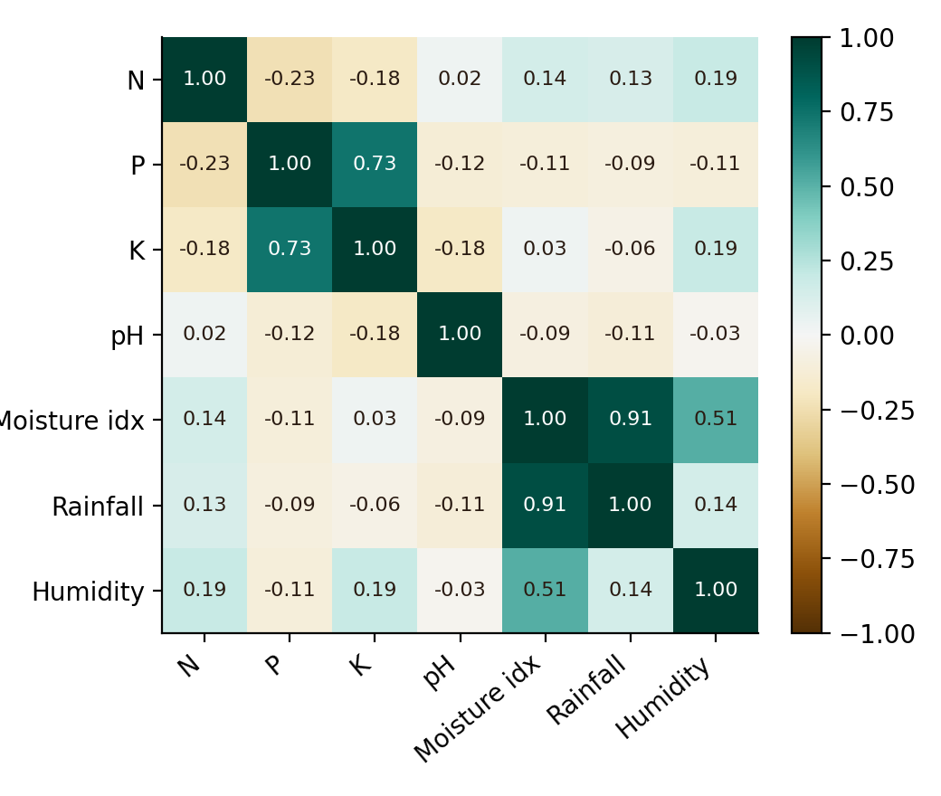
Figure 6.1: Correlation matrix of the seven selected features
The strongest relationship is between the moisture index and rainfall (r = 0.91), which is expected because the index is built from rainfall. Phosphorus and potassium are also strongly related (r = 0.74), and the moisture index is moderately related to humidity (r = 0.51). All other pairs have |r| below 0.24. These correlated groups, a water group and a P–K group, are what PCA combines into single components. Correlation indicates association and does not establish causation.

6.5 Class Distribution
The 22 crop classes are almost balanced: 20 classes have 20 samples each, maize has 30 and rice has 40. Because no class dominates, overall accuracy is a meaningful measure for the validation step, although the small class sizes mean that per-class figures are uncertain.

6.6 EDA Findings and Interpretation
- Soil samples are heterogeneous: nutrient levels differ greatly between crops.
- Potassium, phosphorus and rainfall are right-skewed because a few crops need much higher levels.
- Rainfall, humidity and the moisture index form one correlated group; phosphorus and potassium form another.
- The data contain no missing values or duplicates, but 89 samples have at least one outlying value, which is expected in a mixed-crop dataset.
- Features differ in scale, so standardisation is required before PCA.
- Extreme values are flagged and kept, since they often describe genuine crop-specific conditions.

Chapter 7: PCA Methodology

7.1 Dimensionality Reduction
Dimensionality reduction replaces a large set of correlated variables by a smaller set that keeps most of the information. In this project the aim is to replace seven standardised soil features by three to five principal components that can be plotted, interpreted and used for further analysis.

7.2 Why PCA
PCA suits soil data for three reasons. It works directly on the correlation structure identified in Chapter 6. The components are uncorrelated, which removes redundancy. Each component is a weighted sum of the original features, so its meaning can be read from the weights.

7.3 Steps of PCA
- Build the standardised data matrix Z with n samples (rows) and p features (columns).
- Compute the covariance matrix C = ZᵀZ / (n − 1). For standardised data this is the correlation matrix.
- Find the eigenvalues λ and eigenvectors v of C, using the Jacobi eigenvalue method.
- Sort the eigenvalues in decreasing order and arrange the eigenvectors accordingly.
- Compute the explained variance of each component and the cumulative variance.
- Compute the loadings and project the samples onto the first k components.
C v = λ v
Explained variance of PCₖ (%) = λₖ / Σλ × 100
Loading = eigenvector element × √λ
Scoreₖ = Z · vₖ
Table 7.1: Symbols used in PCA
Symbol | Meaning
n | Number of samples (470)
p | Number of features used (7)
Z | Matrix of standardised features
C | Covariance (here correlation) matrix of Z
λ | Eigenvalue: variance along a component
v | Eigenvector: direction of a component
k | Number of components kept
Loading | Correlation-like weight of a feature on a component

7.4 Jacobi Eigenvalue Method
The Jacobi method repeatedly selects the largest off-diagonal element of the symmetric matrix and applies a plane rotation that sets it to zero. The rotations are accumulated to give the eigenvectors. The process stops when the largest off-diagonal element falls below 10⁻¹⁰ or the iteration limit is reached. As a check on the implementation, the eigenvalues obtained here sum to 7.00, equal to the trace of the 7 × 7 correlation matrix, as they should.

7.5 Choosing the Number of Components
Three guides are used. The cumulative variance should be high enough to preserve the main patterns. The Kaiser rule suggests keeping components whose eigenvalue exceeds 1, which here gives three components. The scree plot shows where the variance curve flattens. The application defaults to three components so that samples can be shown in three dimensions, and the user can raise this to five.

7.6 Validation with k-Nearest Neighbours
To check how much class information the components retain, a k-nearest-neighbour classifier (k = 5, with votes weighted by inverse distance) is trained to predict the crop. The samples are shuffled with a fixed seed and split 80/20 into 376 training and 94 test samples. The same split is used twice: once with the seven standardised features and once with the first three principal components. The difference in accuracy shows the cost of the reduction.

7.7 Crop Yield Predictor
The application also includes a yield predictor for entered soil and climate values. For each of 22 crop profiles, a penalty is added when a value falls outside the crop’s optimal range, in proportion to how far it lies outside. Suitability is 100 minus the penalty, limited to between 5 and 99, and the expected yield is the crop’s average yield multiplied by (0.4 + 0.6 × suitability). The predictor also lists limiting factors and suggested amendments. It is a rule-based estimate from crop profiles and is not a model trained on measured yields.

Chapter 8: Model Development and Evaluation

8.1 Processing Pipeline
The steps are: load the dataset; clean it; flag outliers; engineer features; standardise; compute the correlation matrix; select features; perform PCA; project the samples; split the data with a fixed seed; run k-NN on the original features and on the components; and compute accuracy and per-class metrics.

8.2 Baseline
The baseline for judging PCA is the same k-NN classifier using all seven standardised features. Any reduction in the number of features must be weighed against the accuracy lost relative to this baseline.

8.3 Evaluation Metrics
Table 8.1: Evaluation measures
Measure | Formula | Meaning
Explained variance | λₖ / Σλ | Share of total variation captured by a component
Cumulative variance | Σ of explained variance | Information kept by the first k components
Accuracy | Correct predictions / all predictions | Overall share of test samples classified correctly
Precision (per crop) | TP / (TP + FP) | Of samples predicted as a crop, the share that truly are
Recall (per crop) | TP / (TP + FN) | Of the samples of a crop, the share found
F1-score | 2PR / (P + R) | Harmonic mean of precision and recall

In a 22-class problem, TP, FP and FN are counted for each crop against all the others. Because the classes are nearly balanced, accuracy is a reasonable overall measure.

8.4 Confusion Matrix
A 22 × 22 confusion matrix is produced by the application for the component-based classifier and is viewable on its ML page. It is not reproduced here because of its size; the per-crop precision, recall and F1 derived from it are listed in Table 9.5.

Chapter 9: Results and Discussion
All figures in this chapter were produced by running the project’s own cleaning, feature-engineering, PCA and k-NN modules on the 470-sample dataset with the default settings (median imputation, IQR outlier flagging, seven selected features, three components, 80/20 split).

9.1 Variance Explained by the Components
Table 9.1: Eigenvalues and explained variance
Component | Eigenvalue | Variance (%) | Cumulative (%)
PC1 | 2.226 | 31.80 | 31.80
PC2 | 1.855 | 26.49 | 58.29
PC3 | 1.018 | 14.54 | 72.83
PC4 | 0.928 | 13.26 | 86.09
PC5 | 0.756 | 10.80 | 96.89
PC6 | 0.206 | 2.95 | 99.84
PC7 | 0.011 | 0.15 | 99.99

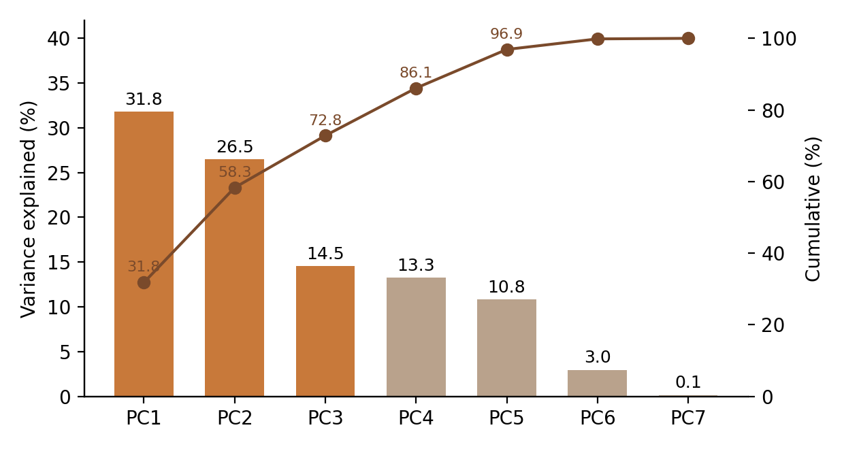
Figure 9.1: Scree plot and cumulative variance (components retained by default in orange)
The first component explains 31.8% of the variance and the second 26.5%, so two components keep 58.3%. Three components keep 72.8%, which reduces the seven features to three (a 57% reduction in dimensions). Five components keep 96.9%, and the last two add only 3.1%, so they can be treated as noise. Three eigenvalues exceed 1 (2.23, 1.85 and 1.02), which agrees with the choice of three components under the Kaiser rule.

9.2 Loadings and Major Factors
Table 9.2: Component loadings (PC1 to PC5)
Feature | PC1 | PC2 | PC3 | PC4 | PC5
N | 0.384 | -0.285 | 0.521 | -0.398 | 0.584
P | -0.384 | 0.808 | 0.013 | 0.111 | 0.311
K | -0.212 | 0.888 | 0.242 | 0.046 | 0.077
pH | -0.075 | -0.379 | 0.310 | 0.844 | 0.204
Moisture index | 0.934 | 0.286 | -0.125 | 0.159 | -0.007
Rainfall | 0.843 | 0.206 | -0.416 | 0.134 | 0.225
Humidity | 0.547 | 0.256 | 0.634 | 0.014 | -0.469

Table 9.3: Major factors contributing to soil nutrient variation
Component | Variance | Main drivers | Soil factor
PC1 | 31.8% | Moisture index (0.93), rainfall (0.84), humidity (0.55) | Water availability
PC2 | 26.5% | Potassium (0.89), phosphorus (0.81) | Potassium–phosphorus reserve
PC3 | 14.5% | Humidity (0.63), nitrogen (0.52), against rainfall (−0.42) | Humidity–nitrogen balance
PC4 | 13.3% | Soil pH (0.84) | Soil acidity
PC5 | 10.8% | Nitrogen (0.58), phosphorus (0.31), against humidity (−0.47) | Nitrogen–phosphorus supply

PC1 is a water-availability factor: the moisture index, rainfall and humidity all load strongly and positively. PC2 is the potassium–phosphorus reserve, reflecting the strong P–K correlation. PC3 contrasts humid, nitrogen-rich soils with high-rainfall ones. PC4 is almost entirely soil pH, which is only weakly correlated with the other features, so it forms its own axis. PC5 mainly describes nitrogen and phosphorus supply set against humidity. The signs of loadings are arbitrary in PCA, so only the relative pattern within a component matters.

9.3 Soil Samples in Principal-Component Space
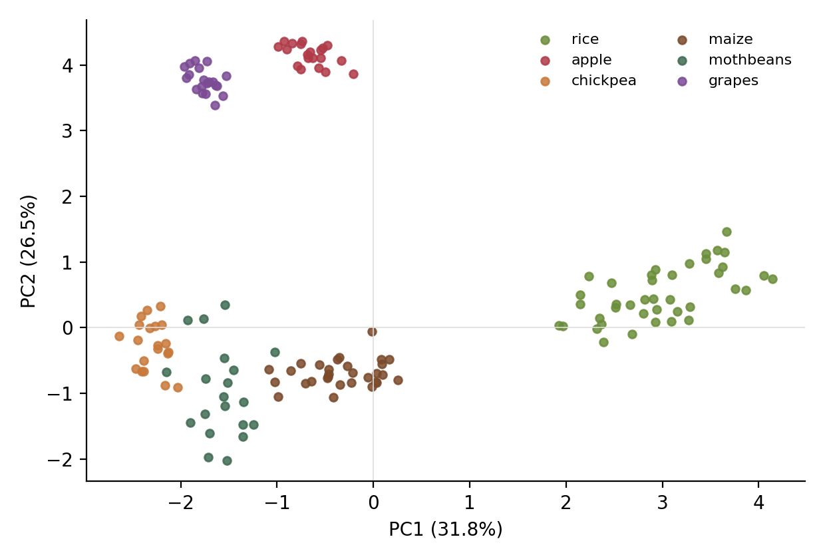
Figure 9.2: Samples of six crops projected on PC1 and PC2
Figure 9.2 shows that the first two components separate crops with distinct soil requirements. Rice lies far to the right on PC1 because it grows with high rainfall and humidity. Apple and grapes lie high on PC2 because of their very high potassium and phosphorus levels. Chickpea, mothbeans and maize sit together at low PC1, and chickpea and mothbeans overlap in this plane, so further components or the original features are needed to separate them.

9.4 Effect of Dimensionality Reduction on Classification
Table 9.4: k-NN accuracy on the test set (94 samples)
Feature set | Number of features | Source data (%) | Stress test (%)
All standardised features | 7 | 90.4 | 87.2
First 3 principal components | 3 | 77.7 | 75.5

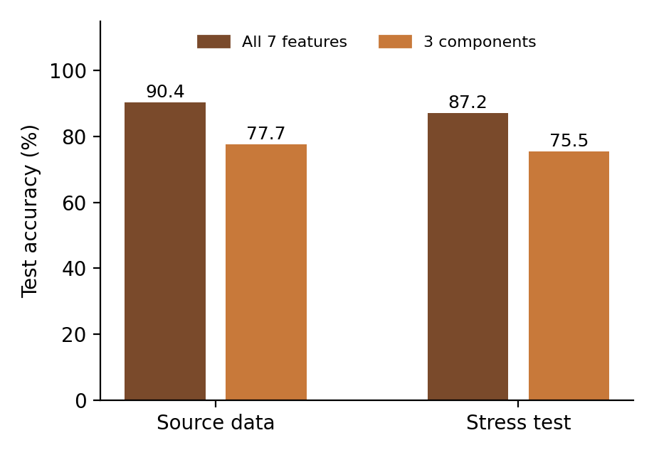
Figure 9.3: Accuracy with all features versus three components
With all seven features the classifier reaches 90.4% accuracy. With three principal components it reaches 77.7%, which is about 86% of the baseline accuracy using 57% fewer features, at a cost of 12.7 percentage points. The loss is consistent with the variance figures: three components keep 72.8% of the variance, so some class-distinguishing information in the remaining 27.2% is lost. The stress-test data show the same pattern (87.2% against 75.5%), and the cleaning steps keep the accuracy loss from the injected errors to a few percentage points. The trade-off is therefore real: three components are best suited to visualisation and interpretation, while a classifier needing the highest accuracy would use more components or the original features.

9.5 Per-Crop Results
Table 9.5: Per-crop precision, recall and F1 with three components (%)
Crop | Precision | Recall | F1 | Test samples
apple | 100.0 | 100.0 | 100.0 | 2
banana | 100.0 | 80.0 | 88.9 | 5
blackgram | 25.0 | 100.0 | 40.0 | 2
chickpea | 100.0 | 100.0 | 100.0 | 4
coconut | 100.0 | 83.3 | 90.9 | 6
coffee | 100.0 | 40.0 | 57.1 | 5
cotton | 100.0 | 57.1 | 72.7 | 7
grapes | 100.0 | 100.0 | 100.0 | 5
jute | 66.7 | 50.0 | 57.1 | 4
kidneybeans | 100.0 | 100.0 | 100.0 | 3
lentil | 83.3 | 83.3 | 83.3 | 6
maize | 100.0 | 70.0 | 82.4 | 10
mango | 40.0 | 100.0 | 57.1 | 2
mothbeans | 0.0 | 0.0 | 0.0 | 1
mungbean | 100.0 | 60.0 | 75.0 | 5
muskmelon | 75.0 | 100.0 | 85.7 | 3
orange | 66.7 | 100.0 | 80.0 | 6
papaya | 66.7 | 100.0 | 80.0 | 2
pigeonpeas | 100.0 | 40.0 | 57.1 | 5
pomegranate | 50.0 | 100.0 | 66.7 | 1
rice | 83.3 | 100.0 | 90.9 | 5
watermelon | 57.1 | 80.0 | 66.7 | 5

Apple, chickpea, grapes and kidney beans are classified perfectly, which agrees with their distinct positions in component space. Mothbeans, blackgram, coffee and jute are weakest. Each crop has only one to ten test samples, so a single error changes a crop’s figures substantially and these per-crop values should be read as indicative only.

9.6 Factors Affecting the Results
Table 9.6: Factors that may affect the results
Factor | Effect
Dataset size | With 470 samples and few per crop, per-crop results are uncertain
Choice of features | Adding or removing features changes the components; derived totals and ratios repeat N, P and K
Number of components | Fewer components give simpler data but lower classification accuracy
Standardisation | Without it, large-scale variables such as rainfall would dominate
Outlier treatment | Flagging keeps genuine extremes; removing them could change the components
Linearity | PCA captures only linear structure and may miss non-linear patterns
Single split | One 80/20 split is used; cross-validation would give a more stable estimate

Chapter 10: Web Application (TerraPCA)

10.1 Purpose
TerraPCA is an interactive web dashboard that presents each stage of the project. It is built with React and TypeScript using the Vite build tool and Tailwind CSS, and runs in a standard browser. All computation, including cleaning, PCA and k-NN, is carried out in the browser by the project’s own modules.

10.2 Modules
Table 10.1: Main sections of the interface
Section | Description
Login | Sign-in screen with researcher profiles before the dashboard is shown
Abstract and Scope | Overview of the project, abstract and workflow
1. Data Cleaning | Missing-value, duplicate, invalid-value and outlier settings, a before-and-after comparison and the cleaning audit; optional noise injection
2. Feature Engineering | Derived features, selectable feature set, standardisation and correlation matrix
3. PCA and Major Factors | Eigenvalues, explained variance, loadings, projections and the major factors behind soil variation; adjustable number of components
4. ML and Yield Predictor | k-NN comparison of original and PCA features, class metrics, and crop suitability and yield estimates from slider inputs
Project Report | Summary of results with print and Markdown download
Data Explorer | Table view of the soil records
Dataset Manager | Choose a bundled dataset or upload a CSV with automatic delimiter detection and column mapping

10.3 Prediction Flow
On the ML and Yield Predictor page the user sets N, P, K, temperature, humidity, pH and rainfall with sliders. The values are standardised with the stored means and deviations and projected onto the principal components, and the page shows the sample’s position in component space. Each crop profile is scored for suitability, and the page lists the best-matching crops with expected yield, limiting factors and suggested amendments.

10.4 Implementation Status
The pipeline results in this report come from the actual dataset bundled with the application. The yield predictor is a rule-based estimator built on crop profiles of optimal ranges, so its yield figures are indicative and have not been validated against measured field yields. The application describes some bundled datasets with nominal sample counts larger than the rows actually included; the figures in this report refer only to the 470 rows analysed.

Chapter 11: Applications, Advantages and Limitations

11.1 Applications
- Precision agriculture: understanding the main factors of soil variation across fields.
- Crop recommendation: matching soil and climate conditions to suitable crops.
- Fertiliser planning: identifying nutrient imbalances through ratios and factors.
- Agricultural research: simplifying multi-variable soil data for analysis and teaching.
- Soil classification: using components as compact inputs for classifiers.
- Visualisation: displaying soil samples in two or three dimensions.

11.2 Advantages
- Data cleaning protects the analysis from missing, duplicate and invalid entries.
- Derived features capture agronomic relationships that raw columns miss.
- PCA removes redundancy and reduces seven features to three while keeping 72.8% of the variance.
- Components are explained through loadings as understandable soil factors.
- Computation is light and runs in a browser on ordinary hardware.
- The dashboard lets users change every setting and see the effect immediately.

11.3 Limitations
- The dataset is small (470 samples, 20 to 40 per crop), so per-crop results are uncertain.
- PCA is linear and unsupervised, so it does not target class separation; accuracy falls from 90.4% to 77.7% with three components.
- Components are combinations of features and are less direct to explain than original variables.
- The yield predictor is rule-based and not validated against measured yields.
- Only one 80/20 split is used; cross-validation was not performed.
- The data do not include soil type, organic matter or micronutrients.

Conclusion
This project presented a pipeline that cleans soil nutrient data, creates useful agronomic features and uses PCA to reduce the number of features while preserving important information and patterns. Data cleaning handled missing, duplicate and invalid data and flagged outliers, and feature engineering added indicators such as the moisture index, nutrient ratios and a fertility index. After standardisation, PCA on seven features showed that three components keep 72.8% of the variance and five keep 96.9%.
The components have clear agronomic meaning: water availability, the potassium–phosphorus reserve, a humidity–nitrogen balance, soil acidity and nitrogen–phosphorus supply. These are the major factors behind soil nutrient variation in the dataset. A k-NN check showed the trade-off in practice: three components give 77.7% accuracy against 90.4% for all features, so the reduced representation is well suited to visualisation and interpretation, while more components are needed when classification accuracy is the priority. The TerraPCA dashboard presents the whole workflow in an accessible form and can serve as a foundation for soil classification and agricultural decision-making.
Future Scope
- Larger and more diverse datasets with real field measurements, soil type and organic matter.
- Cross-validation and tuning of the number of components and of k.
- Supervised and non-linear reduction such as LDA, kernel PCA or autoencoders for comparison.
- Trained models, for example random forests or gradient boosting, on the principal components.
- A yield model trained on measured yields in place of the rule-based predictor.
- Integration with live soil sensors and weather data for real-time recommendations.
- Region-specific analysis with maps of component scores.

References
[1] Jolliffe, I. T. (2002). Principal Component Analysis (2nd ed.). Springer.
[2] Jolliffe, I. T., & Cadima, J. (2016). Principal component analysis: a review and recent developments. Philosophical Transactions of the Royal Society A, 374(2065), 20150202.
[3] Abdi, H., & Williams, L. J. (2010). Principal component analysis. WIREs Computational Statistics, 2(4), 433–459.
[4] Cover, T., & Hart, P. (1967). Nearest neighbor pattern classification. IEEE Transactions on Information Theory, 13(1), 21–27.
[5] Pedregosa, F., et al. (2011). Scikit-learn: Machine learning in Python. Journal of Machine Learning Research, 12, 2825–2830.
[6] Kuhn, M., & Johnson, K. (2013). Applied Predictive Modeling. Springer.
[7] Tukey, J. W. (1977). Exploratory Data Analysis. Addison-Wesley.
[8] Brady, N. C., & Weil, R. R. (2016). The Nature and Properties of Soils (15th ed.). Pearson.
[9] Press, W. H., Teukolsky, S. A., Vetterling, W. T., & Flannery, B. P. (2007). Numerical Recipes: The Art of Scientific Computing (3rd ed.). Cambridge University Press.
[10] Hastie, T., Tibshirani, R., & Friedman, J. (2009). The Elements of Statistical Learning (2nd ed.). Springer.

