

High Level Design &LowLevel Design

|  |
| --- |
| **STAR BANKING MANAGEMENT SYSTEM** |

|  |  |  |  |  |
| --- | --- | --- | --- | --- |
| **GUIDED BY-Mr.Aligsar** |  |  |  |  |
| **Date** | **version** | **Author** | **Brief Description of Changes** | **Approver Signature** |
| October 20,2022 | 1.0 |  |  |  |
|  |  |  |  |  |

**Index**

1. Introduction ------------------------------------------------

1.1 Intended audience ------------------------------------------------

1.2 Project purpose ------------------------------------------------

1.3 Key project objective ------------------------------------------------

1.4 Project scope ------------------------------------------------

2. Design overview ------------------------------------------------

2.1 Design objective ------------------------------------------------

2.2 Design alternative ------------------------------------------------

2.3 User modules ------------------------------------------------

2.4 Validations ------------------------------------------------

-

3. System architecture ------------------------------------------------

4. Environmental Description --------------------------------------------------

4.1 Time zone support ---------------------------------------------------

4.2 Language support --------------------------------------------------

4.3 User desktop requirement ---------------------------------------------------

4.4.1 Deployment Consideration ---------------------------------------------------

4.4.2 Integration Requirements ----------------------------------------------------

4.4.3 Network ---------------------------------------------------

4.5 Configuration ----------------------------------------------------

4..5.1 Operating System --------------------------------------------------

### Introducton:

The Star Bank Management System is an application for maintaining a person's account in a bank. In this project I tried to show the working of a banking account system and cover the basic functionality of a Star Bank Management System

**1.1Purpose**

The banking management system is an application for maintaining a persons, cs account in a bank . The system provides the access to the customer to create an account, deposit/withdraw the cash from his account, also to view reports of all accounts present.

.

**1.2Intended Audience**

This document is intended to be read by user.

**1.3 Key Objectives of the Project**

* To save time and make better accounting system.
* For faster access of data and information.
* For smooth and fair running of the organization.
* To manipulate the banking transaction with instant confirmation for the withdrawl, deposit etc.,

**1.4 Project Scope:**

* Banking Management  is a software for solving financial applications of a user in banking environment in order to nature the needs of an end banking admin by providing various ways to perform banking tasks .
* The bank management system is an application for maintaining a users account in a bank the system provides the access to the user to create an account, to login in an account , to check the balance and for changing the password. The access to the admin is to deposit withdraw transfer the cash from user account.

**2. Design Overview:**

* **Star Banking Management System comprises of the following modules to maintain user database:**

|  |  |
| --- | --- |
| Name of the Module | Create user Module |
| Handled by |  |
| Description | In this module user can create an account by giving aadhar number, name, password and account type. |

|  |  |
| --- | --- |
| Name of the Module | User Registration Module |
| Handled by |  |
| Description | When entering details of the user this module checks the given details are present in the user database, if the details are exiting in the file it will shows you are already a user otherwise it will create a user account. |

|  |  |
| --- | --- |
| Name of the Module | Change password Module |
| Handled by |  |
| Description | This module allows the user to change the password after login. |

|  |  |
| --- | --- |
| Name of the Module | Validation Password Module |
| Handled by |  |
| Description | This module checks the given password is valid or not. |

|  |  |
| --- | --- |
| Name of the Module | Transactions Module |
| Handled by |  |
| Description | In this module admin can do some operations such as deposit, withdraw and transfer. |

**2.1 Design Objectives**

1. Add different user details to the records.
2. Modify/Update the password of user.
3. Displays all the details of the user.
4. Admin updates the account balance.

**2.2 Design alternatives :-**

We have used linked lists and dynamic memory allocations for faster access and no memory wastage.

### 2.3 User Module: -

In the user module user can create account and user can login his/her account to check the balance, change password and his/her details.

* Create or login
* Change the password
* Check the account balance

### 2.4 Validation: -

* The aadhar number should be 12 digits.
* The user name should be in characters
* The Password should be in characters.

3**. System Architecture:**

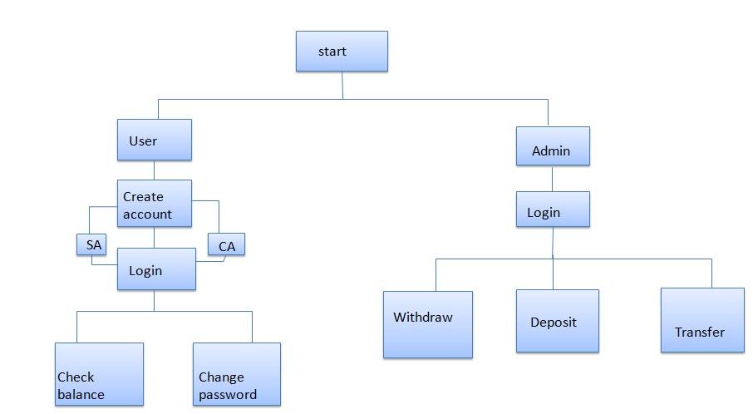

**4.Environment Description:**

**4.1 Time Zone Support:**IST- Kolkata

**4.2 Language Support**: English

**4.3 User Desktop Requirements:**

a. 64-bit processor, 1 GHz or faster

b. At least 2 GB free hard drive space

c. At least 1 GB RAM

**4.4.1 Deployment Considerations:**

* 1. Easy setup: no session storage daemon, use tmpfs and memory caching to enhance performance.
  2. Local storage is used
  3. No network latency to consider
  4. To scale buy a bigger CPU, more memory, larger hard drive, or additional hardware

**4.4.2 Integration Requirements:**

1. Language: C

2. Tools: Valgrind, Makefile ,vi editor, ctags

3. Compiler: GCC

4. Environment: Linux

**4.4.3 Network:**

End to End

**4.5 Configuration:**

**4.5.1 Operating System:-** Linux environment