**Proposal**

**Manners Maketh Man**

**Subject**

**Prof.**

**Major**

**Submission date**

**Team name**

**Team member**

**Capstone Design - MS**

**Park DongJoo**

**Mobile Systems Engineering**

**2023.4.14**

**Manners Maketh Man**

**Jung WooSeop (32184140)**

**Wi JungMyung (32182779)**

**Lee DaBin (32172917)**

**Baek MinJae (32171972)**

**Seo DongHwan (32182108)**

# **1. Why we need the problem solving**

## **1-a) Problems**

Communication is a crucial element that underpins human relationships and the functioning of society. It is through daily interactions with diverse individuals that we share thoughts, emotions, and information, fostering mutual understanding and cooperation. Effective communication plays an essential role in bridging gaps between disparate people, creating common ground, and resolving problems. Ultimately, it contributes to both personal and societal growth. Therefore, having strong communication skills is vital for maintaining harmonious relationships and achieving success in a world where people live and work together.

We figured out 7 problems in communication between people.

1. Elderly people find it difficult to understand slang.
2. Hard to communicate with workspace superiors.
3. Difficulty in understanding others’ emotions innately.
4. Analyzing the other person’s tendencies through communication.
5. Elderly people struggle to understand the emotions of other in chats through platforms like KakaoTalk.
6. Absence of communication & lack of friends occurs lonely death.
7. Criminal psychological analysis is not easy.

## **1-b) Current Status**

|  |  |  |
| --- | --- | --- |
| **Problem** | **Existing solution** | **Limitation of Existing solution** |
| **a.** | Searching, Educational Programs or Workshops | Slang is constantly evolving. |
| **b.** | Books, Counseling communication skill | Results may vary depending on individuals. |
| **c.** | EQ training, memorizing the facial expression, etc. | Take too much time.  Some might have inherent limitations. |
| **d.** | MBTI, MMIP, STRONG, MLST-II, FCPI, etc.(tests) | The participation of the target is required. |
| **e.** | NONE |  |
| **f.** | Apps for one-person-household, Policies | Cannot fulfill the hearts of lonely people. |
| **g.** | Professional people’s analysis | Takes too much time. |

figure 1.1.1) Problem Analysis

|  |  |  |  |
| --- | --- | --- | --- |
| **Problem** | **Solution by Software** | **Customer Expectation** | **Total Score** |
| **a.** | Effective | Understanding slangs to communicate with youngs | 36 |
| **b.** | Not sure | Understand what one’s superior requires and why | 82 |
| **c.** | Effective | For smooth communication with others | 93 |
| **d.** | Not Effective | To gain a deeper understanding of the other. | 63 |
| **e.** | Effective | To communicate more smoothly with youngs | 82 |
| **f.** | Effective | Friends to communicate and a word of comfort | 67 |
| **g.** | Effective | Due to the shortage of criminal psychology experts,  there is a need for tools to increase analysis efficiency. | 61 |

Total score is the overall rating based on social interest (20%), social impact (30%), resources (10%), feasibility (20%), and projected demand (20%).

figure 1.1.2) Problem Analysis

## **1-c) Market Forecast**

|  |  |  |
| --- | --- | --- |
| **Problem** | **Expected Market Size** | **Reason** |
| **a.** | Small | Elderly people have little interest in information about the  latest apps, and it is difficult to provide features more convenient than alternative search engines. |
| **b.** | Big | It's because it's a concern for almost all employees. |
| **c.** | Medium | Although the number of people facing pioneering issues such as autism spectrum is small, solutions are essential for them. |
| **d.** | Small | It is difficult to replace existing solutions due to the tradeoff between convenience and performance. |
| **e.** | Small | Elderly people have little interest in information about the  latest apps, and it is difficult to provide features more  convenient than alternative search engines. |
| **f.** | Big | This is because the number of people at risk of dying alone is increasing due to the aging population and the rise in single-person households. |
| **g.** | Medium | This is because, depending on the convenience of the  solution to the problem, criminal psychology analysis can be widely used even for non-serious crimes. |

figure 1.2) Expected Market Size

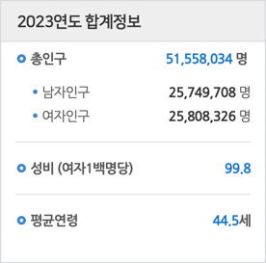

figure 1.3) Korean Population Pyramid

<KOSIS, <https://sgis.kostat.go.kr/jsp/pyramid/pyramid1.jsp>>



figure 1.4) The number of people with autism spectrum disorder

<KOSIS, <https://kosis.kr/statHtml/statHtml.do?orgId=117&tblId=DT_11761_N003>>

figure 1.5) Emotion Detection and Recognition Market Size Expectation

<MarketsandMarkets, Emotion Detection and Recognition Market, 2020>

figure 1.6) Emotion Detection and Recognition Market Size and Outlook by Activity Area

<MarketsandMarkets, Emotion Detection and Recognition Market, 2020>

figure 1.7) Software Market Size and Outlook of Global Emotion Recognition and Analysis

<TechNavio, Global Emotion Recognition and Sentiment Analysis Software Market, 2018>

# **2. Solution proposal**

## **2-a) Solution Overview**

* Solution 1. An application that analyzes text through machine learning and expresses it with emoticons when using SNS in real time.
* Solution 2. An application that translates slang into standard language.
* Solution 3. A consolation chatbot application mainly outputs emotional language.

## **2-b-1) Focusing part and why**

* Improved Communication: result in more effective communication and less confusion.
* Increased Engagement: the use of emoticons is a popular trend in social media communication.
* Accessibility: important for people with disabilities or language barriers.
* Business Profitability: through continuous diversification of emoticons, a paid policy can be used.

## **2-b-2) Focusing part key functions**

* Use OCR technology in real-time to retrieve text data from the user’s SNS chat window and store it in our database.
* The text data will be moved to a process that has three NLP models, each model will analyze the text.
* Each model, GPT, KOBERT, and KOELECTRA, is loaded onto the main server after being trained with data until it achieves high performance.
* The results analyzed by each model are ensembled to derive a single result, which is then stored in the database.
* Based on the result of emotion analysis through machine learning, a specific emoticon is matched and displayed in the user chat interface.

## **2-b-3) Scope of Application (target customers)**

* Examples of socially disadvantaged individuals with disabilities such as autism spectrum disorder.
* Someone who finds it difficult to grasp the emotions implied in the text content.
* In situations where it is even more difficult to understand emotions due to linguistic barriers, such as foreigners.
* Someone who enjoys emoticons through emotion analysis of SNS text.

## **2-c-1) KPI – KGI / End Product**

* An application that analyzes text through machine learning and expresses it with emoticons when using SNS in real time.

**Printed emoticon**

## **2-c-2) KPI – Designing Architecture**

figure 2.1) Block diagram

## **2-c-3) KPI – ML / Frontend / Backend**

* ML (NLP Model) : Build a sentiment analysis NLP model with 90% accuracy.
* Frontend : OCR(Optical Character Recognition) model text from monitor with 95% accuracy.
* Backend : Make response time lower than a second(1 sec).

References for setting KPIs

ML : <https://github.com/kiyoungkim1/LMkor>

<https://github.com/SKT-AI/KoGPT2>

<https://github.com/SKTBrain/KoBERT>

<https://github.com/Beomi/KcBERT>

<https://github.com/monologg/KoELECTRA/blob/master/README_EN.md>

<https://github.com/konlpy/konlpy>

Frontend : <https://www.ncloud.com/product/aiService/ocr>

<https://www.kakaoicloud.com/service/detail/6-9>

Backend : According to the lack time of OCR and NLP models, server delay must be minimalized.

# **3. Proposal of the implementation method**

## **3-a) Capability matching**

|  |  |  |
| --- | --- | --- |
| **Name** | **Primary Programming Language** | **Experienced or Interesting Area** |
| **Jung WooSeop** | Python | Machine-Learning / Front-End |
| **Seo DongHwan** | C/C++ | Embedded development |
| **Baek MinJae** | Python | Machine-Learning / Cloud computing |
| **Lee DaBin** | Python | Machine-Learning |
| **Wi JungMyung** | Python | Reinforcement-Learning / Computer vision |

figure 3.1) Team members’ skills

* Current capability
  + Front-End development
  + Machine-Learning development
* Required capability
  + Back-End development
  + Understanding of Client-Server architecture development

## **3-b) Structure of the team development**

figure 3.2) Team organization chart figure 3.3) Development tools

Front-End)

* PyQt + Javascript
* Developing GUI, conversation extraction(OCR), communication with Back-End

Back-End)

* Django + SQLite
* Developing communication with Front-End and Machine-Learning model
* Developing Machine-Learning model learning and deriving results method

Machine-Learning)

* KoELECTRA, KoBERT, KoGPT + TensorFlow + PyTorch + Keras
* Fine-tuning KoELECTRA, KoBERT, and KoGPT models
* Deriving results through an ensemble of predictive values between fine-tuned models

Version Control System)

* Git + Github
* Development progress and source code for each part will be shared through Git and Github

## **3-c) Time plan of Each Teams**

figure 3.4) Time plan of Front-End & Back-End Team figure 3.5) Time plan of Machine-Learning Team

## **3-d) Risk analysis and hedging**

* Minimizing the capability gap
  + Each member is assigned a role suitable for each experience or field of interest.
* Lack of web programming experience -> progress gap between FE, BE and ML
  + The part that finished development first will help the other part.
* ML models need high computing power
* Performance of the application is sensitive with server’s computing power
  + Providing high-enough performance server.
  + Optimizing connection methods with ML model.
* Privacy infringement due to conversation collection
  + In accordance with Article 24, Paragraph 1 of the Personal Information Protection Act, consent will be obtained for personal information processing, and chat history will be used lawfully.
  + Obtain consent from the user for the personal information processing policy when running the application for the first time.

figure 3.6) Time plan of Front-End & Back-End Team

<Korean Law Information Center, <https://www.law.go.kr/법령/개인정보%20보호법/제24조>>

4. Utilization of the result

## **4-a) Marketing plan with target customers**

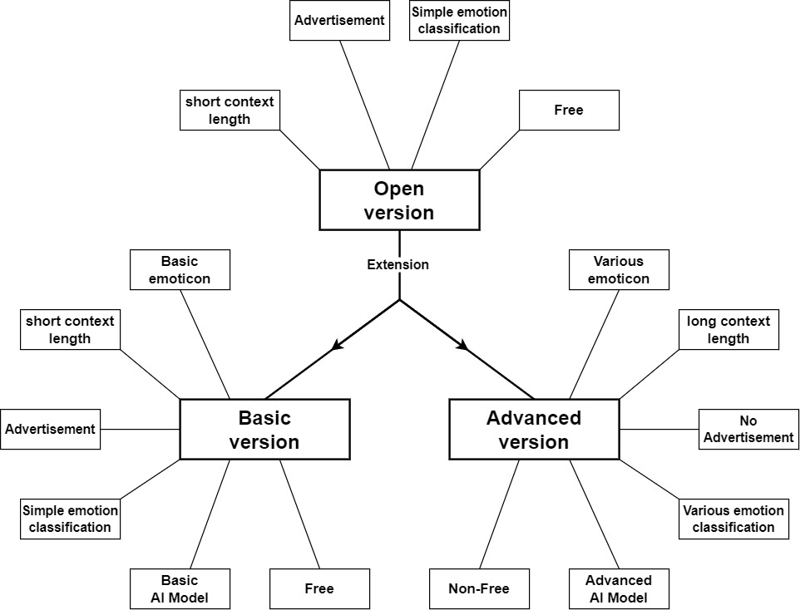

figure 4.1) Marketing plan diagram

## **4-a-1) Open Version**

* An open version is a program that is made available to more users, such as the beta version.
* Open version makes it easier to achieve this program's purpose, so the program is **free** of charge.
* The open version **uses advertising.**
* The program generates revenue by receiving paid advertising and sponsorship to address project maintenance costs without disrupting its nature.
* As mentioned above, this version is a beta version, which **limits the length of the text** considering the speed of development of security and artificial intelligence models.
* Only this Open version program is used until the program's target number of users is achieved.

## **4-a-2) Basic Version**

* This version is an extended version that is used to achieve the target user.
* Like the open version, it is **limited to a short text length** considering the speed of development of security and artificial intelligence models.
* The program generates revenue by receiving paid advertising and sponsorship to address project maintenance costs without disrupting its nature.
* Like the open version, emotion classification is carried out with the same label classification number.
* The model uses a model for ordinary users, not a model specific to the user (target)   
  : the same model as the open version.
* It uses the same kind and number of emoticons as the open version.

## **4-a-3) Advanced Version**

* Various emoticons are available. The advanced version of emoticons not only offers **more various free emoticons** but can also be used by **selling user-made emoticons.**
* When a user designs and **sells emoticons**, **a fee is incurred**.
* To take advantage of the advanced version, we allow **longer text** than the underlying version.
* The advanced version is a **paid version (no free).**
* The advanced version is used without advertising. Maintenance costs and revenues are replaced by higher-end versions of sales costs instead of advertising.
* Unlike the basic version, the advanced version further **subdivides** the label of emotions and classifies **various emotions**.
* The advanced version provides an artificial intelligence classification model that is **optimized for specific users**: Models for autistic patients, models for criminal profiling, and so on.

## **4-b) Impact analysis to industry/society**

|  |  |
| --- | --- |
| Application Fields | Use Cases & Impacts |
| Medical Industry | * **Psychotherapy**: Available for treatment for adults or the elderly in single-person households who complain of emotional disorders due to psychosocial difficulties or communication breakdown. * Used as a **diagnostic and** **objective psychological indicator** of the mental health of patients. * **Help people with autism spectrum disorders**: It will be used not only to recognize the emotions of others, but also to express one's feelings through writing and clearly communicate them to others. This will greatly help people with autism spectrum disorders to carry out social interactions. |
| Business Fields | * **Improve team atmosphere**: It helps in good communication between new employees (MZ generation) and bosses. Therefore, companies are expected to create a good atmosphere within their team, which can lead to a butterfly effect of improved teamwork. * **Improve customer satisfaction**: Companies can better understand customer’s needs and complaints and provide an appropriate way to respond. This can increase customer satisfaction and loyalty, as well as increase repeat purchase and referral rates. |
| Digital Human Technology | * Emotional recognition and **appropriate response**: Digital human influencers can read the other person's feelings when they have real-time conversations with people, so they can continue their appropriate responses or conversations more **like real humans**. |
| Daily life | * **Improve the quality of conversation**: It allows people to better understand the other person’s mood or attitude and choose the appropriate way to talk. This can improve the quality and adhesion of the conversation and strengthen the relationship. |
| Criminal Psychoanalysis | * **Models specialized in criminal sentiment analysis**: Police can apply models to conversations with criminals to analyze things like psychopathy, sociopathic tendencies or empathy. |

figure 4.2) Impact analysis