**Canva.**

**Canva is a free graphic design platform that's great for making invitations, business cards, Instagram posts, and more. A drag and drop interface makes customizing thousands of templates simple and easy. Canva's wide array of features allow you to edit photos without extensive photo editing knowledge or experience**

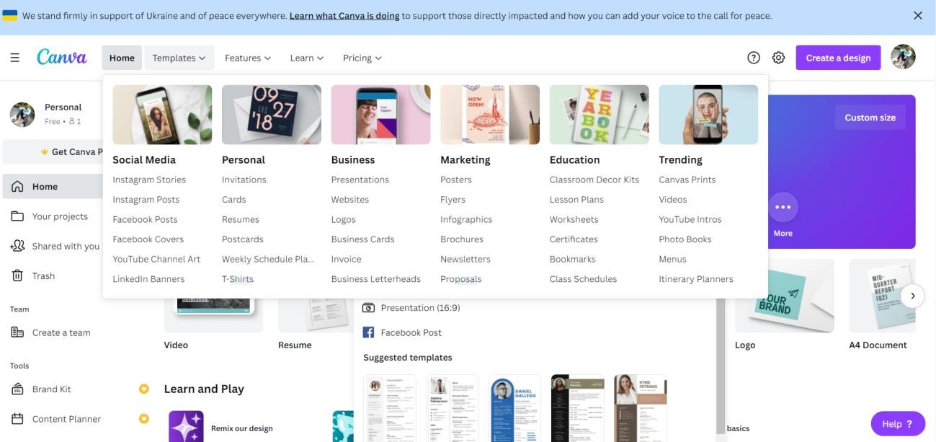

**You can even upload your own photos and add them to Canva's templates using a drag and drop interface. It's like having a basic version of Photoshop that's free and doesn't require extensive photo editing knowledge to use.** **Canva has more than 50,000 templates to choose**

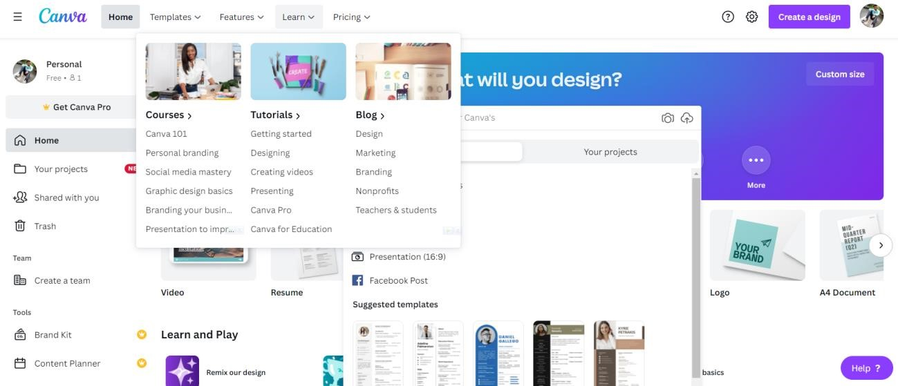

# How to use canva step-by-step

## Choose the right dimensions for your design

choose your design type from the Canva homepage. These are set to the optimal dimensions for each graphic, whether it’s a social media post, or more. Or you can use custom dimensions by searching for “custom size”. You can choose from pixels, millimetres or inches.

## Choose a background

The background for your design could be a color, or an image. Different colors tell different stories.

Background photo- To use a photo as a background, first add a grid. Once placed on a grid, photos can be resized, cropped, flipped and layered to create a variety of visual effects.

Next, search Images or upload your own. Then drag and drop your image onto the grid: it will snap to fit.

You can add filters to change the brightness, saturation and clarity of the photo. This can help when layering text and elements.

Design-A background image supports the message of the content. If there's too much going on in the background, it’s hard to overlay things like text or illustrations. When you are choosing a background image for your design, consider texture over structure. You can crop images to find pockets of texture that will work better—this way you can also remove any space or features in the image that creates too much noise.

## Add your elements

**Keep it simple**

Your design might include text, icons, photos or illustrations. These need to be combined in a way that is visually appealing.

Canva graphic designer Lynneal Santos says it’s a matter of balance.

“Consider the balance and composition of all the elements in the design. When you're laying out your elements, ask are the elements balanced? Are they centered? And ensure they’re not too close to other elements or the edge of the page.”

## Choose the right fonts

**The look of your fonts can have a huge impact on your design**

