Kingdom Krawlers

Game Desi gn Document

### 

Game Logo

Document Version Number (v0.1)

Author Name: Jack Simpkin, Aden Klitscher, John McGuirk, Manning Copeland

# Introduction

A short, "elevator pitch" about your game, not necessarily technical in nature, but more for a brief introduction so everyone knows what the document relates to.

Then elaborate on the following:

Genre: Top Down

Theme: Fantasy

Reference to other games: The legend of Zelda, the binding of isaac

Design Intentions

Kingdom Krawlers is a 2d top-down game where the player’s quest is to save their town from the monsters that terrorize the town each night. To do so, they must delve into the depths of the dungeon and fight, dash and loot their way through the hordes of monsters that protect the (Insert Boss name here)

### Game Atmosphere

How the game feels and its mood - dark, abandoned, happy, etc. Also describe what type of artistic style the game is going after - realistic, cartoony, etc.

Descriptive paragraphs covering the listed points:

Atmosphere mood

Location/level descriptions

Character design

Audio design

The game will have a cartoony feel about it.

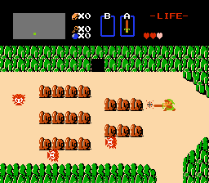 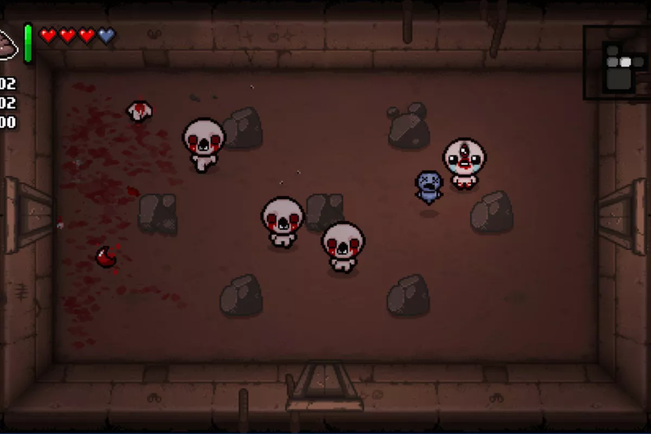

The atmosphere of the game will be very mixed. In the village area of the game it will be upbeat and bright.The further the player goes from the village the darker and gloomier it gets. Facing the boss in the boss level, the player will feel trapped in the area and be forced to kill or be killed.

The main area will be a large area dungeon scattered with enemies throughout. In the middle will be a small village and a safe zone from enemies.This is where the player is able to purchase items from the merchant with the in game currency earned. The further the player wanders from the village the more enemies they are likely to come across.

The boss level,

The boss level is an area located deep in the dungeon, far from the village. Once the player has entered the room, it will be sealed off and the player cannot escape, forcing them to fight. This room **can** be entered at any time once found, but beware the boss is very strong and only the strongest players with the strongest weapons can defeat him!

Character Design,

Keeping with the cartoony styled theme, the character will also be a cartoony looking sprite (along with the enemy and boss characters). When the player equips a new weapon the weapon sprite will appear on the player and this will change every time the player changes to a different looking weapon. Attack animations will be included when the player attacks. A death animation will occur when the player has died. This will be a simple falling over effect when the players health reaches zero. When the player dies, they will respawn in the village with decreased maximum health, they can restore their max health by returning where they died.

Audio Design,

Audio, sound effects and background music will be implemented throughout the game. Depending on where the player is in the level different audio will be playing. For example, the village will have a laid back relaxed theme and make you feel right at home, where as when you are facing the final boss, the music will be intense and in your face, in the middle of the dungeon will have something in between. Sound effects will be included for when the player gets hit by enemies, the player uses weapons, enemies have died, loot has been picked up, the player has been resurrected and when the player has won or lost the game.

### 

### 

### Story

The player lives in a peaceful village one night monsters come to pillage the town. The player tries to protect the village and is killed by a monster but is magically revived in the town centre. The player turns out to be someone who can’t truly be slayed by monsters and is chosen to save the village from the monsters which corrupts the world.

# Gameplay:

The player is able to move between areas freely (except the boss level) and kill enemies using various weapons and tools.

Each area will be its own Unity Scene

Chests can be found throughout the cave/dungeon and are another way of obtaining loot and money

The enemies, when killed have a chance to drop loot (Loot can include health potions, mana potions, speed potions, potions that increase damage, arrows and money)

A merchant will be available in the level to purchase these items.

### Player

### Player Controls

“W, A, S, D” to move

Space Bar to dash

Left mouse button to use melee weapon

“E” Interact with something

Right mouse button to use bow

Number buttons for potions/extras

“I” to open the inventory

“Esc” to pause/unpause the game or close the inventory or shop menus

### Movement

Using the “WASD” keys you can move about on the top down 2d plane in 8 directions, vertically, horizontally and diagonally. A dash mechanic will also be implemented into the game which can be used in combat to attack and evade enemy attacks as well as navigating the environment (e.g dashing over a crevice)

The camera will follow the player around. The Player will also be able to zoom the camera in and out to a certain extent so they can either see more in general or see things in more detail.

By zooming in, the player will be able to see things in more detail. An example of when this could be useful is when the player is fighting multiple enemies simultaneously and the player will need to put an emphasis on precision.

By zooming out, the player will be able to see more of the map. This will be useful for exploration and finding enemies to fight (or avoid as the case may be)

### Combat Mechanics

The player will be using combat when being attacked by enemies. The player uses two main weapons a sword and a bow. The Player will use the left mouse button to swing their swords and the right mouse to draw and fire their bows. The attacks will be directed towards the position of the mouse. The player uses combat to slay enemies, to progress through areas and level up.

### Dash Mechanic

The dash ability propels the player at a fast speed. When the ability is activated the player dashes towards the position of the mouse. The dash will take the player across for one second. If the player presses the dash button when dashing it will cancel the dash. If the player collides with enemies this will cancel the rest of the dash and deal damage to the enemy. The ability has a cooldown and after the cooldown the player can activate the ability again. The Dash can be used to :

* dodge enemy attacks,
* move quickly around,
* ram into enemies to deal damage,
* cross two tile gaps in the ground.

### Collisions

When the player or an enemy gets hit by an attack, it will trigger a knockback effect. How strong the knockback effect can be determined by: Enemy type, Weapon used and the amount of damage dealt, in the players case how much they've leveled up will affect how much knockback they receive. There will also be Invincibility frames when the player is attacked which will last 1 second. When the player or an enemy takes damage, the character model that has taken damage will briefly flash as well as trigger as a form of player feedback.

### Health

The player can never truly lose. They can die and be revived with a health penalty.

The health penalty will stack with each death until the player’s health is half of what the player’s original maximum health was. Once the player’s maximum health is half of what it originally was, the player will no longer receive a health penalty for dying.

### Resurrection

Once the players health reaches 0 they will be respawned in the village at the start of the game. The player will suffer a slight decrease in max health at the cost of dying. The player will keep all their items and if they find the corpse of their dead body, they will increase their health back to its original max health. Multiple corpses will exist in the world, allowing the player to regain all of their lost health if they return to each corpse.

### Leveling Up

The player will get xp by slaying enemies, when the player levels up all their stats improve (Health, dash cooldown, attack damage). The player will level up when they get enough xp. Each time the player levels up the xp requirement will increase for the next level to encourage the player to hunt harder enemies which grant more xp. The player will need to level up to improve their stats to make the boss at the end easier and achievable. When the player levels up they will also have their health restored to full, as a small reward for leveling up.

### Currency

Coins can be acquired through defeating enemies (as loot) as well as selling items that you find in the dungeon. Coins can then be used to buy better weapons and potions which you can find at the merchant and purchased by clicking on the item you want. There will not be a menu that pops up when trying to purchase an item, instead the items will be placed next to the merchant where you'll only need to click on the item if you have the required coins.

#### 

### Merchant

The merchant is an NPC which the player can trade with to purchase or sell equipment such as bows, swords and potions. The merchant will serve as one of the key mechanics of the hub village. The only way to get a gold weapon is buying it off the merchant.

### Merchant table

|  |  |  |
| --- | --- | --- |
| Item | Price (Coins) | Sell price (coins) |
| Gold Sword | 5000 | 500 |
| Gold Bow | 4500 | 450 |
| Grey Bow |  | 15 |
| Grey Sword |  | 20 |
| Blue Bow | 400 | 40 |
| Blue Sword | 500 | 50 |
| Arrows x10 | 50 |  |
| Health Potion | 50 | 5 |
| Health Regen Potion | 100 | 10 |
| Speed Potion | 100 | 10 |
| Invisibility Potion | 200 | 20 |
| Strength Potion | 200 | 20 |
| Haste Potion | 150 | 15 |

### Buying/Selling

The stores will be in the village. The items will be physical in the world, the player will approach the items and an activate button will show on the item when near, then click on the activate button to buy the item. The player can buy items whenever they have enough money to purchase the item. The player will need to buy items to restock their arrows, potions and weapons.

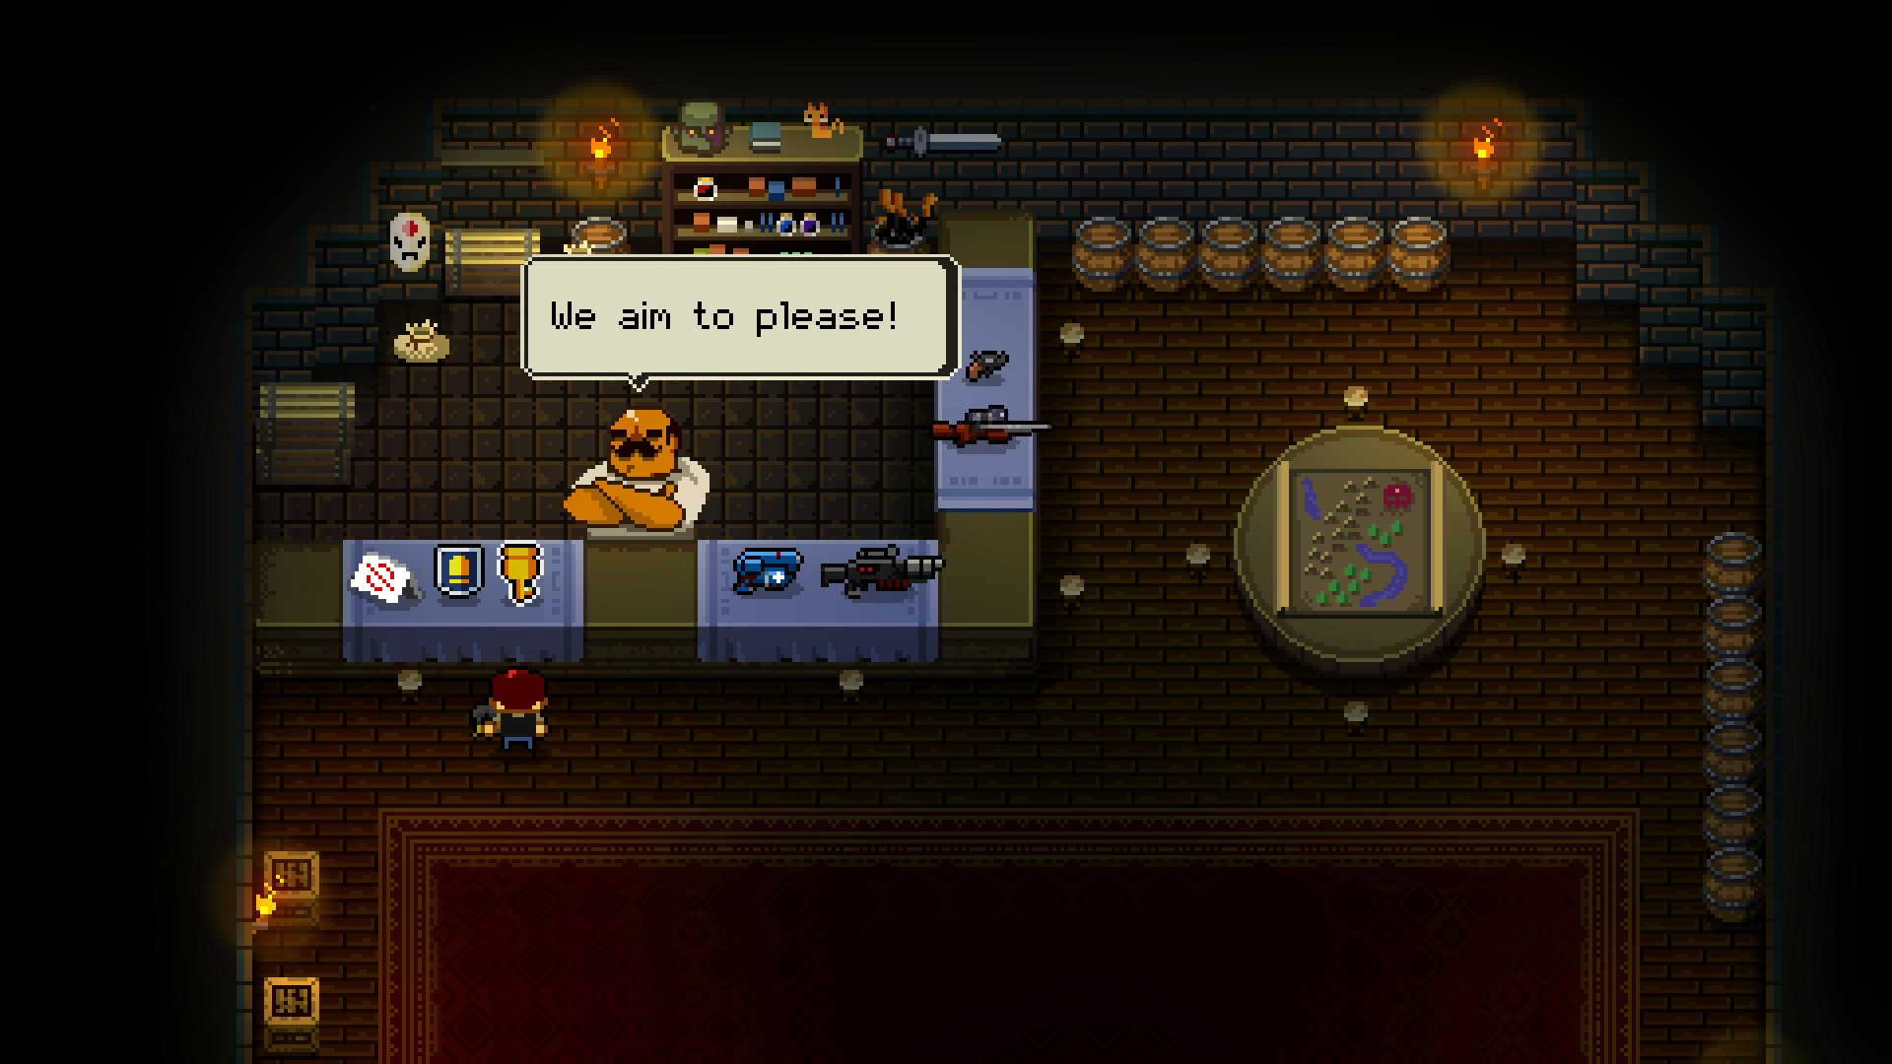

In order to sell loot, the player should talk to the shopkeeper by clicking on him. Doing so will bring up the players inventory which will look almost the same as the regular inventory menu but will have an added “Sell button”

### Loot

Loot can be dropped by enemies and found in chests and can be sold to the merchant in exchange for coins that can be used to buy stronger equipment and items.

If you defeat stronger enemies you'll be more likely to find stronger equipment dropped by the enemy. Each type of enemy has a handful of select items that you can possibly get and what ends up being dropped is determined by a set percentage. (E.g skeleton has 20% chance of dropping blue sword, 50% of dropping potion, 30% of getting between 5-20 coins)

Swords and bows will be your primary weapons for defeating enemies and there’ll be multiple types of each with varying attack power and rarity which can be found from defeating enemies and can be bought from the merchant. It’ll also be possible to find health restoring potions in the same fashion.

The player collects loot by touching/colliding with it. Collected loot will be stored in the player’s inventory (which can be accessed by pressing “i”).

Uncollected loot will have a magnet affect so that when the player walks within the vicinity of it, it will begin to drift towards the player so that it is easier to collect.

The player will have limited inventory space for weapons (Just how limited it will be is yet to be decided. The number will likely change during development in order to properly balance the game) However, the player will be able to carry unlimited potions

The value of the loot will depend on what it does as well as it’s rarity

### Enemy Loot Table

|  |  |  |
| --- | --- | --- |
| Enemy Type | Loot Dropped | Percentage (%) |
| Creeps | Coins (5-15)  Health Potion  Grey Sword  Arrows  Grey Bow  Blue Sword | 65%  5%  10%  15%  4%  1% |
| Skeletons | Coins (15-35)  Grey Bow  Health Potion  Arrows  Health Regen Potion  Blue Bow  Blue Sword | 50%  10%  15%  15%  4%  5%  1% |
| Golems | Coins (35-100)  Blue Sword  Blue Bow  Health Potion  Health Regen Potion | 50%  10%  5%  20%  15% |
| Boss | Coins (10000) | 100% |

### Inventory:

The inventory will show all the items in the players inventory on one side and then have an information box on the other side. The item information box will show things such as the item’s name, a short description of what it does, How much damage the weapon does and how fast it attacks as well as it’s value. Below the information box will be a destroy button, equip button and a sell button (the sell button will only appear when the player talks to the shopkeeper)

Below the inventory it will display how many of each type of potion the player has left as well as how many arrows the player has and how much money they have

At any given time, the player can only have 1 sword and 1 bow equipped

The inventory will contain 20 free spaces for items

### Chests

Chests can be found in the dungeon and can have up to two randomly generated items including coins, weapons and potions. If you happen to find a weapon you can choose to equip it or sell it to the merchant back at the village. Chests can be opened by left clicking on the chest itself

Chests will not have Gold weapons as they can only be acquired at the merchant and have a slim chance of being dropped by creeps. You can acquire between 5 - 500 coins in chests.

### Weapon Stats

### Swords

All swords will attack in a horizontal slashing motion.

Knockback will also coincide with the base damage stat (The higher the damage the stronger the knockback)

|  |  |  |  |
| --- | --- | --- | --- |
| Weapon tier | Base damage | Animation Speed | Range |
| Gold | 40 - 60 | 0.2 seconds | Long |
| Blue | 20 - 35 | 0.5 seconds | Medium |
| Grey | 5 - 15 | 0.8 seconds | Short |

Grey Sword: Power = low, Speed = slow, Range = short

Blue Sword: Power = medium, Speed = average, Range = medium

Gold Sword: Power = high, Speed = fast, Range = long

### Bows

Bows will have unlimited range because most of the combat will take place inside a cave/dungeon which is a relatively confined space where a max range would be a bit redundant

Bows will have limited arrows, if a bow is found in a chest its arrows will be set to the max amount. If we run out of time to develop a limited arrows mechanic, then the player will have unlimited arrows

|  |  |  |
| --- | --- | --- |
| Weapon tier | Base damage | Fire rate |
| Gold | 35 - 50 | 0.5 seconds |
| Blue | 15 - 30 | 0.8 seconds |
| Grey | 2 - 13 | 1 second |

Grey Bow: Power = low, Speed = slow

Blue Bow: Power = medium, Speed = average

Gold Bow: Power = high, Speed = fast

### Potions:

Potions, when consumed will apply some sort of affect to the player for a limited time (with the exception of a health potion which will have an instantaneous affect). Once that time is up, the effect will be removed from the player

Health Potion - Gives player more health

Health regeneration potion - Regenerates health over a period of 15 seconds rather than all at once

Speed potion - Player moves faster for 15 seconds

Strength potion - do more damage for 15 seconds

Invisibility potion - Makes player invisible to enemies for 10 seconds

Haste Potion - Player attacks faster

### Enemies

We’ll have a variety of enemies including mindless creeps though weak will chase you around the dungeon if they’re not killed. Skeletons that fire projectiles, giant golems that are incredibly slow but have a lot of hp as well as the dungeon boss who has a multitude of projectiles, AOE attacks, can spawn mobs and takes a long time to whittle down his hp.

Enemies will respawn in the same place each time but will drop random loot when they die.

Enemies will respawn when the player dies

### Enemy Stats

|  |  |  |  |  |
| --- | --- | --- | --- | --- |
| Enemy Type | HP | Speed | Atk Power | AI |
| Creeps | Low ( 30 HP) | Fast (Just a little bit faster than the player) | Low (15 Damage) | Chases the player uses melee attacks |
| Skeletons | Medium (60 HP) | Average | Medium (30 Damage) | Shoots projectiles (Fireballs in straight line) |
| Golems | High (150 HP) | Slow | High(50 Damage) | AOE attack |
| Boss | Very High (3000 HP) | Stationary | Very High (75 - 200) | Cannot be Knocked back |

### Boss Fight

Upon entering the boss room the player will be trapped in the room until they defeat the boss or are defeated in the process. The boss is killed by attacking it until its health is depleted. The boss will be able to spawn mobs along with having a wide variety of attacks to make the player have to adapt on the fly. The boss will be stationary but its size will take up a good portion of the room and the player can be easily overwhelmed by the constantly spawning mobs that swarm the room. For the player the key to victory will be their ability to manage space as well as spatial awareness, good use of the dash mechanic, and thorough preparations as far as using stronger weapons and stocking up on potions before entering the dungeon.

Attacks will include;

* Big orb that covers a big portion of the room (Will deal big damage if it hits the player). This big orb will take a couple seconds to build up and let the player know that it is coming, thus giving the player a chance to avoid it
* Cone of projectiles orbs, with minimal room in between each orb for the player to dodge (More damage than default attack but less than big orb attack)
* In between the above attacks, the boss will shoot its default orb which deals an average amount of damage.

### Game Areas

Each area will be its own unity scene

*Village:*

The village will have a shop in it that will sell assorted loot and potions

There will be NPC’s that wander around and cannot be interacted with (but they might occasionally say things E.g. a guard might say “good luck” to you as you walk out of the village and into the cave. Some villagers might also casually mention the shop and where it is to let the player know that there is a shop.

The player will also respawn in the village whenever they die

*Tutorial Level:*

The tutorial level will be a pre-designed area with scripted events that will introduce the player to the games various mechanics and the basic storyline

Tutorial level which will introduce the character to movement

A ravine or chasm or something with instructions to introduce the player to the dash mechanics and prevent the player from progressing until they have dashed

A couple weak enemies to introduce the player to the combat mechanics

A door/tunnel/exit which leads to the next level

*Main Dungeon/Level (potentially multiple interconnected areas to increase performance)*

The main Level will be a pre-designed area

The main level will be populated by assorted enemies which will each have a chance to drop loot.

The enemies will respawn whenever the player dies

Throughout the dungeon will be rocks/boulders or rubble which can block the player’s path and can only be destroyed by dashing into them multiple times. They will act as a way of putting the player in a situation where it will not be as easy to run away from enemies.

At the Opposite end of the main level will be the entrance to the boss level

*Boss Level*

This could be a large open area that once the player enters the exit will be blocked off and force the player to fight the boss until either them or the boss dies

### Victory conditions

Boss is dead

### Why is this game fun?

Its fast paced, engaging and its satisfying to fight loads of enemies at once.

But the looting, leveling and currency system will also allow players to play the game at their own pace. This will also mean that the game can be as easy or as challenging as the player wants it to be. It will all depend on how much time the player is willing to put into the game i.e. if the player wants a challenge they can try and fight the boss at a low level. If they want an easy boss fight, they can grind and fight lots of lower level enemies to level up until they are strong enough to fight the boss with impunity.

### Title and Information Screens

A flowchart for the menu system goes here. This details how you can go to specific menu options/screens from other menu options/screens.

Scope:

Scope the size of your design - is it achievable or realistic within your time frame?

If we split up the tasks between us it should be relatively simple to complete everything that we want to complete except maybe the randomly generated dungeon

How much do you aim to include in the project?

The mechanics that will definitely be in the final version of the game are:

The dash mechanic

Enemies that drop loot

A merchant to buy and sell loot

Inventory

Sword and bow combat

Potions

Chests

A boss fight

Multiple areas that the player can wander between

Mechanics we could cut if we needed to:

Limited arrows (We’’ll just let the player have infinite arrows if we can’t implement it in time)

Multiple potion types - We could just leave it at only the health potions if necessary

We could cut out certain potions if needed

Also include any information on plans for content updates later down the track.

*In the future we could add randomly generated dungeons*

# Target Audience

This game is aimed at retro gamers that want a simple, high paced, old school RPG with modern visuals. We’re also aiming at younger gamers to open their minds to older games that while simple, can be every bit as enjoyable as any high budget projects nowadays. It is also targeted towards people who enjoy top down action games.

# Sustainability

*Relevant formulas*

### **𝑃(𝑊) = 𝐼(𝐴) × 𝑉(𝑉)**

### **𝐸(kWh) = 𝑃(W) × 𝑡(hr) / 1000**

**Power Usage**

Assume that on average once we start actually making the game I will spend at most roughly 15 hours each week on this assignment.

Before we start building the game I might spend at most 10 hours each week on the assignment

It will probably take 2 weeks out of the 7 weeks to plan the game and make the GDD etc and then the other 5 weeks will be spent making the game. This means that I would spend at most 95 hours in total on the assignment

*Desktop*

P(w) = 3.3 **×** 17

=56.1

E(kWh) = 56.1 **×** 95/1000

= 5.3295 Kw/h

*Monitor*

P(w) = 14 * 3.2

= 44.8

E(kWh) = 44.8 * 95/1000

= 4.256‬ Kw/h

Total:

9.5855 Kw/h

Desktop = 5.82 kwh

Monitors = 7.847 kwh

= 13.667 kwh

Desktop = 600w

Monitor = 360w

= 91.2 kwh

Desktop = 500w

Monitor = 30.4w

= 50.388 kwh

Total amount of power consumption:

Total of Everyone = 165 kwh

Total kw usage over course of game production = 165**×** 95 = 15675 kw.

How will we reduce resources used:

There are a few ways we can reduce the resources used during production. We will not use any paper as our work is digital. When PC’s aren’t being used they will be turned off at the wall, our PC’s will be running on power saver mode and our monitors brightness will be reduced all of these will save power.

# Feedback

29/10/19: More detailed description

31/10/19: Correct contradictions

14/11/19: Stuck when colliding on walls, Dash inconsistent provide feedback on player, put dash input on mouse, restriction on zooming, Stuck on dash at times, Sprint button op?, Find balance between walking and running speed,

28/11/19: Remove filtering, little jittery on walls, collision box needs shortening,Need HUD for potions also label potion key bindings,

5/12/19: Refine title screen, change colour of projectiles, use E key to pick things up, swords need a buff, health bars above enemies.

10/12/19: Golem attacks other enemies, only skeletons can be killed by arrows, can't kill golems with melee weapons, lack of damage feedback on enemies, Melee weapons basically useless, loot/ chest need to be implemented. The only attack that works on enemies is firing a bow at skeletons, all other attacks on all other enemies have no effect

large golem (?) enemies seem to destroy other enemies (like skeletons) on collision

each enemy seems to have a random pool of health which is confusing as there is no indicator of how much health any enemy actually has.

12/12/19: Not so many enemies, change the colour of the projectiles