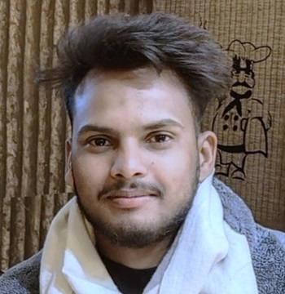**Manish Kumar Arya**

**Contact No :** 7300853175

**Email :** mannuarya2002@gmail.com

**Address :** Rajeev nagar-1st car road Bindukhatta lalkuan

**City** -Haldwani**, Dist.** Nainital

**My-PortFolio :** https://mannuarya.github.io/

**E**DUCATION

**Janata High Secondary School (UK Board)**  Lalkuan , Uttarakhand

10th - Science side - 2018

**Janata High Secondary School (UK Board)**  Lalkuan , Uttarakhand

12th - Science side - 2020

**Government Polytechnic College (Roorkee Board)**  Nainital, Uttarakhand

Diploma of Engineering in Information Technology Aug. 2021 – June 2024

**A**BOUT

**Father Name** : Mr. Ramesh Lal

**Mother Name** : Lt. Pushpa Devi

**Date Of Birth** : 06|12|2002

**Gender** : Male

**Marital Status** : Unmarried

**E**XPERIENCE

**Fresher |**  In present i’m a final year student and pursuing my diploma in Information Technology from GPC Nainital.

**P**ROJECTS

**Event Management System |** python, mysql Dec. 2023 - presentation

* Developed a full-stack software system using with python serving a library with Tkinter as the frontend
* Implemented mysql workbench to get data from user’s data

**Portfolio website |** html, css, javascript, Github feb. 2024 - May 2024

* Developed a Portfolio website for my own self to represent my self and my work and also to get a job opportunity.
* https://mannuarya.github.io/

**C**ERTIFICATION

* Python “O” certificate from “ESTC” at Haldwani of Full stack system designing using with python serving a library with Tkinter and SQlite3.
* IICT Certicate of basic course for MSWrod, MSExcel,PowerPoint,HTML

**T**ECHNICAL **S**KILLS

**Intermediate knowledge of IT** | MsWord , MsExcel, PowerPoint

**Languages**  | Python, Java, C, C++, MySQL(workbench), MongoDB, Javascript, HTML/CSS

**Frameworks** | Typed.js

**Developer Tools |**  Git,Github,Netlify, VsCode, JupiterNotebook, Codeblock, Anaconda

**Libraries |** Tkinter, Panda , OpenCV, Mysql-connector, Bootstrap

**S**OFT **S**KILLS

* Documentaion
* Management
* Communication
* Teamwork

**L**ANGUAGES

* HINDI – Intermediate
* ENGLISH - Beginner