DRM: Oracle tool to manage the Organization Metadata.

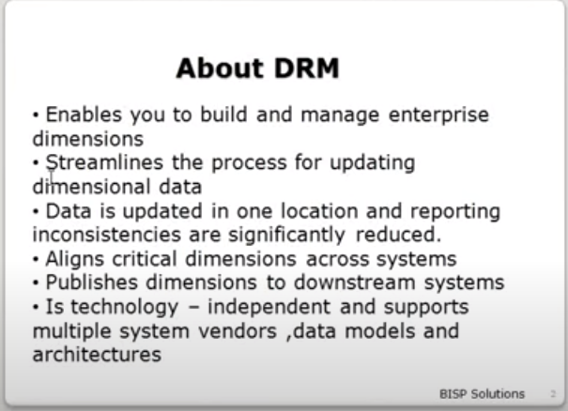

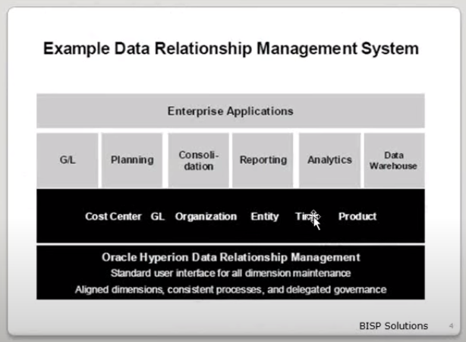

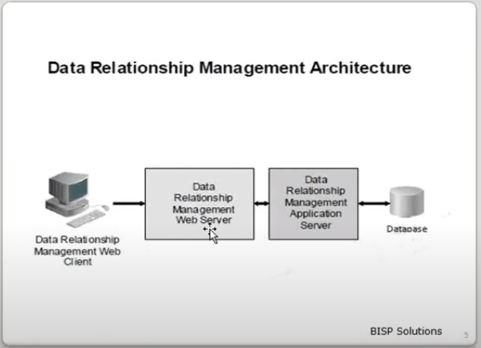

**Web Client**: Primary user interface for managing metadata. It requires Mozilla Firefox or IE.

**Web Server**: Brokers user requests. It requires Microsoft IIS (Internet Information Server)

**Application Server**: Process users requests and manages metadata for each application. It requires Windows 2003 SP1 (32 or 64 Bit) or Windows 2008 servers 32 or 64 Bit) and >ET framework 4.5

**Database**: Store DRM application data and requires Oracle 10.1.x or 11.2.x or SQL server 2005

Where DRM is installed in Sever -  
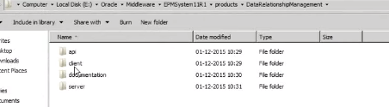

## **ORACLE DRM 11.1.2.4 INSTALLATION & CONFIG GUIDE**

## **Installation Prerequisites**

* [.NET 4.5](http://www.microsoft.com/en-us/download/details.aspx?id=30653) installed on the same.
* IIS (Internet Information Services) turned on said server.
  + - 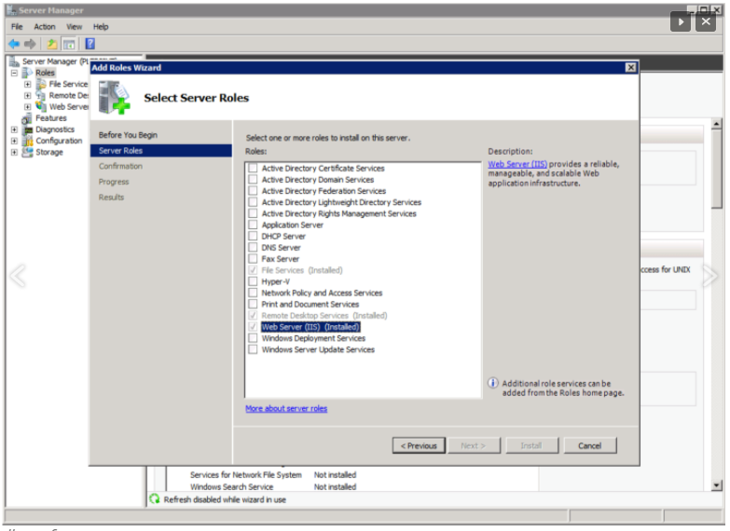
* Windows 2008 R2 server

## **Installation Steps**:

* Once all the pre-requisites are dealt with, we can get down to the business of running the install file.
* Run the setup.exe file; probably good form to run it as administrator.
  + - 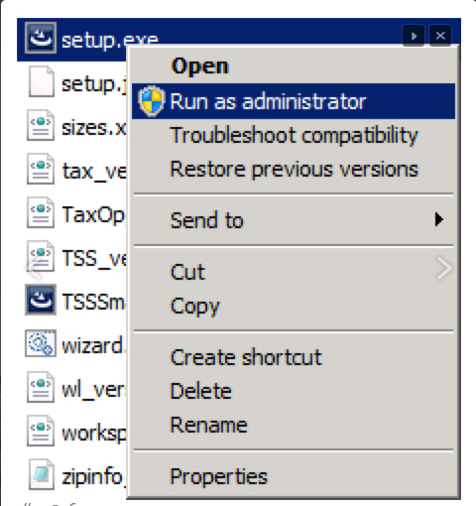
* Follow the wizard, and choose a Custom install so that we can see what we are installing. Even though, we will be doing a plain vanilla install
  + - 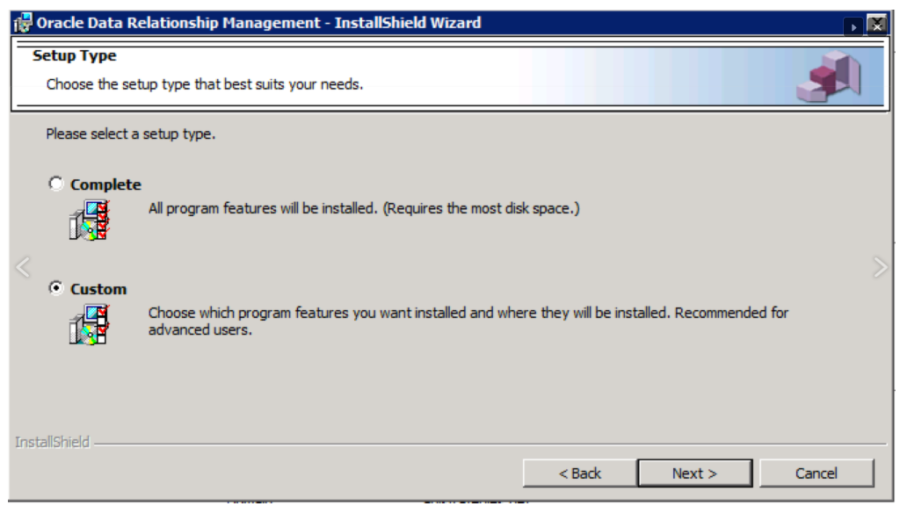
* We can now see the various components that are shipped with the install.
  + - 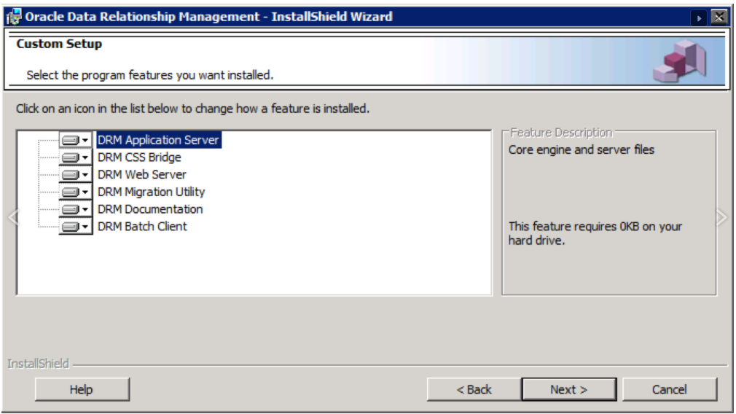
* - **Application Server**: this is the DRM engine. This is the part that processes user requests and talks directly to the database layer.
* – **CSS Bridge**: Connector for Hyperion Shared Services.
* – **Web Server**: this is the layer that connects user requests to the application server. This is also the IIS component.
* – **Migration Utility**: super awesome web application to manage DRM metadata.
* – **Documentation**: this would be documentation.
* – **Batch Client**: Windows client for running batch jobs. This is what we use when automating scenarios such as DRM imports, exports, action scripts etc.
* Click through and finish the install. This will launch the DRM Console.
  + - 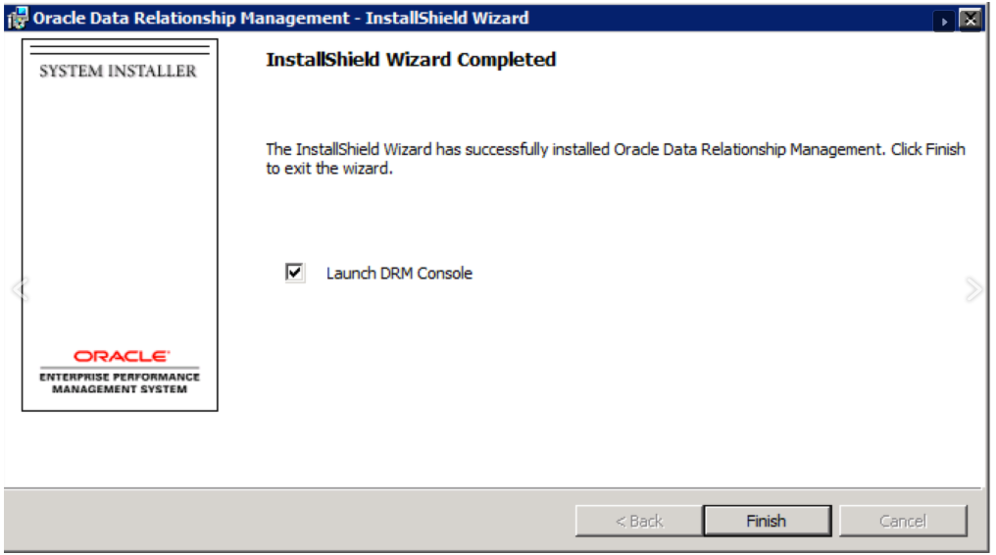
* Now that you have the install set up, the next step is to create and configure an application
* **DRM 11.1.2.4 APPLICATION CREATION OR CONFIGURING EXISTING ONE**
  + Let’s open up the DRM Management Console. The console is the tool from which activities such as creating/existing one application, starting/stopping services, setting up connectivity to Shared Services registering DRM with EPMA etc. The tool itself can be launched from Programs > **Oracle EPM System >Data Relationship Management > Configuration Console**.
    - 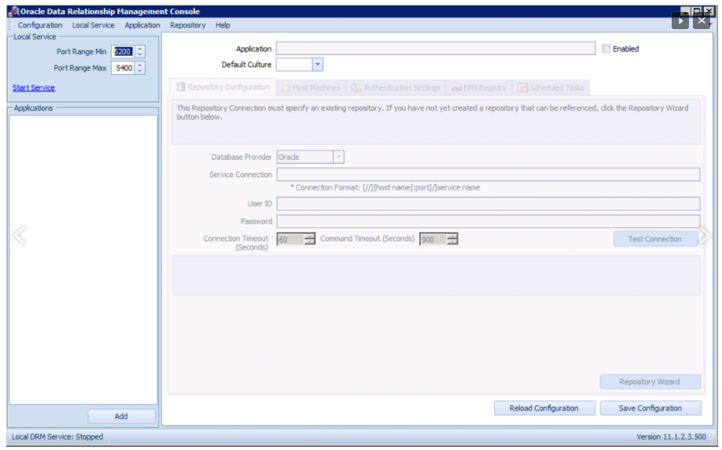
* Now, select *Add*and you will see new tabs being populated
  + - 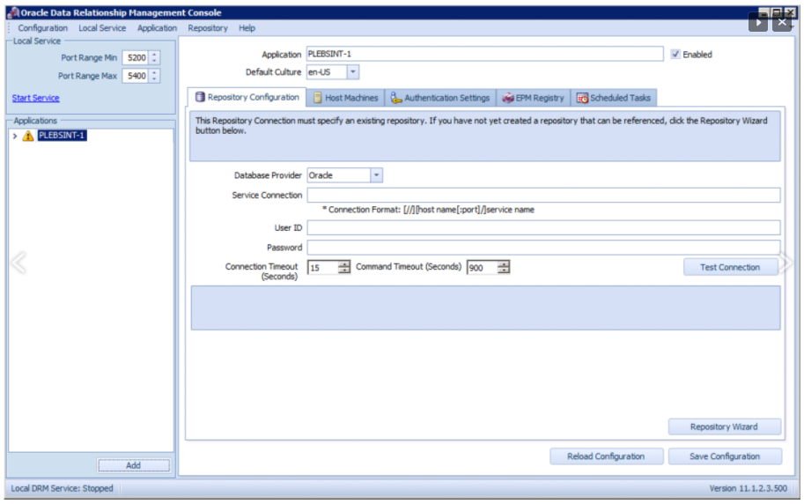

– **Repository Configuration**: this is where the bulk of our work today will be conducted. As the name suggests, this is where the SQL container for the application will be created.

– **Host machines**: here is where we will be setting up the API adapter (for instance, if enabling DRM -> R12 integrations), enabling CSS (Shared Services connectivity) etc.

– **Authentication Settings**: here is where we would set up authentication through DRM locally, through Shared Services or both.

– **EPM Registry**: this is where we register DRM with Shared Services.

– **Scheduled Tasks**: this lets you purge delete versions permanently, from the repository.

* Now, select the Repository Wizard. The wizard will let you choose from creating a new repository or performing an upgrade. Choose the former option.

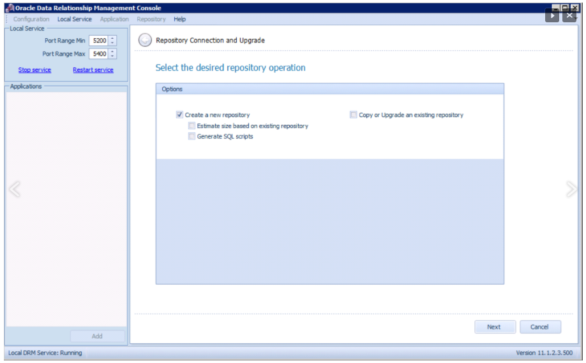

* Now, we need to enter the database details. Note that DRM kindly provides us the syntax needed for the service connection. Probably good form at this point to check your work by selecting the Test Connection button.
  + - 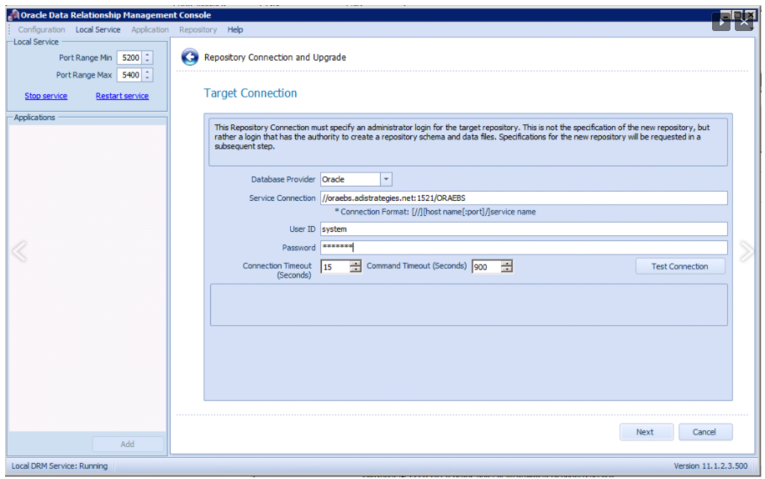
* The next step is to enter the schema name and provide the tablespace details for data files, Indexes and Transactions and Properties. The defaults will suffice.
* An administrator user name and password will need to be provided now.
  + - 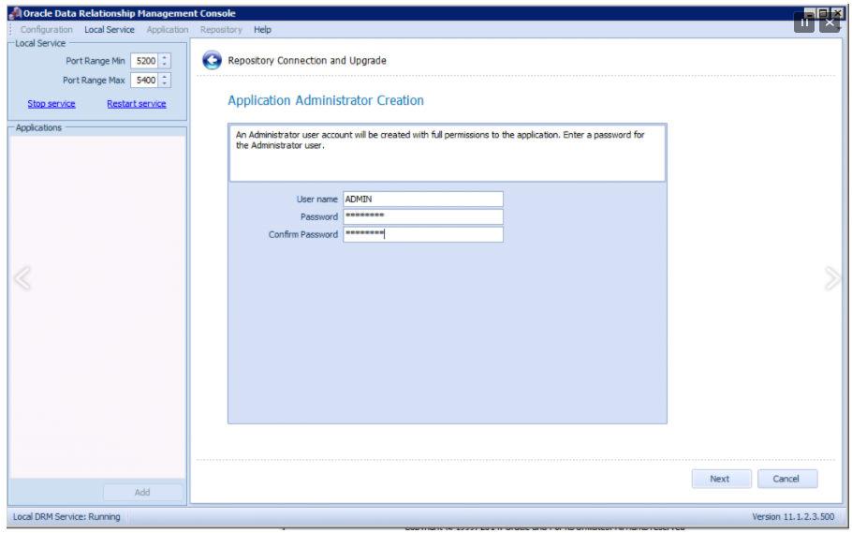
* Click through and finish the process.
  + - 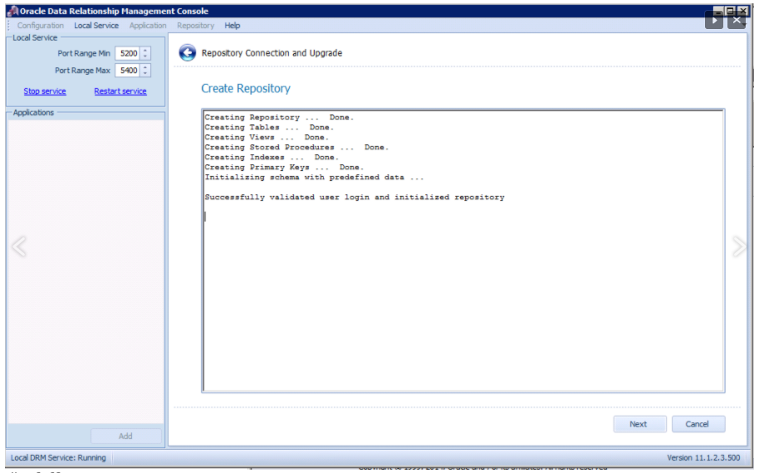
* Finally, we need to save the configuration and start the application. The application be started by right clicking on the application and selecting Start. Note: you might also need to restart the service.
  + - 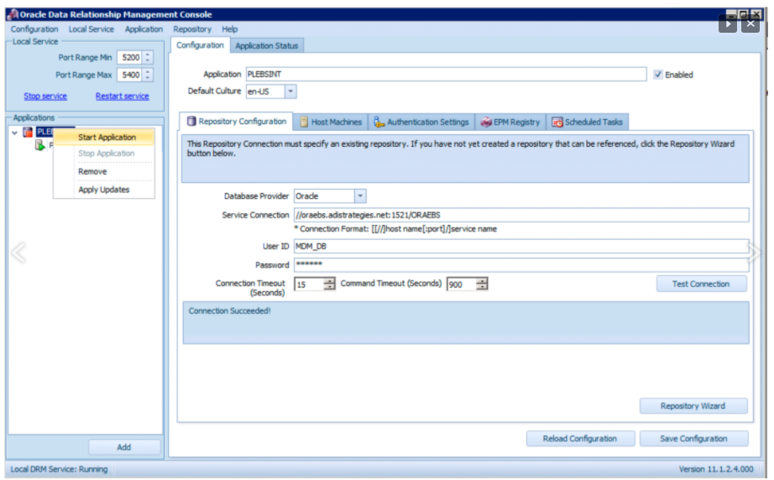
* Now, fire up a browser window and go to:
  + http://servername/drm-web-client
    - 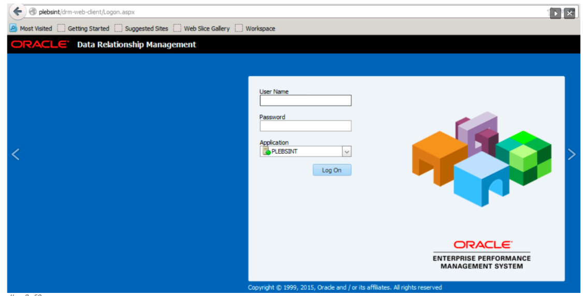

<http://theunlockedcube.com/tag/installation/>

<https://propvalueofdrm.blogspot.com/2016/04/drm-11.1.2.4.330-analytics-part1.html>

<https://propvalueofdrm.blogspot.com/2016/04/drm-11.1.2.4.330-analytics-part2.html>