# Track check in Helicopter using Image processing

Mansi 2020ME21031

Rahul 2020ME10032

## B.Tech Mechanical Engineering

Supervisor

Prof. Arpan Gupta



Department of Mechanical Engineering Indian Institute of Technology Delhi

<September, 2023>

# Contents

List of Figures ii

List of Tables iii

List of Abbreviations iv

1. Introduction 1
   1. Section Heading ...................................................................................................................................... 1
      1. Subsection Heading ................................................................................................................ 2
      2. Mathematical notation ....................................................................................................... 2
      3. Theorems, proofs, definitions and examples .................................................................... 3
   2. Figures and tables ................................................................................................................................. 3 1.2.1 Program code ............................................................................................................................ 3
2. Literature Review 3
   1. Section Heading ...................................................................................................................................... 3
      1. Analysis Methodology ........................................................................................................... 3
3. Work plan and Gantt Chart .............................................................................................................. 4
4. Progress so far ...................................................................................................................................... 4

List of Figures

1.1 This is a figure caption. Note how it appears underneath the figure. ................................ 3

List of Tables

1.1 This is a table caption. Note how it appears above the table. ................................................ 3

# List of Abbreviations

Abbreviation 1 Description 1

Abbreviation 2 Description 2

# Introduction

The introduction to your problem and the motivation of the BTP must be stated clearly in this section. Please see the below instructions mentioned below as bullet points while writing the report.

* The midterm report should be 6–10 pages counting from this Introduction page. It should include and clearly demarcate the problem definition, literature review, work plan with Gantt chart, methodology, and details of work done so far. Always use third person while writing sentences, for example: “Each experiment was repeated three times” and not “I (or we) repeated each experiment three times”. You are encouraged to write your report in LaTeX or WORD (Font Times New Roman and size 12 for normal test) as it suits.
* The report should have a list of references at the end containing the sources from the literature, websites, email communications from experts, etc. Always mention the reference number in the text in the format [1] with the reference number in the bracket.
* Every entry in the list of references should provide complete information on the source from the literature that it refers to and be formatted and connected to at least one in-text citation. Please follow IEEE (https://pitt.libguides.com/citationhelp/ieee) referencing style with number given to each reference.
* A numbered caption describing each figure should be present. See an illustration in a later section in this document. The caption of a figure should clearly mention the source of the figure if it has been obtained from a web page, book, article, thesis, etc., authored by someone else. Screenshots, scans, handwritten content, hand-drawn sketches, and lowresolution figures must be avoided in the report.
* All tables should be numbered and must have captions describing them placed above the table.
* All tables and figures should be cross-referenced in the body of your report. For example, you cannot have a Figure 2 that is not referenced and discussed in a statement in the body of your report.
* All important equations in text should be numbered. Avoid large equations placed in line with text.
* The report should possess page numbers. For the end-term report, a table of contents (possibly auto-generated in Word/Latex) is recommended.
* The paragraphs should be "justified" to the margins and not "left/right aligned." The page margins should be preferably 1 inch on all sides. Left and right margins should never be less than 0.8 inches.

## Problem Definition

The above heading is itself a section heading. Provide objectives of the project briefly in bullet form.

### Subsection Heading 1

The following text is just for illustration. Lorem ipsum dolor sit amet, consectetuer adipiscing elit. Etiam lobortis facilisis sem. Nullam nec mi et neque pharetra sollicitudin. Praesent imperdiet mi nec ante. Donec ullamcorper, felis non sodales commodo, lectus velit ultrices augue, a dignissim nibh lectus placerat pede. Vivamus nunc nunc, molestie ut, ultricies vel, semper in, velit. Ut porttitor. Praesent in sapien.

### Mathematical Notation

LATEX is very good at presenting mathematics, so it is highly recommended to use LATEX for writing reports which are heavily mathematical.

### Theorems, proofs, definitions and examples

Theorem 1.1 [Fermat’s last theorem]. Stroud and Booth (2013), Harten et al. (1983) No three positive integers a, b, and c satisfy the equation an + bn = cn for any integer value of n greater than 2.

Proof. Left as an exercise for the reader.

Definition 1.1. The intersection of two sets A and B, denoted by A∩ B, is the set of all objects that are members of both the sets A and B.

Example 1.1

Given the two sets A = {x : x ∈ N, x < 5} and B = {x : x ∈ N, x is even} then A ∩ B = {2, 4}.

## Figures and tables

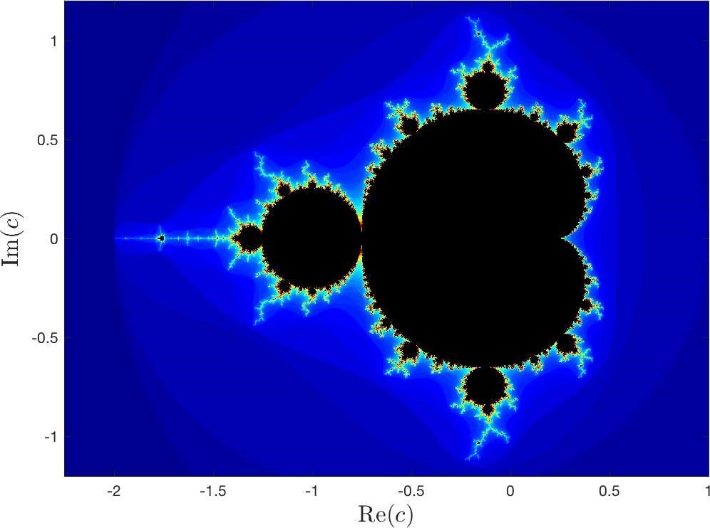

Figure 1.1: This is a figure caption. Note how it appears underneath the figure.

Table 1.1: This is a table caption. Note how it appears above the table.

|  |  |
| --- | --- |
| first column | second column third column |
| This | This This |
| column | column column |
| is left | is centrally is right |
| aligned | aligned aligned |

# Literature Review

The literature review should provide a good review all the relevant papers, case studies etc. related to your work. The following text is for illustration. Lorem ipsum dolor sit amet, consectetuer adipiscing elit. Etiam lobortis facilisis sem. Nullam nec mi et neque pharetra sollicitudin. Praesent imperdiet mi nec ante. Donec ullamcorper, felis non sodales commodo, lectus velit ultrices augue, a dignissim nibh lectus placerat pede. Vivamus nunc nunc, molestie ut, ultricies vel, semper in, velit. Ut porttitor. Praesent in sapien. Lorem ipsum dolor sit amet, consectetuer adipiscing elit. Duis fringilla tristique neque. Sed interdum libero ut metus. Pellentesque placerat. Nam rutrum augue a leo. Morbi sed elit sit amet ante lobortis sollicitudin. Praesent blandit blandit mauris. Praesent lectus tellus, aliquet aliquam, luctus a, egestas a, turpis. Mauris lacinia lorem sit amet ipsum. Nunc quis urna dictum turpis accumsan semper. Lorem ipsum dolor sit amet, consectetuer adipiscing elit. Etiam lobortis facilisis sem. Nullam nec mi et neque pharetra sollicitudin. Praesent imperdiet mi nec ante. Donec ullamcorper, felis non sodales commodo, lectus velit ultrices augue, a dignissim nibh lectus placerat pede. Vivamus nunc nunc, molestie ut, ultricies vel, semper in, velit. Ut porttitor.

## Section Heading

Lorem ipsum dolor sit amet, consectetuer adipiscing elit. Etiam lobortis facilisis sem. Nullam nec mi et neque pharetra sollicitudin. Praesent imperdiet mi nec ante. Donec ullamcorper, felis non sodales commodo, lectus velit ultrices augue, a dignissim nibh lectus placerat pede. Vivamus nunc nunc, molestie ut, ultricies vel, semper in, velit. Ut porttitor. Praesent . Praesent imperdiet mi nec ante. Donec

# Work plan and Gantt Chart

The work plan must be stated in this section along with a Gantt chart of the activities planned in the remaining duration of the project.

# Progress so far

Any preliminary results, computational study, etc. that has been accomplished so far can be mentioned as a part of this section. Some discussion and future work for the remaining of this semester should also be presented .

# References

1. D. Sarunyagate, Ed., Lasers. New York: McGraw-Hill, 1996.

1. G. Liu, K. Y. Lee, and H. F. Jordan, "TDM and TWDM de Bruijn networks and shufflenets for optical communications," IEEE Trans. Comp., vol. 46, pp. 695-701, June 1997.