**Introduction:**

In this laboratory programming assignment, we will be writing the sending and receiving transport-level code in order to implement a simple reliable data transfer protocol using Go-Back-N and a packet version of TCP. We will be testing the network against different possible scenarios, packet loss, packet corruption, acknowledgement loss, acknowledgment corruption and different window sizes. We will compare and contrast how Go-Back-N performs against TCP when dealing with such scenarios.

**Protocol descriptions and explanations:**

***Go-Back-N*:** A transport layer protocol in which a sender sends segments to a server according to a specified window size N. The window represents the total amount of segments that can be sent at a time. After a segment is sent, the sender will expect an acknowledgment (ACK) from the server for each segment sent. The window will only move on to new segment(s) when an ACK for the “base”[1] segment is received. If no ACKs are received after a certain amount of time the sender will simply resend all the packets in its current window. Once all ACKs for the current segments in the window are received, the window will move forward to obtain new segments. Go-Back-N also implements something called “cumulative ACKs” a process in which the receiver will send the ACK for a group of segments in contrast to ACKs for a single segment, this lets the sender know that all segments before that ACK number have been received.

***TCP*:** A transport layer protocol in which a sender sends segments to a server according to a specified window size N. The window represents the total amount of segments that can be sent at a time. After a segment is sent, the sender will expect an acknowledgment (ACK) from the server for each segment sent. The receiver will buffer out of order segments and return ACKs accordingly. The window will only move on to new segment(s) when an ACK for the “base”[2] segment is received. If no ACKs are received after a certain amount of time the sender will only resend the first segment that have not yet been acknowledged. In addition, there is a fast retransmit function that automatically resends the segment if 3 ACKs for the previous packet has been received. TCP also implements something called “cumulative ACKs” a process in which the receiver will send the ACK for a group of segments in contrast to ACKs for a single segment, this lets the sender know that all segments before that ACK number have been received.

**Code Design and Data Structures:**

A Hash map was used to simulate the window because of its fast look up times and organizational efficiency. A Queue was used to buffer waiting segments in the sender. An array list was used to buffer out of order segments in the receiver.

**Correctness Results:\*** (See end of pdf for terminal code print outs)

***Go-Back-N*:**

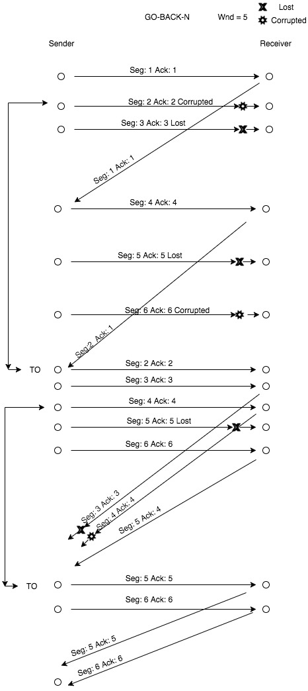

***TCP*:**

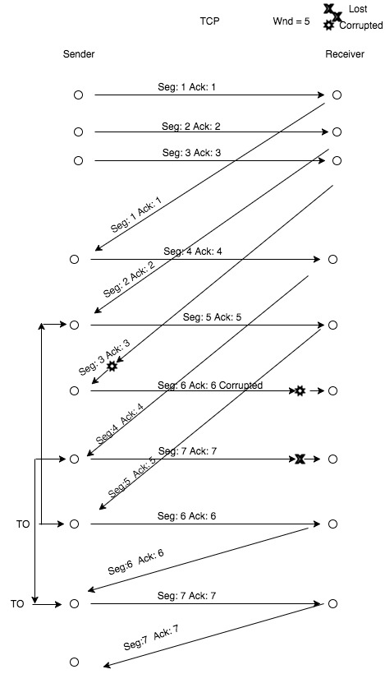

**Analysis:**  * (See looper.sh and data.csv for further details)

For the analysis a shell script was written to run the NetworkSimulator.java program multiple times and store the data it generated in a .csv file that could easily opened by Microsoft Excel. The script looped through 4 variables: loss, corruption, window size, and protocol type. For both loss and corruption it went from 0.0 to 0.9 incrementing by 0.1 respectively, and the window size went from 1 to 10 incrementing by 1. In total the program was run 2000 times to capture every combination of variables for both TCP and GBN. For each of the conditions the number of events required for completion as well as the total time the program took to complete was recorded. In the charts below the number of events is shown on the Y-Axis and when using time instead of events the trends will be the same. `

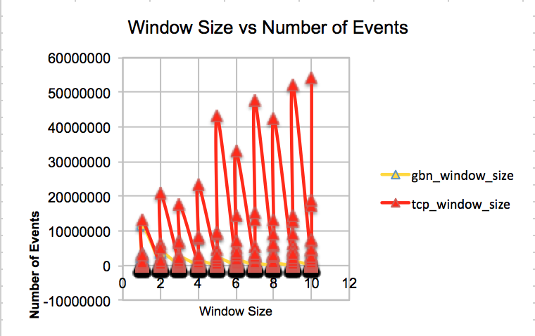

**Conclusion:**

After carefully looking through our data and analysis we can safely say that GBN is far more efficient than TCP. This is likely because GBN will do better when there is more corruption and loss with a window size that is not overly large. We predict that with window sizes that mirror the internet more closely TCP would likely surpass GBN at some point, but for our simulation as corruption and loss increase GBN performs the best.

At corruption and loss levels lower than 0.5, the two protocols are essentially equivalent in terms of the time they take to complete.

**Delegation:**

Manny:

Sender’s transport:

* sendMessage(Message msg
* receiveMessage(Packet pkt)
* timerExpired()
* initialize()

Other:

* Report
* Correctness
* GBN protocols

Conrad:

Receivers transport:

* receiveMessage(Packet pkt)
* initialize()

Packet class:

* setChecksum()
* isCorrupt()

***\* Go-Back-N*:**

Manny Orders > java NetworkSimulator test2.txt 10 .1 .1 5 0 3

'createSendEvent'-Inserting future arrive event at 0 with avg RTT time: 21

'createSendEvent'-Inserting future arrive event at 21 with avg RTT time: 23

YAY IN 1

ADDING to map: 1

Packet seq: 1 ack: 1 sent:)

'createArriveEvent'-Inserting future arrive event at 21 with calculated avg RTT: 26 to: Receiver

startTimer'-Inserting future timer event at time: 21 plus increment = 100

Message sent from sender to receiver at time 21

'createSendEvent'-Inserting future arrive event at 23 with avg RTT time: 24

YAY IN 1

ADDING to map: 2

Packet seq: 2 ack: 2 CORRUPTED

Packet seq: 2 ack: 2 sent:)

'createArriveEvent'-Inserting future arrive event at 23 with calculated avg RTT: 30 to: Receiver

Message sent from sender to receiver at time 23

'createSendEvent'-Inserting future arrive event at 24 with avg RTT time: 26

YAY IN 1

ADDING to map: 3

Packet seq: 3 ack: 3 LOST

Message sent from sender to receiver at time 24

YAY IN 3 AT RECEIVER

Message arriving from sender to receiver at time 26

from receiver:Article 1 Right to Equality

Packet seq: 1 ack: 1 sent:)

'createArriveEvent'-Inserting future arrive event at 26 with calculated avg RTT: 36 to: Sender

'createSendEvent'-Inserting future arrive event at 26 with avg RTT time: 41

YAY IN 1

ADDING to map: 4

Packet seq: 4 ack: 4 sent:)

'createArriveEvent'-Inserting future arrive event at 26 with calculated avg RTT: 42 to: Receiver

Message sent from sender to receiver at time 26

YAY IN 3 AT RECEIVER

Message arriving from sender to receiver at time 30

Sorry msg is from sender is corrupted

YAY IN 2 AT Sender

Message arriving from receiver to sender at time 36

GOT: 1 true 4

REmoving map: 1

startTimer'-Inserting future timer event at time: 36 plus increment = 228

'createSendEvent'-Inserting future arrive event at 41 with avg RTT time: 47

YAY IN 1

ADDING to map: 5

Packet seq: 5 ack: 5 LOST

Message sent from sender to receiver at time 41

YAY IN 3 AT RECEIVER

Message arriving from sender to receiver at time 42

from receiver:Article 4 Freedom from Slavery

Packet seq: 2 ack: 1 sent:)

'createArriveEvent'-Inserting future arrive event at 42 with calculated avg RTT: 49 to: Sender

'createSendEvent'-Inserting future arrive event at 47 with avg RTT time: 59

YAY IN 1

ADDING to map: 6

Packet seq: 6 ack: 6 CORRUPTED

Packet seq: 6 ack: 6 sent:)

'createArriveEvent'-Inserting future arrive event at 47 with calculated avg RTT: 58 to: Receiver

Message sent from sender to receiver at time 47

YAY IN 2 AT Sender

Message arriving from receiver to sender at time 49

GOT: 1 false 5

seqnum != to base base: 2next seq: 7

wait for timeout

YAY IN 3 AT RECEIVER

Message arriving from sender to receiver at time 58

Sorry msg is from sender is corrupted

YAY IN 1

Buffering msg, window is FULL

Message sent from sender to receiver at time 59

YAY IN 5 IM A TIMER

YAY IN 4 IM A TIMER

Timer expired at time 264

base: 2

sequence pkt: 2

Resending pkt: 2

Packet seq: 2 ack: 2 sent:)

'createArriveEvent'-Inserting future arrive event at 264 with calculated avg RTT: 272 to: Receiver

base: 2

sequence pkt: 2

Resending pkt: 3

Packet seq: 3 ack: 3 sent:)

'createArriveEvent'-Inserting future arrive event at 264 with calculated avg RTT: 273 to: Receiver

base: 2

sequence pkt: 2

Resending pkt: 4

Packet seq: 4 ack: 4 sent:)

'createArriveEvent'-Inserting future arrive event at 264 with calculated avg RTT: 277 to: Receiver

base: 2

sequence pkt: 2

Resending pkt: 5

Packet seq: 5 ack: 5 LOST

base: 2

sequence pkt: 2

Resending pkt: 6

Packet seq: 6 ack: 6 sent:)

'createArriveEvent'-Inserting future arrive event at 264 with calculated avg RTT: 278 to: Receiver

startTimer'-Inserting future timer event at time: 264 plus increment = 238

YAY IN 3 AT RECEIVER

Message arriving from sender to receiver at time 272

from receiver:Article 2 Freedom from Discrimination

Packet seq: 2 ack: 2 sent:)

'createArriveEvent'-Inserting future arrive event at 272 with calculated avg RTT: 280 to: Sender

YAY IN 3 AT RECEIVER

Message arriving from sender to receiver at time 273

from receiver:Article 3 Right to Life, Liberty, Personal Security

Packet seq: 3 ack: 3 LOST

YAY IN 3 AT RECEIVER

Message arriving from sender to receiver at time 277

from receiver:Article 4 Freedom from Slavery

Packet seq: 4 ack: 4 CORRUPTED

Packet seq: 4 ack: 4 sent:)

'createArriveEvent'-Inserting future arrive event at 277 with calculated avg RTT: 283 to: Sender

YAY IN 3 AT RECEIVER

Message arriving from sender to receiver at time 278

from receiver:Article 6 Right to Recognition as a Person before the Law

Packet seq: 5 ack: 4 sent:)

'createArriveEvent'-Inserting future arrive event at 278 with calculated avg RTT: 291 to: Sender

YAY IN 2 AT Sender

Message arriving from receiver to sender at time 280

GOT: 2 true 5

REmoving map: 2

ADDING to map: 2

Packet seq: 2 ack: 2 sent:)

'createArriveEvent'-Inserting future arrive event at 280 with calculated avg RTT: 292 to: Receiver

startTimer'-Inserting future timer event at time: 280 plus increment = 235

YAY IN 2 AT Sender

Message arriving from receiver to sender at time 283

Sorry pkt from receiver is corrupted 4

YAY IN 2 AT Sender

Message arriving from receiver to sender at time 291

GOT: 4 true 5

REmoving map: 2

REmoving map: 3

REmoving map: 4

startTimer'-Inserting future timer event at time: 291 plus increment = 235

YAY IN 3 AT RECEIVER

Message arriving from sender to receiver at time 292

from receiver:Article 7 Right to Equality before the Law

Packet seq: 5 ack: 4 sent:)

'createArriveEvent'-Inserting future arrive event at 292 with calculated avg RTT: 297 to: Sender

YAY IN 2 AT Sender

Message arriving from receiver to sender at time 297

GOT: 4 false 2

seqnum != to base base: 5next seq: 3

wait for timeout

YAY IN 5 IM A TIMER

YAY IN 5 IM A TIMER

YAY IN 4 IM A TIMER

Timer expired at time 526

base: 5

sequence pkt: 5

Resending pkt: 5

Packet seq: 5 ack: 5 sent:)

'createArriveEvent'-Inserting future arrive event at 526 with calculated avg RTT: 534 to: Receiver

base: 5

sequence pkt: 5

Resending pkt: 6

Packet seq: 6 ack: 6 sent:)

'createArriveEvent'-Inserting future arrive event at 526 with calculated avg RTT: 537 to: Receiver

startTimer'-Inserting future timer event at time: 526 plus increment = 235

YAY IN 3 AT RECEIVER

Message arriving from sender to receiver at time 534

from receiver:Article 5 Freedom from Torture and Degrading Treatment

Packet seq: 5 ack: 5 sent:)

'createArriveEvent'-Inserting future arrive event at 534 with calculated avg RTT: 540 to: Sender

YAY IN 3 AT RECEIVER

Message arriving from sender to receiver at time 537

from receiver:Article 6 Right to Recognition as a Person before the Law

Packet seq: 6 ack: 6 sent:)

'createArriveEvent'-Inserting future arrive event at 537 with calculated avg RTT: 547 to: Sender

YAY IN 2 AT Sender

Message arriving from receiver to sender at time 540

GOT: 5 true 2

REmoving map: 5

startTimer'-Inserting future timer event at time: 540 plus increment = 235

YAY IN 2 AT Sender

Message arriving from receiver to sender at time 547

GOT: 6 true 1

REmoving map: 6

startTimer'-Inserting future timer event at time: 547 plus increment = 235

YAY IN 5 IM A TIMER

YAY IN 5 IM A TIMER

YAY IN 4 IM A TIMER

Timer expired at time 782

***TCP*:**

Manny Orders > java NetworkSimulator test2.txt 10 .1 .1 5 1 3

'createSendEvent'-Inserting future arrive event at 0 with avg RTT time: 1

'createSendEvent'-Inserting future arrive event at 1 with avg RTT time: 9

YAY IN 1

ADDING to map: 1

Packet seq: 1 ack: 1 sent:)

'createArriveEvent'-Inserting future arrive event at 1 with calculated avg RTT: 4 to: Receiver

startTimer'-Inserting future timer event at time: 1 plus increment = 100

Message sent from sender to receiver at time 1

YAY IN 3 AT RECEIVER

Message arriving from sender to receiver at time 4

from receiver:Article 1 Right to Equality

Packet seq: 1 ack: 1 sent:)

'createArriveEvent'-Inserting future arrive event at 4 with calculated avg RTT: 10 to: Sender

'createSendEvent'-Inserting future arrive event at 9 with avg RTT time: 14

YAY IN 1

ADDING to map: 2

Packet seq: 2 ack: 2 sent:)

'createArriveEvent'-Inserting future arrive event at 9 with calculated avg RTT: 14 to: Receiver

Message sent from sender to receiver at time 9

YAY IN 2 AT Sender

Message arriving from receiver to sender at time 10

GOT: 1 true 2

Removing map: 1

startTimer'-Inserting future timer event at time: 10 plus increment = 163

YAY IN 3 AT RECEIVER

Message arriving from sender to receiver at time 14

from receiver:Article 2 Freedom from Discrimination

Packet seq: 2 ack: 2 sent:)

'createArriveEvent'-Inserting future arrive event at 14 with calculated avg RTT: 22 to: Sender

'createSendEvent'-Inserting future arrive event at 14 with avg RTT time: 53

YAY IN 1

ADDING to map: 3

Packet seq: 3 ack: 3 sent:)

'createArriveEvent'-Inserting future arrive event at 14 with calculated avg RTT: 28 to: Receiver

Message sent from sender to receiver at time 14

YAY IN 2 AT Sender

Message arriving from receiver to sender at time 22

GOT: 2 true 2

Removing map: 2

startTimer'-Inserting future timer event at time: 22 plus increment = 204

YAY IN 3 AT RECEIVER

Message arriving from sender to receiver at time 28

from receiver:Article 3 Right to Life, Liberty, Personal Security

Packet seq: 3 ack: 3 CORRUPTED

Packet seq: 3 ack: 3 sent:)

'createArriveEvent'-Inserting future arrive event at 28 with calculated avg RTT: 36 to: Sender

YAY IN 2 AT Sender

Message arriving from receiver to sender at time 36

Sorry pkt from receiver is corrupted 3

'createSendEvent'-Inserting future arrive event at 53 with avg RTT time: 67

YAY IN 1

ADDING to map: 4

Packet seq: 4 ack: 4 sent:)

'createArriveEvent'-Inserting future arrive event at 53 with calculated avg RTT: 62 to: Receiver

Message sent from sender to receiver at time 53

YAY IN 3 AT RECEIVER

Message arriving from sender to receiver at time 62

from receiver:Article 4 Freedom from Slavery

Packet seq: 4 ack: 4 sent:)

'createArriveEvent'-Inserting future arrive event at 62 with calculated avg RTT: 71 to: Sender

'createSendEvent'-Inserting future arrive event at 67 with avg RTT time: 68

YAY IN 1

ADDING to map: 5

Packet seq: 5 ack: 5 sent:)

'createArriveEvent'-Inserting future arrive event at 67 with calculated avg RTT: 76 to: Receiver

Message sent from sender to receiver at time 67

'createSendEvent'-Inserting future arrive event at 68 with avg RTT time: 74

YAY IN 1

ADDING to map: 6

Packet seq: 6 ack: 6 CORRUPTED

Packet seq: 7 ack: 6 sent:)

'createArriveEvent'-Inserting future arrive event at 68 with calculated avg RTT: 78 to: Receiver

Message sent from sender to receiver at time 68

YAY IN 2 AT Sender

Message arriving from receiver to sender at time 71

GOT: 4 true 4

Removing map: 3

Removing map: 4

startTimer'-Inserting future timer event at time: 71 plus increment = 241

YAY IN 1

ADDING to map: 7

Packet seq: 7 ack: 7 LOST

Message sent from sender to receiver at time 74

YAY IN 3 AT RECEIVER

Message arriving from sender to receiver at time 76

from receiver:Article 5 Freedom from Torture and Degrading Treatment

Packet seq: 5 ack: 5 sent:)

'createArriveEvent'-Inserting future arrive event at 76 with calculated avg RTT: 87 to: Sender

YAY IN 3 AT RECEIVER

Message arriving from sender to receiver at time 78

Sorry msg is from sender is corrupted

YAY IN 2 AT Sender

Message arriving from receiver to sender at time 87

GOT: 5 true 3

Removing map: 5

startTimer'-Inserting future timer event at time: 87 plus increment = 238

YAY IN 5 IM A TIMER

YAY IN 5 IM A TIMER

YAY IN 5 IM A TIMER

YAY IN 5 IM A TIMER

YAY IN 4 IM A TIMER

Timer expired at time 325

Resending pkt: 6

base: 6

Packet seq: 6 ack: 6 sent:)

'createArriveEvent'-Inserting future arrive event at 325 with calculated avg RTT: 328 to: Receiver

startTimer'-Inserting future timer event at time: 325 plus increment = 238

YAY IN 3 AT RECEIVER

Message arriving from sender to receiver at time 328

from receiver:Article 6 Right to Recognition as a Person before the Law

Packet seq: 6 ack: 6 sent:)

'createArriveEvent'-Inserting future arrive event at 328 with calculated avg RTT: 331 to: Sender

YAY IN 2 AT Sender

Message arriving from receiver to sender at time 331

GOT: 6 true 2

Removing map: 6

startTimer'-Inserting future timer event at time: 331 plus increment = 238

YAY IN 5 IM A TIMER

YAY IN 4 IM A TIMER

Timer expired at time 569

Resending pkt: 7

base: 7

Packet seq: 7 ack: 7 sent:)

'createArriveEvent'-Inserting future arrive event at 569 with calculated avg RTT: 575 to: Receiver

startTimer'-Inserting future timer event at time: 569 plus increment = 238

YAY IN 3 AT RECEIVER

Message arriving from sender to receiver at time 575

from receiver:Article 7 Right to Equality before the Law

Packet seq: 7 ack: 7 sent:)

'createArriveEvent'-Inserting future arrive event at 575 with calculated avg RTT: 576 to: Sender

YAY IN 2 AT Sender

Message arriving from receiver to sender at time 576

GOT: 7 true 1

Removing map: 7

startTimer'-Inserting future timer event at time: 576 plus increment = 238

YAY IN 5 IM A TIMER

YAY IN 4 IM A TIMER

Timer expired at time 814

1. The first segment in the window to be sent
2. The first segment in the window to be sent