Hangman in C: Project Report
ECE 131L, Section 012 · Team 5 ·

Team
Name | Role | File(s)
Cesar Marquez-Garcia | Team Lead | hangman.h, scores.c, slides
Manuel Barnett | Implementation Lead | main.c, README
Christopher Rodriguez | QA / Tester | input.c, test plan
Jesse Garcia | Documentation Lead | words.c, function map
Ean Chino | Presenter / Demo Lead | game.c, report

1. Overview
Our program is a menu-driven Hangman game for the terminal. The player _is given a menu of 6 options to choose from(Play Hangman, Add a word, Show word list, Score History, Show stats, Save words and scores). Selecting an option allows the user to view games stats, enter a word, or save the progress of their game(s)
Who it’s for: ___Anybody who wants to play a fun game of hangman crafted by a group of engineer students
Main features: six menu actions (play, add a word, show the word list, show the score history, show statistics, save), input checking on everything the user types, and saved words and scores that load again at startup.

2. Design
How the program is split: five .c files, one per team member, plus one header, hangman.h. _Hangman.h contained the shared constants throughout the whole file that we all could use. _
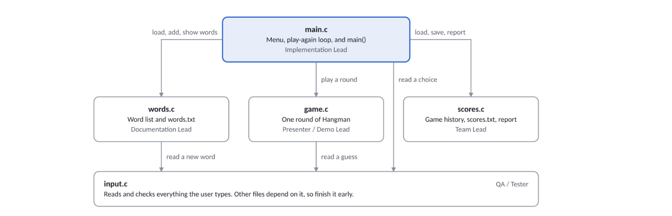

How one round works: ___The user must choose an option from the menu, that is driven by a main ‘playGame’ loop; which you would choose option 1(Play Hangman). The ‘playRound’ function allows the code to run one complete round. You will then have to enter one letter for a word predefined from a list, that uses ‘pickRandomWord’ to choose it. As you progress it will let you know if that letter is right, wrong, or already guessed (alreadyGuessed). Based on how well you guessed that word in few attempts, it will show you the score for that game (computeScore)

3. Data structures

One finished game: the GameRecord struct
Field | Type | What it holds
player | char[WORD_SIZE] | The player’s name
word | char[WORD_SIZE] | The secret word
won | int | 1 for a win, 0 for a loss
wrong | int | Wrong guesses used
score | int | Points for this game

Why we used a struct: _We used structs to help group all our information into one record. This helped us to keep track of where it was going. Such as the players name, word, games won, guesses and score.

Arrays main.c keeps
Variable | What it holds
char words[MAX_WORDS][WORD_SIZE] | The word list, one word per row
GameRecord history[MAX_GAMES] | Every finished game, one per slot

Pass by reference: addWord gets &wordCount and playGame gets &gameCount

File formats
File | One line holds | Example
words.txt | One word, 3 to 24 letters | resistor
scores.txt | One game: player, word, won, wrong, score | Cesar diode 1 2 130

4. Testing
We documented ___8__ test cases with expected outputs. The full list is in ___our notes_______.
How we tested: ___gcc -c. Then completed a full round build
Three tests we want to highlight, including one error case:
Test | What we typed | Expected result | Passed?
Special characters | Any characters that aren’t a letter | Prompt to re-enter a letter | Yes
Length of word | Words with more than 20 characters | Prompt to enter a word that are less than 20 letters | Yes
Same letter guess | Two of the same guesses in a round | Notifies the user and no penalty is given | Yes

Bugs testing found: ___8+___

