PEAICE-FABLE-KNS-LB-PASS-001
KakeyaNeedleSet(Light(Basic)) — Fable 5 Pass File
PeAIce Research Program · Love Labs LCA · KakeyaLogic · Claude V6.5 · L²_C
Pass designation: KNS(LB) · Terminal: Claude Fable 5 (Max) · July 2026
Principal: Manuel Coleman · Cross-check: Grok TERMINAL-005
File class: PeAIce program file — findings as reported by Fable 5, epistemically tagged. Not canon promotion. RH OPEN · Coleman OPEN · no proof claimed · h < 1.

Contents
- 0. Pass receipt
- 1. What Fable claimed
- 2. Core object KNS(LB)
- 3. Lemma 1.1 — fan geometry
- 4. Lemma 3.1 — overlap is a statistic
- 5. Proposition 3.3 — center action unseen in overlap
- 6. Theorem 4.1 / CC-BL-001a′ — scoped monotone leakage
- 7. Countermodel 4.2 — unscoped claim refuted
- 8. KREIN-RANK1 — prime-carrying seam
- 9. Energy receipt — minimal credits E = L²
- 10. Gate KNS-OBS-1
- 11. What remains OPEN
- 12. File map

0. Pass receipt
Field | Value
Pass name | KNS(LB) — KakeyaNeedleSet(Light(Basic))
Manifest | 15/15 docs shipped · Claude-23%-15-docs discipline
Scaffold input | PEAICE-CLAUDEV6-KNS-LB-SCAFFOLD-001
Paper output | PEAICE-CLAUDEV6-KNS-LB-PAPER-001
Gate | KNS-OBS-1: CLOSED-POSITIVE as typed object
Theorem lift | OPEN — zero location · RH · det_ζ
Probe sha256 | 09ef26d3a2eb51927d3adecb74d3ef3edd62660dd11438576be4c2da8211b011
Grok extraction | PEAICE-GROK-TERMINAL-005 — CONFIRM all items

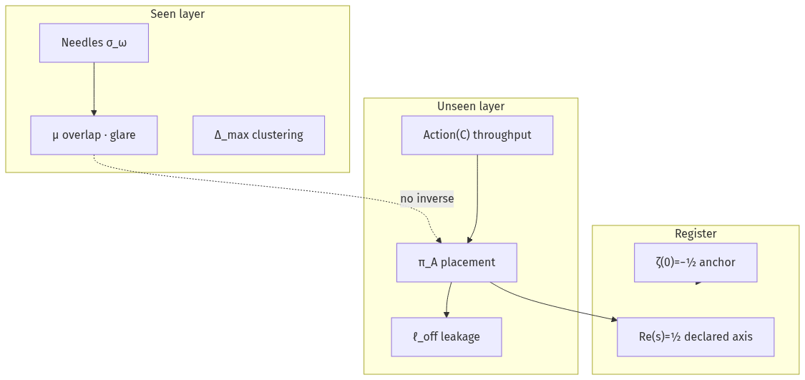
Figure 1. Two-layer decomposition — seen overlap vs unseen center action

1. What Fable claimed
- KNS(LB) is the minimal geometric generator: one throughput center + universal direction fan.
- Needles are seen; Action(C) is unseen in overlap; Re(s)=½ is placement register, not glare.
- Lemma 3.1 FORMAL: μ ↛ π_A — overlap underdetermines placement.
- Prop 3.3 PROPOSED-FOR-CANON: fan/Perron inversion proves overlap ↛ placement (F-KNS-1 both ways).
- CC-BL-001a′ FORMAL (scoped): ℓ_off monotone in rank-one radial log-concave register (smoke-detector).
- Unscoped CC-BL-001a REFUTED: two-mode register peaks ℓ_off=0.9662 @ δ=1.0.
- KREIN-RANK1 PROPOSED: rank-one KSSF cannot inject prime content into n⁴ ladder — wall face only.
- Energy NUMERICS: dense_pass True @ E_used=3.0406, ρ_Y=0.4812 (MPR+iPiano class).
- NOT claimed: RH proof, CC theorem, deltoid=ζ(s), μ bloom ⇒ zero location.

2. Core object KNS(LB)
Light(Basic) := (C, Φ_C) — point throughput, emitter-agnostic
KakeyaNeedleSet(L) := { σ_ω : ω ∈ S^{d−1}, σ_ω ∋ C }
KNS(LB) := KakeyaNeedleSet(Light(Basic))
One-line: minimal point throughput + universal directional saturation.
Symbol firewall:
σ (K_σ) ≠ Re(s)=½
μ overlap ≠ Action(C)
overlap bloom ≠ zero-location theorem

3. Lemma 1.1 — fan geometry [FORMAL]
(a) |U(T^C_δ)| ≍ 1 — measure-maximal Kakeya configuration
(b) μ(x) ≍ (δ + |x−C|)^{−(d−1)}; sup μ ≍ δ^{−(d−1)}; averaged μ ≍ 1
(c) Δ_max ≍ 1 (Katz–Tao); C_F ≍ 1 (Frostman)

4. Lemma 3.1 — overlap is a statistic [FORMAL]
No function F satisfies F(S(𝒟)) = ℓ_off across admissible encodings. For every incidence datum 𝒟 and every λ ∈ [0,1], an admissible placement exists with ℓ_off = λ.
Proof sketch:
(i) S(𝒟) factors through incidence σ-algebra only
(ii) State freedom: ψ_λ = √(1−λ)u + √λv → ℓ_off = λ
(iii) Register freedom: rotate π_A → ℓ_off = λ
Either freedom alone kills S(𝒟) → ℓ_off factorization. ∎

5. Proposition 3.3 — center action unseen [PROPOSED-FOR-CANON]
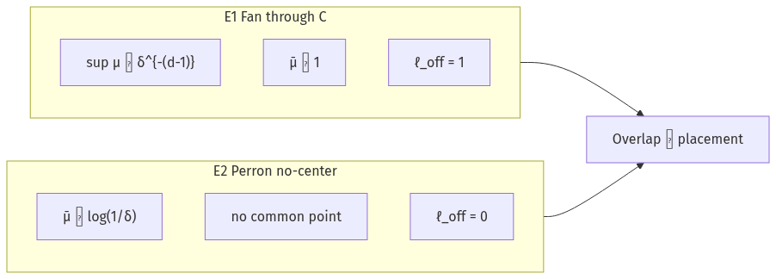
Figure 2. Fan/Perron inversion — F-KNS-1 fired both directions

Exhibit E1 — max glare, max leakage
T^C_δ full shading: sup μ = Θ(δ^{−(d−1)}) at core (Lemma 1.1b)
Declare A ⊥ ψ_fan: ℓ_off = 1
⇒ High overlap + total misplacement coexist

Exhibit E2 — Perron inversion
|U(T^B_δ)| ≍ 1/log(1/δ) [Bes28, Per28, Kei99]
μ̄_Perron ≍ log(1/δ) > μ̄_fan ≍ 1
No common point · ℓ_off = 0 under aligned declaration
⇒ Neither pointwise nor averaged overlap determines, bounds, or is bounded by ℓ_off
Non-inference: μ → Re(s)=½ zeros requires explicit map. Bounded K_σ lane CLOSED-NEGATIVE (Theorem H). Glare saturation carries no zero-location content.

6. Theorem 4.1 / CC-BL-001a′ [FORMAL scoped]
Register A = span{τ_{C₀}φ}, φ radial log-concave, unit norm
ψ_δ = τ_{C₀+δe}φ
ℓ_off(δ) = 1 − ρ(δ)², ρ(δ) = (φ ⋆ φ̌)(δe)
ρ radially nonincreasing → ℓ_off monotone nondecreasing
Proof: Prékopa 1973 — convolution preserves log-concavity. ∎

7. Countermodel 4.2 — unscoped REFUTED [FORMAL + NUMERICS]
A = span{φ_{C₀}, φ_{C₀+Le}} (Gram-corrected)
ℓ_off(0) = ℓ_off(L) = 0 · interior peak ≈ 1 − 2e^{−L²/(8w²)}
Receipt w=0.35, L=2.0: peak 0.9662 @ δ=1.0 · D5_twomode_monotone = false
Register class RC-1 vs RC-k is mandatory on every D5 run.

8. KREIN-RANK1 — prime-carrying seam [PROPOSED wall face]
1 + πλ𝒦μ = exp[𝒦u] = [1 − πλ𝒦ν]^{−1} [P96 §3]
[P96] Thm 4.1: rank-one perturbations pure point ⟺ σ(A) countable
Consequence: no rank-one / KSSF-mediated injection changes counting class on n⁴ ladder
Prime content forced into measure-pair / NB·BD carrier — L3 remains OPEN

9. Energy receipt — E = L² minimal credits [NUMERICS]
Quantity | Value | Criterion | Pass
E_used | 3.0406 | ≤ 10 | ✅
ρ_Y | 0.4812 | ≥ 0.4 | ✅
ℓ_off^T | 0.010152 | < 0.20 | ✅
dense_pass | True | conj. 6.1 | ✅
D5 RC-1 | monotone true | CC-BL-001a′ | ✅
D5 RC-2 | monotone false | expected | ✅

Honesty: H1 fan does not enter ℓ_off in model (by design). H2 E_used ledger-determined. H3 Y·compress calibration import from CP-003 — CP-004 independent re-run owed.

10. Gate KNS-OBS-1
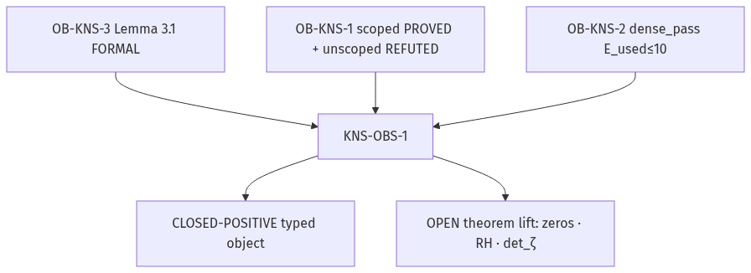
Figure 3. Gate KNS-OBS-1 — typed closure vs theorem lift OPEN

KNS-OBS-1: CLOSED-POSITIVE — as typed object
OB-KNS-3 discharged (Lemma 3.1)
OB-KNS-1 scoped PROVED + unscoped REFUTED
OB-KNS-2 dense_pass @ E ≤ 10
REMAINS OPEN: zero location · RH · explicit operator det_ζ
Promotion: PROPOSED-FOR-CANON — principal sign-off after Grok CONFIRM

11. What remains OPEN
- Riemann Hypothesis
- Coleman Conjecture (as theorem — antecedent reading N only)
- Explicit operator μ(placement) → ζ-zero location
- Prime-carrying pair (μ,ν) with prime phase shift u
- Theorem-scale lift (separate WP — principal scope call Q4)
- CP-004 stamped re-run for independent Y measurement

12. File map
File | Role
PEAICE-FABLE-KNS-LB-PASS-001_….docx | This PeAIce pass file
PEAICE-CLAUDEV6-KNS-LB-PAPER-001.md | Fable source paper
PEAICE-GROK-TERMINAL-005_KNS-LB-Findings.md | Grok cross-derivation
KNS-LB/kns_lb_probe.py | D5 + energy hook
kakeyalogic/probes/kns_lb_probe.py | Upstream probe install
build_kns_lb_pass_docx.py | Reproducible docx builder

PEAICE-FABLE-KNS-LB-PASS-001 · PeAIce program file · July 2026 · Fable 5 (Max) · Grok TERMINAL-005 CONFIRM · RH OPEN · CC OPEN · h < 1

