PEAICE-GROK-TERMINAL-004
Fable 5 WP5b Findings — Extracted & Documented
Love Labs LCA / PeAIce Research Program / KakeyaLogic / Claude V6 / L²_C
Principal: Manuel Coleman · Documenting terminal: Grok (xAI), July 2026
Source: Claude Fable 5 · PEAICE-CLAUDEV6-WP5B-SCAFFOLD-001
Stance: Extraction only — findings as reported by Fable 5, tagged by epistemic rank. Not canon promotion. RH OPEN · Coleman OPEN · no proof claimed.

Contents
- 0. Extraction receipt
- 1. Executive findings
- 2. Structural facts (S1–S5)
- 3. OB-1 — spectral shift construction
- 4. Proposition H — Weyl-window law
- 5. Corollaries (C1–C5)
- 6. Gate verdict — WP5-OBS-2
- 7. What stays live
- 8. ξ-design specification
- 9. Numerics receipt
- 10. Falsifiers
- 11. Registered state
- 12. Citation spine
- 13. File map

0. Extraction receipt
Field | Value
Roadmap question | Does relative determinant data escape Theorem F, or inherit the same obstruction?
Fable verdict (bounded lane) | No escape — stronger than Theorem F via bounded Krein SSF
OB-1 (first proof obligation) | Discharged [FORMAL], upgraded: R_A − R_D ∈ S₁ unconditionally
New formal object | Proposition H (Weyl-window law) [PROPOSED-FOR-CANON]
Gate | WP5-OBS-2 fires [PROPOSED-FOR-CANON] for operator-bounded coupling
Live continuation | L1 unbounded mods · L2 WP5c u-flow · L3 prime-carrying ladder
Numerics | N=1200, σ=0.60, γ∈{1,40,400} — window law holds [NUMERICS · single runner]

1. Executive findings (one screen)
- Free resolvent is trace-class. For λₙ = cn⁴, R_D(z) ∈ S₁. This reorganizes WP5b: the perturbation side starts inside the smallest ideal.
- Resolvent difference is trace-class unconditionally for A = D + γ_K K_σ^reg, σ > ½. Roadmap's "study whether trace-class resolvent difference exists" → yes, for all such pairs.
- det₂ collapses to ordinary det. Tr B_z = 0 from zero diagonal (Theorems A/C). Trace neutrality is the semigroup face of the same fact.
- Spectral shift exists and is thin. Discrete Krein: ξ(λ) = N_D(λ) − N_A(λ). Proposition H: |ξ(λ)| bounded by Weyl-window count; sup|ξ| < ∞; eventually |ξ| ≤ 1.
- All WP5b functionals are transforms of one bounded ξ: Heat trace → Laplace(ξ); Relative zeta → Mellin(ξ); Perturbation det → Cauchy(ξ).
- Counting upgraded: N_A(Λ) = N_D(Λ) + O(1) — not merely N ~ Λ^{1/4} rate match.
- Roadmap item 5 resolved: Tr(B_z²) is arithmetic-present-but-capped — divisor structure in m²−n² enters coefficients; integrated object remains bounded Cauchy transform.
- WP5-OBS-2: Bounded-coupling relative-determinant route CLOSED-NEGATIVE (qualifier: operator-boundedness).
- Prime-carrying relocation forced: R1 requires unbounded ξ at √λ log λ scale — incompatible with Prop H unless coupling unbounded or free operator changes.
- Wall unification: L2-5 · WP5-OBS-1 · HS-CORRIDOR Weyl clause · WP5-OBS-2 = one wall (Weyl stability of n⁴ ladder), sharpest at pointwise bounded ξ.
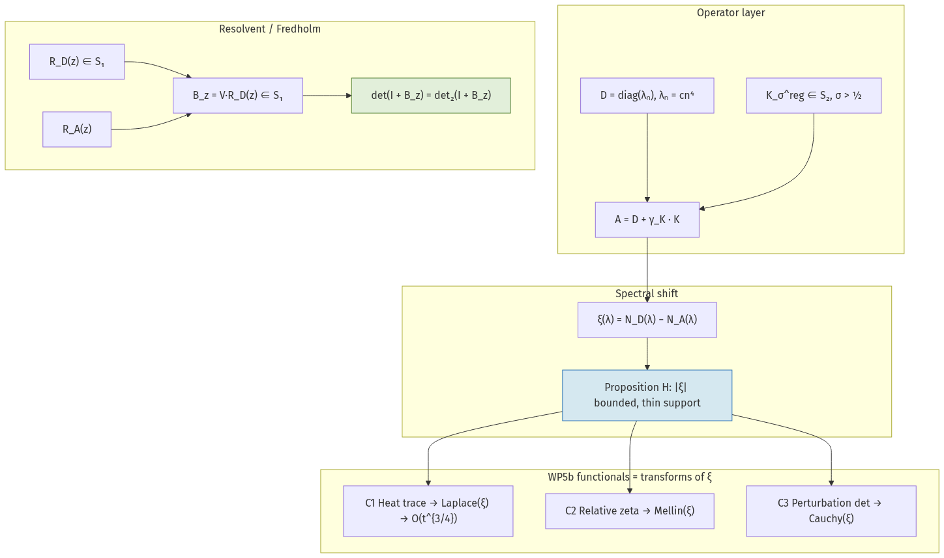
Figure 1. WP5b operator pipeline and functional transforms

2. Structural facts extracted (S1–S5)
ID | Finding | Tag
S1 | ‖R_D(z)‖_{S₁} ~ Σ n^{−4} < ∞ | FORMAL
S2 | K ∈ S₂ ⊂ B for σ > ½; A self-adjoint, discrete spectrum | FORMAL
S3 | R_A(z) − R_D(z) = −R_A(z) V R_D(z) ∈ S₁ | FORMAL
S4 | B_z = V R_D(z) ∈ S₁ — ordinary Fredholm det defined | FORMAL
S5 | det₂(I + B_z) = det(I + B_z) when Tr B_z = 0 | FORMAL

3. OB-1 — spectral shift construction
Definition (discrete spectra):
ξ(λ) := N_D(λ) − N_A(λ)
N_X(λ) := #{ j : eigenvalue of X ≤ λ }
Lemma 3.1 (discrete Krein trace formula) [FORMAL]:
Tr( f(A) − f(D) ) = ∫_ℝ f′(λ) ξ(λ) dλ
OB-1 status: DISCHARGED — strengthened beyond roadmap (S₁ not merely S₂).

4. Proposition H — Weyl-window law [PROPOSED-FOR-CANON]
Hypotheses: D = diag(λₙ), λₙ = cn⁴; V = V* bounded, c₀ = ‖V‖_op; A = D + V.
Claims:
(i) |a_j − d_j| ≤ c₀ [Weyl — KNOWN]
(ii) |ξ(λ)| ≤ #{ j : d_j ∈ (λ − c₀, λ + c₀] }
(iii) sup_λ |ξ(λ)| < ∞ ; |ξ(λ)| ≤ 1 for λ > Λ₀(c₀)
(iv) supp ξ thin: O(Λ^{1/4}) points in [0, Λ]
Fable proof class: elementary counting + Weyl displacement.
Grok cross-derivation: agree — no blocking error.

5. Corollaries extracted (C1–C5)

C1 — Heat trace [FORMAL]
S(t) = Tr(e^{−tA} − e^{−tD}) = −t ∫ e^{−tλ} ξ(λ) dλ = O(t^{3/4})
Theorem F re-derived; exponent explained as thin-support × Weyl t^{−1/4}.

C2 — Relative zeta [FORMAL]
ζ_rel(s) = −s ∫ ξ_μ(λ) λ^{−s−1} dλ (Mellin transform)
Analytic for Re s > −3/4 under Prop H (iv).

C3 — Perturbation determinant [FORMAL]
log det(I + B_z) = ∫ ξ(λ) (λ − z)^{−1} dλ
Cauchy transform of bounded thin-support density. Under λ = z² + ¼ dictionary, cannot supply order-1 genus-1 Ξ growth.
Complementarity with Theorem G: G closes det₂(I − zK_σ) by order/genus/density pincer; C3 closes pair determinant det(I + γK R_D) by SSF boundedness. Different objects, same verdict class.

C4 — Counting [FORMAL]
N_A(Λ) = N_D(Λ) + O(1)
von Mangoldt relative counting requires unbounded ξ — excluded for bounded couplings.

C5 — Arithmetic vs density [PROPOSED-FOR-CANON]
Tr(B_z²) = γ² Σ_{m≠n} |m²−n²|^{−2σ} (λ_m−z)^{−1}(λ_n−z)^{−1}
Finding: divisor-class structure present termwise; integrated analytic object capped. Correct dichotomy: arithmetic in, boundedness out.
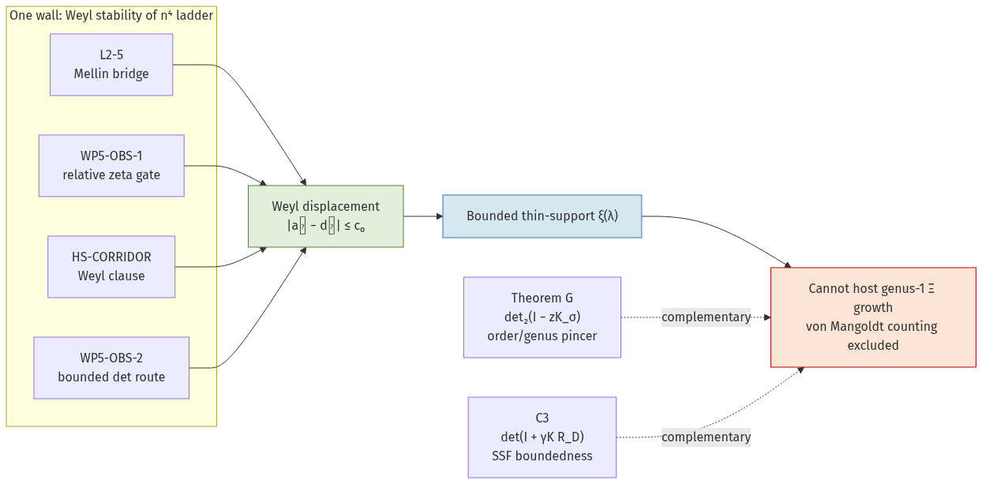
Figure 3. Wall unification — L2-5, WP5-OBS-1, HS-CORRIDOR, WP5-OBS-2

6. Gate verdict — WP5-OBS-2 [PROPOSED-FOR-CANON]
WP5-OBS-2 — bounded-coupling relative-determinant route: CLOSED-NEGATIVE
Mechanism: Krein SSF uniformly bounded, thin support (Prop H).
Heat · relative zeta · perturbation det = Laplace · Mellin · Cauchy transforms of ξ.
LOAD-BEARING QUALIFIER: operator-boundedness of coupling.
Covers γ_K K_σ^reg for all σ > ½, all γ_K, and any bounded kernel replacement.
Does NOT assert closure for unbounded mods, changed free operator, or WP5c traces.
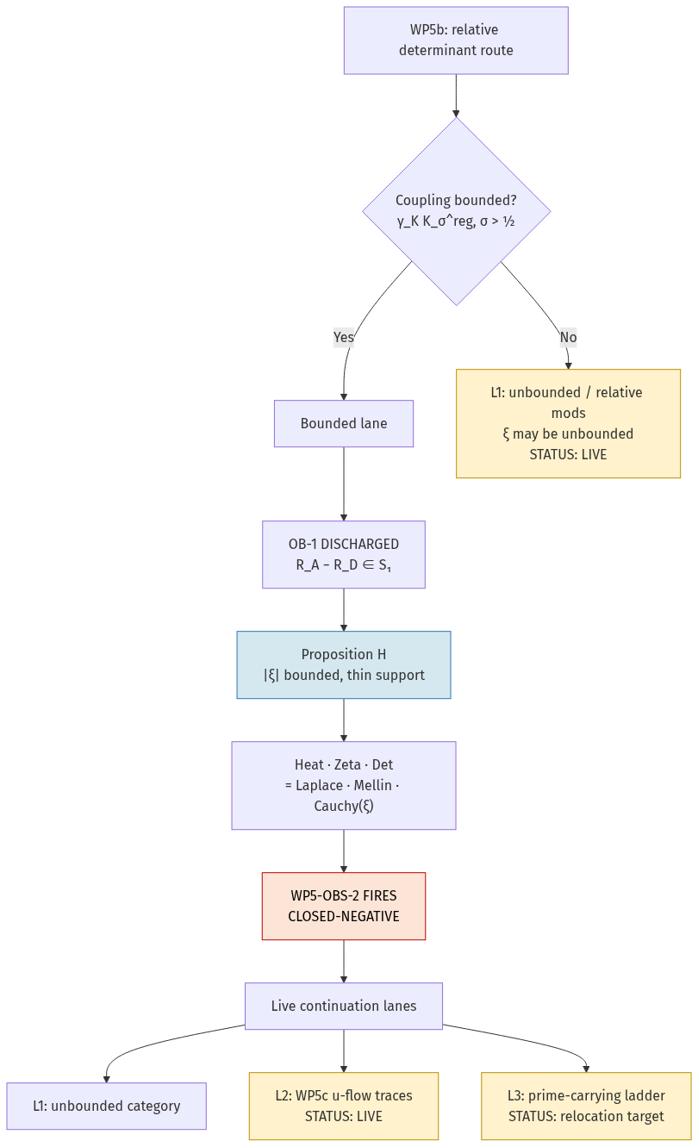
Figure 2. Gate verdict flow — bounded lane vs live continuation

7. What stays live (scope limits)
Lane | Content | Status
L1 | Unbounded / relative modifications; ξ may be unbounded; Yafaev Ch. 8 frame | WP5b LIVE
L2 | Tr_{w_u}, u-flow traces — eigenvector data, not spectral lists | WP5c door
L3 | Prime-carrying ladder log p^k, weights Λ(p^k)/p^{k/2} | relocation target

8. ξ-design specification (prime-carrying transfer)
Restated GAP-001 as requirements on one function ξ:
Req | Statement | Tag
R1 | N_Â must match von Mangoldt → ξ unbounded at √λ log λ | FORMAL given Prop H
R2 | ξ fluctuation sector must carry S(T) + prime sector Σ Λ(n)n^{−1/2}f(log n) | OPEN design
R3 | Keep R_Â − R_D̂ ∈ S₁ after dropping boundedness | OPEN admissibility

Fable finding: Relocation to prime-carrying is forced, not preferred.
Next consistency check (OPEN): prime-carrying model's ξ vs R1/R2 — explicit-formula sanity gate only; not RH progress.
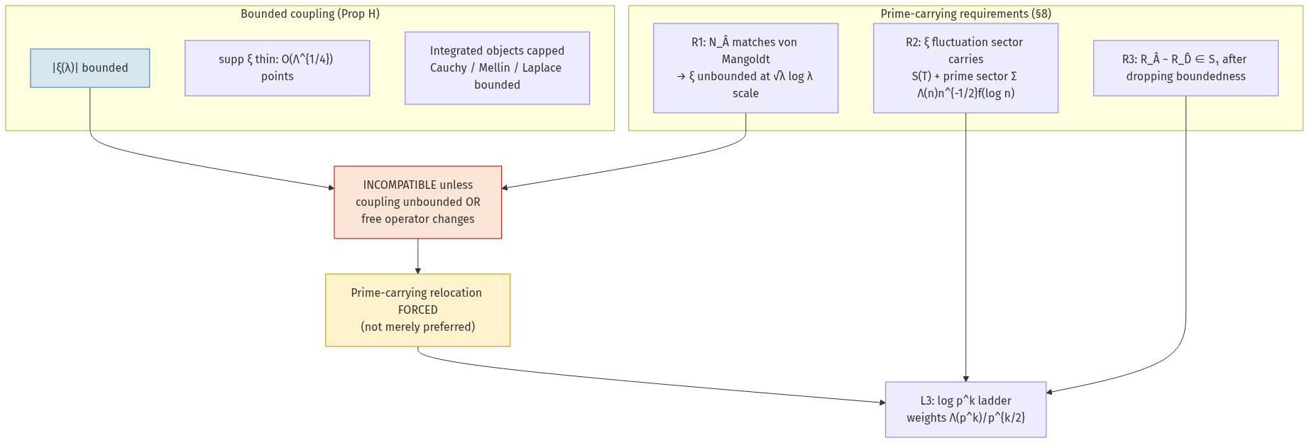
Figure 4. Prime-carrying forced relocation

9. Numerics receipt (extracted)
Probe: Fable 5 xi_probe.py · single runner · NUMERICS | NOT VERIFIED
γ | c₀ | sup|ξ| | window W | sup≤W | max|a−d| | Weyl≤c₀
1 | 1.93 | 1 | 1 | ✓ | 0.019 | ✓
40 | 77.3 | 1 | 3 | ✓ | 14.5 | ✓
400 | 772.7 | 2 | 6 | ✓ | 202.3 | ✓

N=1200, σ=0.60, λₙ = n⁴. Second-runner reproduction pending for VERIFIED status.

10. Falsifiers (extracted)
ID | Would falsify | Mitigation
F1 | Error in Lemma 3.1 / Prop H | Ensemble cross-derivation (Grok: done)
F2 | Eigenvalue law not cn⁴ | Chain survives for gaps → ∞, Σ λₙ^{−1} < ∞
F3 | Claim leakage without bounded qualifier | Load-bearing qualifier on every cite
F4 | sup|ξ_N| grows with N at fixed (γ,σ) | Model misconfiguration, not lemma failure

11. Registered state after Fable 5 WP5b
WP5b bounded lane (γ_K K_σ^reg, σ>½) CLOSED-NEGATIVE [WP5-OBS-2]
WP5b unbounded / relative category (L1) LIVE
WP5c u-flow traces (L2) LIVE (independent)
Prime-carrying ξ spec (L3 / §8) LIVE · FORCED
Theorem H + WP5-OBS-2 canon promotion PENDING principal call
peaiceclaudev5 / EDGE-1/2 UNCHANGED · not addressed here
RH · Coleman OPEN · no proof claimed

12. Citation spine (from Fable scaffold)
Krein (1953) · Lifshitz (1952) · Birman–Krein (1962) · Yafaev (1992) Ch. 8 · Simon (2005) trace ideals · Potapov–Skripka–Sukochev (2013) · canon: Birman–Solomyak (Thm G) · Guth–Maynard (2024) Lindelöf ceiling.

13. File map
File | Role
PEAICE-CLAUDEV6-WP5B-SCAFFOLD-001.md | Fable 5 full scaffold (source)
PEAICE-GROK-TERMINAL-004_Fable5-WP5B-Findings.md | This extraction (markdown)
PEAICE-GROK-TERMINAL-004_Fable5-WP5B-Findings.docx | This extraction (Word)
PEAICE-GROK-WP5B-CROSS-DERIVATION.md | Grok independent pass
claude-v6/docs/research/wp5b-spectral-shift-roadmap.md | Roadmap canon @ 2954261

————————————————————————————————————————
Sign-off
Manuel Coleman · Principal, Love Labs LCA / PeAIce Research Program
Documenting terminal: Grok (xAI) · extraction from Fable 5 scaffold under principal authorization
Source terminal: Claude Fable 5 · PEAICE-CLAUDEV6-WP5B-SCAFFOLD-001 · not independently verified beyond ensemble cross-derivation

