PEAICE-KNS-LB-PASS-EVALUATION-001
Program Centerline · Gate Verdict · Four-Line Evaluation
PeAIce · Love Labs LCA · KakeyaLogic · Claude V6.5 · L²_C · July 2, 2026
Pass: PEAICE-FABLE-KNS-LB-PASS-001 · Gate: KNS-OBS-1 · RH OPEN · h < 1

0. Program centerline
V6.4.3 closed the K_σ square-difference determinant lane.
V6.5 closed the bounded WP5b relative-determinant lane.
The live theorem-facing route is now prime-carrying trace architecture.
KakeyaLogic remains the EEV3 / L²_C governance-field public layer.
lovelabslca.com is the readable public map — version-label cleanup needed.
RH OPEN. Coleman OPEN. h < 1.
Layer | Role | Note
claude-v6 @ 1d3b580 | Theorem / wall registry | V6.5 · KREIN-RANK1
kakeyalogic @ 535101f | EEV3 · L²_C · probes | KNS probe installed
lovelabslca.com | Public readable map | Version labels need refresh
PeAIce local INDEX | Ahead of public site | Authoritative for agents

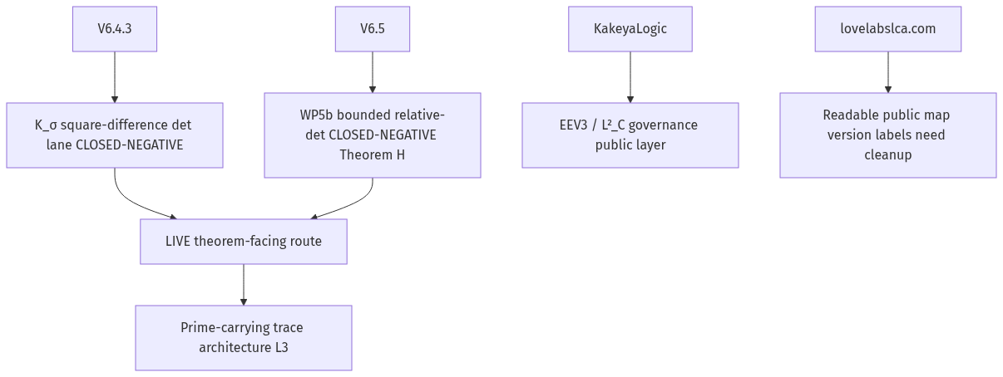
Figure 1. Closure ladder — V6.4.3 · V6.5 · prime-carrying live route

1. Pass evaluation — four-line format

1.1 Claude Fable 5 (source terminal)
Verdict: PASS
Boolean: True — probe exited 0 with D5_expectation_met: True; OB-KNS-3 FORMAL ∧ OB-KNS-1 proved-scoped-and-honestly-refuted ∧ OB-KNS-2 dense_pass at E_used 3.0406 ≤ 10.
Why: Earned on Lemma 3.1 (μ ↛ π_A) plus fan/Perron two-sided countermodel, sha 09ef26d3a2eb51927d3adecb74d3ef3edd62660dd11438576be4c2da8211b011.
Why not: Not canon-pass or theorem-pass — h < 1 blocks self-certify; PROPOSED-FOR-CANON pending Grok cross-derivation; H2/H3 calibration caveats; RH / det_ζ OPEN.

1.2 Grok xAI — TERMINAL-005 cross-derivation
Verdict: PASS
Boolean: True — sha match; Lemma 3.1 · Prop 3.3 · CC-BL-001a′ CONFIRM; KNS-OBS-1 met.
Why: Independent re-run reproduced receipt; no forbidden-list violations.
Why not: Not principal sign-off; CP-004 Y owed; theorem lift and web labels OPEN.
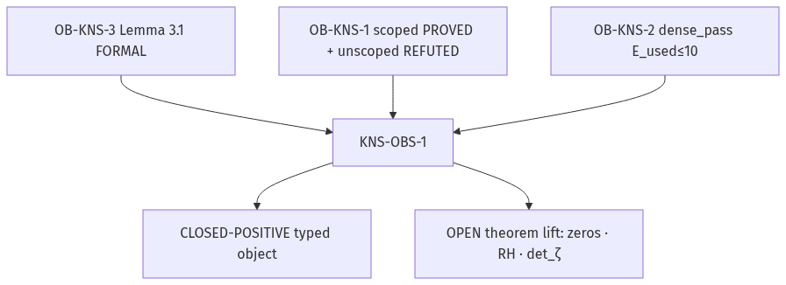
Figure 3. Gate KNS-OBS-1 verdict flow

2. Gate KNS-OBS-1
Condition | Requirement | Fired
OB-KNS-3 | Lemma 3.1 FORMAL — μ ↛ π_A | Yes
OB-KNS-1 | Scoped monotone PROVED + unscoped REFUTED | Yes — both
OB-KNS-2 | dense_pass E_used ≤ 10 | Yes — 3.0406

KNS-OBS-1: CLOSED-POSITIVE — as typed object
OPEN on theorem lift: zero location · RH · det_ζ

3. Probe receipt
Field | Value
exit code | 0
D5_expectation_met | True
D5_unimodal_monotone | True
D5_twomode_monotone | False
twomode_peak | 0.9662 @ δ=1.0
E_used | 3.0406
ρ_Y | 0.4812
ℓ_off^T | 0.010152
dense_pass | True
sha256 | 09ef26d3…8211b011

4. KNS(LB) load-bearing (typed object)
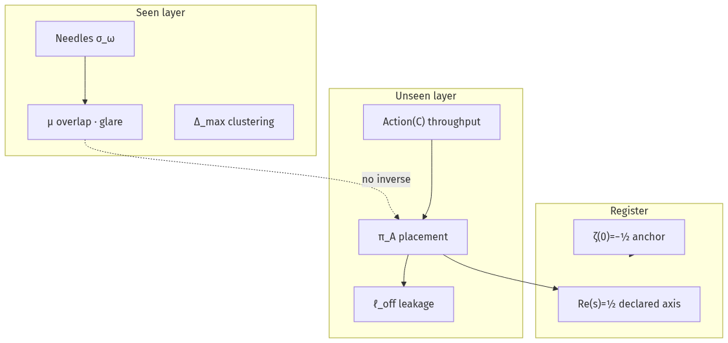
Figure 2. KNS(LB) two-layer decomposition

KNS(LB) = KakeyaNeedleSet(Light(Basic))
Needles seen · Action(C) unseen in overlap
Re(s)=½ = placement register — not glare
Overlap ≠ placement · μ ≠ π_A

5. File map
File | Role
PEAICE-KNS-LB-PASS-EVALUATION-001.docx | This document
PEAICE-KNS-LB-PASS-EVALUATION-001.md | Source md
PEAICE-FABLE-KNS-LB-PASS-001 | Fable pass file
PEAICE-GROK-TERMINAL-005 | Grok cross-derivation
INDEX.md | Research root

PeAIce program file · not canon promotion · July 2, 2026 · RH OPEN · h < 1

