Libraries installed

The Pycocotools package includes the tools in the form of an API accesible for python applications, originally intended for loading, parsing and visualizing annotation on the famous large image dataset COCO. The API is contained in the python file coco.py.

Cython is installed at the same time. Cython_bbox is a Python library designed to accelerate bounding box computations commonly used in object detection tasks. It leverages Cython, a superset of Python that allows compiling Python code into efficient C extensions.

Faiss-cpu and faiss-gpu are libraries that provide implementations of the FAISS (Facebook AI Similarity Search) library for efficient similarity search.

ONNX (Open Neural Network eXchange) isn't actually a library in the traditional sense. It defines a common set of operators (the building blocks of machine learning models) and a file format. Once a model is in the ONNX format, it can be used by various tools and runtime environments that support ONNX, so one is not limited by the original format. Onnxruntime would be the runtime engine for running models in the ONNX format.

Having the TensorFlow libraries already installed in the environment, we install TensorRT, a runtime engine that optimizes pre-trained models for NVIDIA GPUs by removing unnecessary computations, converting the model to a format designed for NVIDIA GPUs and leveraging hardware acceleration features.

The requirements.txt file install several libraries we all use in our usual Data mining projects, plus some specifics like Torchvision, a library specifically made for Computer Vision tasks.

Datasets

AICUP (train) dataset

This dataset is separated in the train and test datasets. The train dataset is composed by the images but also labels, which consists in .txt files that match the images’ name. The label contains the coordinates and dimensions of the elements within the images:

class | center_x | center_y | width | height | track_ID
0 | 0.704687 | 0.367592 | 0.032291 | 0.1 | 1

The train dataset is downloaded and must be located at our project’s root directory as /train.

The test dataset isn’t actually used in this pipeline, instead we’ll see how the file generate_AICUP_patches.py will generate it.

ReID dataset

ReID stands for Re-Identification, it seems to be a naming standard for person identification datasets, but apparently it’s just the AICUP dataset adapted for a ReID format that fast_reid can work with. This conversion happens via /fast_reid/datasets/generate_AICUP_patches.py on the AICUP train dataset:

- The ratio for the the train set is 0.8 and 0.2 for the test set.
- It converts the images’ size to 720 x 1280 under .bmp (Bitmap) loss-less format. It’s also easy to read and write for all OS.
- It patches the labels onto the new .bmp images.
- The patched files are then written onto:
  - /content/AICUP_Manny_32/fast_reid/datasets/AICUP-ReID/bounding_box_train
  - /content/AICUP_Manny_32/fast_reid/datasets/AICUP-ReID/bounding_box_test

The images within these two sets are stored under the same directory, with no inner forkings, with a new resolution and file format. This is the structure and file format fast_reid framework will work with.

YoloV7 dataset

The YoloV7 dataset is also the AICUP dataset adapted for the yolo format that YoloV7 can work with. This script will generate new images separated in a new train and validation datasets. This conversion happens via /yolov7/tools/AICUP_to_YOLOv7.py on the AICUP train dataset:

- The ratio for the the train set is 0.8 and 0.2 for the validation set.
- There’s no apparent change in the size of images.
- The images are renamed according to its corresponding /label text file name.

The purpose of the script and the new dataset is to split the AICUP dataset into a train and validation dataset, keeping the same /images and /labels structure. It would look like this is the structure and naming conventions YoloV7 will work with.

Deep Learning Frameworks and Models

Fast_ReID Deep Learning Framework

A framework designed for Person Re-Identification algorithms. It offers pre-trained models and tools ready to use in other projects. These models aren’t trained relying on a single model architecture, but offers instead implementations of popular architectures specialized in person identification:

- ResNet: Convolutional Neural Network.
- OSNet: Specialized in handling small variation detection.
- HRNet: Mantains high-resolution features for better identification.

The pool of available models within the framework is called Model Zoo. These models are trained using the architectures mentioned before, along with Re-ID algorithms like:

- Triplet Loss: A loss function that encourages the model to embed images of the same person together in the feature space while pushes the ones of different people apart.
- SphereNet: Learns discriminative features for person Re-ID.
- Margin Loss: Loss function that creates a larger margin between a person’s features and those of different people.

In conclusion, Fast-ReID allows you to choose models, that implement different architectures, algorithms and loss functions, to train them on your own datasets. These “baselines” are available for download at https://github.com/JDAI-CV/fast-reid/blob/master/MODEL_ZOO.md. Sample from Github:

Method | Pretrained | Rank@1 | mAP | mINP | download
BoT(R50) | ImageNet | 94.4% | 86.1% | 59.4% | model
BoT(R50-ibn) | ImageNet | 94.9% | 87.6% | 64.1% | model
BoT(S50) | ImageNet | 95.2% | 88.7% | 66.9% | model
BoT(R101-ibn) | ImageNet | 95.4% | 88.9% | 67.4% | model

Implementation of Fast_ReID

It would seem the Fast-ReID utilities set for this project, despite executed, can’t execute successfully, according to the result of the specific cell in the original pipeline, never training past epoch 2, error which is documented in the READ_ME file of the baseline project:

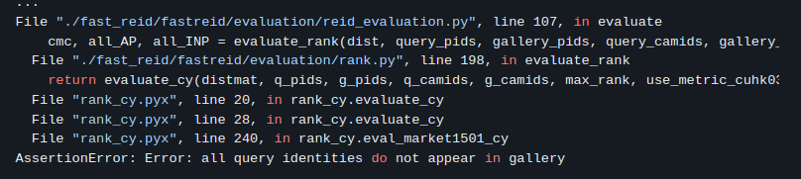Figure 1: The lack of two datasets "query" and "gallery" required for evaluation seem to stop the process
This discontinuation is later observed in further steps (Tracking and Creating the submission file for AICUP), as the results of the FastReID training are never dealt with within the code.

YOLOv7

YOLOv7 (You Only Look Once) is a real-time object detection model. It’s the 7th iteration of previous YOLO versions. The last version available is YOLOv10, released in 2024.

It can effectively reduce about 40% of parameters, 50% of computation and requires cheaper hardware, as opposed to other computer vision neural networks, and can be trained much faster on small datasets without pre-trained weights. This efficiency is suitable for applications where both real-time performance and accurate object detection is important. The model surpasses all known object detectors in both accuracy and speed in the the range from 5 FPS to 160 FPS, having the highest accuracy of 56.8% AP (Average Precision) at 30+ FPS on GPU V100.

The model relies on CNN (Convolutional Neural Network) for extracting features from images, object localization and measurement of objects within the image, and object classification. It also implements techniques that don’t involve CNNs, such as ELAN (Efficient Layer Aggregation Network), focused on optimizing information flow through the network during feature extraction, with the main goal of ensuring deeper networks learn and converge more effectively during training.

The ELAN approach

Gradient is information that deepens the detail handled by Neural Networks. The CNNs may suffer from vanishing gradients as weights propagate through many layers, and specially in deeper layers. Some algorithms, like the ResNet family, try to prevent the gradient loss by introducing a bias that propagates through layers. ELAN tackles this issue by strategically controlling the path lengths of gradients within the network.

- Shuffling: rearranges the feature channels within a layer, preventing gradients from getting stuck in specific channels
- Channel Splitting and Concatenation: it splits inout channels into multiple branches with fewer branches, processing data separately and recombining the features using concatenation, favoring gradient flow and feature diversity.
- Efficient Transition Blocks: these blocks ensure efficiency for proper information flow and resolution changes when transitioning different stages of the network.

YOLOv7 Pipeline stages

The model follows a set of stages to process the images and identify objects within it:

- Backbone feature extraction:
  - Images are fed to YOLOv7’s backbone network, a CNN architecture.
  - This backbone network extracts hierarchical features from the image. These features capture various levels of detail, like edges, textures, shapes and parts.

- Neck (Feature Fusion):
  - This component takes the feature maps extracted in the previous step.
  - It combines and merges these features from various resolutions, trying to create new features that better represent objects, therefore easier to detect during object detection.
  - To match the spatial dimensions of different resolutions’ features, it uses Up-sampling techniques.

- Head (Prediction):
  - Takes on the fused feature maps from the Neck stage.
  - Via CNN, it makes two crucial predictions for each potential object in the image:
    - Bounding Box Prediciton: predicts location and size of the box tagging the object.
    - Class Prediction: this step assigns the class label to the detected object within the tag.

Implementation of YOLOv7

The values for each convolutional layer’s parameters, splitting, concatenation and up-sampling, in the case of given pipeline are located in the yaml file /yolov7/cfg/training/yolov7-AICUP.yaml:

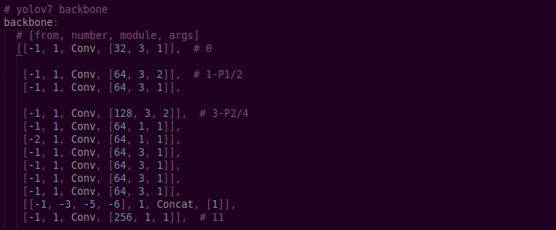Figure 2: Example of Convolutional Layering in YOLOv7

Bibliography

COCO Dataset

http://cocodataset.org/

Fast-ReID Framework

https://github.com/JDAI-CV/fast-reid
https://github.com/JDAI-CV/fast-reid/blob/master/MODEL_ZOO.md

YOLOv7

https://viso.ai/deep-learning/yolov7-guide/
https://arxiv.org/pdf/2207.02696

