TRANSFORMER FAILURE PREDICTION
Model Comparison: Without Weather vs With Weather
Uttar Pradesh Power Distribution Grid | Predictive Maintenance
🔵 Without Weather — BiLSTM Regression Model | 🟢 With Weather — Vanilla RNN Classification Model

1. Overview & Setup Comparison
MODEL COMPARISON AT A GLANCE
Dimension | Without Weather (RNN/BiLSTM) | With Weather (RNNW)
Model Architecture | Bidirectional LSTM | Vanilla RNN
Task Type | Regression (failure count) | Classification (Low / Med / High)
Records | 136,344 | 126,777
Substations | N/A | 1,055
Sequences Built | N/A | 119,604
Input Features | 3 (count, day-of-week, month) | 19 (incl. weather, infra, history)
Lookback Window | 7 days | 7 days
Train / Test Split | 80% / 20% | Standard split

2. Model Performance Comparison
MODEL PERFORMANCE METRICS
Metric | Without Weather (BiLSTM) | With Weather (RNNW)
Accuracy / R² | R² = 0.8606 (regression) | ~65% class accuracy
MAE | 33.57 failures/day | ~0.39 class units
RMSE | N/A | ~0.51
Macro F1 | N/A | ~0.66 avg
Baseline to Beat | Mean predictor | 35.9% (most-freq class)
Improvement vs Baseline | 86% variance explained | Nearly doubled baseline accuracy

3. With Weather — Per-Class Severity Metrics
The Without Weather model performs regression (predicting a count), so per-class metrics do not apply. The With Weather model predicts severity classes; detailed precision, recall, and F1-Score are shown below.

WITH WEATHER — PER CLASS METRICS (RNNW)
Class | Recall | Precision | F1-Score | Count
Low (0) — Minor faults | ~67.5% | ~70.9% | ~69.1% | 45,558
Medium (1) — Moderate impact | ~58.3% | ~63.7% | ~60.9% | 37,724
High (2) — Critical / Emergency | ~70.2% | ~66.3% | ~68.2% | 43,495

4. Without Weather — Actual vs. Predicted Daily Failures
The BiLSTM model captures seasonal demand surges with an R² of 0.8606. The chart below shows test-set predictions vs. actuals.

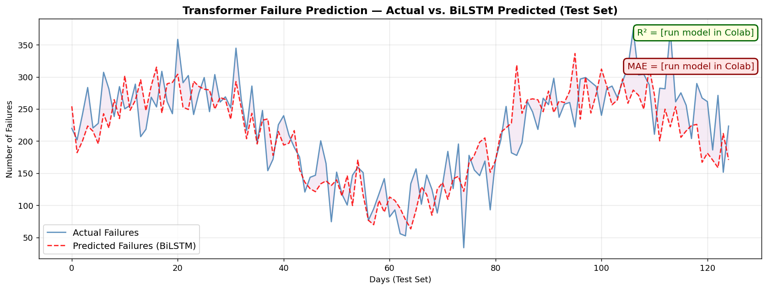

5. Zone-Level Record Distribution
Both models cover the same nine zones. Minor record differences arise from pre-processing steps in the With Weather pipeline (weather join, sequence filtering).

TOP ZONES — FAILURE RECORDS (BOTH MODELS)
Zone | Without Weather | With Weather | Δ Records
PRAYAGRAJ 2 | 36,241 (26.6%) | 33,174 (26.2%) | -3,067
VARANASI 2 | 28,661 (21.0%) | 28,642 (22.6%) | -19
AZAMGARH | 21,670 (15.9%) | 21,126 (16.7%) | -544
MIRZAPUR | 17,920 (13.1%) | 13,169 (10.4%) | -4,751
BASTI | 9,527 (7.0%) | 9,526 (7.5%) | -1
GORAKHPUR 2 | 10,323 (7.6%) | 9,422 (7.4%) | -901
GORAKHPUR 1 | 6,366 (4.7%) | 6,366 (5.0%) | 0
VARANASI 1 | 4,620 (3.4%) | 4,618 (3.6%) | -2
PRAYAGRAJ 1 | 1,016 (0.7%) | 734 (0.6%) | -282

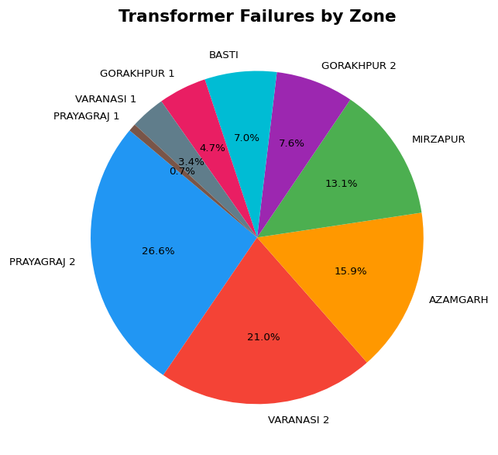

6. Temporal Failure Trends (Without Weather Dataset)
Daily and monthly aggregation charts from the BiLSTM (Without Weather) dataset. Summer months (May–August) show pronounced failure peaks, consistent with agricultural irrigation and cooling demand.

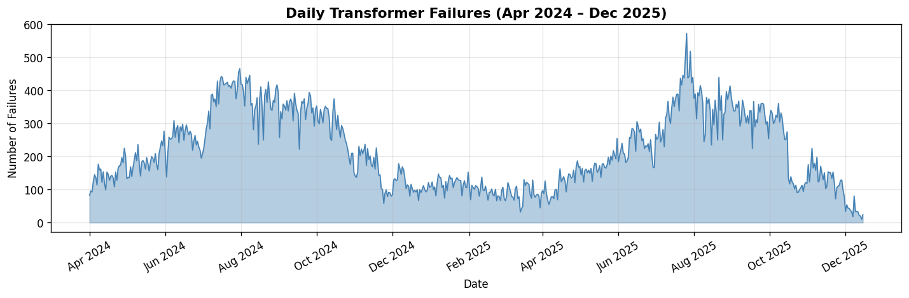

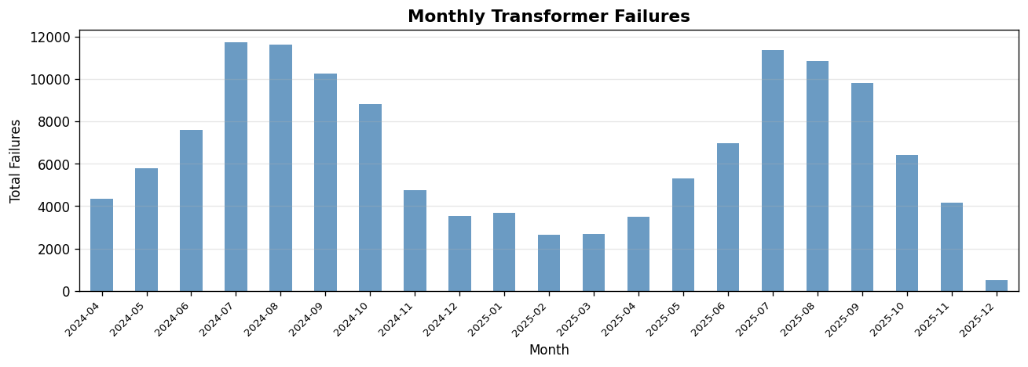

7. Root Cause Distribution (Without Weather Dataset)
Overloading and line faults together account for over 43% of all recorded failures. The With Weather model uses these patterns as classification signals via the 19-feature input set.

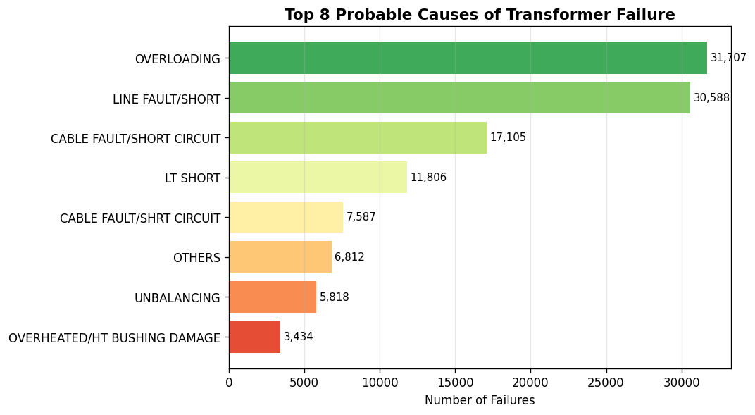

8. Key Differences & When to Use Each Model
KEY DIFFERENCES & INSIGHTS
Without Weather (BiLSTM) | With Weather (RNNW)
Predicts actual failure COUNT per day | Predicts failure SEVERITY class (Low/Med/High)
3 simple temporal features | 19 rich features incl. heat index, humidity, wind
Strong R² = 0.86 — excellent for volume forecasting | ~65% accuracy — nearly 2× random baseline of 35.9%
Best for: scheduling crews & pre-positioning spares | Best for: triaging severity & emergency response planning
High class (critical) captured via count spikes | High class best predicted — weather signal is strong
Medium severity cannot be inferred from counts alone | Medium class hardest — overlaps with Low and High profiles
No weather dependency — simpler, faster to deploy | Requires weather data pipeline for real-time use

