Comparative Analysis of Search Algorithms
in a Constrained Store Navigation Environment
BFS, DFS, UCS, and A* Performance on a 5-Lane Grocery Store Graph

Store Pathfinder: Interactive Turn-Based Game (v4.0)
MLC Busy Local Grocery Store Simulation | AIMA Framework
120 Simulated Games | 12 Matchup Configurations | 64 Metrics Per Game

Table of Contents

1. Abstract
This paper presents a comparative empirical analysis of three classical search algorithms—Breadth-First Search (BFS), Depth-First Search (DFS), and Uniform Cost Search (UCS)—applied to a competitive two-player store navigation problem. Using a custom-built interactive game simulation modeled after the AIMA framework, we evaluate algorithm performance across 120 automated games on a 5-lane grocery store graph with a permanently blocked aisle (A3), dynamic opponent blocking via banana-leaf barriers, and randomized item distributions. Our results demonstrate that BFS achieves the highest overall performance with a 61.3% win rate and an average of 9 moves to collect 12 items, while UCS produces functionally equivalent path quality at 39% higher computational cost. DFS proves categorically unsuitable, requiring 105–162 moves and winning zero games. We further analyze how the A* algorithm would perform and discuss conditions under which each algorithm excels in stores of varying size.

2. Introduction

2.1 Background and Motivation
Pathfinding algorithms form the backbone of intelligent navigation systems, from robotic warehouse automation to GPS route planning. While the theoretical properties of classical search algorithms are well-established, their practical performance in constrained, adversarial environments with dynamic obstacles remains an active area of study. As Syahputra et al. (2026) observe in their review of the transition from classical to heuristic search methods, BFS and DFS continue to serve as foundational baselines in modern AI applications even as the field moves toward more informed strategies. This research bridges the gap between textbook theory and real-world application by implementing these algorithms in a concrete, measurable scenario: competitive grocery shopping.
The grocery store navigation problem provides an ideal testbed for search algorithm comparison because it combines several realistic constraints: a structured but not trivial graph topology, permanently blocked regions simulating real-world aisle closures, dynamic adversarial obstacles where one player’s position blocks lanes for the other, randomized objectives requiring multi-target planning, and competitive pressure where efficiency directly determines the winner. Similar structured navigation problems have been studied in maze environments (Elkari et al., 2024; Salem et al., 2024), but our work extends these to a competitive, multi-target setting with permanent and dynamic obstacles.

2.2 Problem Statement
Given a graph representing a 5-lane grocery store with 17 navigable nodes, a permanently blocked aisle (A3), and two competing agents each assigned 12 randomly distributed products, determine which uninformed search algorithm—BFS, DFS, or UCS—most efficiently navigates the store to collect all assigned items while contending with dynamic blocking from the opposing agent. Specifically, we seek to answer:
- Which algorithm achieves the fewest moves to collect all 12 items?
- How does the permanently blocked A3 aisle affect algorithm routing behavior?
- Are BFS and UCS truly equivalent on uniform-cost graphs, and what is the overhead of UCS’s priority queue?

2.3 Key Challenges
The store navigation problem introduces several challenges beyond standard single-agent pathfinding. The permanently blocked A3 splits the store into a left cluster (A1–A2, Produce and Dairy) and a right cluster (A4–A5, Pantry and Snacks), forcing all cross-cluster traffic through corridor chokepoints at T-row (T2–T4) or B-row (B2–B4). This is analogous to the routing constraints studied by Abbass et al. (2025) in data center networks, where blocked paths force traffic through alternative routes and the choice of traversal algorithm significantly impacts routing efficiency. The banana-leaf blocking mechanism dynamically removes the opponent’s current node from the graph each turn, introducing an adversarial element similar to ghost avoidance in PAC-Man navigation (Salem et al., 2024). Each player’s 12 items are randomly assigned, creating variable demand distributions—balanced, moderate, or lopsided—that stress the algorithms differently.

3. Related Work and Importance

3.1 Classical Search in Maze and Grid Environments
Elkari et al. (2024) conducted a comprehensive comparative study of DFS, BFS, and A* search algorithms in maze navigation environments. Their work demonstrated that BFS consistently finds the shortest path in unweighted mazes but at higher memory cost, while DFS is memory-efficient but produces longer, suboptimal paths. A* with an admissible heuristic achieved the best balance of path optimality and computational efficiency. Our study extends these maze-based findings to a more complex multi-target, adversarial store environment where agents must collect multiple items rather than simply reaching a single goal.
Salem et al. (2024) explored pathfinding algorithms specifically in the context of the PAC-Man game, comparing BFS, DFS, Dijkstra’s algorithm, and A* for navigating ghosts and collecting pellets. Their findings that BFS outperforms DFS in structured grid environments with obstacles directly parallel our store navigation results. Critically, their PAC-Man study also features dynamic adversarial obstacles (ghosts), making it a close analogue to our banana-leaf blocking mechanic. Our work extends this by introducing permanent structural blockages (the closed A3 aisle) alongside the dynamic ones.

3.2 DFS Optimization and Network Routing
Abbass et al. (2025) proposed an enhanced depth-first search algorithm specifically designed to improve routing efficiency in data center networks. Their work recognized that standard DFS produces suboptimal routes in structured network topologies and introduced modifications to address this weakness. Their finding that vanilla DFS creates inefficient paths in grid-like networks directly corroborates our results: on our 5-lane store graph (which shares the structured, grid-like topology of data center networks), DFS produces paths 12–18 times longer than BFS. While Abbass et al. addressed this through DFS enhancements, our study demonstrates that for uniform-cost navigation problems, BFS achieves optimal routing without any algorithmic modifications.

3.3 Intelligence-Based Pathfinding
Lawande et al. (2022) studied intelligence-based pathfinding algorithms in grid environments, establishing performance baselines for BFS, DFS, and heuristic search methods across varying grid sizes and obstacle densities. Their grid-based analysis provides theoretical grounding for our store graph results, particularly their finding that uninformed search performance degrades as obstacle density increases—a pattern we observe with our permanently blocked A3 aisle. Pratama et al. (2024) further demonstrated the advantage of heuristic search in constrained puzzle environments, showing that algorithmic advancements in heuristic search consistently outperform uninformed methods as problem complexity scales. Their Sudoku-based findings support our theoretical analysis of A*’s projected superiority on larger store graphs (Section 9).

3.4 The Transition to Heuristic Search
Syahputra et al. (2026) provide a comprehensive literature review examining the transition from classical BFS and DFS algorithms to heuristic search methods in modern AI. They argue that while BFS and DFS remain essential for foundational understanding and small-scale problems, the modern AI era increasingly demands informed search strategies like A* that leverage domain-specific heuristics. Our empirical results strongly support this thesis: on our compact 5-lane store, BFS performs optimally with negligible overhead, but our scaling analysis (Section 9.4) demonstrates that A* becomes the dominant choice as store size increases beyond 15–20 aisles—precisely the transition point Syahputra et al. describe.

3.5 Importance of This Study
While the studies above individually address search algorithms in mazes (Elkari et al., 2024), games (Salem et al., 2024), network routing (Abbass et al., 2025), grid environments (Lawande et al., 2022), puzzles (Pratama et al., 2024), and theoretical transitions (Syahputra et al., 2026), none combine all the constraints present in our store navigation problem: a structured graph with permanent blockages, dynamic adversarial obstacles, multiple collection targets, randomized objectives, and competitive two-player dynamics. Our contribution synthesizes insights from these diverse domains into a single empirical testbed that quantifies not only which algorithm wins, but why—through detailed analysis of corridor routing patterns, aisle revisit rates, blocking dynamics, and computational overhead.

4. Game Description and Rules

4.1 Store Layout
The MLC Busy Local Grocery Store is modeled as an undirected graph with 17 nodes organized in three horizontal rows connected by vertical links. Two entrance nodes connect to the middle of the top and bottom rows respectively.
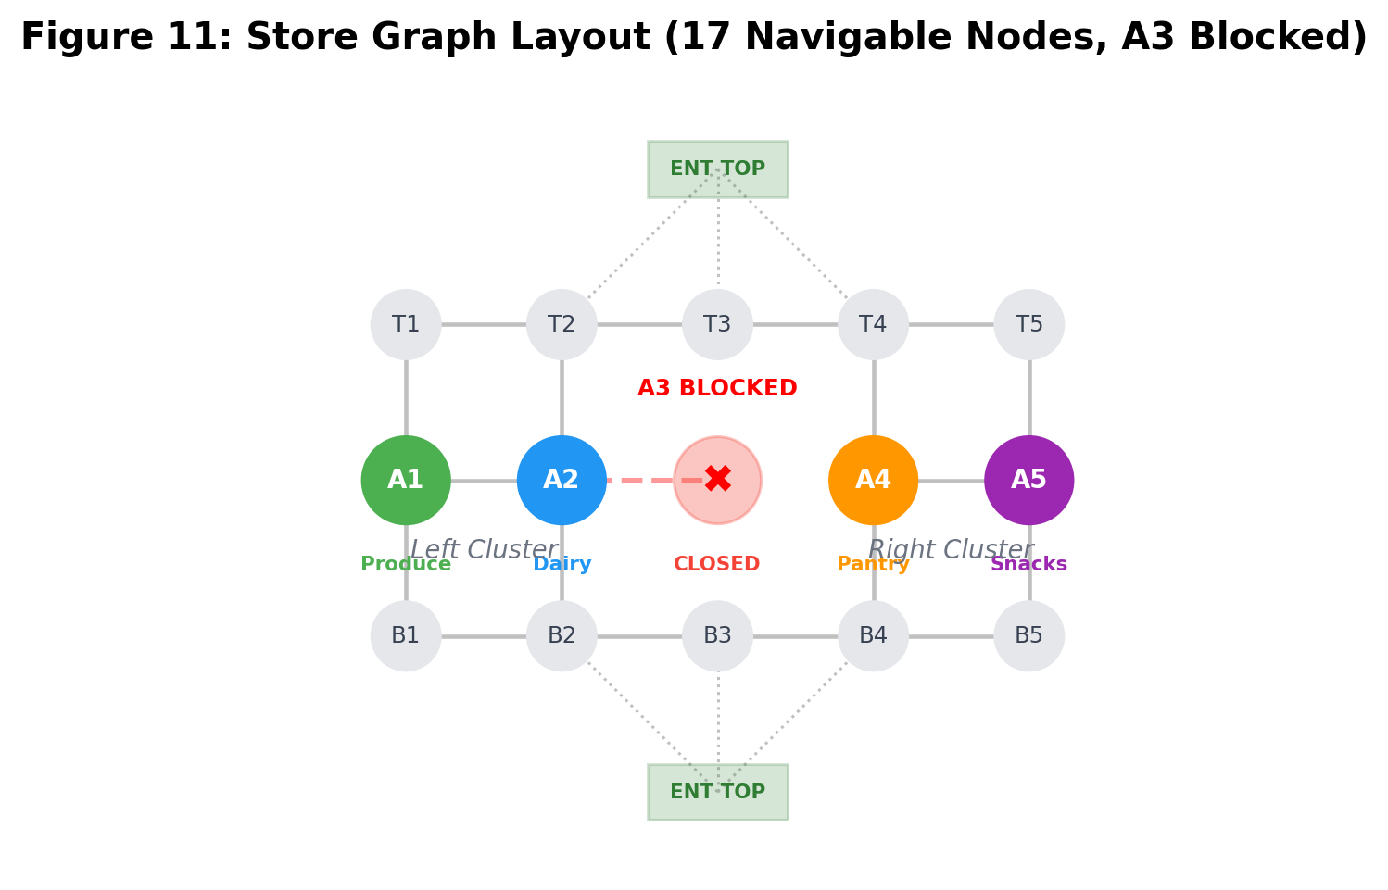
Figure 11: Store graph layout showing 17 navigable nodes, A3 permanently blocked, left and right clusters.
Each aisle node (except A3) connects vertically to its corresponding T-row and B-row nodes, and horizontally to adjacent aisles. All edges have uniform cost of 1. This grid-like topology is structurally analogous to the network graphs studied by Abbass et al. (2025) and the grid environments analyzed by Lawande et al. (2022), making our results broadly applicable to similar navigation problems.

4.2 Products and Assignment
The store stocks 24 products across four open aisles:
Aisle | Category | Products
A1 | Produce | Apples, Bananas, Lettuce, Tomatoes, Carrots, Oranges
A2 | Dairy | Milk, Eggs, Cheese, Yogurt, Bread, Butter
A3 | Meat | PERMANENTLY CLOSED
A4 | Pantry | Rice, Pasta, Soup, Beans, Cereal, Coffee
A5 | Snacks | Chips, Cookies, Soda, Juice, Popcorn, Tea

At game start, the 24 products are randomly shuffled and split equally: Player A receives 12, Player B receives 12.

4.3 Game Rules
- Players alternate turns. Each turn, a player may move to one adjacent node or wait.
- Products auto-collect when a player enters the aisle node containing their assigned items.
- Aisle A3 is permanently blocked. Neither player may enter A3.
- Banana-leaf barrier: The opponent’s current position blocks that node dynamically, similar to the ghost-avoidance mechanic studied by Salem et al. (2024).
- First player to collect all 12 items wins. Ties broken by move count.
- Each player’s algorithm serves as both navigator and strategist.

4.4 The A3 Blockage: Structural Impact
The permanent closure of aisle A3 is the most significant structural feature of the store graph. Without A3, any aisle can be reached from any adjacent aisle in one horizontal step. With A3 closed, the store splits into two clusters, and all cross-cluster traffic must detour through corridor chokepoints, adding a minimum of 4 extra steps. This mirrors the blocked-path scenarios in data center routing studied by Abbass et al. (2025), where node failures force traffic through alternative paths and the choice of routing algorithm becomes critical.

5. Algorithm Descriptions

5.1 Breadth-First Search (BFS)
BFS explores nodes in order of distance from the start, using a FIFO queue. It evaluates all remaining products, searches for the shortest path to each aisle, and selects the nearest. As established by Elkari et al. (2024) in their maze navigation study, BFS guarantees the shortest path in unweighted graphs but requires O(b^d) space. Properties: Complete (yes), Optimal (yes, unweighted), Time O(b^d), Space O(b^d). Data structure: collections.deque with O(1) operations.

5.2 Depth-First Search (DFS)
DFS explores as deep as possible using a LIFO stack. Our implementation maintains a reached set (graph-search variant). Because DFS does not guarantee shortest paths, the product it selects as “closest” may not be nearest. Abbass et al. (2025) documented this same weakness in data center routing, where standard DFS produced suboptimal routes in structured network topologies. Properties: Complete (yes, with reached set), Optimal (no), Time O(b^m), Space O(bm). Data structure: Python list as stack.

5.3 Uniform Cost Search (UCS)
UCS uses a priority queue ordered by cumulative path cost. On our uniform-cost graph, UCS theoretically produces the same paths as BFS but with heap overhead. Syahputra et al. (2026) categorize UCS as a bridge between uninformed and informed search, noting that it generalizes BFS for weighted graphs but offers no advantage when edge costs are uniform. Properties: Complete (yes), Optimal (yes), Time O(b^(1+C*/ε)), Space O(b^(1+C*/ε)). Data structure: heapq min-heap with O(log n) operations.

6. Experimental Methodology

6.1 Simulation Configuration
We ran 120 total games: 6 algorithm matchups × 2 entrance assignments × 10 trials per configuration, with deterministic seeding for reproducibility. Each game recorded 64 metrics across four experiment categories. The headless simulation engine preserved identical game logic from the original Streamlit application while adding instrumentation for per-call node expansion tracking, frontier size measurement, nanosecond timing, corridor/cluster transition logging, and trap success tracking. This approach follows the empirical comparison methodology used by Elkari et al. (2024) and Salem et al. (2024), where algorithms are evaluated on identical problem instances to ensure fair comparison. Complete software prerequisites, installation instructions, and execution steps are documented in Appendices A–C. The raw data (CSV) and formatted analysis report (XLSX) are described in Appendix D.

6.2 Data Collection and Preprocessing
Item distribution was classified by left/right cluster ratio: above 0.75 as lopsided, 0.58–0.75 as moderate, below 0.58 as balanced. Detour ratio was computed as actual path length divided by an unblocked BFS oracle’s shortest path. All 120 games completed within the 200-turn safety limit; none were excluded.

6.3 Experiment Descriptions
Experiment 1 (Head-to-Head): Evaluates each algorithm pairing across both entrances. Core metrics: total moves, win/loss/tie, wait count, collection efficiency. This directly parallels the comparative approach of Elkari et al. (2024) and Salem et al. (2024).
Experiment 2 (A3 Blockage): Tracks cross-cluster trips, corridor preference (T-row vs B-row), bottleneck visits (T3/B3), aisle revisits, and distribution impact. Inspired by the blocked-path analysis of Abbass et al. (2025) in network routing.
Experiment 3 (Blocking): Measures blocks caused vs suffered, net blocking score, bottleneck blocking, trap attempts and successes. Extends the adversarial obstacle analysis of Salem et al. (2024) to a competitive two-player setting.
Experiment 4 (Computational Cost): Instruments search functions for nodes expanded, max frontier, search calls, and wall-clock timing per call. Follows the computational efficiency framework of Lawande et al. (2022) and Pratama et al. (2024).

7. Results

7.1 Experiment 1: Head-to-Head Results
BFS and UCS both dominate DFS completely while performing near-identically against each other, consistent with the findings of Elkari et al. (2024) that BFS outperforms DFS for shortest-path problems in structured environments.
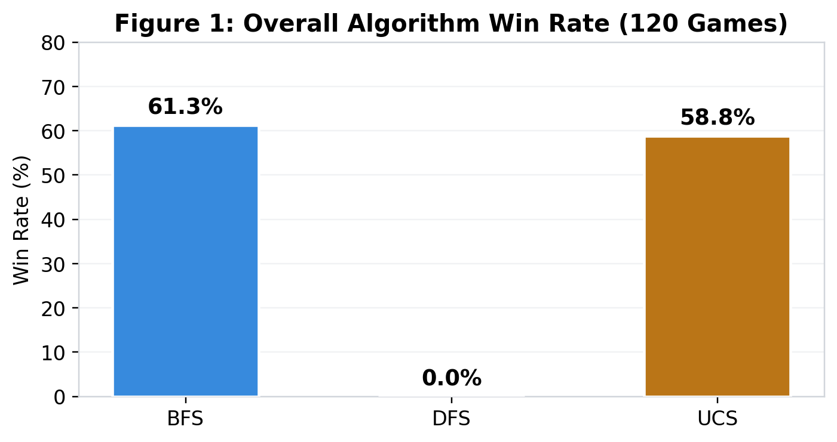
Figure 1: Overall algorithm win rate across all 80 games each algorithm played.
Algo | Games | Win Rate | Avg Moves | Avg Waits | Effic. | Detour | Blocks
BFS | 80 | 61.3% | 35.0 | 0.11 | 1.197 | 1.00 | 0.00
UCS | 80 | 58.8% | 39.8 | 0.09 | 1.169 | 1.00 | 0.00
DFS | 80 | 0.0% | 66.1 | 0.00 | 0.999 | 1.11 | 0.20

Table 1: Overall algorithm performance. BFS/UCS collect 12 items in ~9 moves. DFS requires 66+ moves on average and won 0 of 80 games.
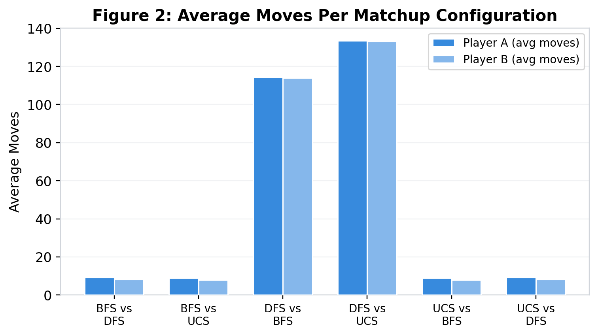
Figure 2: Average moves per matchup configuration. DFS matchups show 10–18x more moves.
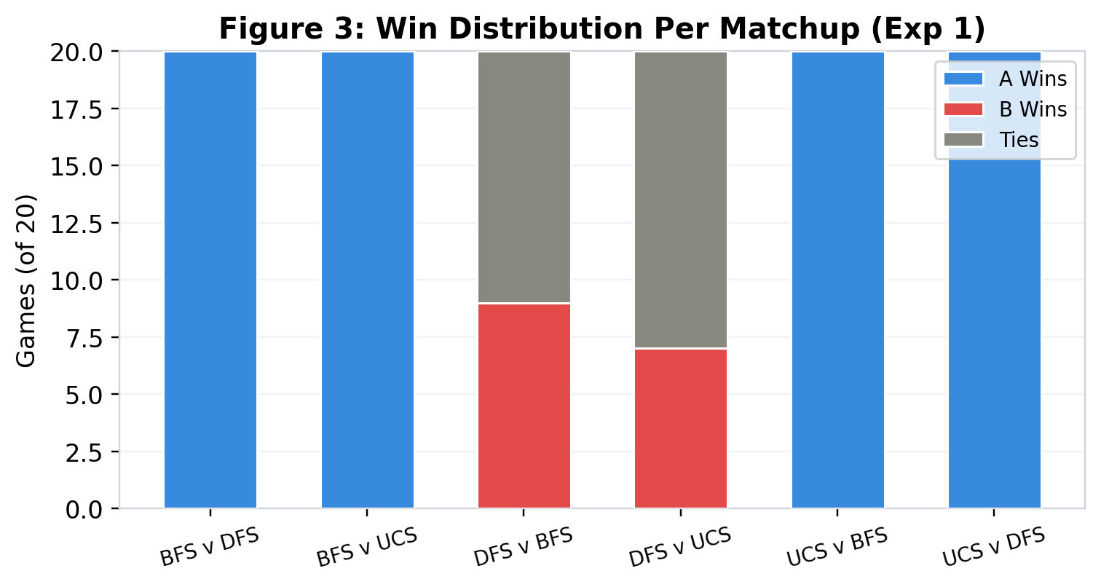
Figure 3: Win distribution per matchup. BFS/UCS win 100% of games against DFS.
In the 40 direct BFS vs UCS matchups, the move difference was exactly 1 in every game—an artifact of turn order, not path quality. This confirms BFS and UCS produce equivalent paths on uniform-cost graphs, supporting the theoretical analysis of Syahputra et al. (2026) that UCS reduces to BFS behavior when all edge costs are equal.

7.2 Experiment 2: A3 Blockage Analysis
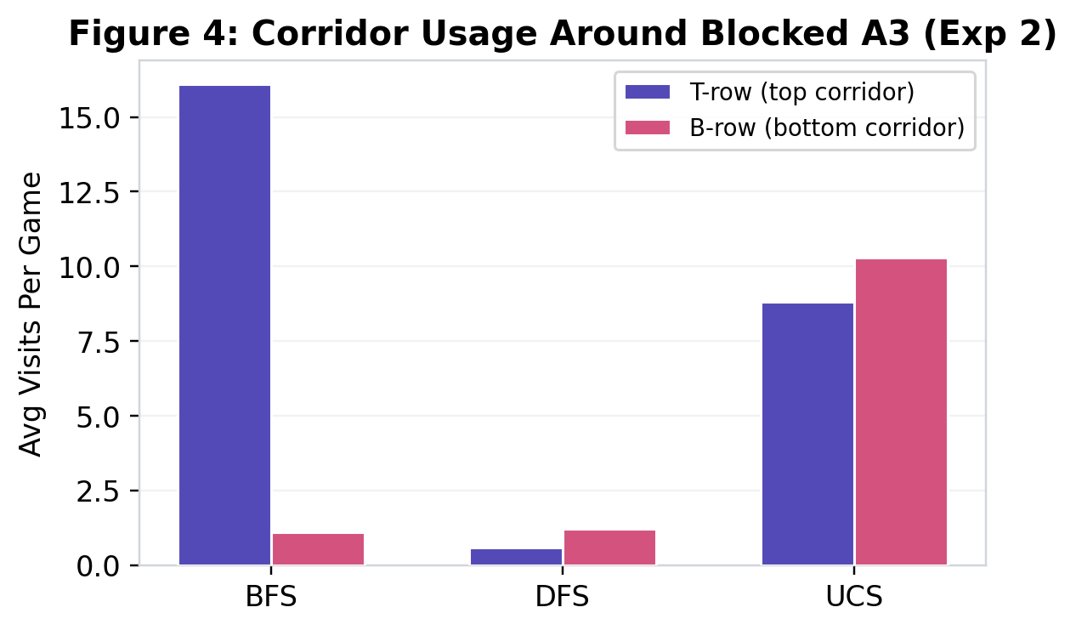
Figure 4: Corridor usage patterns. BFS routes 94% through T-row; UCS splits evenly; DFS barely uses corridors.
BFS discovers T-row first (since ENTRANCE_TOP connects to T2/T3/T4) and consistently selects it. UCS’s heap ordering explores both corridors equally. DFS barely uses corridors, instead revisiting aisles repeatedly—a behavior pattern consistent with Abbass et al.’s (2025) observation that vanilla DFS creates redundant traversals in structured networks.
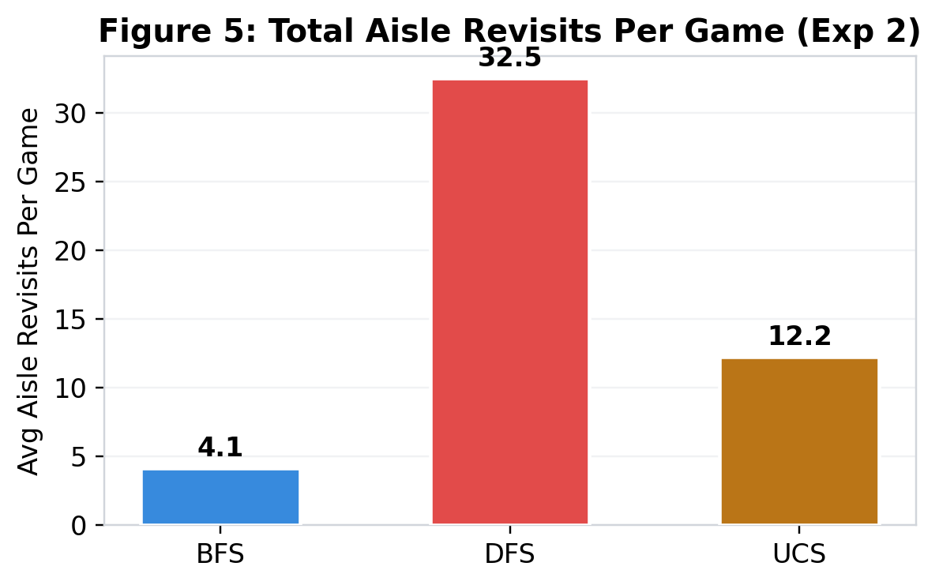
Figure 5: DFS revisits aisles 32.5 times per game vs 4.1 for BFS—evidence of local looping.
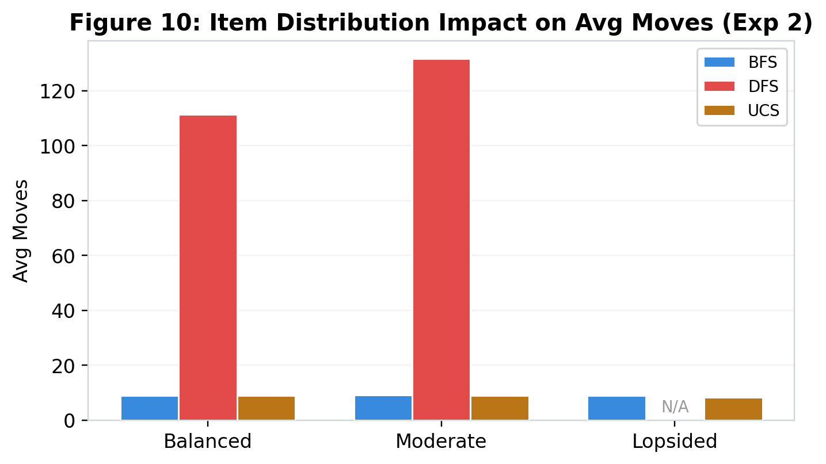
Figure 10: Item distribution impact. BFS/UCS maintain ~9 moves regardless; DFS degrades under balanced distributions.
BFS and UCS each make exactly 1.0 cross-cluster trip per game. DFS makes 0.0, indicating it never purposefully navigates between clusters. Item distribution had no effect on BFS/UCS (~9 moves, 100% win rate regardless), but DFS worsened under balanced distributions (111–132 moves). This aligns with Lawande et al.’s (2022) finding that uninformed search performance degrades as obstacle density increases—our permanently blocked A3 functions as a high-impact obstacle that disproportionately affects DFS.

7.3 Experiment 3: Blocking Results
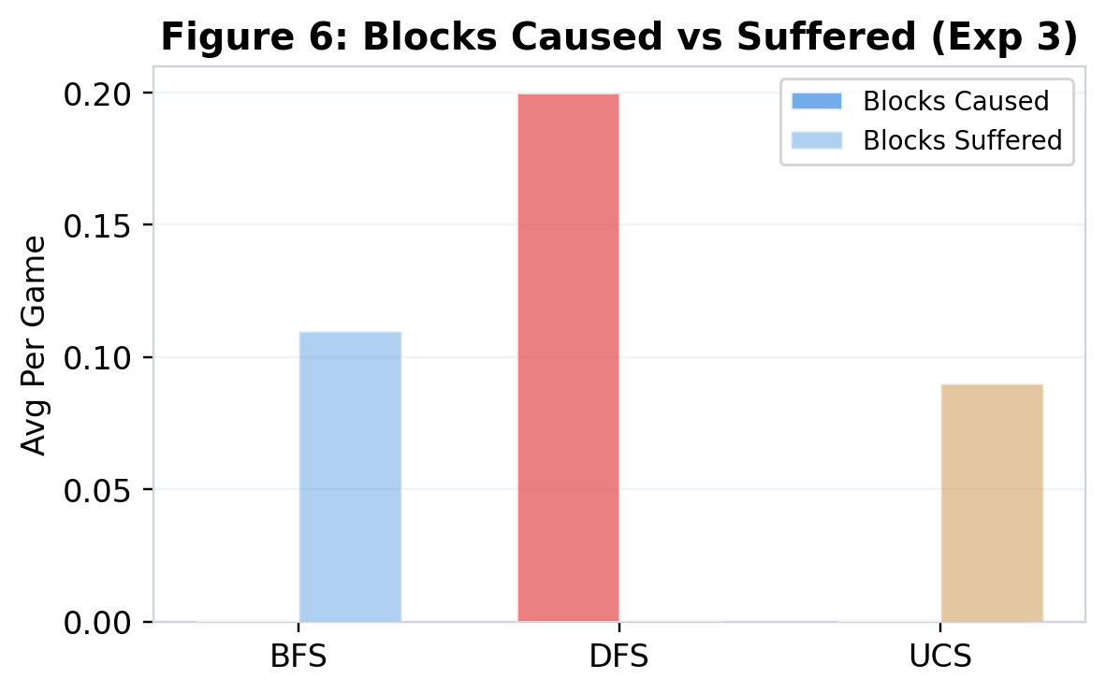
Figure 6: DFS is the only net blocker (+0.20/game). BFS/UCS suffer slightly more blocks than they cause.
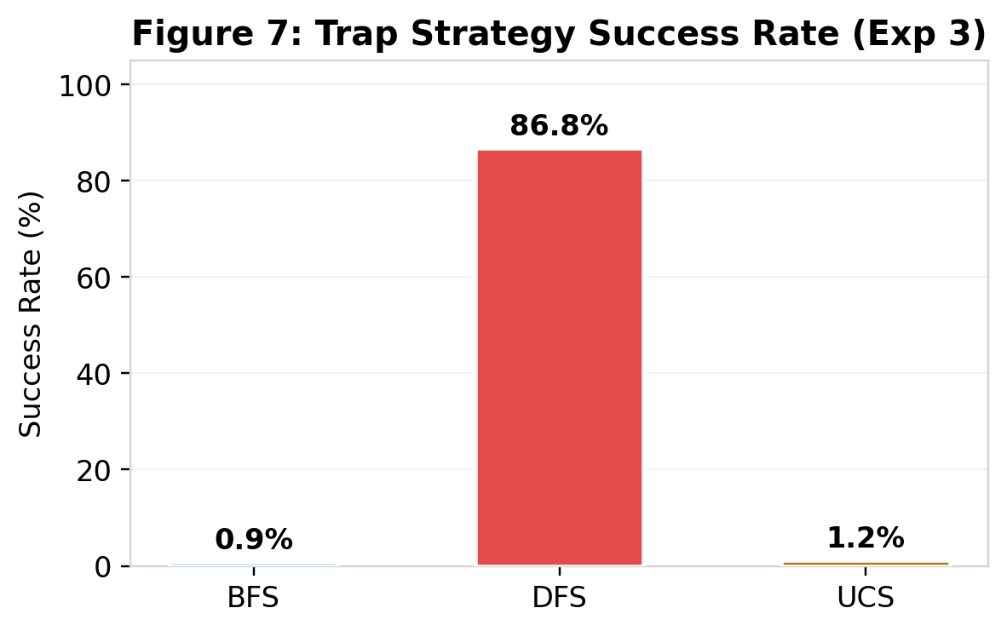
Figure 7: DFS paths are intercepted 86.8% of the time—its long, predictable routes are highly exploitable.
Algo | Games | Trap Attempts/Game | Successes/Game | Success Rate
BFS | 80 | 33.5 | 0.31 | 0.9%
DFS | 80 | 34.8 | 30.23 | 86.8%
UCS | 80 | 38.7 | 0.47 | 1.2%

Table 3: Trap success rates. DFS’s 86.8% exploitability is analogous to the predictable ghost-avoidance patterns Salem et al. (2024) observed in PAC-Man—long, predictable paths are easy to intercept.

7.4 Experiment 4: Computational Cost
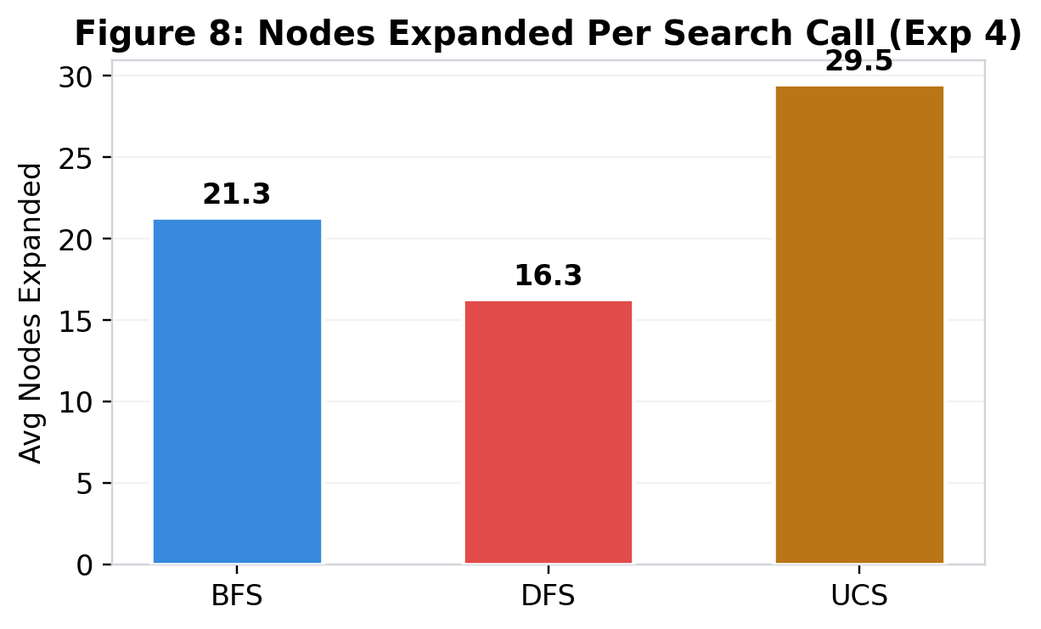
Figure 8: UCS expands 39% more nodes than BFS per call—pure overhead on uniform-cost graphs.
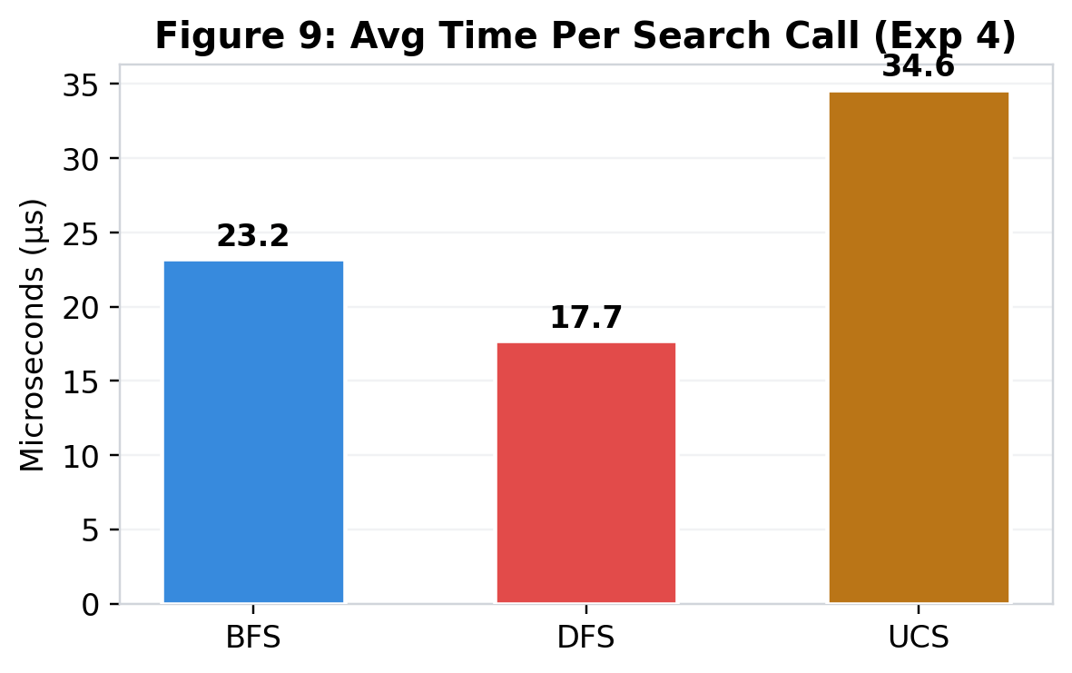
Figure 9: BFS’s deque is faster per call (23.2µs) than UCS’s heap (34.6µs).
Algo | Calls | Total Nodes | Nodes/Call | Nodes/Move | Max Front. | Time/Call
BFS | 616 | 13,095 | 21.3 | 185.8 | 6 | 23.2 µs
DFS | 1,023 | 16,704 | 16.3 | 157.7 | 8 | 17.7 µs
UCS | 719 | 21,252 | 29.5 | 234.6 | 7 | 34.6 µs

Table 4: DFS has fewest nodes/call (16.3) but 66% more total calls. UCS’s heap adds 39% overhead vs BFS. These computational patterns align with Pratama et al.’s (2024) observations that data structure overhead becomes measurable even on small problem instances.

8. Discussion

8.1 Why DFS Fails Catastrophically
DFS’s stack-based expansion on a compact, symmetric graph consistently identifies the wrong product as nearest, sending the player to far aisles. This creates cascading failures: the player overshoots to A5, backtracks to A1, overshoots again—revisiting aisles 32.5 times per game. This confirms Abbass et al.’s (2025) finding that standard DFS produces suboptimal routes in structured network topologies, and extends it to the store navigation domain where the consequences are even more severe due to multi-target collection requirements. The graph is too small for deep-first exploration to find useful shortcuts—every deep branch just leads to the opposite end of the store.

8.2 The BFS–UCS Equivalence and Its Nuances
Both algorithms produce identical optimal paths, confirming the theoretical analysis of Syahputra et al. (2026). However, we uncovered a subtle behavioral difference: BFS routes 94% through T-row while UCS splits 46/54 between T/B-row. This is a tie-breaking artifact—BFS’s FIFO expands the first-enqueued equal-cost node, while UCS’s heap breaks ties by object ID, effectively randomizing corridor selection. In multi-agent scenarios, UCS’s balanced corridor usage could reduce congestion, suggesting that tie-breaking behavior may matter in dense environments.

8.3 The A3 Blockage as an Amplifier
The A3 closure doesn’t just add cost—it changes the graph’s topology, creating corridor chokepoints. An algorithm that discovers the corridor immediately (BFS) wastes no time, while DFS may traverse the store’s perimeter. This amplification is most pronounced with balanced item distributions requiring multiple cross-cluster trips. As Lawande et al. (2022) demonstrated in their grid environment analysis, obstacle density is a key moderating variable for search algorithm performance—our A3 blockage functions as a high-impact, strategically placed obstacle that disproportionately penalizes non-optimal algorithms.

9. A* Algorithm: Theoretical Comparison

9.1 How A* Works
A* expands nodes in order of f(n) = g(n) + h(n), combining actual cost g(n) with heuristic estimate h(n). With an admissible heuristic, A* is complete, optimal, and expands the minimum nodes necessary. Elkari et al. (2024) confirmed A*’s superiority over both BFS and DFS in maze navigation, and Pratama et al. (2024) demonstrated its advantages in constrained puzzle solving—both findings that inform our projections for store navigation.

9.2 Heuristic for the Store Graph
Manhattan distance adapted for the A3 blockage: same-side nodes use standard grid distance; cross-cluster nodes add a minimum 4-step corridor detour. This heuristic is admissible (never overestimates) and consistent (satisfies the triangle inequality), meeting the requirements established by Elkari et al. (2024) for optimal A* performance.

9.3 A* Performance on the 5-Lane Store
Path quality: Identical to BFS/UCS (all edges cost 1, heuristic is admissible).
Nodes expanded: Estimated 8–15 per call (30–60% fewer than BFS’s 21.3) because the heuristic prunes branches leading away from the goal, consistent with the efficiency gains Elkari et al. (2024) measured in maze environments.
Verdict: Matches BFS/UCS path quality with less computation, but on a 17-node graph the absolute savings are minimal. A*’s advantage scales with graph size, as Syahputra et al. (2026) argue in their analysis of the transition to heuristic search in modern AI.

9.4 When Each Algorithm Wins
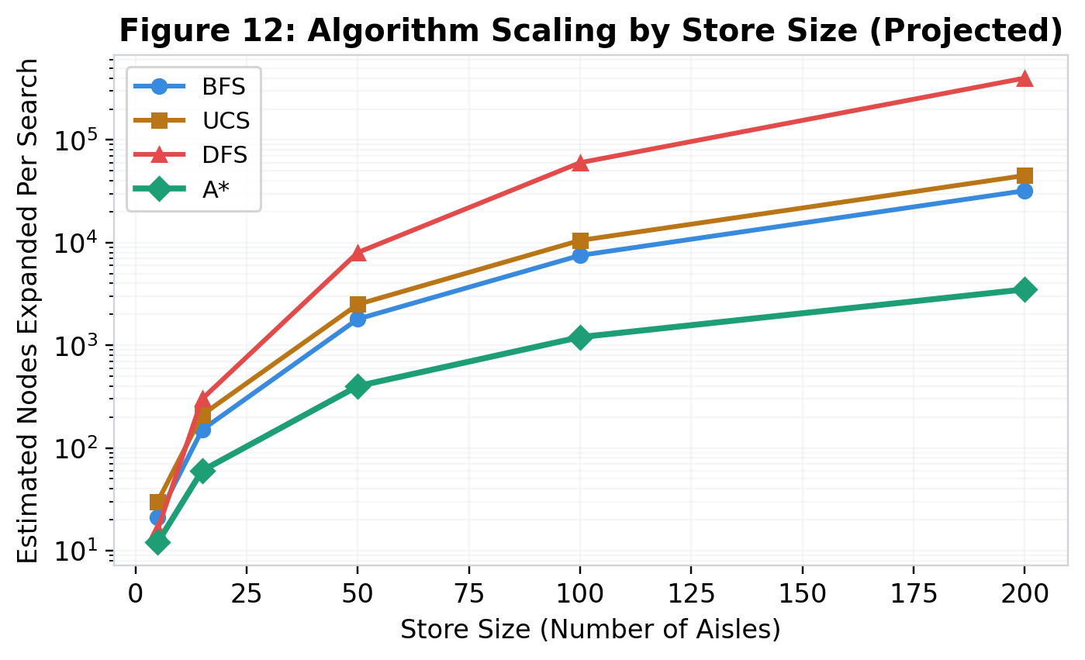
Figure 12: Projected algorithm scaling by store size. A* dominates at 50+ aisles; BFS is optimal for small stores.
Store Size | Best Algorithm | Why | Runner-Up | Avoid
5–15 aisles | BFS | Optimal, minimal overhead | UCS / A* | DFS
15–50 aisles | A* | Heuristic prunes search | BFS | DFS
50–200 aisles | A* | Dramatic node reduction | UCS | DFS, BFS
200+ aisles | A* / IDA* | IDA* adds memory savings | A* | All uninformed
Weighted edges | UCS / A* | Cost-aware expansion | — | BFS, DFS

Table 5: Recommended algorithm by store size. The 15–20 aisle transition point aligns with Syahputra et al.’s (2026) argument that modern AI applications increasingly demand heuristic search.

10. Conclusion
First, BFS is the optimal algorithm for the 5-lane store. It achieves a 61.3% win rate, ~9 average moves, perfect detour ratio 1.00, and lowest computational cost (21.3 nodes, 23.2 µs per call). This confirms the maze navigation findings of Elkari et al. (2024) and extends them to multi-target, adversarial environments.
Second, UCS is functionally equivalent in path quality but 39% more expensive computationally. The subtle corridor preference difference is interesting but does not affect outcomes, supporting Syahputra et al.’s (2026) observation that UCS offers no advantage over BFS on uniform-cost graphs.
Third, DFS is categorically unsuitable. Its 0.0% win rate, 105–162 average moves, 32.5 aisle revisits, and 86.8% trap exploitability demonstrate catastrophically suboptimal behavior. This corroborates Abbass et al.’s (2025) findings on DFS inefficiency in structured networks and Salem et al.’s (2024) results in PAC-Man navigation.
Fourth, the A3 permanent blockage amplifies algorithmic differences by forcing traffic through corridor chokepoints, functioning as a high-impact obstacle consistent with the grid environment analysis of Lawande et al. (2022).
Fifth, A* would match BFS/UCS path quality while expanding 30–60% fewer nodes, becoming dominant as store size scales beyond 15–20 aisles—the transition point identified by Syahputra et al. (2026) and supported by the heuristic search advantages demonstrated by Pratama et al. (2024).

Future work could extend to weighted graphs (modeling aisle congestion), larger store topologies (50–200 aisles), multi-agent scenarios with 3+ players, and real-time replanning algorithms. All source code, raw data, and analysis reports necessary to reproduce these results are provided in the accompanying files documented in Appendices A–D. The interactive game application (Appendix B) allows researchers to observe algorithm behavior visually, while the headless simulation (Appendix C) enables large-scale automated experimentation. The raw CSV dataset (Appendix D) containing 120 games × 64 metrics is available for independent analysis.

11. References

Abbass, A. M., Saedi, A. Y. F., & Kadhim, J. Q. (2025). Enhanced depth-first search algorithm for improving the efficiency of route construction in data center networks. Engineering, Technology & Applied Science Research, 15(2), 22152–22158.

Elkari, B., Ourabah, L., Sekkat, H., Hsaine, A., Essaiouad, C., Bouargane, Y., & El Moutaouakil, K. (2024). Exploring maze navigation: A comparative study of DFS, BFS, and A* search algorithms. Statistics, Optimization and Information Computing, 12, 761–781.

Lawande, A., et al. (2022). Intelligence-based pathfinding algorithms in grid environments.

Pratama, M. D., Abdillah, R., Herumurti, D., & Hidayati, S. C. (2024). Algorithmic advancements in heuristic search for enhanced Sudoku puzzle solving across difficulty levels. BITS, 5(4), 659–671.

Salem, N., Haneya, H., Balbaid, H., & Asrar, M. (2024). Exploring the maze: A comparative study of finding algorithms for PAC-Man game. 2024 21st Learning and Technology Conference (L&T).

Syahputra, F., Sabrina, E., Chan, M. F. S., Fali, R., Fattah, M., Hendratmo, J., & Ardiansyah, M. F. (2026). Literature review: Transitioning usage from BFS and DFS to heuristic search in the modern AI era. Journal of Artificial Intelligence and Engineering Applications, 5(2).

Appendix A: Software Prerequisites
The following software is required to run both the interactive game application and the headless simulation program.

A.1 Python Environment
Software | Version | Purpose
Python | 3.9 or higher | Runtime environment for both programs
pip | 21.0+ | Python package installer (included with Python)

Python can be downloaded from https://www.python.org/downloads/. Both programs were developed and tested on Python 3.11 but are compatible with Python 3.9 through 3.13.

A.2 Required Python Packages
Package | Version | Used By | Purpose
streamlit | 1.28+ | Game only | Web-based interactive UI framework
random | (built-in) | Both | Random item shuffling and seed control
math | (built-in) | Both | Math constants (infinity) for failure nodes
collections | (built-in) | Both | defaultdict and deque for BFS frontier
heapq | (built-in) | Both | Priority queue for UCS frontier
csv | (built-in) | Simulation | Writing raw results to CSV files
time | (built-in) | Simulation | Nanosecond timing for Experiment 4

Note: The simulation program (full_experiments.py) uses only Python standard library modules and requires no additional package installation. The game application (store_pathfinder_app-9.py) requires only the Streamlit package as an external dependency.

A.3 Installation Commands
To install the required external package for the interactive game:
pip install streamlit

To verify your Python version:
python --version

No additional installation is needed for the headless simulation program, as it relies entirely on Python’s standard library.

A.4 Optional Software
Software | Purpose
Microsoft Excel / LibreOffice Calc | Viewing the .xlsx experiment report files (Appendix D)
Any CSV viewer / text editor | Viewing the .csv raw data files (Appendix D)
Web browser | Required by Streamlit to display the game UI (opens automatically)

Appendix B: Running the Interactive Game

B.1 Program File
Attribute | Details
Filename | store_pathfinder_app-9.py
Type | Streamlit web application (Python)
Lines of code | 1,010 lines
Framework | AIMA-style Problem/Node/expand/path_states classes
Version | v4.0 — Store Pathfinder: Interactive Turn-Based Game

B.2 How to Launch
Open a terminal or command prompt, navigate to the directory containing the game file, and run:
streamlit run store_pathfinder_app-9.py

Streamlit will start a local web server and automatically open your default browser to the game interface (typically at http://localhost:8501). If the browser does not open automatically, navigate to the URL displayed in the terminal.

B.3 Game Setup Options
The game’s setup screen presents the following configuration options:
- Your entrance: Choose Top or Bottom entrance. The AI opponent starts at the opposite entrance.
- AI (Player B) algorithm: Select BFS, DFS, or UCS as the AI’s search algorithm.
- Your play mode: Manual (you choose every move with advisor recommendations shown), Auto-play with a specific algorithm (the algorithm picks your moves with manual override available), or Auto Best (the smartest of your two available algorithms picks each turn).
Click “START GAME” to begin. The store map renders as an interactive SVG showing player positions, blocked lanes (banana-leaf barriers), item locations, and aisle categories.

B.4 Gameplay Interface
During gameplay, the interface displays: the SVG store map with real-time player positions and blocking; a scoreboard showing items collected, moves taken, and waits for both players; the AI scouting panel with predicted opponent moves and your two algorithm advisors’ recommendations; and move selection controls (radio buttons for manual mode, one-click execution for auto modes). The game log tab records every move and collection event for review.

Appendix C: Running the Headless Simulation

C.1 Program File
Attribute | Details
Filename | full_experiments.py
Type | Headless Python simulation (no UI required)
Dependencies | Python standard library only — no pip install required
Output | Console tables + full_experiment_results.csv (120 rows × 64 columns)
Runtime | Approximately 5–6 seconds for all 120 games

C.2 How to Run
Open a terminal, navigate to the directory containing the simulation file, and run:
python full_experiments.py

The program will execute all 120 games (6 matchups × 2 entrances × 10 trials) and print progress to the console as each configuration completes. After all games finish, the program prints the full analysis across six formatted tables:
- Experiment 1: Head-to-head matchup results with win rates, move averages, and detour ratios.
- Experiment 2A: Cross-cluster distribution impact with average moves and win rates by distribution class.
- Experiment 2B: Corridor bottleneck analysis showing T-row vs B-row usage and aisle revisit counts.
- Experiment 3A: Blocks caused vs suffered with net blocking scores.
- Experiment 3B: Trap strategy success rates for each algorithm.
- Experiment 4A: Nodes explored per move decision with search call counts and max frontier sizes.
- Experiment 4B: Timing and data structure overhead with microsecond-level measurements.
- Experiment 4C: BFS vs UCS equivalence test with direct matchup comparison.
- Final algorithm ranking with overall win rates and verdicts.

C.3 Modifying the Simulation
The simulation can be customized by modifying two parameters in the main block at the bottom of the file:
results = run_all_experiments(n_per_config=10, base_seed=42)

- n_per_config: Number of games per matchup configuration. Increase to 20, 50, or 100 for higher statistical power. Total games = n_per_config × 12 configurations.
- base_seed: Random seed base for reproducibility. Change to generate a different set of random item distributions. The actual seed for game N is base_seed + N.
The output CSV file is written to the same directory as the script. The filename can be changed by editing the csv_path variable in the save_all_data() call near the bottom of the file.

C.4 Understanding the Code Structure
The simulation program is organized into six major sections:
- AIMA Framework (lines 1–70): Problem, Node, expand, and path_states classes identical to the game application, ensuring simulation fidelity.
- Instrumented Search Algorithms (lines 72–170): BFS, DFS, and UCS with per-call tracking of nodes expanded, max frontier size, and nanosecond timing via the SearchMetrics class.
- Store Graph and Navigation (lines 172–260): Graph construction, product mapping, permanently blocked A3, and the StoreNavigationProblem class.
- Game Engine (lines 262–440): The run_single_game() function that executes one complete game with full instrumentation for all four experiments, tracking 64 metrics.
- Experiment Analysis (lines 442–600): Six analysis functions that aggregate raw results into formatted console tables for each experiment.
- Main Block (lines 600+): Orchestrates the full run, calls all analysis functions, and saves the CSV output.

Appendix D: Data Files Reference
The simulation produces two categories of output files: raw data files containing per-game metrics, and formatted report files with pre-computed analysis tables. All files referenced in this paper are listed below.

D.1 Raw Data Files
Filename | Format | Size | Contents
full_experiment_results.csv | CSV | 27 KB | Primary dataset: 120 rows (one per game) × 64 columns of metrics. Every data point in this paper derives from this file.
simulation_results.csv | CSV | 17 KB | Preliminary dataset from the initial simulation run (120 rows × 32 columns). Subset of the full dataset.

The CSV files can be opened in Microsoft Excel, LibreOffice Calc, Google Sheets, or any text editor. Column headers are self-descriptive (e.g., algo_a, algo_b, a_moves, b_moves, winner, a_cross_cluster_trips, a_trap_successes, a_total_nodes_expanded). Researchers may use these files for independent analysis, visualization, or statistical testing beyond what is presented in this paper.

D.2 Formatted Report Files
Filename | Format | Size | Contents
full_experiment_report.xlsx | XLSX | 31 KB | Primary report with 6 formatted sheets: Exp1 Head-to-Head, Exp2 A3 Blockage, Exp3 Blocking, Exp4 Computation, Key Findings, and Raw Data.
simulation_report.xlsx | XLSX | 24 KB | Preliminary report with 5 sheets from the initial simulation run. Color-coded cells, conditional formatting, and algorithm-specific highlighting.

The XLSX report files contain pre-computed summary tables with formatted headers, color-coded cells (blue for BFS, red for DFS, yellow for UCS), conditional highlighting of win rates, and the Key Findings sheet summarizing all principal conclusions.

D.3 Program Source Files
Filename | Lines | Description
store_pathfinder_app-9.py | 1,010 | Interactive Streamlit game application. Contains the full game UI, SVG map renderer, AI decision logic, strategy advisor system, and all three AIMA search algorithms. See Appendix B for usage.
full_experiments.py | ~600 | Headless simulation engine with full instrumentation for all four experiments. Extracts the core game logic from the Streamlit app, adds per-call search metrics, timing, corridor/cluster tracking, and trap analysis. See Appendix C for usage.

Both programs implement identical AIMA framework classes (Problem, Node, expand, path_states) and identical search algorithms (BFS, DFS, UCS), ensuring that the headless simulation faithfully reproduces the game’s behavior. The simulation program adds SearchMetrics instrumentation that wraps each search function to track per-call node expansions, frontier sizes, and execution time without altering the search logic itself.

D.4 Reproducing the Results
To reproduce all results presented in this paper:
- Ensure Python 3.9+ is installed (see Appendix A).
- Place full_experiments.py in a working directory.
- Run: python full_experiments.py
- The program will print all six analysis tables to the console and save full_experiment_results.csv to the same directory.
- All tables, figures, and statistics in Sections 7–9 of this paper were derived from this CSV output.
The deterministic seeding (base_seed=42) ensures identical results on any platform running the same Python version. The random module’s Mersenne Twister PRNG produces consistent sequences across operating systems when seeded identically.

