Prerequisite

1. Open the Application (https://bugasura.io/) in any Browser  
2. Valid Login credentials should be available

Test Data:  
Email Address – muralimanohar296@gmail.com  
Password -Welcome@1234  
  
Test Steps:

Step 1. Click on 'Login' button in Home Page.

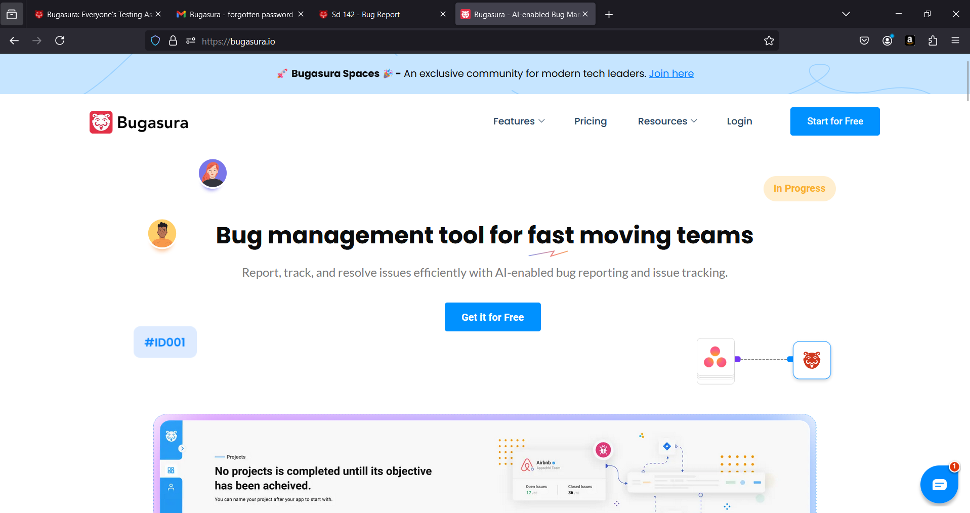

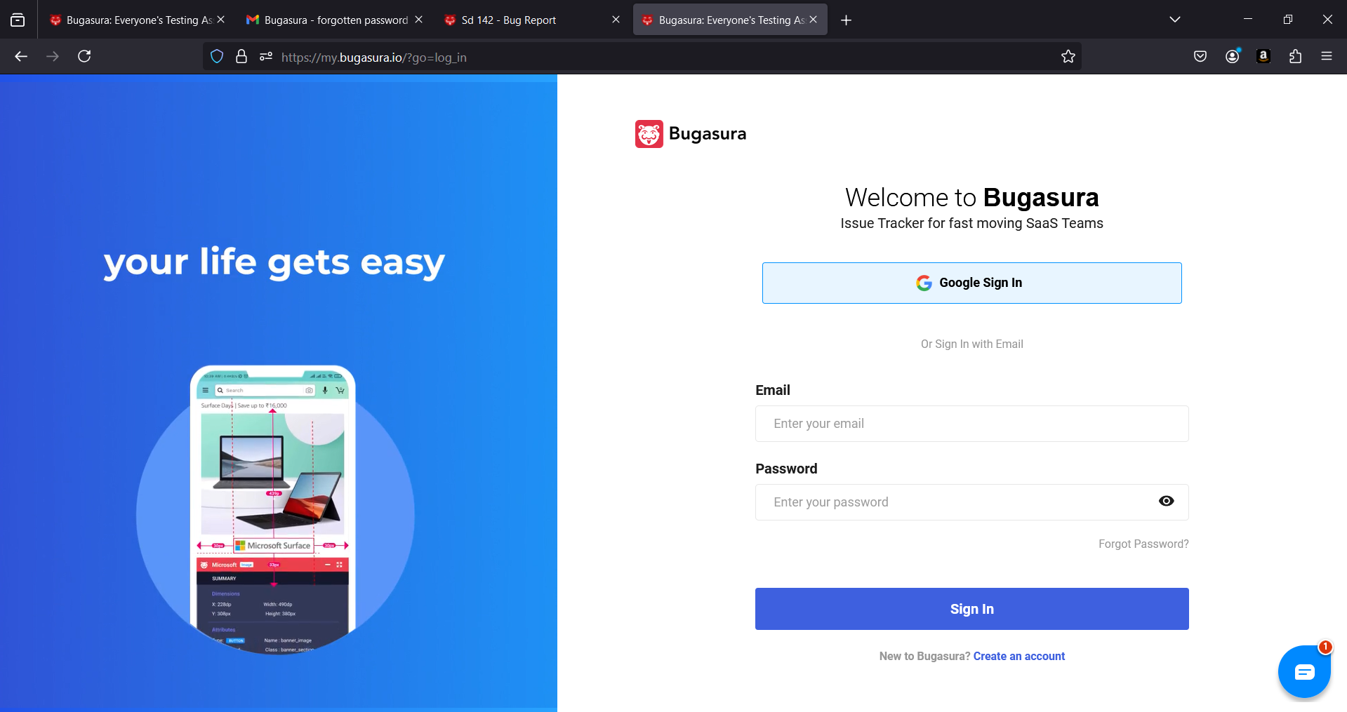

Step 2. Enter valid email address in the 'E-Mail Address' field - Refer Test Data  
Step 3.Enter valid password into the 'Password' field - Refer Test Data

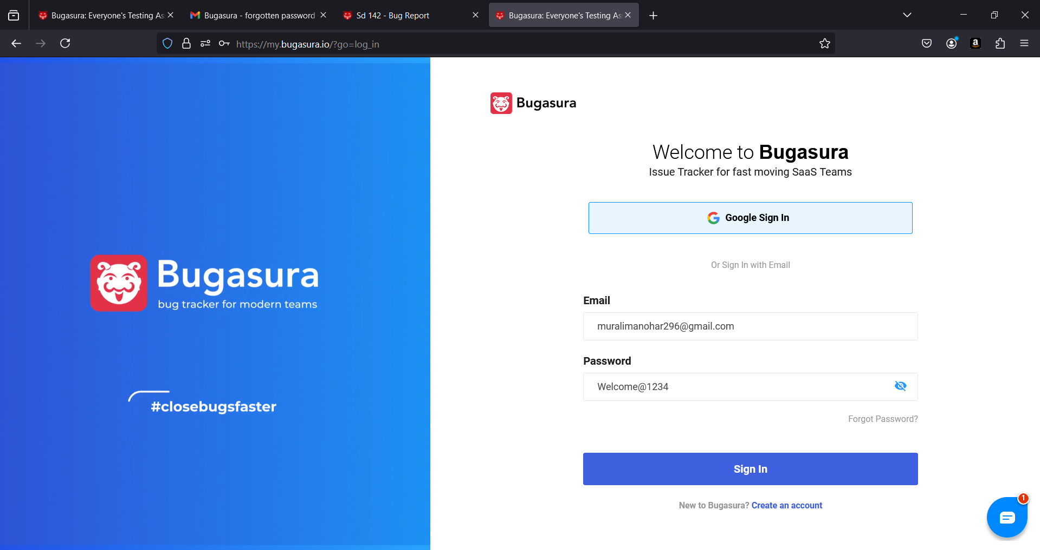

Step 4. Click on 'Sign In' button.

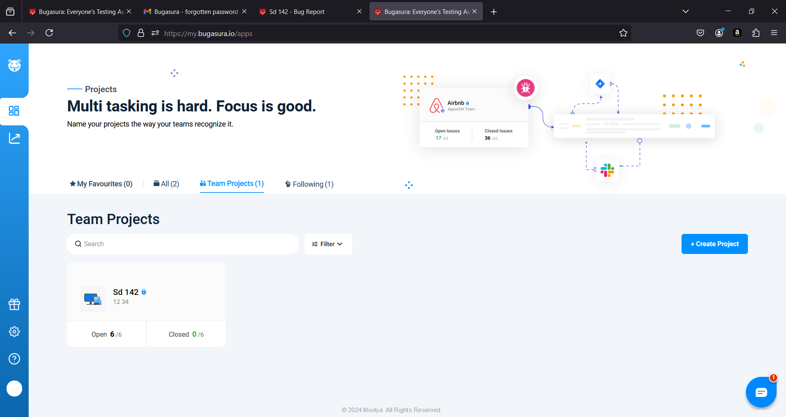

Step 5. Click on the My Profile button at the bottom left of the screen

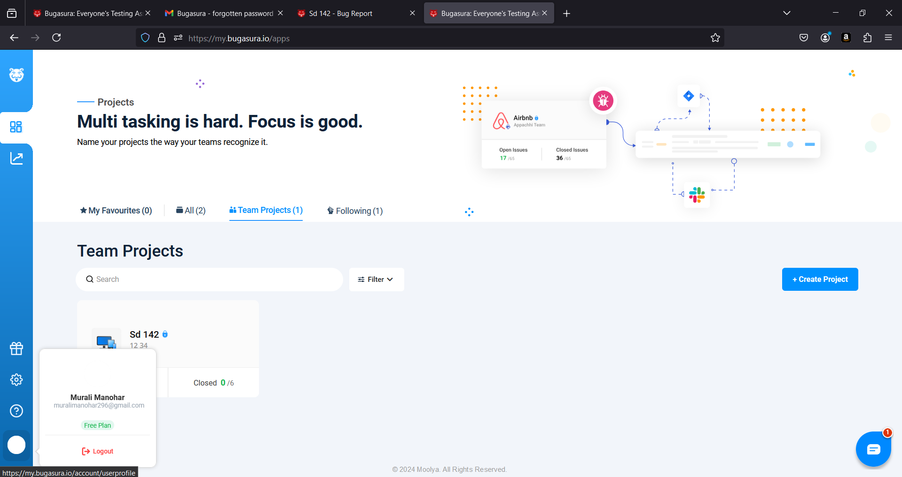

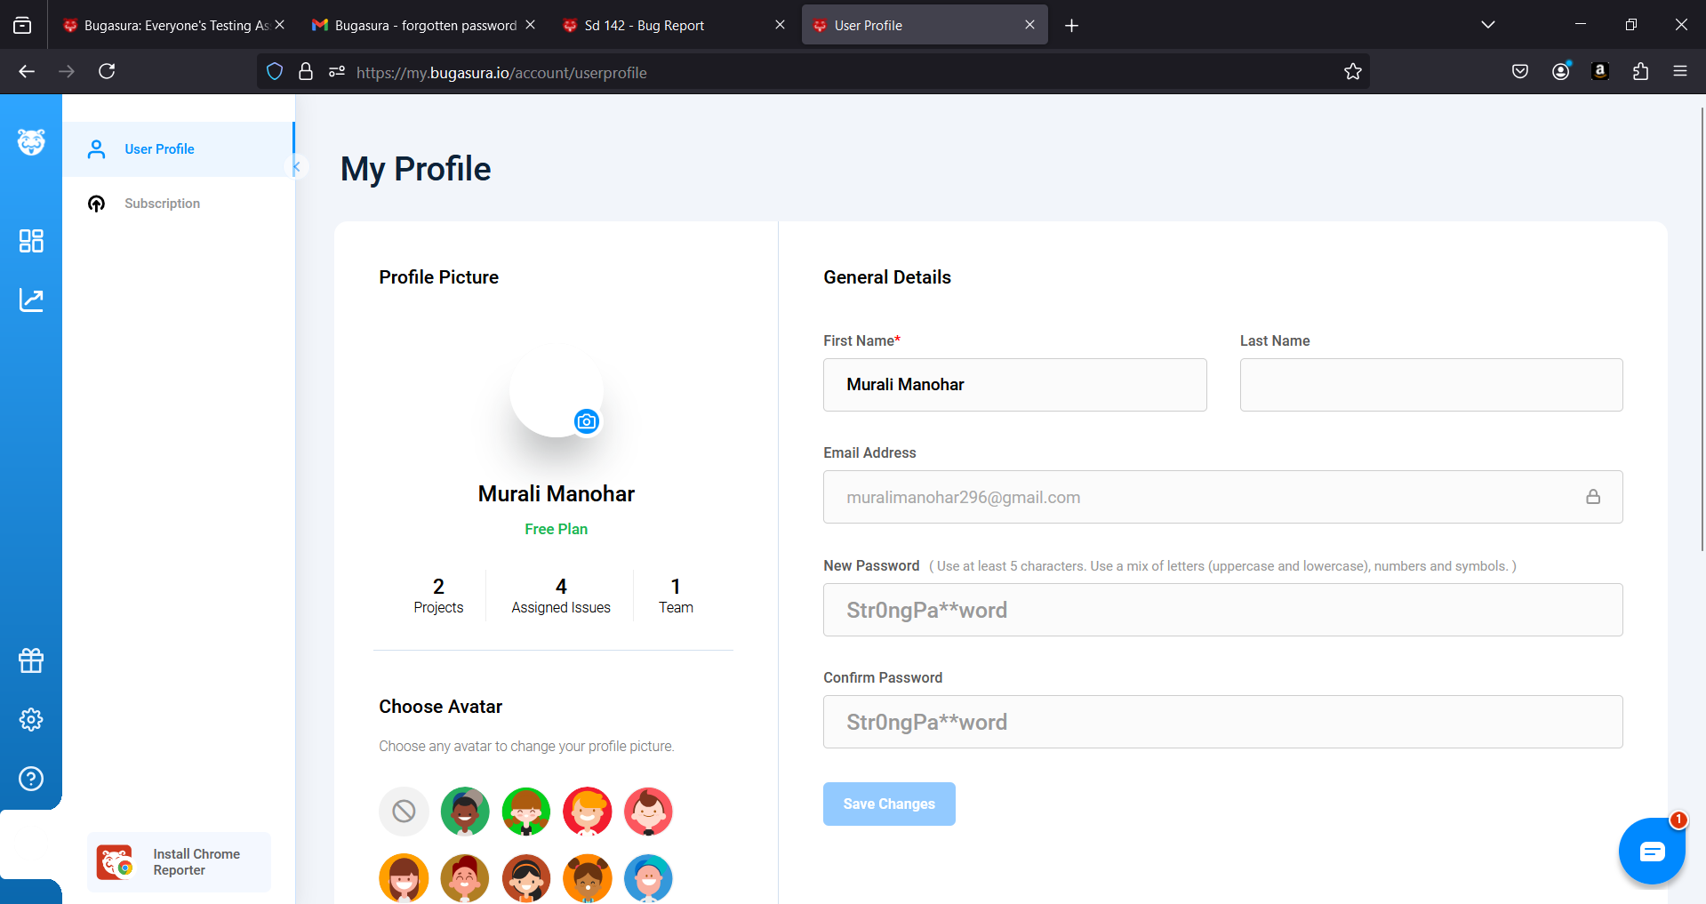

Step 6. Verify User Profile is selected in the menu option.



Step 7. Enter the current password which was entered in step3 in New Password field

Step 8. Enter the same password in Confirm Password field

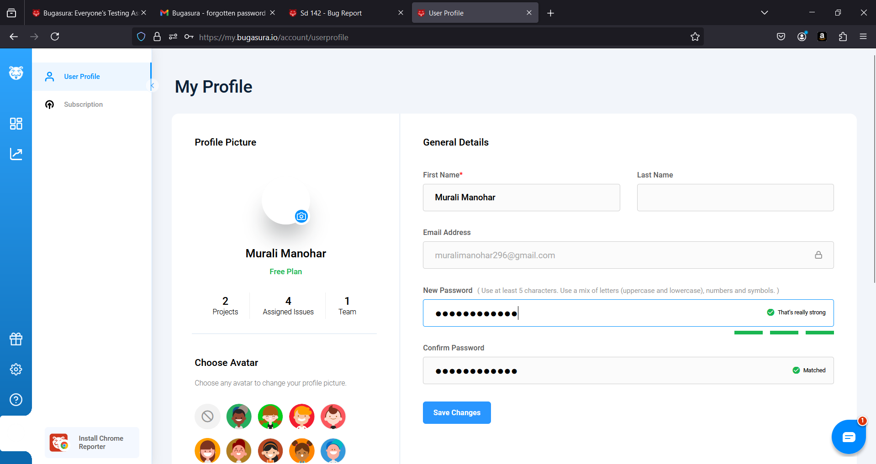

Step 9. Click on Save Changes button.

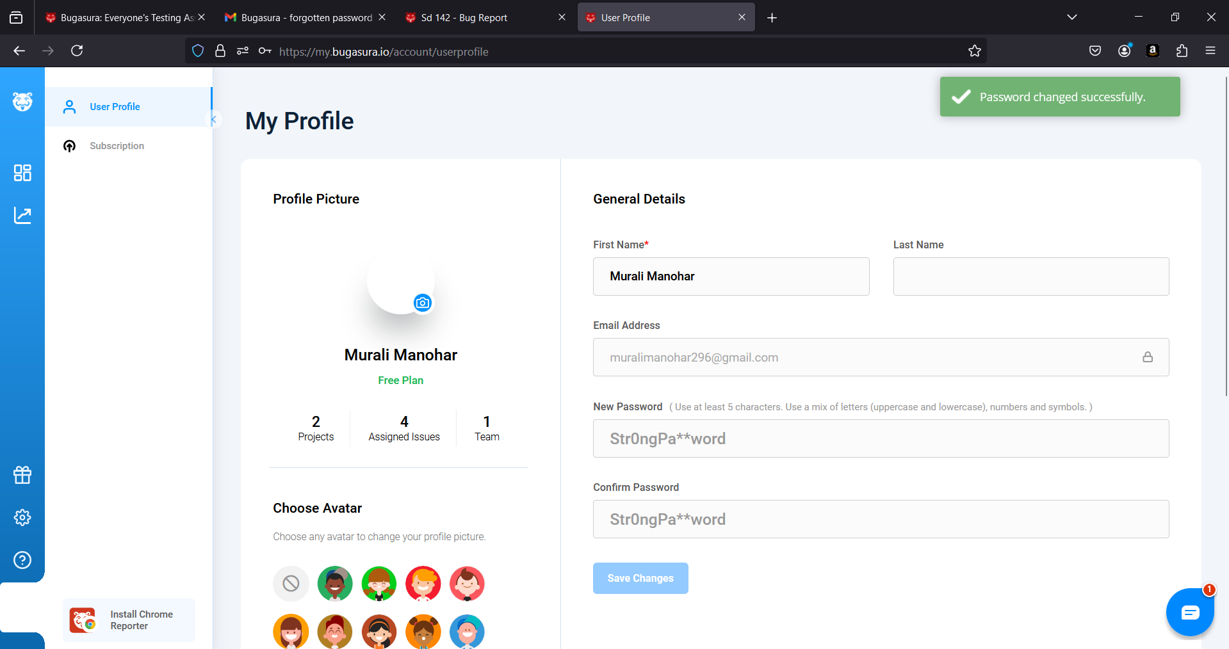

**Actual Result:**

User is able to click on Save Changes button. On clicking it application is resetting the same old password. No error message is displayed.

**Expected Result:**

User should be able to click on Save Changes button. On clicking it application should not reset the password. User should be displayed with an error message saying 'Same password should not be used again'.