Bike demand data: download template with trained dataset.

1. Download template:
2. Make the grids in **prediction.html** file as below. The grid shape has to be defined in **style.css** file. (**not** styleIndex.css file) The grids and their ids are already defined in **prediction.html** file.

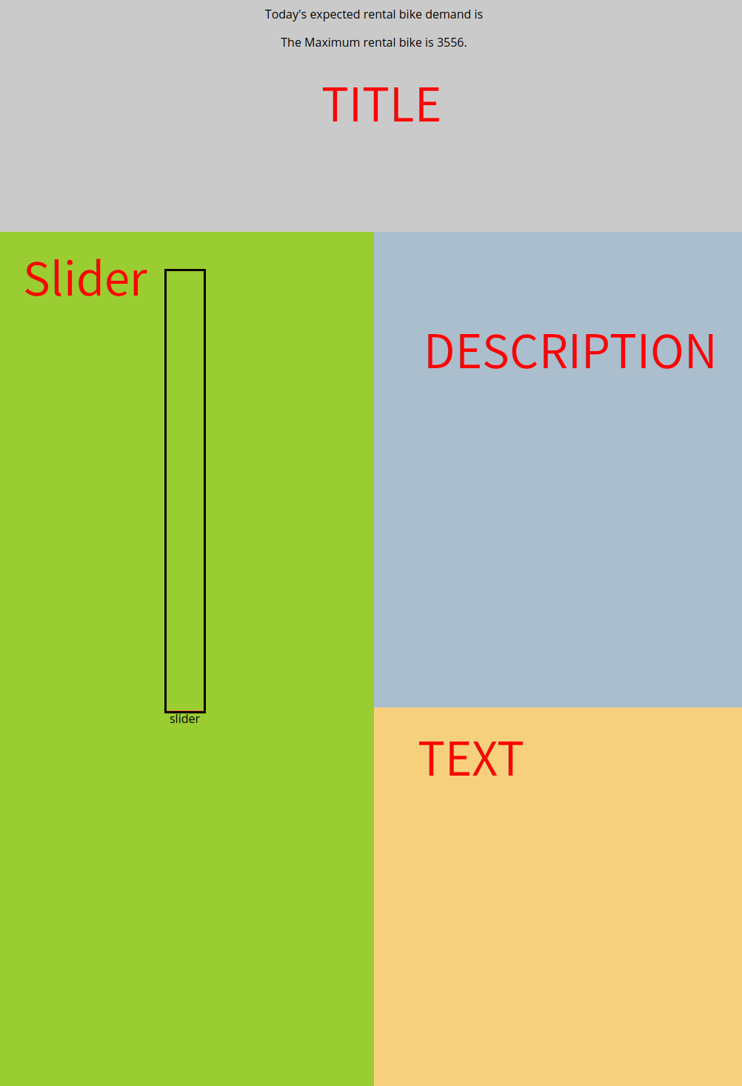

1. In **script.js file,** Finish the input fields using the ids of input fields in **index.html** file. (The Temperature and WindSpeed should be parsed into float numbers)
2. Print the prediction results in the **console**.
3. Display the prediction result in the div “rentalBikes” in **prediction.html**. (point) Make sure that **only integer** number is displayed.
4. Make a variable “slider” that connects to “slider” div in **prediction.html** file.
5. 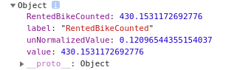Make the slider responsible to the result value.   
   The maximum amount of the rental bike in the dataset is 3556 and the minimum is 0. The height of the slider is 600px in style.css file. Accordingly every 6 rental bike will take 1px of the slider.   
   For example: if there are 300 rental bike as the prediction result, then 50px of the slider will grow. Meaning, we need to divide the prediction value (rentedBikeCounted) by 6 to get the right ‘px’ value.
6. In ‘description’ div, print all the input values that were filled in the form.   
   First make a variable “descript” that connects to “description” div in prediction.html.  
   By now, the result should look like below:

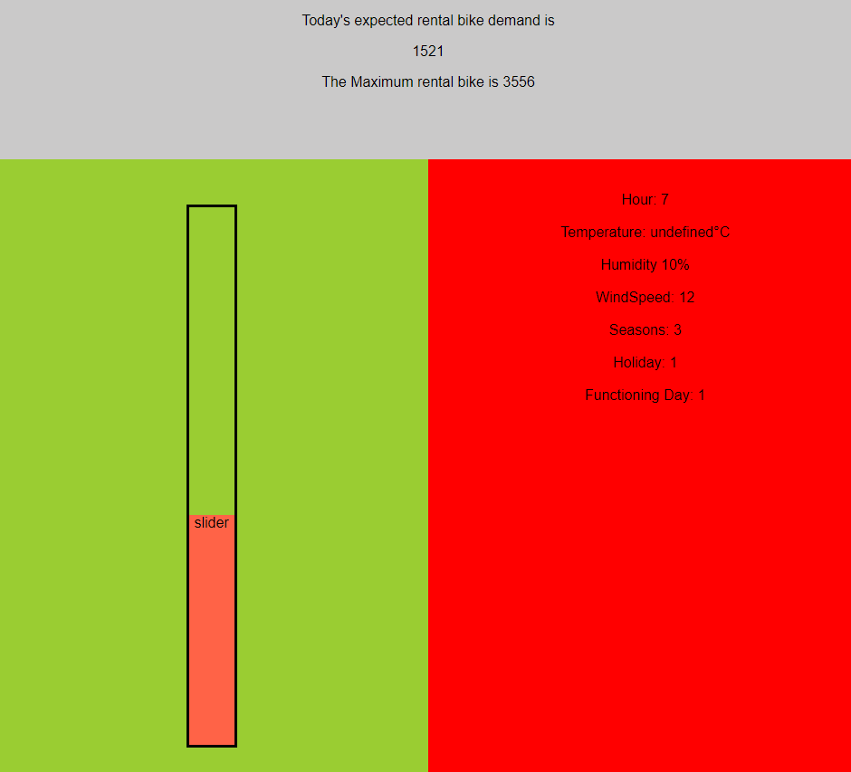

1. Depending on the prediction value, make the hidden texts in “**text**” grid visible, and change the background colour of ‘**description**’ grid.  
   If the prediction result is **below 1000**: then print the text in “**enough**” grid is visible, change the description grid colour into **green**.

If the prediction result is **between 1000 and 3000**: then print the text in “**stillEnough**” grid is visible, change the description grid colour into **yellow**.  
If the prediction result is **above 3000**: then print the text in “**onlyFew**” grid is visible, change the description grid colour into **red**.

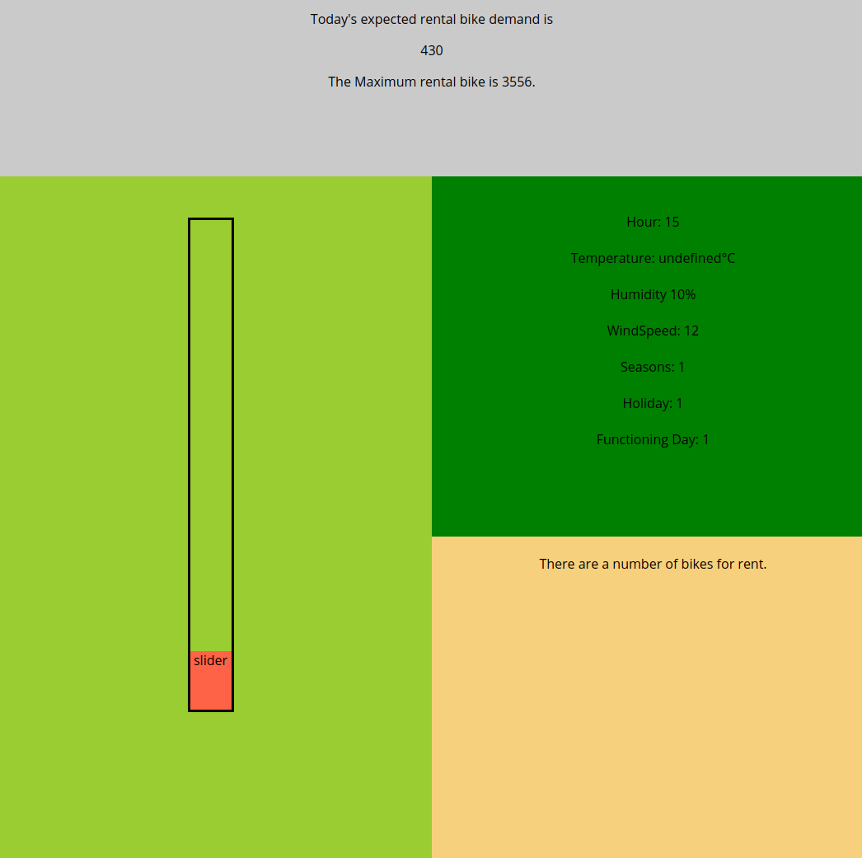

1. BONUS? Inside the slider now there is a text ‘slider’ written. Replace it with the prediction result value.

