PayVerse
Technical Document
Architecture · servers and infrastructure · databases · data flows · logging and monitoring · operations

Version 1.0 · October 2026

Document control
Item | Value
Document | PayVerse Technical Document v1.0
Audience | Developers, DevOps / SRE, technical reviewers
Environment described | Local / staging environment on Docker Compose (as verified 18–19 Oct 2026) and the Kubernetes deployment (Helm)
Repository | /Users/manoranjan/claude/payverse (Git)
Credentials | Not included. All secrets live in the environment file (.env) or a Kubernetes Secret; see section 13.
Companion documents | PayVerse User Manual (screens and functions), web/README.md, docs/PHASE-0-PLAN.md (original design), CLAUDE.md (engineering decisions)

Contents
- 1. System overview
- 2. Technology stack
- 3. Servers and infrastructure
- 4. Services catalogue
- 5. Databases (PostgreSQL)
- 6. Cache and locks (Redis)
- 7. Messaging (Kafka)
- 8. Security
- 9. How the main flows work
- 10. Logging, monitoring and tracing
- 11. Operations runbook
- 12. Deployment (Kubernetes, CI/CD)
- 13. Configuration reference
- 14. Testing
- 15. Known limitations

1. System overview
PayVerse is a digital-wallet and UPI-style payments platform built as 12 Java microservices behind an API gateway, with a React single-page web app. Each service owns its data (database-per-service), talks to other services synchronously over REST for commands that need an answer, and publishes facts asynchronously to Kafka through a transactional outbox. All external providers (payment gateway, payout, billers, UPI switch, KYC, SMS/email/push) are simulated by Mock adapters with predictable behaviour.
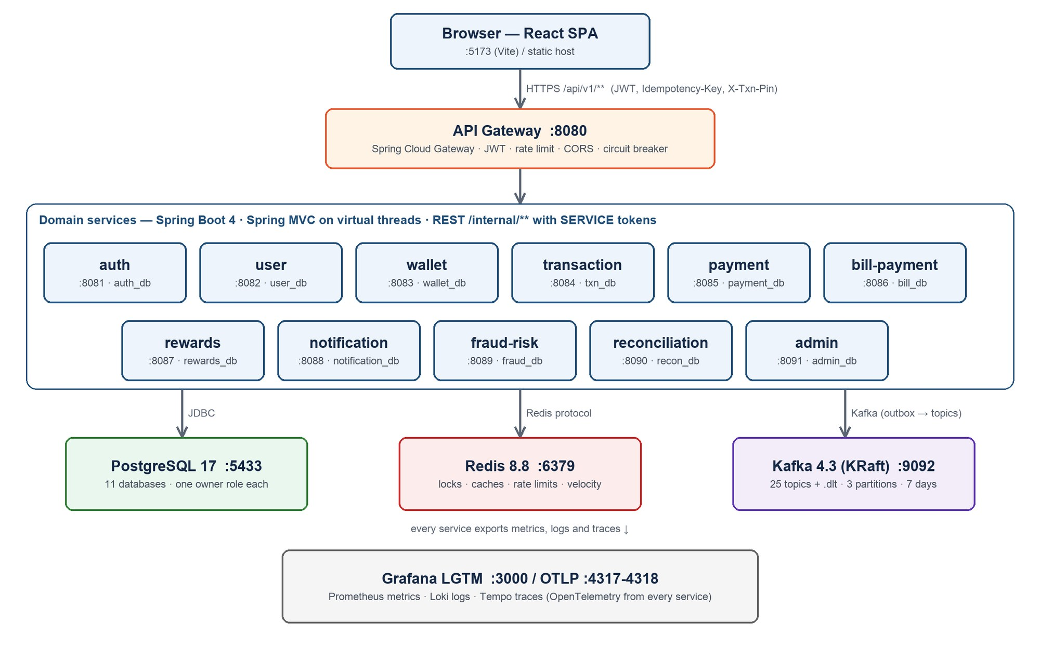
Figure 1. Runtime architecture

1.1 Design principles
- Money correctness first: a double-entry ledger is the single source of truth for balances; every movement is a balanced journal; the database rejects unbalanced journals, negative balances and edits to posted entries.
- Idempotency everywhere money moves: clients send an Idempotency-Key; internal saga steps use deterministic keys (<txnId>:debit / :credit / :compensate). Retries return the original result (HTTP 200, replayed=true).
- Sagas instead of distributed transactions: each step is its own committed transaction; failures are compensated; a recovery job resumes stuck sagas.
- Facts on Kafka, commands over REST (decision D1). Events are written to an outbox table in the same transaction as the business change and relayed by a poller, so no event is lost or published for a rolled-back change.
- Privacy by default: PII encrypted at rest (AES-256-GCM) with HMAC blind indexes for lookups; masked in APIs, UI and logs.
- Everything observable: OpenTelemetry metrics, traces and logs from every service into Grafana (LGTM).

2. Technology stack
Layer | Technology | Version
Language / runtime | Java (language level 21), Eclipse Temurin JRE on Alpine | 21
Framework | Spring Boot (MVC, Data JPA, Security, Actuator, Batch) | 4.1.1
Cloud components | Spring Cloud Gateway (WebFlux), Spring Cloud CircuitBreaker + Resilience4j | 2025.1.3 (Gateway 5.0.3), R4j 2.4.0
Database | PostgreSQL + Flyway migrations, Hibernate | 17 (alpine)
Cache / locks | Redis | 8.8 (alpine)
Messaging | Apache Kafka in KRaft mode (no ZooKeeper) | 4.3.1
JSON / mapping | Jackson 3 (tools.jackson), MapStruct, Lombok | 3.x, 1.6.3
API documentation | springdoc-openapi (Swagger UI per service) | 3.1.1
Observability | OpenTelemetry SDK/OTLP, Grafana otel-lgtm (Grafana, Prometheus, Loki, Tempo, Pyroscope) | OTel 1.62, LGTM 0.36.0
Frontend | React, TypeScript, Vite, React Router, TanStack Query | 19.1, 5.8, 6.4, 7.18, 5.104
Testing | JUnit 5, Testcontainers, WireMock, ArchUnit, JaCoCo, Vitest, Testing Library | TC 2.0.5, WM 3.13.2, AU 1.5.1
Load testing | k6 (Docker) | 1.2.3
Packaging / deploy | Docker images, Docker Compose, Helm 3 chart, Kubernetes ≥ 1.31, GitHub Actions | —

3. Servers and infrastructure

3.1 Environments
Environment | Where | How it is started
Local / staging (verified) | One Docker host (OrbStack on macOS, linux/arm64; 10 vCPU, 8 GB RAM VM) | docker compose with profiles infra, core, payments, extras
Developer (from source) | Infra in Docker, services as local JVMs | make infra-up, then make run-<service>
Kubernetes | Any cluster ≥ 1.31 (Helm chart deploy/helm/payverse) | helm install; managed Postgres/Redis/Kafka recommended in production

3.2 Containers (Docker Compose)
Container | Image | Host port → container | Memory limit | Profile
payverse-postgres-1 | postgres:17-alpine | 5433 → 5432 | 768 MiB | infra
payverse-redis-1 | redis:8.8-alpine | 6379 → 6379 | 256 MiB | infra
payverse-kafka-1 | apache/kafka:4.3.1 | 9092 → 9092 (internal listener kafka:29092) | 1 GiB | infra
payverse-kafka-init-1 | apache/kafka:4.3.1 | — (one-shot topic creation) | 256 MiB | infra
payverse-otel-lgtm-1 | grafana/otel-lgtm:0.36.0 | 3000 (Grafana), 4317 (OTLP gRPC), 4318 (OTLP HTTP) | 1.5 GiB | infra
payverse-api-gateway-1 | payverse/api-gateway:local | 8080 | 640 MiB | core
payverse-auth-service-1 | payverse/auth-service:local | 8081 | 640 MiB | core
payverse-user-service-1 | payverse/user-service:local | 8082 | 640 MiB | core
payverse-wallet-service-1 | payverse/wallet-service:local | 8083 | 640 MiB | core
payverse-transaction-service-1 | payverse/transaction-service:local | 8084 | 640 MiB | payments
payverse-payment-service-1 | payverse/payment-service:local | 8085 | 640 MiB | payments
payverse-bill-payment-service-1 | payverse/bill-payment-service:local | 8086 | 640 MiB | payments
payverse-fraud-risk-service-1 | payverse/fraud-risk-service:local | 8089 | 640 MiB | payments
payverse-rewards-service-1 | payverse/rewards-service:local | 8087 | 640 MiB | extras
payverse-notification-service-1 | payverse/notification-service:local | 8088 | 640 MiB | extras
payverse-reconciliation-service-1 | payverse/reconciliation-service:local | 8090 | 640 MiB | extras
payverse-admin-service-1 | payverse/admin-service:local | 8091 | 640 MiB | extras

Measured usage with all 16 containers running: about 6.2 GB of the host's 8 GB (each Java service ~360–430 MiB, Kafka ~370 MiB, LGTM ~770 MiB, Postgres ~110 MiB).

3.3 Service container settings
Setting | Value | Why
JVM | -Xms128m -Xmx256m -XX:MaxMetaspaceSize=224m -XX:ReservedCodeCacheSize=64m -XX:MaxDirectMemorySize=64m -Xss512k -XX:+UseSerialGC -XX:+ExitOnOutOfMemoryError | Predictable footprint; Spring MVC services use 140–157 MiB of metaspace
MALLOC_ARENA_MAX | 2 | Limits native-memory fragmentation
Health check | wget http://localhost:<port>/actuator/health/readiness every 10 s (start period 90 s, 6 retries) | docker compose up --wait means truly ready
Restart policy | unless-stopped | Survives crashes and host restarts
Spring profile | docker (service URLs use container names) | —
Threads | Virtual threads for HTTP and @Async; Kafka consumer loops on platform threads | Avoids Java 21 virtual-thread pinning in the Kafka client
Image | eclipse-temurin:21-jre-alpine, layered Spring Boot jar, non-root user 10001 | Gateway ~434 MB, services ~510 MB

3.4 Network and storage
Item | Details
Network | Docker bridge network payverse_default; containers resolve each other by name (auth-service, postgres, kafka …).
Ingress | Only the gateway (8080) and the web app need to be reachable by users. Service ports 8081–8091 are published for debugging only.
Volumes | payverse_postgres-data, payverse_redis-data (AOF), payverse_kafka-data, payverse_lgtm-data — survive make infra-down; deleted by make infra-reset.
Topic bootstrap | kafka-init runs infra/kafka/create-topics.sh once (auto-create is disabled).
Database bootstrap | infra/postgres/init/01-create-databases.sh creates 11 databases and owner roles on the first start of an empty volume.

3.5 Web application hosting
The web app is a static bundle (npm run build → web/dist, ~96 kB gzipped initial JavaScript). In development Vite serves it on :5173 and proxies /api to the gateway (removing the browser Origin header, so no CORS is needed). In production serve web/dist from any static host or CDN and route /api/** to the gateway on the same origin, or add the app's origin to CORS_ALLOWED_ORIGINS.

4. Services catalogue
Service | Port | DB | Responsibility | Publishes | Consumes | Calls (REST)
api-gateway | 8080 | — (Redis) | Entry point for /api/v1/**: validates JWTs (JWKS from auth), routes by path, Redis token-bucket rate limiting (5 OTP/PIN calls per minute per IP; 20 requests/s with bursts of 40 per user or IP on other routes), circuit breaker per route (10 s), CORS, correlation IDs, access log. Downstream DNS cached ≤ 10 s. | — | — | all services
auth-service | 8081 | auth_db | OTP login/sign-up, RS256 access tokens (15 min), rotating refresh tokens with reuse detection, transaction PIN (Argon2, lockout after 5), devices, JWKS, client-credentials tokens for services, signing-key rotation. | user-registered, new-device-login, pin-locked | — | —
user-service | 8082 | user_db | Profiles, KYC tiers (NONE → MIN_KYC → FULL_KYC) via MockKycVerifier, bank accounts, beneficiaries; encrypted PII. | kyc-upgraded, bank-account-linked | user-registered | —
wallet-service | 8083 | wallet_db | Double-entry ledger, wallets, KYC limits (IST periods), add money (via payment-service), withdraw (MockPayoutAdapter), freeze, integrity report (nightly 02:30 IST). | wallet-created, ledger-posted, money-added, money-withdrawn, status-changed | user-registered, kyc-upgraded | auth, user, payment
transaction-service | 8084 | txn_db | Transfer saga, payee resolution (VPA/mobile/QR/user), money requests, split bills, statements (CSV/PDF), refunds; SagaRecoveryJob every 10 s. | transaction initiated/completed/failed/reversed, money-requested | — | auth, user, wallet, payment, fraud
payment-service | 8085 | payment_db | UPI IDs (VPA), QR codes (static/dynamic, PNG), collect requests, mock payment-gateway charges, mock UPI switch records (RRN). | pg-charge-settled, collect-requested | user-registered, transaction completed/failed | transaction, user
bill-payment-service | 8086 | bill_db | Billers, bill fetch/pay saga with refund on decline, auto-pay mandates (scheduler every 60 s), MockBillerAdapter. | payment-completed, payment-failed, mandate-executed | — | auth, wallet
rewards-service | 8087 | rewards_db | Cashback rules with budgets, scratch cards, coupons, referrals; credits rewards to wallets every 1 s; expires scratch cards. | cashback-granted, scratch-card-issued | user-registered, kyc-upgraded, money-added, transaction completed/reversed, bill payment-completed | wallet
notification-service | 8088 | notification_db | Turns events into SMS/email/push (mock) from DB templates; dispatcher every 1 s with back-off; dead-letter desk for every service's .dlt topic. | — | 18 topics + payverse.*.dlt | —
fraud-risk-service | 8089 | fraud_db | Rule-based risk scoring per transfer (score ≥ 50 REVIEW, ≥ 80 BLOCK), flags, velocity (Redis), device and PIN-lock signals. | transaction-flagged | new-device-login, pin-locked, transaction completed | wallet
reconciliation-service | 8090 | recon_db | Spring Batch jobs: PG charges vs ledger, transfers vs UPI switch, ledger integrity; nightly 02:30 IST and on demand. | mismatch-detected | — (reads internal feeds over REST) | wallet, payment, transaction
admin-service | 8091 | admin_db | Disputes, maker-checker refunds (retries every 30 s), admin audit log, back-office proxies (users, freeze, key rotation). | refund-approved | — | auth, user, wallet, transaction

4.1 Gateway routes
Path prefix | Service
/api/v1/auth/otp/**, /api/v1/auth/pin/** (strict rate limit) | auth-service
/api/v1/auth/** | auth-service
/api/v1/users/** | user-service
/api/v1/wallets/** | wallet-service
/api/v1/transfers/**, /transactions/**, /money-requests/**, /split-bills/** | transaction-service
/api/v1/vpa/**, /collect-requests/**, /qr/**, /pg/** | payment-service
/api/v1/billers/**, /bills/**, /mandates/** | bill-payment-service
/api/v1/rewards/**, /admin/cashback-rules/**, /admin/coupons/** | rewards-service
/api/v1/notifications/**, /admin/templates/**, /admin/notifications/**, /admin/dead-letters/** | notification-service
/api/v1/admin/risk/** | fraud-risk-service
/api/v1/admin/recon/** | reconciliation-service
/api/v1/admin/**, /api/v1/disputes/** | admin-service
/api-docs/<service> | OpenAPI documents of each service

4.2 Scheduled jobs
Service | Job | Schedule
all (common-outbox) | Outbox relay → Kafka | polling, continuous
transaction-service | SagaRecoveryJob — resumes due/stale sagas | every 10 s (stale after 60 s)
bill-payment-service | BillPaymentProcessor recovery | every 10 s
bill-payment-service | MandateService — due auto-pay runs | every 60 s
rewards-service | RewardCreditService — credit pending cashback | every 1 s
rewards-service | ScratchCardService — expire cards | every 60 s
notification-service | NotificationDispatcher — send pending messages | every 1 s
admin-service | RefundService — retry PROCESSING refunds | every 30 s
wallet-service | Ledger integrity check | 02:30 IST daily
reconciliation-service | All recon jobs for the previous day | 02:30 IST daily

5. Databases (PostgreSQL)
Setting | Value
Server | PostgreSQL 17, container payverse-postgres-1
Host / port (from the Docker host) | localhost : 5433 (5432 is left free for a native PostgreSQL on developer machines)
Host / port (inside Docker) | postgres : 5432
Superuser | payverse / POSTGRES_PASSWORD from .env
Service roles | <prefix>_svc, each owns only its <prefix>_db (REVOKE ALL FROM PUBLIC) / SERVICE_DB_PASSWORD from .env
Migrations | Flyway on service start: classpath:db/migration (service) + classpath:db/common (shared: outbox, processed events, idempotency, audit log); out-of-order enabled
Schema validation | Hibernate validates the schema at startup (no auto-DDL)

Database | Owner role | Business tables | JDBC URL (host)
auth_db | auth_svc | users, devices, refresh_tokens, signing_keys, transaction_pins | jdbc:postgresql://localhost:5433/auth_db
user_db | user_svc | profiles, kyc_records, bank_accounts, beneficiaries | jdbc:postgresql://localhost:5433/user_db
wallet_db | wallet_svc | wallets, ledger_accounts, journals, ledger_entries, wallet_limit_usage | jdbc:postgresql://localhost:5433/wallet_db
txn_db | txn_svc | transactions, transaction_status_history, money_requests, split_bills | jdbc:postgresql://localhost:5433/txn_db
payment_db | payment_svc | vpas, qr_codes, collect_requests, pg_orders, upi_switch_records | jdbc:postgresql://localhost:5433/payment_db
bill_db | bill_svc | billers, bill_payments, mandates, mandate_executions | jdbc:postgresql://localhost:5433/bill_db
rewards_db | rewards_svc | cashback_rules, rewards, scratch_cards, coupons, coupon_redemptions, referral_codes, referrals, kyc_qualified_users, user_activity | jdbc:postgresql://localhost:5433/rewards_db
notification_db | notification_svc | notifications, templates, dead_letter_events | jdbc:postgresql://localhost:5433/notification_db
fraud_db | fraud_svc | risk_rules, risk_assessments, flags, known_devices, user_risk_profiles | jdbc:postgresql://localhost:5433/fraud_db
recon_db | recon_svc | recon_runs, recon_records, recon_mismatches (+ Spring Batch metadata batch_*) | jdbc:postgresql://localhost:5433/recon_db
admin_db | admin_svc | disputes, refund_requests | jdbc:postgresql://localhost:5433/admin_db

Every database also has the shared tables outbox_events, processed_events, idempotency_records, audit_log and flyway_schema_history.

5.1 Data rules enforced in the database
- Money is NUMERIC(19,2) plus CHAR(3) currency — never floating point. The API sends amounts as strings ("100.00").
- Ledger: a deferred trigger rejects unbalanced journals; journals and entries are append-only; wallets.balance >= 0; one reversal per journal; unique idempotency keys.
- audit_log and posted ledger rows cannot be updated or deleted (trigger payverse_reject_modification()).
- Encrypted columns (mobile, document numbers, account numbers) hold AES-256-GCM ciphertext; lookups use HMAC blind-index columns.
- Uniqueness guards business idempotency: e.g. UNIQUE(payer_user_id, idempotency_key) on transactions, UNIQUE(transaction_id) on risk assessments, UNIQUE(mandate_id, scheduled_for) on mandate runs.

5.2 Connecting and useful queries
# SQL shell inside the container (no client needed)
docker exec -it payverse-postgres-1 psql -U payverse -d wallet_db

# from the host with psql / DBeaver / IntelliJ
psql "postgresql://wallet_svc:<SERVICE_DB_PASSWORD>@localhost:5433/wallet_db"

\dt -- tables
SELECT version, description, success FROM flyway_schema_history ORDER BY installed_rank;
SELECT status, count(*) FROM outbox_events GROUP BY status; -- relay backlog
SELECT user_id, balance, kyc_tier, status FROM wallets ORDER BY updated_at DESC LIMIT 10;
SELECT id, status, amount, created_at FROM transactions ORDER BY created_at DESC LIMIT 10; -- txn_db

5.3 Backup and restore
# backup one database (custom format)
docker exec payverse-postgres-1 pg_dump -U payverse -Fc wallet_db > wallet_db_$(date +%F).dump
# backup everything
docker exec payverse-postgres-1 pg_dumpall -U payverse > payverse_all_$(date +%F).sql
# restore one database (stop its service first)
docker compose stop wallet-service
docker exec -i payverse-postgres-1 pg_restore -U payverse -d wallet_db --clean --if-exists < wallet_db_2026-10-19.dump
docker compose start wallet-service

Note: Restore all databases of a consistent point in time together; services reconcile through events and the recon jobs, but a single-database restore can leave cross-service references behind.

6. Cache and locks (Redis)
Setting | Value
Server | Redis 8.8, container payverse-redis-1, AOF persistence
Host / port | localhost:6379 (host) · redis:6379 (Docker)
Password | REDIS_PASSWORD from .env

Key prefix | Owner | Purpose
lock:wallet:<id> (WalletLock) | wallet-service | Per-wallet lock held for the posting transaction (plus @Version optimistic locking)
wallet:summary:<userId> (BalanceCache) | wallet-service | Cached balance view, evicted on every posting
withdraw:… | wallet-service | Withdrawal de-duplication
otp:<mobile> / ratelimit:… | auth-service | OTP state and per-mobile OTP throttling
ip:<address> / user:<id> | api-gateway | Token buckets for request rate limiting
saga lock / refund:<id> | transaction-service | One runner per saga (SagaLock, SET NX) and per refund
refund:… / mandate:… | bill-payment-service | Bill refund and mandate-run locks
collect:… | payment-service | Collect-request approval lock
fraud:velocity:<userId> | fraud-risk-service | Sorted set of recent transfers for the velocity rules

docker exec -it payverse-redis-1 redis-cli -a '<REDIS_PASSWORD>' --no-auth-warning
> SCAN 0 MATCH lock:* COUNT 100
> TTL wallet:summary:<userId>
> INFO memory

7. Messaging (Kafka)
Setting | Value
Broker | Apache Kafka 4.3.1, single node, KRaft (broker + controller), container payverse-kafka-1
Bootstrap | localhost:9092 (host) · kafka:29092 (Docker) — PLAINTEXT, no authentication (local only)
Topics | 25 domain topics payverse.<domain>.<event>.v1, each with a <topic>.dlt dead-letter topic; 3 partitions; retention 7 days; auto-create disabled
Event format | JSON envelope {eventId, type, version, aggregateId, occurredAt, payload}; no schema registry (decision D5)
Producer side | Transactional outbox: OutboxPublisher writes in the business transaction; a polling relay publishes and marks rows sent (decision D6)
Consumer side | ProcessedEventGuard records eventId per consumer group, so redelivery has no effect; failures retry 3× (1 s, 2 s, 4 s) then go to <topic>.dlt
Consumer groups | fraud-risk-service, notification-service, notification-service.dlt, payment-service, rewards-service, user-service, wallet-service

Domain | Events (topic = payverse.<domain>.<event>.v1)
auth | user-registered, new-device-login, pin-locked
user | kyc-upgraded, bank-account-linked
wallet | created, ledger-posted, money-added, money-withdrawn, status-changed
transaction | initiated, completed, failed, reversed, money-requested
payment | pg-charge-settled, collect-requested
bill | payment-completed, payment-failed, mandate-executed
rewards | cashback-granted, scratch-card-issued
fraud | transaction-flagged
recon | mismatch-detected
admin | refund-approved

make topics # list topics
docker exec payverse-kafka-1 /opt/kafka/bin/kafka-consumer-groups.sh --bootstrap-server localhost:9092 --describe --all-groups # lag
docker exec payverse-kafka-1 /opt/kafka/bin/kafka-console-consumer.sh --bootstrap-server localhost:9092 \
--topic payverse.transaction.completed.v1 --from-beginning --max-messages 5 --property print.key=true

8. Security
Area | Implementation
User authentication | Mobile + OTP (6 digits, 5 min). auth-service issues an RS256 JWT access token (15 min) and an opaque refresh token (only its SHA-256 stored), rotated on every use; reusing an old refresh token revokes the whole token family.
Signing keys | Stored in auth_db.signing_keys with the private key encrypted; published at http://localhost:8081/.well-known/jwks.json; rotation via the back office keeps retired keys in the JWKS for a day.
Transaction PIN | Argon2 hash; sent as X-Txn-Pin on money moves; 5 wrong attempts lock it (event pin-locked); never retried automatically.
Authorisation | Roles USER, SUPPORT, ADMIN, SERVICE. /api/v1/admin/** needs ADMIN or SUPPORT; approvals, freezes, rule/coupon/template changes, recon runs and key rotation need ADMIN. Refund approval must be by a different admin than the requester (enforced in code and by a DB check).
Service-to-service | client_credentials token (role SERVICE) from POST /api/v1/auth/oauth/token, cached and refreshed; required for every /internal/** endpoint.
Transport | HTTPS terminated at the ingress/load balancer in Kubernetes; internal traffic stays inside the cluster network (network policies in the chart).
PII | AES-256-GCM EncryptedStringConverter (key id + key in env), HMAC blind index for search, @Masked fields in responses, log scrubbing of mobiles/PAN/Aadhaar/account numbers/tokens.
Abuse controls | Gateway rate limits (5 OTP/PIN calls per minute per IP; 20 req/s, burst 40 per user/IP elsewhere) and per-mobile OTP throttling in auth-service, fraud scoring on every transfer, KYC tier limits, wallet freeze.
Web client | Access token in memory, refresh token in localStorage (dev trade-off; a BFF with HttpOnly cookie is recommended for production); idempotency keys per payment; PIN never stored.
Secrets | Never in code or images: .env (local, generated by make env, git-ignored) or a Kubernetes Secret (generated once by the chart or provided as existingSecret).

9. How the main flows work

9.1 Sign-up and login
- Web → gateway → auth-service POST /auth/otp/request: OTP generated, rate-limited, sent by LogOtpSender (MOCK; written to the auth log).
- POST /auth/otp/verify with deviceId: user created on first login (event auth.user-registered) or device session bound; tokens returned.
- wallet-service creates the wallet (tier NONE), payment-service issues the default VPA, user-service creates the profile, rewards records referral codes, notification sends a welcome.
- Minimum KYC → user-service verifies and publishes user.kyc-upgraded → wallet-service raises the tier and limits.

9.2 Add money
- POST /wallets/me/add-money (Idempotency-Key) → wallet-service → payment-service POST /internal/pg/charges (idempotent per key, MOCK gateway).
- On success wallet-service posts the journal PG_CLEARING → user wallet, publishes wallet.money-added; payment-service publishes payment.pg-charge-settled.
- rewards-service evaluates cashback rules; the reconciliation PG_VS_LEDGER job later proves every charge has a ledger credit.

9.3 Transfer saga (pay someone)
- POST /transfers (Idempotency-Key, X-Txn-Pin) → transaction-service verifies the PIN with auth-service and resolves the payee (VPA via payment-service, mobile via auth lookup, QR decode).
- Row inserted INITIATED (unique per payer + key) → fraud-risk-service scores it (ALLOW / REVIEW / BLOCK; fail-open up to ₹2,000 if fraud is down).
- Step 1: wallet debit (key <txnId>:debit) payer → TRANSFER_SUSPENSE → DEBITED. Step 2: wallet credit (<txnId>:credit) suspense → payee → SUCCESS.
- If the credit is refused: COMPENSATING → reverse (<txnId>:compensate) → FAILED. 5xx/timeouts are retried with back-off by SagaRecoveryJob; each step is its own transaction.
- Events transaction.initiated/completed/failed; payment-service writes the UPI switch record (RRN); notifications and rewards react.

9.4 Bill payment and auto-pay
- POST /bills/pay → bill-payment-service saga: wallet debit (<id>:debit) → MockBillerAdapter (idempotent per payment id) → SUCCESS, or declined → refund (<id>:refund) → FAILED.
- Mandates: MandateService claims due runs under a row lock (UNIQUE(mandate_id, scheduled_for)) and pays with key mandate:<id>:<time>; bills above the mandate maximum are SKIPPED and notified.

9.5 Dispute and refund (maker-checker)
- User raises a dispute → admin-service. An agent resolves it with REFUND → refund request REQUESTED (maker).
- A different ADMIN approves → approval, admin.refund-approved and audit are committed first, then transaction-service POST /internal/transactions/{id}/refund.
- transaction-service reverses the payee's credit journal, then the payer's debit journal → transaction REVERSED + transaction.reversed. If the payee has spent the money the refund FAILS and nothing moves; PROCESSING refunds are retried every 30 s.

9.6 Notifications
- notification-service consumes 18 topics, renders the template for each channel and stores one PENDING row per (event, user, template, channel).
- NotificationDispatcher sends every second under a row lock; failures back off 5 s·2^n and become DEAD after 5 attempts (admins can requeue). Every service's .dlt topic is captured in dead_letter_events for replay.

9.7 Reconciliation
- Spring Batch jobs read internal feeds over REST ([from, to), paged): wallet journals, PG charges, UPI switch records, transactions.
- PG_VS_LEDGER, TRANSFERS_VS_UPI and WALLET_INTEGRITY compare both sides; mismatches are stored and published (recon.mismatch-detected) for the back office.

10. Logging, monitoring and tracing

10.1 Logs
Item | Details
Format | JSON (logstash encoder) on stdout by default; profile plainlog gives human-readable lines. Fields: @timestamp, level, logger_name, thread_name, message, correlationId, traceId/spanId, plus context (method, path, status, userId, durationMs on the gateway access log).
PII | Scrubbed before writing: mobiles, PAN, Aadhaar, account numbers, tokens and request bodies are never logged in clear.
Correlation | The gateway assigns X-Correlation-Id to every request and returns it in error responses (correlationId); the same ID appears in every service's log lines and in traces.
Where logs go | 1) container stdout (docker logs), 2) OpenTelemetry logback appender → Loki in Grafana (label service_name).
Retention | Docker json-file logs until the container is removed; Loki keeps logs in the lgtm-data volume.

docker logs -f --tail 200 payverse-wallet-service-1 # follow one service
docker logs payverse-transaction-service-1 2>&1 | grep '"level":"ERROR"' # errors only
docker logs payverse-api-gateway-1 2>&1 | grep <correlationId> # one request through the gateway
make logs # all containers
tail -f .run/wallet-service.log # services run from source (make run-*)
make otp # latest mock OTPs from the auth log

Logs in Grafana: Explore → Loki. Useful LogQL queries:
{service_name="api-gateway"} |= "/api/v1/transfers" # access log for transfers
{service_name=~".+"} | json | level="ERROR" # errors from every service
{service_name=~".+"} |= "<correlationId>" # follow one request across services
sum by (service_name) (count_over_time({service_name=~".+"} | json | level="ERROR" [5m])) # error rate

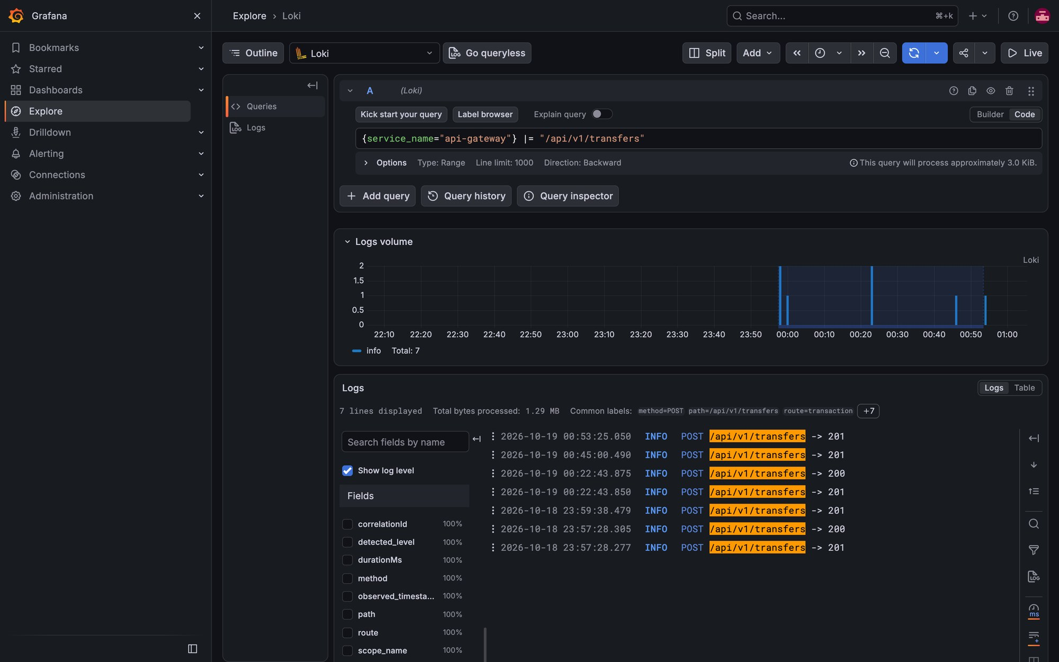
Figure 2. Grafana Explore → Loki: gateway access log for transfers

10.2 Metrics and dashboards
Every service pushes metrics over OTLP to the LGTM container (Prometheus). Open Grafana at http://localhost:3000 (user admin / admin) → Dashboards:
Dashboard | What it shows
PayVerse — Services | Requests/s, 5xx %, p95 latency, 4xx by code, slowest endpoints, heap, CPU, GC pauses, live threads per service.
PayVerse — Payments | Transfers completed/failed, value moved, money added, bills paid, cashback paid, risk blocks, refunds, recon mismatches, notifications DEAD, outbox backlog and oldest unpublished event.
JVM Overview / RED Metrics | Built-in OpenTelemetry dashboards from the LGTM image.

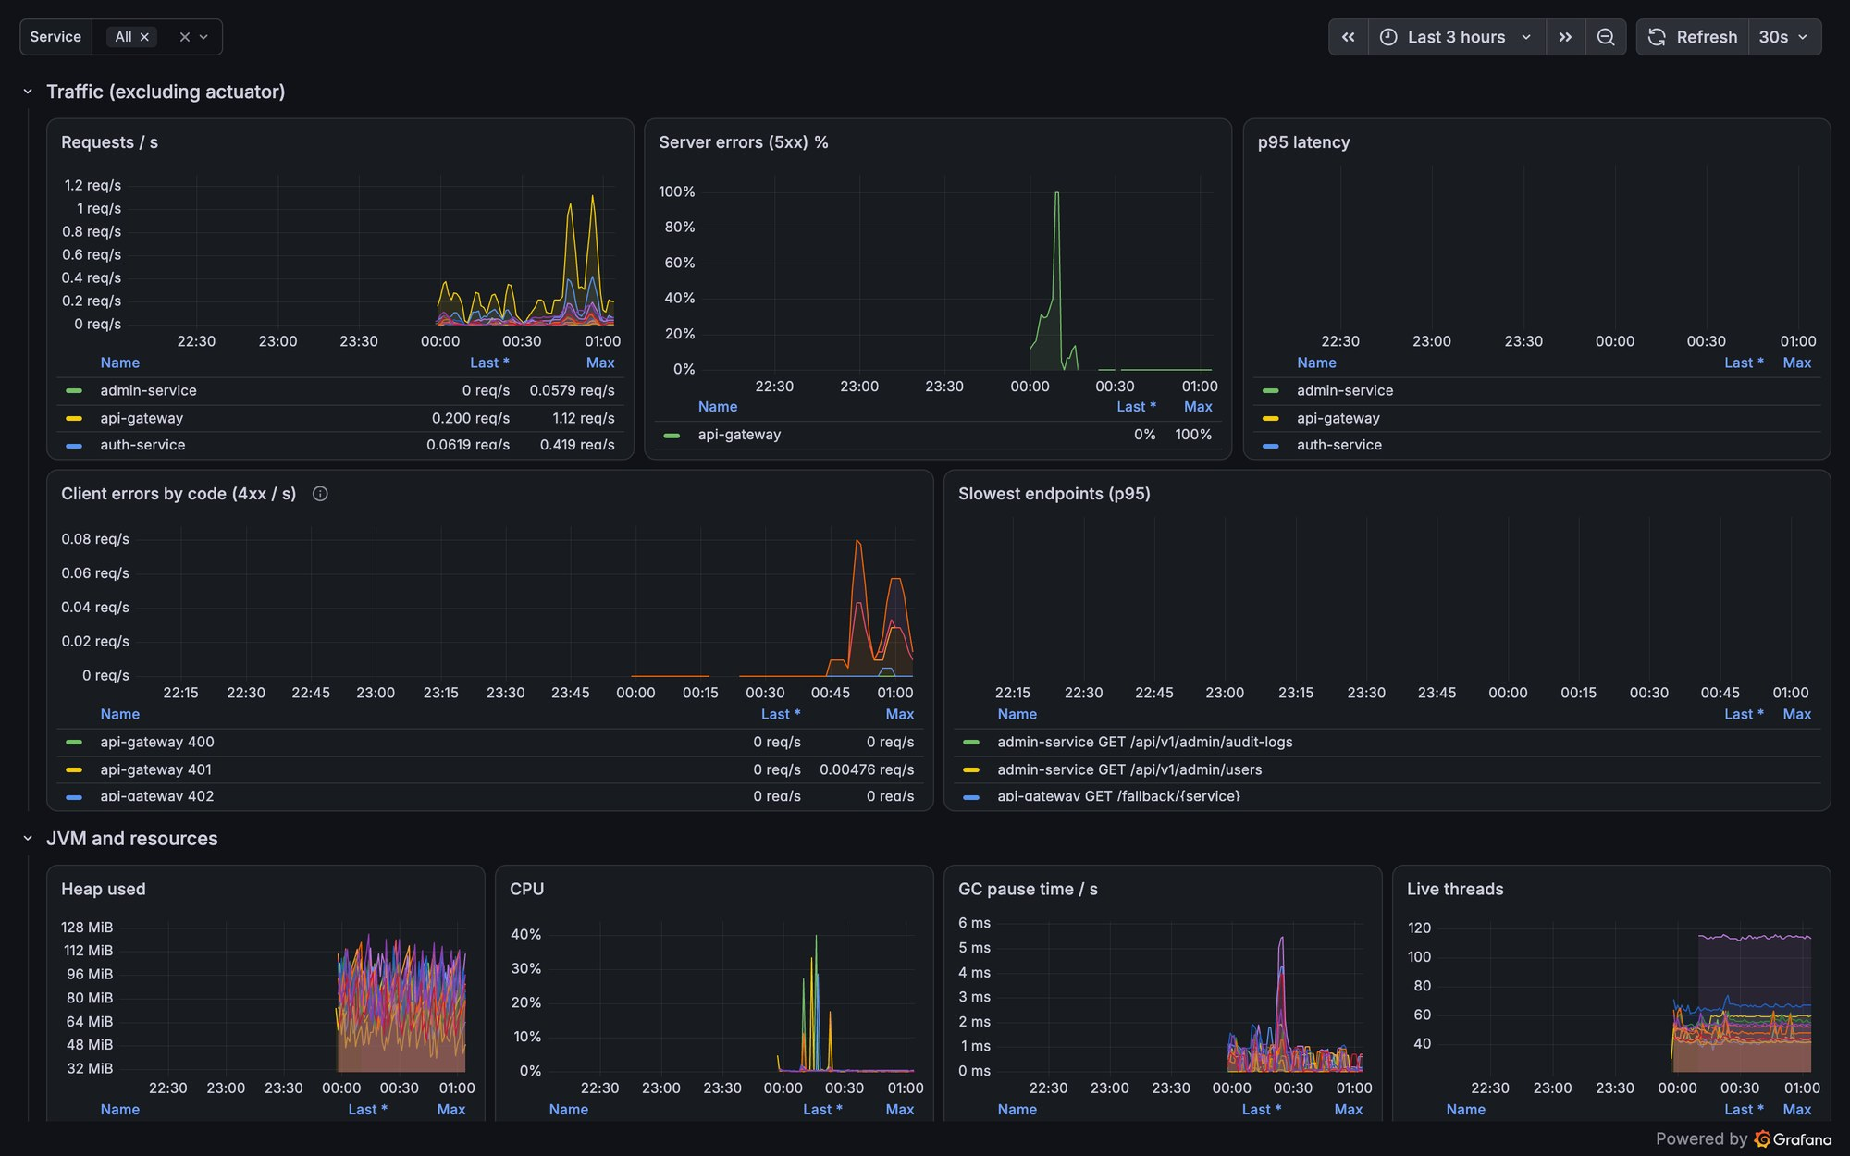
Figure 3. PayVerse — Services dashboard
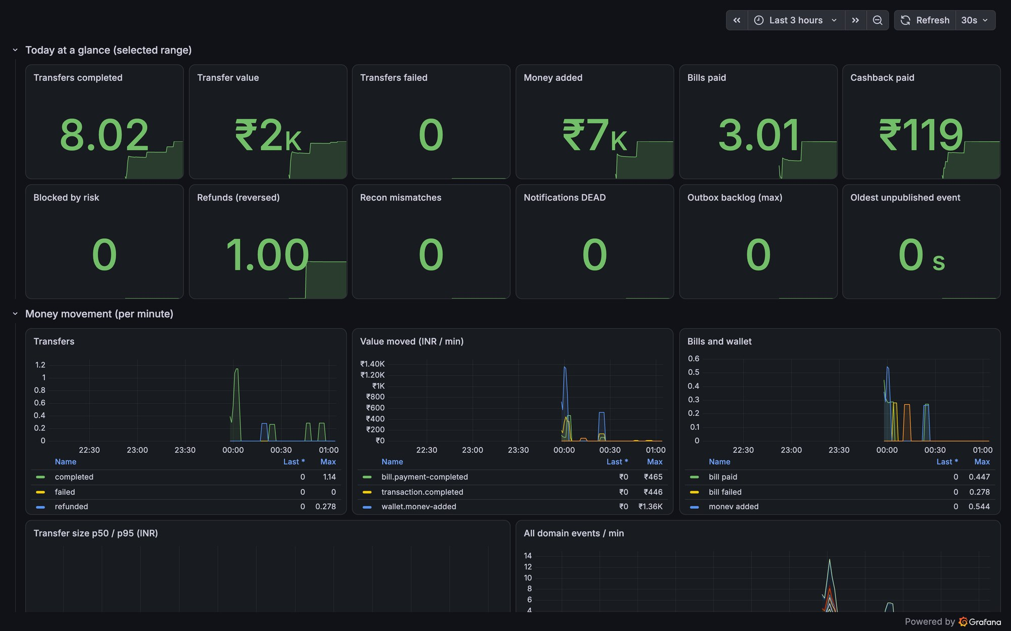
Figure 4. PayVerse — Payments dashboard
Business metric | Meaning
payverse.events{type} | Count of each domain event published (after commit)
payverse.events.amount{type} | Sum of amounts in events that carry one (INR)
payverse.outbox.backlog / payverse.outbox.oldest.age | Unpublished outbox rows and the age of the oldest — alert if growing
payverse.risk.decisions{decision} / payverse.risk.rule.hits{rule} | Fraud decisions and which rules fire
payverse.notifications{channel,status} | Notifications sent / failed / dead

10.3 Traces
OpenTelemetry traces every HTTP request, REST call between services, Kafka publish/consume and scheduled job. In Grafana → Explore → Tempo search by service, or paste a trace ID; logs carry traceId so you can jump between logs and traces.
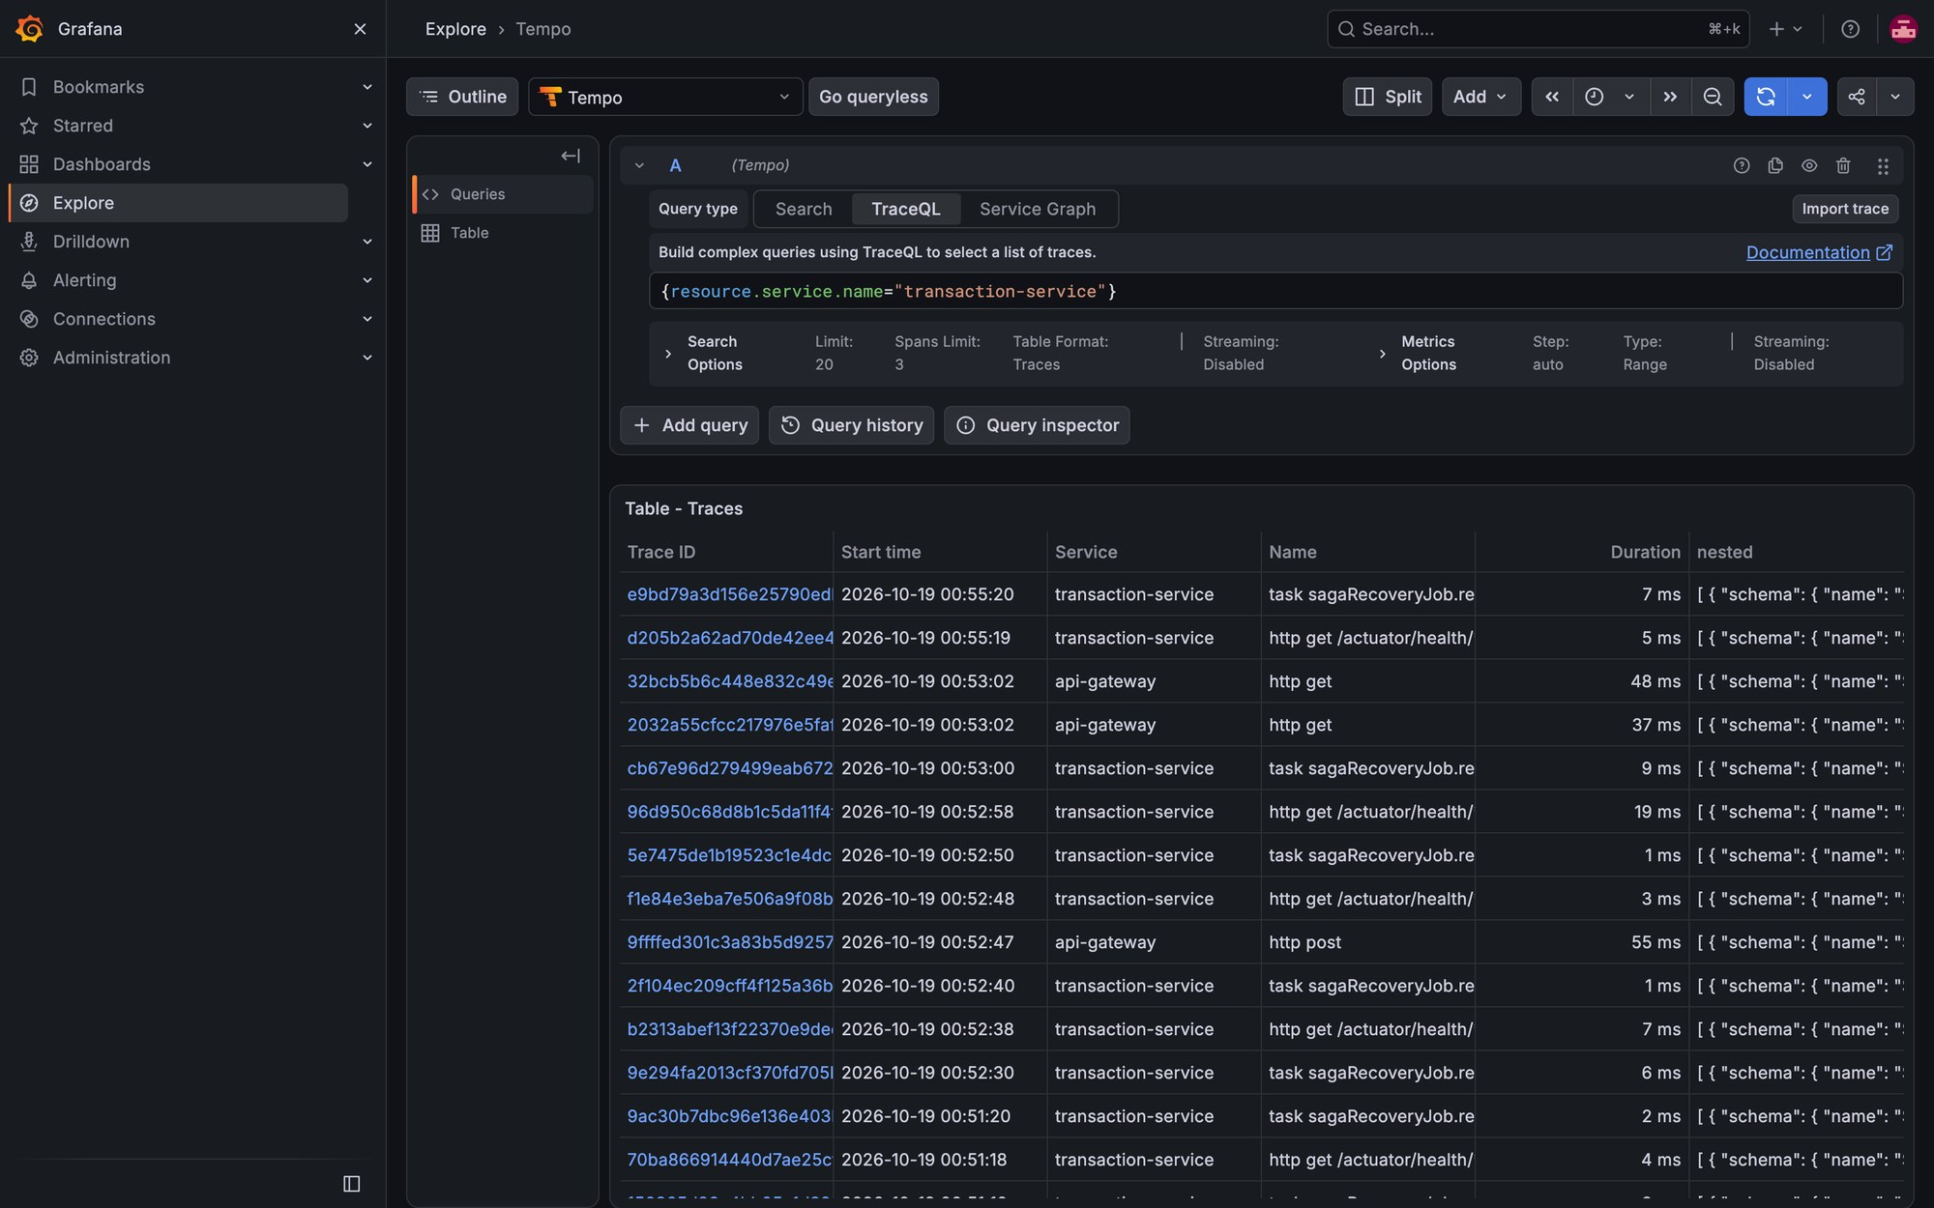
Figure 5. Grafana Explore → Tempo: recent traces of transaction-service

10.4 Health endpoints
Endpoint | Use
GET http://localhost:<port>/actuator/health/liveness | Process is alive (Kubernetes liveness probe)
GET http://localhost:<port>/actuator/health/readiness | Ready for traffic: DB, Redis, Kafka reachable (Docker health check, readiness probe)
GET http://localhost:<port>/actuator/health | Overall status (details for authenticated callers)
GET http://localhost:<port>/actuator/info, /actuator/metrics | Build info and metric names
GET http://localhost:<port>/swagger-ui.html | Interactive API documentation of that service

make ps # every container's health and memory
for p in 8080 8081 8082 8083 8084 8085 8086 8087 8088 8089 8090 8091; do
printf "%s " $p; curl -s localhost:$p/actuator/health/readiness; echo; done

10.5 Suggested alerts
Alert | Condition
Service down | readiness ≠ UP for 2 minutes, or container unhealthy
Error rate | 5xx > 2% of requests for 5 minutes on any route
Latency | p95 > 1 s for 10 minutes
Outbox stuck | payverse.outbox.oldest.age > 60 s
Consumer lag | Kafka lag growing for 10 minutes on any group
Dead letters | new rows in dead_letter_events / notifications DEAD > 0
Reconciliation | recon mismatches > 0 after the nightly run
Ledger | integrity report unhealthy or transfer suspense ≠ 0

11. Operations runbook

Start everything
make build
docker compose --profile infra --profile core --profile payments --profile extras up -d --build --wait --wait-timeout 420
make web-dev # web app on :5173

Stop
make down # services only, infra keeps running
make infra-down # all containers, data kept
make infra-reset # all containers AND data (irreversible)

Restart / rebuild one service
docker restart payverse-wallet-service-1
./mvnw -q -pl services/wallet-service -am -DskipTests package && docker compose --profile infra --profile core up -d --build --wait wallet-service

Run one service from source (debugging)
docker stop payverse-wallet-service-1
make run-wallet-service # logs in .run/wallet-service.log

Check health and resources
make ps
docker stats --no-stream

End-to-end smoke test
make e2e # whole stack + scenario, prints E2E PASSED
make e2e-local # against services run from source

Read OTPs (mock SMS)
make otp

Replay a dead-lettered event
Back office → Templates & DLT → Dead letters → Replay (ADMIN), or POST /api/v1/admin/dead-letters/{id}/replay

Rotate the JWT signing key
Back office → Users → Rotate JWT signing key (ADMIN). Old keys stay valid for a day.

Grant staff roles
Add mobiles to ADMIN_MOBILES / SUPPORT_MOBILES in .env (comma-separated)
docker compose --profile infra --profile core up -d auth-service # roles apply at next login

Change secrets
Edit .env; DB/Redis passwords apply only to a fresh volume → make infra-reset. Changing the PII keys makes existing encrypted data unreadable.

Load test
make load # k6 in Docker; RATE, DURATION, USERS env vars

11.1 Common incidents
Symptom | Likely cause | Fix
Container (unhealthy), health endpoint hangs | Deadlock or downstream outage; on Java 21 virtual-thread pinning (fixed for Kafka listeners) | docker logs <c> --tail 200; thread dump: docker exec <c> kill -3 1 then docker logs; docker restart <c>
Gateway returns 503 “… temporarily unavailable” instantly | Circuit breaker open: the service is down or was unreachable | Check that service's health/logs; the breaker half-opens after 10 s. DNS for recreated containers refreshes within 10 s.
Gateway 429 | Rate limit (5 OTP/PIN per minute per IP) | Wait a minute; tune in api-gateway application.yml
Web “PayVerse is unavailable right now” | Gateway down or wrong GATEWAY_URL | Start the stack; check http://localhost:8080/actuator/health
Transfer stuck PENDING | A saga step got a 5xx/timeout | SagaRecoveryJob retries automatically; check transaction-service and wallet-service logs by transaction ID
Balance looks wrong | — | Run the Ledger integrity recon job; balances are the sum of ledger entries and cannot drift silently
Testcontainers: no Docker environment | Socket path after reboot | export DOCKER_HOST=$(docker context inspect --format '{{.Endpoints.docker.Host}}')
Postgres refused on 5432 | Docker Postgres is on 5433 | Use port 5433
Service OOM-killed | Memory limit 640 MiB | make ps; raise mem_limit or start fewer profiles

12. Deployment (Kubernetes, CI/CD)
Item | Details
Helm chart | deploy/helm/payverse — one generic template per service from values.services (probes, resources, PodDisruptionBudget, HPA, ingress, NetworkPolicies), optional single-node dev infra (Postgres, Redis, Kafka, LGTM).
Secrets | Generated once by the chart (lookup + resource-policy keep) or provided as secrets.existingSecret (deploy/k8s/create-secret.sh). Never commit generated keys.
Rendered manifests | deploy/k8s/payverse-dev.yaml (make k8s-render) for kubectl apply without Helm.
Ingress | Gateway behind the ingress; the ingress must overwrite X-Forwarded-For (gateway uses forward headers for rate limiting).
Memory | Heap = 40% of the container limit (Helm); metaspace capped at 224 MiB.
Production data stores | Use managed PostgreSQL (with backups/PITR), Redis and Kafka (3 brokers, replication factor 3); the bundled infra is single-node.
CI (GitHub Actions) | verify with coverage gate (JaCoCo 80% on service/entity/model packages), ArchUnit layer rules, generated-file checks (dashboards, topics), Helm lint + kubeconform, web typecheck/tests/build, multi-arch images to GHCR, nightly make e2e.

make helm-lint # lint + kubeconform (Kubernetes 1.31)
helm install payverse deploy/helm/payverse -n payverse --create-namespace
kubectl -n payverse get pods
kubectl -n payverse logs deploy/wallet-service -f

13. Configuration reference (environment variables)
Variable | Purpose | Value in this environment
POSTGRES_USER / POSTGRES_PASSWORD | Postgres superuser | payverse / generated
SERVICE_DB_PASSWORD | Password of every <prefix>_svc role | generated
POSTGRES_HOST / POSTGRES_PORT | Database address | localhost / 5433 (host); postgres / 5432 (Docker)
REDIS_HOST / REDIS_PORT / REDIS_PASSWORD | Redis address and password | localhost / 6379 / generated
KAFKA_BOOTSTRAP_SERVERS | Kafka | localhost:9092 (host); kafka:29092 (Docker)
JWT_ISSUER | Issuer claim of access tokens | http://localhost:8081
CORS_ALLOWED_ORIGINS | Browser origins accepted by the gateway | http://localhost:3000
SERVICE_CLIENT_SECRET | client_credentials secret for service tokens | generated
ADMIN_MOBILES / SUPPORT_MOBILES | Mobiles granted staff roles at login | comma-separated / comma-separated
OTP_SENDER | OTP delivery | log (MOCK)
PAYVERSE_CRYPTO_KEY_ID / _ENCRYPTION_KEY / _BLIND_INDEX_KEY | PII encryption key id, AES-256 key, HMAC key (base64, 32 bytes) | generated
OTEL_EXPORTER_OTLP_ENDPOINT | Telemetry endpoint | http://localhost:4318 (host); http://otel-lgtm:4318 (Docker)
TRACING_SAMPLING_PROBABILITY | Trace sampling | 1.0
LOG_FORMAT | logstash (JSON) or plain | logstash
*_SERVICE_URL | Base URL of each service for REST calls | http://<service>:<port> in Docker
RISK_ASSESSOR | remote (fraud-risk-service) or permissive (MOCK ALLOW) | remote
NOTIFICATION_MOCK_FAILING_CHANNELS | Force failures on channels for testing | empty
GATEWAY_URL (web) | Where the web dev proxy sends /api | http://localhost:8080

Create the file with make env (random secrets) and extend it after upgrades with make env-upgrade. Service-specific tuning lives in each service's application.yml under payverse.* (limits, intervals, thresholds).

14. Testing
Suite | Command | Scope
Backend unit tests (391) | make test | Entities, services, mappers, architecture rules — no Docker
Backend integration tests | ./mvnw verify | Testcontainers (Postgres, Redis, Kafka), WireMock for downstreams, concurrency test (100 parallel transfers), JaCoCo gate
Web tests (17) | make web-test | API client (refresh, idempotency), formatting, pages with a mocked API
End to end | make e2e | Whole stack: sign-ups, add money, transfer + idempotent replay, bill, cashback, ledger sums, integrity
Long scenario | make smoke | Every phase's features against services run from source
Load | make load | k6: seeded users, reads and transfers with thresholds

15. Known limitations
- Bundled infrastructure is single-node (no HA, no backups) — use managed services in production.
- Access tokens stay valid until expiry (15 min) after logout or device revocation (no deny-list).
- Refunds are full refunds only; reversing a debit or refund does not give back daily-limit usage.
- No penny-drop / name-match verification when linking bank accounts (simulation).
- Dynamic QRs expire but are not single-use.
- Add money charges the mock gateway inside the request; a commit failure after a successful charge is detected by the PG_VS_LEDGER recon job (CHARGED_NOT_CREDITED) and refunded manually.
- The gateway's 429 responses carry no Retry-After header.
- The Helm chart is validated (lint + kubeconform) but has not been deployed to a live cluster as part of these checks.

