PayVerse
User Manual
Web application · customer and back-office guide

Version 1.0 · October 2026

About this manual
This manual explains every screen of the PayVerse web application, button by button. Each screen has an annotated screenshot: the numbered orange markers match the numbered rows in the table under it, which explain what each element is and what it does.
Part A covers the customer app (signing in, wallet, payments, requests, bills, rewards, history and profile). Part B covers the back office used by operations staff (ADMIN and SUPPORT roles).

What you need
- A modern browser — Chrome, Edge, Safari or Firefox — on a computer or phone.
- The PayVerse address provided by your administrator (for the test environment: http://localhost:5173).
- A mobile number that can receive SMS. There are no passwords: every sign-in uses a one-time code.
- A 4- or 6-digit transaction PIN, which you choose the first time you sign in.

Key terms
Term | Meaning
Wallet | Your PayVerse balance. Money is added from a bank/card/UPI and can be withdrawn to a linked bank account.
UPI ID | Your payment address, e.g. asha@payverse. Share it so people can pay you.
Transaction PIN | The 4- or 6-digit code that approves every payment. Never share it. Five wrong attempts lock it.
OTP | One-time password sent by SMS to sign in or reset your PIN. Valid for 5 minutes.
KYC tier | Your verification level: None (no payments), Min KYC (up to ₹10,000) or Full KYC (higher limits).
Money request | A request for someone to pay you; they approve it with their PIN.
UPI collect | A request sent to a UPI ID; it expires after 24 hours.
Mandate (auto-pay) | Your permission for PayVerse to pay a bill automatically every week or month, never above your limit.
Dispute | A complaint about a payment; support can refund it.

Payment statuses
Status | Meaning
Success | The money reached the payee.
Pending | Still being processed; it updates by itself — do not pay again.
Failed | Nothing was taken (or it was returned automatically). The reason is shown.
Reversed | The payment was refunded after a dispute.

Part A — Customer app

A1. Getting started

Sign in or create an account
The first screen. PayVerse has no passwords: you sign in with your mobile number and a one-time code (OTP). The same screen creates an account the first time a number is used.
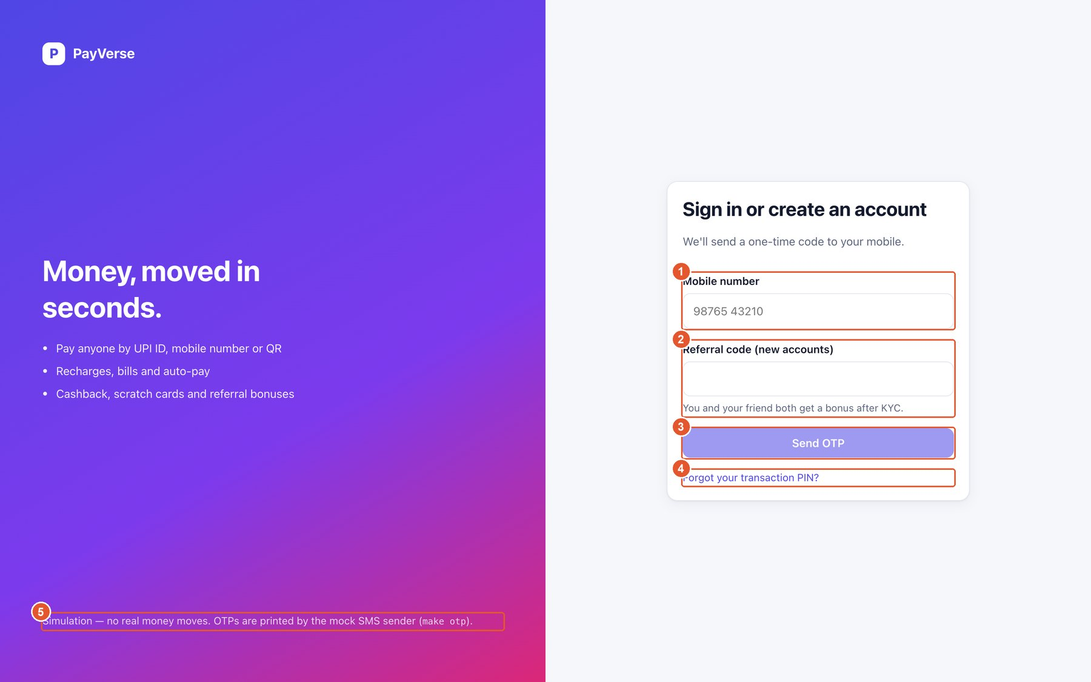
Figure 1. Sign in or create an account
No. | Element | What it does
1 | Mobile number | Enter your 10-digit Indian mobile number (starts with 6, 7, 8 or 9). The +91 prefix is added for you.
2 | Referral code (optional) | Opened with “Have a referral code?”. Enter a friend's code to earn the referral bonus after your KYC; links like …/login?ref=CODE fill it in automatically.
3 | Send OTP | Sends a 6-digit one-time code to the number. The button is enabled once the number is valid.
4 | Forgot your transaction PIN? | Opens the PIN reset flow (verified with an OTP).
5 | Simulation notice | Reminder that this environment moves no real money; codes are delivered by the mock SMS sender.

Enter the one-time code
After pressing Send OTP the screen asks for the 6-digit code sent to your mobile. Codes are valid for 5 minutes.
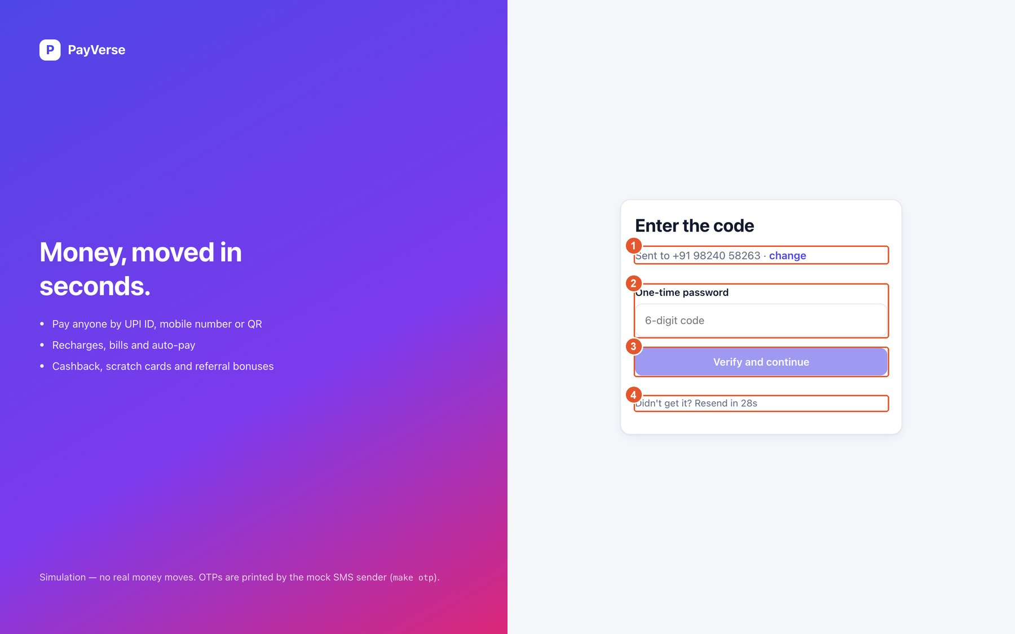
Figure 2. Enter the one-time code
No. | Element | What it does
1 | Number the code was sent to | Shows where the code went. Press “change” to correct the number.
2 | One-time password | Type the 6-digit code from the SMS.
3 | Verify and continue | Checks the code and signs you in. New users continue to onboarding, existing users go to Home.
4 | Resend | After a short countdown you can request a new code. Up to 5 codes per minute can be requested.

Reset a forgotten transaction PIN
Opened from “Forgot your transaction PIN?”. You prove it is you with an OTP and then choose a new PIN.
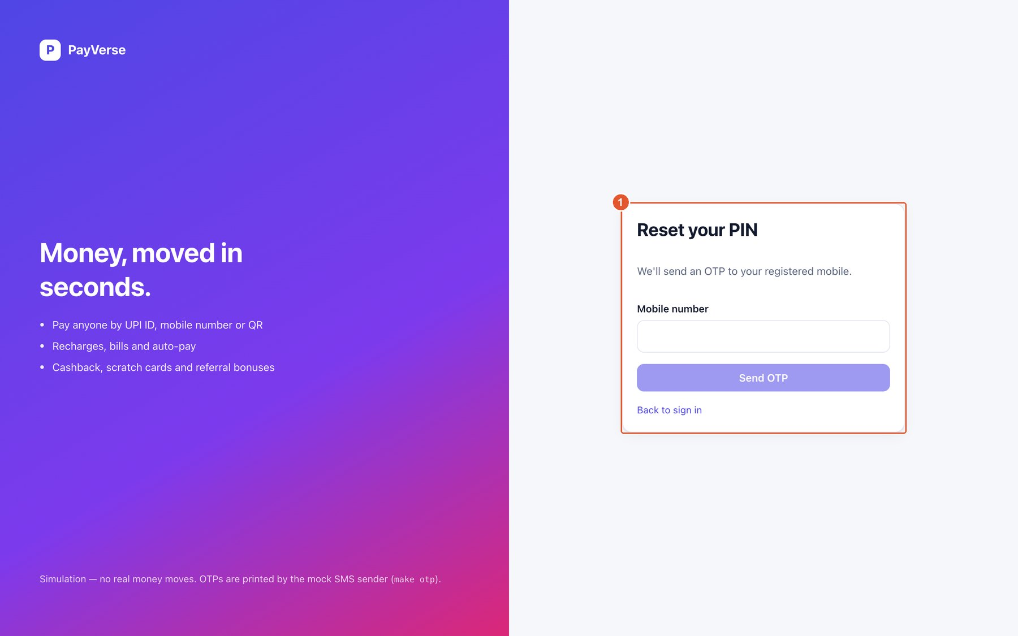
Figure 3. Reset a forgotten transaction PIN
No. | Element | What it does
1 | Reset form | Enter your mobile number, request an OTP, then enter the code and the new PIN twice. All your devices stay signed in.

Onboarding step 1 — set your transaction PIN
New accounts are guided through two steps. First you choose the PIN that approves every payment.
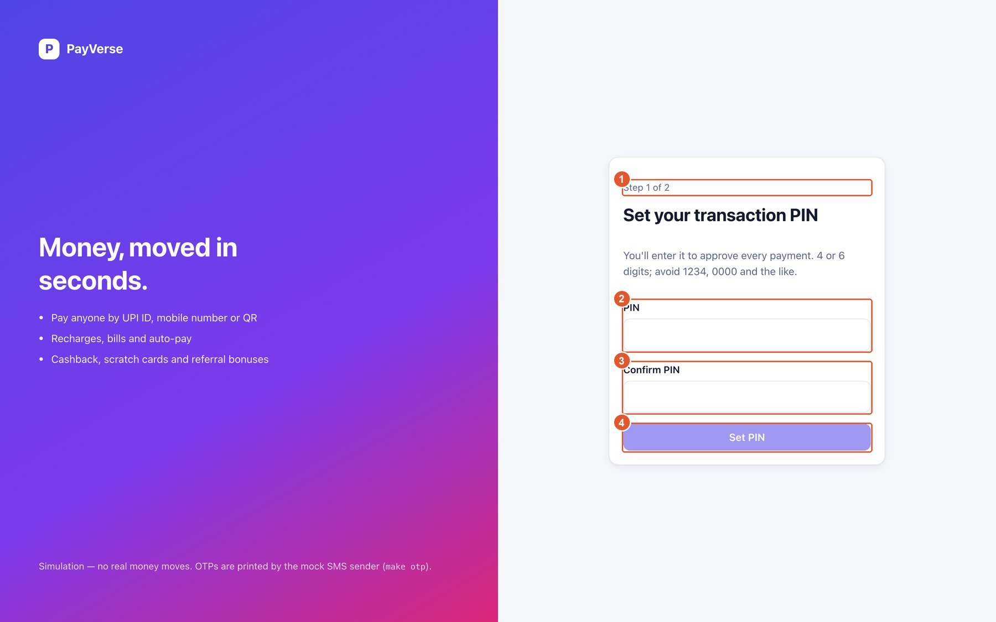
Figure 4. Onboarding step 1 — set your transaction PIN
No. | Element | What it does
1 | Progress | Shows which onboarding step you are on.
2 | PIN | Choose 4 or 6 digits. Easy PINs such as 1234 or 0000 are refused.
3 | Confirm PIN | Type the same PIN again; a message appears if they differ.
4 | Set PIN | Saves the PIN and moves to step 2.

Onboarding step 2 — verify your identity (minimum KYC)
Minimum KYC unlocks payments: a wallet of up to ₹10,000. You can skip it and finish later from Profile → KYC.
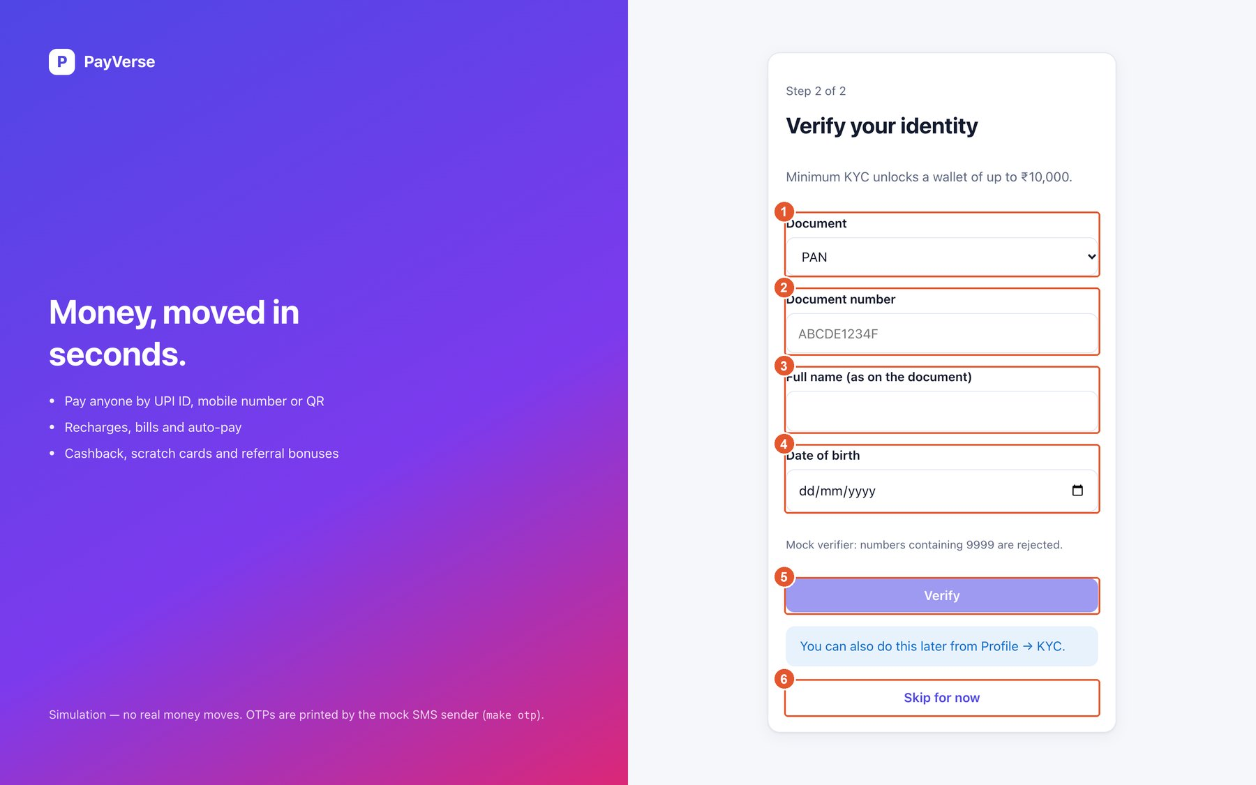
Figure 5. Onboarding step 2 — verify your identity (minimum KYC)
No. | Element | What it does
1 | Document | Choose PAN, Voter ID or Driving licence.
2 | Document number | The number exactly as printed; the expected format is shown as a hint.
3 | Full name | Your name as on the document. It is locked after verification.
4 | Date of birth | Pick your date of birth.
5 | Verify | Verifies the document. Your wallet is upgraded to the Min KYC tier a moment later.
6 | Skip for now | Go to Home without KYC; payments stay locked until you verify.

Home before KYC
If you skip KYC, Home reminds you to finish it. The wallet stays at tier None with zero limits until you verify.
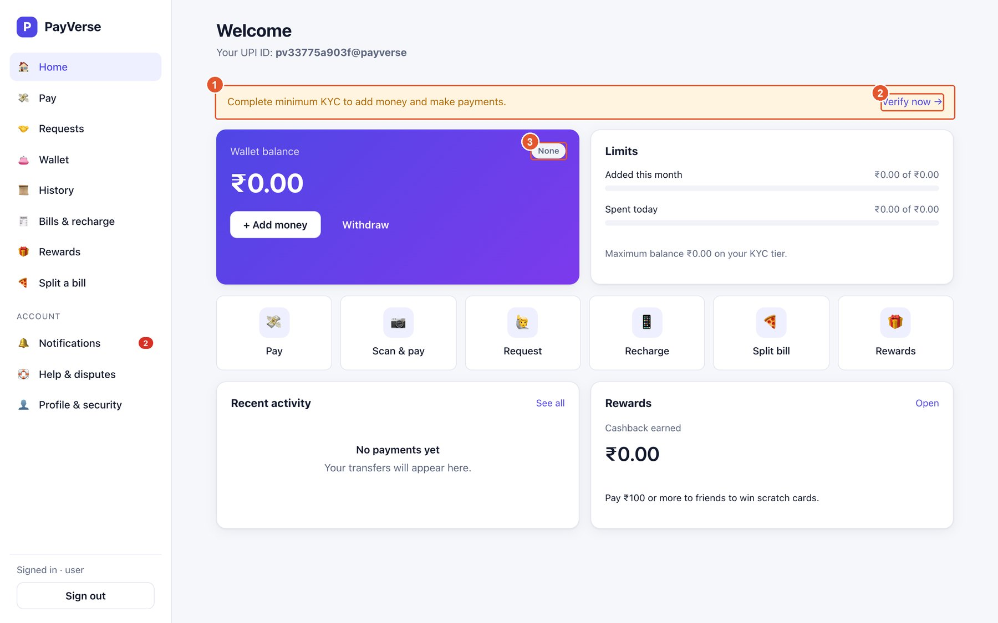
Figure 6. Home before KYC
No. | Element | What it does
1 | KYC reminder | Explains why payments are locked.
2 | Verify now | Opens Profile → KYC to complete verification.
3 | Tier badge | Shows None until KYC is done.

A2. Home and navigation

Home
Your dashboard after signing in: balance, limits, shortcuts, recent payments and rewards. The menu on the left is available on every screen.
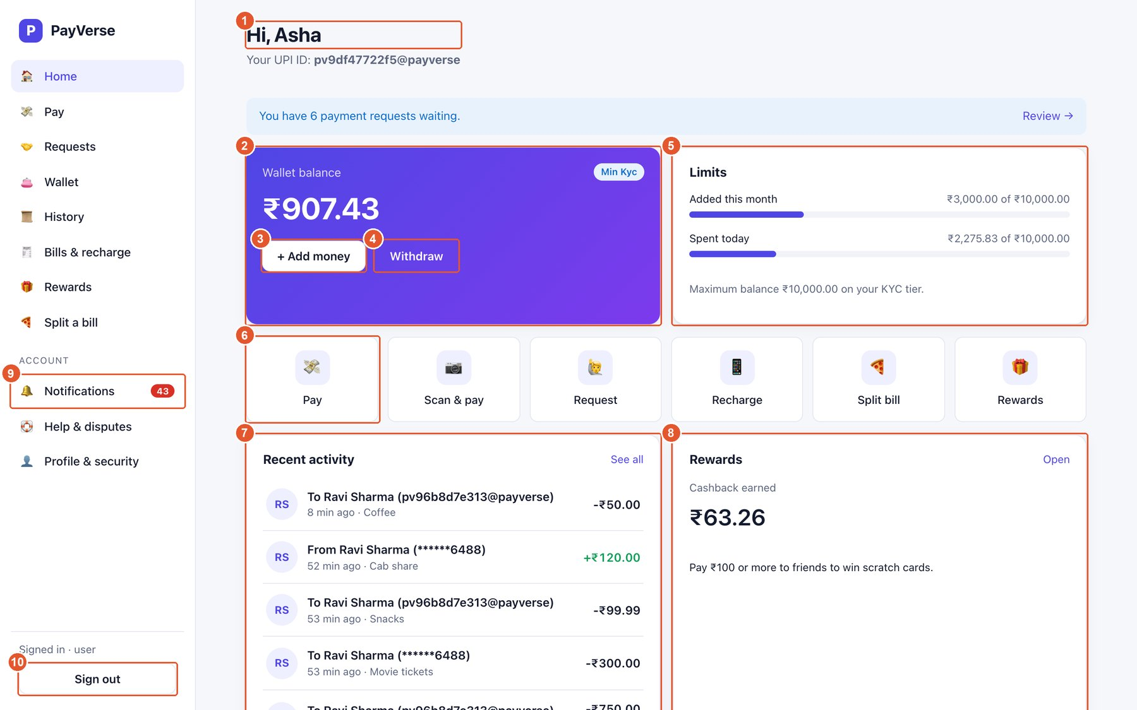
Figure 7. Home
No. | Element | What it does
1 | Greeting and UPI ID | Your first name and your default UPI ID — share it so people can pay you.
2 | Wallet balance | Current balance and your KYC tier badge (None, Min KYC or Full KYC).
3 | Add money | Load money into the wallet (opens Wallet → Add money).
4 | Withdraw | Move money to your linked bank account.
5 | Limits | How much you have added this month and spent today against your tier's limits.
6 | Quick actions | Shortcuts to Pay, Scan & pay, Request, Recharge, Split bill and Rewards.
7 | Recent activity | Your latest payments; click one for details, or “See all” for the full history.
8 | Rewards | Cashback earned so far. “Open” goes to the Rewards page.
9 | Notifications badge | Number of unread notifications.
10 | Sign out | Ends the session on this device.

A3. Wallet

Wallet — add money
Load money from UPI, a card or net banking. The amount is credited to your wallet immediately.
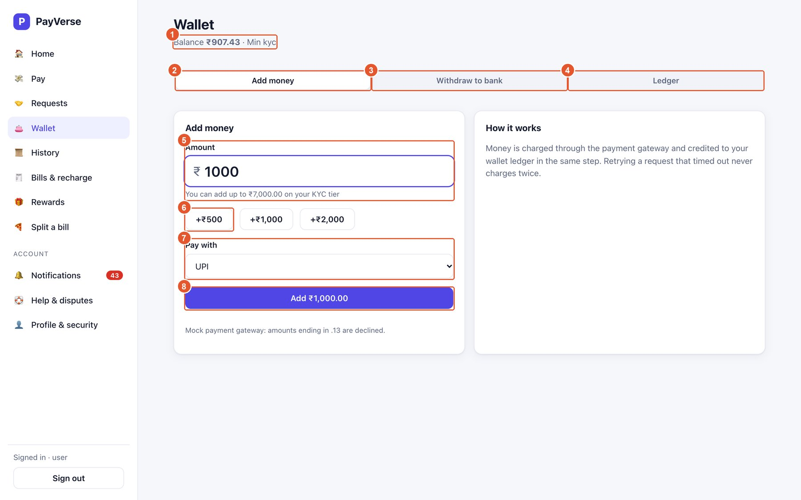
Figure 8. Wallet — add money
No. | Element | What it does
1 | Current balance and tier | Shown at the top of every wallet tab.
2 | Add money tab | This screen.
3 | Withdraw to bank tab | Move money to a linked bank account.
4 | Ledger tab | Every credit and debit with the running balance.
5 | Amount | How much to add. The hint shows how much more you can add this month on your tier.
6 | Quick amounts | Add ₹500, ₹1,000 or ₹2,000 to the amount with one tap.
7 | Pay with | UPI, debit/credit card or net banking.
8 | Add ₹… | Charges the chosen method and credits the wallet. Retrying after a time-out never charges twice.

Tip: Your first top-up of ₹500 or more earns ₹25 cashback.

Note: Test environment: amounts ending in .13 are declined by the mock bank.

Wallet — withdraw to bank
Send wallet money to one of your linked bank accounts.
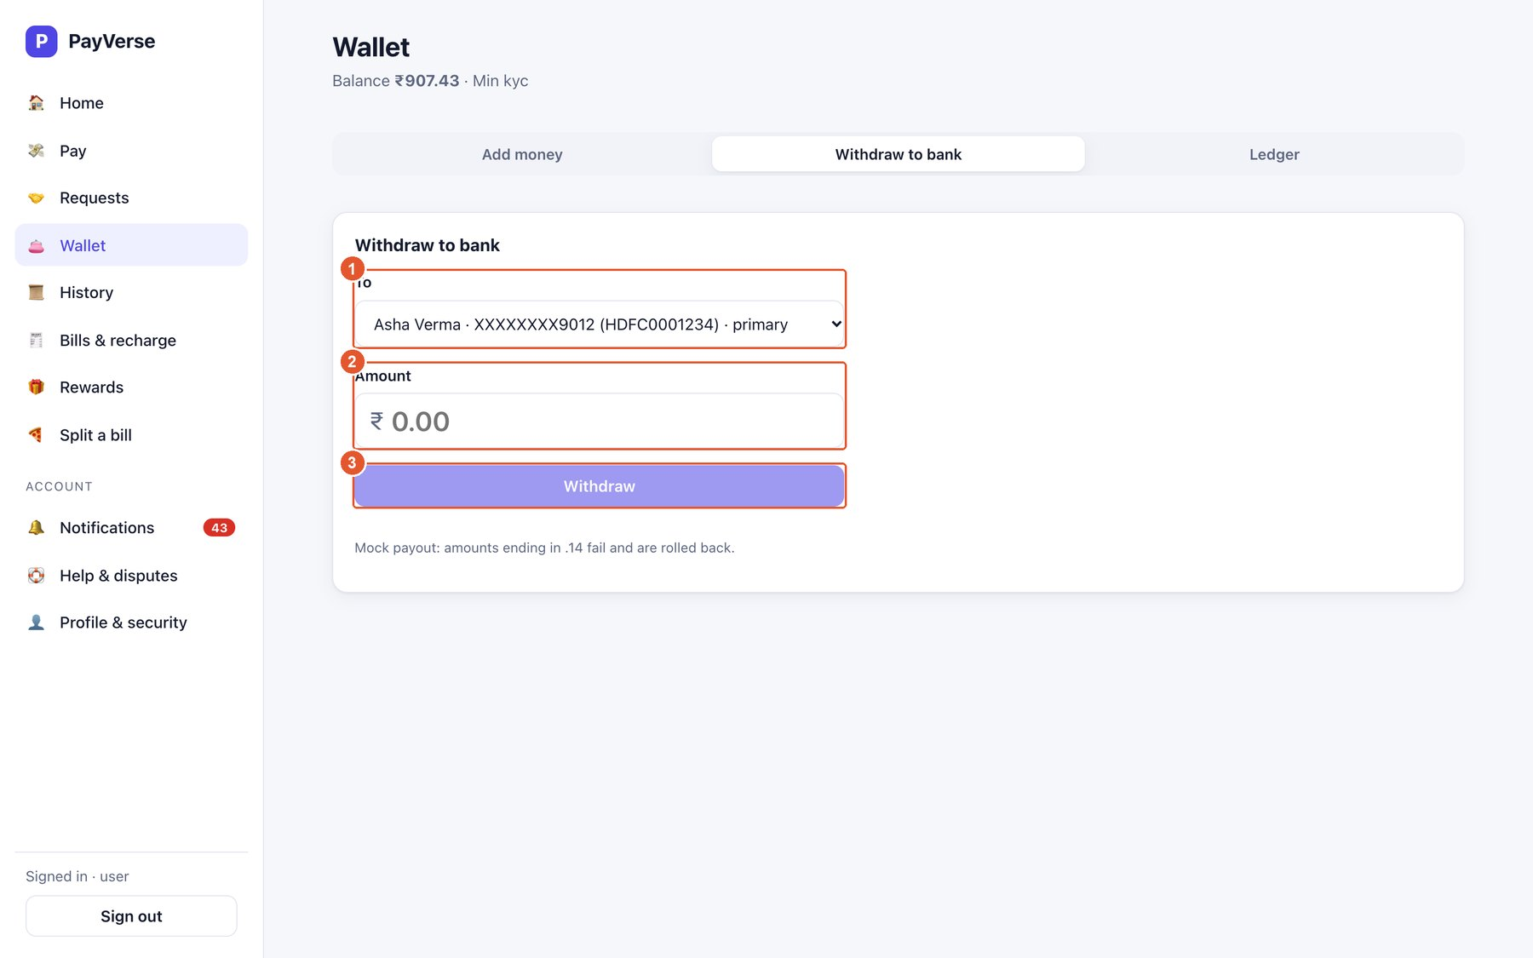
Figure 9. Wallet — withdraw to bank
No. | Element | What it does
1 | To | The bank account to receive the money (masked). Link accounts in Profile → Bank accounts.
2 | Amount | How much to withdraw (up to your balance).
3 | Withdraw | Asks for your PIN, then sends the money. A confirmation toast shows the masked account.

Note: Test environment: amounts ending in .14 fail and are fully rolled back.

Wallet — ledger
A bank-statement-style list of every movement in your wallet.
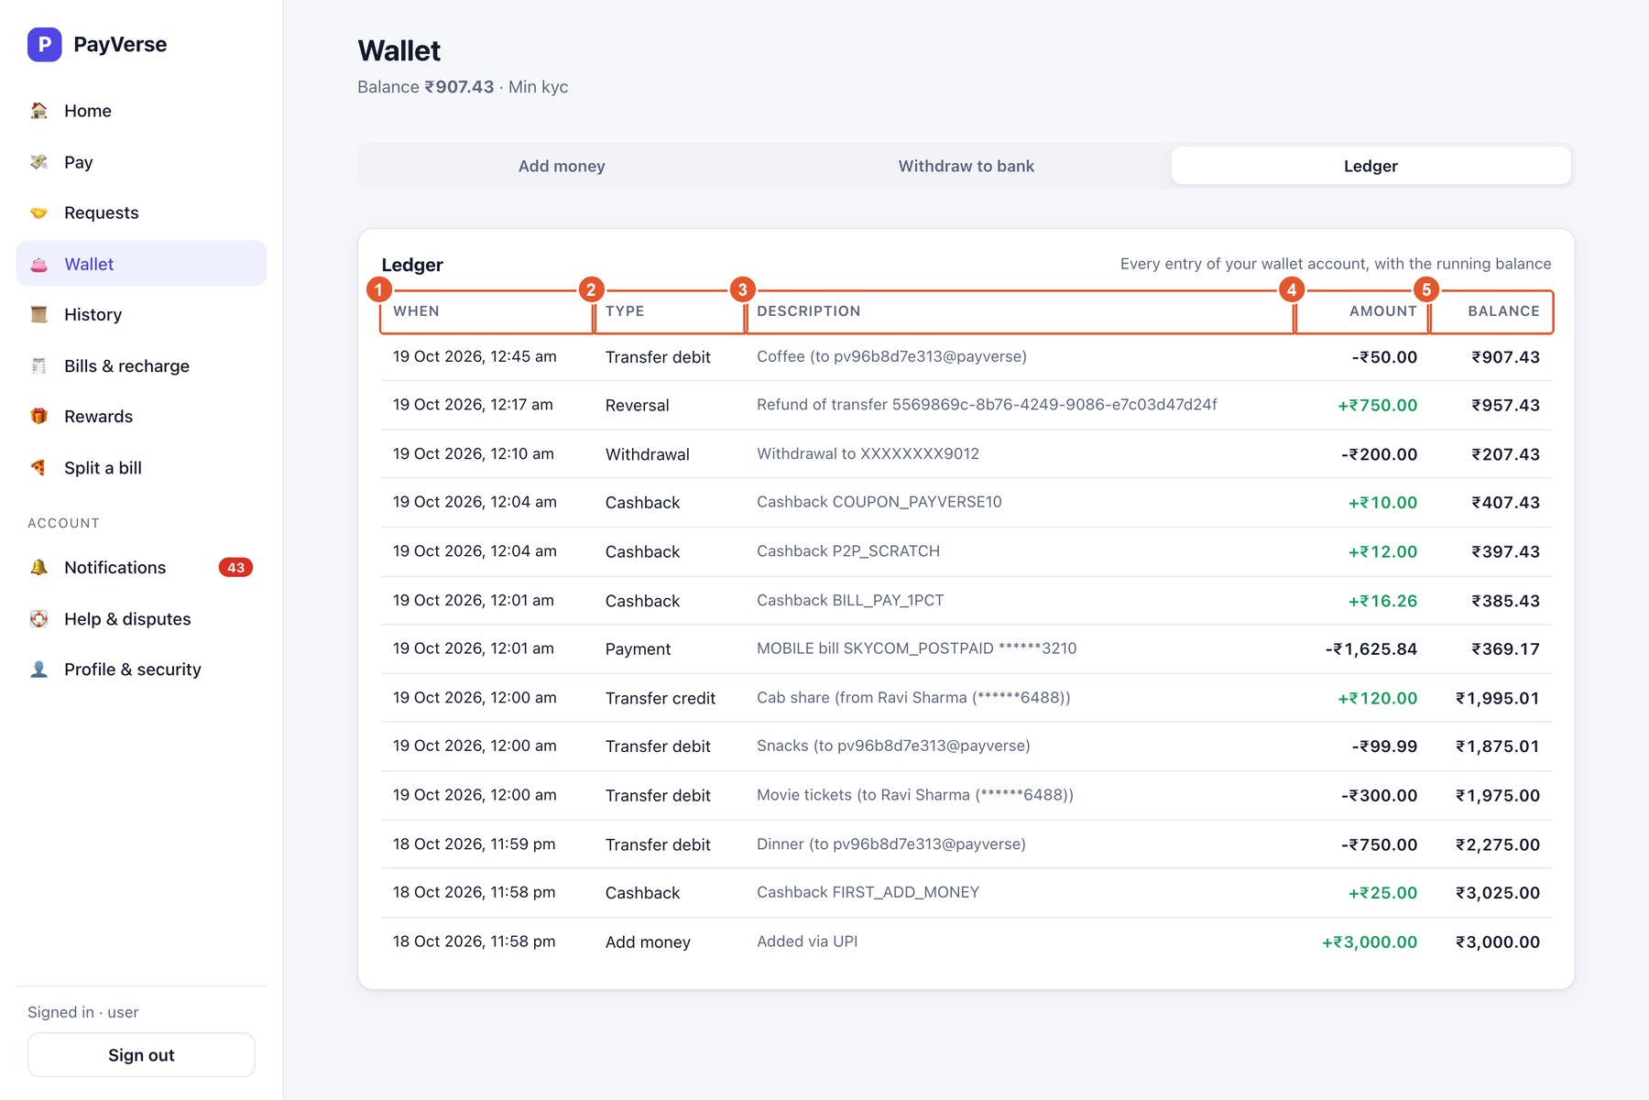
Figure 10. Wallet — ledger
No. | Element | What it does
1 | When | Date and time of the entry.
2 | Type | Add money, Withdrawal, Transfer, Cashback, Bill payment, Refund…
3 | Description | What the entry was for.
4 | Amount | Green for credits, red for debits.
5 | Balance | Your balance right after this entry.

A4. Pay

Pay — by UPI ID
Pay anyone with a UPI ID, a mobile number or a QR code.
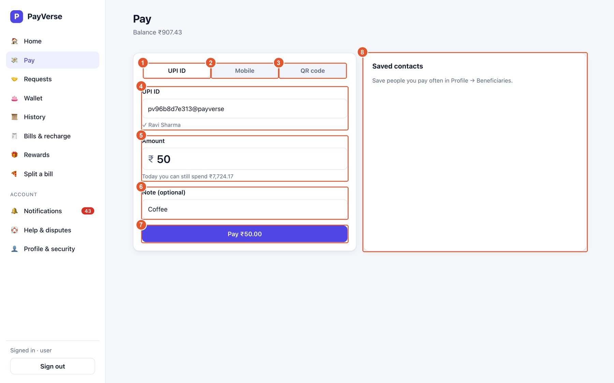
Figure 11. Pay — by UPI ID
No. | Element | What it does
1 | UPI ID tab | Pay a UPI ID such as name@payverse.
2 | Mobile tab | Pay a PayVerse user by mobile number.
3 | QR code tab | Paste a UPI link or upload a QR image.
4 | UPI ID | Type the payee's UPI ID. When you leave the field the payee's verified name appears underneath (✓ Ravi Sharma) — check it before paying.
5 | Amount | Amount to pay; the hint shows how much you can still spend today.
6 | Note (optional) | A message the payee sees, e.g. Dinner or Rent.
7 | Pay ₹… | Opens the PIN prompt to approve the payment.
8 | Saved contacts | People you saved in Profile → Beneficiaries; tap one to fill the form.

Approving a payment with your PIN
Every money movement (payments, withdrawals, approvals, auto-pay) asks for your transaction PIN in this dialog.
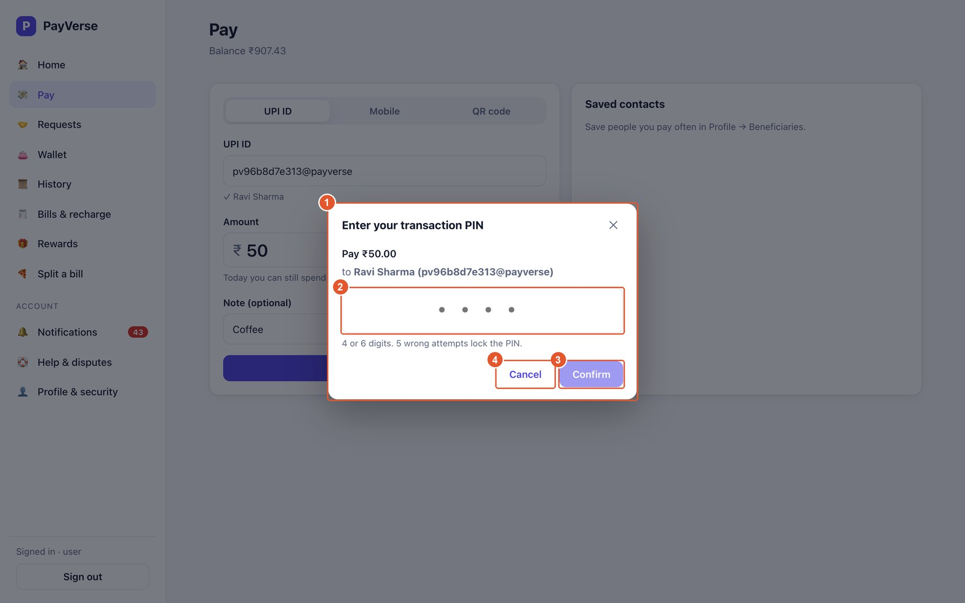
Figure 12. Approving a payment with your PIN
No. | Element | What it does
1 | PIN dialog | Shows what you are approving: amount and payee.
2 | PIN | Enter your 4- or 6-digit PIN. After 5 wrong attempts the PIN is locked; the remaining attempts are shown on errors.
3 | Confirm | Approves and sends the payment.
4 | Cancel | Closes the dialog; nothing is paid.

Payment receipt
Shown after a successful payment. If the bank is slow the status shows Pending and updates by itself.
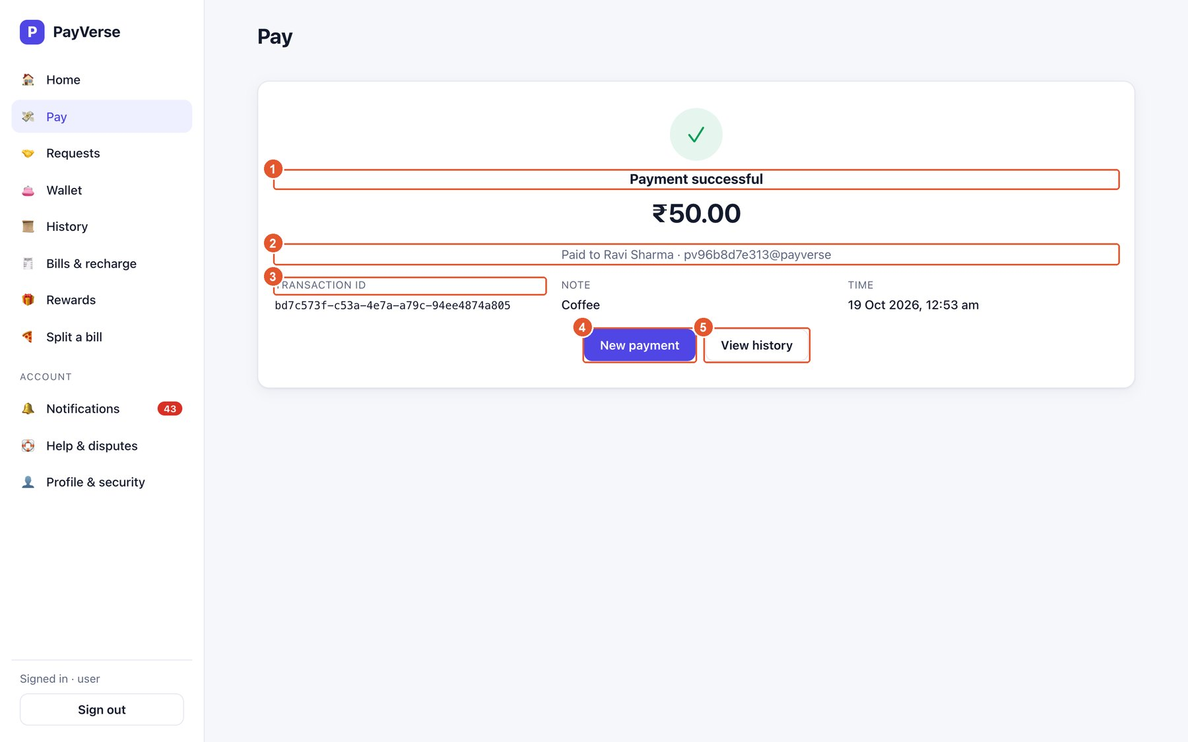
Figure 13. Payment receipt
No. | Element | What it does
1 | Status | Successful, Pending or Failed (with the reason).
2 | Payee | Name and UPI ID of who you paid.
3 | Transaction ID | Quote it when contacting support.
4 | New payment | Start another payment.
5 | View history | Open the History page.

Pay — by mobile number
Pay any PayVerse user by their registered mobile number.
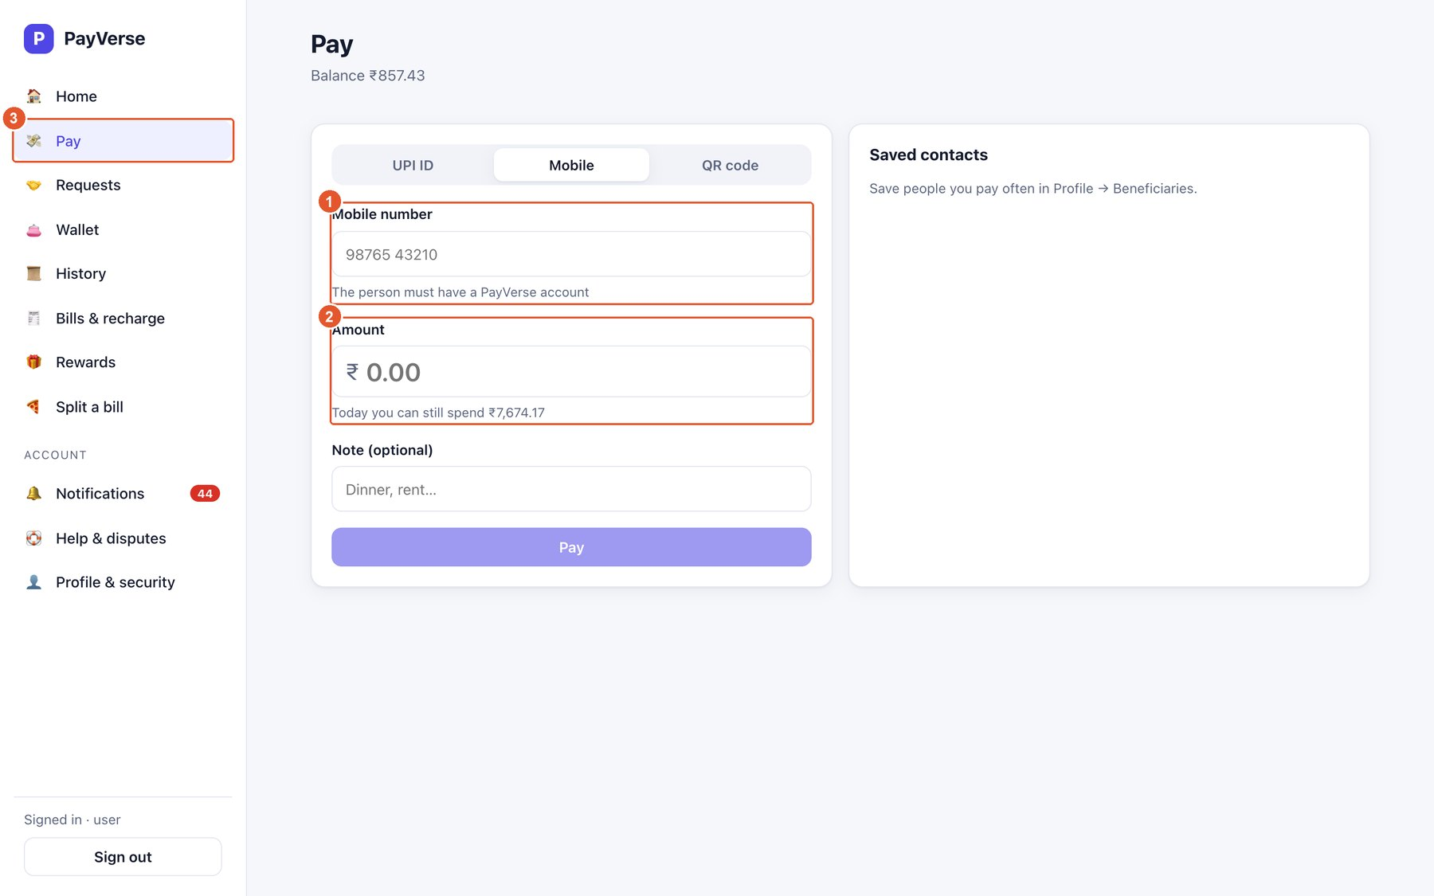
Figure 14. Pay — by mobile number
No. | Element | What it does
1 | Mobile number | The payee's 10-digit mobile number.
2 | Amount | Amount to pay.
3 | Pay | Opens the PIN prompt.

Pay — scan or upload a QR code
Pay a shop or a person from their PayVerse/UPI QR code.
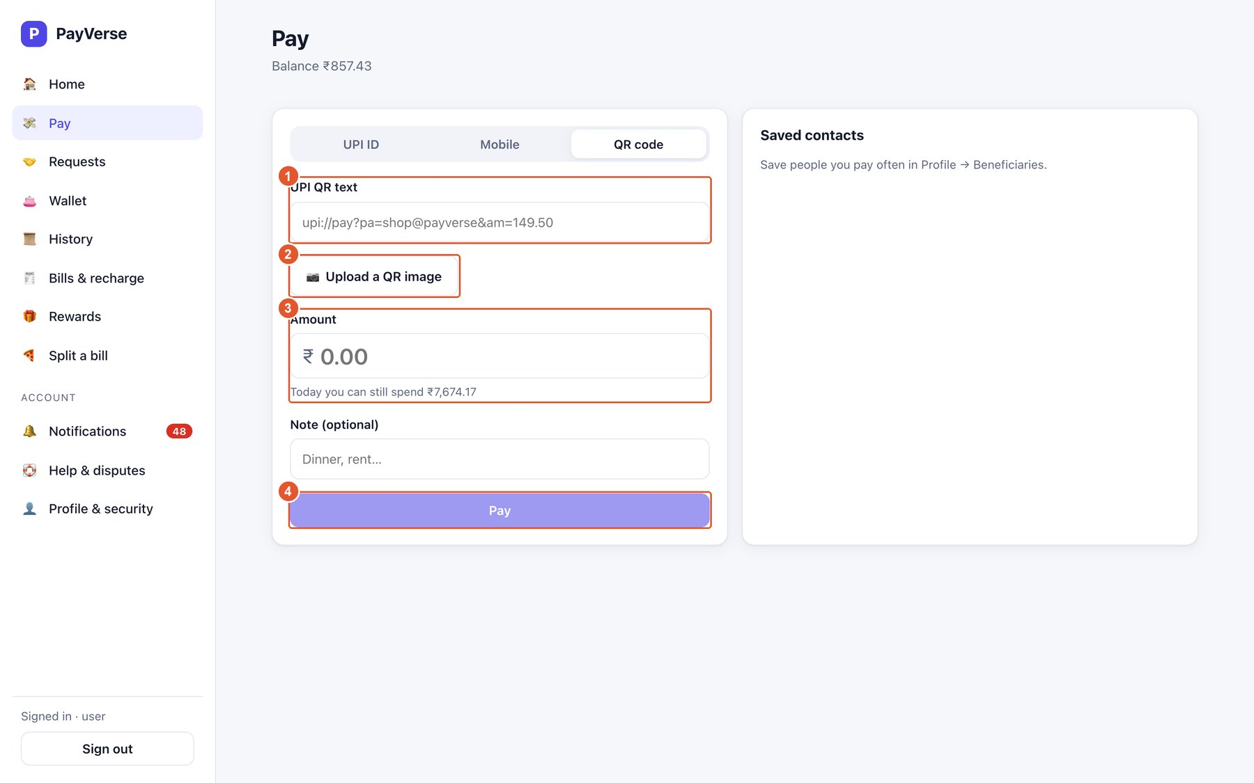
Figure 15. Pay — scan or upload a QR code
No. | Element | What it does
1 | UPI QR text | Paste the upi://pay?… link from a QR code; the payee (and, for a dynamic QR, the fixed amount) is read from it.
2 | Upload a QR image | Upload a photo or screenshot of the QR instead; it is decoded for you.
3 | Amount | Amount to pay (filled in and locked for a dynamic QR).
4 | Pay | Opens the PIN prompt.

A5. Requests and splits

Requests — asked of me
Money requests from PayVerse users and UPI collect requests waiting for you.
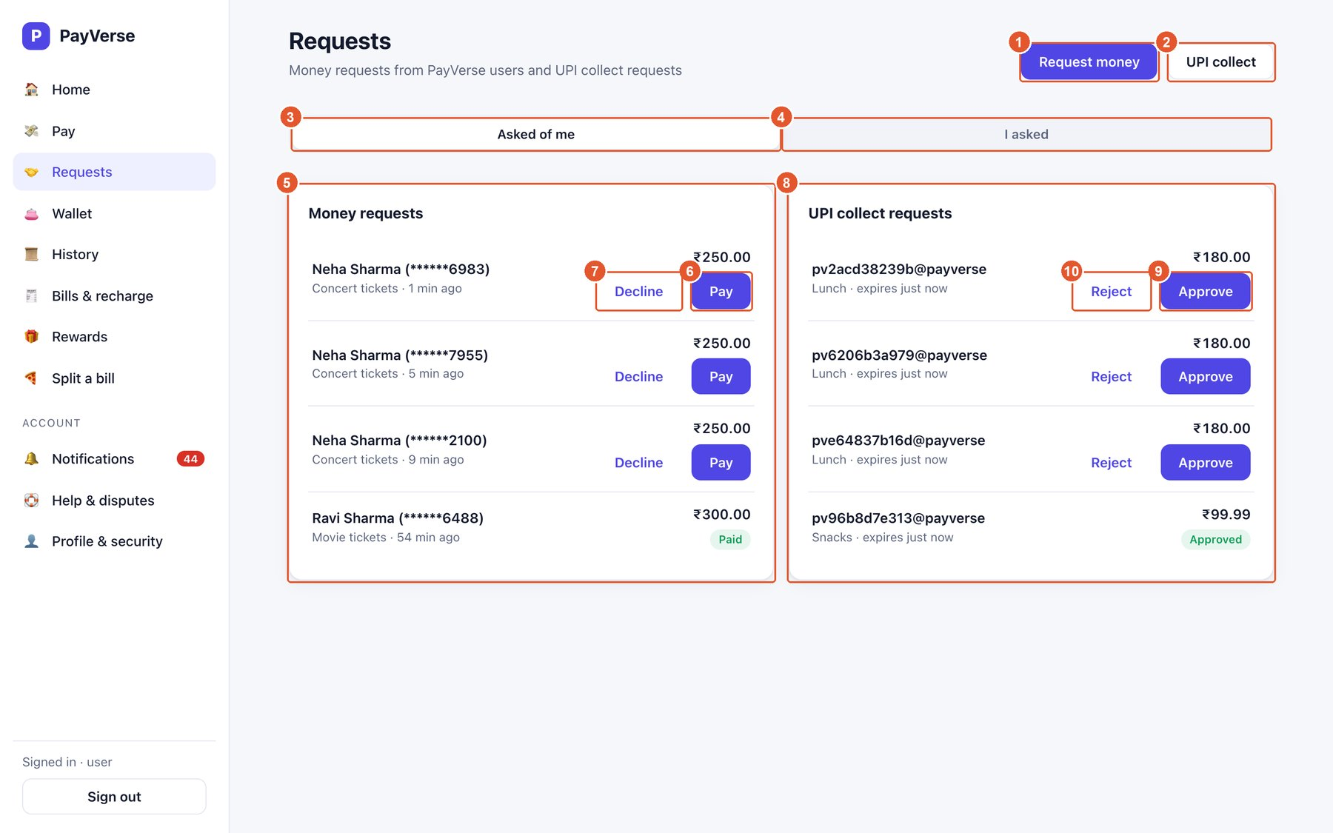
Figure 16. Requests — asked of me
No. | Element | What it does
1 | Request money | Ask someone to pay you (by UPI ID or mobile).
2 | UPI collect | Send a UPI collect request to a UPI ID.
3 | Asked of me | Requests you need to pay or decline (this tab).
4 | I asked | Requests you sent; cancel them while pending.
5 | Money requests | Who is asking, how much and why.
6 | Pay | Pay the request (PIN required).
7 | Decline | Refuse the request.
8 | UPI collect requests | Collect requests from UPI IDs; they expire after 24 hours.
9 | Approve | Pay the collect request (PIN required).
10 | Reject | Refuse it.

Request money
Ask a PayVerse user to pay you. They see it under Requests → Asked of me and get a notification.
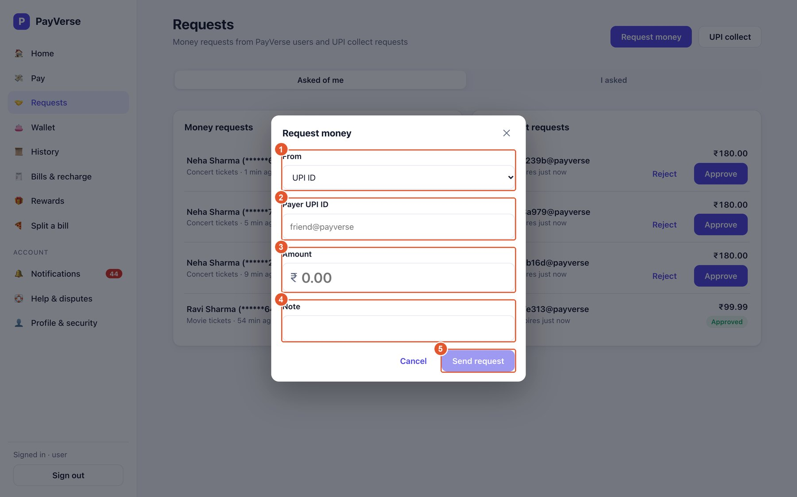
Figure 17. Request money
No. | Element | What it does
1 | Ask by | UPI ID or mobile number.
2 | Payer | Who should pay you.
3 | Amount | How much you are asking for.
4 | Note | Why — e.g. Cab share.
5 | Send request | Sends it. Requests expire after 7 days.

Split a bill
Share a cost: everyone else receives a money request for their share.
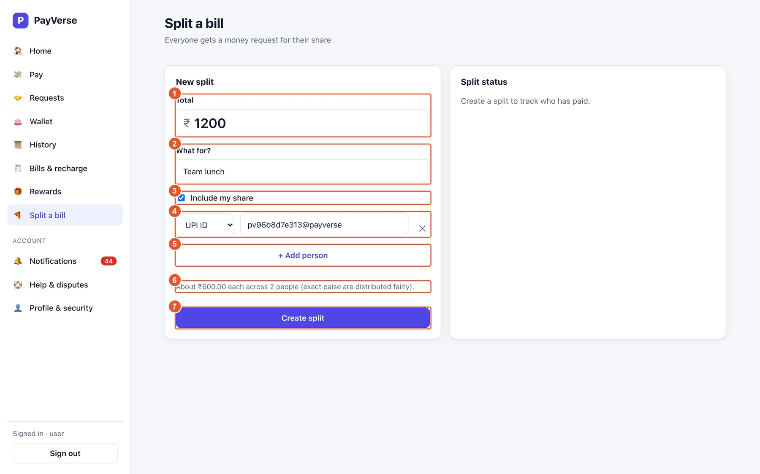
Figure 18. Split a bill
No. | Element | What it does
1 | Total | The full bill.
2 | What for? | Shown to everyone in the request.
3 | Include my share | Tick if you are part of the split (you pay your share yourself).
4 | Participant | Each person by UPI ID or mobile; ✕ removes a row.
5 | Add person | Adds another participant.
6 | Share preview | Each person's share; paise are distributed fairly.
7 | Create split | Sends the requests. The status card on the right tracks who has paid.

A6. Bills and recharge

Pay a bill
Pay mobile, electricity, DTH, FASTag and credit-card bills from your wallet.
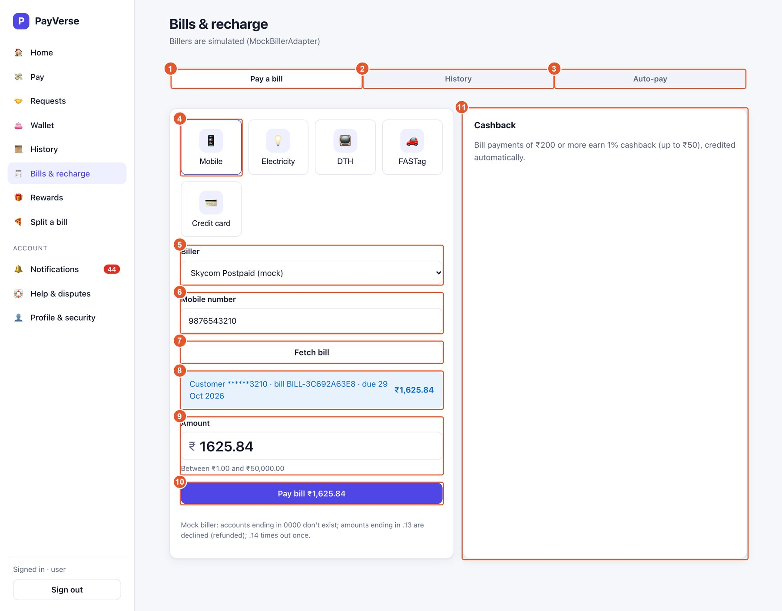
Figure 19. Pay a bill
No. | Element | What it does
1 | Pay a bill | This tab.
2 | History | Bills you paid, with status and refunds.
3 | Auto-pay | Recurring automatic payments.
4 | Category | Choose the bill type.
5 | Biller | The company to pay.
6 | Account / consumer number | Your number with the biller; it is checked against the biller's format.
7 | Fetch bill | Gets the amount due and due date (for billers that support it).
8 | Bill details | Customer name, bill number, due date and amount due.
9 | Amount | Pre-filled with the amount due; editable within the biller's limits.
10 | Pay bill | Pay from the wallet (PIN required).
11 | Cashback info | Bill payments of ₹200+ earn 1% cashback (up to ₹50).

Note: Test environment: account numbers ending 0000 are unknown; amounts ending .13 are declined and refunded.

Bill history
Every bill payment with its status. Failed payments show the refund.
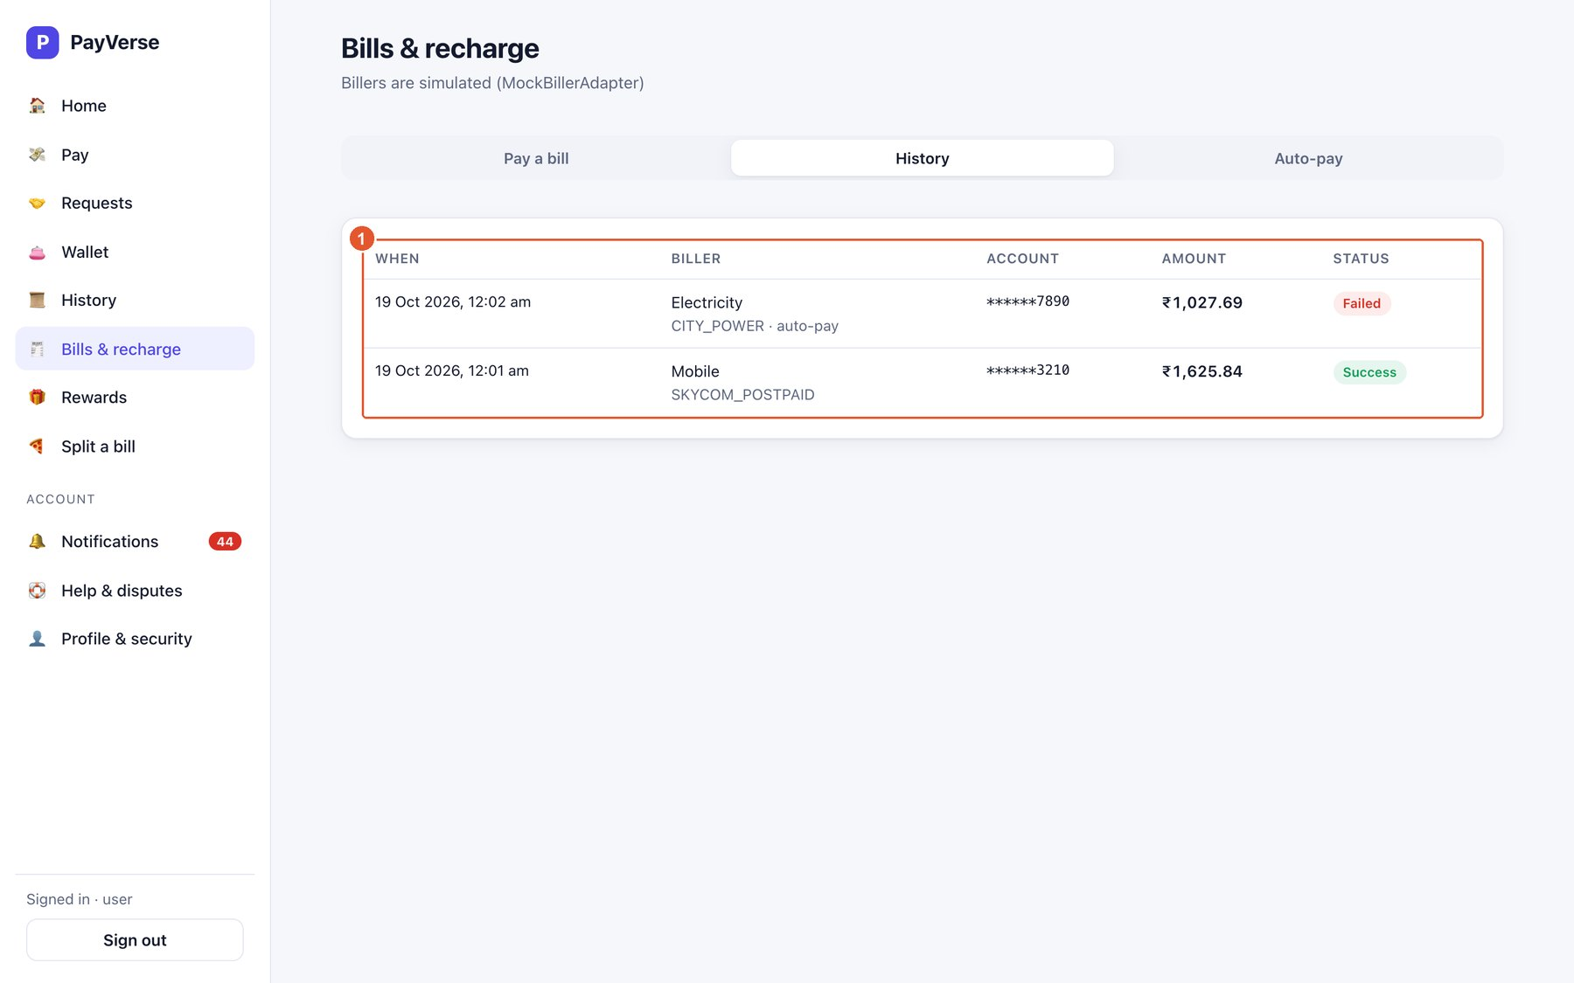
Figure 20. Bill history
No. | Element | What it does
1 | Payments | Date, biller, account (masked), amount, status and biller reference.

Auto-pay
Bills that are paid automatically every week or month, never above your limit.
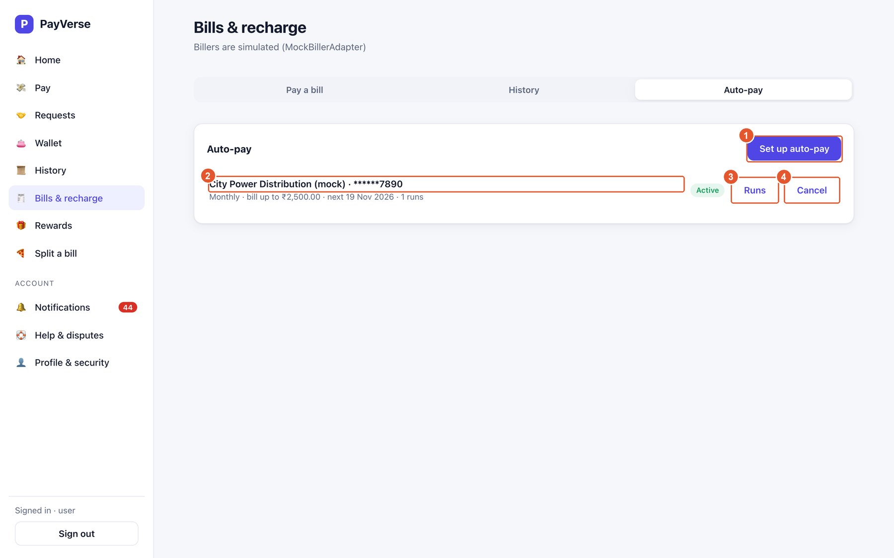
Figure 21. Auto-pay
No. | Element | What it does
1 | Set up auto-pay | Create a new mandate.
2 | Mandate | Biller, account, frequency, limit, next run date and number of runs.
3 | Runs | Every execution with its result (paid, skipped above limit, failed).
4 | Cancel | Stops future payments.

Set up auto-pay
Authorising with your PIN is your consent for the future automatic payments.
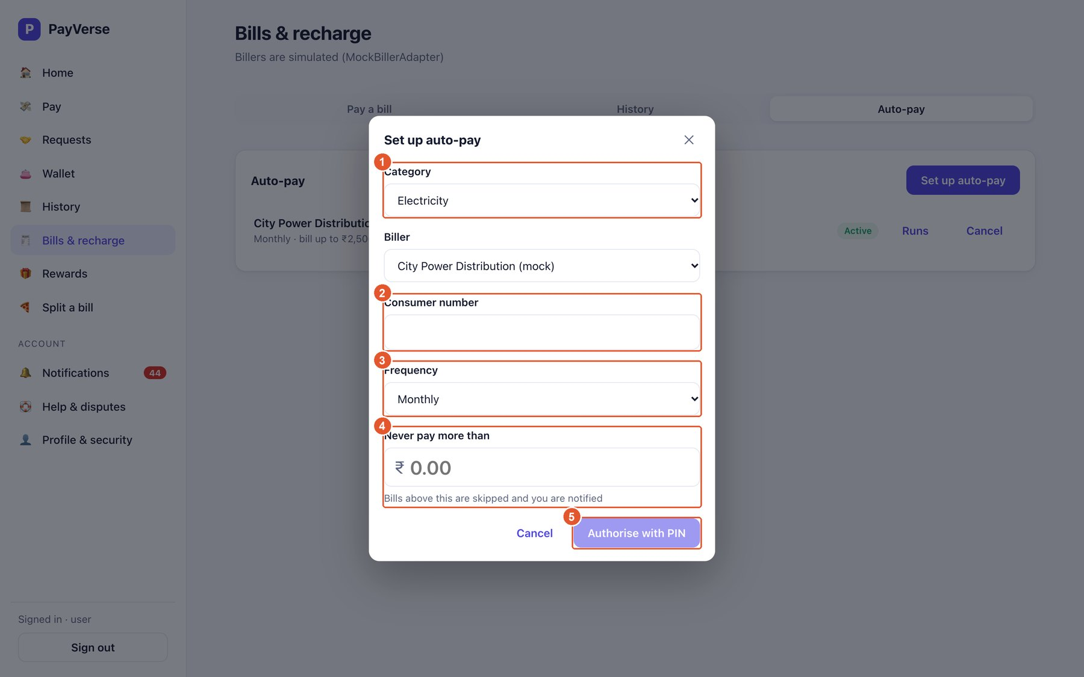
Figure 22. Set up auto-pay
No. | Element | What it does
1 | Category and biller | What to pay.
2 | Account number | Validated against the biller's format; an error explains what is wrong.
3 | Frequency | Monthly or weekly.
4 | Limit | Bills above this are skipped and you are notified.
5 | Authorise with PIN | Creates the mandate after PIN approval.

A7. Rewards

Rewards
Cashback, scratch cards, coupons and referrals. Cashback is credited straight to your wallet.
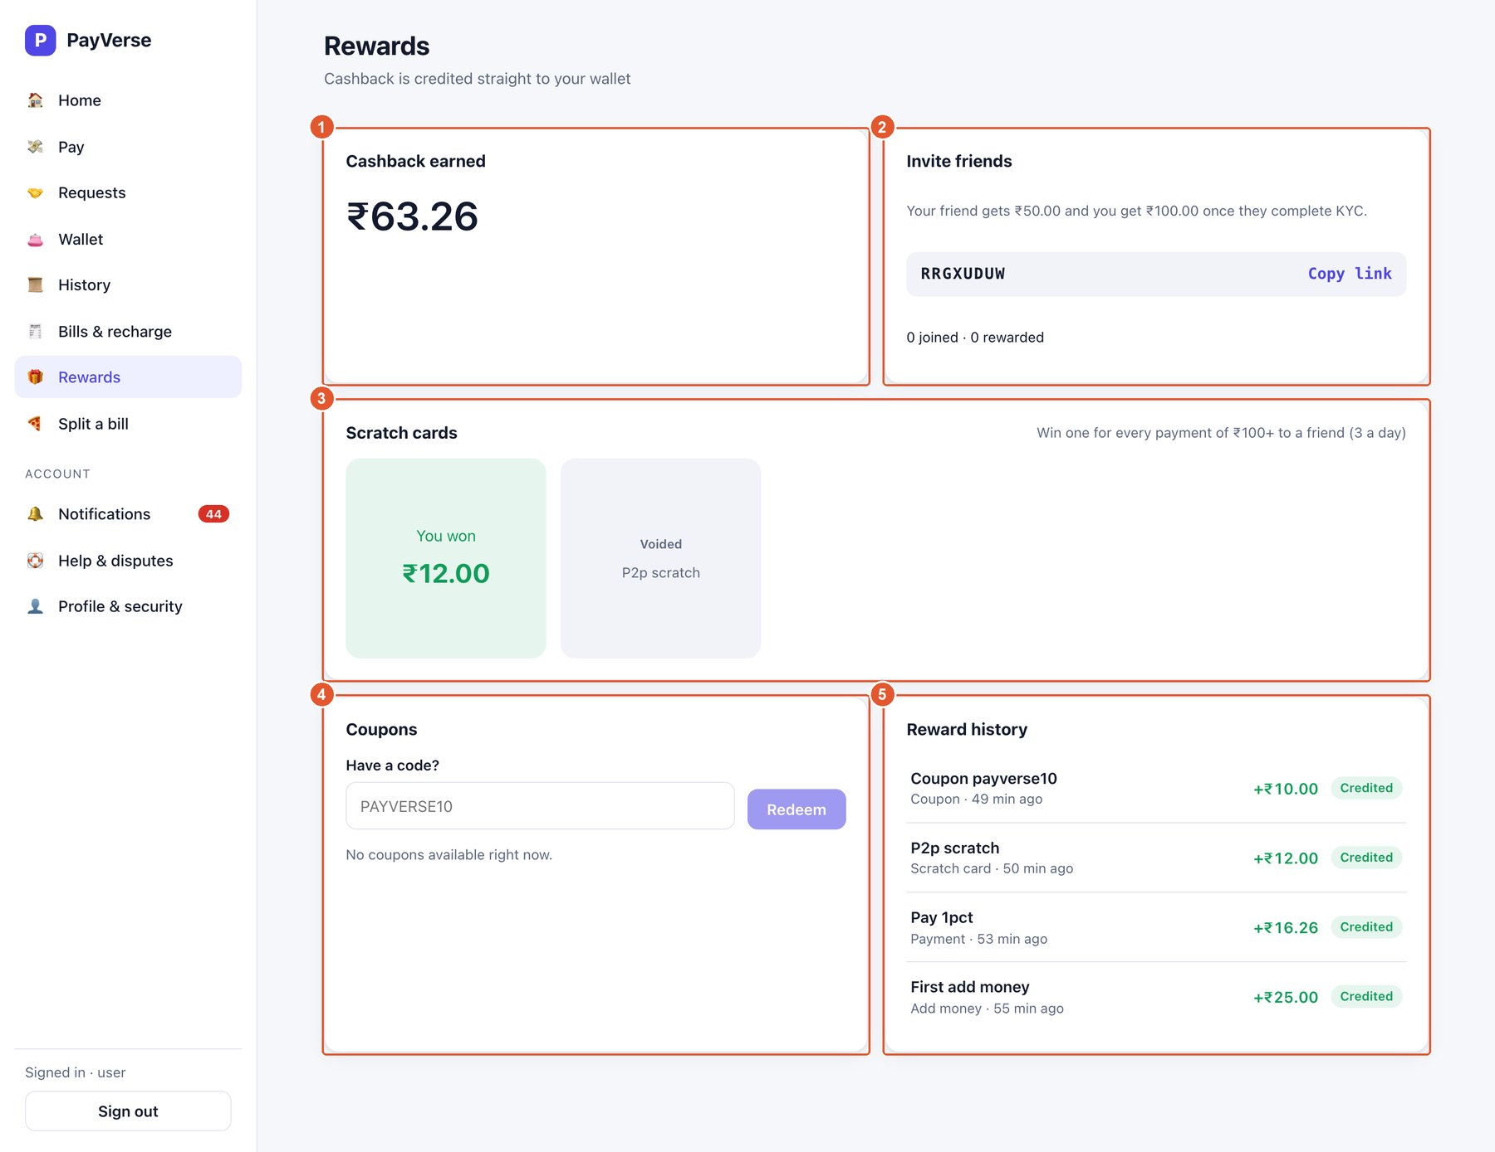
Figure 23. Rewards
No. | Element | What it does
1 | Cashback earned | Total credited, plus anything still pending.
2 | Invite friends | Your referral code; “Copy link” copies an invite link. You earn ₹100 and your friend ₹50 when they complete KYC.
3 | Scratch cards | Won for payments of ₹100+ to friends. Tap a card to scratch it; each has an expiry date.
4 | Coupons | Type a coupon code and press Redeem; available coupons are listed below.
5 | Reward history | Every reward with its status (Pending credit, Credited).

A8. History and help

History
All transfers you sent and received, with filters.
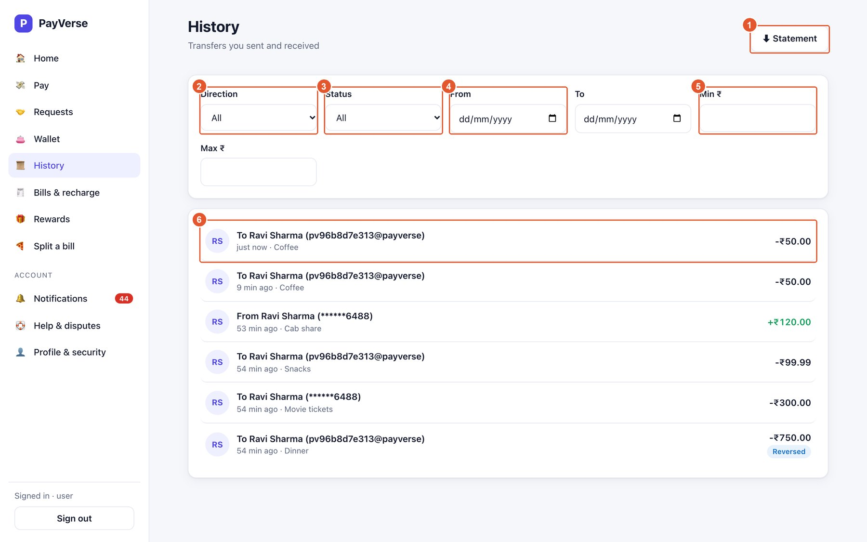
Figure 24. History
No. | Element | What it does
1 | Statement | Download a CSV or PDF statement for a date range.
2 | Direction | All, Sent or Received.
3 | Status | Success, Pending, Failed, Reversed.
4 | From / To | Date range.
5 | Min / Max ₹ | Amount range.
6 | Transaction | Click any row to see full details. A Reversed badge means the payment was refunded.

Transaction details
Everything about one payment, including each status change.
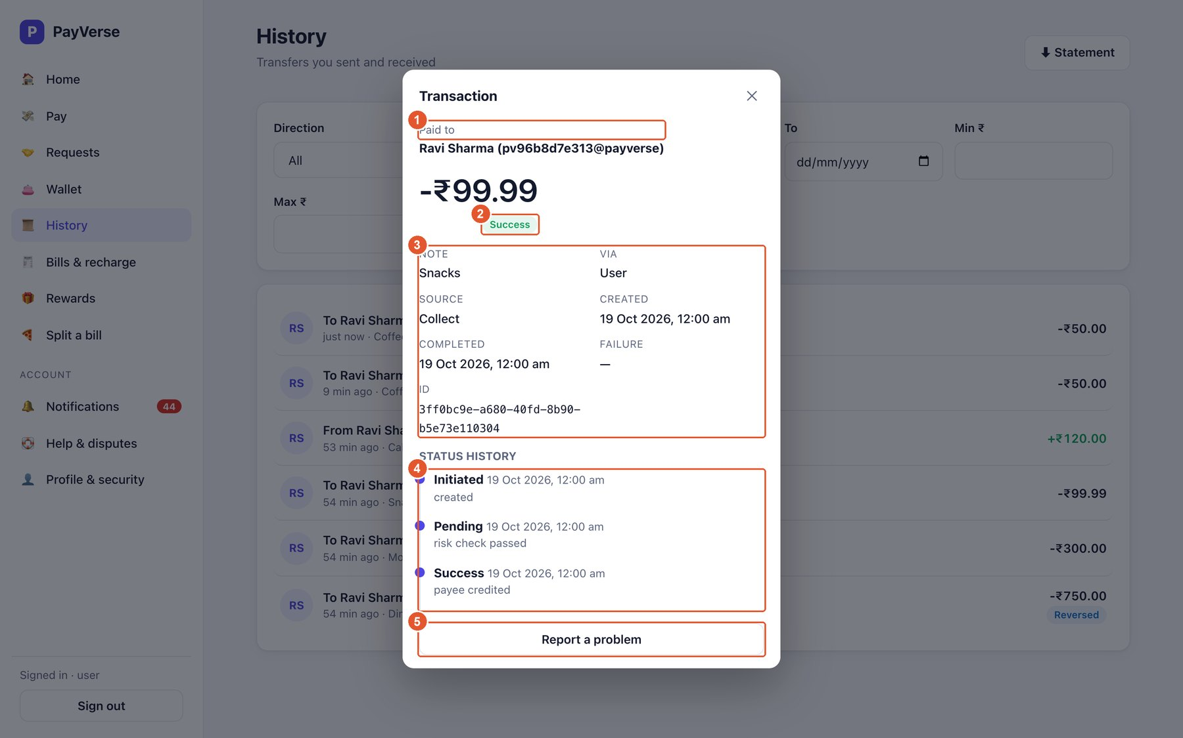
Figure 25. Transaction details
No. | Element | What it does
1 | Counterparty | Who you paid or who paid you.
2 | Status | Current status of the payment.
3 | Details | Note, method, source, times, failure reason and the transaction ID.
4 | Status history | Each step: Initiated → Pending (risk check) → Success (or Failed / Reversed).
5 | Report a problem | Raise a dispute about this payment (only for successful payments).

Download a statement
Statements are generated for the dates you choose.
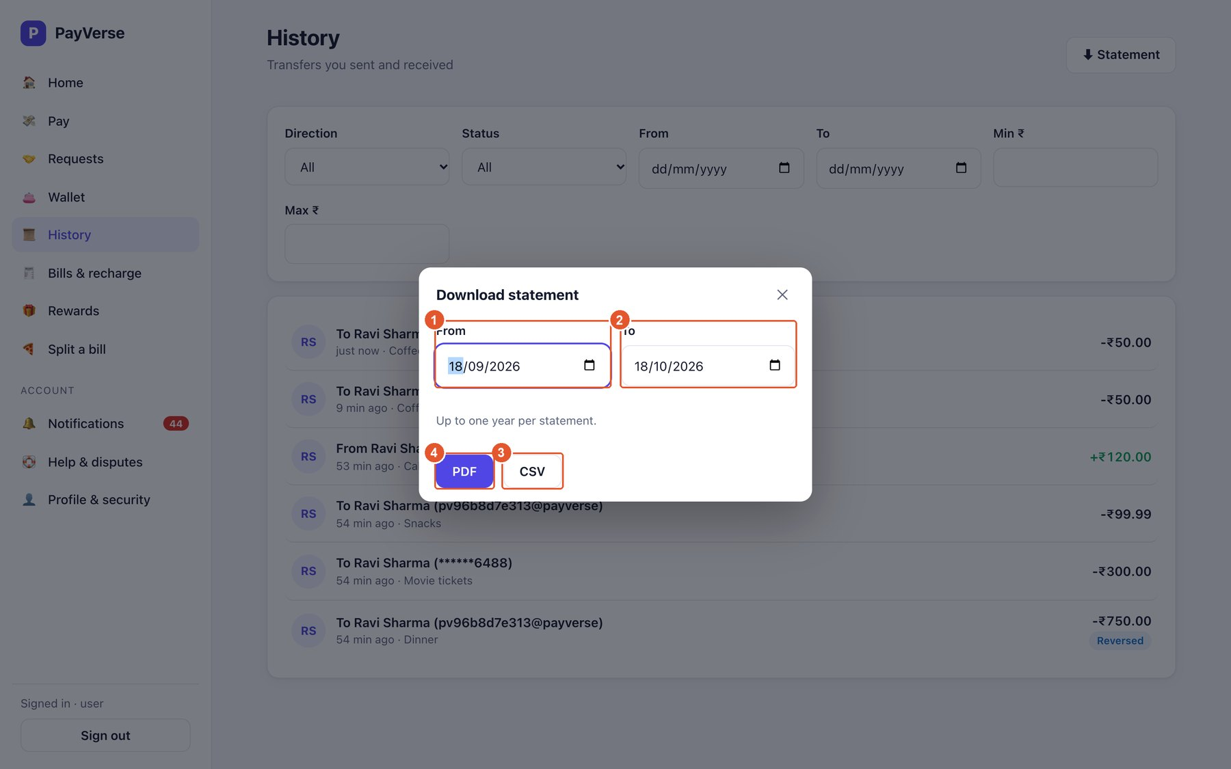
Figure 26. Download a statement
No. | Element | What it does
1 | From | Start date (default: 30 days ago).
2 | To | End date.
3 | CSV | Spreadsheet download.
4 | PDF | Printable statement.

Raise a dispute
Tell us what went wrong; the support team reviews it and can refund the payment.
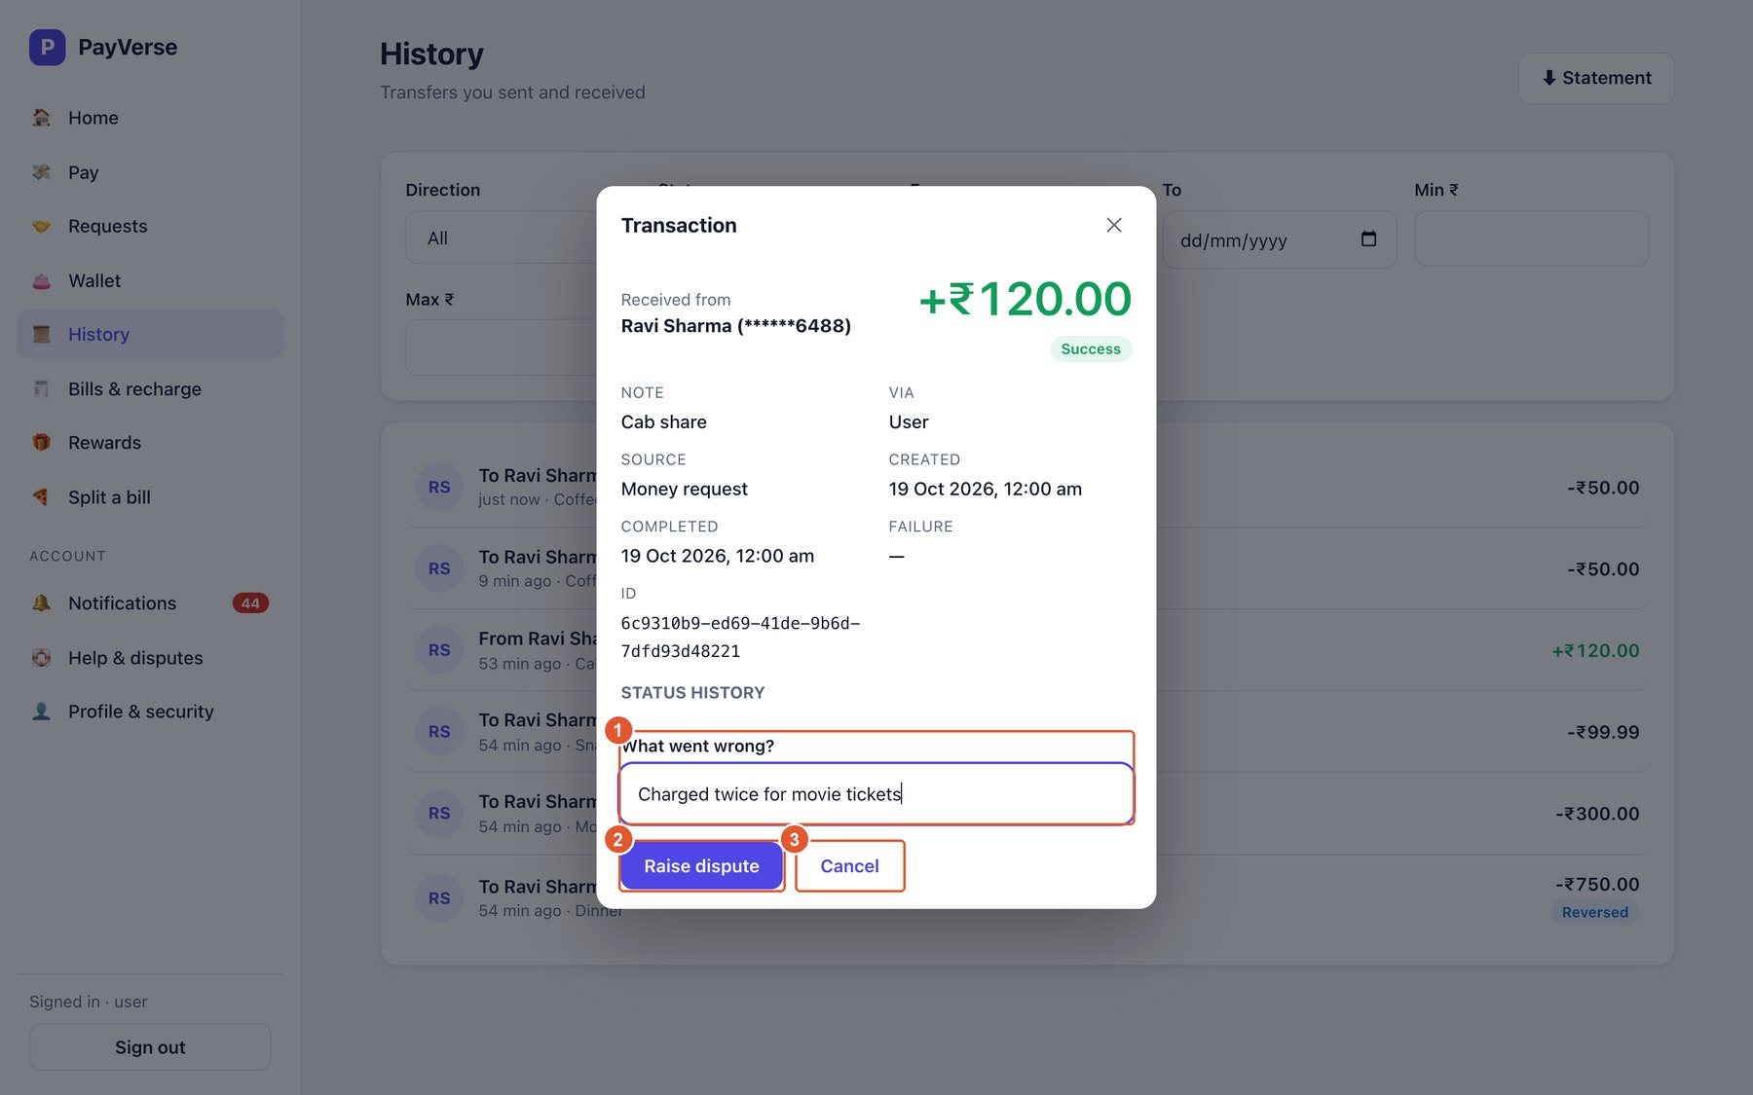
Figure 27. Raise a dispute
No. | Element | What it does
1 | What went wrong? | Describe the problem (at least 5 characters).
2 | Raise dispute | Submits it; track it under Help & disputes.
3 | Cancel | Close without raising.

Help & disputes
Your disputes and their progress.
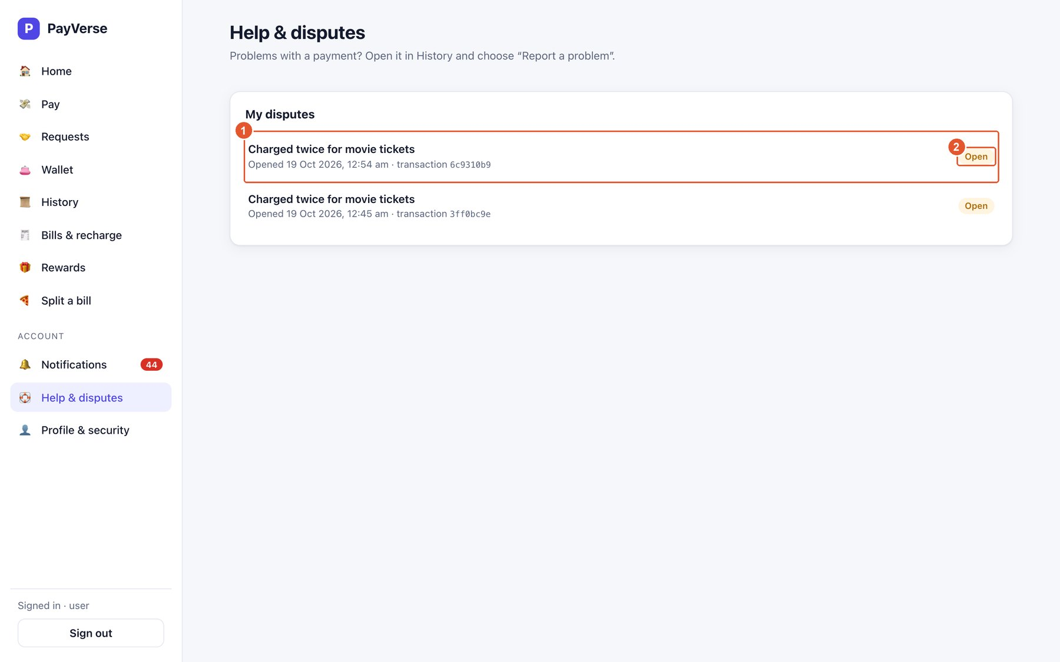
Figure 28. Help & disputes
No. | Element | What it does
1 | Dispute | Your description, when it was opened and the transaction it concerns.
2 | Status | Open → In review → Resolved (Refunded or Rejected).

Notifications
Messages about payments, cashback, KYC, bills and security.
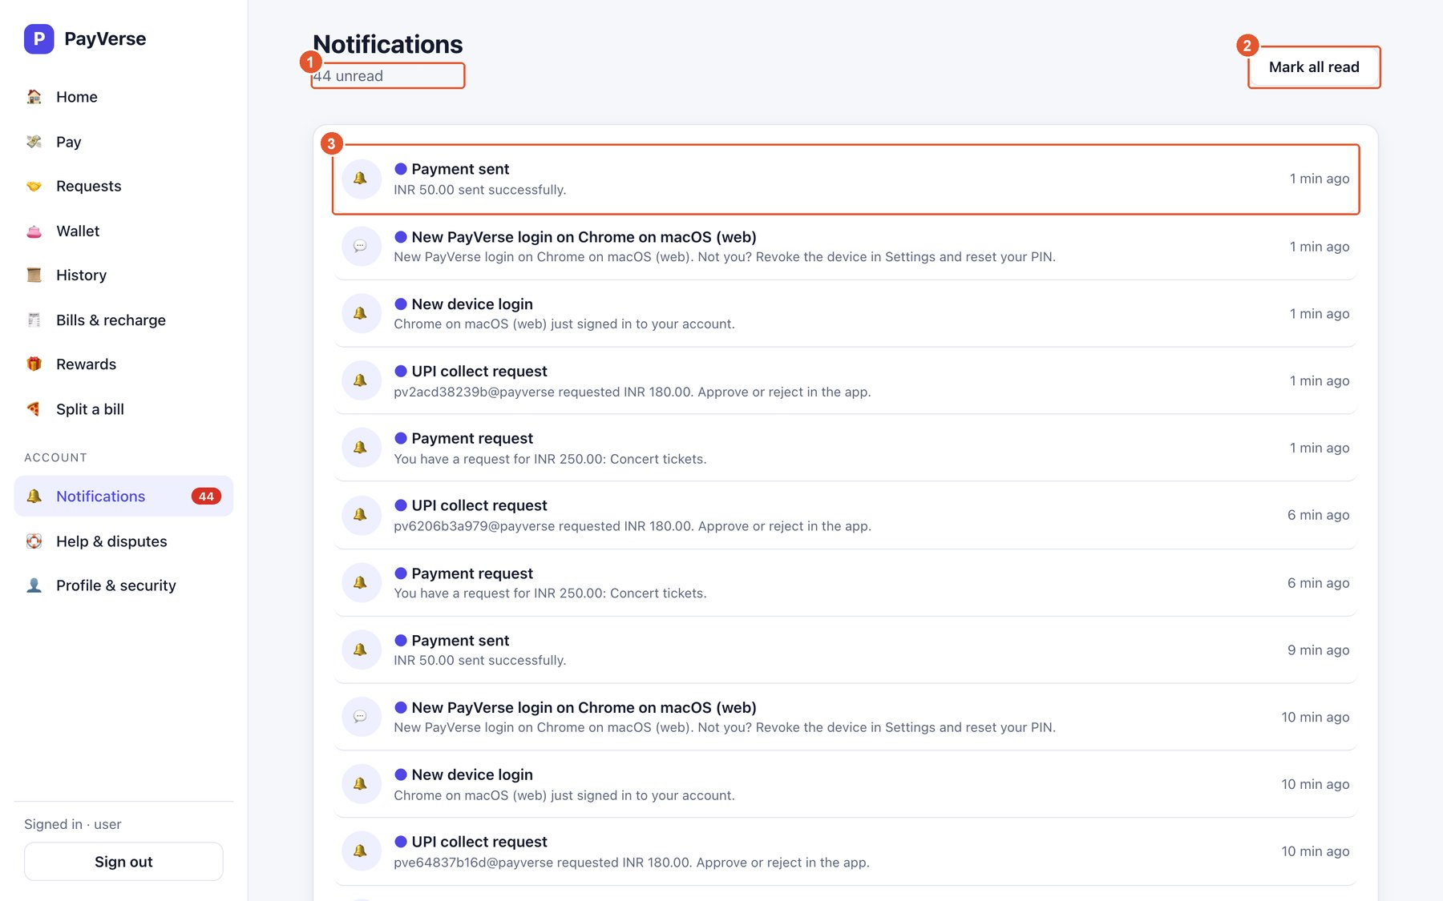
Figure 29. Notifications
No. | Element | What it does
1 | Unread count | How many messages you have not read.
2 | Mark all read | Marks everything as read.
3 | Notification | Title, message and time. Unread items have a dot; click to mark one as read.

A9. Profile and security

Profile
Your personal details and account information.
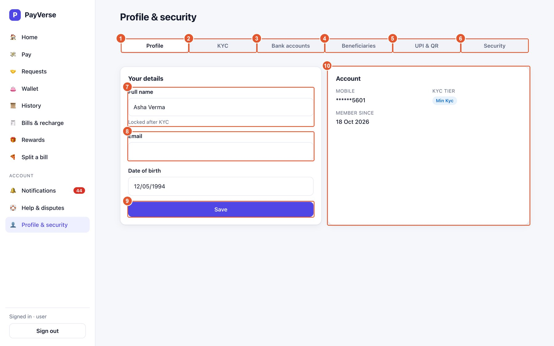
Figure 30. Profile
No. | Element | What it does
1 | Profile tab | This tab.
2 | KYC | Verification level and upgrades.
3 | Bank accounts | Link accounts for withdrawals.
4 | Beneficiaries | Saved contacts.
5 | UPI & QR | UPI IDs and QR codes.
6 | Security | PIN and devices.
7 | Full name | Locked after KYC.
8 | Email | Optional; used for email notifications.
9 | Save | Saves your changes.
10 | Account | Masked mobile, KYC tier and member-since date.

KYC
Your verification level decides your limits. Upgrade to Full KYC with Aadhaar for higher limits.
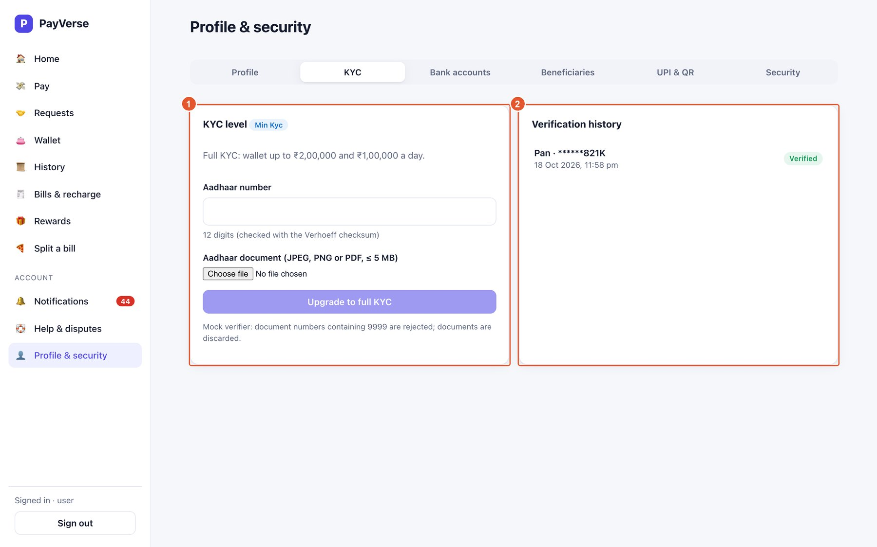
Figure 31. KYC
No. | Element | What it does
1 | Current level | Your tier and verification history.
2 | Upgrade | Full KYC: Aadhaar number plus a document image upload, then Verify.

Bank accounts
Accounts you can withdraw to (up to 5).
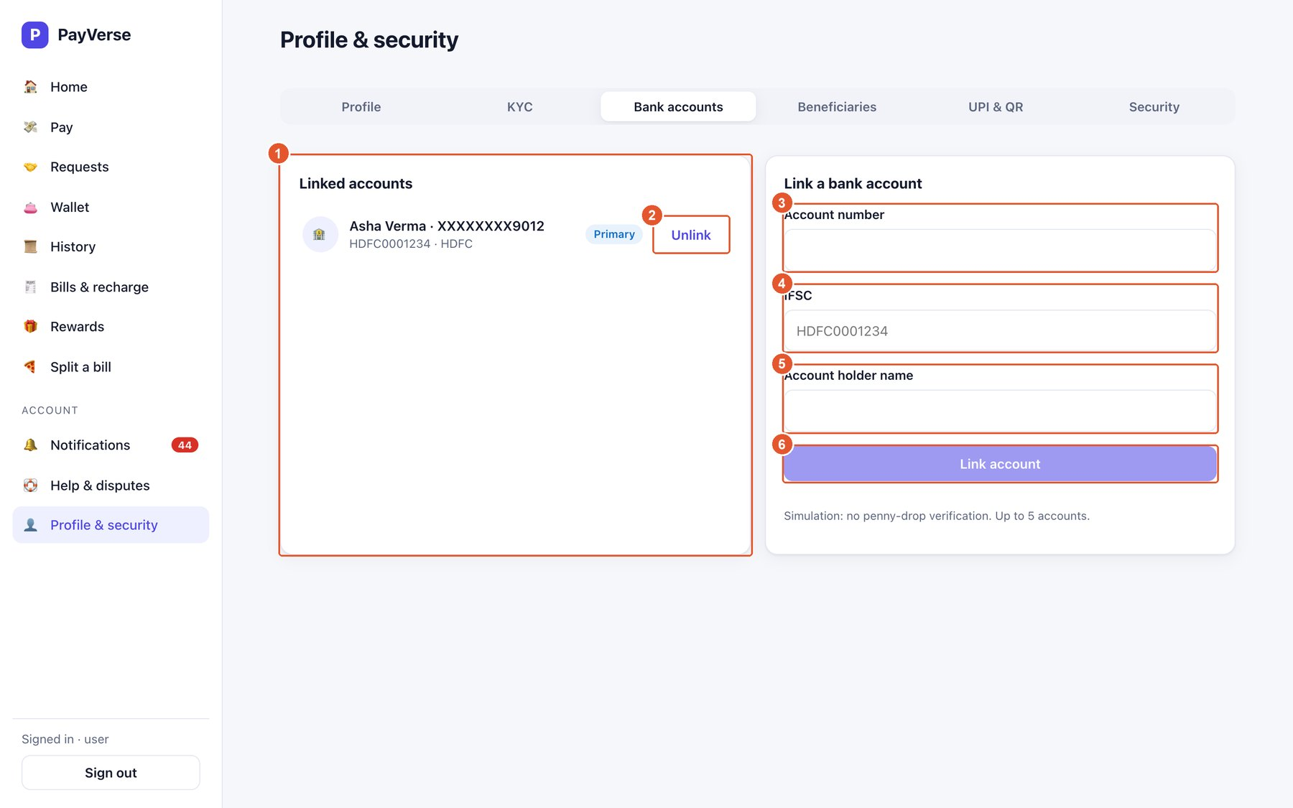
Figure 32. Bank accounts
No. | Element | What it does
1 | Linked accounts | Masked account numbers; the Primary one is pre-selected for withdrawals.
2 | Unlink | Removes an account.
3 | Account number | 9–18 digits.
4 | IFSC | The branch code, e.g. HDFC0001234.
5 | Account holder name | As on the bank account.
6 | Link account | Adds the account.

Beneficiaries (saved contacts)
Save people you pay often; they appear on the Pay screen.
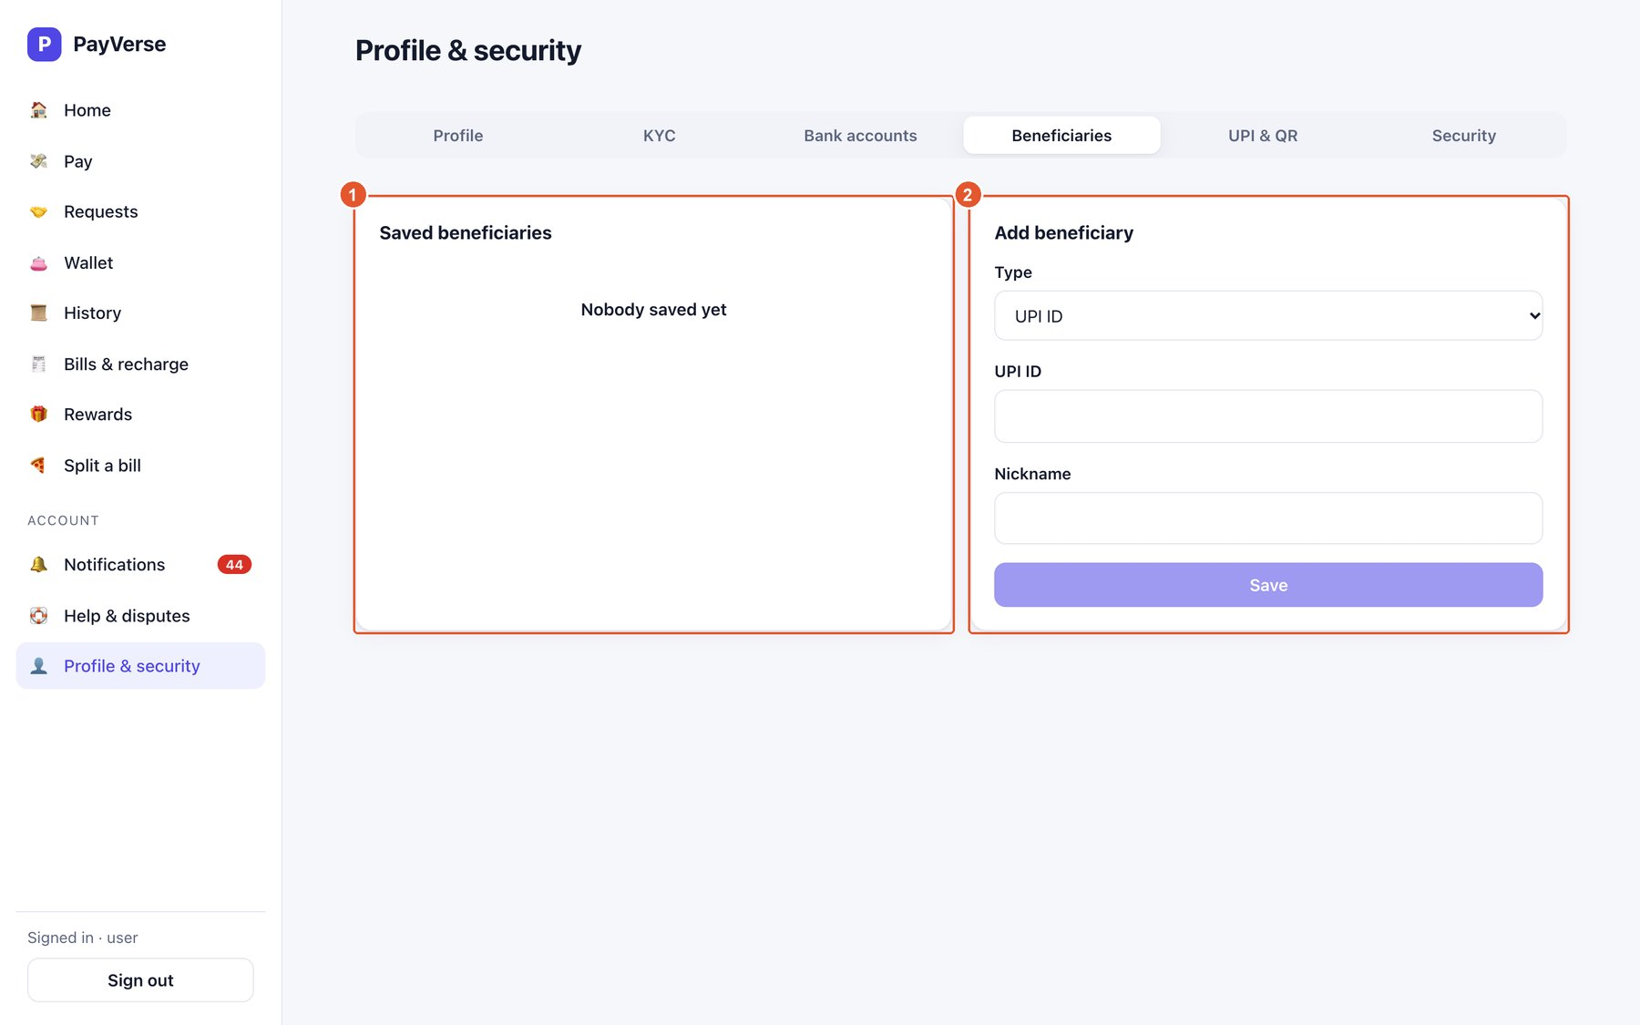
Figure 33. Beneficiaries (saved contacts)
No. | Element | What it does
1 | Saved contacts | Your saved contacts; remove any you no longer need.
2 | Add a contact | Choose UPI ID, mobile or bank account, enter the details and a nickname, then save.

UPI IDs and QR codes
Manage how people pay you.
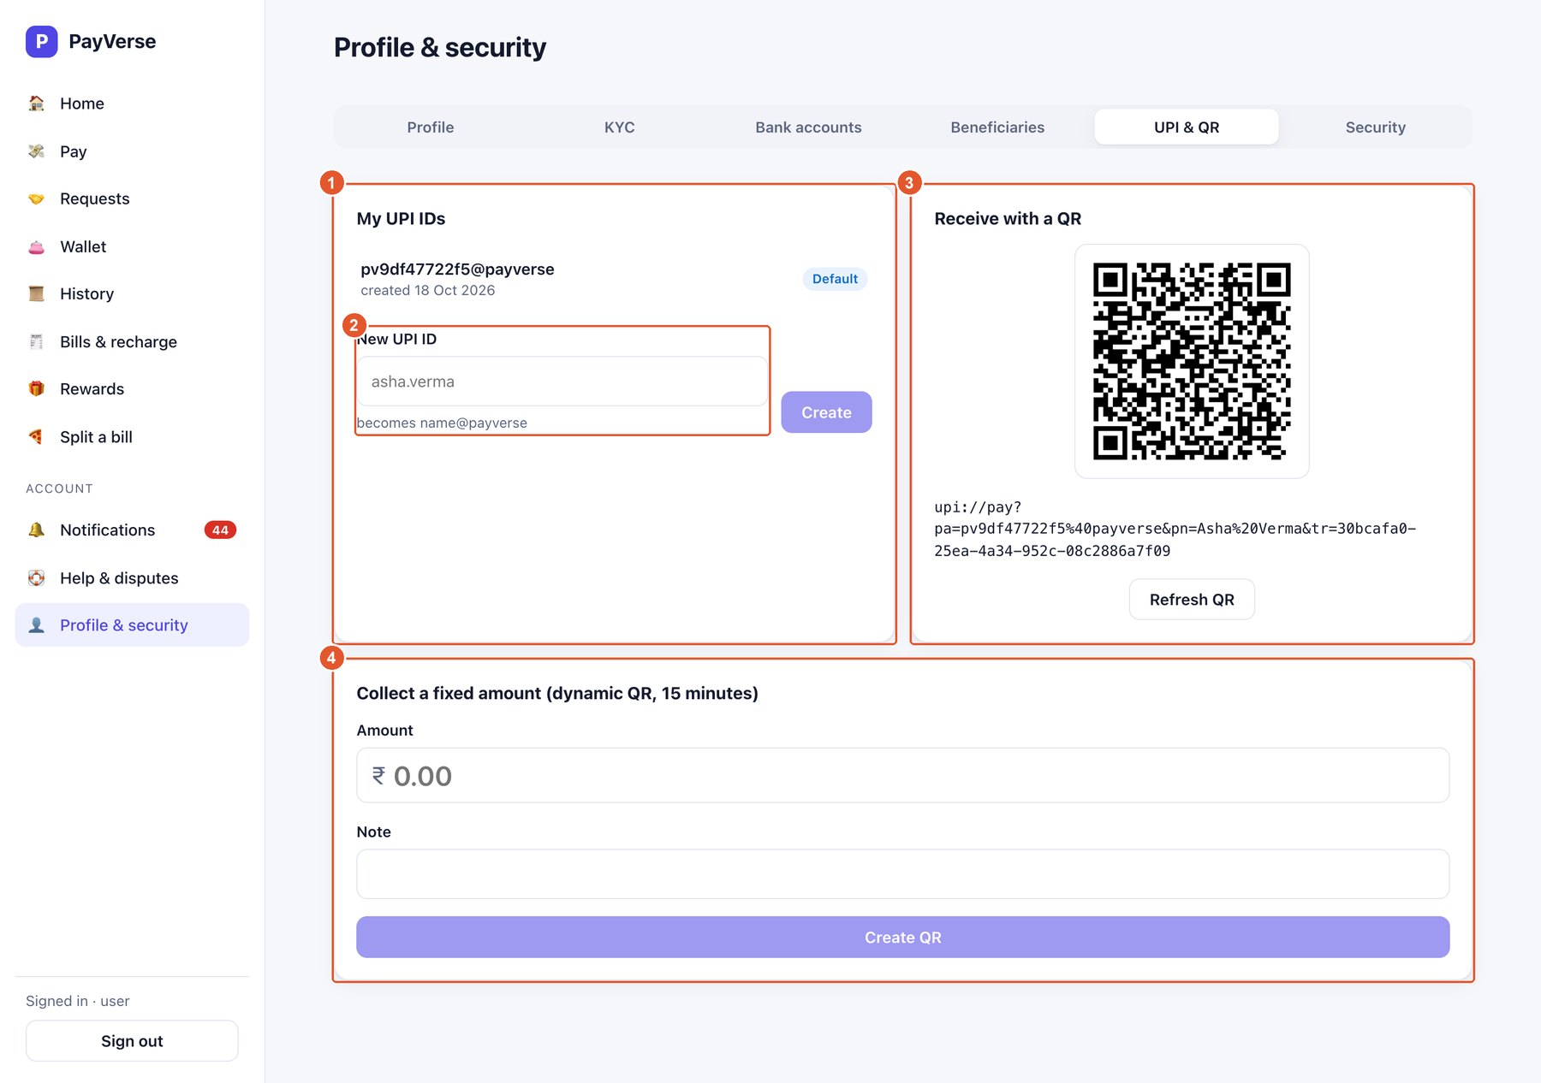
Figure 34. UPI IDs and QR codes
No. | Element | What it does
1 | My UPI IDs | Your UPI IDs; the Default one is shown on Home.
2 | New UPI ID | Create another (it becomes name@payverse).
3 | Receive with a QR | Your static QR code; anyone can scan it to pay you. Refresh QR regenerates the image.
4 | Dynamic QR | Create a QR for a fixed amount that expires in 15 minutes — ideal for shops.

Security
Change your PIN and control where you are signed in.
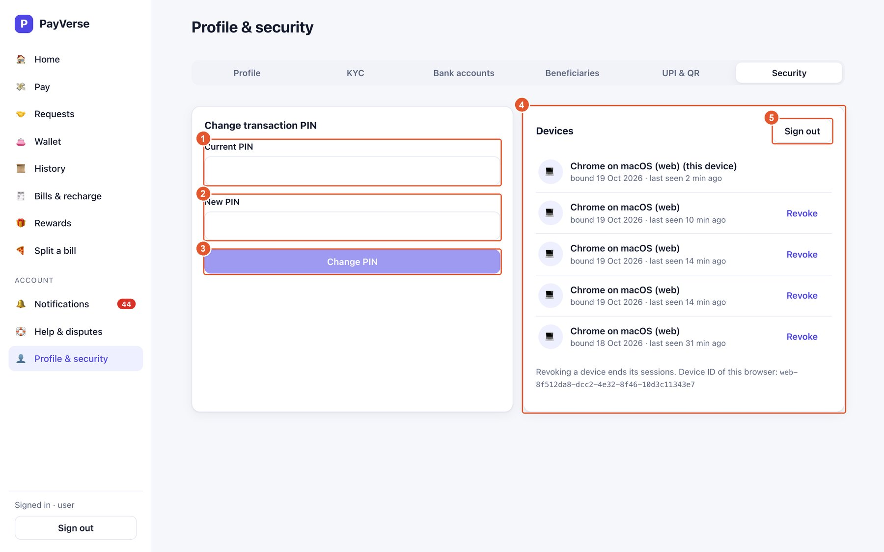
Figure 35. Security
No. | Element | What it does
1 | Current PIN | Your existing PIN.
2 | New PIN | The new 4- or 6-digit PIN.
3 | Change PIN | Saves the new PIN.
4 | Devices | Every device signed in to your account; this device is labelled.
5 | Sign out | Signs out of this device.

A10. Using PayVerse on a phone

Phone layout
PayVerse works in a phone browser. The menu moves to the bottom.
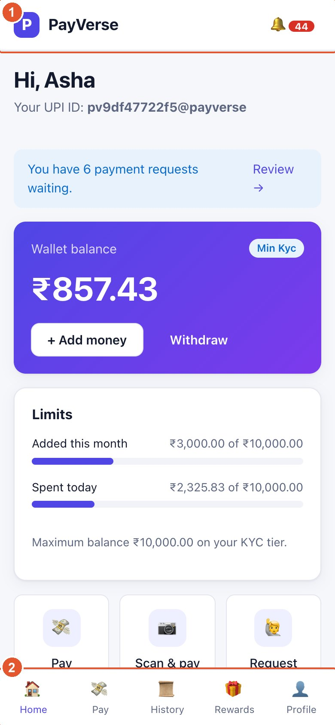
Figure 36. Phone layout
No. | Element | What it does
1 | Top bar | Logo and the notifications bell with the unread count.
2 | Bottom navigation | Home, Pay, History, Rewards and Profile.

Part B — Back office
The back office is visible only to staff accounts (ADMIN or SUPPORT). Staff sign in exactly like customers; the BACK OFFICE section then appears at the bottom of the menu. Every back-office action is recorded in the audit log. Refund approvals always need a second ADMIN (maker-checker).
Task | SUPPORT | ADMIN
View every back-office screen (users, disputes, refunds, risk, recon, rewards, templates, audit) | ✓ | ✓
Take and resolve disputes | ✓ | ✓
Request a refund | ✓ | ✓
Approve or reject a refund (never your own request) | — | ✓
Freeze / unfreeze a wallet | — | ✓
Resolve a fraud flag | ✓ (without freezing) | ✓ (can also freeze)
Tune risk rules | view | ✓
Run reconciliation jobs, resolve mismatches | view | ✓
Create cashback rules and coupons | view | ✓
Edit notification templates, replay dead letters | view | ✓
Rotate the token-signing key | — | ✓

Users
Back-office menu items appear for staff (ADMIN or SUPPORT). Find a customer and check their wallet.
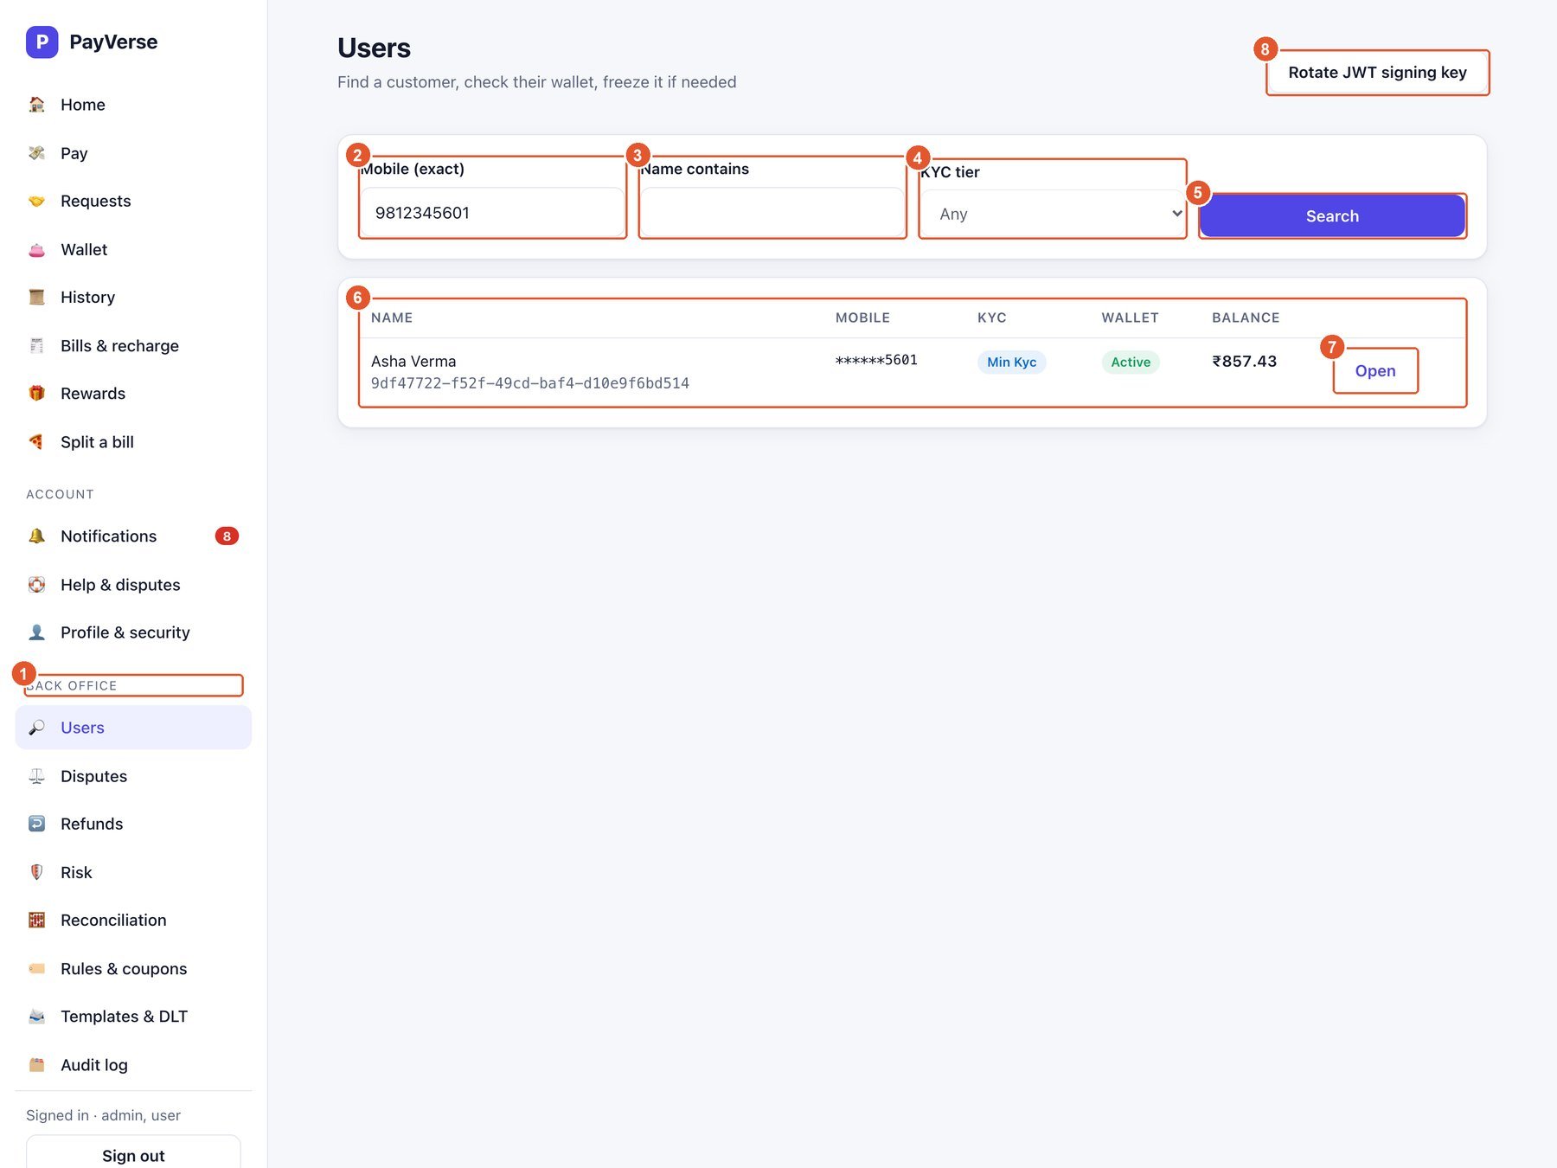
Figure 37. Users
No. | Element | What it does
1 | Back-office menu | Users, Disputes, Refunds, Risk, Reconciliation, Rules & coupons, Templates & DLT, Audit log.
2 | Mobile (exact) | Find one customer by full mobile number.
3 | Name contains | Search by part of the name.
4 | KYC tier | Filter by tier.
5 | Search | Runs the search.
6 | Results | Name, masked mobile, KYC tier, wallet status and balance.
7 | Open | Customer details and freeze/unfreeze.
8 | Rotate JWT signing key | ADMIN only: rotates the token-signing key (existing sessions keep working).

Customer details — freeze / unfreeze
Freezing stops a wallet from sending money (refunds and reversals still work). Every action is audited.
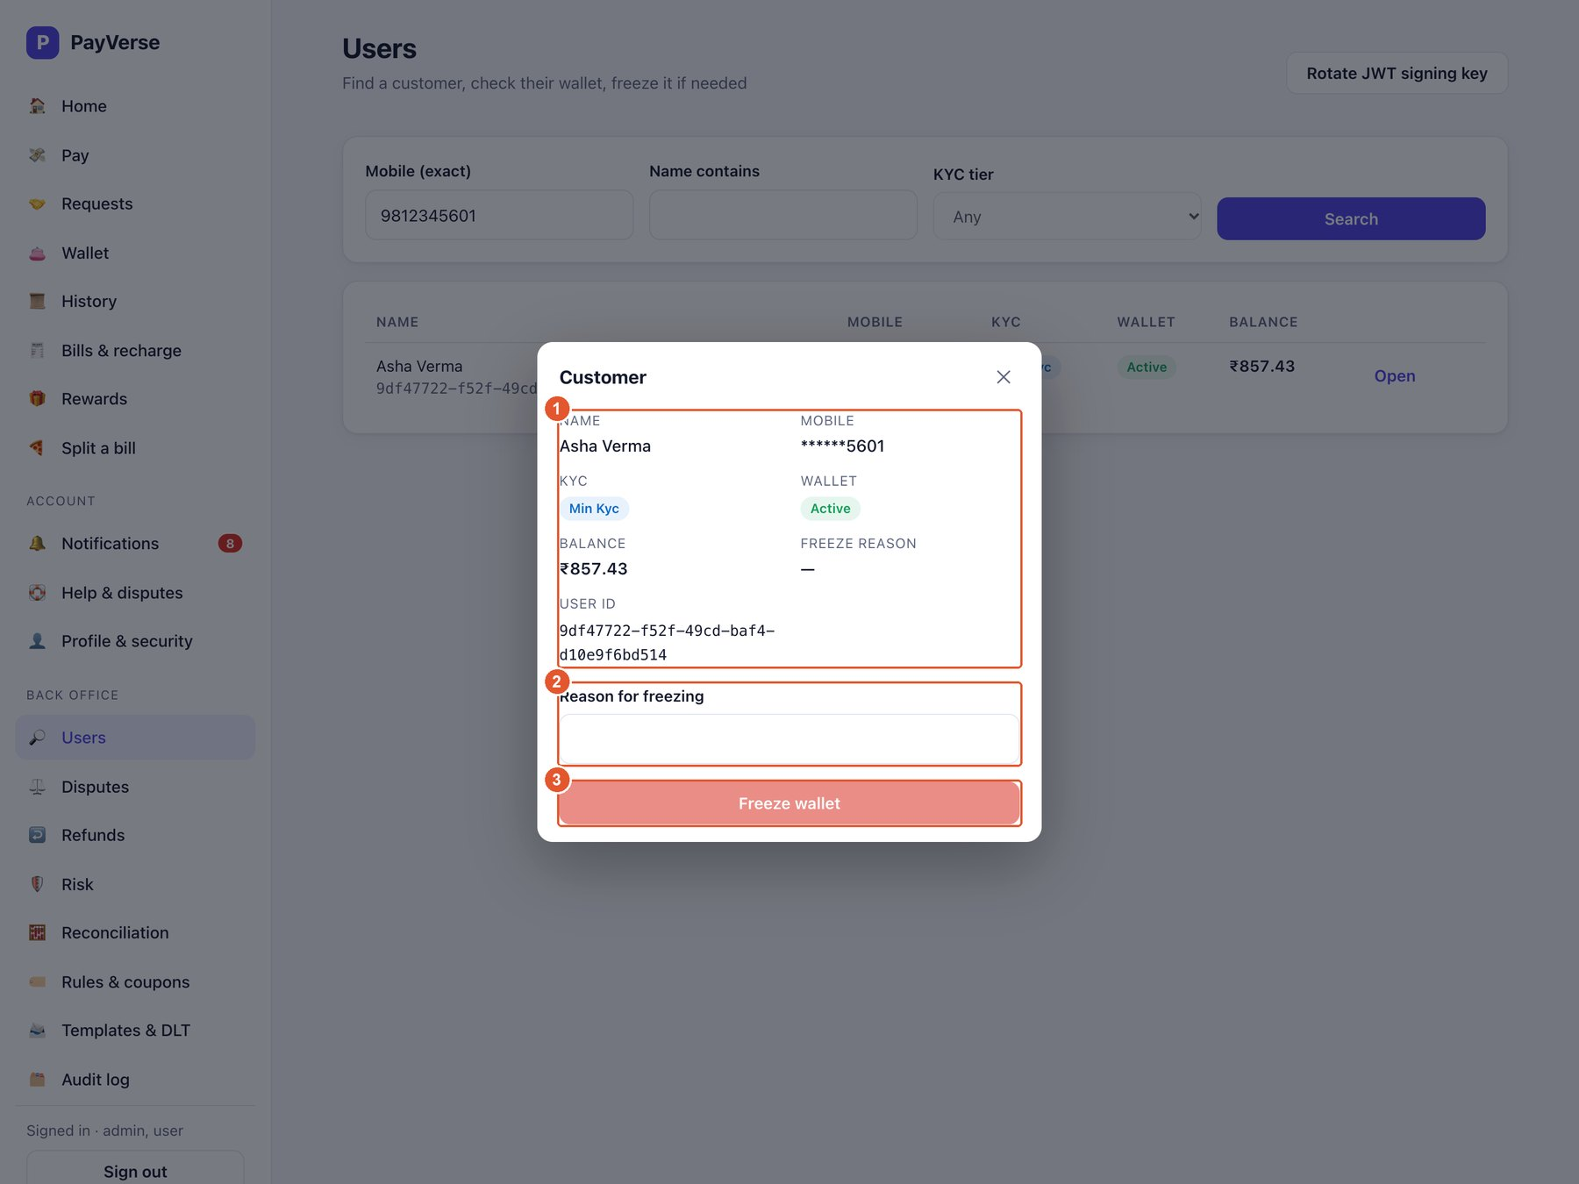
Figure 38. Customer details — freeze / unfreeze
No. | Element | What it does
1 | Customer | Name, mobile, KYC, wallet status, balance, freeze reason and user ID.
2 | Reason | Required; stored in the audit log.
3 | Freeze wallet | Freezes the wallet. When frozen this becomes “Unfreeze wallet”.

Tip: Freezing and unfreezing is available to ADMIN accounts only.

Disputes
Customer disputes waiting for review.
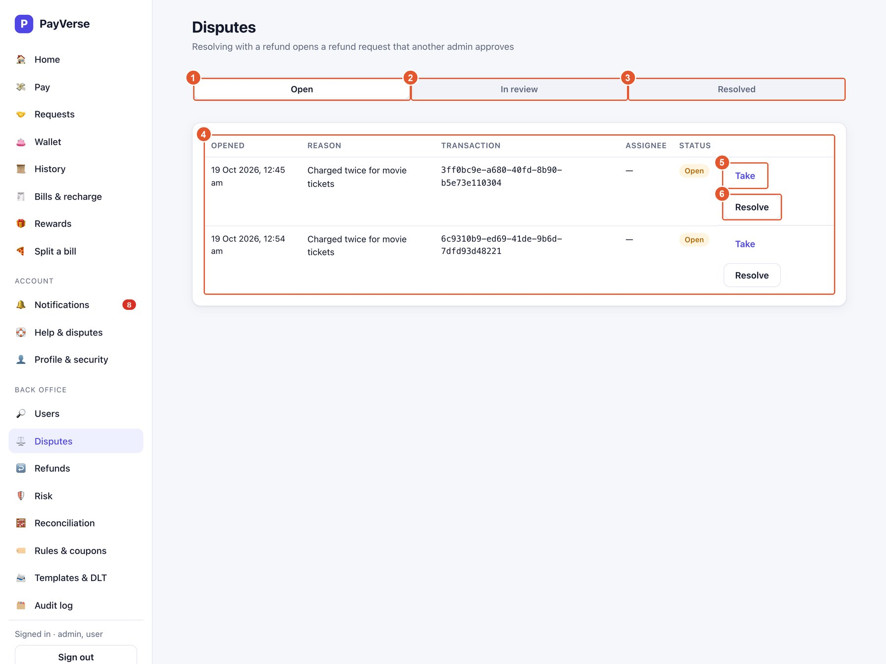
Figure 39. Disputes
No. | Element | What it does
1 | Open | New disputes.
2 | In review | Disputes someone has taken.
3 | Resolved | Finished disputes.
4 | Dispute | When, the customer's reason, transaction, assignee and status.
5 | Take | Assign the dispute to yourself (moves it to In review).
6 | Resolve | Close it with a refund or a rejection.

Resolve a dispute
Choosing Refund creates a refund request that a different admin must approve.
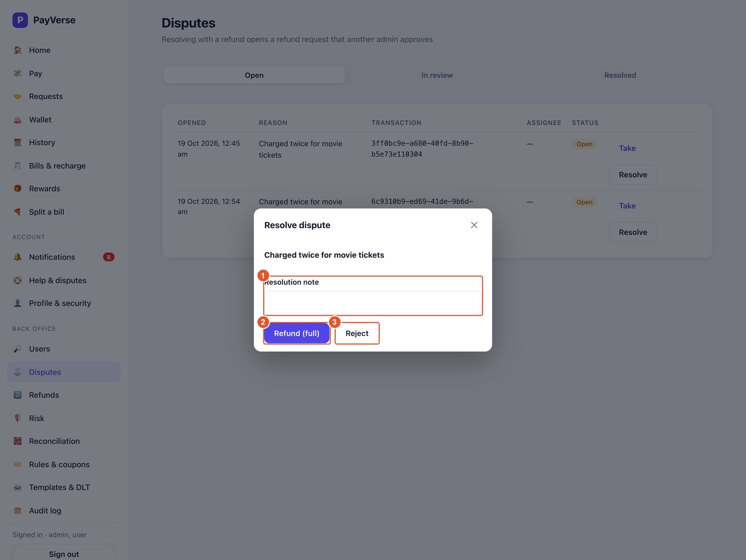
Figure 40. Resolve a dispute
No. | Element | What it does
1 | Resolution note | Explain the decision (kept in the audit log).
2 | Refund (full) | Creates a full refund request (maker step).
3 | Reject | Closes the dispute without a refund.

Refunds (maker-checker)
Anyone in the team can request a refund; a different admin approves it.
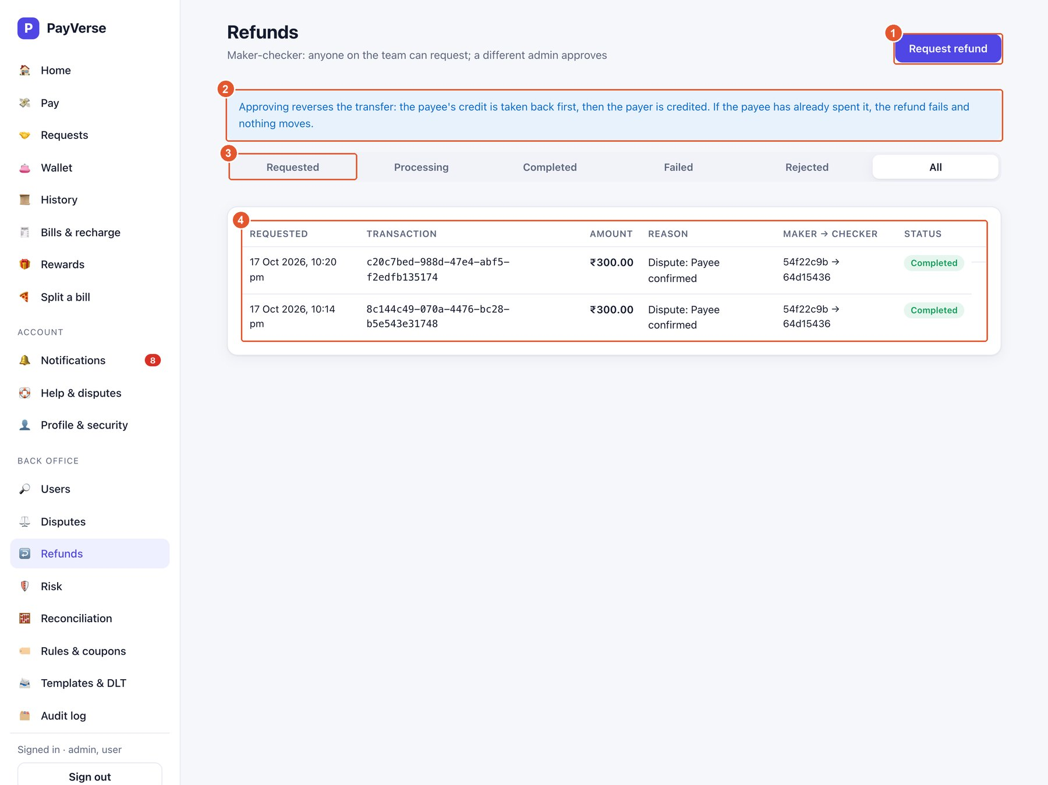
Figure 41. Refunds (maker-checker)
No. | Element | What it does
1 | Request refund | Request a refund for a transaction ID directly.
2 | How refunds work | The payee's credit is reversed first, then the payer is credited. If the payee already spent it, the refund fails and nothing moves.
3 | Status tabs | Requested, Processing, Completed, Failed, Rejected, All.
4 | Refund | Transaction, amount, reason, maker → checker and status. Approve/Reject appear only for someone other than the requester.

Tip: Approve and Reject are available to ADMIN accounts only, and never on a request you made yourself.

Risk — flagged transactions
Transfers the fraud engine scored 50+ (review) or 80+ (blocked).
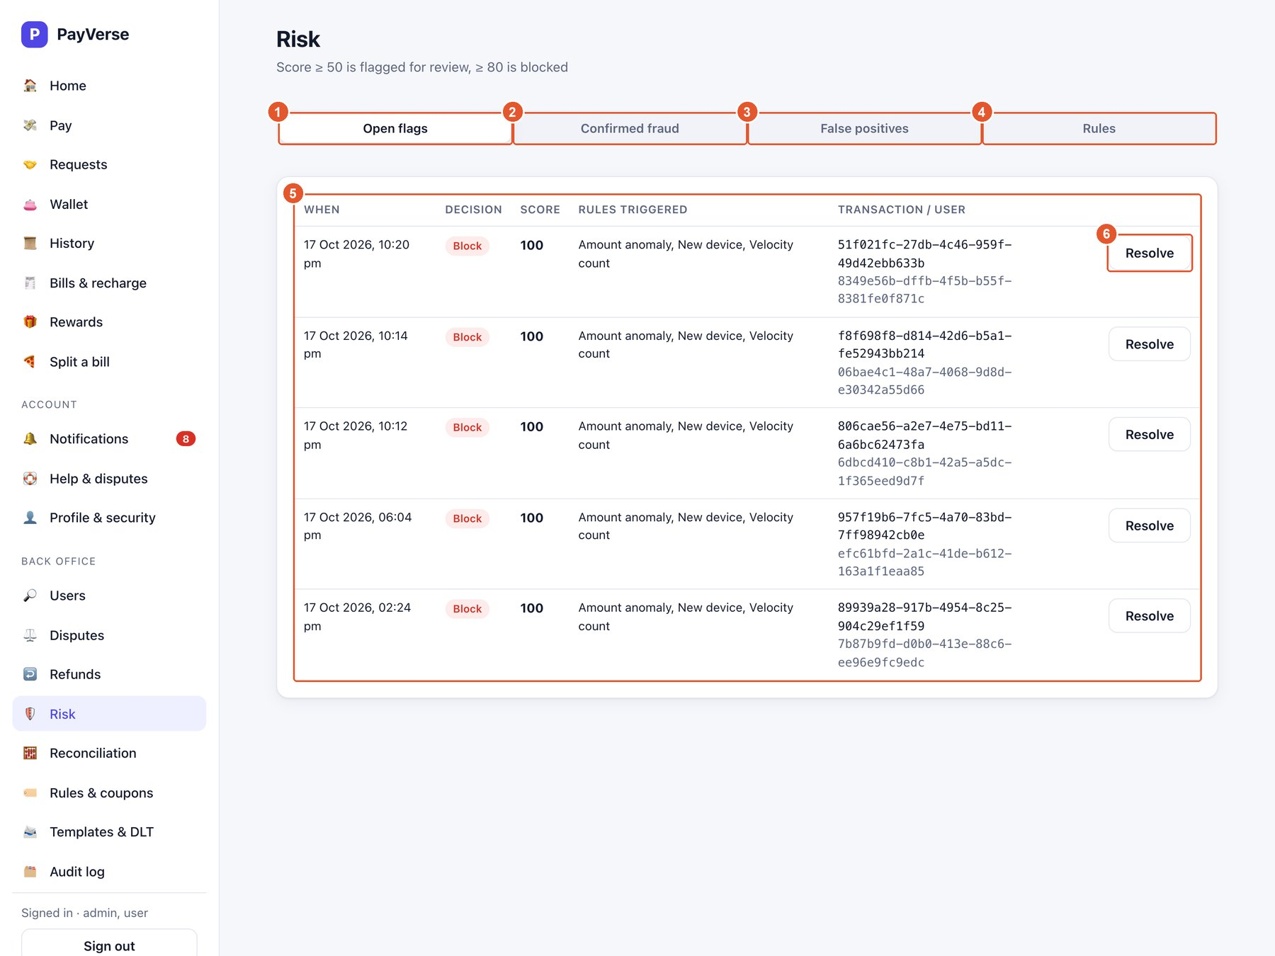
Figure 42. Risk — flagged transactions
No. | Element | What it does
1 | Open flags | Waiting for a decision.
2 | Confirmed fraud | Flags resolved as fraud.
3 | False positives | Flags cleared.
4 | Rules | Tune the scoring rules.
5 | Flag | Decision, score, triggered rules and the transaction/user.
6 | Resolve | Confirm fraud (optionally freezing the wallet) or mark as a false positive.

Tip: SUPPORT can resolve flags; freezing the wallet while confirming fraud needs ADMIN.

Risk — rules
Each rule adds its weight to the score when triggered. Score ≥ 50 = review, ≥ 80 = block.
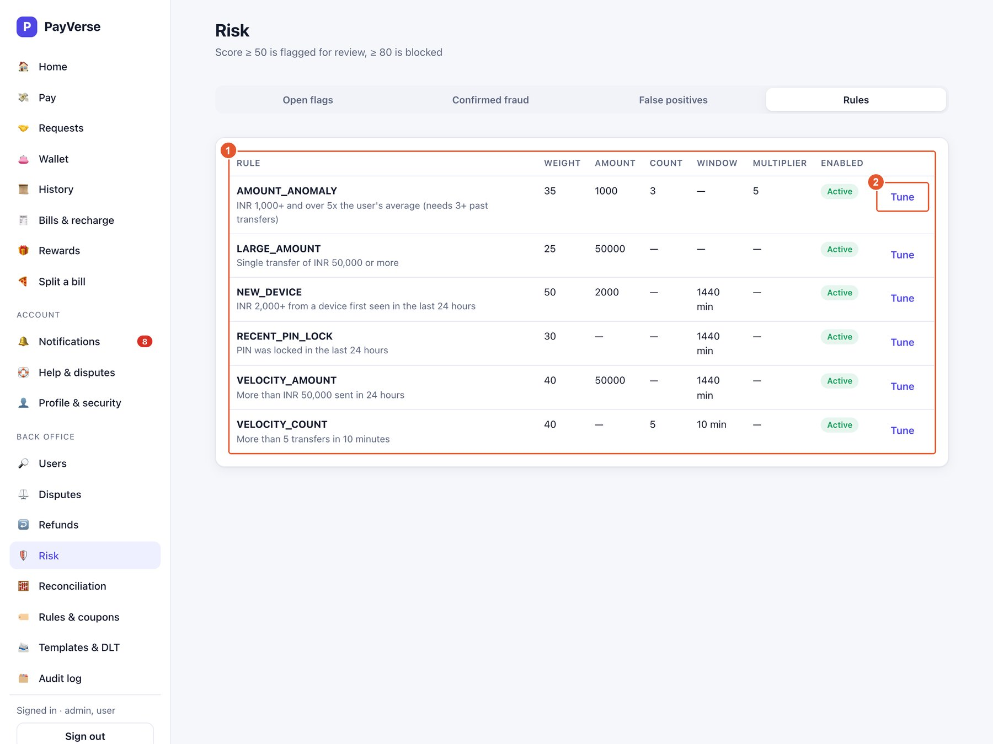
Figure 43. Risk — rules
No. | Element | What it does
1 | Rules | Weight, amount threshold, count, time window, multiplier and whether the rule is enabled.
2 | Tune | Edit a rule's numbers or disable it; applies to the next transfer.

Tip: Tune is available to ADMIN accounts only.

Reconciliation
Checks that money records agree across systems. Jobs also run nightly at 02:30 IST.
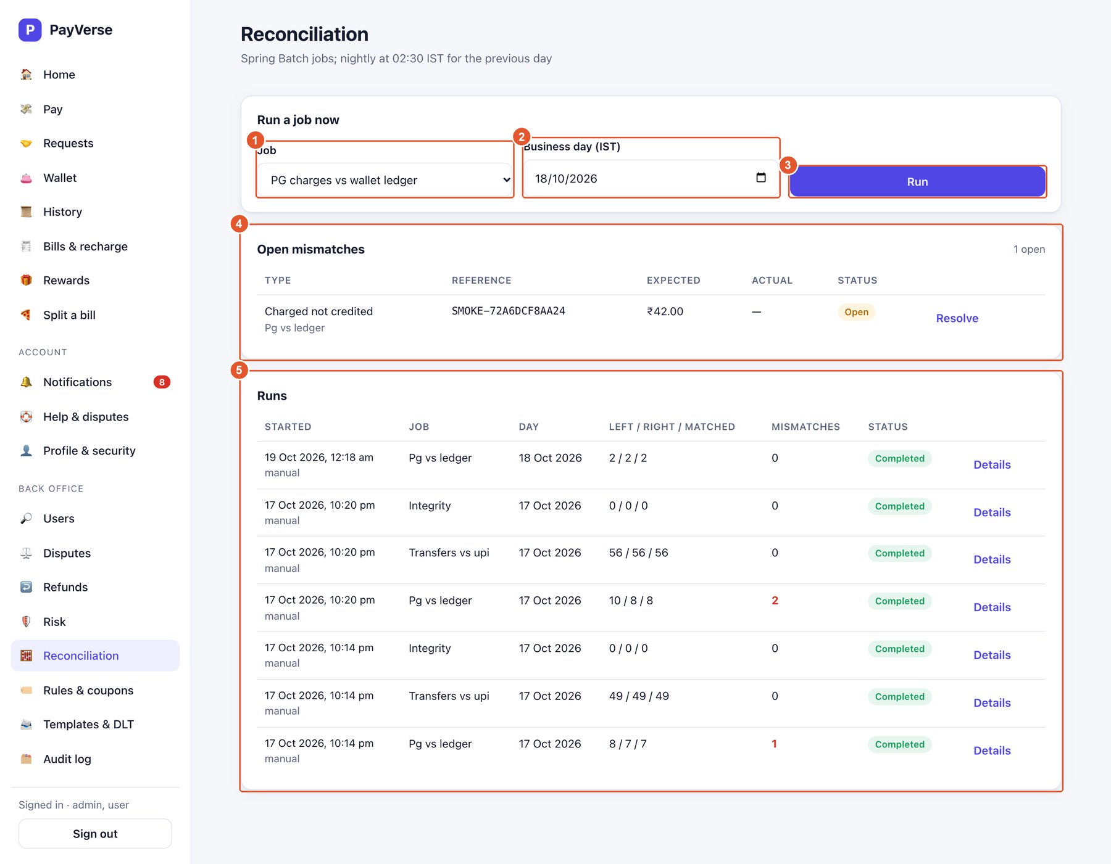
Figure 44. Reconciliation
No. | Element | What it does
1 | Job | PG charges vs wallet ledger, Transfers vs UPI switch, or Ledger integrity.
2 | Business day (IST) | The day to check.
3 | Run | Starts the job now.
4 | Open mismatches | Differences found; Resolve each with a note.
5 | Runs | Past runs with counts (left / right / matched), mismatches and status; Details shows more.

Tip: Running jobs and resolving mismatches is available to ADMIN accounts only.

Rules & coupons
Cashback rules and promotional coupons.
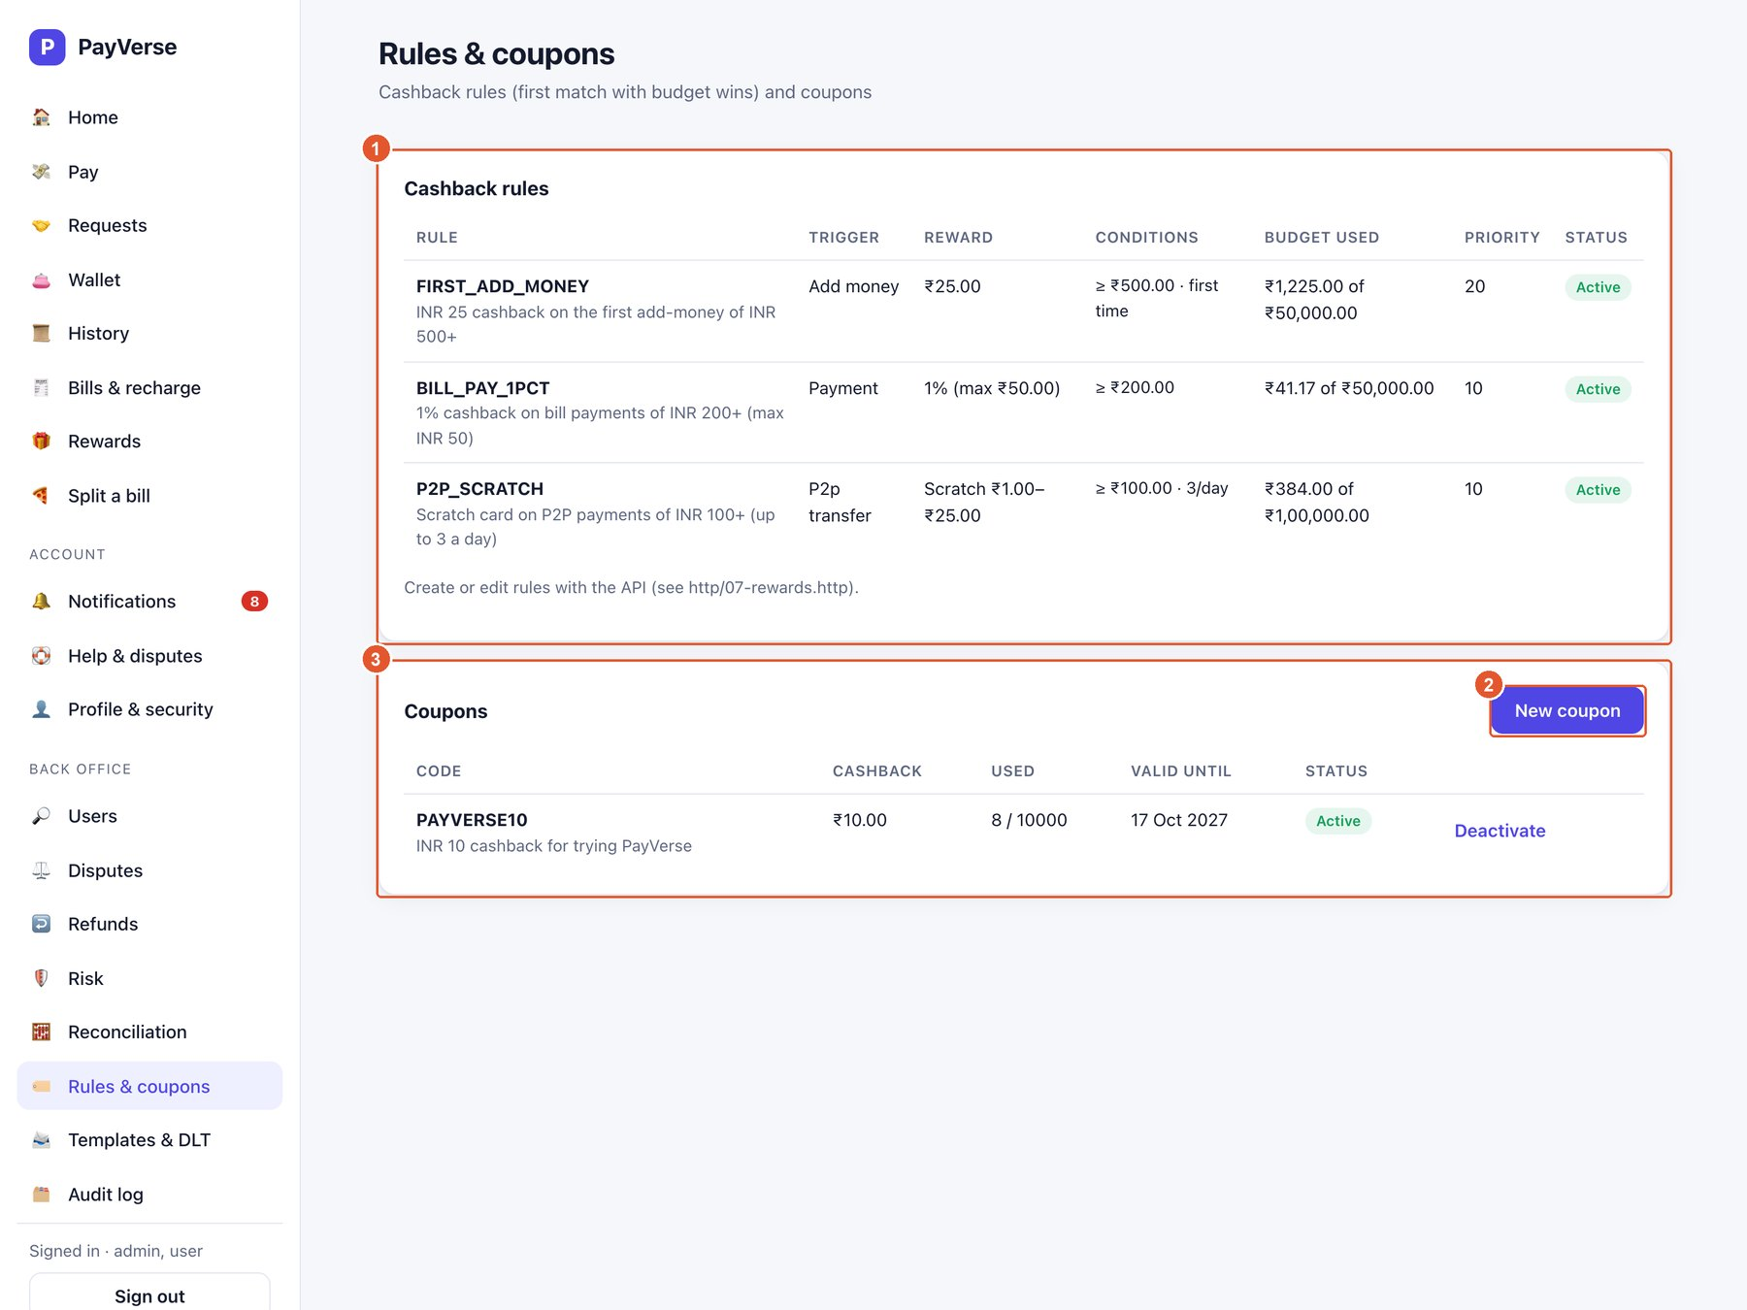
Figure 45. Rules & coupons
No. | Element | What it does
1 | Cashback rules | Trigger, reward, conditions, budget used, priority and status (first matching rule with budget wins).
2 | New coupon | Create a coupon: code, cashback, maximum uses and validity.
3 | Coupons | Coupon usage and validity; Deactivate stops a coupon.

Tip: Creating or changing rules and coupons is available to ADMIN accounts only.

Templates & dead letters
Message templates for every notification, and failed events.
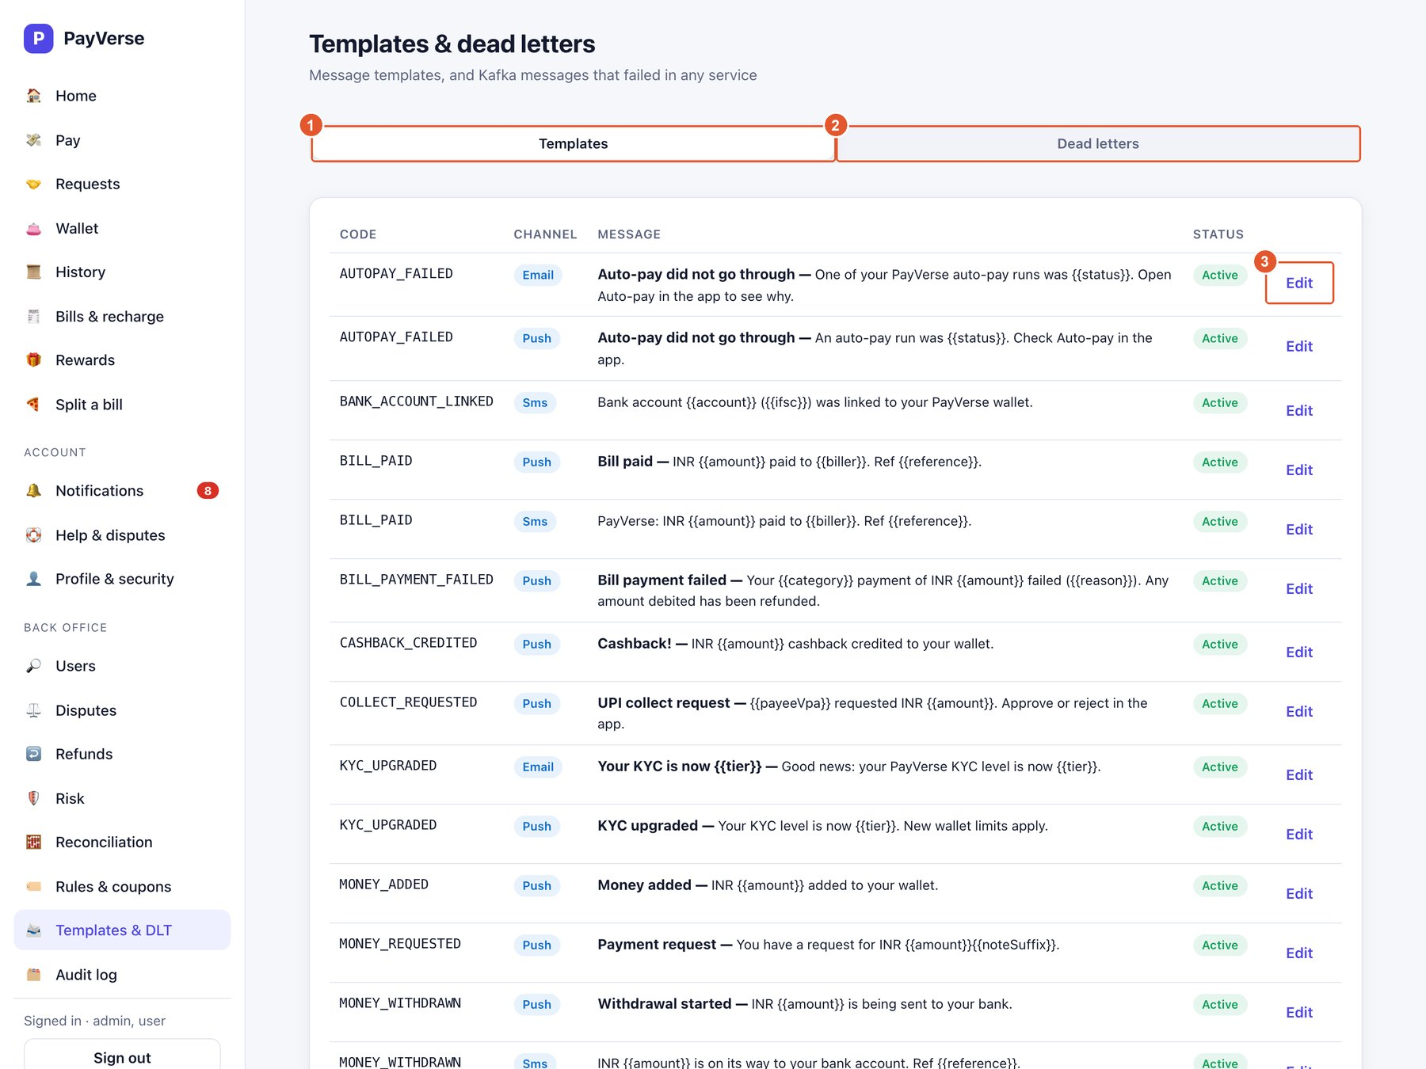
Figure 46. Templates & dead letters
No. | Element | What it does
1 | Templates | Every notification's channel and text; {{placeholders}} are filled in automatically.
2 | Dead letters | Events a service could not process; Replay sends one back for another try.
3 | Edit | Change a template's text or disable it.

Tip: Editing templates and replaying dead letters is available to ADMIN accounts only.

Audit log
A permanent, unchangeable record of every back-office action.
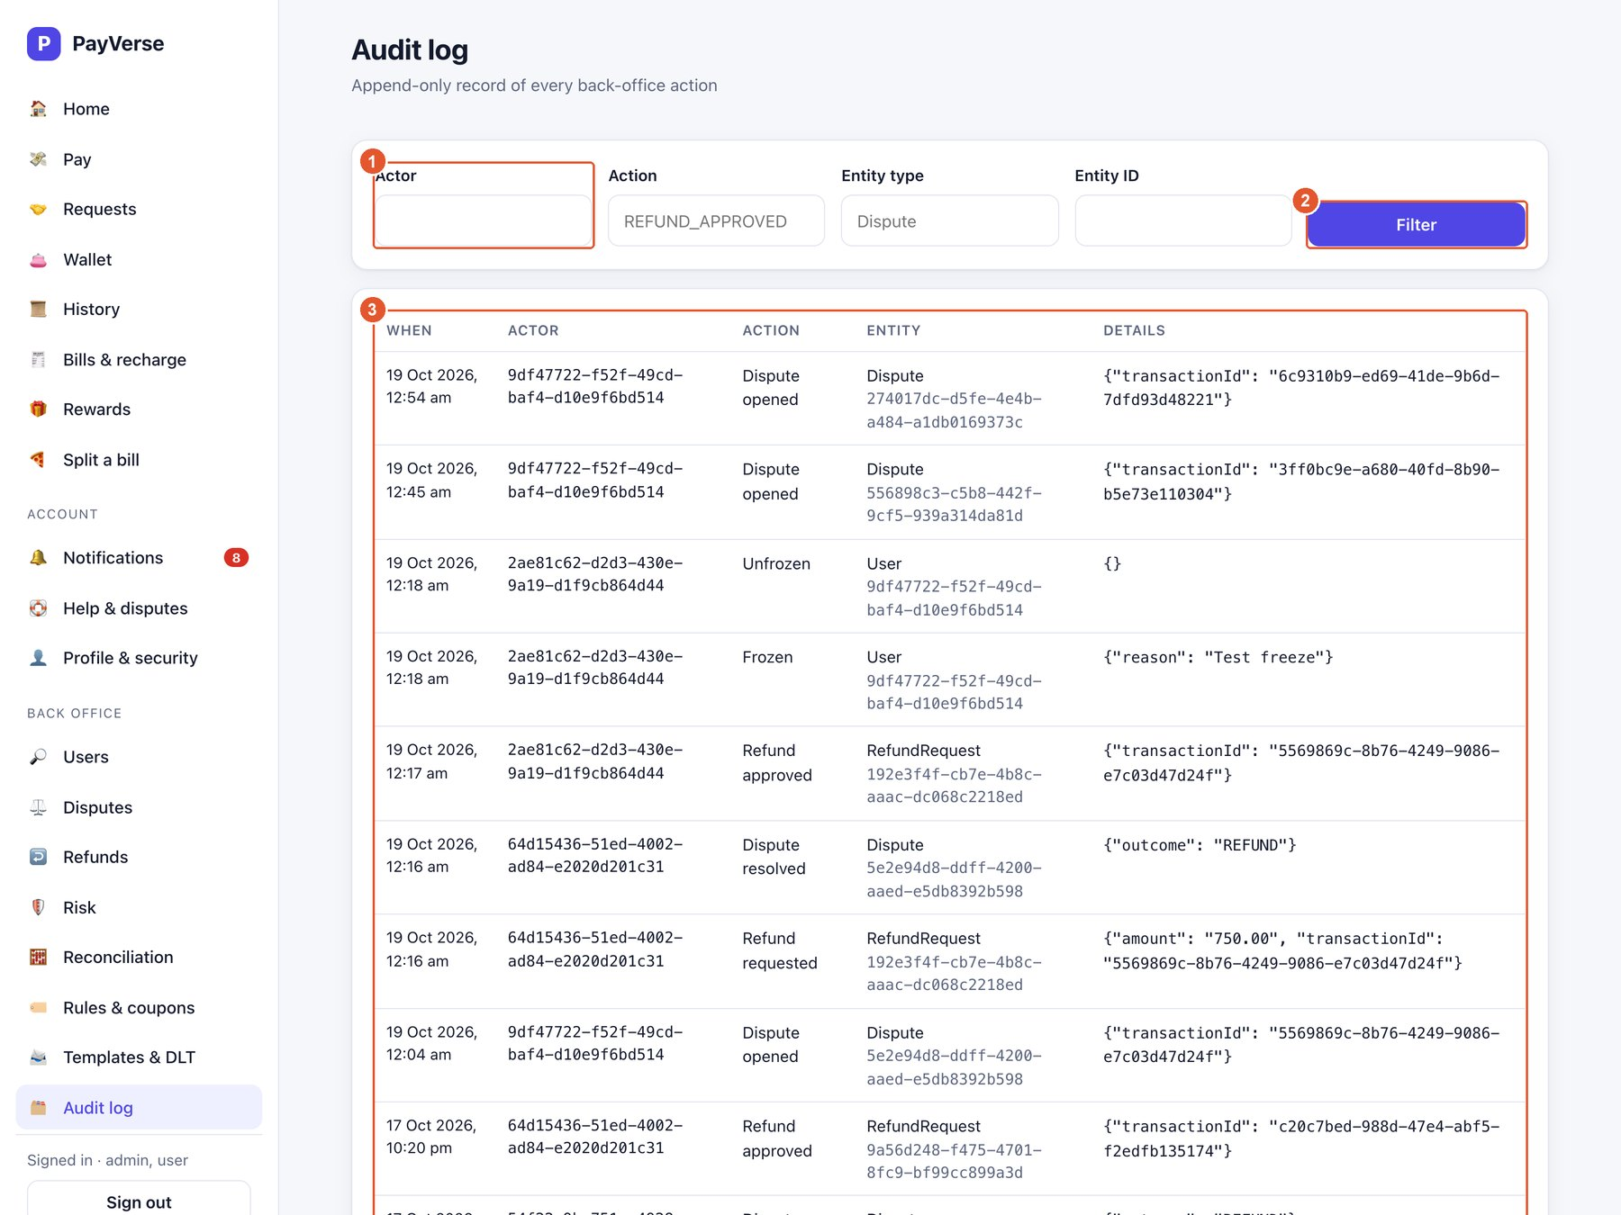
Figure 47. Audit log
No. | Element | What it does
1 | Filters | Filter by actor, action, entity type and entity ID.
2 | Filter | Apply the filters.
3 | Entries | When, who, what action, on which entity, and the details.

Quick reference — common tasks

Pay someone
- Pay → UPI ID (or Mobile / QR code).
- Enter the UPI ID and check the name shown under it.
- Enter amount and note → Pay.
- Enter your PIN → Confirm.

Add money
- Wallet → Add money.
- Enter the amount, choose UPI / card / net banking → Add.

Withdraw to your bank
- Profile & security → Bank accounts → link your account (once).
- Wallet → Withdraw to bank → choose the account and amount → Withdraw → PIN.

Ask someone for money
- Requests → Request money.
- Choose UPI ID or mobile, enter amount and note → Send request.

Pay a request you received
- Requests → Asked of me.
- Pay (or Approve for a UPI collect) → PIN, or Decline / Reject.

Split a bill
- Split a bill → total and description.
- Add each person → Create split.

Pay a bill
- Bills & recharge → choose category and biller.
- Enter your account number → Fetch bill → Pay bill → PIN.

Set up auto-pay
- Bills & recharge → Auto-pay → Set up auto-pay.
- Choose biller, account, frequency and limit → Authorise with PIN.

Download a statement
- History → Statement → choose dates → CSV or PDF.

Report a problem with a payment
- History → click the payment → Report a problem.
- Describe it → Raise dispute. Track it in Help & disputes.

Change your PIN
- Profile & security → Security → current PIN and new PIN → Change PIN.

Forgot your PIN
- Sign-in screen → Forgot your transaction PIN? → verify with an OTP → choose a new PIN.

Frequently asked questions
I did not receive the OTP. Wait for the countdown and press Resend. Check the number shown under “Sent to”. Up to 5 codes can be requested per minute.
Why can't I make payments? Payments need at least Min KYC. Finish Profile & security → KYC. If your wallet is frozen, contact support.
My payment shows Pending. It is still being processed and will update by itself. Do not pay again — retries never charge twice.
I entered a wrong PIN several times. After 5 wrong attempts the PIN is locked. Use “Forgot your transaction PIN?” to reset it.
Where is my cashback? Rewards → Cashback earned. Cashback shows Pending credit for a few seconds, then Credited to your wallet.
How do I get a refund for a wrong payment? Raise a dispute from History. Support reviews it; approved refunds return the money to your wallet and the payment shows Reversed.
Can I use PayVerse on my phone? Yes — open the same address in your phone's browser. The menu moves to the bottom of the screen.
How do I sign out of another device? Profile & security → Security → Devices.

Appendix — test environment values
These values only apply to the test environment, where all banks, billers and SMS are simulated. They let you try failure cases on purpose.
Try this | What happens
Add money with an amount ending .13 (e.g. 100.13) | The bank declines the payment; nothing is charged.
Withdraw an amount ending .14 | The bank transfer fails and the money returns to your wallet.
Bill account number ending 0000 | The biller reports an unknown account.
Bill amount ending .13 | The biller declines; the money is refunded automatically.
KYC document number containing 9999 | Verification is rejected.
Coupon PAYVERSE10 | ₹10 cashback (while the coupon is active).
Where are OTPs? | The test SMS sender writes them to the system log; your administrator can read them out.

