1. Imported data from local to SQL server database using SQL server Management Studio.

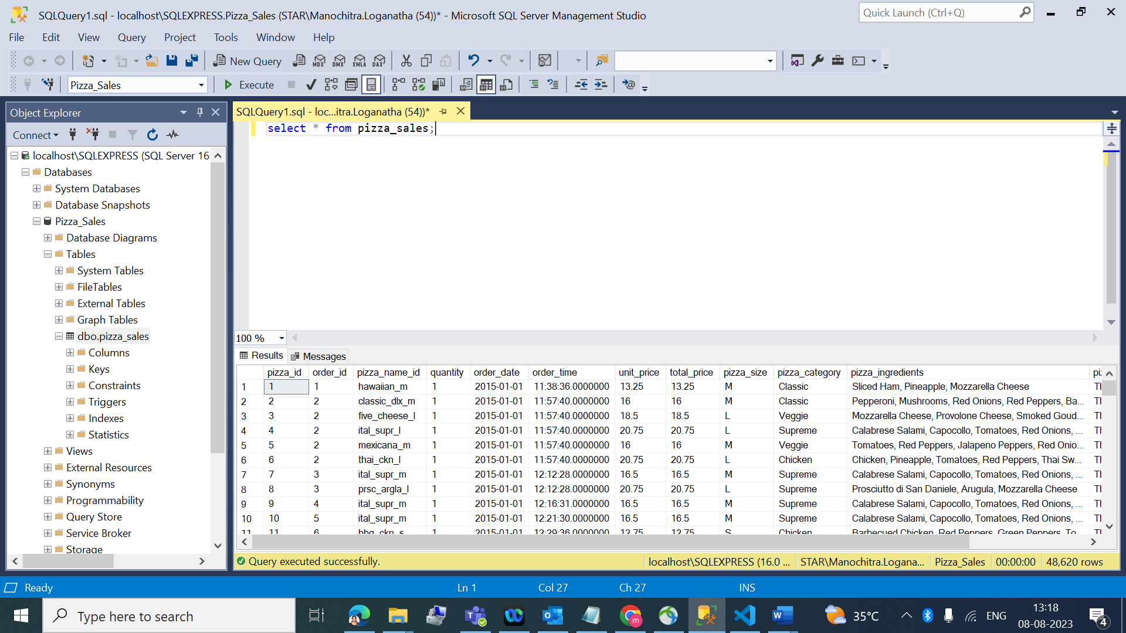

1. Calculated primary and Secondary KPI with the help of SQL queries.

* **Total Revenue:**

select sum(total_price) AS Total_Revenue from pizza_sales;

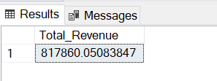

* **Average Order Value:**

SELECT sum(total_price)/COUNT(DISTINCT order_id) AS Avg_Order_Value FROM pizza_sales;

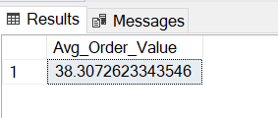

* **Total_Pizza_Sold:**

SELECT SUM(quantity) AS Total_Pizza_Sold FROM pizza_sales;

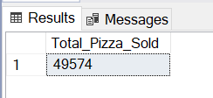

* **Total_Orders:**

SELECT COUNT(DISTINCT order_id) AS Total_orders FROM pizza_sales;

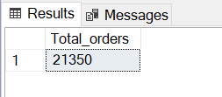

* **Average Pizzas Per order:**

SELECT CAST(CAST(SUM(quantity) AS DECIMAL(10,2))/

CAST(COUNT(DISTINCT order_id) AS DECIMAL(10,2)) AS DECIMAL(10,2)) AS Avg_Pizzas_Per_order FROM pizza_sales;

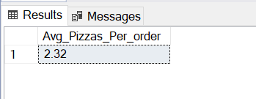

* **Daily Trend for Total Orders:**

SELECT DATENAME(DW,order_date) AS order_day, COUNT(DISTINCT order_id)

AS Total_orders FROM pizza_sales GROUP BY DATENAME(DW,order_date);

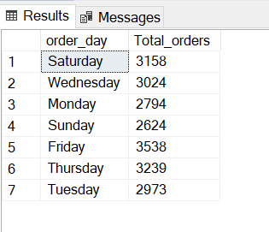

* **Monthly Trend for Total Orders:**

SELECT DATENAME(MONTH,order_date) AS Order_month, COUNT(DISTINCT

order_id) AS Total_orders FROM pizza_sales GROUP BY

DATENAME (MONTH,order_date) ORDER BY Total_orders DESC;

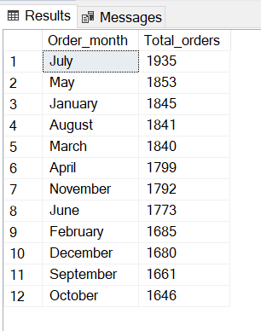

* **Percentage of Sales by Pizza Category:**

SELECT pizza_category, SUM (total_price) AS Total_Sales ,

SUM(total_price)* 100/ (SELECT SUM(total_price) FROM pizza_sales)

AS PCT FROM pizza_sales GROUP BY pizza_category;

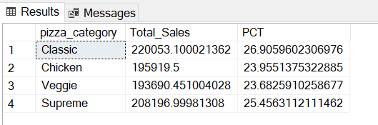

* **Percentage of Sales by Pizza Category for particular month:**

SELECT pizza_category, SUM (total_price) AS Total_Sales ,

SUM(total_price) * 100/ (SELECT SUM(total_price) FROM pizza_sales WHERE

MONTH(order_date)=1) AS PCT FROM pizza_sales WHERE MONTH(order_date)=1

GROUP BY pizza_category;

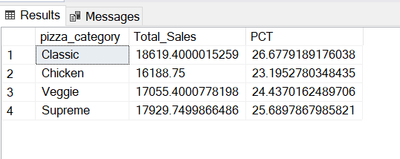

* **Percentage of Sales by Pizza Size for first quarter.**

SELECT pizza_size, CAST(SUM (total_price) AS DECIMAL(10,2)) AS Total_Sales , CAST(SUM(total_price) * 100/ (SELECT SUM(total_price) FROM pizza_sales

WHERE DATEPART(QUARTER,order_date)=1) AS DECIMAL(10,2)) AS PCT

FROM pizza_sales

WHERE DATEPART(QUARTER,order_date)=1

GROUP BY pizza_size

ORDER BY PCT DESC;

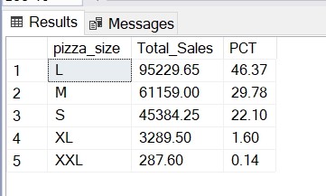

* **Top 5 Pizza by Revenue.**

SELECT TOP 5 pizza_name, CAST(SUM(total_price) AS DECIMAL(10,2)) AS Total_Revenue

FROM pizza_sales

GROUP BY pizza_name

ORDER BY Total_Revenue DESC;

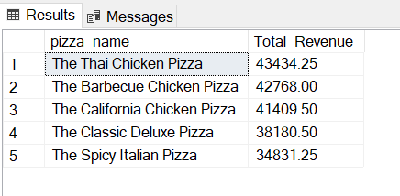

* **Bottom 5 Pizza by Revenue.**

SELECT TOP 5 pizza_name, CAST(SUM(total_price) AS DECIMAL(10,2)) AS Total_Revenue

FROM pizza_sales

GROUP BY pizza_name

ORDER BY Total_Revenue ASC;

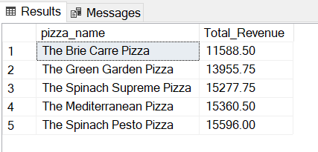

* **Top 5 Pizza by Quantity.**

SELECT TOP 5 pizza_name, SUM(quantity) as Total_Quantity

FROM pizza_sales

GROUP BY pizza_name

ORDER BY Total_QUANTITY DESC;

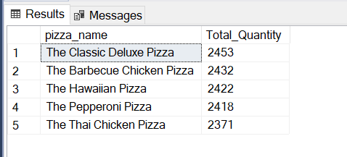

* **Bottom 5 Pizza by Quantity.**

SELECT TOP 5 pizza_name, SUM(quantity) as Total_Quantity

FROM pizza_sales

GROUP BY pizza_name

ORDER BY Total_QUANTITY ASC;

