1. Installed and Connected server from SSMS.

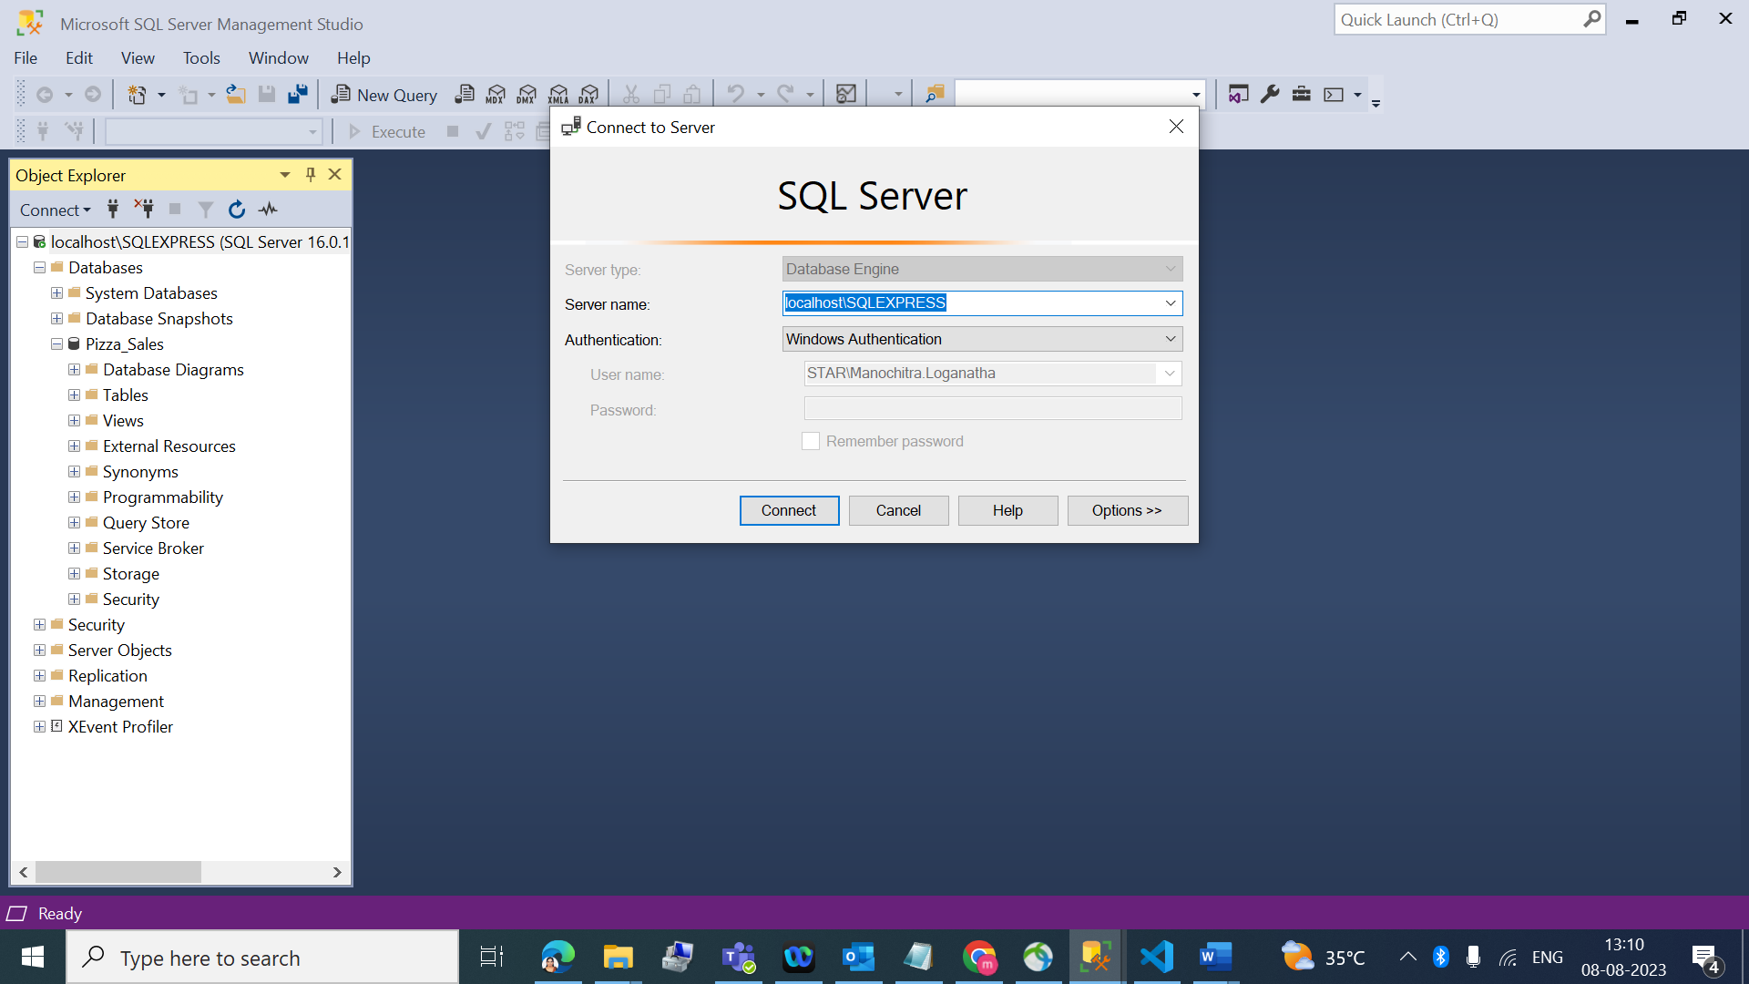

1. Created new database and table to process data.

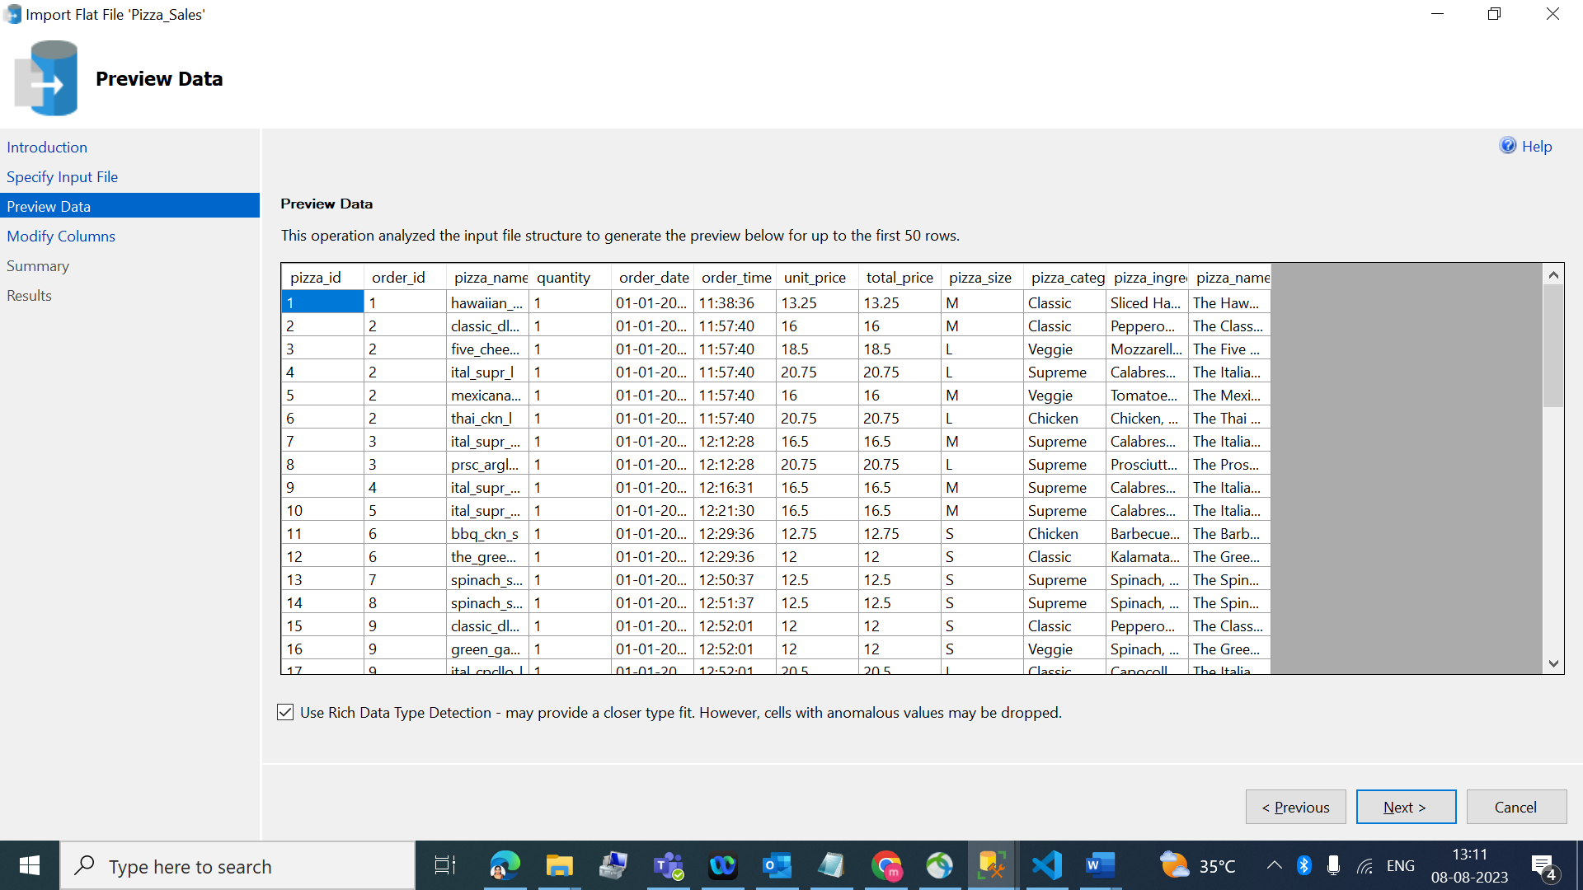

1. Modified data types of the column according to the data processed.

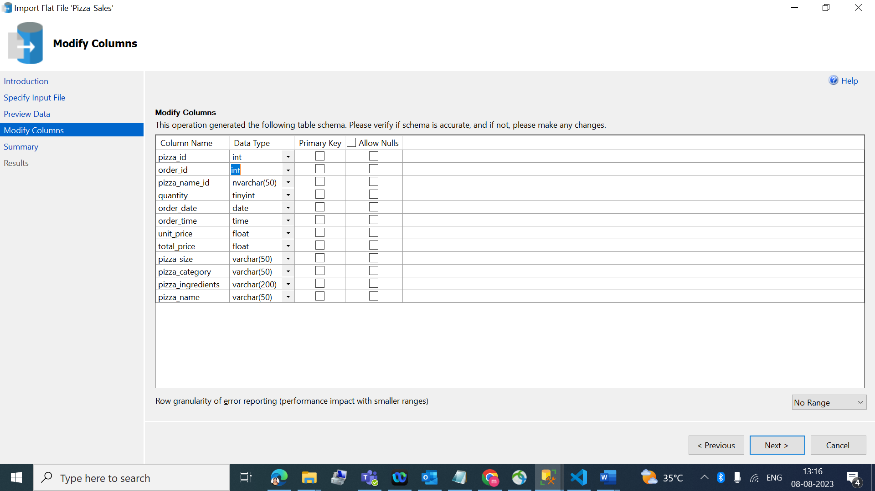

1. Successfully imported data into database table.

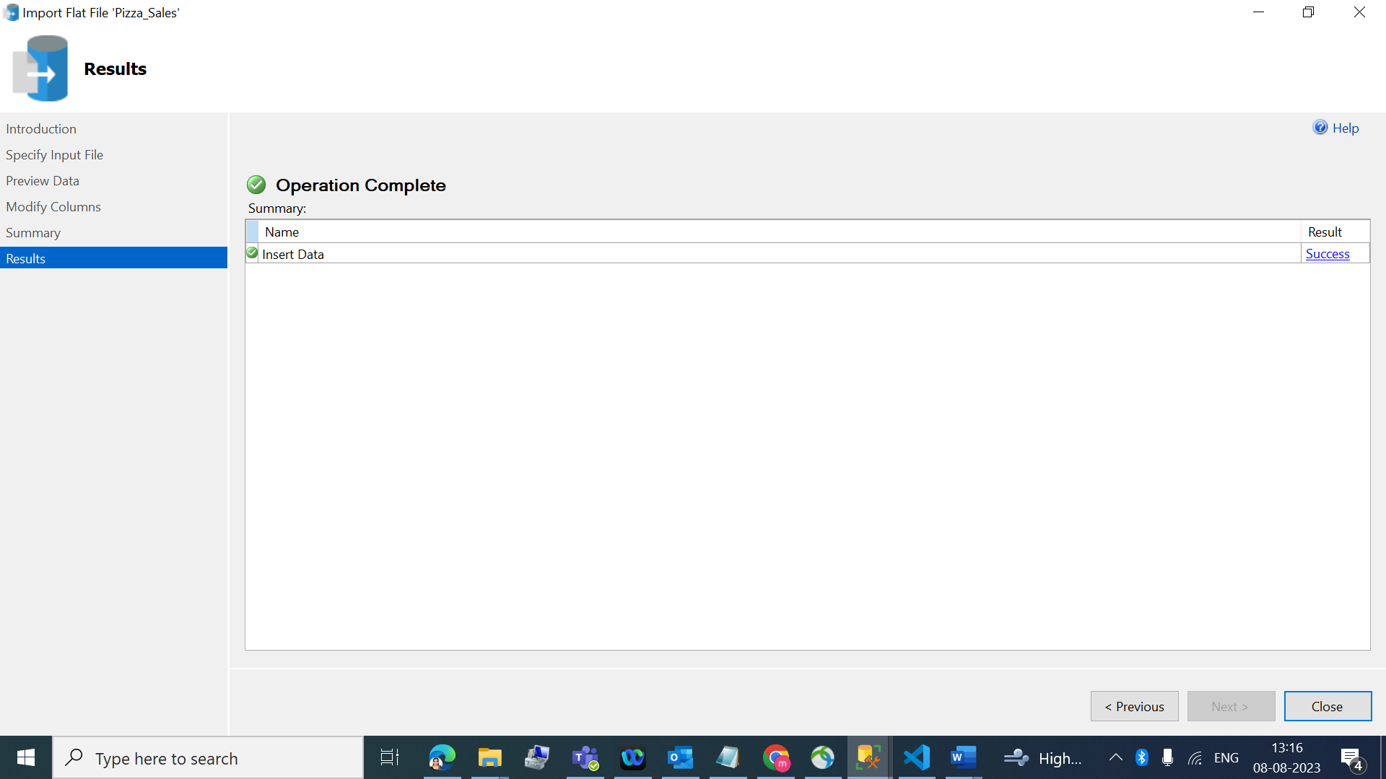

1. Validated the data from SSMS.

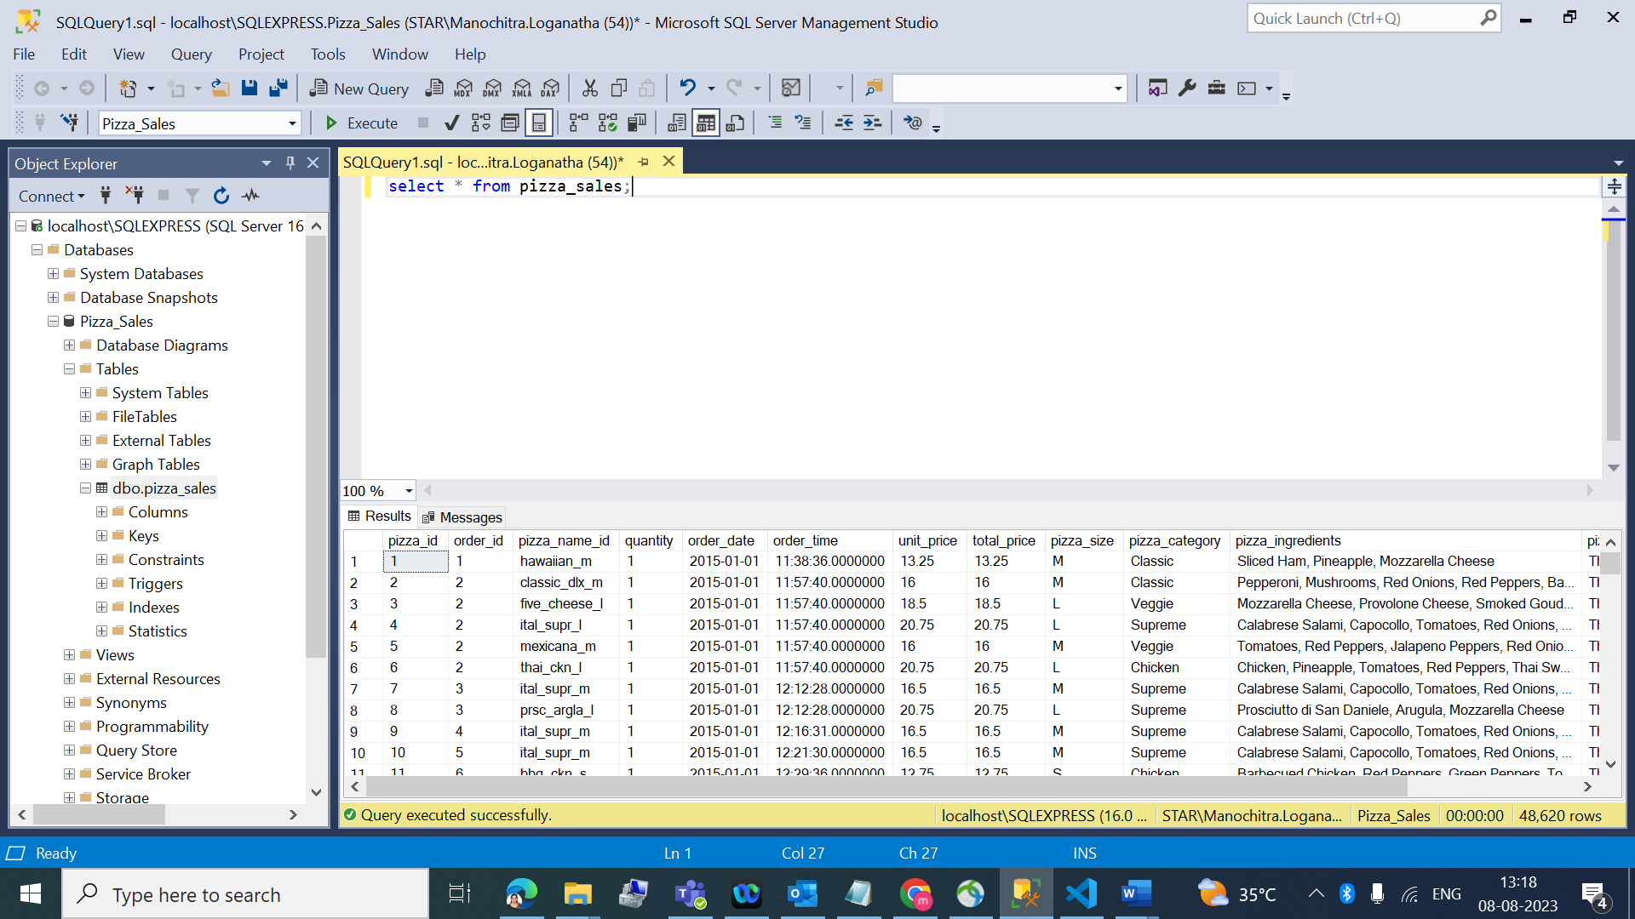

1. Calculated primary and Secondary KPI with the help of SQL queries.

* **Total Revenue:**

SELECT sum(total_price) AS Total_Revenue FROM pizza_sales;

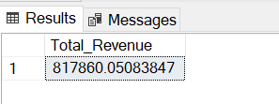

* **Average Order Value:**

SELECT sum(total_price)/COUNT(DISTINCT order_id) AS Avg_Order_Value FROM pizza_sales;

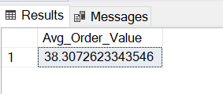

* **Total_Pizza_Sold:**

SELECT SUM(quantity) AS Total_Pizza_Sold FROM pizza_sales;

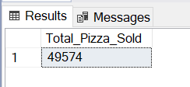

* **Total_Orders:**

SELECT COUNT(DISTINCT order_id) AS Total_orders FROM pizza_sales;

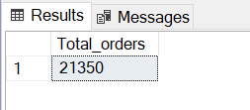

* **Average Pizzas Per order:**

SELECT CAST(CAST(SUM(quantity) AS DECIMAL(10,2))/

CAST(COUNT(DISTINCT order_id) AS DECIMAL(10,2)) AS DECIMAL(10,2)) AS Avg_Pizzas_Per_order FROM pizza_sales;

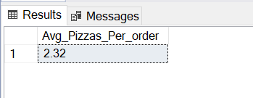

* **Daily Trend for Total Orders:**

SELECT DATENAME(DW,order_date) AS order_day, COUNT(DISTINCT order_id)

AS Total_orders FROM pizza_sales GROUP BY DATENAME(DW,order_date);

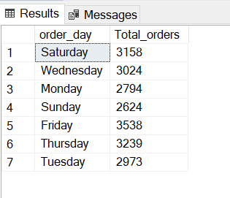

* **Monthly Trend for Total Orders:**

SELECT DATENAME(MONTH,order_date) AS Order_month, COUNT(DISTINCT

order_id) AS Total_orders FROM pizza_sales GROUP BY

DATENAME (MONTH,order_date) ORDER BY Total_orders DESC;

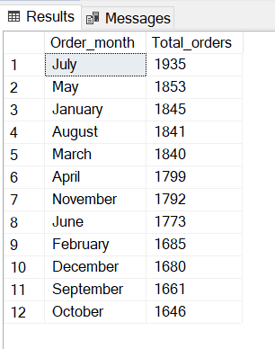

* **Percentage of Sales by Pizza Category:**

SELECT pizza_category, SUM (total_price) AS Total_Sales ,

SUM(total_price)* 100/ (SELECT SUM(total_price) FROM pizza_sales)

AS PCT FROM pizza_sales GROUP BY pizza_category;

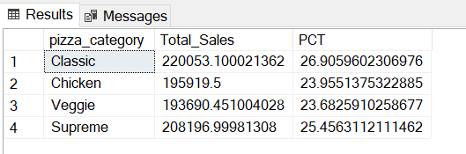

* **Percentage of Sales by Pizza Size for first quarter.**

SELECT pizza_size, CAST(SUM (total_price) AS DECIMAL(10,2)) AS Total_Sales , CAST(SUM(total_price) * 100/ (SELECT SUM(total_price) FROM pizza_sales WHERE DATEPART(QUARTER,order_date)=1) AS DECIMAL(10,2)) AS PCT FROM pizza_sales WHERE DATEPART(QUARTER,order_date)=1 GROUP BY pizza_size

ORDER BY PCT DESC;

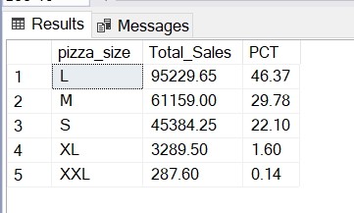

* **Top 5 Pizza by Revenue.**

SELECT TOP 5 pizza_name, CAST(SUM(total_price) AS DECIMAL(10,2)) AS Total_Revenue

FROM pizza_sales

GROUP BY pizza_name

ORDER BY Total_Revenue DESC;

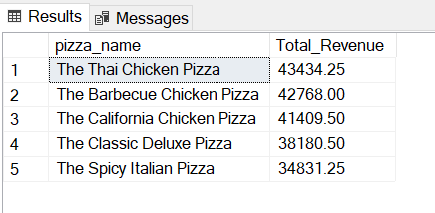

* **Bottom 5 Pizza by Revenue.**

SELECT TOP 5 pizza_name, CAST(SUM(total_price) AS DECIMAL(10,2)) AS Total_Revenue

FROM pizza_sales

GROUP BY pizza_name

ORDER BY Total_Revenue ASC;

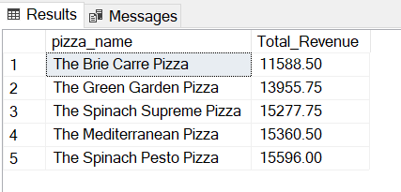

* **Top 5 Pizza by Quantity.**

SELECT TOP 5 pizza_name, SUM(quantity) as Total_Quantity

FROM pizza_sales

GROUP BY pizza_name

ORDER BY Total_QUANTITY DESC;

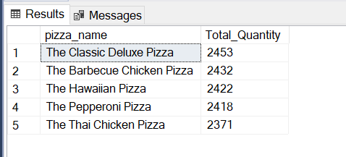

* **Bottom 5 Pizza by Quantity.**

SELECT TOP 5 pizza_name, SUM(quantity) as Total_Quantity

FROM pizza_sales

GROUP BY pizza_name

ORDER BY Total_QUANTITY ASC;

