What is a commit message, and how is the commit command executed?

The commit command is executed in a Git project to record the progress in the local repository. The commit command is executed only after the files to be committed have been added to the staging area using the git add command.

The command that makes it possible to write a commit message is ‘git commit -m’.

### **Name a few Git commands with their function.**

* Git config - Configure the username and email address
* Git add - Add one or more files to the staging area
* Git diff - View the changes made to the file
* Git init - Initialize an empty Git repository
* Git commit - Commit changes to head but not to the remote repository

### **Explain the git push command.**

The [Git push command](https://www.simplilearn.com/tutorials/git-tutorial/git-push-command) is used to push the content in a local repository to a remote repository. After a local repository has been modified, a push is executed to share the modifications with remote team members.

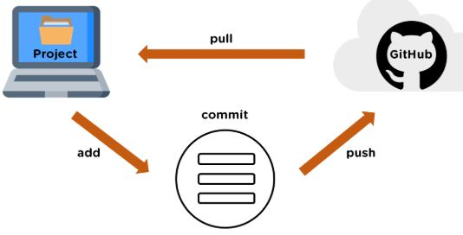

### **Explain the git pull command.**

Git pull is used to fetch and merge changes from the remote repository to the local repository. Git pull is a combination of two commands: git fetch; followed by git merge.

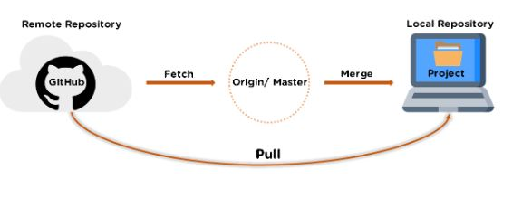

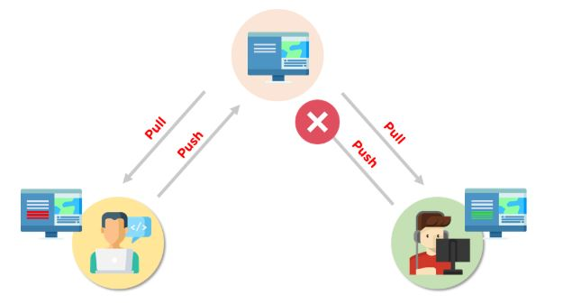

How do you resolve a merge conflict?

To resolve a merge conflict in Git, follow these steps:

* The most simple way to resolve the conflicted file is to open it and make the required changes
* After editing the file, we can use the git add a command to stage the new merged content
* The final step is to create a new commit with the help of the git commit command
* Git will create a new merge commit to finalize the merge

### **What is the process to revert a commit that has already been pushed and made public?**

There are two processes through which you can revert a commit:

1. Remove or fix the bad file in a new commit and push it to the remote repository. Then commit it to the remote repository using:

**git commit –m “commit message”**

2. Create a new commit to undo all the changes that were made in the bad commit. Use the following command:

**git revert <commit id>**

### **What does the git reset --mixed and git merge --abort commands do?**

**git reset --mixed** is used to undo changes made in the working directory and staging area.

**git merge --abort** helps stop the merge process and return back to the state before the merging began.

How do you find a list of files that has been changed in a particular commit?

The command to get a list of files that has been changed in a particular commit is:

git diff-tree –r {commit hash}

* -r flag allows the command to list individual files
* commit hash lists all the files that were changed or added in the commit.

### **What is the difference between fork, branch, and clone?**

|  |  |  |
| --- | --- | --- |
| **Fork** | **Branch** | **Clone** |
| The fork is the process when a copy of the repository is made. It's usually experimentation in the project without affecting the original project. They’re used to advise changes or take inspiration from someone else’s project. | Git branches refer to individual projects within a git repository. If there are several branches in a repository, then each branch can have entirely different files and folders. | Git clone refers to creating a clone or a copy of an existing git repository in a new directory. Cloning automatically creates a connection that points back to the original repository, which makes it very easy to interact with the central repository. |

### **What is the command used to fix a broken commit?**

To fix a broken commit in Git, you may use the “git commit --amend” command, which helps you combine the staged changes with the previous commits instead of creating an entirely new commit.

### **If you recover a deleted branch, what work is restored?**

The files that were stashed and saved in the stash index can be recovered. The files that were untracked will be lost. That’s why it's a good idea to stage and commit your work or stash them.

**How will you create a git repository?**

* Have git installed in your system.
* Then in order to create a git repository, create a folder for the project and then run git init.

### Tell me something about git stash?

Git stash can be used in cases where we need to switch in between branches and at the same time not wanting to lose edits in the current branch

**What is ‘git status’ is used for?**

As ‘Git Status’ shows you the difference between the working directory and the index, it is helpful in understanding a git more comprehensively.

Create your center repository …make it public or private.

https://github.com/Manodesh02/June2021.git

Git bash is git client. Git version 2.31.1

To set your username and emailId.

$ git config --global user.name "Manoj D"

$ git config --global user.email [deshmukh.manoj02@gmail.com](mailto:deshmukh.manoj02@gmail.com)

$ git config --global push.default "simple"