Rail Fence

1. Encrypt the message "Enjoy your Journey" using Rail Fence with depth 2 and 3
ENJOYYOURJOURNEY (16 characters)

* Depth 2:
* Row 0: EJYORORE
* Row 1: NOYUJUNY
* Ciphertext: EJYORORENOYUJUNY

* Depth 3:
* Row 0: EYRR
* Row 1: NOYUJUNY
* Row 2: JOOE
* Ciphertext: EYRRNOYUJUNYJOOE

2. Encrypt the message as per your choice using Rail Fence with depth 2 and 3
("CRYPTOLOGY")
* Depth 2:
* Row 0: CYOOG
* Row 1: RPTLY
* Ciphertext: CYOOGRPTLY

* Depth 3:
* Row 0: CTG
* Row 1: RPOLOY
* Row 2: YL
* Ciphertext: CTGRPOLOYYL

3. Decrypt the cipher "EOCSNYUWLEJYREASONS" , encrypted using Rail fence with depth 4.

characters=19
1 | 2 | 3 | 4 | 5 | 6 | 7 | 8 | 9 | 10 | 11 | 12 | 13 | 14 | 15 | 16 | 17 | 18 | 19
*E |  |  |  |  |  | *O |  |  |  |  |  | *C |  |  |  |  |  | *S
 | *N |  |  |  | *Y |  | *U |  |  |  | *W |  | *L |  |  |  | *E
 |  | *J |  | *Y |  |  |  | *R |  | *E |  |  |  | *A |  | *S
 |  |  | *O |  |  |  |  |  | *N |  |  |  |  |  | *S

Plain text : ENJOY YOUR NEW CLASSES

4. Decrypt the cipher "BOOIGUYUBOSNUUTYRKAS", encrypted using Rail fence with depth 3.
characters=20
1 | 2 | 3 | 4 | 5 | 6 | 7 | 8 | 9 | 10 | 11 | 12 | 13 | 14 | 15 | 16 | 17 | 18 | 19 | 20
*B |  |  |  | *O |  |  |  | *O |  |  |  | *I |  |  |  | *G
 | *U |  | *Y |  | *U |  | *B |  | *O |  | *S |  | *N |  | *U |  | *U |  | *T
 |  | *Y |  |  |  | *R |  |  |  | *K |  |  |  | *A |  |  |  | *S

Plain text : BUY YOUR BOOKS IN AUGUST

5. Decrypt the cipher "SEMSERTISINCMOO" encrypted using Rail fence with depth 2.
15
1 | 2 | 3 | 4 | 5 | 6 | 7 | 8 | 9 | 10 | 11 | 12 | 13 | 14 | 15
*S |  | *E |  | *M |  | *S |  | *E |  | *R |  | *T |  | *I
 | *S |  | *I |  | *N |  | *C |  | *M |  | *O |  | *O

Plain text : SESIMNSCEMROTOI

Permutation
1. Encrypt the following message "We are discovered " using the key "53124"

WEAREDISCOVERED

WEARE DISCO VERED
1 2 3 4 5
W E A R E CIPHER= E A E W R
5 3 2 1 4

1 2 3 4 5
D I S C O CIPHER= O S D I C
5 3 2 1 4

1 2 3 4 5
V E R E D CIPHER= D R V E E
5 3 2 1 4

CIPHER= E A E W R O S D I C D R V E E

DES

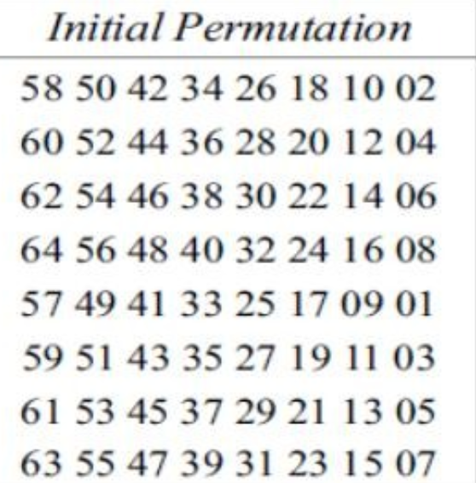

- Using the initial permutation table, determine the output of the initial permutation box when the input is given in hexadecimal as: 0X0002 0000 0000 0001
Convert Hexadecimal to 64-bit Binary
Each hexadecimal digit expands into 4 binary bits. The total string has 16 hex digits, giving 16 \times 4 = 64 bits.
The input is 0002 0000 0000 0001. Expanding this into binary (indexed from 1 to 64 from left to right):
* 0002 has a 2 at the fourth nibble, which means bit 15 is 1 (0000 0000 0000 0010).
* 0001 has a 1 at the final nibble, which means bit 64 is 1 (0000 0000 0000 0001).
All other 62 bit positions in the 64-bit block are 0.
* Active Input Bits: Only Bit 15 and Bit 64 are equal to 1.

Trace Where the Active Bits Move
Since only input bits 15 and 64 are 1, you only need to find where these two numbers appear inside the IP table:
* Locating Bit 64:
Scanning the table row-by-row, the number 64 appears at the 25th position (Row 4, Column 1).
* Therefore, input bit 64 moves to output bit position 25, making output bit 25 equal to 1.
* Locating Bit 15:
Scanning the table, the number 15 appears at the 63rd position (Row 8, Column 7).
* Therefore, input bit 15 moves to output bit position 63, making output bit position 63 equal to 1.
Form the Final Output
All other output bit positions receive zeros because their corresponding input positions were 0.
* Output Binary Representation: A 64-bit string with 1s at position 25 and position 63, and 0 everywhere else.
* Output Hexadecimal Representation: Converting that 64-bit binary back to hex yields:
0000 0080 0000 0002

- Given the 4-bit binary Plaintext (M) 1101 and the Key (K) 1011, calculate the resulting Ciphertext (C) using a bitwise Exclusive-OR (XOR) operation. Show your bit-by-bit work.
- Plaintext (M): 1101 (binary)
- Key (K): 1011 (binary)

Plaintext (M): 1101
Key (K): 1011
M XOR K
* Bit 1: 1 XOR 1 = 0 //When same= 0 and different =1
* Bit 2: 1 XOR 0 = 1
* Bit 3: 0 XOR 1 = 1
* Bit 4: 1 XOR 1 = 0

Ciphertext (C): 0110

- The input to S-box 1 is 000000.What is the output?

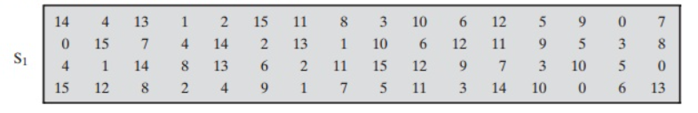

0 0000 0
00 - 0TH ROW
0000 – 0TH COLUMN

Oth row oth column is 14

output is 1110

Product Cipher
Explore ADFGVX cipher

Introduction to the ADFGVX Cipher
The ADFGVX cipher is a historical field cipher used by the German Army during World War I, starting in March 1918. Designed by Lieutenant Fritz Nebel, it was an evolution of the earlier ADFGX cipher and is a classic example of fractionation combined with transposition.
It earned its name from the six letters chosen for the ciphertext alphabet—A, D, F, G, V, and X—because their Morse code representations are distinct and less prone to operator error or misinterpretation on noisy telegraph lines.
How the ADFGVX Cipher Works
The encryption process relies on two main cryptographic steps: Polybius Square Substitution (fractionation) and Columnar Transposition (permutation).
Step 1: The 6x6 Polybius Square
Unlike the standard 5x5 square used for the Playfair or ADFGX ciphers (which requires combining 'I' and 'J'), the ADFGVX cipher uses a 6x6 grid containing all 26 letters of the English alphabet (A–Z) and the 10 digits (0–9).
* The rows and columns of the grid are labeled with the letters A, D, F, G, V, X in that order.
* The grid is populated using a secret keyword to fill in the initial cells, followed by the remaining unused letters and digits in alphabetical/numerical order.
Example 6x6 Grid:
A D F G V X
A | P 3 H Q 4 G
D | E V 2 W I B
F | 5 X 5 L N 8
G | T O D 1 S 6
V | F Z 7 M 9 K
X | R A C U J E *(Note: Grid filled conceptually for illustration)*

Step 2: Substitution (Fractionation)
Every character in the plaintext is replaced by the row-column coordinate pair from the grid. For instance, if 'H' is located at row A, column F, it becomes the bigram AF. This process doubles the length of the message and breaks up letter frequencies.
Step 3: Columnar Transposition
To obscure patterns further, the resulting fractionated letters are written into a grid beneath a secret keyword (e.g., GERMANY).
* The columns are then rearranged alphabetically based on the keyword's letters.
* The final ciphertext is read off column by column.
Historical Impact and Breaking
The cipher was famously cracked in May 1918 by Georges Painvin, a brilliant French Army cryptanalyst. Painvin was able to intercept German messages and exploit the structural weaknesses caused by varying message lengths and repeating transpositions, giving the Allied forces crucial intelligence during the final months of WWI.

